Merging Student One Card patron records

Version 1, 20181119 jg

1. Open two Sierra Desktop Application (SDA) windows using your individual login.
   1. Note, the “clerkcc” login is not scoped to perform this task
2. In the left window, navigate to the “Merge Duplicate Patron Records” from the Function drop down, under Circulation:

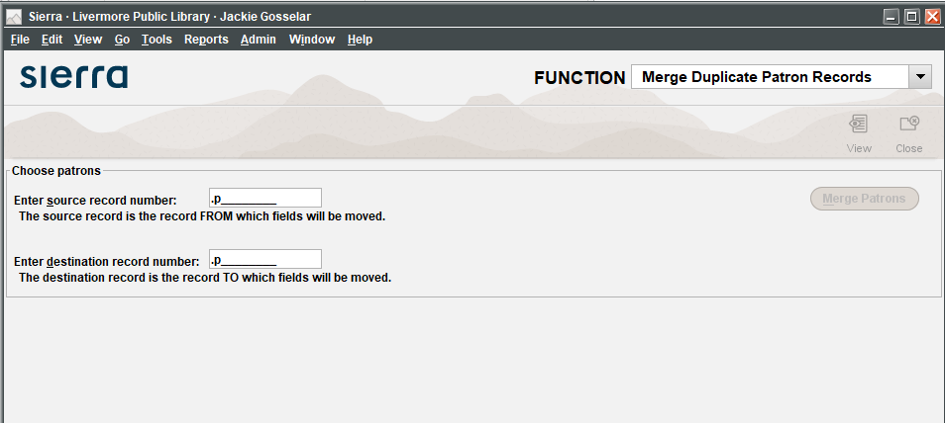

1. In the right window, navigate to “Check Out (Circulation Desk)” from the Function drop down, under Circulation:

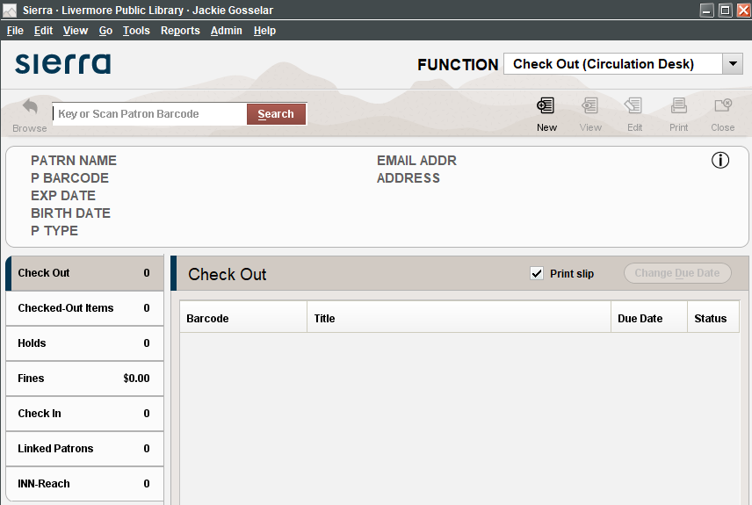

1. Using the Excel file of duplicate Student One Card patron names, copy a name from the list and search in the “Check Out” function in the right window, prepending the name with an “n.” Click search.
   1. Note, this list of duplicate patrons will be provided with each new load of student data
2. Two records should display; the original patron record and the newly created LVJUSD Student One Card record:

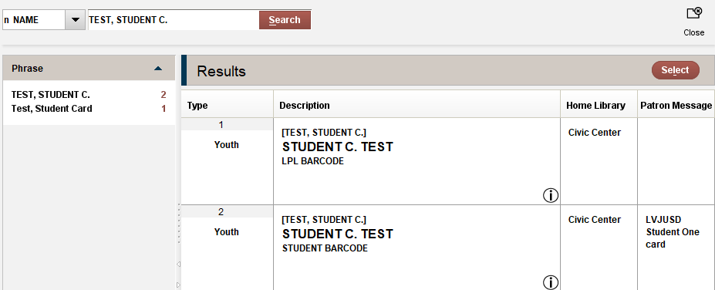

1. Open the record with the patron message “LVJUSD Student One Card”
   1. Click “view” and copy the patron record number (ex: p11421356) :
   2. Paste this record number into the “Source record number” field in the Merge Duplicate Patron Record window in the left pane:

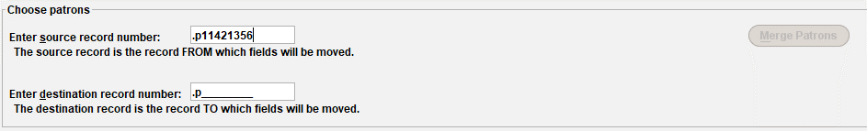

* 1. Close the patron record in the right window.

1. In the right window, click the “Browse” icon to return to your patron name search, and then open the other patron record for the same name (this should be the original patron record with a conventional barcode):

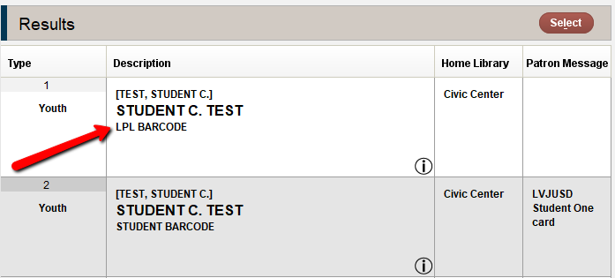

* 1. Click “view” and copy the other copy patron record number (ex: p11421344).
  2. Paste this record number into the “Destination record number” field in the Merge Duplicate Patron Record window in the left pane:

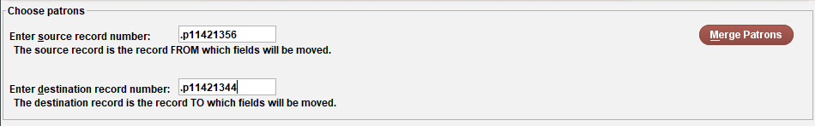

1. Close the patron record in the right window.
2. Now, the red “Merge Patrons” button will become active in the left window. Click it.
3. Review the personal data on the screen to verify that this is indeed the same patron.
   1. Some fields may vary, but use your best judgement to determine if these two records represent the same person.
   2. If all looks correct, click on the “Merge Patrons” button at the top, which will merge the unique fields in both records to the destination record.

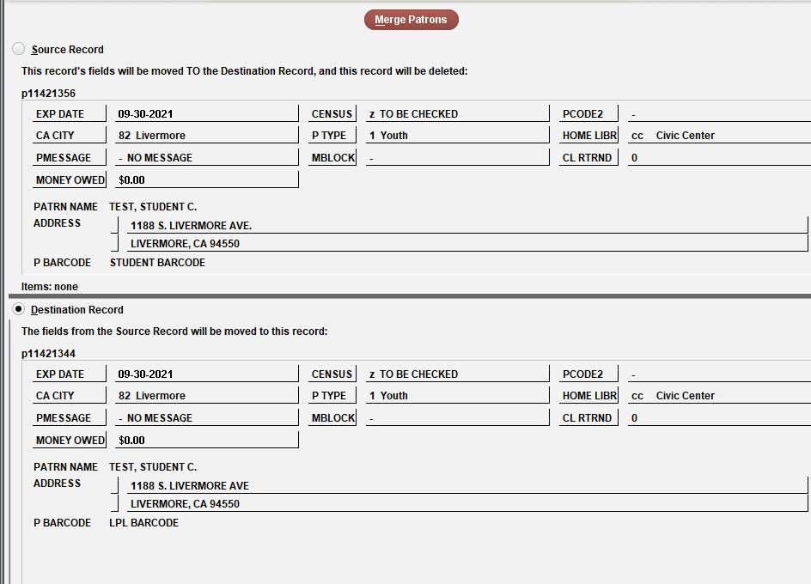

1. To verify, search for the patron name again in the right window in “Check Out” function, and you should find a newly merged patron record.
   1. Ensure that the new record has both barcodes and a note indicating that the record was merged. The card should now work using both the student ID and their LPL library card barcode.
   2. The patron record will maintain the popup “LVJUSD Student One card” in the message field.

