DESIGN AND SIMULATION OF AN INTELLIGENT MULTIMODAL FOREARM WEARABLE FOR EMG-BASED MUSCLE ACTIVITY AND MOTION MONITORING
Project Name: ForearmSense AI
A Project-Based Learning Report Submitted in partial fulfilment of the requirements for the award of the degree of
Bachelor of Technology
in The Department of Electronics and Communication Engineering
Course: Analog Electronic Circuit Design — Course Code: 25EC1302E
Submitted by:
A Jaswant Goud — 2510040007
G Abhishek — 2510040015
O GopiChand — 2510040023
C Meghasyam — 2510040072
Under the Guidance of:
Dr A. Bhuvaneshwari


Department of Electronics and Communication Engineering
Koneru Lakshmaiah Education Foundation
Aziz Nagar, Hyderabad – 500075
October 2026

ABSTRACT
Non-invasive interpretation of forearm muscle recruitment and hand kinematics is central to wearable biomedical instrumentation, rehabilitation engineering, and human–computer interaction. Unimodal systems that observe surface electromyography (sEMG) or inertial motion independently struggle to separate voluntary grip activation from posture-induced baseline shifts and wrist instability during repetitive hand-gripper exercises.
This Project-Based Learning (PBL) report presents the engineering design, mathematical modeling, and reproducible simulation of ForearmSense AI for Analog Electronic Circuit Design (25EC1302E). The project is mapped around a confirmed benchtop hardware inventory: an Arduino Uno (exact revision unconfirmed; classic ATmega328P R3 10-bit ADC analyzed as a provisional example alongside R4 14-bit operation), a single-channel BioAmp EXG Pill biopotential analog front end (AFE) with existing electrodes, an MPU-6050 six-axis IMU (accelerometer and gyroscope, no magnetometer), a mechanical hand gripper, and a laptop USB host, with no working optical pulse sensor. For 25EC1302E coursework, a custom +3.30 V AFE (TI INA826 at G₁ = 10.00 V/V plus OPA2376 Sallen–Key Butterworth filters, 50 Hz Twin-T notch, and G₂ = 50.00 V/V post-amplifier yielding G_{total} = 499.91 V/V across 20.28–452.7 Hz) is derived and explicitly distinguished as a theoretical/simulated educational reference rather than a BioAmp EXG Pill specification.
Analytical calculations and saved Python simulations (forearmsense_reproducibility_suite.py, seeds 42 and 108) verify a theoretical reference CMRR of 101.1 dB, an input-referred noise floor of 0.782 µV_{rms} (AFE) / 0.947 µV_{rms} (system), −71.73 dB anti-aliasing attenuation at 3550 Hz under 4000 Hz reference sampling (contrasted against the 125 Hz and 250 Hz Nyquist limits of legacy 250 Hz serial and 500 Hz internal sampling), +23.90 dB simulated sEMG SNR improvement, 0.53° complementary-filter pitch RMSE, and 92.93% ± 0.98% (Random Forest) saved 5-fold trial-grouped synthetic classification accuracy.
Repository software provides a FastAPI and React/Vite synthetic signal laboratory, while live serial ingestion, recording, and replay remain planned. A 35-second three-hold gripper protocol and leakage-free validation rules are established for bench testing.
Index Terms — Surface Electromyography (sEMG), BioAmp EXG Pill, Arduino Uno, Inertial Measurement Unit (MPU-6050), Grip Activation & Movement Stability, Theoretical AECD Filter Design (INA826/OPA2376), Nyquist Anti-Aliasing, Trial-Grouped Cross-Validation.
Table 0: Project Team Members and Institutional Metadata
S. No. / Field | Student Name / Specification | Roll Number / Details
Student 1 | A Jaswant Goud | 2510040007
Student 2 | G Abhishek | 2510040015
Student 3 | O GopiChand | 2510040023
Student 4 | C Meghasyam | 2510040072
Project Title | Design and Simulation of an Intelligent Multimodal Forearm Wearable for EMG-Based Muscle Activity and Motion Monitoring | Project Name: ForearmSense AI
Course & Code | Analog Electronic Circuit Design | Course Code: 25EC1302E
Department & Campus | Department of Electronics and Communication Engineering | KL University, Aziz Nagar, Hyderabad
Faculty Guide | Dr A. Bhuvaneshwari | Academic Year: 2026–2027 (Oct 2026)

LIST OF FIGURES
Table LOF: Directory of Engineering Schematics, Block Diagrams, and Simulation Figures
Figure No. | Figure Title and Description | Page
Figure 1 | Confirmed ForearmSense AI benchtop setup (1-Ch BioAmp EXG Pill, MPU-6050, hand gripper) and stack [Conceptual] | Page 8
Figure 2 | System block diagram: confirmed Arduino Uno + BioAmp + MPU-6050 path vs. theoretical AECD reference track [Conceptual] | Page 8
Figure 3 | Surface EMG MUAP volume-conductor model, Cole–Cole interface, and physical BioAmp vs. theoretical AECD input [Conceptual] | Page 10
Figure 4 | Theoretical AECD Stage-1 TI INA826 schematic (G₁ = 10.00 V/V) and subtractor CMRR vs. tolerance [SIMULATED] | Page 11
Figure 5 | Theoretical AECD 2nd-order Sallen–Key Butterworth HPF schematic (fc = 20.28 Hz) and Bode response [SIMULATED] | Page 14
Figure 6 | Theoretical AECD 4th-order Sallen–Key LPF + G₂ = 50 post-amp and Nyquist comparison (125/250 Hz vs. 4 kHz) [SIMULATED] | Page 14
Figure 7 | Simulated complete theoretical AECD reference chain Bode magnitude and phase response (53.98 dB passband) [SIMULATED] | Page 15
Figure 8 | Simulated 1-channel sEMG conditioning (f_{s,ADC} = 4000 Hz) and recommended 35-second hand-gripper task protocol [SIMULATED] | Page 19
Figure 9 | Simulated Welch PSD analysis, hardware Nyquist ceilings (125/250 Hz), and synthetic spectral shift model [SIMULATED] | Page 19
Figure 10 | Simulated MPU-6050 pitch complementary filter (α = 0.98) and optional synthetic optical pulse model [SIMULATED ONLY] | Page 17
Figure 11 | Simulated digital filter analysis (1000 Hz reference): 4th-order IIR vs. 65-tap Hamming FIR magnitude, delay, and poles [SIMULATED] | Page 18
Figure 12 | Previously saved trial-grouped 5-fold CV synthetic ML benchmark and Random Forest confusion matrix [SIMULATED] | Page 21
Figure 13 | Software laboratory architecture: implemented FastAPI + React/Vite synthetic lab vs. planned live serial ingestion [Conceptual] | Page 21

LIST OF TABLES
Table LOT: Directory of Engineering Specification, Calculation, and Validation Tables
Table No. | Table Title and Technical Scope | Page
Table 1 | Confirmed Physical Hardware Inventory vs. Theoretical AECD Course Reference Specifications | Page 9
Table 2 | Theoretical AECD Reference Front-End (INA826 + OPA2376) Electrical Parameters and Headroom Verification | Page 12
Table 3 | Theoretical AECD Stage-by-Stage Gain Allocation (G₁ = 10.0, G₂ = 50.0), Offset Budgets, and Physical AFE Contrast | Page 13
Table 4 | Theoretical AECD Active Filter Component Values, Cutoffs, Q Factors, and Stopband Attenuation | Page 15
Table 5 | Sampling Regimes, Nyquist Alias Boundaries (250 Hz Serial / 500 Hz Internal vs. 4 kHz Reference), and ADC Resolution | Page 17
Table 6 | Digital Signal Processing (DSP) Algorithm Comparison Across Time-Domain Grip Metrics and Spectral Analysis | Page 20
Table 7 | Previously Saved Trial-Grouped 5-Fold Cross-Validation Synthetic ML Benchmark (Mean ± 95% CI, Macro-F1, Brier) | Page 21
Table 8 | Master Experimental Matrix (Experiments 1–12): Domain, Provenance, Governing Equations, and Evidence Status | Page 22
Table 9 | Comprehensive Engineering Risk Analysis, Hardware Boundaries, and Design Mitigations | Page 26
Table 10 | Master Verification and Validation (V&V) Plan: Analytical, Saved Synthetic, Physical Status, and Target Criteria | Page 27
Table 11 | Multidisciplinary Course Outcome Traceability Matrix Across AECD (50%), DSP (25%), and ML (15%) | Page 7

TABLE OF CONTENTS
Table TOC: Document Structure, Chapter Hierarchy, and Verified Page Numbers
Section / Chapter | Section Title and Technical Contents | Page
Front Matter | Cover Page, Abstract, Project Team Metadata, List of Figures, List of Tables | Pages 1–4
Chapter 1 | 1. INTRODUCTION | Page 5
1.1 | Background: Forearm Surface EMG, Inertial Kinematics, and Gripper Biomechanics | Page 5
1.2 | Problem Statement: Unimodal Ambiguity, Sampling Boundaries, and Hardware Constraints | Page 5
1.3 | Motivation and Engineering Applications in Grip and Stability Monitoring | Page 6
1.4 | Measurable Engineering Objectives Across Hardware and AECD Coursework | Page 6
1.5 | Scope, Evidence Boundaries, and Non-Clinical / Non-Dynamometer Limitations | Page 7
1.6 | Course Outcome Integration and Curriculum Traceability (Table 11) | Page 7
Chapter 2 | 2. METHODOLOGY — ANALOG FRONT END, SENSORS, DSP, AND MACHINE LEARNING | Page 8
2.1 | Overall System Architecture: Confirmed Benchtop Hardware vs. AECD Reference (Figures 1–2, Table 1) | Page 8
2.2 | Forearm Surface EMG Acquisition, Skin–Electrode Interface, and BioAmp EXG Pill (Figure 3, Eqs. 2.1–2.4) | Page 9
2.3 | Theoretical AECD Instrumentation Amplifier Design, Gain Split, CMRR, and Noise (Figure 4, Eqs. 2.5–2.11) | Page 10
2.4 | Theoretical Active Filter Design and Honest Anti-Aliasing Analysis (Figures 5–7, Table 4, Eqs. 2.12–2.15) | Page 13
2.5 | Operational Amplifier Selection Study: OPA2376 vs. OPA2333 vs. LM741 (Eq. 2.16) | Page 15
2.6 | Supply Rail Architecture, Theoretical Battery Runtime, and IEC 60601-1 Safety Boundaries (Eq. 2.17) | Page 16
2.7 | Six-Axis IMU (MPU-6050) Kinematics, Derivative Definitions, and Timing Skew (Eq. 2.18) | Page 16
2.8 | Absence of Hardware PPG Sensor and Simulated Optical Model Boundaries (Figure 10, Eq. 2.19) | Page 16
2.9 | Digital Signal Processing (DSP), Rate Distinction, and 35-Second Task Protocol (Figures 8–9, 11, Eqs. 2.20–2.25) | Page 17
2.10 | Machine Learning Pipeline, Saved Synthetic Benchmark, and Real-Data Hygiene (Figures 12–13, Eq. 2.26) | Page 20
Chapter 3 | 3. EXPERIMENTS — REPRODUCIBLE SIMULATIONS AND HARDWARE PLAN (Table 8) | Page 21
3.1–3.12 | Experiments 1–11 (Executed / Saved Simulation Suite) and Experiment 12 (Proposed 35-Second Bench Protocol) | Pages 22–25
Chapter 4 | 4. RESULTS — ANALYTICAL, REPRODUCED SIMULATION, AND V&V PLAN (Tables 9–10) | Page 25
Chapter 5 | 5. CONCLUSION AND FUTURE WORK | Page 27
Chapter 6 | 6. REFERENCES (18 Verified Datasheets, Standards, and Biomedical Engineering Papers) | Page 28

DESIGN AND SIMULATION OF AN INTELLIGENT MULTIMODAL FOREARM WEARABLE FOR EMG-BASED MUSCLE ACTIVITY AND MOTION MONITORING

1. INTRODUCTION

1.1 Background: Biomedical Wearable Electronics, Surface EMG, and Forearm Biomechanics
Biomedical wearable instrumentation combines analog biopotential conditioning with digital kinematic sensing to study human neuromuscular coordination during functional hand tasks [2], [6], [9]. At the core of non-invasive muscle monitoring is Surface Electromyography (sEMG), which records the extracellular electrical potentials generated by recruited skeletal muscle fibers beneath cutaneous electrodes [1], [2].
When spinal alpha motor neurons fire action potential impulse trains at recruitment rates between 6 Hz and 50 Hz, depolarization waves propagate bidirectionally along the muscle sarcolemma at conduction velocities of 3.0 m/s to 5.5 m/s [1], [3]. Filtered through the biological volume conductor (muscle tissue, fascia, subcutaneous fat, and skin), the superposition of these Motor Unit Action Potentials (MUAPs) produces an interference waveform at the skin surface. In our theoretical Analog Electronic Circuit Design (AECD) reference model, full-scale cutaneous sEMG input is standardized at 5.0 mV_{pp} (±2.50 mVpeak, or ~0.50–0.83 mV_{rms} during strong contractions) across a primary passband of 20 Hz to 450 Hz [1], [2].
During repetitive hand-gripper squeezes, superficial extrinsic forearm flexors—primarily the Flexor Digitorum Superficialis (FDS) and Flexor Carpi Radialis (FCR)—generate electrical activation bursts accompanied by subtle wrist pitch/roll oscillations [3], [4]. Pairing a single-channel biopotential Analog Front-End (Upside Down Labs BioAmp EXG Pill [12]) with a six-axis MEMS Inertial Measurement Unit (TDK InvenSense MPU-6050 [16]) interfaced to an Arduino Uno [17] enables synchronized investigation of grip activation envelopes, grip/release timing, repetition consistency, and hand movement stability.

1.2 Problem Statement
Developing a rigorous student-built EMG-and-motion instrumentation system around fixed benchtop hardware while satisfying undergraduate AECD theoretical design requirements presents three fundamental engineering challenges:
• Unimodal Grip vs. Motion Ambiguity: An inertial sensor tracks three-axis linear acceleration and angular velocity (ω) during wrist movement, but cannot detect isometric muscle activation when a hand gripper is held stationary [1], [9]. Conversely, single-channel forearm sEMG amplitude is sensitive to posture-induced electrode skin stretching and baseline motion drift unless evaluated alongside simultaneous IMU stability metrics [3], [9].
• Single-Supply Analog Headroom & Off-the-Shelf Module Boundaries: In theoretical AECD circuit design, legacy instrumentation amplifiers (such as the TI INA128, requiring at least ±2.25 V or 4.5 V [13]) fail on a single +3.30 V wearable supply rail, and excessive Stage-1 DC gain saturates internal buffers under ±50 mV Ag/AgCl half-cell offsets [11], [14]. Meanwhile, on the physical bench, the pre-assembled BioAmp EXG Pill [12] provides a single fixed analog channel whose internal circuit parameters must be kept strictly distinct from custom INA826/OPA2376 theoretical designs.
• Sampling Rate, Nyquist Aliasing, and Telemetry Rate Distinction: Legacy project specifications describe ~500 Hz internal Arduino EMG acquisition and ~250 Hz serial output. At a 250 Hz serial rate, the Nyquist frequency is 125 Hz (and at 500 Hz acquisition, Nyquist is 250 Hz), which cannot preserve the full 20–450 Hz sEMG spectrum and causes unattenuated high-frequency energy to fold into the passband [2]. Honest engineering analysis requires distinguishing internal ADC sampling (f_{s,ADC}), serial packet output (f_{s,ser}), and UI plot refresh rate while comparing low-rate serial operation against an anti-aliased 4000 Hz -> 1000 Hz multirate reference architecture.

1.3 Motivation and Engineering Applications
A transparently bounded EMG-and-motion platform built around the BioAmp EXG Pill, MPU-6050, Arduino Uno, and mechanical hand gripper supports four practical educational and biomechanical applications: (1) Quantifying forearm flexor activation onset, hold duration, and release timing across structured squeeze/rest cycles [1], [8]; (2) Evaluating repetition-to-repetition activation consistency across successive holds following initial hold calibration; (3) Assessing hand and wrist movement stability during exertion via MPU-6050 pitch/roll complementary filtering, angular velocity (ω), angular acceleration (α = d²θ/dt²), and angular jerk (ζ_{θ} = d³θ/dt³) [9], [16]; and (4) Demonstrating leakage-free multimodal signal processing and trial-grouped machine learning verification [4], [7]. Because only one BioAmp EXG Pill module is present, dual-channel agonist–antagonist co-activation is excluded from the physical scope.

1.4 Measurable Engineering Objectives
• Objective 1 — Physical Benchtop Mapping & Theoretical AECD Reference AFE: Map the physical system around the confirmed single-channel BioAmp EXG Pill [12], MPU-6050 [16], mechanical hand gripper, and Arduino Uno [17] (evaluating classic Uno R3 10-bit ADC Δq = 4.883 mV as a provisional example alongside Uno R4 14-bit Δq = 0.305 mV), while deriving a complete +3.30 V custom AECD reference AFE (TI INA826 at G₁ = 10.00 V/V + TI OPA2376 at G₂ = 50.00 V/V, G_{total} = 499.91 V/V, CMRR = 101.1 dB, RTI noise = 0.782 µV_{rms}) strictly as theoretical/simulated coursework [14].
• Objective 2 — Active Filtering and Honest Anti-Aliasing Evaluation: Synthesize a theoretical 2nd-order Sallen–Key Butterworth HPF (f_{c,HPF} = 20.28 Hz), 50 Hz Twin-T notch (Q = 6.25), and 4th-order Butterworth LPF (f_{c,LPF} = 452.7 Hz) achieving −71.73 dB attenuation at 3550 Hz under 4000 Hz reference sampling, and contrast this against the 125 Hz / 250 Hz Nyquist boundaries of 250 Hz serial and 500 Hz internal Arduino sampling.
• Objective 3 — Six-Axis IMU Stability Tracking and 35-Second Gripper Protocol: Formulate MPU-6050 pitch/roll complementary filtering (α = 0.98; yaw unobservable without a magnetometer) and exact kinematic derivative metrics (ω, α = d²θ/dt², ζ_{θ} = d³θ/dt³), and specify a standardized 35-second three-hold hand-gripper session protocol separating Hold 1 reference calibration from Holds 2–3 evaluation.
• Objective 4 — Reproducible Software Verification and Leakage-Free ML Hygiene: Audit the implemented FastAPI + React/Vite synthetic signal laboratory and previously saved 5-fold trial-grouped cross-validation results (verification_results.json, seed = 108), while establishing strict session/participant grouping and predictor hygiene for future real-data collection.

1.5 Scope and Limitations
This report strictly separates six evidence categories: (1) confirmed hardware inventory, (2) implemented software, (3) analytical calculations, (4) saved/reproduced synthetic simulation results, (5) unmeasured physical hardware metrics, and (6) proposed experimental protocols. ForearmSense AI is a non-clinical educational system with no IEC 60601-1 certification [6]. The mechanical hand gripper is not an instrumented dynamometer; sEMG amplitude (RMS/MAV) measures electrical activation rather than force in Newtons, kilograms, or strength percentiles [1]. Envelope variation across holds is an activation observation, not proof of disease, glycogen depletion, or physiological fatigue. Finally, because no working PPG sensor is available, no heart rate, SpO₂, blood flow, or pulse transit time is measured; optional software optical waveforms are labelled SIMULATED and excluded from hardware conclusions.

1.6 Course Outcome Integration and Multidisciplinary Traceability
Table 11 traces the project engineering activities across Analog Electronic Circuit Design (50% core weight), Digital Signal Processing (25%), and Machine Learning (15%), explicitly distinguishing physical benchtop hardware from theoretical AECD coursework and saved synthetic simulations.
Table 11: Course Outcome and Multidisciplinary Topic Traceability Matrix
Curriculum Domain & Topic | ForearmSense AI Engineering Realization | Evidence Category | Section
AECD: Biopotential Interface & Protection | Physical 1-Ch BioAmp EXG Pill (Z_{in}≈10¹² Ω) vs. Theoretical BAT54S + 10 kΩ protection & Cole–Cole model | Confirmed HW & Analytical Theory | Section 2.2, Fig. 3
AECD: Differential & In-Amp Design | Theoretical coursework study: INA128 (≥4.5V failure) vs. +3.3V TI INA826 (G₁=10.0) & INA333 headroom/CMRR | Theoretical & Simulated AECD Work | Section 2.3, Tables 2–3
AECD: Op-Amp Non-Idealities | Theoretical GBW loop-gain at 450 Hz, SR, Vos, IB: TI OPA2376 (5.5 MHz) vs. OPA2333 & LM741 | Theoretical & Analytical AECD Work | Section 2.5, Eq. 2.16
AECD: Active Filters & Anti-Aliasing | Theoretical Sallen–Key HPF (20.28 Hz), Twin-T 50 Hz notch, 4th-order LPF (−71.7 dB @ 3550 Hz) vs. 125/250 Hz Nyquist | Analytical & Executed Simulation | Section 2.4, Exps 3, 5, 6
AECD: Supply Rails & Electrical Safety | Arduino Uno USB 5V/3.3V rails vs. theoretical LDO power tree; IEC 60601-1 non-isolated laptop USB hazard analysis | Confirmed HW & Analytical Safety | Section 2.6, Table 9
DSP: Sampling, Rates & Quantization | Distinguishing f_{s,ADC} (~500 Hz), f_{s,ser} (~250 Hz), & UI FPS; provisional Uno R3 10-bit vs. R4 14-bit vs. 4 kHz->1 kHz ref | Analytical & Executed Simulation | Section 2.4.2, 2.9, Table 5
DSP: Z-Transform & FIR/IIR Filters | Bilinear transform, Z-plane pole stability (|p|max=0.9538), 65-tap FIR linear phase (32 ms at 1 kHz ref) | Analytical & Executed Simulation | Section 2.9, Exp 7
DSP: Grip Timing, PSD & Kinematics | 35 s gripper protocol, RMS/MAV activation, MPU-6050 CF pitch/roll (no yaw), exact α=d²θ/dt² & jerk ζ_{θ}=d³θ/dt³ | Analytical, Sim & Proposed Protocol | Section 2.7, 2.9, Exps 8–9
ML: Saved Synthetic Benchmark | Previously saved 5-fold trial-grouped CV across 5 classifiers (verification_results.json, N=750, seed=108) | Saved Synthetic Software Demo | Section 2.10, Exp 11, Table 7
ML: Real-Data Hygiene & Bench Plan | Session/subject grouping, Hold 1 calib separation, training-only scaling, operator trigger & feature hygiene | Proposed Benchtop Protocol | Section 2.10, Exp 12, Table 10

2. METHODOLOGY

2.1 Overall Multimodal System Architecture
The ForearmSense AI architecture is structured into two explicitly separated tracks (Figures 1 and 2, Table 1): (1) the confirmed physical benchtop hardware inventory used for studying single-channel forearm grip activation, grip/release timing, repetition consistency, and hand movement stability, and (2) the theoretical and simulated Analog Electronic Circuit Design (AECD, 25EC1302E) reference chain retained for op-amp-level coursework analysis.
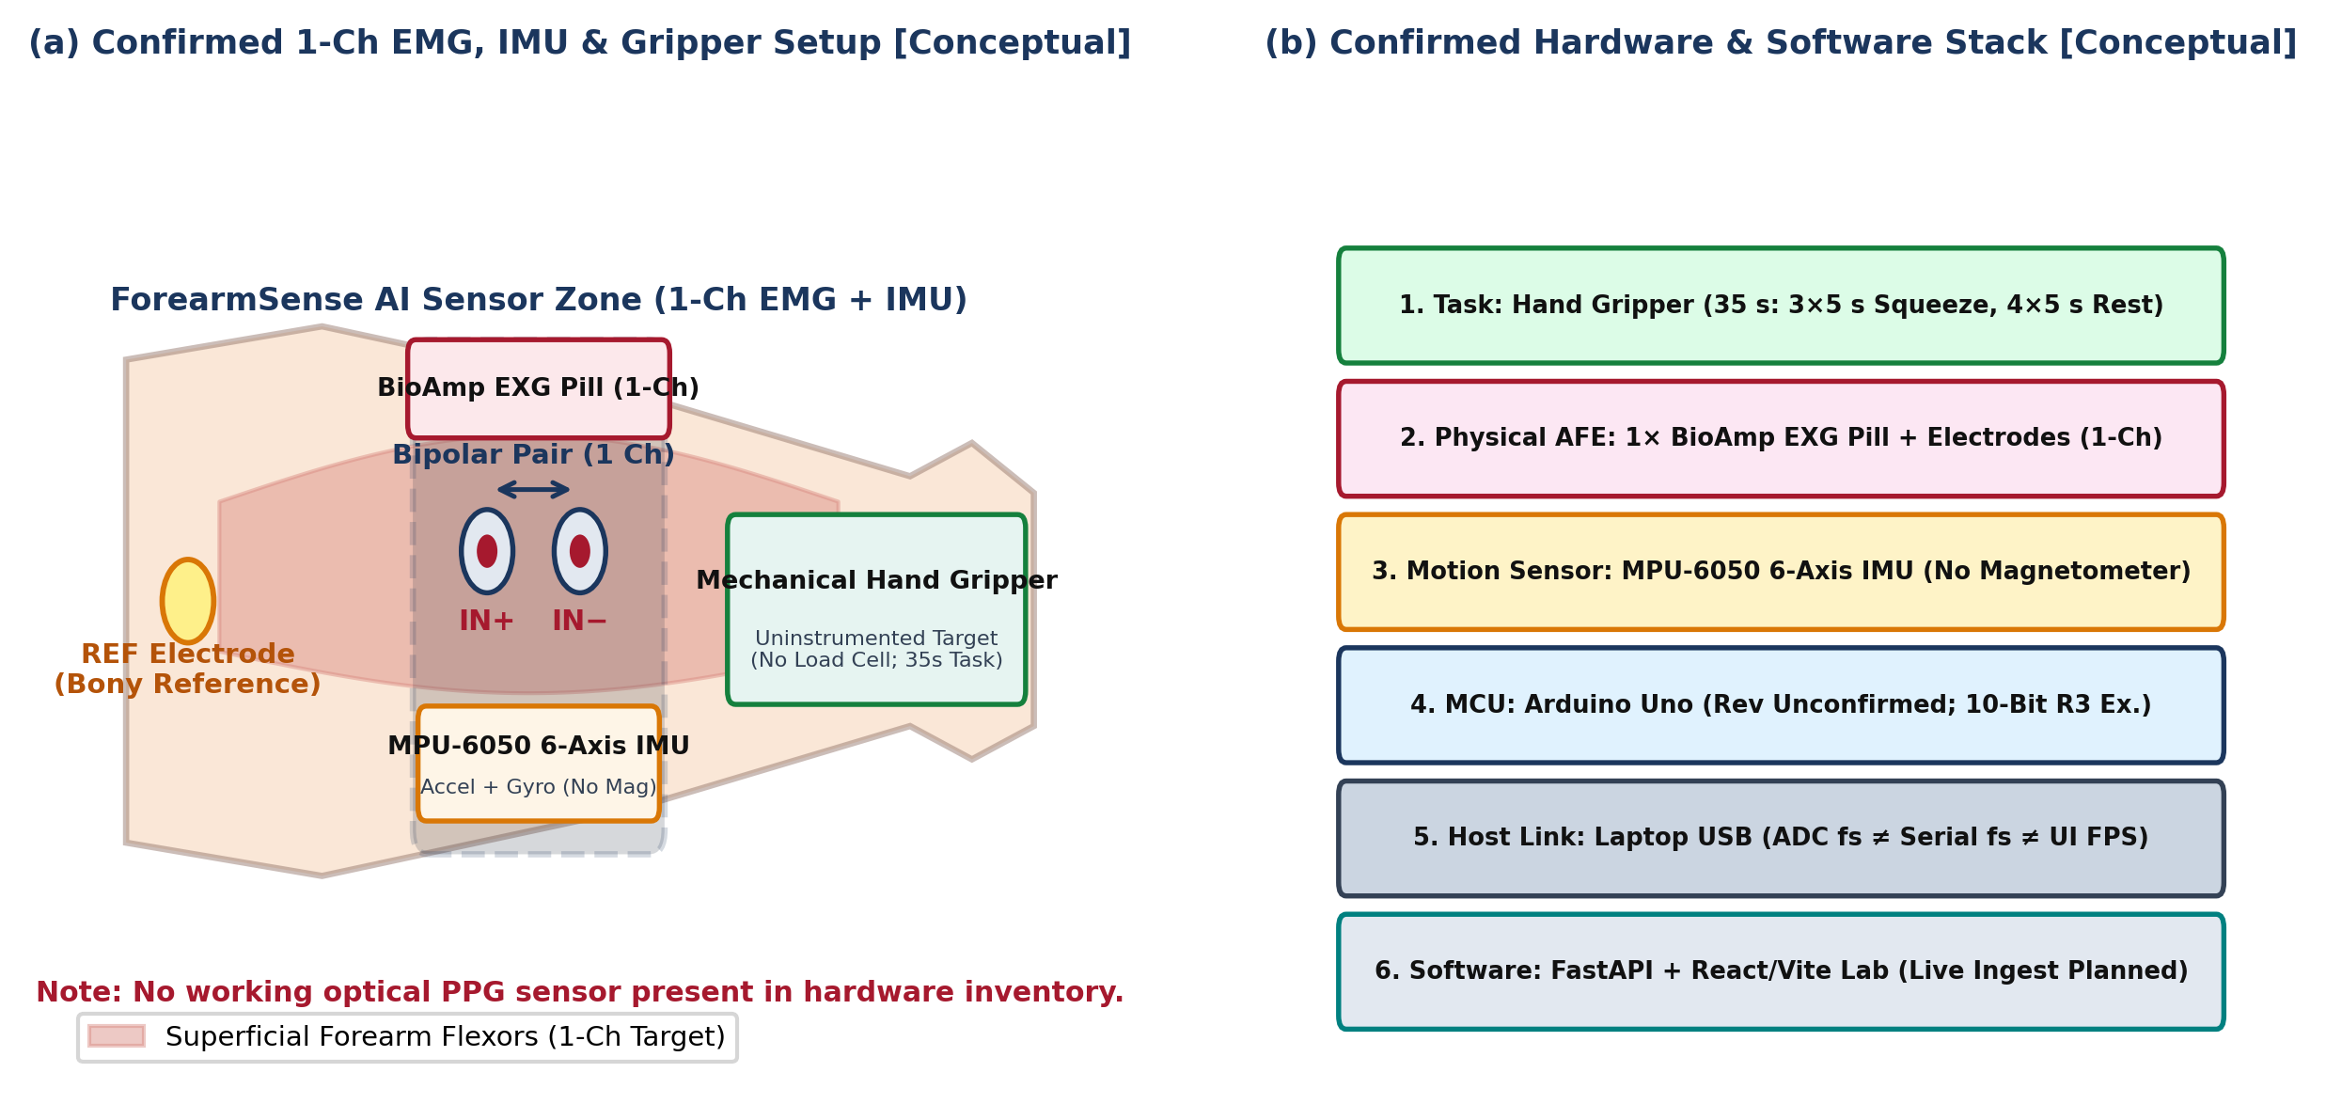
Figure 1: Confirmed ForearmSense AI benchtop setup and architecture stack [Conceptual]: (a) single-channel BioAmp EXG Pill electrodes over superficial forearm flexors, bony reference, MPU-6050 6-axis IMU, and uninstrumented mechanical hand gripper (no working PPG sensor); (b) six-layer hardware-to-software architecture stack.
On the physical bench (Figure 2, top solid block), cutaneous sEMG potentials from a single superficial forearm flexor site are conditioned by one Upside Down Labs BioAmp EXG Pill module [12] using existing three-lead electrodes (IN+, IN−, and REF) while preserving existing wiring without solder modifications. Simultaneously, three-axis linear acceleration (a_{x}, a_{y}, a_{z}) and three-axis angular velocity (ω_{x}, ω_{y}, ω_{z}) are acquired by a TDK InvenSense MPU-6050 six-axis MEMS IMU over I2C [16]. Both sensors interface to an Arduino Uno microcontroller [17] connected via USB serial to a host laptop, while the participant performs structured squeeze/rest repetitions on a mechanical hand gripper. No working optical pulse (PPG) sensor is present in the physical system.
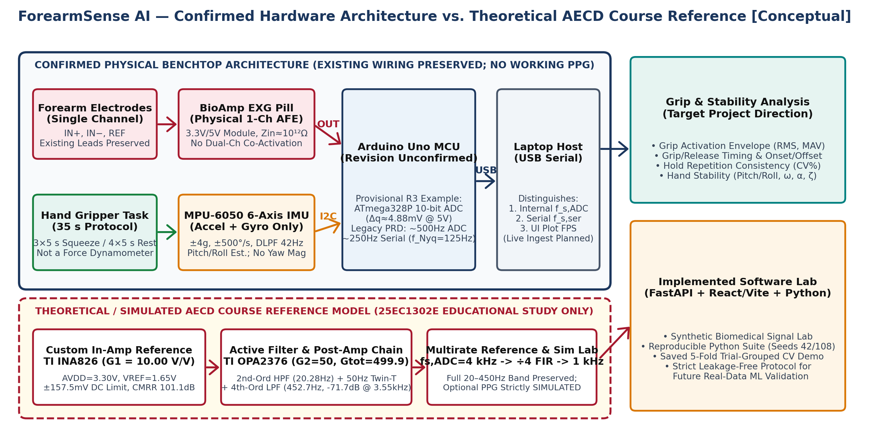
Figure 2: ForearmSense AI system block diagram [Conceptual] separating the confirmed physical hardware path (1-Ch BioAmp EXG Pill, MPU-6050, hand gripper, Arduino Uno, laptop USB link) from the theoretical/simulated 25EC1302E AECD coursework reference chain (TI INA826 + OPA2376 + 4 kHz multirate decimation).
Because the exact revision of the benchtop Arduino Uno has not yet been confirmed, our analysis avoids assuming a single fixed ADC specification. Classic Arduino Uno R3 operation (ATmega328P, 16 MHz, 10-bit SAR ADC across 5.0 V yielding Δq,R3 = 4.883 mV) is evaluated as a provisional baseline alongside the Arduino Uno R4 architecture (Renesas RA4M1, 48 MHz, up to 14-bit SAR ADC yielding Δq,R4 = 0.305 mV) [17]. In parallel, the theoretical AECD reference track (Figure 2, bottom dashed block) models a custom +3.30 V cascade (TI INA826 at G₁ = 10.00 V/V + TI OPA2376 active filters and G₂ = 50.00 V/V post-amplifier + 4000 Hz 12-bit SAR ADC decimated 4:1 to 1000 Hz).
Table 1: Confirmed Physical Hardware Inventory vs. Theoretical AECD Course Reference Specifications
Subsystem & Evidence Tier | Component / Module & Provenance | Supply & Interface | Verified Scope & Operational Boundaries
Physical sEMG Front End [Confirmed HW] | 1× Upside Down Labs BioAmp EXG Pill v1.0 + existing electrodes [12] | VCC = 3.3 V / 5.0 V; 1 Analog Output (OUT) | Single-channel biopotential AFE (Z_{in} ≈ 10¹² Ω); no dual-channel co-activation
Physical Motion IMU [Confirmed HW] | TDK InvenSense MPU-6050 6-Axis MEMS IMU [16] | VDD = 3.3 V / 5 V module; I2C (SDA, SCL) | 3-axis accel (±4 g) + 3-axis gyro (±500 °/s); no magnetometer (yaw unreferenced)
Physical Task Target [Confirmed HW] | Mechanical Hand Gripper (Uninstrumented) | Manual squeeze/release resistance target | 35 s protocol (3×5 s holds); not a force dynamometer (no N or kg output)
Acquisition MCU [Confirmed HW] | Arduino Uno (Exact revision unconfirmed) [17] | USB 5.0 V host power & UART serial link | Provisional R3: 10-bit ADC (4.883 mV/LSB); R4 option: up to 14-bit ADC (0.305 mV/LSB)
Optical PPG Sensor [Hardware Absent] | No working optical pulse sensor on bench | None in physical hardware (Simulated in SW) | No measured HR, SpO₂, blood flow, or PTT; software PPG strictly labelled SIMULATED
Host Laptop & Software [Implemented SW] | FastAPI Backend + React/Vite Frontend + Python 3.11.2 Suite | Localhost web lab + saved JSON/CSV logs | Synthetic signal lab implemented; live serial ingestion, recording & replay planned
Theoretical AECD In-Amp [Course Model] | TI INA826AIDGK (Alt: INA333); R_{G} = 5.49 kΩ (0.1%) [14] | Simulated AVDD = +3.30 V, V_{REF} = +1.650 V | Theoretical G₁ = 10.00 V/V (20 dB), CMRR_{sys} = 101.1 dB (Not BioAmp spec)
Theoretical AECD Filters [Course Model] | TI OPA2376 (5.5 MHz GBW) + 4 kHz Reference ADC [14] | Simulated Sallen–Key HPF/LPF4 + Twin-T | 20.28–452.7 Hz, G₂ = 50.0 V/V, G_{tot} = 499.91 V/V, −71.73 dB alias atten @ 3550 Hz

2.2 Forearm EMG Signal Acquisition, Skin–Electrode Interface, and BioAmp EXG Pill
Within a contracting forearm muscle during a gripper squeeze, the cutaneous sEMG voltage is the spatio-temporal superposition of M recruited motor unit action potential trains (MUAPTs), modeled as an LTI convolution of neural impulse trains with each motor-unit volume-conductor impulse response [1], [2]:
 | $$v_{EMG}(t) = \sum_{i=1}^{M}{h_{i}(t) * u_{i}(t)} + n(t) = \sum_{i=1}^{M}{\sum_{k=1}^{K_{i}}{h_{i}(t - t_{i,k})}} + n(t)$$ | (2.1)
where h_{i}(t) is the extracellular action potential impulse response of the i-th motor unit, u_{i}(t) is the Dirac impulse train firing at instants t_{i,k}, M is the number of recruited motor units, and n(t) is additive thermal and instrumentation noise.
In an idealized single-fiber traveling-wave model where a planar depolarization wave propagates at constant velocity v_{c} = 4.0 m/s beneath two point electrodes separated by d_{IED} = 20 mm, the inter-electrode transit delay τ_{d} and theoretical bipolar spatial filter magnitude |H_{bip}(f)| are given by:
 | $$τ_{d} = \frac{d_{IED}}{v_{c}} = \frac{20 mm}{4.0 m/s} = 5.0 ms , \left|H_{bip}(f)\right| = 2 \left|sin\left(π f τ_{d}\right)\right|$$ | (2.2)
where d_{IED} = 20 mm is the nominal inter-electrode spacing [3], v_{c} = 4.0 m/s is the nominal muscle fiber conduction velocity, and τ_{d} = 5.0 ms is the resulting transit time.
In practical surface recordings over the forearm flexors, discrete spectral zeroes at multiples of 1/τ_{d} = 200 Hz are smoothed into a continuous unimodal spectrum (peaking between 60 Hz and 140 Hz) because hundreds of motor units fire across depths of 2–15 mm, conduction velocities of 3.0–5.5 m/s, and finite circular electrode contact areas [1], [2].
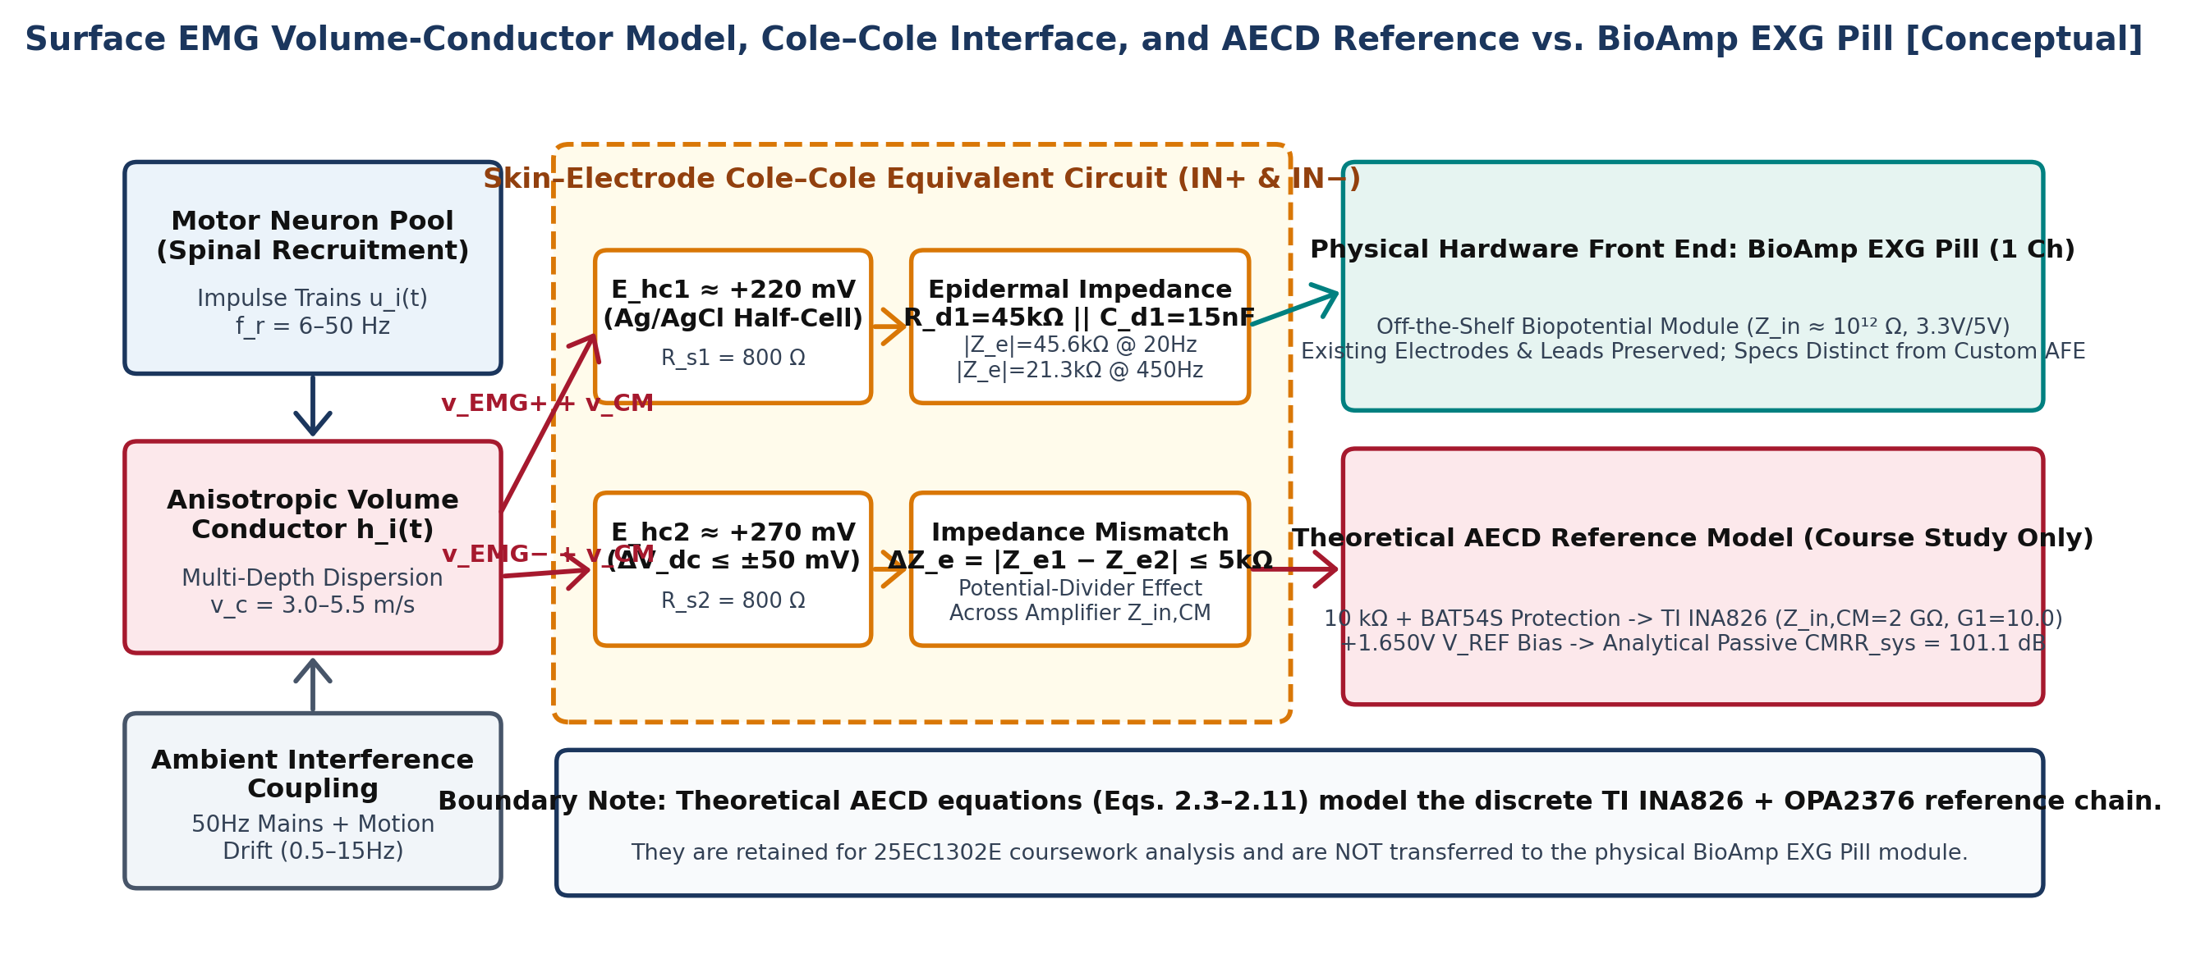
Figure 3: Surface EMG electrophysiological volume-conductor model, Cole–Cole skin–electrode equivalent circuit, and explicit boundary between the physical 1-channel BioAmp EXG Pill front end and the theoretical AECD TI INA826 reference model [Conceptual].
As illustrated in Figure 3, each skin–electrode contact is represented by a DC half-cell potential E_{hc} ≈ +220 mV in series with a complex Cole–Cole epidermal impedance Z_{e}(jω) [6], [11]:
 | $$Z_{e}(jω) = R_{s} + \frac{R_{d}}{1 + jω R_{d}C_{d}}$$ | (2.3)
where R_{s} = 800 Ω is the series gel and sweat-duct resistance, R_{d} = 45 kΩ is the epidermal charge-transfer resistance, and C_{d} = 15 nF is the Helmholtz double-layer capacitance (yielding |Z_{e}| = 45.64 kΩ at 20 Hz, |Z_{e}| = 21.27 kΩ at 450 Hz, and average real resistance R_{e,real,avg} = 25.46 kΩ in our theoretical AECD model).
Under dynamic hand-gripper movement, uneven skin pressure produces an impedance mismatch ΔZ_{e} = |Z_{e1} − Z_{e2}| <= 5.0 kΩ and a differential DC offset ΔV_{dc} <= ±50.0 mV. Through potential division across the amplifier common-mode input impedance Z_{i,CM}, ΔZ_{e} converts 50 Hz common-mode body potential v_{CM} into differential interference [11]:
 | $$v_{diff,total} = v_{EMG,diff} + v_{CM}\left[\frac{ΔZ_{e}}{Z_{i,CM}} + \frac{1}{{CMRR}_{InAmp}}\right]$$ | (2.4)
where v_{EMG,diff} is the true differential muscle signal, v_{CM} is the 50 Hz common-mode body voltage, ΔZ_{e} is the electrode impedance mismatch, and Z_{i,CM} is the common-mode input impedance (~10¹² Ω in the BioAmp EXG Pill documentation [12] and 2.0 GΩ in our theoretical TI INA826 reference circuit [14]). Existing electrode leads and jumpers on the single BioAmp EXG Pill are preserved without solder modifications.

2.3 Theoretical AECD Instrumentation Amplifier Design: Gain Split, CMRR, and Noise

2.3.1 Coursework Context and Supply Compatibility Audit (Theoretical Reference Only)
While the physical benchtop prototype uses the pre-built BioAmp EXG Pill module [12], the Analog Electronic Circuit Design (25EC1302E) curriculum requires first-principles design of a discrete single-supply biopotential conditioning chain. All specifications derived in Sections 2.3–2.5 apply strictly to this theoretical/simulated AECD reference architecture and are never attributed to the physical BioAmp EXG Pill. Operating a custom AFE from a single +3.30 V rail (AVDD = +3.30 V, V_{REF} = +1.650 V) rules out legacy instrumentation amplifiers such as the TI INA128, whose datasheet requires a minimum ±2.25 V (4.50 V) supply and an input common-mode window of [(V−) + 2.0 V, (V+) − 2.0 V] [13]. Auditing low-voltage candidates confirms that the TI INA826 (2.7–36 V supply, I_{Q} = 200 µA, input range 0.0 V to V₊ − 1.0 V = +2.30 V, rail-to-rail output [0.05 V, 3.25 V], CMRR >= 100 dB, 600 kHz bandwidth at G = 10, and 18 nV/√Hz noise [14]) provides 2.78× lower noise and 17× wider bandwidth than the micropower INA333 (50 nV/√Hz, 35 kHz [14]) and 5.5× lower noise than the AD8232 (100 nV/√Hz [14]).
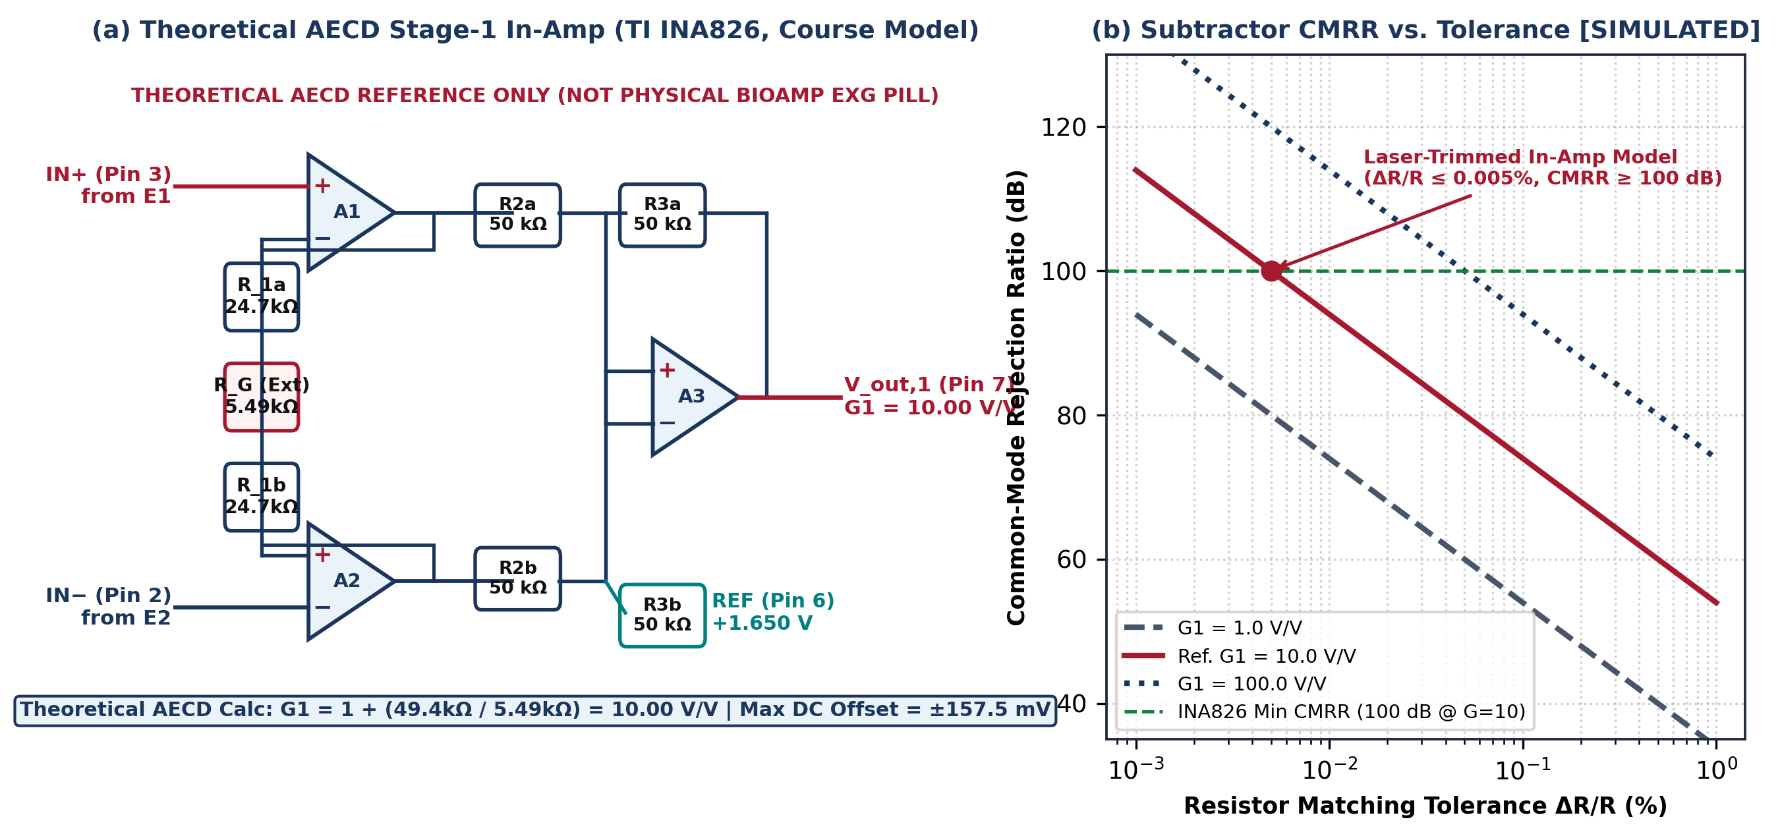
Figure 4: Theoretical AECD Stage-1 instrumentation amplifier analysis (25EC1302E coursework reference, not physical BioAmp EXG Pill): (a) schematic of U1 (TI INA826 on AVDD = +3.30 V, V_{REF} = +1.650 V) with internal R1a = R1b = 24.7 kΩ and external R_{G} = 5.49 kΩ yielding G₁ = 10.00 V/V; (b) simulated subtractor CMRR vs. resistor matching tolerance ΔR/R [SIMULATED].

2.3.2 Theoretical Gain Allocation, Internal Headroom, and Offset Tolerance
In the three-op-amp instrumentation amplifier topology of Figure 4(a), input buffers A1 and A2 amplify the differential input V_{in,diff} = V_{in+} − V_{in−} symmetrically around the input common-mode bias V_{CM}:
 | $$V_{o1} = V_{CM} + \frac{1}{2}G_{1}V_{d} , V_{o2} = V_{CM} - \frac{1}{2}G_{1}V_{d}$$ | (2.5)
where V_{o1} and V_{o2} are the internal buffer outputs of op-amps A1 and A2, V_{CM} = +1.650 V is the mid-rail common-mode bias, and G₁ is the first-stage differential gain.
With internal laser-trimmed feedback resistors R_{1a} = R_{1b} = 24.7 kΩ (2R₁ = 49.4 kΩ) and an external 0.1% precision resistor R_{G} = 5.49 kΩ, the theoretical Stage-1 instrumentation amplifier gain is:
 | $$G_{1} = 1 + \frac{2 R_{1}}{R_{G}} = 1 + \frac{49.4 kΩ}{5.49 kΩ} ≈ 10.00 V/V (+20.00 dB)$$ | (2.6)
where R₁ = 24.7 kΩ is the internal feedback resistance of the INA826 and R_{G} = 5.49 kΩ is the external gain-setting resistor (if realized with the INA333 where 2R₁ = 100 kΩ, selecting R_{G} = 11.1 kΩ yields G₁ = 10.01 V/V).
Under a worst-case combined input of ΔV_{dc,max} = ±50.0 mV DC electrode offset plus V_{EMG,peak} = ±2.50 mV AC signal (V_{in,diff,max} = ±52.5 mV), setting G₁ = 10.00 V/V limits internal buffer nodes V_{o1}, V_{o2} to 1.650 V ± 0.2625 V ∈ [1.3875 V, 1.9125 V], preserving 387.5 mV of margin below the +2.300 V INA826 input ceiling. Stage-1 output V_{out,1} swings across [1.125 V, 2.175 V], and the maximum DC electrode offset tolerated before Stage-1 output clipping (±1.600 V swing around V_{REF}) is:
 | $$ΔV_{dc,clip} = \frac{V_{swing,max}}{G_{1}} - V_{EMG,peak} = \frac{1.600 V}{10.00} - 2.50 mV = ±157.5 mV$$ | (2.7)
where V_{swing,max} = 1.600 V is the linear half-rail output swing of the INA826 on a +3.30 V supply and V_{EMG,peak} = 2.50 mV is the peak AC sEMG design amplitude.
After the 2nd-order Sallen–Key high-pass filter (f_{c,HPF} = 20.28 Hz) blocks the ±0.50 V amplified DC offset, the non-inverting post-amplifier (U4: OPA2376, with R_{f} = 49.0 kΩ and R_{g} = 1.00 kΩ returned to V_{REF} = +1.650 V) supplies the second-stage gain:
 | $$G_{2} = 1 + \frac{R_{f}}{R_{g}} = 1 + \frac{49.0 kΩ}{1.00 kΩ} = 50.00 V/V (+33.98 dB)$$ | (2.8)
Multiplying the two cascaded stages yields the theoretical reference passband voltage gain:
 | $$G_{total} = G_{1} · G_{2} = 9.9982 × 50.00 = 499.91 V/V (+53.98 dB)$$ | (2.9)
where G₁ = 9.9982 V/V and G₂ = 50.00 V/V, mapping a full-scale ±2.50 mV_{peak} (5.0 mV_{pp}) sEMG input to ±1.250 V around +1.650 V ([0.400 V, 2.900 V], utilizing 75.8% of a 0–3.30 V reference ADC span).

2.3.3 Theoretical System CMRR and Multi-Stage RTI Noise Budget
In a discrete four-resistor subtractor with tolerance ΔR/R, subtractor CMRR is bounded by G₁/(2·ΔR/R) (53.98 dB for 1% resistors at G₁ = 10). By contrast, the monolithic laser-trimmed INA826 specifies CMRR_{InAmp} >= 100 dB (104 dB typical at G₁ = 10 [14]), while ΔZ_{e} = 5.0 kΩ across Z_{in,CM} = 2.0 GΩ yields an impedance-balance CMRR of 112.04 dB. Combining both terms via Equation (2.4) yields the theoretical passive system CMRR:
 | $${CMRR}_{diff} ≈ \frac{G_{1}}{2 (ΔR / R)} , {CMRR}_{sys} = -20 \log_{10}\left[{10}^{-104/20} + {10}^{-112.04/20}\right] = 101.1 dB$$ | (2.10)
where CMRR_{diff} is the discrete resistor-mismatch limit and CMRR_{sys} = 101.1 dB is the composite theoretical CMRR with passive +1.650 V biasing (active Driven-Right-Leg feedback is retained strictly as an unverified theoretical option due to two-pole stability constraints [11]).
Across the theoretical passband Δf = 452.7 − 20.28 = 432.42 Hz, a 4th-order Butterworth filter exhibits an Equivalent Noise Bandwidth ENBW = 1.026 × Δf = 443.66 Hz. Integrating all uncorrelated noise sources Referred-to-Input (RTI) at T = 310 K gives the theoretical AFE input-referred noise floor:
 | $$e_{n,RTI,AFE} = \sqrt{ENBW · \left[e_{n1}^{2} + {\left(\frac{\sqrt{5}e_{n2}}{G_{1}}\right)}^{2} + 4k_{B}T(2R_{e,real} + R_{G}) + 2{\left(i_{n1}\left|Z_{e}\right|\right)}^{2}\right]} = 0.782 {µV}_{rms}$$ | (2.11)
where e_{n1} = 18.0 nV/√Hz and i_{n1} = 0.20 pA/√Hz are the INA826 noise densities, e_{n2} = 7.5 nV/√Hz is the OPA2376 noise density across 5 stages, R_{e,real} = 25.46 kΩ is the average real electrode resistance, and k_{B} T = 4.28×10⁻²¹ J. Including 12-bit 4 kHz reference ADC quantization (0.233 µV_{rms}) and thermal noise (0.480 µV_{rms}), total theoretical system RTI noise is 0.947 µV_{rms} (6.25 µV_{pp}).
Table 2: Theoretical AECD Reference Front-End (INA826 + OPA2376) Electrical Parameters and Headroom Verification
Parameter (AECD Ref Only) | Target Spec | Engineering Justification | Analytical / Simulated Value
Full-Scale sEMG Input | 5.0 mV_{pp} (±2.50 mVpeak) | Standardized theoretical AECD design input (~0.50–0.83 mV_{rms}) [1] | 5.0 mV_{pp} (±2.50 mVpeak) [Theoretical]
Passband Bandwidth (−3 dB) | 20 Hz to 450 Hz | Captures >95% MUAP energy; rejects <15 Hz motion drift [2] | 20.28–452.7 Hz (ENBW = 443.7 Hz)
Two-Stage Gain Split | G₁ = 10.0, G₂ = 50.0 V/V | Prevents Stage-1 saturation under ±50 mV DC offset | G_{total} = 499.91 V/V (53.98 dB)
Passive System CMRR | >= 100 dB @ 50 Hz | Combines INA826 (104 dB) & Z_{in,CM} = 2 GΩ / 5 kΩ (112 dB) | 101.1 dB passive (Theoretical Ref)
Stage-1 DC Offset Limit | >= ±50 mV without clipping | At G₁ = 10, ±50 mV shifts V_{out,1} by ±0.50 V around 1.65 V | ±157.5 mV max before clipping
Internal A1/A2 Headroom | V_{o1}, V_{o2} <= +2.30 V | INA826 input CM ceiling is (V+)−1.0 V = 2.30 V at +3.30 V [14] | V_{o1,max} = 1.9125 V (387.5 mV margin)
Input-Referred Noise (RTI) | <= 1.0 µV_{rms} (20–450 Hz) | RSS of INA826, OPA2376, electrode thermal, and 12-bit ref ADC | 0.782 µV_{rms} (AFE) / 0.947 µV_{rms} (Sys)
HPF Overload Recovery | <= 50 ms from 50 mV step | Decay of 2nd-order HPF (τ_{rec} = 11.0 ms) into ±32 mV G₂ window | 30.2 ms recovery (Theoretical Sim)

Table 3: Theoretical AECD Stage-by-Stage Gain Allocation (G1 = 10.0, G2 = 50.0), Offset Budgets, and Physical AFE Contrast
Stage / Hardware Track | Topology & Component Values | Stage Gain | Cumulative | Offset & Headroom Status | Output Swing
Stage 1: In-Amp (Ref U1: INA826) | Monolithic 3-Op-Amp (R1=24.7kΩ, R_{G}=5.49kΩ) | 10.00 V/V (+20.00 dB) | 10.00 V/V | ±50mV DC -> ±0.50V (Linear to ±157.5mV) | 1.65V ± 25.0 mVpk
Stage 2: Active HPF (Ref U2A) | 2nd-Order Sallen–Key Butterworth (fc=20.28 Hz) | 1.00 V/V (0.00 dB) | 10.00 V/V | Blocks ±0.50V DC -> 0.00V (τ=11.0 ms) | 1.65V ± 25.0 mVpk
Stage 3: 50 Hz Notch (Ref U2B) | Bootstrapped Twin-T Notch (fn=50.0 Hz, Q=6.25) | 1.00 V/V (0.00 dB) | 10.00 V/V | < 25 µV (OPA2376 Vos) | 1.65V ± 25.0 mVpk
Stage 4: 4th-Order LPF (Ref U3A/B) | 2× Sallen–Key Butterworth Biquads (fc=452.7 Hz) | 1.00 V/V (0.00 dB) | 10.00 V/V | < 50 µV around +1.650 V | 1.65V ± 25.0 mVpk
Stage 5: Post-Amp (Ref U4: OPA2376) | Non-Inverting Op-Amp (Rf=49.0kΩ, Rg=1.00kΩ) | 50.00 V/V (+33.98 dB) | 499.91 V/V (+53.98 dB) | ±1.25 mV max Vos shift | 0.400 V to 2.900 V
Physical Hardware AFE (Bench) | Upside Down Labs BioAmp EXG Pill v1.0 [12] | Fixed Module Gain | 1 Channel | AC-coupled biopotential front end | 0 to VCC (3.3V/5V)

2.4 Theoretical Active Filter Design and Honest Anti-Aliasing Analysis

2.4.1 Second-Order Sallen–Key High-Pass Filter (fc,HPF = 20.28 Hz, Theoretical Reference)
Whereas a first-order passive RC network has cutoff f_{c} = 1/(2πRC) and rolls off at only 20 dB/decade, the theoretical unity-gain 2nd-order Sallen–Key active high-pass filter (U2A: OPA2376, Figure 5a) realizes a maximally flat 40 dB/decade Butterworth response:
 | $$f_{c} = \frac{1}{2π R C} , H_{HPF}(s) = \frac{s^{2}}{s^{2} + \frac{C_{1} + C_{2}}{R_{2}C_{1}C_{2}}s + \frac{1}{R_{1}R_{2}C_{1}C_{2}}}$$ | (2.12)
 | $$f_{c,HPF} = \frac{1}{2π \sqrt{R_{1}R_{2}C_{1}C_{2}}} = 20.28 Hz , Q_{HPF} = \frac{\sqrt{R_{1}R_{2}C_{1}C_{2}}}{R_{1}(C_{1} + C_{2})} = 0.701 , τ_{rec} = \frac{1}{ζ ω_{0}} = 11.0 ms$$ | (2.13)
where C₁ = C₂ = 100 nF (C0G/NP0) and E24 1% resistors R₁ = 56.0 kΩ and R₂ = 110.0 kΩ yield f_{c,HPF} = 20.28 Hz, Q_{HPF} = 0.701 (ζ = 0.713), and overload recovery time constant τ_{rec} = 11.0 ms (recovering from a 50 mV step in 30.2 ms in simulation).
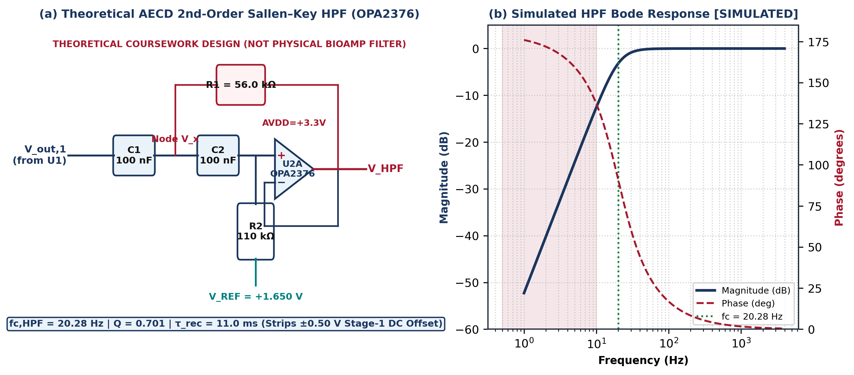
Figure 5: Theoretical AECD second-order Sallen–Key Butterworth active high-pass filter (U2A: OPA2376): (a) reference schematic with C1=C2=100 nF, R1=56.0 kΩ, R2=110.0 kΩ; (b) simulated Bode response confirming f_{c,HPF} = 20.28 Hz [SIMULATED].

2.4.2 Honest Anti-Aliasing Analysis: 250 Hz Serial / 500 Hz Internal vs. 4000 Hz Reference
A critical distinction must be drawn between legacy Arduino serial acquisition parameters and the theoretical 4000 Hz multirate reference model. The legacy PRD describes ~500 Hz internal EMG acquisition (f_{s,int} ≈ 500 Hz) and ~250 Hz serial packet output (f_{s,ser} ≈ 250 Hz), pending verification against actual Arduino firmware. By the Shannon–Nyquist theorem, the maximum unaliased frequencies and reference alias edge are:
 | $$f_{Nyq,ser} = \frac{250 Hz}{2} = 125 Hz , f_{Nyq,ADC} = \frac{500 Hz}{2} = 250 Hz , f_{alias,min} = 3550 Hz$$ | (2.14)
At 250 Hz serial output, the Nyquist limit is f_{Nyq,ser} = 125 Hz, so full-band 20–450 Hz sEMG spectral analysis (such as wideband MNF/MDF above 125 Hz) is unsupported. Even at 500 Hz internal sampling (f_{Nyq,int} = 250 Hz), energy from 250–450 Hz folds into 0–250 Hz unless analog anti-aliasing precedes the ADC, and decimating 500 Hz to 250 Hz without a digital low-pass filter (<125 Hz) folds 125–250 Hz energy into 0–125 Hz. In contrast, in our theoretical 4000 Hz reference model, the 4th-order Sallen–Key Butterworth LPF (Figure 6a: Biquad 1A with R₃ = R₄ = 16.0 kΩ, C₃ = 24 nF, C₄ = 20 nF, f_{c1} = 454.0 Hz, Q₁ = 0.548; Biquad 1B with R₅ = R₆ = 15.0 kΩ, C₅ = 62 nF, C₆ = 9.1 nF, f_{c2} = 446.8 Hz, Q₂ = 1.305) achieves f_{c,LPF} = 452.7 Hz and an −80 dB/decade roll-off:
 | $${\left|H_{LPF4}(j f)\right|}_{dB} = -10 \log_{10}\left[1 + {\left(\frac{f}{452.7 Hz}\right)}^{8}\right] = -71.73 dB (at 3550 Hz)$$ | (2.15)
where f is the input frequency in Hz, providing −51.79 dB attenuation at 2000 Hz and −71.73 dB at the 3550 Hz passband alias edge prior to 64-tap Hamming FIR 4:1 decimation to 1000 Hz (Figures 6–7, Table 4).
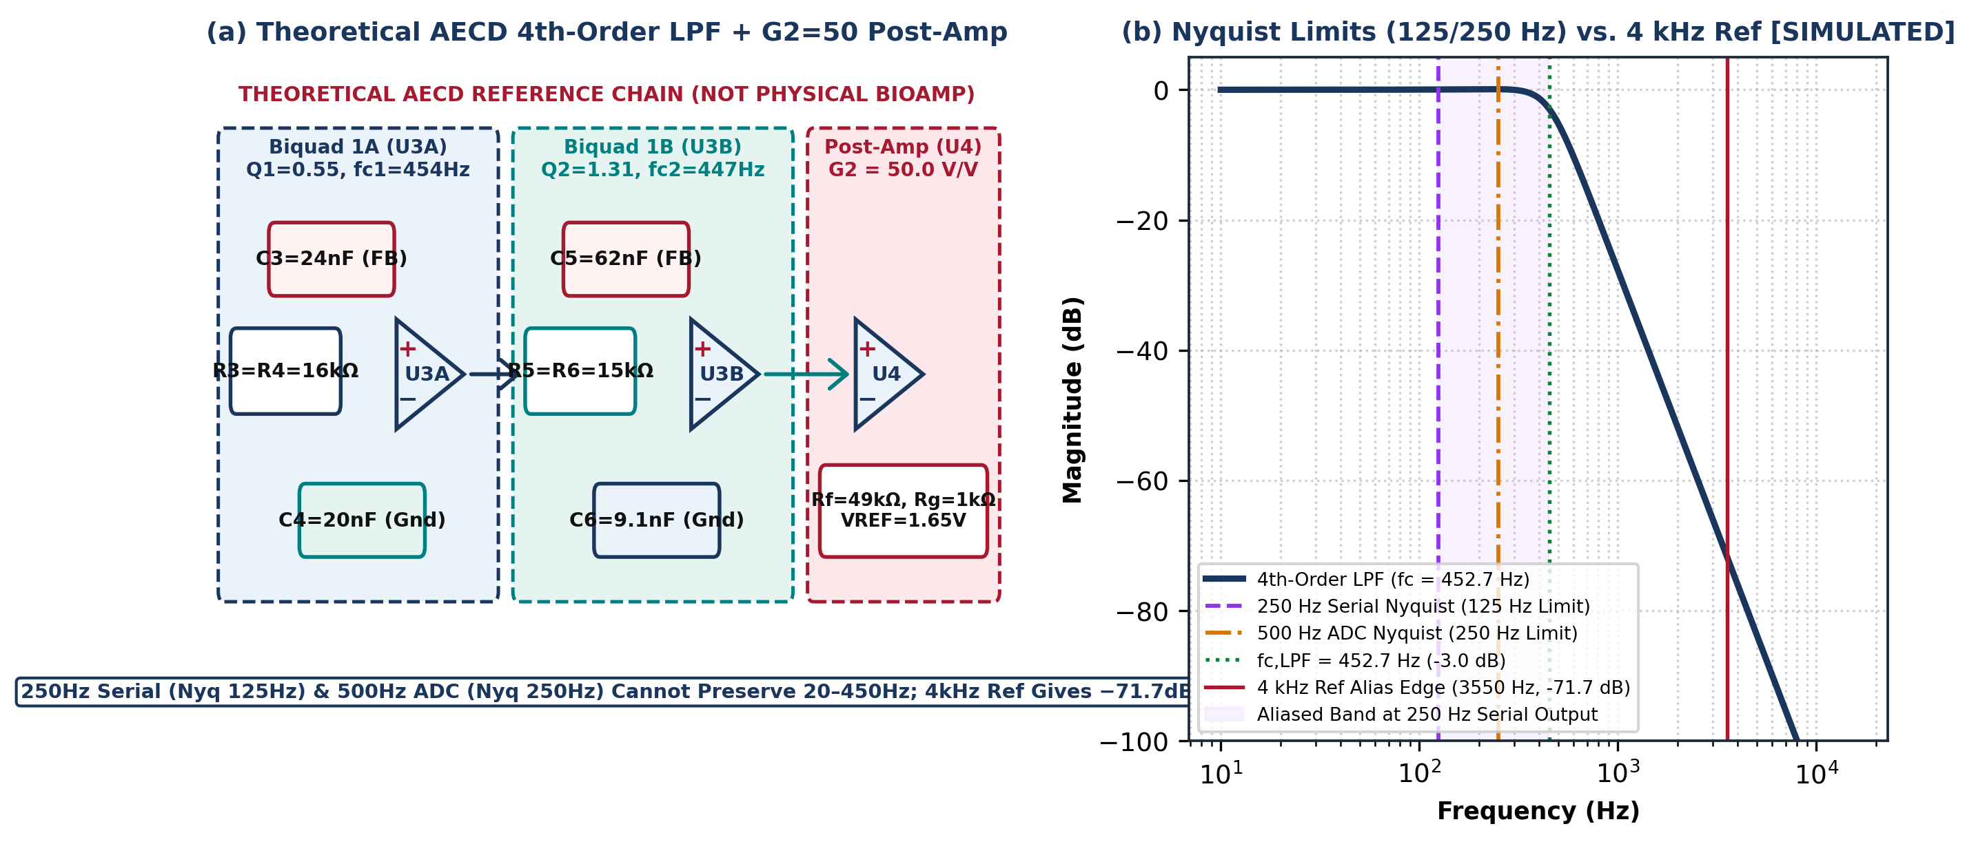
Figure 6: Theoretical AECD fourth-order Sallen–Key Butterworth anti-aliasing LPF and G₂ = 50 post-amplifier (OPA2376): (a) reference schematic; (b) simulated Nyquist comparison contrasting the 125 Hz (250 Hz serial) and 250 Hz (500 Hz internal) Nyquist ceilings against the −71.73 dB attenuation at 3550 Hz under 4000 Hz reference sampling [SIMULATED].
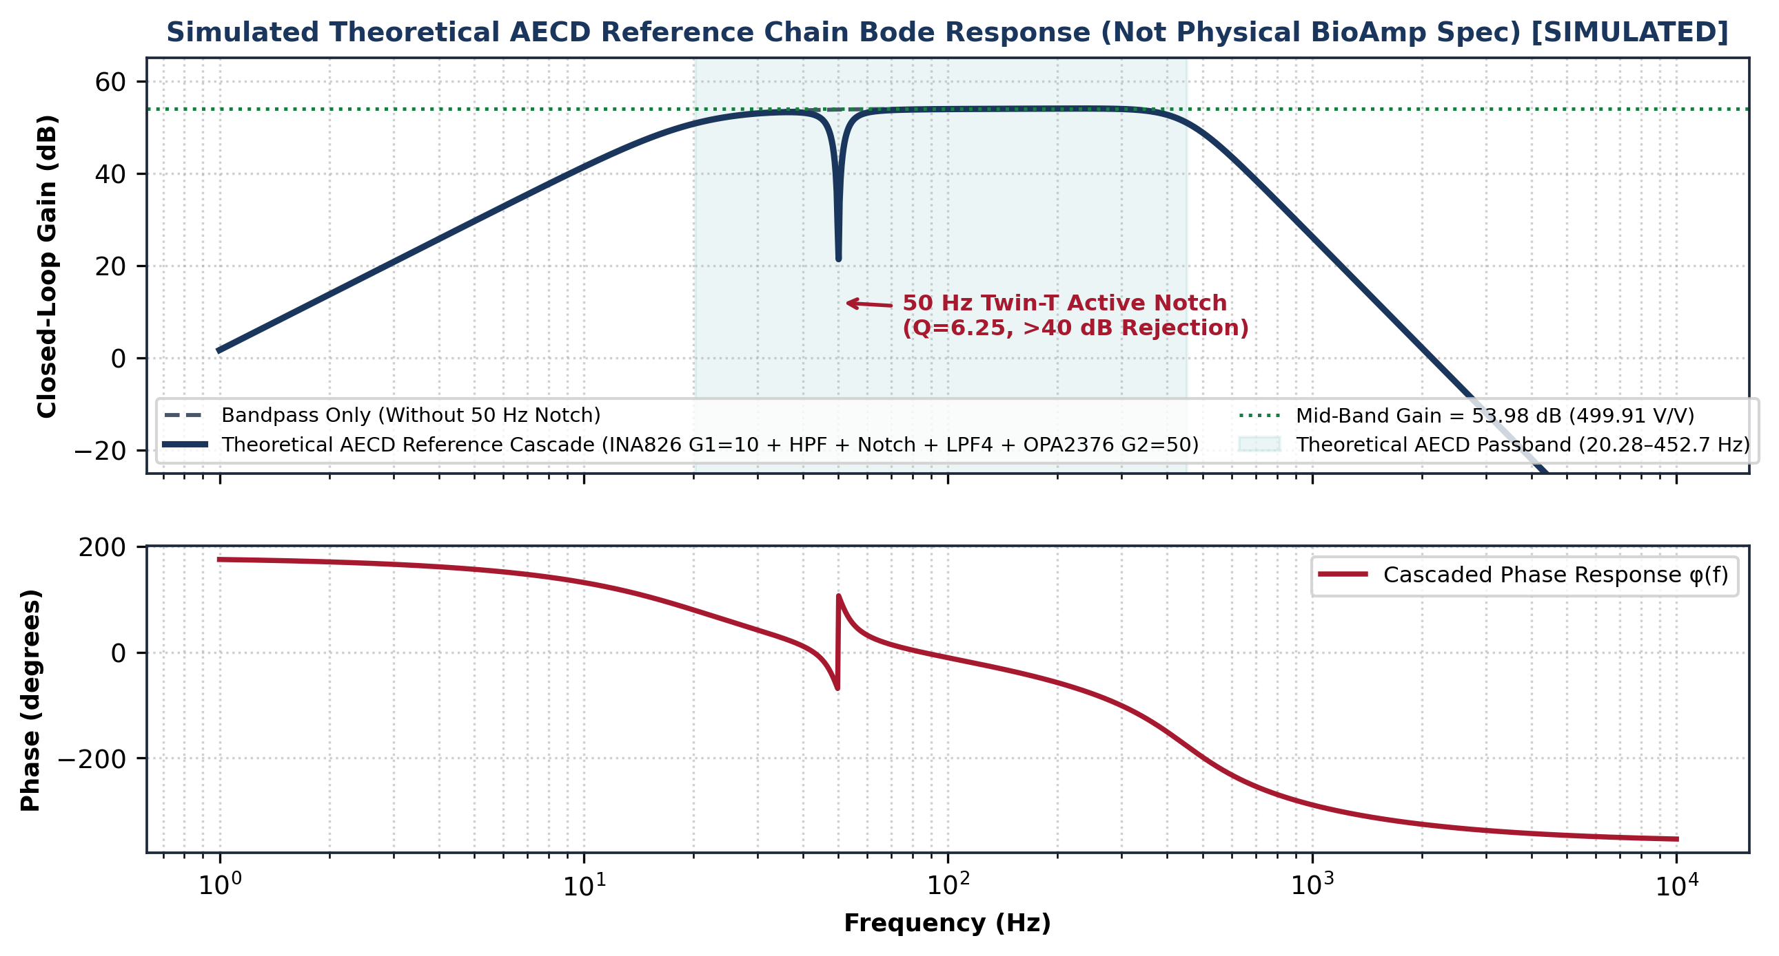
Figure 7: Simulated complete theoretical AECD reference Analog Front-End (AFE) Bode magnitude and phase response showing the flat 53.98 dB (499.91 V/V) passband across 20.28–452.7 Hz and 50 Hz Twin-T notch (>40 dB depth) [SIMULATED].
Table 4: Theoretical AECD Active Filter Component Values, Cutoffs, Q Factors, and Stopband Attenuation (Coursework Reference)
Filter Stage (AECD Ref) | Circuit Topology | Theoretical Values | Selected E24 Values | Target / Actual fc | Factor Q | Roll-Off / Stopband
High-Pass Filter (Ref U2A) | 2nd-Order Sallen–Key Butterworth | C1=C2=100 nF, R1=56.27 kΩ, R2=112.54 kΩ | C1=C2=100 nF, R1=56 kΩ, R2=110 kΩ | 20.0 / 20.28 Hz | Q = 0.701 | +40 dB/dec (<20 Hz)
50 Hz Notch (Ref U2B) | Bootstrapped Active Twin-T | C=100 nF, 2C=200 nF, R=31.83 kΩ, R/2=15.92 kΩ | C=100nF, R=30k+1.8kΩ, R/2=15k+910Ω | 50.0 / 50.03 Hz | Q = 6.25 | >40 dB notch @ 50 Hz
AAF LPF Biquad 1A (Ref U3A) | 2nd-Order Sallen–Key (Low-Q) | R3=R4=16.1 kΩ, C3=23.8 nF, C4=20.0 nF | R3=R4=16 kΩ, C3=24 nF, C4=20 nF | 450.0 / 454.0 Hz | Q1 = 0.548 | −40 dB/dec (Stage 1A)
AAF LPF Biquad 1B (Ref U3B) | 2nd-Order Sallen–Key (High-Q) | R5=R6=14.9 kΩ, C5=62.1 nF, C6=9.1 nF | R5=R6=15 kΩ, C5=62 nF, C6=9.1 nF | 450.0 / 446.8 Hz | Q2 = 1.305 | −71.73 dB @ 3550 Hz
Digital Decimator (Ref Sim) | 64-Tap Hamming Windowed FIR | Linear-phase sinc low-pass (fc = 450 Hz) | 64 IEEE-754 float taps (÷4 decimation) | 450.0 / 450.0 Hz | Linear Phase | >55 dB @ 500–2000 Hz

2.5 Operational Amplifier Analysis and Quantitative Device Selection (Theoretical AECD Study)
For a non-inverting amplifier with feedback factor β = R_{g} / (R_{g} + R_{f}) and open-loop gain-bandwidth product GBW, the closed-loop frequency response A_{CL}(jf) and minimum slew rate SR_{min} required to avoid distortion at peak swing V_{p} = 1.25 V and f_{max} = 450 Hz are:
 | $$A_{CL}(j f) = \frac{1 / β}{1 + j \left(\frac{f}{β · GBW}\right)} , {SR}_{min} = 2π f_{max}V_{p} = 0.00353 V/µs$$ | (2.16)
where 1/β = G₂ = 50.00 V/V, f_{CL} = β·GBW is the closed-loop −3 dB bandwidth, and A_{loop}(f) = β·GBW/f is the loop gain.
Quantitative comparison for 25EC1302E explains why the TI OPA2376 (2.2–5.5 V supply, GBW = 5.5 MHz, e_{n} = 7.5 nV/√Hz, SR = 2.0 V/µs, V_{OS} <= 25 µV [14]) is selected in the theoretical reference design over the micropower OPA2333 (GBW = 350 kHz, e_{n} = 55 nV/√Hz, SR = 0.16 V/µs) and legacy LM741 (minimum ±5 V supply, ±2 V dropout, I_{B} = 80 nA): at G₂ = 50.0 V/V, OPA2333 has f_{CL} = 7.0 kHz and a loop gain at 450 Hz of only 15.6× (23.8 dB), whereas OPA2376 provides f_{CL} = 110.0 kHz, a loop gain of 244.4× (47.8 dB), and 7.3× lower voltage noise.

2.6 Supply Rail Architecture, Theoretical Battery Runtime, and Biomedical Electrical Safety
On the physical bench, the Arduino Uno is powered via USB from the host laptop and supplies regulated onboard power to the BioAmp EXG Pill (compatible with 3.3 V or 5.0 V [12]) and MPU-6050 breakout [16], preserving existing bench connections. For the theoretical portable AECD power-tree study (modeling a 3.7 V, 500 mAh Li-Po cell feeding TPS7A20 LDOs across 16.50 mA duty-cycled and 25.50 mA continuous current envelopes with 75%–85% usable capacity above the 3.44 V dropout threshold), the theoretical battery runtime window is:
 | $$T_{bat} = \frac{C_{bat} · η_{usable}}{I_{total}} ∈ \left[\frac{500 mAh × 0.75}{25.50 mA} , \frac{500 mAh × 0.85}{16.50 mA}\right] = [14.7 h, 25.8 h]$$ | (2.17)
where C_{bat} = 500 mAh is the nominal Li-Po capacity, η_{usable} ∈ [0.75, 0.85] is the pre-dropout discharge fraction, and I_{total} ∈ [16.50 mA, 25.50 mA] is the modeled portable current.
Biomedical Electrical Safety Frameworks (IEC 60601-1 & ISO 14971): Connecting an Arduino Uno via a non-isolated USB cable to an AC-powered laptop creates a mains leakage hazard. Placing a 100 kΩ resistor on a 3.30 V or 5.0 V rail (33–50 µA) does NOT establish IEC 60601-1 compliance because: (1) Type BF Normal-Condition patient auxiliary DC current is limited to 10 µA (50 µA applies only to Single-Fault Condition) [6]; (2) regulator faults expose higher rail voltages; and (3) compliance requires >= 4.0 mm 2-MOPP creepage/clearance and certified USB galvanic isolation or battery-only laptop operation (>5 m from AC appliances per Upside Down Labs guidelines [12]). No safety certification is claimed.

2.7 Six-Axis IMU (MPU-6050) Kinematics, Derivative Definitions, and Synchronization
The TDK InvenSense MPU-6050 integrates a three-axis accelerometer (±4 g at 8192 LSB/g) and a three-axis gyroscope (±500 °/s at 65.5 LSB/(°/s), 42 Hz internal DLPF [16]). Because the MPU-6050 has no built-in magnetometer, absolute yaw around the vertical gravity vector is unobservable. Forearm pitch and roll relative to gravity are estimated via a discrete-time complementary filter (α = 0.98), while hand movement stability is quantified using exact angular derivatives:
 | $$θ_{CF}[n] = α\left(θ_{CF}[n-1] + ω_{y}[n]Δt\right) + (1-α)θ_{acc}[n] , α = \frac{dω}{dt} = \frac{d^{2}θ}{dt^{2}} , ζ_{θ} = \frac{dα}{dt} = \frac{d^{3}θ}{dt^{3}}$$ | (2.18)
where θ_{acc}[n] = atan2(−a_{x}[n], √(a_{y}^2[n] + a_{z}^2[n])) is the accelerometer tilt estimate, ω_{y} = dθ/dt (in deg/s) is the pitch angular velocity (first derivative of angle), α = dω/dt = d²θ/dt² (in deg/s²) is the angular acceleration (second derivative of angle), and ζ_{θ} = dα/dt = d³θ/dt³ (in deg/s³) is the angular jerk (third derivative of angle, correcting earlier guides; linear jerk is j = da/dt = d³x/dt³). Combining 14-byte I2C burst transfer at 400 kHz (382.5 µs), 42 Hz DLPF delay (4.8 ms [16]), and clock drift yields a 1.5–5.2 ms inter-channel timing skew budget.

2.8 Absence of Hardware PPG Sensor and Simulated Optical Model Boundaries
The confirmed physical hardware inventory contains no working optical photoplethysmography (PPG) sensor. Consequently, no measured heart rate (HR), arterial oxygen saturation (SpO₂), blood flow, or pulse transit time (PTT) can be acquired from hardware. In the software laboratory, an optional synthetic optical generator (modeling a 660 nm Red / 880 nm IR MAX30102 sensor [15] under the modified Beer–Lambert relation [10], [12]) is retained strictly as a SIMULATED educational module:
 | $$I(t, λ) = I_{0}(λ) exp\left[-ε(λ) c d(t)\right] , R = \frac{I_{AC,660} / I_{DC,660}}{I_{AC,880} / I_{DC,880}}$$ | (2.19)
where I(t,λ) is the simulated backscattered optical intensity and R is the synthetic red-to-infrared ratio-of-ratios. All outputs from Equation (2.19) and Figure 10(b) are explicitly labelled SIMULATED and excluded from hardware conclusions [10], [18].
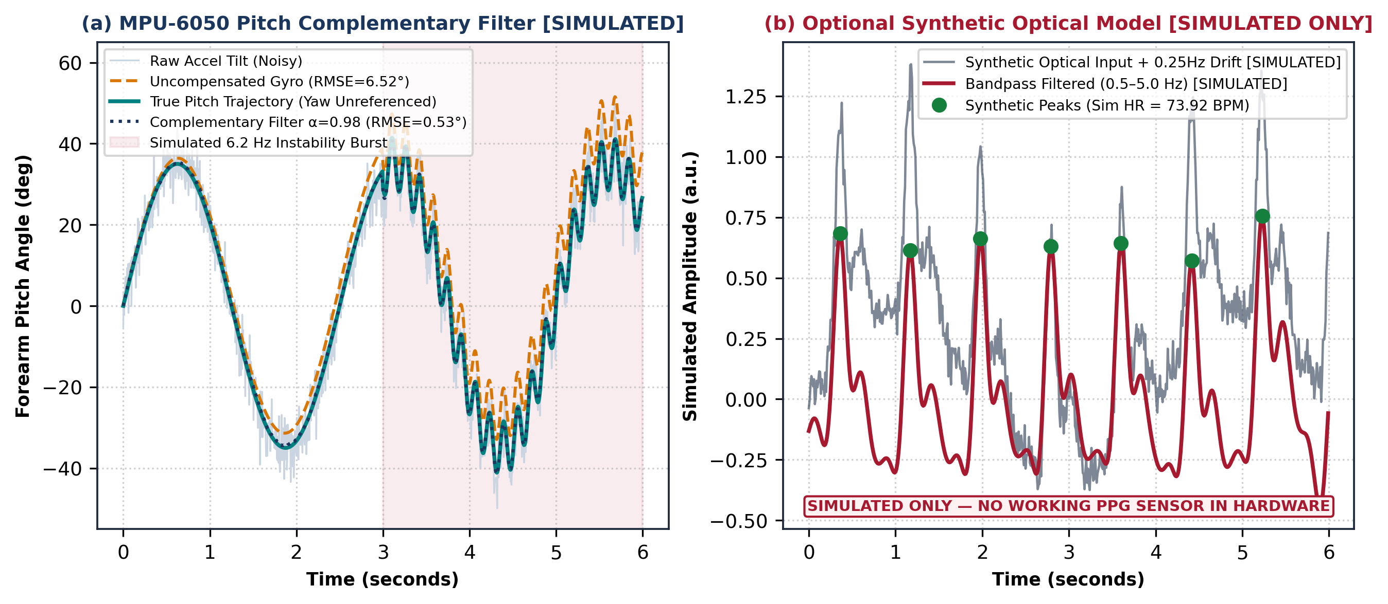
Figure 10: Executed sensor-processing simulations: (a) MPU-6050 complementary filter (α = 0.98, pitch RMSE = 0.53°, yaw unreferenced) vs. uncompensated gyro drift (6.52°) [SIMULATED]; (b) optional synthetic optical pulse extraction (Est. HR = 73.92 BPM vs. 74.0 BPM true) — strictly SIMULATED ONLY as no working PPG sensor exists in hardware.

2.9 Digital Signal Processing (DSP), Rate Distinction, and 35-Second Task Protocol
Because the exact Arduino Uno revision on the bench is unconfirmed, ADC quantization is parameterized across candidate revisions rather than assumed uniform. Comparing the provisional classic Arduino Uno R3 10-bit SAR ADC (ATmega328P, V_{FS} = 5.00 V, 1024 levels), the Arduino Uno R4 14-bit SAR ADC (Renesas RA4M1, V_{FS} = 5.00 V, 16384 levels) [17], and the theoretical 12-bit 3.30 V reference model (f_{s,ADC} = 4000 Hz decimated 4:1 to 1000 Hz) yields:
 | $$Δ_{q,R3} = \frac{5.00 V}{2^{10}} = 4.883 mV , Δ_{q,R4} = \frac{5.00 V}{2^{14}} = 0.305 mV , {SQNR}_{ref} = 80.48 dB$$ | (2.20)
where Δ_{q,R3} = 4.883 mV is the provisional Uno R3 10-bit step size, Δ_{q,R4} = 0.305 mV is the Uno R4 14-bit step size, and Δ_{q,ref} = 805.66 µV (SQNR_{ref} = 80.48 dB) is the theoretical 12-bit reference step size. System analysis strictly distinguishes three rates (Table 5): (1) internal MCU ADC sampling rate f_{s,ADC} (~500 Hz in legacy PRD vs. 4000 Hz in theoretical reference), (2) serial UART packet rate f_{s,ser} (~250 Hz in legacy PRD, Nyquist 125 Hz), and (3) frontend UI plot refresh rate f_{UI} (~30–60 FPS rendering).
Table 5: Sampling Regimes, Nyquist Alias Boundaries, ADC Resolution Examples, and Rate Distinction
Acquisition / Display Regime | Signal Pathway | Rate (fs or FPS) | Effective Nyquist | ADC Resolution & Step Size | Spectral & Aliasing Boundary
Arduino Uno R3 (Provisional Ex.) | 1-Ch BioAmp sEMG (~500 Hz int / ~250 Hz ser) | 500 Hz ADC / 250 Hz Serial | 250 Hz (ADC) / 125 Hz (Ser) | 10-bit SAR (ATmega328P, Δq = 4.883 mV @ 5V) | Full 20–450 Hz band unsupported at 250/500 Hz
Arduino Uno R4 (Revision Option) | 1-Ch BioAmp sEMG (Configurable ADC) | Up to 1000+ Hz (If verified) | ≥ 500 Hz (If fs ≥ 1 kHz) | 14-bit SAR (Renesas RA4M1, Δq = 0.305 mV @ 5V) | Requires bench board & firmware confirmation
Theoretical AECD Reference Sim | Simulated 20–450 Hz sEMG Chain | 4000 Hz Primary -> ÷4 FIR to 1000 Hz | 2000 Hz (ADC) / 500 Hz (DSP) | 12-bit Reference (3.30 V, Δq = 805.7 µV, 80.5 dB) | −71.73 dB analog alias rejection @ 3550 Hz
MPU-6050 6-Axis IMU Stream | 3-Axis Accel + 3-Axis Gyro (0–42 Hz DLPF) | 100–200 Hz I2C Burst Read | 50–100 Hz (DLPF = 42 Hz) | 16-bit Signed (±4 g @ 8192 LSB/g, ±500 °/s) | Pitch/Roll CF + ω, α, ζ_{θ}; Yaw unreferenced
UI Plot Refresh Rate (Frontend) | React/Vite Canvas Rendering Loop | ~30–60 Hz Visual Frame Rate | Visual Display Only | Screen Pixel Interpolation | Must never be confused with ADC or serial fs

In the Z-domain, discrete-time LTI filters are governed by the rational transfer function H(z), where BIBO stability requires all poles |p_m| < 1, while a symmetric M-tap linear-phase FIR filter provides constant group delay τ_{g}:
 | $$H(z) = \frac{Y(z)}{X(z)} = \frac{\sum_{k=0}^{M}{b_{k}z^{-k}}}{1 + \sum_{m=1}^{N}{a_{m}z^{-m}}} , τ_{g} = \frac{M - 1}{2 f_{s,DSP}} = \frac{64}{2000 Hz} = 32.0 ms$$ | (2.21)
where b_{k} and a_{m} are the feedforward and feedback coefficients (with |p_m|_{max} = 0.9538 < 1.0 for our 4th-order Butterworth IIR bandpass filter), and M = 65 taps yields τ_{g} = 32.0 ms at the 1000 Hz reference rate (Figure 11).
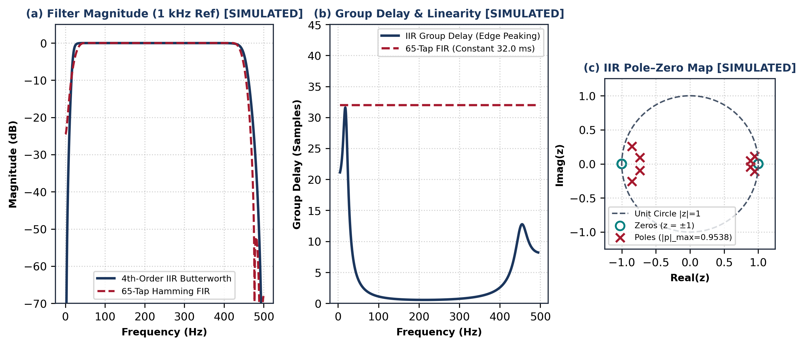
Figure 11: Simulated digital filter analysis at f_{s,DSP} = 1000 Hz reference rate: (a) 4th-order IIR Butterworth vs. 65-tap Hamming FIR magnitude; (b) group delay linearity; (c) IIR Z-plane pole–zero map (|p|max = 0.9538 < 1) [SIMULATED].
Each conditioned sEMG stream is segmented into L = 200 ms sliding windows with 50% overlap (100 ms stride). Applying a Hamming window w[n] and N-point FFT yields the Discrete Fourier Transform X[k] and Welch Power Spectral Density P_{xx}(f_{k}):
 | $$X[k] = \sum_{n=0}^{N-1}{w[n] x[n] e^{-j2πkn/N}} , P_{xx}(f_{k}) = \frac{{\left|X[k]\right|}^{2}}{f_{s} U L}$$ | (2.22)
From each window, time-domain activation features—Root Mean Square (RMS), Mean Absolute Value (MAV), and Waveform Length (WL) [7], [8]—and spectral distribution indices—Mean Frequency (MNF) and Median Frequency (MDF) [1]—are computed as:
 | $$RMS = \sqrt{\frac{1}{L}\sum_{n=0}^{L-1}{x^{2}[n]}} , MAV = \frac{1}{L}\sum_{n=0}^{L-1}{\left|x[n]\right|} , WL = \sum_{n=1}^{L-1}{\left|x[n] - x[n-1]\right|}$$ | (2.23)
 | $$MNF = \frac{\sum_{k=1}^{K}{f_{k}P_{xx}(f_{k})}}{\sum_{k=1}^{K}{P_{xx}(f_{k})}} , \sum_{k=1}^{k_{MDF}}{P_{xx}(f_{k})} = \frac{1}{2}\sum_{k=1}^{K}{P_{xx}(f_{k})}$$ | (2.24)
A standardized 35-second hand-gripper session protocol is defined (Figure 8c): 0–5 s rest, 5–10 s comfortable squeeze (Hold 1), 10–15 s rest, 15–20 s comfortable squeeze (Hold 2), 20–25 s rest, 25–30 s comfortable squeeze (Hold 3), and 30–35 s rest. Because the gripper is not a dynamometer, RMS and MAV quantify electrical muscle activation rather than force in N, kg, or strength percentiles. Any reference calibration on Hold 1 (5–10 s) must be separated from evaluation on Holds 2 and 3 (15–20 s, 25–30 s), and envelope variation is treated strictly as an activation observation, not proof of physiological fatigue or disease. To suppress in-band (15–35 Hz) motion artifacts, an optional 16-tap LMS adaptive filter updates w[n] using the IMU acceleration reference r_{IMU}[n]:
 | $$e_{clean}[n] = x_{EMG}[n] - w^{T}[n] r_{IMU}[n] , w[n+1] = w[n] + 2µ e_{clean}[n] r_{IMU}[n]$$ | (2.25)
where e_{clean}[n] is the motion-corrected sEMG output and µ = 0.005 is the LMS step size. Figures 8 and 9 and Table 6 summarize the time- and frequency-domain DSP simulations.
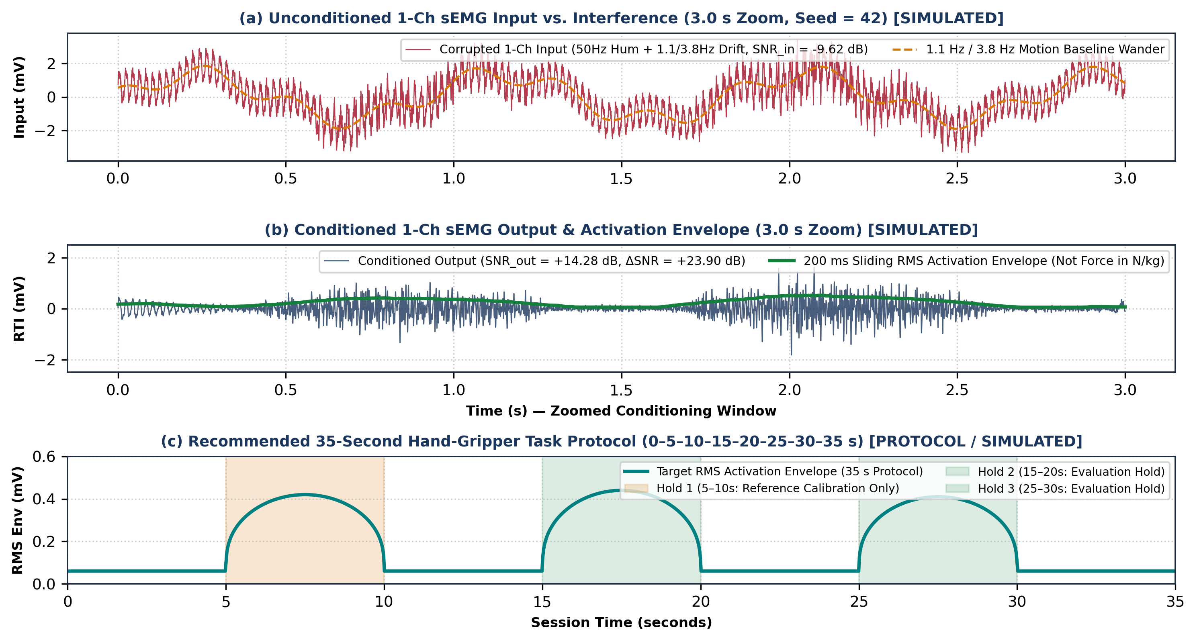
Figure 8: Simulated 1-channel sEMG conditioning and task protocol [SIMULATED, Seed = 42]: (a) corrupted input (SNRin = −9.62 dB); (b) conditioned output and 200 ms RMS activation envelope (SNRout = +14.28 dB, ΔSNR = +23.90 dB); (c) recommended 35-second three-hold hand-gripper protocol (Hold 1 reference separated from Holds 2–3 evaluation).
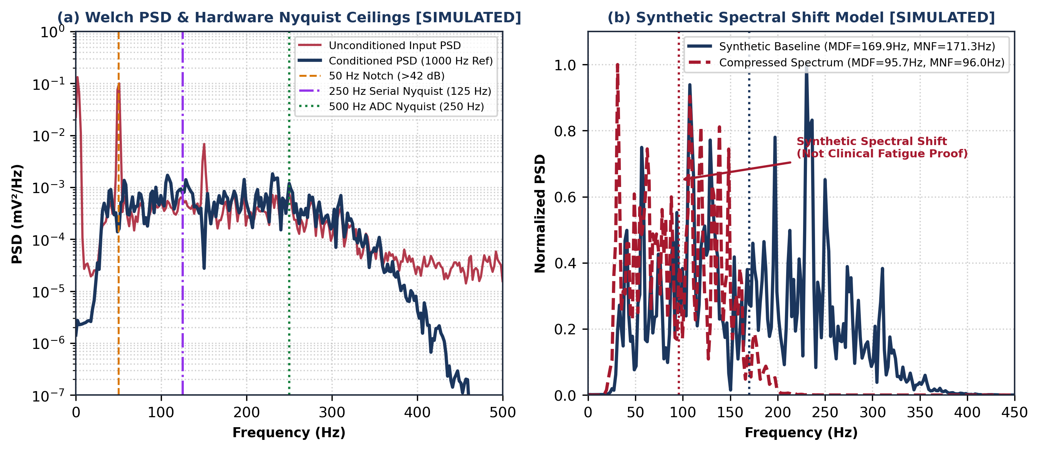
Figure 9: Simulated Welch PSD analysis [SIMULATED]: (a) input vs. conditioned PSD at 1000 Hz reference contrasted against the 125 Hz (250 Hz serial) and 250 Hz (500 Hz ADC) Nyquist ceilings; (b) synthetic spectral compression shift from MDF = 169.9 Hz to 95.7 Hz (activation/spectral model only, not clinical fatigue proof).
Table 6: Digital Signal Processing (DSP) Algorithm Comparison Across Time-Domain Grip Metrics and Spectral Analysis
DSP Stage | Mathematical Structure | Computational Load | Stability & Bandwidth Limit | Role in ForearmSense AI
Time-Domain Activation & Timing | 200 ms sliding RMS, MAV, WL + threshold onset/offset detector | O(L) ops / window | Zero phase distortion; works at 250 Hz, 500 Hz, or 1 kHz | Quantifies grip activation, hold timing & Hold 2–3 consistency (not force in N/kg)
4th-Order IIR Bandpass | 2× Direct-Form II Butterworth biquads | 10 MACs / sample | BIBO stable (|p|max = 0.9538 < 1.0) | 20–450 Hz at 1 kHz ref; must be restricted <100 Hz if applied to 250 Hz serial data
65-Tap Hamming FIR | Symmetric non-recursive linear-phase FIR | 65 MACs / sample | Exact linear phase (τ_{g} = 32.0 ms @ 1 kHz) | Preserves MUAP waveform morphology in reference simulation
2nd-Order IIR Notch | 50 Hz biquad notch (Q = 30) | 10 MACs / sample | >42 dB power-line hum suppression | Suppresses 50 Hz mains coupling on laptop bench
512-Pt Welch PSD | Hamming windowed periodogram | ~2,560 MACs / win | Δf = 1.95 Hz @ 1 kHz ref | Valid across 20–450 Hz only at fs ≥ 1 kHz; unsupported above 125 Hz at 250 Hz serial
IMU Stability & Derivatives | Complementary filter (α=0.98) + finite differences | O(1) per IMU sample | Eliminates gyro pitch/roll drift; yaw unreferenced | Tracks wrist tilt, ω (deg/s), α = d²θ/dt² (deg/s²), and angular jerk ζ_{θ} = d³θ/dt³

2.10 Machine Learning Pipeline, Saved Synthetic Benchmark, and Real-Data Hygiene
Inspection of the supplied repository confirms that the current software implementation consists of a FastAPI backend and React/Vite frontend providing a synthetic biomedical signal laboratory, accompanied by the verification suite (forearmsense_reproducibility_suite.py, saved outputs in /working_dir/c_6eb092db73583cf7/artifacts/file_generation/ttl=63d/intermediate/reproducibility_package/verification_results.json and ml_grouped_cv_results.csv). Live Arduino serial ingestion, session recording, and replay were planned in earlier revisions but are not implemented in the supplied workspace and are not claimed as completed. For probabilistic classification across K classes with feature vector x, multinomial softmax probabilities and the Brier score BS are defined as:
 | $$P(y = k ; x) = \frac{exp\left(w_{k}^{T}x + b_{k}\right)}{\sum_{j=1}^{K}{exp\left(w_{j}^{T}x + b_{j}\right)}} , BS = \frac{1}{N}\sum_{i=1}^{N}{\sum_{k=1}^{K}{{\left(p_{i,k} - y_{i,k}\right)}^{2}}}$$ | (2.26)
where w_{k} and b_{k} are the weight vector and bias for class k, p_{i,k} is the predicted probability, and y_{i,k} ∈ {0,1} is the ground-truth indicator.
In the previously saved synthetic verification benchmark (verification_results.json, seed = 108, N = 750 windows across 25 simulated trials, 14-D synthetic feature vector, evaluated via Trial-Grouped 5-Fold Cross-Validation and kept strictly distinct from any 3-fold repository configuration), holding out entire synthetic trials prevents window-overlap leakage (Table 7, Figure 12). Synthetic accuracy verifies software pipeline mechanics only and does not establish human or hardware generalization. For future real-data ML on the 1-channel BioAmp EXG Pill + MPU-6050 setup, five rules are enforced: (1) keep overlapping windows from a session together; (2) hold participants out (Leave-One-Subject-Out) when claiming new-person generalization; (3) fit preprocessing/scalers only on training data; (4) exclude identifiers, trigger labels (GOOD/BAD/REST), and simulated physiology from predictors; and (5) treat GOOD/BAD/REST triggers as operator annotations, not clinical ground truth.
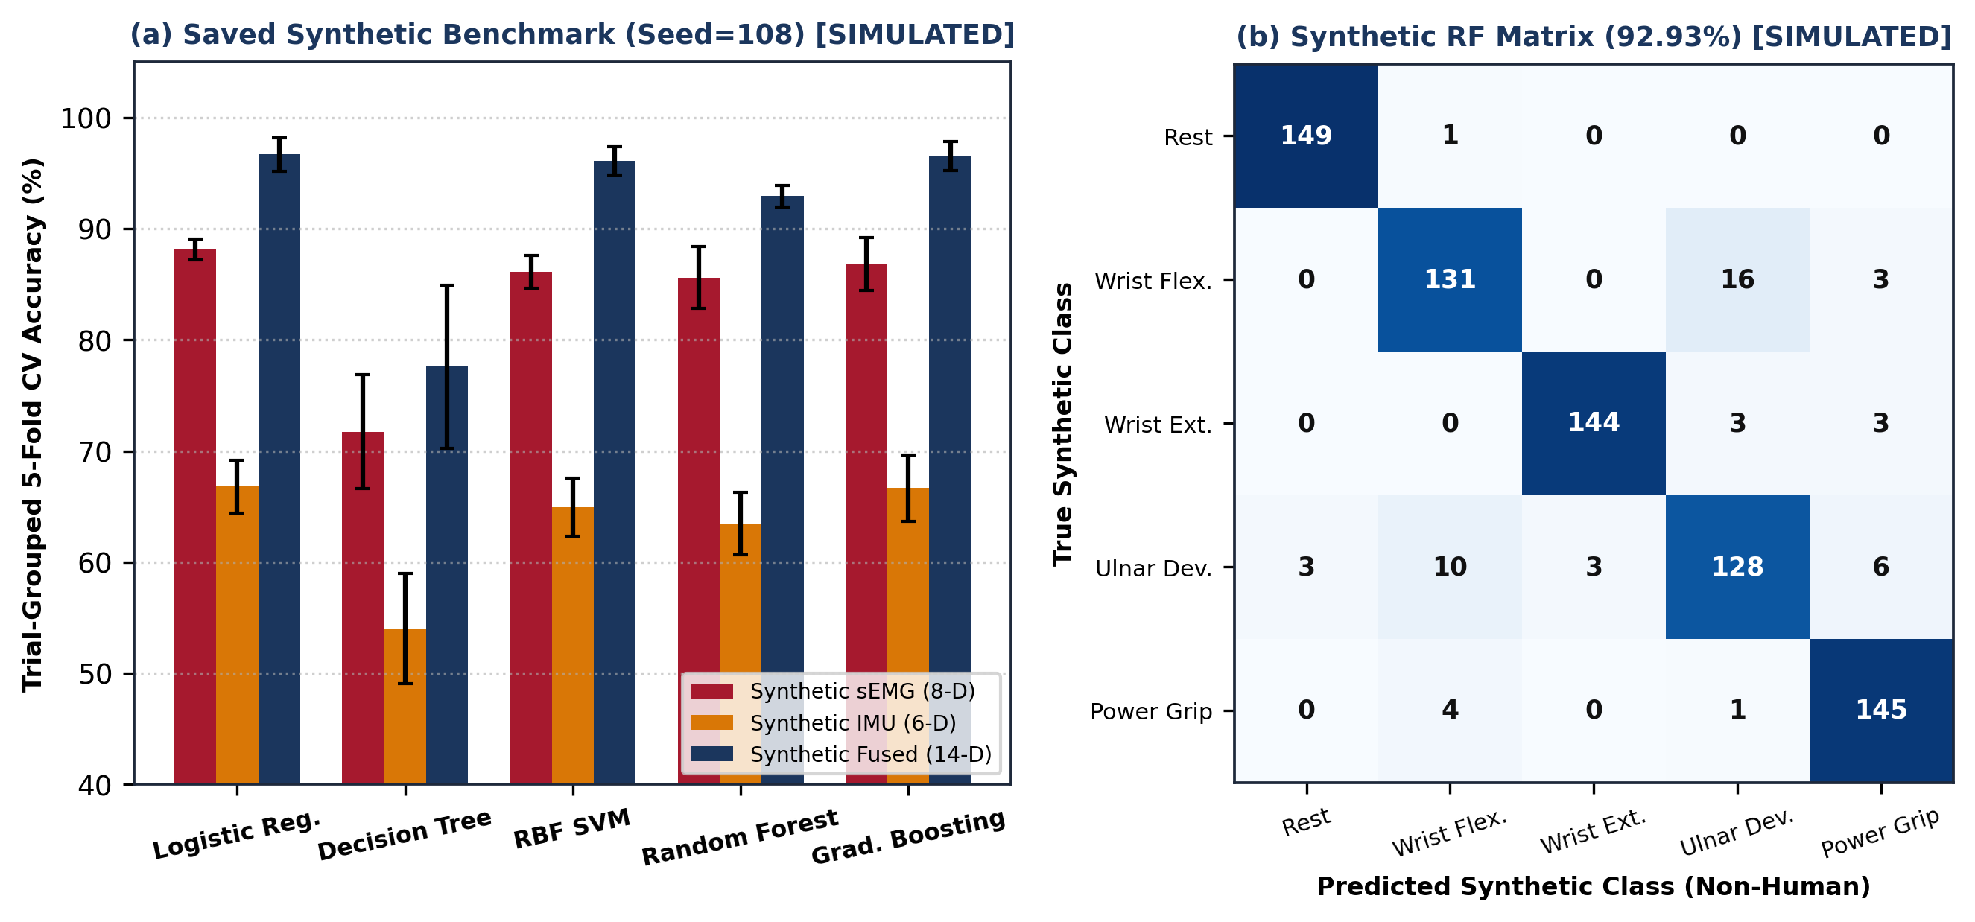
Figure 12: Previously saved trial-grouped 5-fold cross-validation synthetic ML pipeline verification (verification_results.json, 25 synthetic trials, N = 750 windows, Seed = 108 — software testbed only, non-generalizable to human hardware) [SIMULATED]: (a) mean accuracy ± 95% CI; (b) Random Forest confusion matrix (92.93% ± 0.98%).
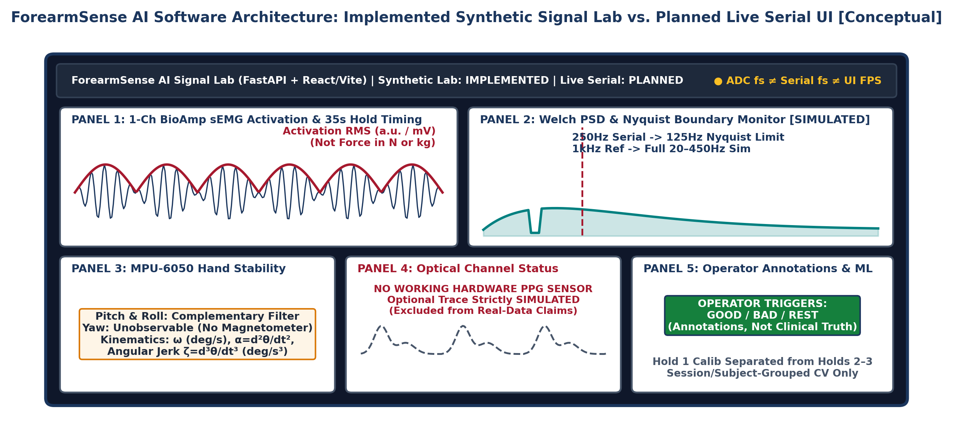
Figure 13: ForearmSense AI software laboratory architecture [Conceptual] distinguishing the implemented FastAPI + React/Vite synthetic signal laboratory from the planned live Arduino Uno serial ingestion, 35-second gripper task tracker, and operator annotation view.
Table 7: Previously Saved Trial-Grouped 5-Fold Cross-Validation Synthetic ML Benchmark (verification_results.json, Seed = 108 — Synthetic Software Demo Only)
Classifier Model | Mechanism | Syn. sEMG (8-D) | Syn. IMU (6-D) | Syn. Fused (14-D) | Bal. Acc | Macro F1 | Brier
Logistic Regression | Linear softmax + L2 | 88.13 ± 0.96% | 66.8 ± 2.39% | 96.67 ± 1.49% | 96.67% | 96.64% | 0.0637
Decision Tree (d=4) | Axis-aligned Gini splits | 71.73 ± 5.14% | 54.0 ± 4.96% | 77.6 ± 7.33% | 77.6% | 77.62% | 0.3597
RBF SVM (γ=0.12) | Kernel margin max | 86.13 ± 1.46% | 64.93 ± 2.6% | 96.13 ± 1.27% | 96.13% | 96.12% | 0.1581
Random Forest (35T) | Bootstrap subspace | 85.6 ± 2.79% | 63.47 ± 2.81% | 92.93 ± 0.98% | 92.93% | 92.91% | 0.2051
Gradient Boosting | Residual ensemble | 86.8 ± 2.39% | 66.67 ± 2.98% | 96.53 ± 1.33% | 96.53% | 96.52% | 0.1399

3. EXPERIMENTS — REPRODUCIBLE SIMULATIONS AND HARDWARE PLAN
Twelve structured experiments organize the verification of ForearmSense AI across the Theoretical/Simulated AECD Coursework domain (Experiments 1–5), Digital Signal Processing & Sensor Modeling domain (Experiments 6–10), and Machine Learning & Physical Benchtop Protocol domain (Experiments 11–12). Experiments 1–11 report saved/reproduced simulations from forearmsense_reproducibility_suite.py (Python 3.11.2, NumPy 2.1.3, SciPy 1.15.2, Matplotlib 3.10.1, seeds 42 and 108, logged in verification_results.json), whereas Experiment 12 defines the proposed physical benchtop protocol using the Arduino Uno, 1-channel BioAmp EXG Pill, MPU-6050, and 35-second hand-gripper task (Table 8).
Table 8: Master Experimental Matrix Across Theoretical AECD, Simulated DSP/ML, and Proposed Benchtop Domains
Exp | Experiment Title | Domain | Environment & Provenance | Governing Model | Evidence Status
Exp 1 | 1-Ch Synthetic sEMG & 35s Task Model | Biomedical / AECD | Python 3.11.2 (SciPy 1.15.2, Seed=42) | Eq. (2.1): 1-Ch MUAP & 3-hold gripper envelope | Saved/Executed Sim (Fig. 8)
Exp 2 | Theoretical INA826 Gain, Headroom & CMRR | AECD (Theory) | Python [Saved Sim] + AECD Course Derivation | Eqs. (2.5)–(2.10): G₁=10.0, ±157.5mV DC (Not BioAmp) | Saved/Executed Sim (Fig. 4)
Exp 3 | Theoretical Sallen–Key HPF & LPF4 | AECD (Theory) | Python (scipy.signal.bode) [Saved Sim] | Eqs. (2.12)–(2.15): 20.28 Hz & 452.7 Hz ref filters | Saved/Executed Sim (Figs. 5–6)
Exp 4 | sEMG Hum & Motion Drift Rejection | AECD + DSP | Python [Saved Sim] @ 4000 Hz Ref (Seed=42) | 50/150Hz hum + 1.1/3.8Hz wander filtering | Saved/Executed Sim (Fig. 8a–b)
Exp 5 | Theoretical AFE Cascade Bode Analysis | AECD (Theory) | Python (signal.bode, 1500 pts) [Saved Sim] | Cascaded G₁·G₂·H_{HP}·H_{Notch}·H_{LP4} (53.98 dB) | Saved/Executed Sim (Fig. 7)
Exp 6 | Sampling, Nyquist (125/250Hz) & ADC Bits | AECD + DSP | Analytical + Python [Saved Sim] | Eqs. (2.14), (2.20): Uno R3 10b vs R4 14b & Nyquist | Analytical & Sim (Table 5)
Exp 7 | FIR vs. IIR Filter & Pole–Zero Stability | DSP (Core) | Python (freqz, group_delay, tf2zpk) [Saved Sim] | Eq. (2.21): |p|max=0.9538 vs. 32 ms FIR @ 1 kHz | Saved/Executed Sim (Fig. 11)
Exp 8 | Activation RMS & Welch PSD Boundaries | DSP (Core) | Python (signal.welch, Seed=42) [Saved Sim] | Eqs. (2.22)–(2.24): RMS/MAV & Nyquist PSD limits | Saved/Executed Sim (Fig. 9)
Exp 9 | MPU-6050 Pitch/Roll CF & α, ζ_{θ} Kinematics | Sensors + DSP | Python [Saved Sim] @ 200 Hz (α=0.98) | Eq. (2.18): Pitch CF (RMSE 0.53°), ω, α, ζ_{θ}; no yaw | Saved/Executed Sim (Fig. 10a)
Exp 10 | Optional Synthetic Optical Model (No HW) | Simulated Only | Python [Saved Sim] @ 100 Hz (No HW PPG) | Eq. (2.19): SIMULATED Beer–Lambert pulse only | SIMULATED ONLY (Fig. 10b)
Exp 11 | Saved 5-Fold Trial-Grouped CV ML Demo | Machine Learning | Saved Artifact: verification_results.json (Seed=108) | Eq. (2.26): 25 synthetic trials (N=750), 5-fold CV | Saved Synthetic Demo (Fig. 12)
Exp 12 | 35s Hand-Gripper & Uno Benchtop Protocol | HW Integration | Proposed Physical Benchtop Experiment | Arduino Uno + 1-Ch BioAmp + MPU-6050 + Gripper | Proposed Protocol (Unmeasured)

3.1 Experiment 1: Single-Channel Synthetic sEMG and 35-Second Gripper Envelope Generation [Saved Simulation, Seed = 42]
Aim, Theory & Methodology: Synthesize a reproducible single-channel surrogate sEMG waveform (full-scale ±2.50 mVpeak = 5.0 mV_{pp} at f_{s,ADC} = 4000 Hz reference rate) alongside the target 35-second three-hold hand-gripper activation profile. Using Python 3.11.2 (NumPy 2.1.3, SciPy 1.15.2) and Equation (2.1), unit-variance white noise is shaped by a 4th-order Butterworth bandpass filter (30–320 Hz), normalized to 0.42 mV_{rms}, modulated by contraction envelopes, and summed with 15 µV_{rms} baseline noise.
Parameters, Saved/Expected Output & Evidence Boundary: Parameters & Saved Output (verification_results.json): Zoomed 3.0 s waveform (Figure 8a–b) yields Rest RMS = 0.060 mV, Moderate Squeeze RMS = 0.376 mV, and Strong Squeeze RMS = 0.457 mV, while Figure 8(c) models the 35 s protocol (Holds at 5–10 s, 15–20 s, 25–30 s). Boundary: Amplitude represents electrical activation, not mechanical force in N or kg.

3.2 Experiment 2: Theoretical Instrumentation Amplifier (INA826) Gain, Headroom & CMRR Analysis [Saved Simulation / AECD Theory]
Aim, Theory & Methodology: Verify as an AECD (25EC1302E) theoretical coursework exercise that a Stage-1 TI INA826 at G₁ = 10.00 V/V on a +3.30 V supply (V_{REF} = +1.650 V) prevents internal input-buffer and output saturation under ±50.0 mV DC electrode offsets while achieving >100 dB passive system CMRR via Equations (2.5)–(2.10).
Parameters, Saved/Expected Output & Evidence Boundary: Parameters & Saved Output: R1 = 24.7 kΩ, R_{G} = 5.49 kΩ, ΔZe = 5.0 kΩ, Z_{in,CM} = 2.0 GΩ. Analytical/Simulated Output: G₁ = 10.00 V/V (+20.00 dB); internal buffer peak Vo1,max = 1.9125 V (387.5 mV below 2.30 V limit); linear DC offset limit = ±157.5 mV; passive CMRR = 101.1 dB (Figure 4b, Table 3). Boundary: Theoretical AECD reference calculation only; not transferred to the physical BioAmp EXG Pill.

3.3 Experiment 3: Theoretical Active Sallen–Key High-Pass and Anti-Aliasing Low-Pass Filter Analysis [Saved Simulation / AECD Theory]
Aim, Theory & Methodology: Evaluate the cutoff frequencies, quality factors, overload recovery time, and 3550 Hz alias-edge attenuation of the theoretical 2nd-order Sallen–Key HPF (20.28 Hz) and 4th-order Sallen–Key Butterworth LPF (452.7 Hz) using OPA2376 op-amp models via Equations (2.12)–(2.15) in scipy.signal.bode.
Parameters, Saved/Expected Output & Evidence Boundary: Parameters & Saved Output: HPF (100 nF, 56 kΩ, 110 kΩ) yields f_{c,HPF} = 20.28 Hz, Q = 0.701, τ_{rec} = 11.0 ms (30.2 ms recovery from 50 mV step); LPF (Biquads 1A/1B) yields f_{c,LPF} = 452.7 Hz with −51.79 dB @ 2000 Hz and −71.73 dB @ 3550 Hz (Figures 5b, 6b, Table 4). Boundary: Educational AECD filter synthesis study.

3.4 Experiment 4: Single-Channel sEMG Noise, 50 Hz Mains, and Motion Drift Rejection [Saved Simulation, Seed = 42]
Aim, Theory & Methodology: Quantify simulated time-domain SNR improvement when the synthetic single-channel sEMG waveform is corrupted by 50/150 Hz power-line interference (1.70 mV_{pp}), 1.1/3.8 Hz motion baseline wander (3.80 mV_{pp}), and 0.12 mV_{rms} wideband noise, and conditioned through the bandpass and 50/150 Hz notch cascade.
Parameters, Saved/Expected Output & Evidence Boundary: Saved Output (verification_results.json): Unconditioned input SNRin = −9.62 dB improves to SNRout = +14.28 dB (ΔSNR = +23.90 dB), with the 200 ms sliding RMS envelope cleanly resolving grip onset and release timing (Figure 8a–b). Boundary: Simulated SNR improvement; physical bench SNR depends on electrode skin preparation and laptop mains isolation.

3.5 Experiment 5: Complete Theoretical AFE Frequency Response and Bode Plot Analysis [Saved Simulation / AECD Theory]
Aim, Theory & Methodology: Evaluate the end-to-end closed-loop gain (499.91 V/V = 53.98 dB), bandwidth, 50 Hz Twin-T notch depth (Q = 6.25), and phase response of the theoretical five-stage AECD reference AFE across 1,500 logarithmic frequency points (1 Hz to 10 kHz) in scipy.signal.bode.
Parameters, Saved/Expected Output & Evidence Boundary: Saved Output: Flat 53.98 dB mid-band gain across 20.28–452.7 Hz, >40 dB rejection at 50.0 Hz, +40 dB/dec low-end slope, and −80 dB/dec high-end roll-off (Figure 7). Boundary: Represents the theoretical INA826+OPA2376 cascade, not the physical BioAmp EXG Pill frequency response.

3.6 Experiment 6: Sampling Rate Regimes, Nyquist Aliasing Boundaries, and Provisional Arduino Uno Quantization [Analytical & Simulated]
Aim, Theory & Methodology: Contrast the legacy PRD sampling regime (~500 Hz internal acquisition, ~250 Hz serial output) and provisional Arduino Uno ADC resolutions (Uno R3 10-bit ATmega328P vs. Uno R4 14-bit RA4M1) against the 4000 Hz -> 1000 Hz multirate reference model via Equations (2.14) and (2.20).
Parameters, Saved/Expected Output & Evidence Boundary: Analytical & Simulated Output: Provisional Uno R3 10-bit ADC @ 5.0 V gives Δq,R3 = 4.883 mV (Uno R4 14-bit gives Δq,R4 = 0.305 mV; 12-bit 3.30 V reference gives Δq,ref = 805.66 µV, SQNR = 80.48 dB). At 250 Hz serial output (fNyq = 125 Hz) and 500 Hz internal sampling (fNyq = 250 Hz), full 20–450 Hz spectral analysis is unsupported due to Nyquist folding (Figure 6b, Table 5).

3.7 Experiment 7: FIR vs. IIR Digital Filter Design and Pole–Zero Stability Comparison [Saved Simulation]
Aim, Theory & Methodology: Compare a 4th-order IIR Butterworth bandpass filter (8 poles) against a 65-tap Hamming-windowed FIR bandpass filter at the 1000 Hz reference rate using Equation (2.21) in scipy.signal (freqz, group_delay, tf2zpk).
Parameters, Saved/Expected Output & Evidence Boundary: Saved Output (verification_results.json): The 4th-order IIR filter achieves steep roll-off at 10 MACs/sample with maximum pole radius |pm|max = 0.9538 < 1.0 (unconditionally stable), whereas the 65-tap FIR filter achieves exact linear phase with constant 32.0 ms group delay at 65 MACs/sample (Figure 11, Table 6).

3.8 Experiment 8: Sliding RMS Activation Envelope and Welch PSD Bandwidth Boundaries [Saved Simulation, Seed = 42]
Aim, Theory & Methodology: Evaluate 200 ms sliding RMS activation tracking and 512-point Hamming-windowed Welch PSD estimation (MNF and MDF via Equations 2.22–2.24) on the 1000 Hz reference stream under baseline (30–320 Hz shaping) and spectrally compressed (22–180 Hz shaping) synthetic bursts.
Parameters, Saved/Expected Output & Evidence Boundary: Saved Output (verification_results.json): Welch PSD (Δf = 1.95 Hz resolution at 1000 Hz) tracks synthetic spectral compression from MNF = 171.3 Hz, MDF = 169.9 Hz to MNF = 96.0 Hz, MDF = 95.7 Hz (Figure 9b). Boundary: At 250 Hz serial output, spectral estimates are strictly bounded below 125 Hz; envelope or spectral changes are activation observations, not proof of physiological fatigue.

3.9 Experiment 9: Simulated MPU-6050 Complementary Orientation and Kinematic Derivative Tracking [Saved Simulation]
Aim, Theory & Methodology: Verify that the α = 0.98 discrete-time complementary filter (Equation 2.18 at fs,IMU = 200 Hz) eliminates +1.8 °/s gyroscope thermal bias drift while tracking a ±35° (0.4 Hz) wrist pitch trajectory and a ±6.5° (6.2 Hz) hand instability burst, alongside angular velocity ω, angular acceleration α = d²θ/dt², and angular jerk ζ_{θ} = d³θ/dt³.
Parameters, Saved/Expected Output & Evidence Boundary: Saved Output (verification_results.json): Uncompensated gyroscope integration diverges to RMSE = 6.52°, whereas the complementary filter locks onto the true pitch trajectory and instability burst with RMSE = 0.53° (Figure 10a). Boundary: Because the MPU-6050 has no magnetometer, absolute yaw around gravity is unobservable.

3.10 Experiment 10: Optional Synthetic Optical Waveform Conditioning [SIMULATED ONLY — No Working Hardware PPG]
Aim, Theory & Methodology: Evaluate the software laboratory’s optional synthetic optical pulse generator (Equation 2.19 at fs,PPG = 100 Hz, simulated true HR = 74.0 BPM) corrupted by 0.25 Hz baseline drift and white noise, using a 3rd-order Butterworth bandpass filter (0.5–5.0 Hz) and peak detection.
Parameters, Saved/Expected Output & Evidence Boundary: Saved Output (verification_results.json): Synthetic peak detection recovers 7 systolic peaks with simulated HR = 73.92 BPM (MAE = 0.08 BPM; Figure 10b). Strict Hardware Boundary: No working PPG sensor exists on the physical bench; this experiment is SIMULATED ONLY and excluded from all physical hardware and real-data conclusions.

3.11 Experiment 11: Saved Trial-Grouped 5-Fold Cross-Validation Synthetic ML Pipeline Benchmark [Saved Simulation, Seed = 108]
Aim, Theory & Methodology: Audit the previously saved leakage-free software classification benchmark across 5 supervised models (Logistic Regression, CART, RBF SVM, Random Forest, Gradient Boosting) using Trial-Grouped 5-Fold Cross-Validation across 25 simulated trials (N = 750 windows, Equation 2.26, artifact: verification_results.json).
Parameters, Saved/Expected Output & Evidence Boundary: Saved Output (verification_results.json & ml_grouped_cv_results.csv): Synthetic 14-D fusion yields 92.93% ± 0.98% accuracy (Macro-F1 = 92.91%, Brier = 0.2051) for Random Forest and 96.53% ± 1.33% (Brier = 0.1399) for Gradient Boosting (Figure 12, Table 7). Strict Boundary: Saved synthetic software benchmark only (distinct from any 3-fold repo config); does not establish human or hardware generalization.

3.12 Experiment 12: Proposed 35-Second Hand-Gripper and Arduino Uno Benchtop Verification Protocol [Proposed]
Aim, Theory & Methodology: Define the physical benchtop verification protocol using the confirmed hardware inventory (Arduino Uno, 1-channel BioAmp EXG Pill with existing electrodes, MPU-6050, mechanical hand gripper, and laptop) without altering existing wiring or inventing participant measurements.
Parameters, Saved/Expected Output & Evidence Boundary: Proposed Protocol & Criteria: (1) Confirm exact Arduino Uno board revision (ATmega328P R3 vs. RA4M1 R4) and actual sketch ADC/serial timing; (2) Execute the 35-second comfortable gripper session (0–5 s rest, 5–10 s Hold 1 reference calibration, 10–15 s rest, 15–20 s Hold 2 evaluation, 20–25 s rest, 25–30 s Hold 3 evaluation, 30–35 s rest); (3) Quantify Hold 2–3 activation consistency, onset/release timing, and MPU-6050 stability (pitch/roll CF, ω, α, ζ_{θ}) under strict session/participant-grouped validation (Table 10). Status: Proposed protocol; no human trials fabricated.

4. RESULTS — ANALYTICAL, REPRODUCED SIMULATION, AND V&V PLAN
All project outcomes are partitioned across our six evidence categories: (4.1) Analytical Design Calculations for the theoretical 25EC1302E AECD reference chain and provisional Arduino Uno ADC/Nyquist bounds, (4.2) Saved Python Simulation Results from forearmsense_reproducibility_suite.py (verification_results.json and ml_grouped_cv_results.csv, Python 3.11.2, seeds 42 and 108), and (4.3) Hardware Boundaries, Risk Mitigations, and Proposed 35-Second Benchtop Validation Criteria (Tables 9 and 10).

4.1 Analytical Calculations (Theoretical AECD Reference & Provisional Uno Bounds)
• Theoretical AECD Gains & Headroom (Equations 2.5–2.9 — Not Physical BioAmp): Stage-1 TI INA826 gain G₁ = 10.00 V/V (+20.00 dB; 10.01 V/V with INA333, R_{G} = 11.1 kΩ) and Stage-2 TI OPA2376 gain G₂ = 50.00 V/V (+33.98 dB) yield G_{total} = 499.91 V/V (+53.98 dB). Stage 1 tolerates ±157.5 mV DC offset, keeps A1 <= 1.9125 V (387.5 mV margin), and maps ±2.50 mVpeak sEMG to [0.400 V, 2.900 V] (never transferred to the 1-ch BioAmp EXG Pill).
• Theoretical CMRR & RTI Noise Floor (Equations 2.10–2.11): Combining INA826 CMRR (104 dB) with ΔZe = 5 kΩ across Z_{in,CM} = 2 GΩ (112.04 dB) yields passive CMRR = 101.1 dB. Over ENBW = 443.66 Hz, theoretical RTI noise is 0.782 µV_{rms} (AFE) and 0.947 µV_{rms} (total reference system; 1.273 µV_{rms} for INA333).
• Nyquist Limits & Provisional Arduino Uno Quantization (Equations 2.12–2.20): Legacy ~500 Hz ADC and ~250 Hz serial rates have 250 Hz and 125 Hz Nyquist ceilings (unsupported across full 20–450 Hz). In the 4 kHz reference model, the 4th-order LPF (f_{c,LPF} = 452.7 Hz) gives -51.79 dB @ 2 kHz and -71.73 dB @ 3550 Hz. Provisional Uno R3 10-bit step size is Δq,R3 = 4.883 mV (Uno R4 14-bit: 0.305 mV; 12-bit 3.30 V ref: 0.8057 mV, SQNR = 80.48 dB).

4.2 Saved / Reproduced Python Simulation Results (verification_results.json)
• Simulated sEMG Conditioning & Spectral Shift Model (Figures 8–9, Seed = 42): At f_{s,ADC} = 4000 Hz reference sampling, conditioning improved sEMG SNR from -9.62 dB to +14.28 dB (ΔSNR = +23.90 dB), resolving Rest (0.060 mV), Moderate (0.376 mV), and Strong Squeeze (0.457 mV) RMS envelopes. At 1 kHz, 512-pt Welch PSD tracked synthetic spectral compression from MNF = 171.3 Hz, MDF = 169.9 Hz to MNF = 96.0 Hz, MDF = 95.7 Hz.
• Digital Filters, IMU Orientation, Optical Model, and Saved 5-Fold ML (Figures 10–12, Table 7): 4th-order IIR max pole radius is |pm|max = 0.9538 < 1.0; 65-tap FIR group delay is 32.0 ms. MPU-6050 complementary filtering (α = 0.98) reduced pitch RMSE from 6.52° to 0.53° (yaw unreferenced). The SIMULATED optical model gave MAE = 0.08 BPM (excluded from hardware). Saved 5-fold trial-grouped CV (25 trials, seed = 108) achieved 92.93% ± 0.98% (RF, Brier = 0.2051) and 96.53% ± 1.33% (Gradient Boosting).

4.3 Hardware Boundaries, Engineering Risk Analysis, and Master V&V Plan
Table 9: Comprehensive Engineering Risk Analysis, Hardware Boundaries, and Design Mitigations
Risk ID & Boundary | Root Cause Identified | Severity | Engineered Mitigation in ForearmSense AI | Status
R1: Unconfirmed Uno Revision | Uno R3 (10-bit) vs. R4 (14-bit) ADC difference | High | Use R3 10-bit (4.88 mV) as provisional example; verify board | Mitigated in Sec 2.1
R2: Single-Ch BioAmp Scope | 1 BioAmp module = 1 ch; custom AFE ≠ BioAmp | Critical | Limit HW to 1-ch flexor; keep INA826/OPA2376 theoretical | Resolved Across Report
R3: Serial Nyquist (125/250 Hz) | ~250 Hz ser (125 Hz Nyq) & ~500 Hz ADC alias | Critical | Bound low-rate claims <125 Hz; contrast with 4 kHz ref | Resolved in Sec 2.4.2
R4: No Working PPG Sensor | Physical optical sensor absent on bench | Critical | Zero HW HR/SpO₂/PTT claims; label sim trace SIMULATED | Resolved in Sec 2.8
R5: Uninstrumented Gripper | Mechanical gripper lacks force load cell | High | Report sEMG in mV / % Hold 1; never claim N, kg, or %ile | Resolved in Sec 1.5
R6: IMU Yaw & Derivatives | MPU-6050 has no mag; α vs. jerk conflation | Medium | CF for pitch/roll only; define α=d²θ/dt², jerk ζ_{θ}=d³θ/dt³ | Resolved in Sec 2.7
R7: ML Leakage & Overclaim | Window overlap & synthetic-to-human gap | High | Cite saved 5-fold artifact; enforce session/subject CV split | Resolved in Sec 2.10
R8: Laptop USB Mains Safety | Non-isolated USB link to AC-mains laptop | Critical | Run laptop on battery (>5 m from AC) or use USB isolator | Resolved in Sec 2.6

Table 10: Master Verification and Validation (V&V) Plan: Analytical, Saved Synthetic, Physical Status, and Target Criteria
Engineering Metric | Analytical / Provisional Model | Saved / Reproduced Sim Value | Physical Hardware Status | Target Verification Criterion
Uno ADC & Sketch Timing | Provisional R3: 10b (4.88 mV); R4: 14b | Ref Sim: 12b @ 4 kHz -> 1 kHz (80.5 dB) | Not Yet Measured (Board Pending) | Confirm Uno rev & f_{s,ADC} / f_{s,ser}
1-Ch BioAmp vs. AECD Ref | AECD Ref: G_{tot} = 499.91 V/V, CMRR 101.1 dB | Ref Sim: 53.98 dB, +23.90 dB ΔSNR | Not Yet Measured on BioAmp Pill | Clean 1-ch grip envelope (SNR > 10 dB)
Anti-Aliasing & Bandwidth | 250 Hz ser -> 125 Hz Nyq; 4 kHz -> −71.7 dB | Ref Sim: −71.73 dB @ 3550 Hz (Fig. 6b) | Not Yet Measured (Bench Pending) | Bound spectral claims < f_{Nyq}
35s Gripper Task Protocol | Holds: 5–10s (Cal), 15–20s & 25–30s (Eval) | Simulated 3-hold profile (Fig. 8c) | Not Yet Measured on Participants | Separate Hold 1 cal from Holds 2–3 CV%
MPU-6050 Tilt & Derivatives | CF α = 0.98; ω, α = d²θ/dt², ζ_{θ} = d³θ/dt³ | Saved Sim: Pitch CF RMSE = 0.53° (Fig. 10a) | Not Yet Measured During Gripper | Track pitch/roll & α, ζ_{θ}; no yaw claim
Optical Channel Boundary | No working HW PPG; Eq. (2.19) theoretical | Saved Sim: MAE = 0.08 BPM [SIMULATED] | Hardware Sensor Absent (Zero Data) | Exclude sim PPG from HW conclusions
Software Lab & Live Serial | FastAPI + React/Vite synthetic lab active | Saved JSON/CSV verification suite | Live Serial, Record & Replay Planned | Build pyserial ingest & CSV logger
Real-Data ML Hygiene | Saved 5-Fold Trial-Grouped CV (N=750) | Saved Sim: RF 92.93 ± 0.98% (Table 7) | Not Yet Evaluated on Human Data | Session/subject split & train-only fit

5. CONCLUSION AND FUTURE WORK
This Project-Based Learning (PBL) report has presented a transparently bounded engineering design, mathematical analysis, and reproducible simulation framework for ForearmSense AI under Analog Electronic Circuit Design (25EC1302E). By mapping the physical architecture around the confirmed benchtop inventory—an Arduino Uno microcontroller (evaluating classic ATmega328P R3 10-bit ADC operation at Δq = 4.883 mV as a provisional example alongside Uno R4 14-bit operation), a single-channel Upside Down Labs BioAmp EXG Pill with existing electrodes, a TDK InvenSense MPU-6050 six-axis IMU, an uninstrumented mechanical hand gripper, and a host laptop with no working optical pulse sensor—the report establishes a rigorous methodology for studying single-channel grip activation, grip/release timing, repetition consistency, and hand movement stability. Simultaneously, to fulfill 25EC1302E coursework requirements, a custom +3.30 V multi-stage AFE (TI INA826 at G₁ = 10.00 V/V paired with TI OPA2376 Sallen–Key Butterworth filters, 50 Hz Twin-T notch, and G₂ = 50.00 V/V post-amplifier) was derived and simulated as an explicit theoretical reference model achieving 499.91 V/V (53.98 dB) passband gain across 20.28–452.7 Hz, ±157.5 mV Stage-1 DC offset tolerance, 101.1 dB passive CMRR, 0.782 µV_{rms} AFE input-referred noise, and −71.73 dB anti-aliasing attenuation at 3550 Hz under 4000 Hz reference sampling.
Crucially, this revision resolves legacy ambiguities by contrasting the 125 Hz and 250 Hz Nyquist limits of ~250 Hz serial and ~500 Hz internal sampling against the 4000 Hz -> 1000 Hz reference architecture, distinguishing internal ADC sampling from serial packet rate and UI refresh rate, defining exact angular acceleration (α = d²θ/dt²) and angular jerk (ζ_{θ} = d³θ/dt³) kinematics without claiming unreferenced yaw, and separating the implemented FastAPI + React/Vite synthetic signal laboratory and saved 5-fold trial-grouped cross-validation results (92.93% ± 0.98% Random Forest, 96.53% ± 1.33% Gradient Boosting in verification_results.json) from unmeasured physical hardware outcomes. Future work will confirm the exact benchtop Arduino Uno revision and firmware timing, implement live serial ingestion and session recording, and execute the 35-second three-hold hand-gripper protocol under session- and participant-grouped validation.

6. REFERENCES
[1] C. J. De Luca, "The use of surface electromyography in biomechanics," Journal of Applied Biomechanics, vol. 13, no. 2, pp. 135–163, May 1997. DOI: 10.1123/jab.13.2.135
[2] R. Merletti, A. Botter, A. Troiano, E. Merlo, and M. A. Minetto, "Technology and instrumentation for detection and conditioning of the surface electromyographic signal: State of the art," Clinical Biomechanics, vol. 24, no. 2, pp. 122–134, Feb. 2009. DOI: 10.1016/j.clinbiomech.2008.08.006
[3] H. J. Hermens, B. Freriks, C. Disselhorst-Klug, and G. Rau, "Development of recommendations for SEMG sensors and sensor placement procedures," Journal of Electromyography and Kinesiology, vol. 10, no. 5, pp. 361–374, Oct. 2000. DOI: 10.1016/S1050-6411(00)00027-4
[4] M. Atzori et al., "Electromyography data for non-invasive naturally-controlled robotic hand prostheses," Scientific Data, vol. 1, Art. no. 140053, Dec. 2014 (Ninapro DB1/DB2 Repository). DOI: 10.1038/sdata.2014.53
[5] E. Scheme and K. Englehart, "Electromyogram pattern recognition for control of powered upper-limb prostheses: State of the art and challenges for clinical use," Journal of Rehabilitation Research and Development, vol. 48, no. 6, pp. 643–659, 2011. DOI: 10.1682/JRRD.2010.09.0177
[6] J. G. Webster and A. J. Nimunkar, Eds., Medical Instrumentation: Application and Design, 5th ed. Hoboken, NJ, USA: John Wiley & Sons, 2020 (IEC 60601-1 safety & biopotential amplifiers). ISBN: 978-1-119-45733-6
[7] A. Phinyomark, P. Phukpattaranont, and C. Limsakul, "Feature reduction and selection for EMG signal classification," Expert Systems with Applications, vol. 39, no. 8, pp. 7420–7431, Jun. 2012. DOI: 10.1016/j.eswa.2012.01.102
[8] B. Hudgins, P. Parker, and R. N. Scott, "A new strategy for multifunction myoelectric control," IEEE Transactions on Biomedical Engineering, vol. 40, no. 1, pp. 82–94, Jan. 1993. DOI: 10.1109/10.204774
[9] M. Georgi, C. Amma, and T. Schultz, "Recognizing hand and finger gestures with IMU based motion and EMG based muscle activity sensing," in Proc. Int. Conf. Bio-Inspired Systems and Signal Processing (BIOSIGNALS), Lisbon, Portugal, 2015, pp. 99–108. Link: SciTePress 2015/52769
[10] J. Allen, "Photoplethysmography and its application in clinical physiological measurement," Physiological Measurement, vol. 28, no. 3, pp. R1–R39, Mar. 2007. DOI: 10.1088/0967-3334/28/3/R01
[11] E. M. Spinelli, R. Pallàs-Areny, and M. A. Mayosky, "AC-coupled front-end for biopotential measurements," IEEE Transactions on Biomedical Engineering, vol. 50, no. 3, pp. 391–395, Mar. 2003. DOI: 10.1109/TBME.2003.808826
[12] Upside Down Labs, "BioAmp EXG Pill v1.0 — Biopotential Signal Acquisition Hardware Documentation (Single-Channel 3.3V/5V EMG/ECG/EOG/EEG Front-End)," New Delhi, India, 2026. Link: docs.upsidedownlabs.tech/bioamp-exg-pill
[13] Texas Instruments, "INA128, INA129 Precision, Low-Power Instrumentation Amplifiers Datasheet (±2.25 V to ±18 V Supply Specification)," SBOS051B, Dallas, TX, USA. Link: ti.com/lit/ds/symlink/ina129.pdf
[14] Texas Instruments, "INA826 Precision, 200-µA Supply Current, 2.7-V to 36-V Instrumentation Amplifier Datasheet (SBOS562)," "INA333 Micro-Power Zero-Drift In-Amp Datasheet (SBOS445)," and "OPA2376 Low-Noise, 5.5-MHz RRIO Op-Amp Datasheet (SBOS406)," Dallas, TX, USA. Link: ti.com/lit/gpn/INA826
[15] Analog Devices / Maxim Integrated, "MAX30102 High-Sensitivity Pulse Oximeter and Heart-Rate Sensor for Wearable Health Datasheet (19-7740; 1.8V Core, Red/IR LEDs)," Norwood, MA, USA. Link: analog.com/max30102.pdf
[16] TDK InvenSense, "MPU-6000 and MPU-6050 Product Specification Revision 3.4 (Six-Axis MEMS Accelerometer and Gyroscope)," Sunnyvale, CA, USA, Aug. 2013. Link: MPU-6050 Datasheet Rev 3.4
[17] Arduino SA, "What's the difference between UNO R3 (ATmega328P 10-Bit ADC) and UNO R4 Minima/WiFi (Renesas RA4M1 14-Bit ADC) boards?" Official Arduino Technical Documentation, 2026. Link: support.arduino.cc/UNO-R3-vs-R4
[18] O. Gleisner, O. Yosef-Hai, O. Goldberg, I. Nitzan, and M. Nitzan, "Overestimation of oxygen saturation measured by pulse oximetry in hypoxemia: Effect of optical pathlengths-ratio increase and skin pigmentation," Sensors / ResearchGate, Jan. 2023. Link: ResearchGate ID: 367534869

