CONFIDENTIAL — PREPARED FOR OTS LEADERSHIP
EXTERNAL ATTACK SURFACE
& THREAT INTELLIGENCE ASSESSMENT
Open Technology Solutions Consortium
Bellco Credit Union • SECU of Maryland • FourLeaf Federal Credit Union • S3 CUSO

Prepared by Pellera Technologies
Cybersecurity Advisory — West Region
March 18, 2026
This report was produced using exclusively passive, legal Open Source Intelligence (OSINT) techniques.
No active scanning, vulnerability exploitation, or authenticated access was attempted.

Table of Contents

1. Executive Summary

1.1 Purpose & Scope
Pellera Technologies conducted this assessment as a complimentary, consultative engagement to provide Open Technology Solutions and its consortium members with visibility into their externally observable security posture. Our objective is to help OTS leadership understand how the consortium appears to a sophisticated threat actor using only publicly available information — and to provide a prioritized, actionable roadmap for strengthening defenses.
All intelligence was gathered using passive reconnaissance techniques. No systems were accessed, probed, or tested. Every finding in this report is based on information freely available to any motivated adversary today.

1.2 The OTS Consortium at a Glance
Metric | Value
Combined Assets Under Management | $27.6 Billion
Total Members Served | 1,100,000+
Credit Union Partners | 3 (Bellco, SECU MD, FourLeaf FCU)
CUSO Partners | 2 (OTS, S3 Shared Service Solutions)
Managed Domains | 15+ (including legacy and marketing domains)
Shared Data Centers | Primary (Flexential CO) + Secondary + Cloud (AWS, Azure)
Geographic Footprint | Colorado, Maryland, New York/New Jersey + nationwide digital
Regulatory Jurisdiction | NCUA, FFIEC, NYDFS, Maryland State, GLBA, PCI DSS

1.3 Why This Matters — Financial Risk Context
To contextualize the findings in this report, we present industry-standard financial benchmarks for cybersecurity incidents affecting financial institutions of comparable size and profile:

Risk Metric | Industry Benchmark | OTS Consortium Exposure
Average cost of a data breach (Financial Services) | $6.08M (IBM/Ponemon 2024) | $6–18M+ given 3 CUs sharing infrastructure
Cost per compromised record | $181 (Financial Services avg.) | 1.1M members × $181 = $199M theoretical maximum
Member notification costs (at scale) | $3–5 per member | $3.3M–$5.5M for full consortium notification
NYDFS penalty exposure (FourLeaf) | Up to $250K per violation | Multiple violations possible — multi-million potential
NCUA regulatory action | Consent orders, operational restrictions | Reputational + operational impact
Business interruption (ransomware) | $1.2M–$4.5M (CU industry avg.) | OTS shared infrastructure multiplies downtime across all CUs
Cyber insurance premium increase post-breach | 50–200% increase for 3–5 years | Applies to all consortium members simultaneously
Member attrition post-breach | 3–7% within 12 months | 33K–77K members = $330M–$770M in deposit flight risk
Estimated total risk exposure |  | $15M–$50M+ (conservative range for a significant incident)

Key insight: Because OTS operates shared infrastructure serving all three credit unions from a common data center environment, a single breach event has a multiplier effect — one incident triggers notification obligations, regulatory scrutiny, insurance claims, and member trust impacts across three separate institutions simultaneously. The financial exposure is not additive; it is compounding.

1.4 Summary of Observations
We identified 13 significant observations across the consortium’s external attack surface, categorized by severity:

1.4.1 Risk Heat Map
Each observation is plotted by likelihood of exploitation versus potential business impact:

 | Low Impact | Moderate Impact | High Impact | Critical Impact
High Likelihood |  | #2 Bellco DMARC pct=50 | #1 bethpagefcu.com DMARC p=none  #4 SPF lookup limit exceeded
Moderate Likelihood | #10 Detectify gaps | #6 WHOIS exposure  #7 lovebethpage no DNSSEC  #8 Wildcard cert | #3 Shared /24 subnet  #5 Legacy subdomains (85+)  #9 Live Citrix gateway  #11 Cisco ASA + Palo Alto mixed
Low Likelihood |  | #12 Camera systems exposed  #13 GRC platform internet-facing

1.4.2 Observations Summary Table

# | Observation | Severity | Entity
1 | Legacy bethpagefcu.com domain has DMARC p=none — zero email spoofing protection for a domain trusted by 480K+ members | CRITICAL | FourLeaf/OTS
2 | Bellco DMARC at p=quarantine;pct=50 — half of spoofed emails delivered for $8.5B institution | HIGH | Bellco/OTS
3 | Single /24 subnet hosts ADFS, web, mail, and DNS for ALL entities — lateral movement risk | HIGH | All
4 | FourLeaf SPF chains to 5 legacy sub-records with 100+ IP ranges; likely exceeds 10-lookup limit | HIGH | FourLeaf/OTS
5 | bethpagefcu.com has 85+ live subdomains including Citrix, VPN, ADFS, test/UAT, and internal hostnames | HIGH | FourLeaf/OTS
6 | OTS employee names/contact exposed via WHOIS on Network Solutions domains | MEDIUM | OTS
7 | lovebethpage.com lacks DNSSEC — DNS cache poisoning risk on shared infrastructure | MEDIUM | FourLeaf/OTS
8 | Wildcard certificate (*.bethpagefcu.com) enables valid TLS on any legacy subdomain | MEDIUM | FourLeaf/OTS
9 | Citrix gateway on legacy domain resolves to 4 live IPs — Citrix heavily targeted (CVE-2023-4966) | MEDIUM | FourLeaf/OTS
10 | Detectify ASM deployed but coverage gaps across legacy/marketing domains | LOW | OTS
11 | Cisco ASA SSL VPN (2) coexists with Palo Alto — mixed firewall increases patching complexity | MEDIUM | FourLeaf/OTS
12 | Camera/physical security systems internet-accessible (bpgmpcam01, cam.open-techs.com) | MEDIUM | FourLeaf/OTS
13 | GRC platform hosted on internet-facing OTS infrastructure | MEDIUM | OTS

2. Remediation Action Plan
The following action plan prioritizes remediation by severity and effort. Each item includes estimated timeline, resource requirements, and industry-benchmark costs. Items are organized into three phases: Immediate (0–30 days), Short-Term (30–90 days), and Medium-Term (90–180 days).

2.1 Phase 1 — Immediate Actions (0–30 Days)
These items address the highest-severity risks that are exploitable today with minimal attacker effort.

# | Action Item | Owner | Est. Effort | Industry Cost Benchmark
1 | Escalate bethpagefcu.com DMARC from p=none to p=quarantine immediately, with a 90-day path to p=reject. Monitor Dmarcian aggregate reports for legitimate sender breakage. | OTS DNS/Email Team | 2–4 hours (DNS change) + 2 hrs/week monitoring | $0 (DNS change) + existing Dmarcian license
2 | Advance bellco.org DMARC from pct=50 to pct=100. This is a single TXT record edit. | OTS DNS Team | 1 hour | $0 (DNS change)
3 | Enable WHOIS privacy on fourleaffcu.com and lovebethpage.com via Network Solutions. This prevents social engineering targeting of named OTS staff. | OTS Domain Admin | 30 minutes | $0–$15/yr (registrar privacy service)
4 | Enable DNSSEC on lovebethpage.com to match all other consortium domains. | OTS DNS Team | 1–2 hours | $0 (supported by registrar)
5 | Verify camera/physical security endpoints (bpgmpcam01.bethpagefcu.com, cam.open-techs.com) are not accessible from the public internet. If they are, restrict to VPN-only access immediately. | OTS Network + FourLeaf Facilities | 2–4 hours | $0 (firewall rule change)

2.2 Phase 2 — Short-Term Actions (30–90 Days)

# | Action Item | Owner | Est. Effort | Industry Cost Benchmark
6 | Conduct a comprehensive legacy domain audit. Catalog all subdomains on bethpagefcu.com (85+), lovebethpage.com/net/org, bethpagefinancial.com/net/org/info, youthaccounts.com, freecheckingforlongisland.com. For each: determine if migrated, decommission DNS if yes, plan migration if no. | OTS Infrastructure Team | 40–80 hours (analyst time) | $8K–$15K (if outsourced)
7 | Flatten and migrate FourLeaf SPF records. Replace the 5-level bethpagefcu.com include chain with fourleaffcu.com-native records. Use SPF flattening (IP-based entries) to stay within the 10-lookup limit. Audit the /18 Lightpath block (16,384 IPs authorized to send email). | OTS Email/DNS Team + Dmarcian | 20–40 hours | $5K–$10K (Dmarcian professional services or internal)
8 | Revoke the *.bethpagefcu.com wildcard certificate. Replace with specific-name certificates for any services that must remain on the legacy domain during transition. | OTS PKI/Certificate Team | 8–16 hours | $500–$2K (replacement certs)
9 | Review and decommission legacy VPN/remote access endpoints. The coexistence of Cisco ASA SSL VPN and Palo Alto GlobalProtect creates patching complexity. Consolidate to a single platform. | OTS Network Security | 40–80 hours | $10K–$25K (migration/professional services)
10 | Implement network segmentation within the 12.178.113.0/24 data center subnet. Deploy VLANs and east-west firewall policies to separate per-CU infrastructure and isolate identity services (ADFS) from web-facing systems. | OTS Network Engineering | 80–160 hours | $25K–$50K (design + implementation)

2.3 Phase 3 — Medium-Term Actions (90–180 Days)

# | Action Item | Owner | Est. Effort | Industry Cost Benchmark
11 | Expand external attack surface monitoring to cover ALL consortium domains (not just primaries). Ensure Detectify or equivalent ASM tool monitors legacy, marketing, and defensive domains. Set up automated alerts for new certificate issuance, DNS changes, and exposed services. | OTS Security Operations | 20–40 hours setup + ongoing | $15K–$30K/yr (ASM platform licensing)
12 | Conduct a targeted penetration test focused on the Bethpage-to-FourLeaf transition: phishing simulations using legacy domain, SPF bypass attempts, legacy endpoint exploitation, and member confusion testing. | External Pen Test Provider | 2–4 weeks | $30K–$60K (CREST/OSCP-certified firm)
13 | Restrict GRC platform (grc1.open-techs.com) access to VPN-only. This system likely contains compliance data, audit findings, and risk assessments that would be high-value intelligence for an attacker. | OTS Security + GRC Team | 4–8 hours | $0 (access control change)
14 | Implement a domain lifecycle management policy. Define retention periods, security requirements, and decommission procedures for marketing/campaign/defensive domains. Apply to all 15+ domains in the portfolio. | OTS Security Governance | 20–40 hours (policy development) | $5K–$10K (if consultant-assisted)
15 | Advance all consortium DMARC policies to p=reject. By this phase, all legitimate email flows should be identified via Dmarcian reporting. Full enforcement prevents impersonation across all domains. | OTS Email Security | Ongoing monitoring | $0 (DNS changes + existing tooling)

2.4 Remediation Investment Summary

Phase | Timeline | Estimated Total Investment | Risk Reduction
Phase 1 (Immediate) | 0–30 days | $0–$500 | Eliminates CRITICAL email spoofing and WHOIS exposure risks
Phase 2 (Short-Term) | 30–90 days | $48K–$102K | Reduces legacy attack surface by 60–70%; network segmentation
Phase 3 (Medium-Term) | 90–180 days | $50K–$100K | Continuous monitoring, pen test validation, policy maturity
TOTAL (6 months) | 0–180 days | $98K–$202K | Estimated 80%+ reduction in external attack surface risk

Context: The total remediation investment of $98K–$202K over 6 months represents 0.07–0.15% of the consortium’s estimated breach exposure of $15M–$50M. This is a highly favorable return on security investment (ROSI).

3. Strategic Security Roadmap
Beyond the immediate remediation of observations identified in this assessment, the following roadmap outlines strategic investments that will materially strengthen the consortium’s security posture over the next 12 months and 3 years. These recommendations are informed by our understanding of OTS’s architecture, the credit union threat landscape, and emerging regulatory requirements.

3.1 Twelve-Month Priorities (2026–2027)

3.1.1 Zero Trust Architecture for Shared Infrastructure
OTS’s shared infrastructure model creates exceptional efficiency but also concentrates risk. A Zero Trust approach — where every access request is verified regardless of network location — is the natural evolution for a multi-tenant CUSO environment.
- Implement identity-based micro-segmentation between consortium entities within the data center
- Deploy conditional access policies in Azure AD/Entra ID for all ADFS-integrated applications
- Migrate from legacy ADFS to Azure AD/Entra ID native authentication where possible
- Implement Privileged Access Management (PAM) for OTS administrators who have cross-CU access
Estimated investment: $150K–$300K (design, implementation, licensing)
Timeline: 6–12 months

3.1.2 Unified Security Operations Center (SOC)
Given the shared infrastructure and multi-entity regulatory obligations, a unified SOC — either internal or managed — would provide centralized visibility across all consortium entities while maintaining per-CU compliance reporting.
- Deploy a SIEM/XDR platform with per-tenant data separation for compliance
- Integrate Palo Alto Prisma Access, Microsoft 365, AWS CloudTrail, and Azure AD logs
- Establish 24/7 monitoring with defined escalation paths per credit union
- Implement automated incident response playbooks for the top 10 threat scenarios
Estimated investment: $250K–$500K/yr (managed SOC) or $500K–$1M+ (internal build)
Timeline: 3–6 months for managed; 9–12 months for internal

3.1.3 Comprehensive Third-Party Risk Management (TPRM)
Our analysis confirmed 30+ technology vendors across the consortium. Each integration point is a potential attack vector. The MOVEit (2023) and Change Healthcare (2024) breaches demonstrate the cascading impact of vendor compromise.
- Build a vendor risk register covering all confirmed technology partners
- Implement continuous vendor security monitoring (SecurityScorecard, BitSight, or similar)
- Establish contractual security requirements and right-to-audit clauses
- Conduct annual vendor risk assessments with tiered depth based on data access level
Estimated investment: $50K–$100K (platform + FTE time)

3.1.4 Incident Response Readiness
The NCUA 72-hour reporting requirement and the consortium’s shared infrastructure create unique IR challenges. An incident affecting OTS triggers obligations for all three CUs simultaneously.
- Develop consortium-wide incident response plan with per-CU notification trees
- Conduct tabletop exercise simulating a ransomware attack on the OTS data center
- Establish retainer with an IR firm for guaranteed 2-hour response SLA
- Pre-negotiate breach notification vendor contracts (legal, forensics, member notification, credit monitoring)
Estimated investment: $30K–$75K (planning + retainer + exercise)

3.2 Three-Year Strategic Vision (2026–2029)

3.2.1 Cloud-First Security Transformation
The consortium currently operates a hybrid architecture spanning on-premises (Flexential), multiple cloud providers (AWS, Azure, GCP), and SaaS platforms. Over three years, a deliberate cloud-first migration would reduce the on-premises attack surface while enabling cloud-native security controls.
- Migrate remaining on-premises workloads to cloud (AWS/Azure) with infrastructure-as-code
- Implement Cloud Security Posture Management (CSPM) across all cloud accounts
- Deploy cloud-native WAF (AWS WAF/Azure Front Door) to replace on-premises perimeter
- Consolidate identity to a single cloud-native IdP (Entra ID) across all entities
- Target: Reduce physical data center footprint by 50–70% within 3 years

3.2.2 AI-Powered Threat Detection & Response
As the threat landscape evolves, AI-driven security operations will become a competitive differentiator for CUSOs. OTS has an opportunity to lead the consortium into next-generation security.
- Evaluate and deploy AI/ML-based threat detection for anomalous member account behavior
- Implement AI-assisted SOC automation (SOAR) to reduce mean-time-to-respond (MTTR)
- Pilot AI-powered phishing detection for inbound email across all entities
- Explore AI-driven fraud detection integrated with Fiserv DNA core banking

3.2.3 Regulatory Readiness & Continuous Compliance
Regulatory requirements are intensifying across all jurisdictions. Proactive investment in compliance infrastructure will reduce examination friction and demonstrate security maturity to regulators.
- Implement continuous compliance monitoring against FFIEC CAT, NYDFS 23 NYCRR 500, and NCUA Part 748
- Automate NCUA 72-hour incident reporting with pre-populated templates and workflow triggers
- Build a consolidated risk register and GRC dashboard visible to all CU boards
- Prepare for CIRCIA (Cyber Incident Reporting for Critical Infrastructure Act) final rule enforcement (expected 2026–2027)
- Establish a formal cybersecurity governance committee with CU board representation

3.2.4 Consortium Security Culture & Human Firewall
KnowBe4 is confirmed for security awareness at FourLeaf. Expanding this across all entities with advanced social engineering simulation and metrics would strengthen the “human firewall” layer.
- Standardize security awareness training across all consortium entities (2,000+ employees)
- Implement phishing simulation campaigns with entity-specific scenarios (e.g., rebrand confusion)
- Establish security champion program within each CU’s business lines
- Target: <5% phishing click rate consortium-wide within 18 months

4. Detailed Findings — Open Technology Solutions (OTS)

4.1 Organization Profile
Entity: Open Technology Solutions, LLC (CUSO)
HQ: Centennial/Englewood, CO
Domain: open-techs.com (registered 2003, GoDaddy, DNSSEC signed)
DNS Authority: dns3/dns5/dns6.open-techs.com — serves ALL consortium domains
Primary Data Center: Flexential Colorado Corp. colocation (12.178.113.0/24, 64.78.158.0/24)
Secondary Network: Lumen/Level 3 (8.24.31.0/24)
SASE/VPN: Palo Alto Prisma Access (130.41.0.0/16)

4.2 DNS Authority — Centralization Risk
OTS operates the authoritative DNS for the entire consortium. All domains delegate to OTS nameservers. While this centralization provides operational efficiency, it creates a single point of failure: a compromise of OTS DNS would redirect email, web traffic, and authentication for all entities simultaneously.

Domain | Nameservers | Registrar | DNSSEC | WHOIS Privacy
bellco.org | dns5/dns6.open-techs.com | GoDaddy | Signed | Yes
secumd.org | dns3/dns5/dns6.open-techs.com | GoDaddy | Signed | Yes
fourleaffcu.com | dns5/dns6.open-techs.com | Network Solutions | Signed | NO — Exposed
bethpagefcu.com | dns3/dns5/dns6.open-techs.com | GoDaddy | Signed | Yes
open-techs.com | dns3/dns5/dns6.open-techs.com | GoDaddy | Signed | Yes
s3cuso.com | dns3/dns5/dns6.open-techs.com | GoDaddy | Signed | Yes
lovebethpage.com | dns5/dns6.open-techs.com | Network Solutions | UNSIGNED | NO — Exposed

4.3 Shared Data Center Architecture
ARIN registration data and reverse DNS enumeration confirm all consortium entities share infrastructure on a single /24 subnet at the OTS primary data center. The reverse DNS sweep revealed 15+ domains hosted on 12.178.113.0/24 including Bellco’s website, OTS internal systems, and all legacy Bethpage/FourLeaf marketing domains.

IP Block | Owner (ARIN) | Purpose
12.178.113.0/24 | AT&T Enterprises (static allocation) | PRIMARY DC — Web, ADFS, mail, DNS for all CUs
8.24.31.0/24 | Level 3 Parent/Lumen | SECONDARY — VPN concentrators
64.78.144.0/20 | Flexential Colorado Corp. | COLOCATION PROVIDER
47.19.0.0/16 | Cablevision Lightpath (Bethpage, NY) | FourLeaf LOCAL — Citrix, office connectivity
130.41.0.0/16 | Palo Alto Networks | Prisma Access SASE

4.4 Shodan Intelligence — Exposed Services
A Shodan search for SSL certificates issued to bethpagefcu.com returned 14 live internet-facing services, confirming significant legacy infrastructure remains publicly accessible:

Finding | Detail
Total exposed services | 14 with bethpagefcu.com SSL certificates
Top organizations | Open Technology Solutions (5), Palo Alto Networks (4), Bethpage FCU (2), Amazon (2)
Server software | Microsoft IIS/10.0 (3 instances), Cisco ASA SSL VPN (2), F5 BigIP (1)
Operating systems | Windows (3), PAN-OS (2)
TLS versions | TLSv1.2 and TLSv1.3 supported
Location | Colorado Springs, CO (OTS data center)
Mixed firewall environment | Cisco ASA + Palo Alto GlobalProtect coexistence increases patching complexity

4.5 OTS Internal Infrastructure (DNSDumpster)
DNS enumeration of open-techs.com revealed the full scope of OTS’s internal infrastructure. Notable discoveries include:

Subdomain | Significance
bethpage.retired.open-techs.com | Explicitly labeled “retired” but still resolving — confirms decommission in progress
grc1.open-techs.com | GRC (Governance, Risk, Compliance) platform — high-value target
isoc.open-techs.com | Information Security Operations Center
cam.open-techs.com | Camera/physical security system
otglobalvpn.open-techs.com | OTS’s own VPN endpoint
ots-corp-vcse.open-techs.com | Cisco Video Communication Server Expressway
empower / empower-test | Empower platform (retirement/benefits?)
bl.preprod / bl.uat.1 / bl.uat.2 | Bellco pre-production and UAT environments
bp.preprod / bptest / bptest1 | Bethpage pre-production and test environments
bltool / bltool1-3 | Bellco internal tools (4 instances)
mail2.bp / mail2.bl | Per-CU mail relays
ftp.open-techs.com | FTP server — legacy file transfer protocol

4.6 Confirmed Technology Stack
Through DNS analysis, certificate transparency, ARIN data, Shodan, and public records, the following technology stack was confirmed:

Category | Technology | Evidence
Core Banking | Fiserv DNA | Press releases
Digital Banking | Alkami ORB Platform + MANTL | Press releases
Email | Microsoft 365 (all entities) | MX records
Email Security | Proofpoint (gateway) + Dmarcian (DMARC) | SPF + securereader DNS + DMARC rua
Firewall/SASE | Palo Alto Prisma Access + Cisco ASA (legacy) | CNAME + ARIN + Shodan
Load Balancer | F5 BigIP | Shodan
Web Server | Microsoft IIS/10.0 + ASP.NET | Shodan
Identity/SSO | Microsoft ADFS (Azure + on-prem) | DNS subdomains
Remote Access | Citrix (FourLeaf) + GlobalProtect VPN | CT + DNS
MDM | Jamf (Apple devices) | TXT record
ASM | Detectify | TXT record
Virtualization | VMware Cloud | TXT record
Infrastructure | Cisco Intersight + Cisco UC (Expressway/Unity) | TXT + CT
Security Awareness | KnowBe4 | TXT record
CDN/WAF | Cloudflare | DNSDumpster + Crunchbase
Project Mgmt | Atlassian (Jira/Confluence) | TXT record
Workflow | Nintex | TXT record
Data Integration | Matillion (SAML) | TXT record
Video | Pexip (MS Teams interop) | TXT record
Collab | Miro | TXT record
IT Automation | OpCon (SMA Technologies) | Case study
Payments | CO-OP Financial Services | Press releases
Cloud | AWS (multi-region) + Azure + GCP | DNS A records
Colocation | Flexential Colorado | ARIN

4.7 Email Security Posture

Domain | DMARC | Pct | Enforcement | Risk
bethpagefcu.com | p=none | N/A | ZERO | CRITICAL
bellco.org | p=quarantine | 50% | PARTIAL | HIGH
fourleaffcu.com | p=quarantine→reject | 50-100% | TRANSITIONING | MEDIUM
open-techs.com | p=reject | 100% | FULL | LOW
s3cuso.com | p=reject | 100% | FULL | LOW
secumd.org | p=reject | 100% | FULL | LOW

5. Detailed Findings — Bellco Credit Union
Assets: $8.5 billion | Members: 375,000+ | HQ: Greenwood Village, CO
CEO: Doug Ferraro | Domain: bellco.org | 29+ branches (rapidly expanding)

Bellco is in an aggressive growth phase, having opened 6+ new branches between 2023 and 2025, expanding from the Denver metro into northern Colorado and the Western Slope. Each new branch introduces additional network edge points, endpoint fleets, and physical security requirements. The DNSDumpster map (Appendix B) reveals infrastructure spanning OTS DC, AWS, Cloudflare, Google Cloud, NTT America, Verizon Business, and Taylor Corporation.

Key Observations
- DMARC at p=quarantine;pct=50 — half of spoofed Bellco emails are delivered to recipients
- Complex SPF record with multiple includes at risk of exceeding 10-lookup limit
- 47 subdomains identified via certificate transparency
- VPN infrastructure (blvpn, bldenvpn, blglobalvpn, bl7600vpn) reveals multi-site architecture
- Test environments (mtest-5, bl-tst-ebiis) visible in certificate transparency logs
- Confirmed on Microsoft 365, Cloudflare CDN, Palo Alto GlobalProtect

6. Detailed Findings — SECU of Maryland
Assets: $5.7 billion | Members: 267,000+ | HQ: Linthicum, MD
CEO: Dave Sweiderk | EVP/CIEO: Jason Reimer (joined mid-2024)
Domain: secumd.org | 23 financial centers + digital/virtual

SECU has the strongest email security posture in the consortium (DMARC p=reject, clean SPF). However, its infrastructure shows different patterns from Bellco and FourLeaf — including Rackspace hosting (knowmoney.secumd.org), Google Cloud Platform (metapixeldata), and Leadfusion (calculators). SECU’s email architecture appears distinct, using Mailgun rather than Microsoft 365 for transactional email.

Key Observations
- Best-in-consortium DMARC posture (p=reject, clean SPF with 4 includes)
- 32 subdomains identified; multiple test environments (cf-temp-test-online, cookietest, m-test5)
- Jason Reimer (EVP/CIEO) joined mid-2024 and is publicly active in digital transformation
- Active MANTL and Black Dragon Capital partnerships signal modernization investment
- Multi-layered regulatory environment: NCUA + Maryland cybersecurity laws + MD Privacy Act
- Meta Pixel tracking endpoint (metapixeldata.secumd.org) — privacy/compliance consideration

7. Detailed Findings — FourLeaf Federal Credit Union
Assets: $13.4 billion (largest in consortium) | Members: 480,000+
HQ: 899 S. Oyster Bay Rd, Bethpage, NY 11714 | CEO: Linda Armyn
New Domain: fourleaffcu.com (registered June 2024) | Legacy: bethpagefcu.com (2001)
Rebrand: March 3, 2025 — Bethpage Federal Credit Union → FourLeaf Federal Credit Union

7.1 Rebrand Transition — Risk Concentration
The Bethpage-to-FourLeaf rebrand represents the highest concentration of security risk in this assessment. Multiple risk factors compound simultaneously:

7.1.1 Legacy Domain (bethpagefcu.com) — Fully Operational
Despite the rebrand, bethpagefcu.com remains a fully live, internet-facing domain with active email infrastructure (MX points to Microsoft 365), 85+ resolving subdomains, and DMARC set to p=none (zero enforcement). A summary of confirmed live services:

Service | Endpoint | Status
Email (DMARC p=none) | bethpagefcu.com MX → outlook.com | LIVE — CRITICAL
Web | bethpagefcu.com → AWS (dual-region) | LIVE
Citrix Gateway | citrix.bethpagefcu.com → 4 Lightpath IPs | LIVE
VPN | vpn.bethpagefcu.com → 8.24.31.11 | LIVE
Auth | auth.bethpagefcu.com → 12.178.113.11 (OTS DC) | LIVE
ADFS | adfs.bethpagefcu.com → 130.41.x.x (Palo Alto) | LIVE
Online Banking | online.bethpagefcu.com → 64.78.158.211 (Flexential) | LIVE
Beta/Staging | beta.bethpagefcu.com → 50.234.x.x (Azure) | LIVE
Camera System | bpgmpcam01.bethpagefcu.com → 47.19.240.x (Lightpath) | LIVE
Internal Servers | bpgmisv003/004 → various | Hostnames exposed

7.1.2 SPF Dependency Chain
FourLeaf’s SPF record chains to 5 bethpagefcu.com sub-records containing hundreds of IP ranges. This creates a fragile dependency and likely exceeds the RFC 7208 10-DNS-lookup limit, causing silent email authentication failures.

7.1.3 Breach History
June 2012: Bethpage FCU disclosed that an employee uploaded 86,000 member records (names, addresses, DOBs, card numbers, account numbers) to an insecure FTP site during a Visa-to-MasterCard conversion. The data was searchable via Google for 30 days. This occurred during a platform transition — the same pattern of risk present in the current rebrand.

8. Regulatory Landscape
Regulation | Applies To | Key Requirement
NCUA Part 748 | All CUs | 72-hour cyber incident reporting
FFIEC CAT | All CUs | NIST-based cybersecurity assessment
NYDFS 23 NYCRR 500 | FourLeaf | CISO, annual risk assessment, MFA, encryption, 72hr notification
Maryland Cyber Laws (2022) | SECU | Permanent state CISO; local gov preparedness
Maryland Privacy Act (2025) | SECU | Consumer data rights; security obligations
GLBA / Reg P | All CUs | Financial privacy; safeguards rule
PCI DSS | All CUs | Card data security
CIRCIA (upcoming) | All CUs | Critical infrastructure reporting (final rule expected 2026–2027)

Appendix A: Pellera Technologies — Engagement Proposal
Based on the observations in this assessment, Pellera Technologies offers the following engagement options tailored to the OTS consortium’s specific needs. Each can be scoped independently or combined into a comprehensive security partnership.

A.1 Penetration Testing & Attack Surface Management
Targeted engagement focused on the Bethpage-to-FourLeaf transition, legacy domain exploitation, SPF bypass, and social engineering vectors identified in this assessment.
Scope: External penetration test + legacy domain phishing simulation + SPF/DMARC validation
Duration: 2–4 weeks
Deliverable: Detailed findings report with proof-of-concept, risk ratings, and remediation guidance

A.2 Managed Detection & Response (MDR) / SOC Services
24/7 threat monitoring across the consortium’s shared infrastructure, with per-CU compliance reporting and unified incident escalation.
Scope: SIEM/XDR deployment, log integration (Palo Alto, M365, AWS, Azure AD), 24/7 monitoring
Duration: 12-month engagement (renewable)
Deliverable: Monthly threat intelligence reports, real-time alerting, quarterly posture reviews

A.3 vCISO / GRC Advisory
Part-time virtual CISO advisory engagement providing strategic security leadership, compliance management, and board-level reporting across the consortium.
Scope: FFIEC CAT alignment, NYDFS compliance, NCUA exam preparation, policy development, risk register management
Duration: 12-month engagement (10–20 hrs/month)
Deliverable: Security roadmap, compliance dashboard, board presentation materials, policy library

A.4 Incident Response Retainer
Pre-negotiated retainer providing guaranteed rapid response SLA for the consortium, with pre-staged forensic capabilities and pre-approved legal/notification vendor relationships.
Scope: 2-hour response SLA, consortium-specific IR playbooks, annual tabletop exercise
Duration: 12-month retainer (renewable)
Deliverable: IR plan, playbooks, tabletop exercise report, retainer coverage

Next Steps: We welcome the opportunity to discuss these observations and how Pellera can support OTS’s security strategy. Please reach out to schedule a consultative conversation at your convenience.

Appendix B: OSINT Methodology & Commands
All intelligence was gathered using passive, legal techniques. No active scanning, exploitation, or authenticated access was attempted. The following tools and methods were employed:

B.1 Certificate Transparency Logs
Queried crt.sh for all SSL/TLS certificates issued to each domain:
curl -s "https://crt.sh/?q=%.bellco.org&output=json" | jq '.[].name_value' | sort -u
curl -s "https://crt.sh/?q=%.secumd.org&output=json" | jq '.[].name_value' | sort -u
curl -s "https://crt.sh/?q=%.fourleaffcu.com&output=json" | jq '.[].name_value' | sort -u
curl -s "https://crt.sh/?q=%.open-techs.com&output=json" | jq '.[].name_value' | sort -u
curl -s "https://crt.sh/?q=%.bethpagefcu.com&output=json" | jq '.[].name_value' | sort -u

B.2 DNS Enumeration
dig [domain] MX TXT NS +short
dig _dmarc.[domain] TXT +short
dig spf1-5.bethpagefcu.com TXT +short

B.3 Legacy Subdomain Verification
dig citrix.bethpagefcu.com A +short → 47.19.240.8/.15/.19, 47.19.217.44
dig vpn.bethpagefcu.com A +short → 8.24.31.11
dig auth.bethpagefcu.com A +short → 12.178.113.11
dig testauth.bethpagefcu.com A +short → blv1.gpcloudservice.com (Palo Alto)
dig adfs.bellco.org A +short → 12.178.113.209

B.4 WHOIS & ARIN
whois [domain] (all 7 domains)
whois -h whois.arin.net [IP] (6 IP blocks)

B.5 Reverse DNS
dig -x 12.178.113.{1..254} +short
dig -x 8.24.31.{1..254} +short

B.6 DNSDumpster
Visual infrastructure maps generated via dnsdumpster.com for all 6 primary domains.

B.7 Shodan
ssl.cert.subject.cn:"bethpagefcu.com" → 14 results
net:12.178.113.0/24 → 0 results (filtered/firewalled)

B.8 Wayback Machine
Wayback CDX API queries for bethpagefcu.com and open-techs.com

Appendix C: Infrastructure Maps & Shodan Results
Generated by DNSDumpster.com and Shodan.io on March 18, 2026.

C.1 Shodan — bethpagefcu.com SSL Certificate Search
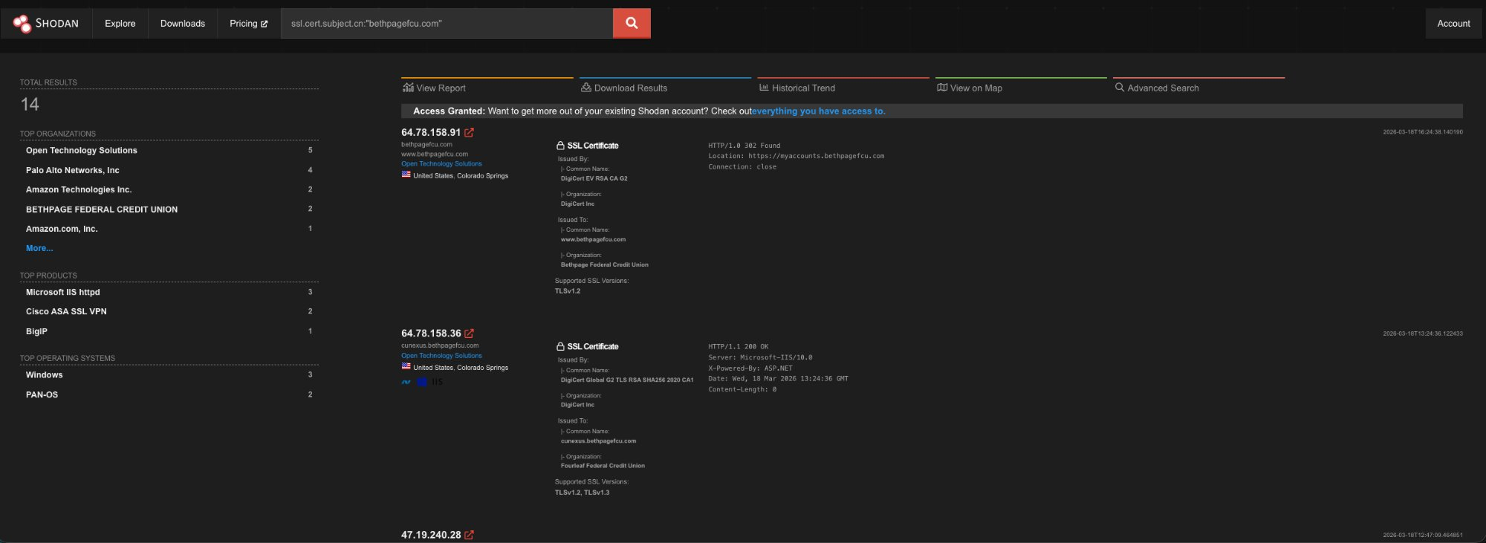

C.2 open-techs.com — OTS Infrastructure
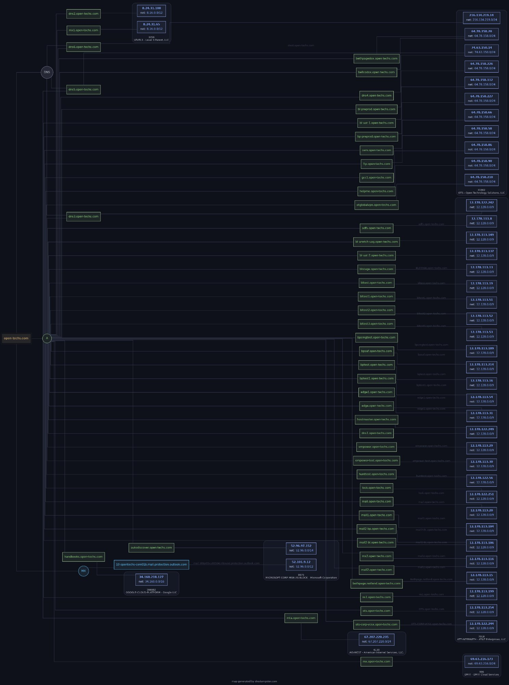

C.3 bellco.org — Bellco Credit Union
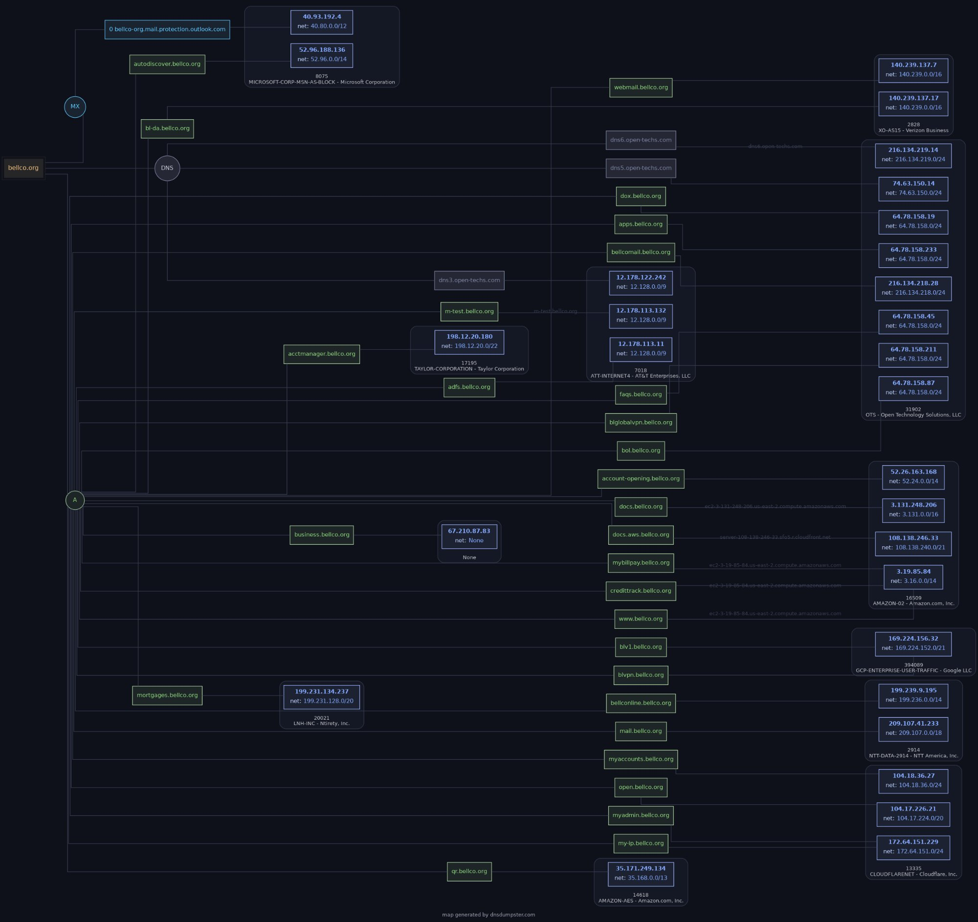

C.4 secumd.org — SECU Maryland
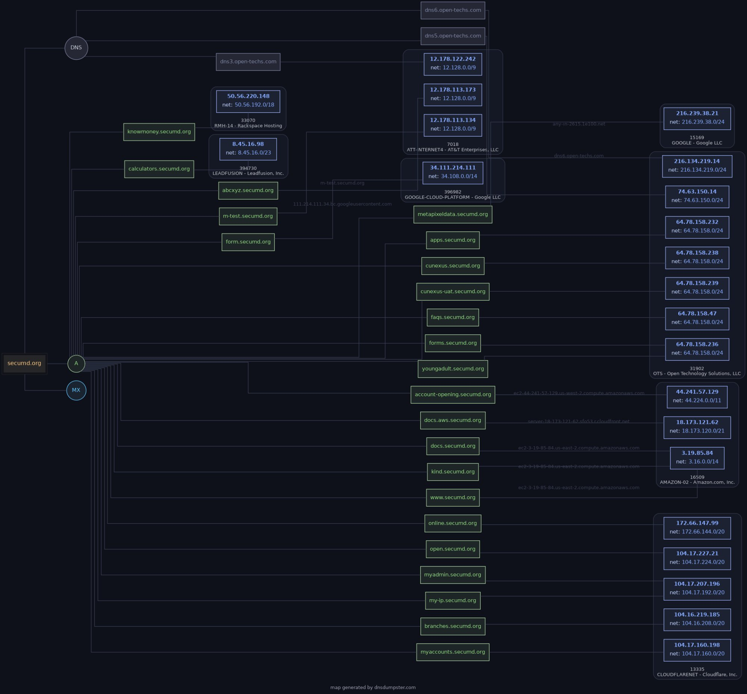

C.5 bethpagefcu.com — Legacy Bethpage
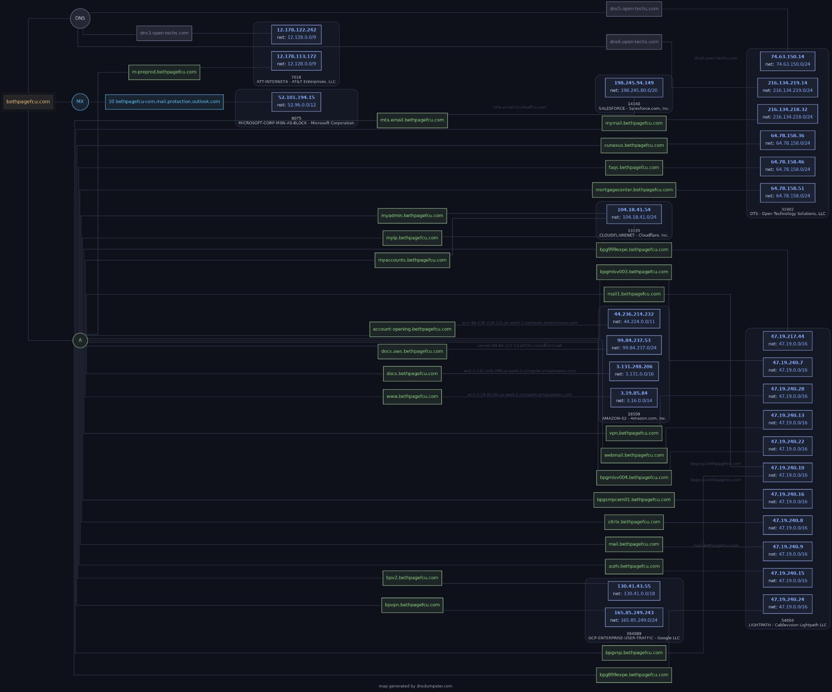

C.6 fourleaffcu.com — FourLeaf FCU
