RTA3 Manual
Table of Contents
RTA3 Manual 1
General Usage 2
Current Spectrum 3
Channel History 5
Band Selection 8
Time Domain Measurements 9

General Usage

Access the RTA3 via the web page on :

http://rfimonitor.kat.ac.za:6543/

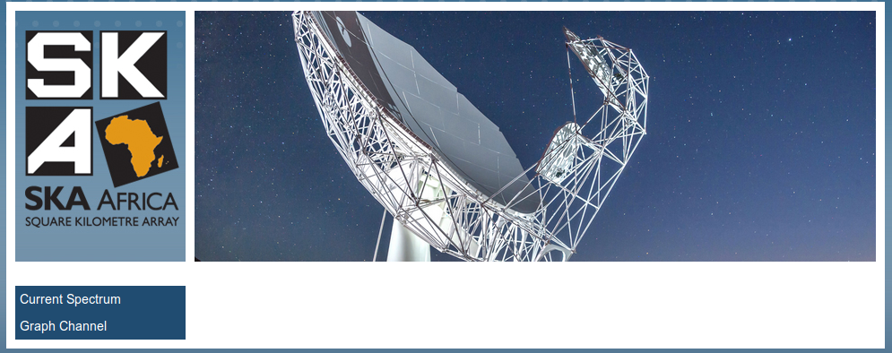

On the left hand side of the page you can see 2 links. These links will take you to 2 views of the data which are described in the rest of this document.

Current Spectrum

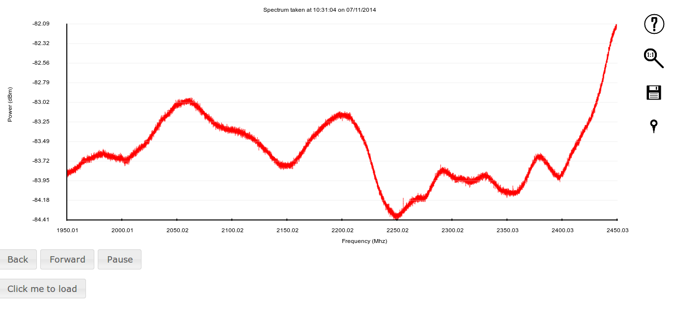Illustration 1: The Current Spectra view. Displays a "real-time" view of the spectra on site as the are captured.
When the page loads you will only see the buttons Back, Forward, Pause and Click me to load. Press the Click me to load button to open the visualisation.

This visulaisation shows you the current spectrum updated once every 2 seconds. The update rate is based on the integration time of the RTA3 which is tunable.

There are a number of interactions which are possible with the visualisation. You can control the visualisation by pressing the symbols on the right of the plot or using the shortcut keys. A description of the functionality follows :

Clicking the question mark symbol on the top right of the visualisation will display a help panel. This panel will describe how to use the different functionality available.
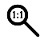
Clicking the magnifying glass will reset the zoom to display all data. This can also be achieved by pressing the “r” key.


Clicking the disk icon will open a new tab containing a PNG file of your current view in the visualisation. This can then be saved to your PC. This can also be achieved by pressing the “s” key.

Clicking the pin icon will load a data label which will print the values of data points closest to your mouse cursor. This can also be achieved by pressing the “t” key.

This icon will only be visible after toggling data labels. You can turn off the data labels by clicking this icon or pressing the “t” key.

Zooming

You can zoom in by scrolling your mouse wheel over a point.

You can zoom over a selection of the plot by holding the “z” key and clicking and dragging your mouse over the selection. Your selection area will be displayed with 2 blue vertical blue lines.

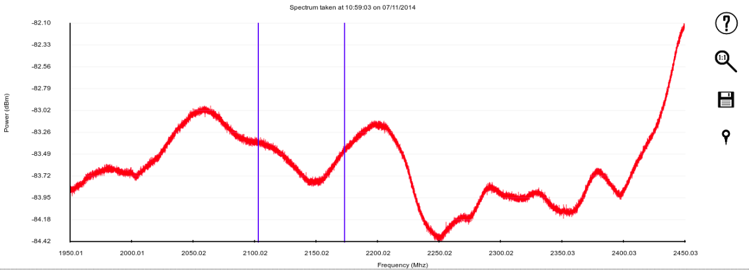
Releasing your mouse button before releasing the “z” key will cause the visualisation to zoom in.
Releasing the “z” key before releasing the mouse button will cancel the zoom and your view will remain unchanged.

Panning
You can pan across the data by clicking and dragging the mouse

Pause
You can pause the data updates by clicking on the “Pause” button.
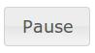

This will stop the automatic update of spectra. You can then manually go backwards or forwards through spectra by using the “Back” and “Forward”

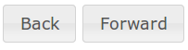

You can resume the automatic updates and return to a “real-time” view by pressing the “Resume” button which will replace the “Pause” button once the visualisation is paused.

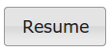

Channel History
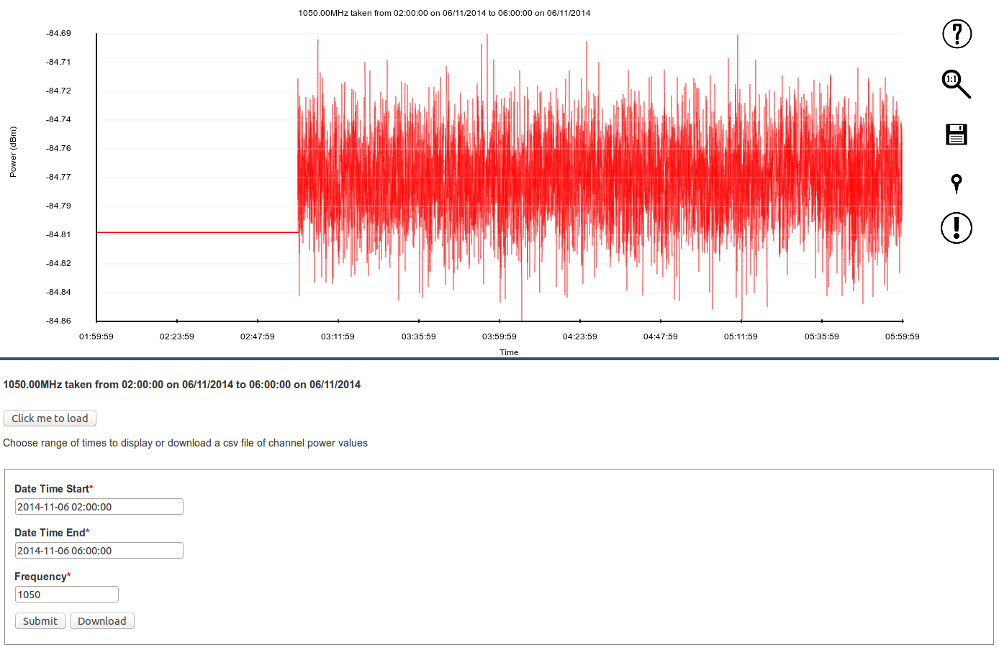Illustration 2: The Graph Channel view. This view will show you data for one channel and multiple times. The channel and time range can be selected using the forms below the visualisation.
When you open this page you will on see the “Click me to load” button and the data selection forms. Press the “Click me to load” button to display the visualisation.

You can interact with the visualisation in the same way as the Current Spectrum view. There is one extra icon which will be described in this section, for other functionality look at the Current Spectrum section of this document.

The exclamation mark will display over range events in black. This tells us the data that we cannot trust in the time view.


This icon will only appear oncce you toggle the over range view. This icon will return the view to standard.

All other interactions are the same as for the Current Spectrum view.

Data range selection
The data displayed in the Graph Channel view can be selected using the form below the visualisation.

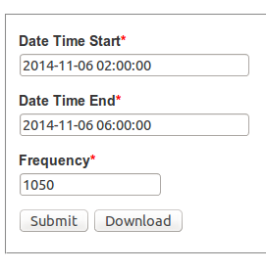

Selecting a start time and end time will bring up a calender which allows you to choose your times.

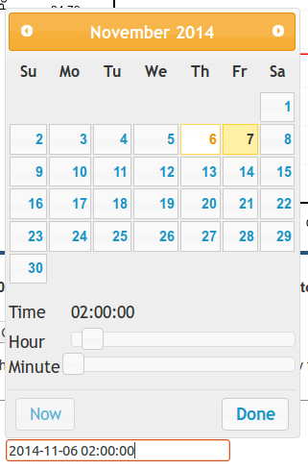

Simply enter your date and time and press Done.

To select a frequency you simply type in your frequency in the frequency form. The visualisation will display the channel which is closest to that frequency.
You the click the “submit” button to update the visualisation to show data in the selected range.

To download the data as a CSV file you can instead click the “Download” button.
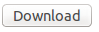

Band Selection
The RTA3 can collect data on 4 separate bands. Only one band can be viewed at a time.
The bands are
Band 1 : 100MHz – 750 MHz
Band 2 : 650MHz – 1050 MHz
Band 3 : 900 MHz – 1670 MHz
Band 4 : 1950 MHz – 2450 MHz
In order to change the band we are collecting on we need to ssh onto the rfimonitor.
There is a guest profile on the server which can be used to ssh using the details :
Username : guest
Password : guest
You can ssh onto the machine using the command below
ssh guest@rfimonitor.kat.ac.za or using the ip address
ssh guest@192.168.216.10
After sshing onto the machine you must open a python shell which can be done by using the command
python
You must then import the RTA3 software using
import rfDB2
and you can change the band by running the command
rfDB2.rfi_monitor.change_mode(1) #To change to band1
rfDB2.rfi_monitor.change_mode(2) #To change to band2
rfDB2.rfi_monitor.change_mode(3) #To change to band3
rfDB2.rfi_monitor.change_mode(4) #To change to band4
Allow about 10 seconds for the RTA to be reprogrammed. If you are viewing the Current Spectrum view it will automatically update to view the new band.

Time Domain Measurements
The RTA3 can also perform time domain measurements, however this currently cannot be performed using the web interface. In order to use the time domain You must ssh into the rfimonitor with an X server. You can do this using one of the commands below.
ssh -X guest@rfimonitor.kat.ac.za or using the ip address
ssh -X guest@192.168.216.10
The password for the guest account is guest.
Once you ssh in you must first stop the current running monitor. You can do this by running the command :
sudo stop monitor
The system is now ready for you to take over manual control of the RTA3.
First create a directory which will store your measurements. When you run the time domain capture the data collected will be saved in the directory you run the script from, it is important to make sure you run the script from the correct directory.
Each file time you run the script a file will be saved which has the unix timestamp that the script was run. It will have the name something like 1411******.time.h5 .
Once you have got your directories in order you can run the r2_time.py script using the command below
r2_time.py -l [trigger_level] -t [capture_length] config_file=[config_file] rf_atten=[atten]
an example run with a trigger level of 1 mV capture length of 800 ms using band 1 and an attenuation of 60 would look like this :
r2_time -l 1 -t 800 config_file=/etc/ratty2/default_band1 rf_atten=-60
The command line should tell you that you are programming the RTA 3, eventually it will finish programming and begin to capture data. Each capture should be accompanied by a message similar to that below being printed to the terminal.
At all times you must ensure that the ADC level is not above -20 dBm. If it is above this please close the script and run again with more attenuation.
Be aware of messages such as the one below. This indicates your attenuation is too low and your ADC is clipping and your data is unreliable.
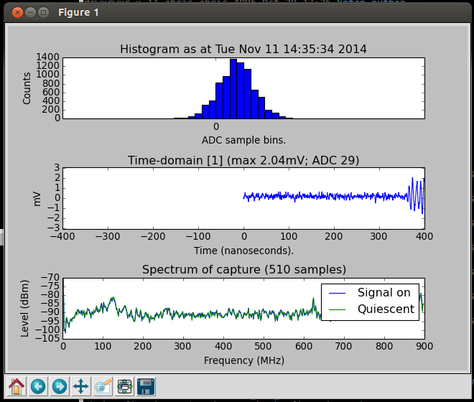
The script will also open a graphical interfacce like the one displayed below. This displays the data you capture as it is captured.
To stop running the script simply press the x button on the GUI and press [ctrl + c] on the terminal.
If this does not work, go to the terminal and press [ctrl + z]. This will background your process, you should see something printed to the terminal like the image below
Next you must run :
kill -9 %n
With n being the number in square brackets that is printed to the terminal after pressing [ctrl + z]
After you have collected your data and stopped all of your RTA capture scripts you must restart the monitor, you can do this by running the command :
sudo start monitor

