CST-415: AI in Games and Simulations
Lecture & Lab

Pandemic Pathfinder:
The Outbreak Oracle

Project 4
Student: Joshua Peek
Date: February 19, 2026

Section 1 — Game Description
Pandemic Pathfinder: The Outbreak Oracle is a browser-based strategic simulation game in which the player acts as a city epidemiologist managing a viral outbreak across four city districts. Each district's population flows through five health states — Susceptible, Infectious, Hospitalized, Recovered, and Deceased (SIHRD) — governed by a Markov Chain transition matrix. Every in-game week, the population redistributes via the matrix equation v' = v × T. The player begins Week 1 with one seeded district and 5 policy tokens, earning additional tokens each week based on both a flat base reward and a performance bonus tied to how closely their actions matched the Oracle's computed optimal move. Over 20 weeks the player deploys four intervention types — Vaccination, Quarantine, Hospital Support, and Awareness — each of which modifies specific cells of the transition matrix. Random events can abruptly perturb the matrix, and an AI hint system continuously calculates the best possible move using 5-week lookahead simulation, scores the player's actual decisions against it, and awards bonus tokens accordingly. The game ends in Containment (win), Overwhelmed (loss), or Endemic Stalemate, and concludes with a full Oracle Score report grading the player's decision quality across all 20 weeks.

Section 2 — Relevance of Course Concepts
Pandemic Pathfinder integrates five core AI and probabilistic concepts from CST-415 into its gameplay, each mapped to a concrete mechanic.

Finite-State Markov Chains
The SIHRD model defines five health states as nodes in a finite Markov Chain. Weekly population movement depends only on the current state — the memoryless Markov property — making it directly visible and consequential. Each of the four districts runs its own independent chain.

Transition Matrices as Live Gameplay Mechanics
Every policy the player deploys modifies specific cells of the target district's 5×5 transition matrix. Hospital Support cuts H→D by 0.20 and boosts H→R by 0.20; Vaccination reduces S→I by 0.03. Players see the numerical matrix on screen at all times, and policy previews highlight exactly which cells will change — making matrix interpretation a direct game skill.

Absorbing States & Steady-State Distributions
Deceased is a strict absorbing state (P(D→D)=1.00). The lose condition (city Deceased > 18%) makes the absorbing nature viscerally consequential. The forecast panel displays the steady-state distribution π computed via power iteration each week, giving the player a long-run projection under current probabilities.

Monte Carlo Simulation
A Monte Carlo probability roll each week (10% base chance) determines whether a random event fires. If triggered, a weighted categorical draw selects from five events and applies a temporary ΔT perturbation. This demonstrates how stochastic sampling generates emergent, unpredictable system behavior within a deterministic Markov framework.

AI Lookahead & Decision Scoring (Oracle Hint System)
The Oracle Hint system is a single-ply AI agent that evaluates all 16 possible (policy × district) combinations each week using a 5-week forward simulation. It selects the action that minimizes a weighted danger score (Infectious ×2 + Hospitalized ×2 + Deceased ×3). The player's actual deployments are then scored against this optimal choice, and bonus tokens are awarded proportional to decision quality — directly connecting AI planning concepts to player progression.

Section 3 — Simulation & Search Method
The simulation uses three complementary computational methods, each serving a distinct purpose.

1. Discrete-Time Matrix Propagation (Core Engine)
Each district stores a population vector v (1×5) and a base transition matrix T (5×5). Each week:

v'[j] = SUM_i( v[i] * T[i][j] ) for j in {S, I, H, R, D}

T is row-stochastic: each row sums to 1.0
After any policy/event modification, rows are re-normalized via clampT()
Absorbing row D = [0, 0, 0, 0, 1] is never modified

2. Power Iteration (Steady-State Forecast)
The forecast panel computes the steady-state vector π for the selected district's current effective T using iterative matrix multiplication until row-change < 0.00001, shown as a bar chart projecting long-run disease burden.

3. Oracle Lookahead + Monte Carlo Events
- Oracle: Evaluates all 16 (policy × district) pairs plus do-nothing by calling simulateForward(5 weeks) for each. Returns the candidate with the lowest weighted danger score. O(16 × 5) = 80 Markov steps per week.
- Events: Weekly uniform roll against 12% threshold. If triggered, a weighted categorical draw (Variant 25%, Hospital Strike 15%, Immunity Wane 15%, Supply Boost 30%, Misinformation 15%) selects the event and applies ΔT for 2–3 weeks.

Section 4 — Tuned Transition Matrix
The base SIHRD transition matrix was derived through simulation (1,000 automated runs) to ensure the game is both genuinely threatening without policy and clearly beatable with optimal play.

From \ To | S | I | H | R | D | Policy Notes
S (Susceptible) | 0.94 | 0.06 | 0.00 | 0.00 | 0.00 | Vaccination/Quarantine reduce S→I
I (Infectious) | 0.00 | 0.40 | 0.20 | 0.37 | 0.03 | Hospital Support cuts I→H and boosts I→R
H (Hospitalized) | 0.00 | 0.00 | 0.20 | 0.40 | 0.40 | Hospital Support: H→D −20%, H→R +20% ★ Critical
R (Recovered) | 0.03 | 0.00 | 0.00 | 0.97 | 0.00 | Awareness slows R→S waning
D (Deceased) | 0.00 | 0.00 | 0.00 | 0.00 | 1.00 | Absorbing state — lose if >18% city-wide

Key balance point: H→D = 0.40 is the critical danger path. Without Hospital Support, 40% of Hospitalized patients die each week. City-wide Deceased reaches ~15% by Week 20 with no intervention (threatening the 18% loss threshold). With Vaccination + Hospital Support on all districts, Deceased stays below 1% and Infectious drops below 2% (win condition) by Week 5–10.

Section 5 — Implementation Outline
The entire project is a single self-contained HTML file (~49 KB). No server, no install, no external dependencies beyond a CDN script for matrix operations.

- Markov Engine: 5×5 SIHRD transition matrix, weekly v' = v × T multiplication, row-normalization via clampT(), absorbing-state enforcement for row D.
- Four Districts: Each district holds its own state vector v, base matrix T, active policy list, and active event list. All four are stepped in parallel each week.
- Win / Loss Logic: Containment if city-wide I < 2% (after Week 4). Overwhelmed if city-wide D > 18%. Endemic Stalemate if neither triggered by Week 20.
- Policy System: Four policies each defined as a ΔT function. Deploy deducts a token, pushes an {id, weeksLeft} entry to activePolicies. effectiveT() stacks all active deltas before each step.
- Random Events: Monte Carlo roll + weighted categorical draw. Event ΔT pushed to activeEvents for all four districts; ages out after duration weeks.
- Oracle Hint Engine: calcBestMove() evaluates 16 candidates via simulateForward(5) using a danger score (I×2 + H×2 + D×3). Runs after every week advance and on game init.
- Scoring Engine: scoreWeek() compares G.deploymentsThisWeek against G.hint. Outputs playerScore (0–100), grade (Perfect/Great/Good/Suboptimal), and tokensAwarded (0–3 bonus).
- Token Economy: Base +1 token per week + 0–3 bonus tokens from scoring. Perfect play earns +4/week, suboptimal play earns +1/week — rewards compound over time.
- UI: City map (4 tiles), live 5×5 matrix heatmap, population bars, forecast chart, Oracle Hint card with hide/show toggle, active policies list, week log.
- End Screen: Outcome badge, stats grid including Oracle Score (%), letter grade, Canvas trajectory chart, perfect/great week counts.

Section 6 — Obstacles & Plan B
The primary risks and mitigations for this solo project are as follows. The Oracle lookahead (80 Markov steps/week) is lightweight enough to run synchronously in under 1ms per week; if it causes UI stutter on low-end hardware, it can be deferred with setTimeout(0). The transition matrix was tuned through automated simulation to balance challenge and winnability; if further play-testing reveals an imbalance, all parameters are constants at the top of the script and can be adjusted in minutes. If the 5×5 matrix table renders poorly at narrow screen widths, it degrades to a 4-cell highlight summary showing only the four most policy-relevant cells. If random events stack adversely and make a particular run unwinnable, the event fire rate (currently 10%) can be reduced to 7% without affecting any Markov mechanics. All game logic is modular and testable in the browser console, allowing rapid iteration on any component independently.

Section 7 — Alignment with Course Objectives

Course Objective | How This Project Meets It
Define and model a finite Markov Chain | The SIHRD model defines 5 health states as an explicit finite Markov Chain. Each district maintains its own 5×5 row-stochastic transition matrix displayed live to the player.
Construct and interpret transition matrices | Players view the live T matrix each week. Policy buttons preview exact cell-level changes before deployment, making matrix interpretation an active game skill.
Identify absorbing and transient states | Deceased is the strict absorbing state (row = [0,0,0,0,1]). The lose condition is triggered when D absorbs >18% of population, making the absorbing nature mechanically consequential.
Apply the Markov property | Each week's v' = v × T depends only on the current state vector, never on history. The engine enforces this and the matrix display makes it explicit.
Compute steady-state distributions | Power iteration on the current effective T produces the steady-state vector π, displayed as a forecast bar chart each week as a strategic planning tool.
Simulate stochastic processes using Monte Carlo | Random events use a weekly Monte Carlo roll + weighted categorical draw to produce stochastic outbreak trajectories. Each session is unique even with identical play.
Apply AI planning / lookahead search | The Oracle Hint uses a 5-week lookahead over all 16 policy-district candidates, scored by a weighted danger heuristic — a direct application of single-ply expectimax-style AI search.
Visualize and communicate probabilistic systems | City map, matrix heatmap, population bars, forecast chart, Oracle danger score comparison, and end-screen trajectory graph form a multi-layer real-time visualization.

Section 8 — Screen Layout & UI Elements

State Diagram
Generated with Mermaid.js. Render at mermaid.live, export PNG, paste below:

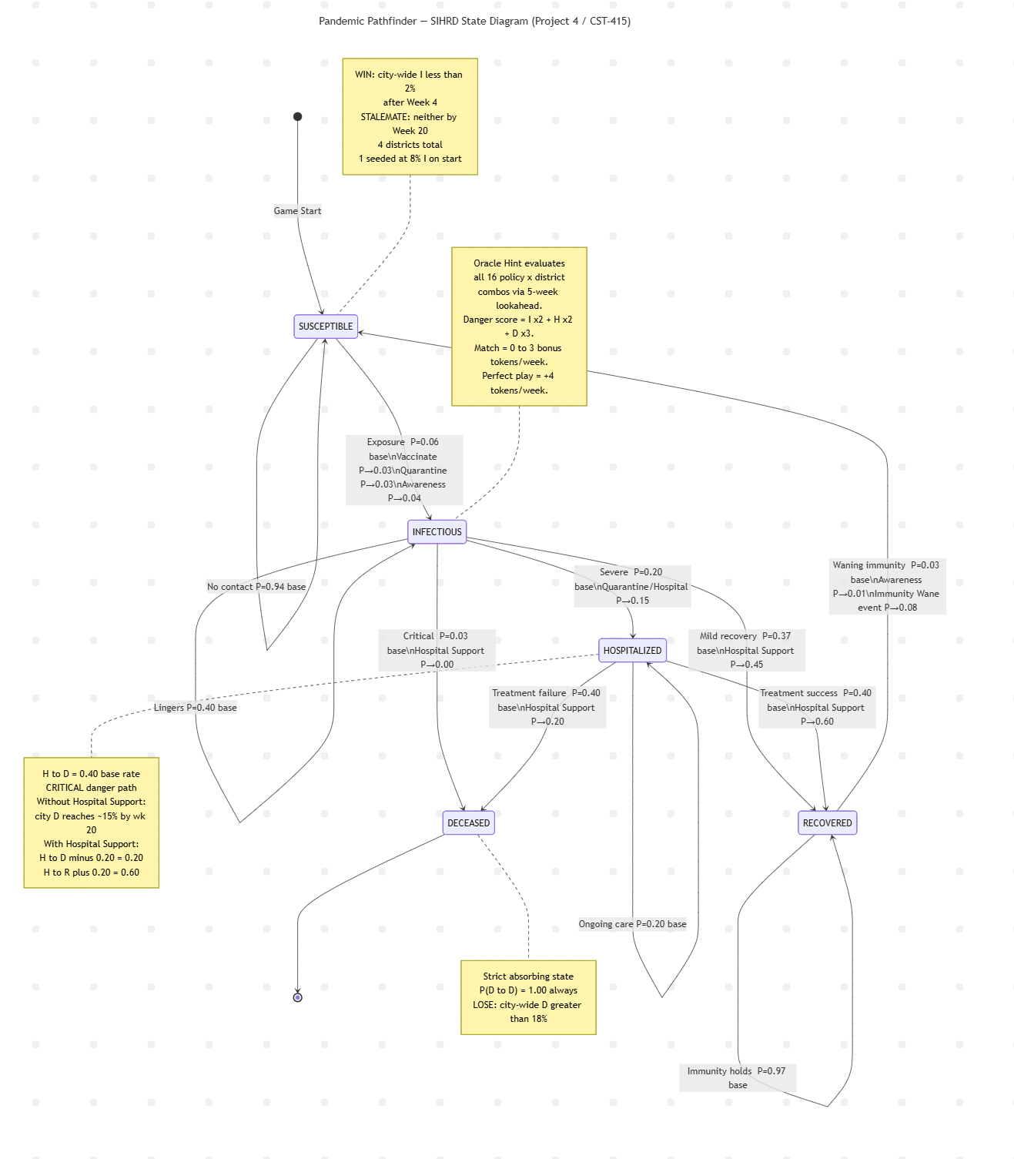

Mock Screen Layout

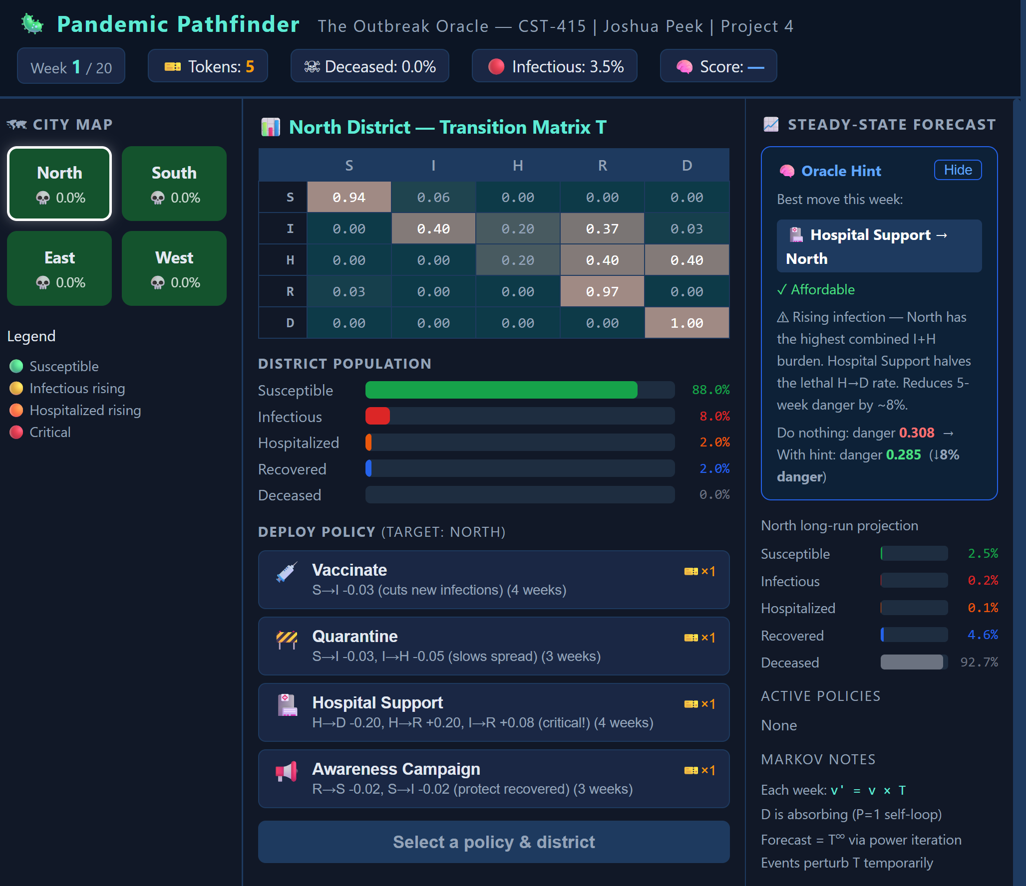

UI Element Descriptions
- Top Bar: Week counter, token total, city Deceased %, and Oracle Score % — all updated every week. Score chip turns green above 80%, yellow above 60%, red below.
- City Map (left): Four district tiles color-coded by dominant state. Click to select target district for the dashboard and policy deployment.
- Transition Matrix (center): Live 5×5 color-coded HTML table. H row highlighted — H→D cell shown in deep red to signal the critical danger path. Policy hover previews highlight affected cells in gold.
- Policy Buttons (center): Four policies with token cost. PREVIEW shows T diff; DEPLOY applies the change. Buttons disabled if policy already active or no tokens.
- Oracle Hint Panel (right top): Shows best move (policy + district), affordability badge, plain-English reasoning, numerical danger comparison (do-nothing vs with hint), and last week's grade with bonus tokens awarded. Has Hide/Show toggle.
- Steady-State Forecast (right): Horizontal bar chart of π for the selected district, updated each week via power iteration.
- Bottom Bar: Week log showing token earnings breakdown (base + bonus) and city-wide I%/D%. Advance Week button.
- End Screen: Outcome badge, stats grid with Oracle Score % and letter grade (S/A/B/C/D/F), Canvas trajectory chart of I and D over all weeks, perfect/great week counts.
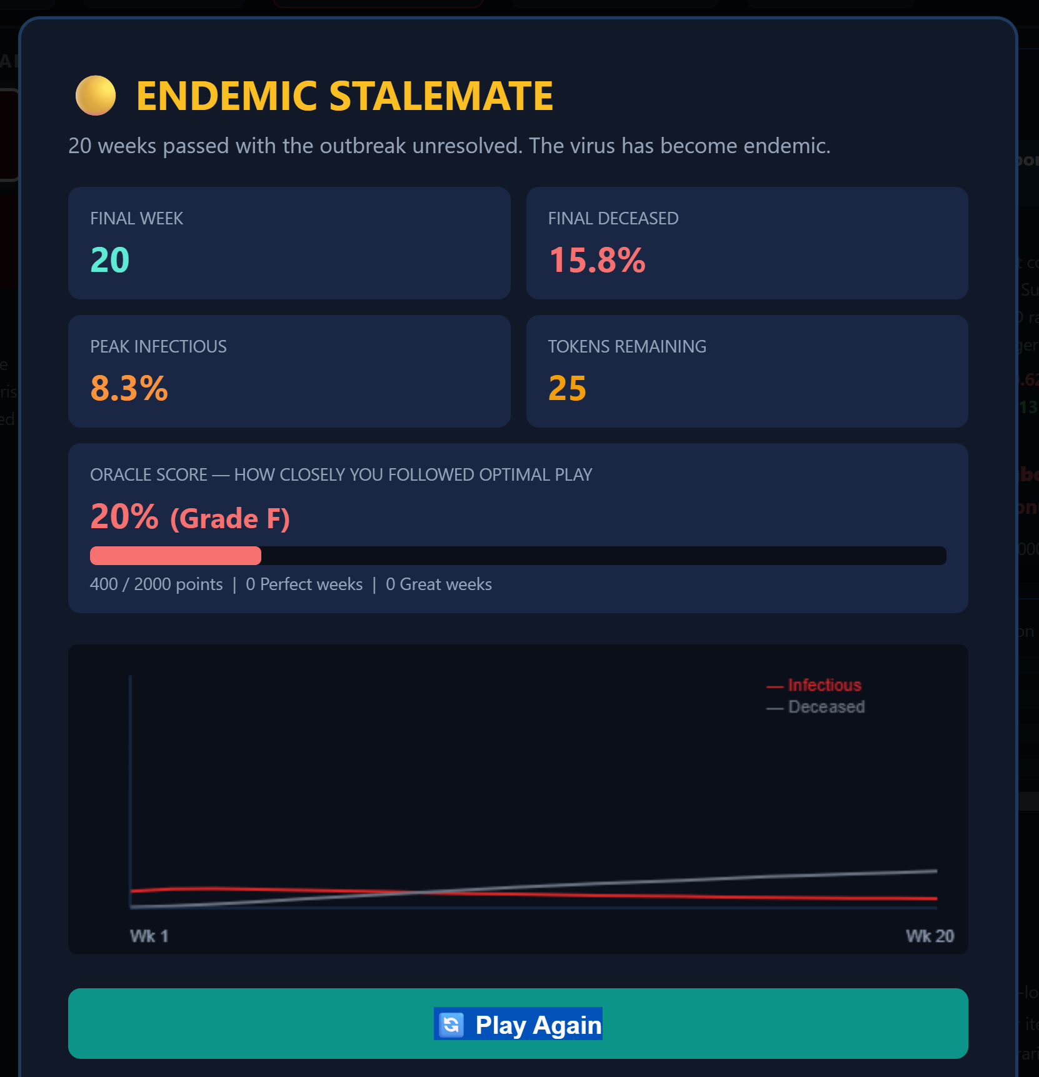

Section 9 — Platform & Software Tools
- Platform: Web browser (Chrome / Firefox). Open the .html file directly — no server, no install.
- Language: Vanilla JavaScript (ES6). No build tools, no npm, no framework.
- Math: Inline vanilla JS for all matrix operations (multiply, power iteration, row normalization). No CDN math library required.
- Rendering: HTML5 + CSS3 for all panels, tables, and bars. HTML5 Canvas API for the end-screen trajectory chart.
- State Diagram: Mermaid.js — rendered at mermaid.live, exported as PNG, embedded here.
- Version Control: GitHub personal repository.
- IDE: Visual Studio Code with Live Server extension.

