
- Take a screenshot of the results at this point.
- Paste the image into a Microsoft Word document.
- Put a caption below the image explaining what is being demonstrated.
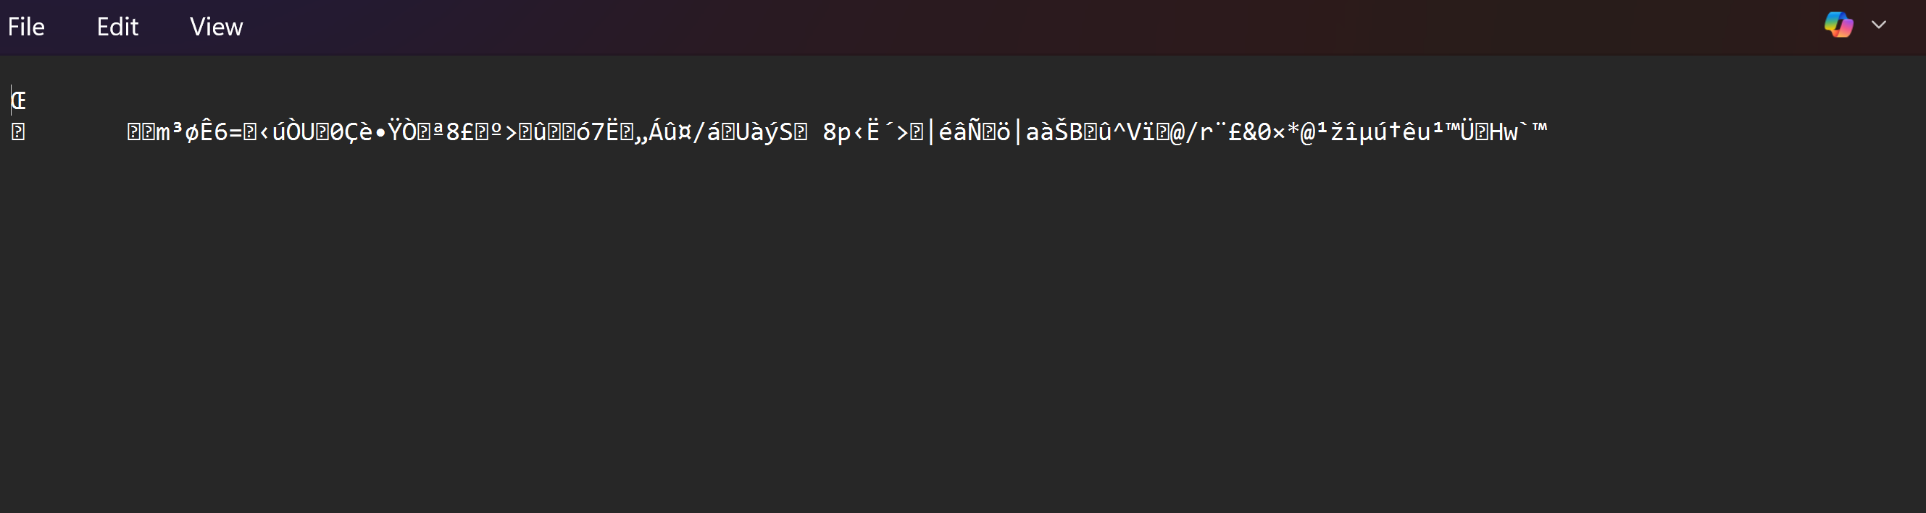


- Take a screenshot of the directory results at this point.
- Paste the image into a Microsoft Word document.
- Put a caption below the image explaining what is being demonstrated.
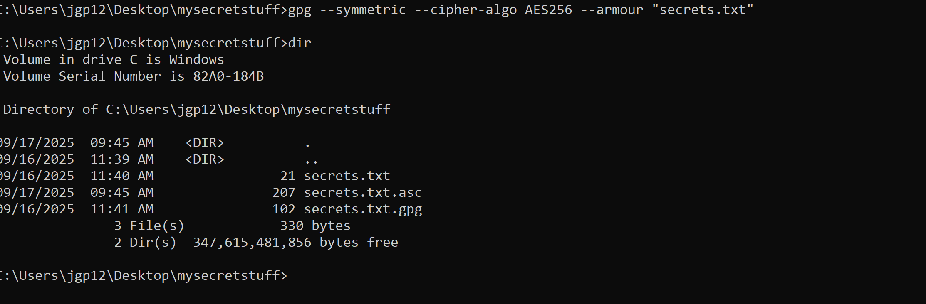
Figure 32 Encrypted message in ASCII characters with TextEdit.

- Take a screenshot of the ascii version of the encrypted document.
- Paste the image into a Microsoft Word document.
- Put a caption below the image explaining what is being demonstrated.
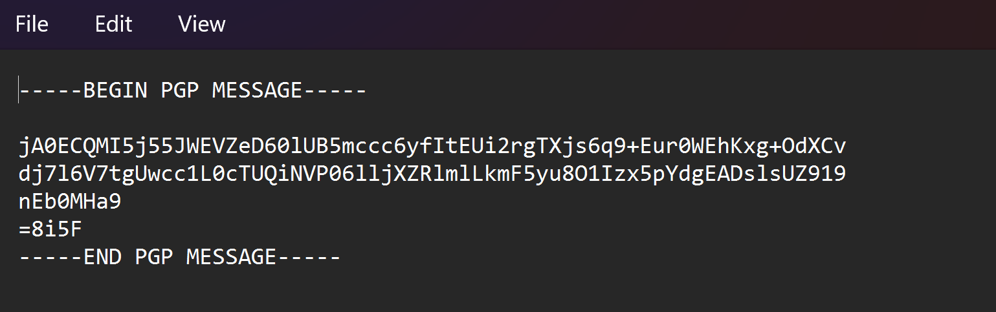
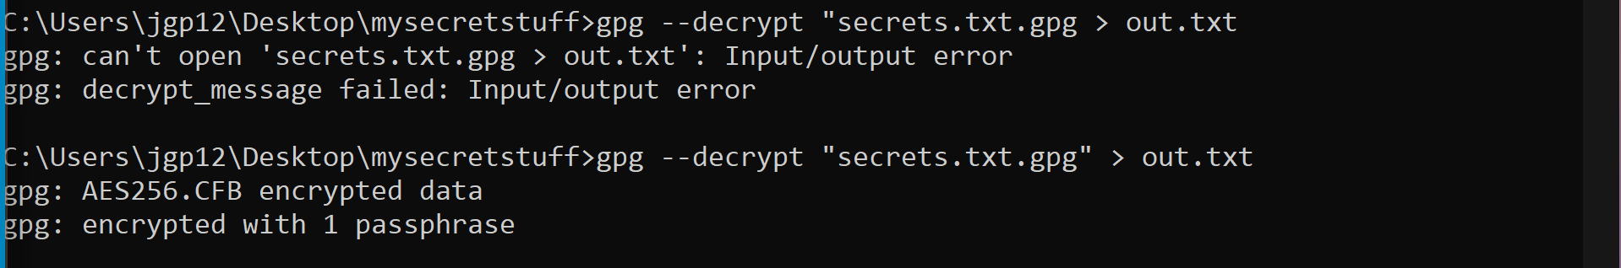

with a small value for p and q (50 bits).

Figure 50 Encrypting a string with a medium-length value for p and q (1000 bits).


- Take a screenshot of the application running one of the encryption operations at this point.
- Paste the image into a Microsoft Word document.
- Put a caption below the image explaining what is being demonstrated.
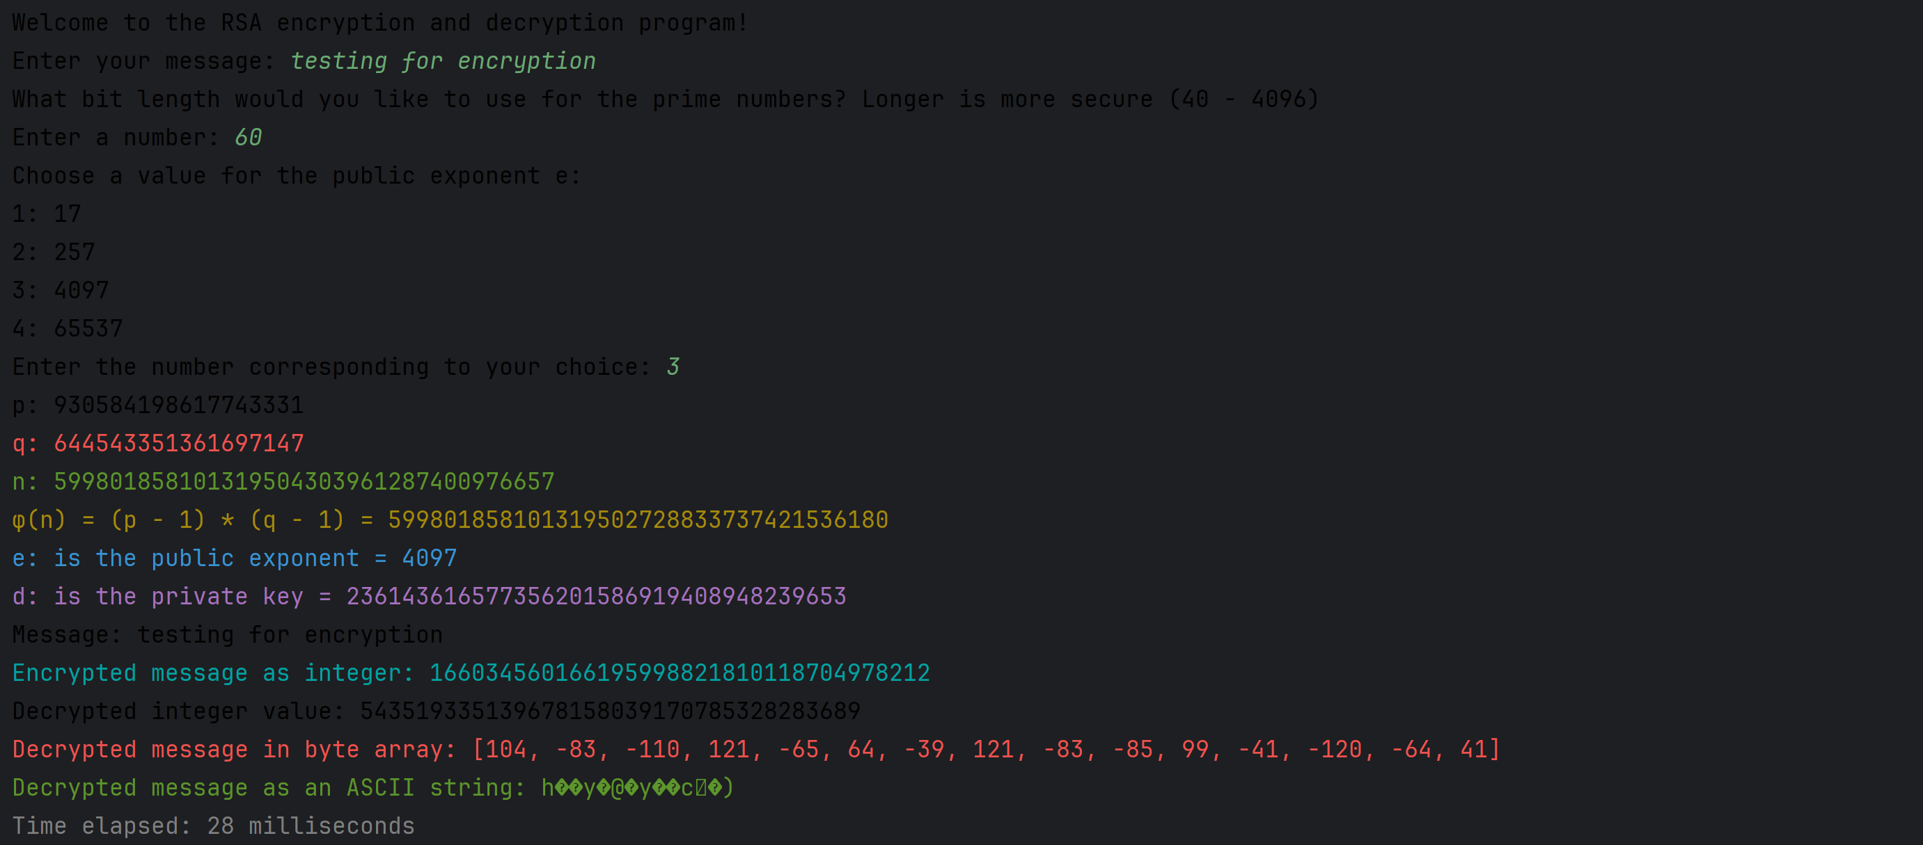
Running the application, small numbers
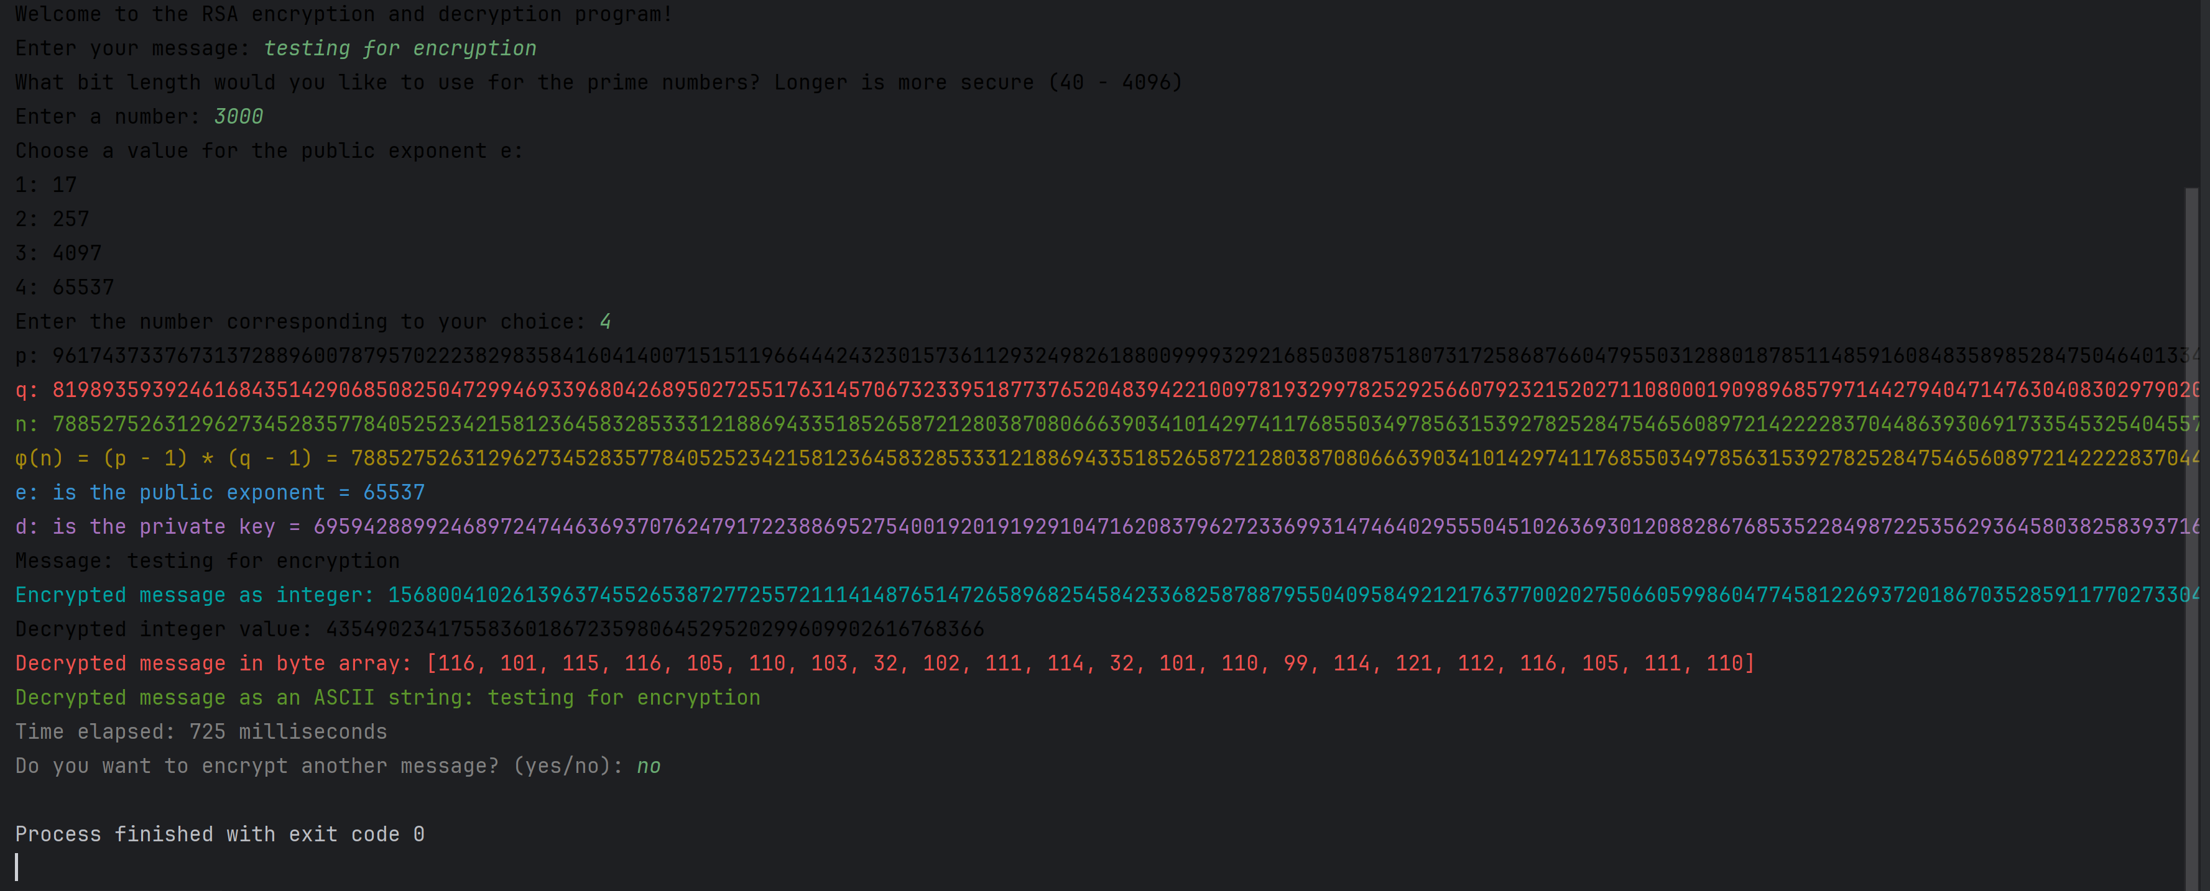Running the application with large numbers


- Take a screenshot of the information about your key.
- Paste the image into a Microsoft Word document.
- Put a caption below the image explaining what is being demonstrated.
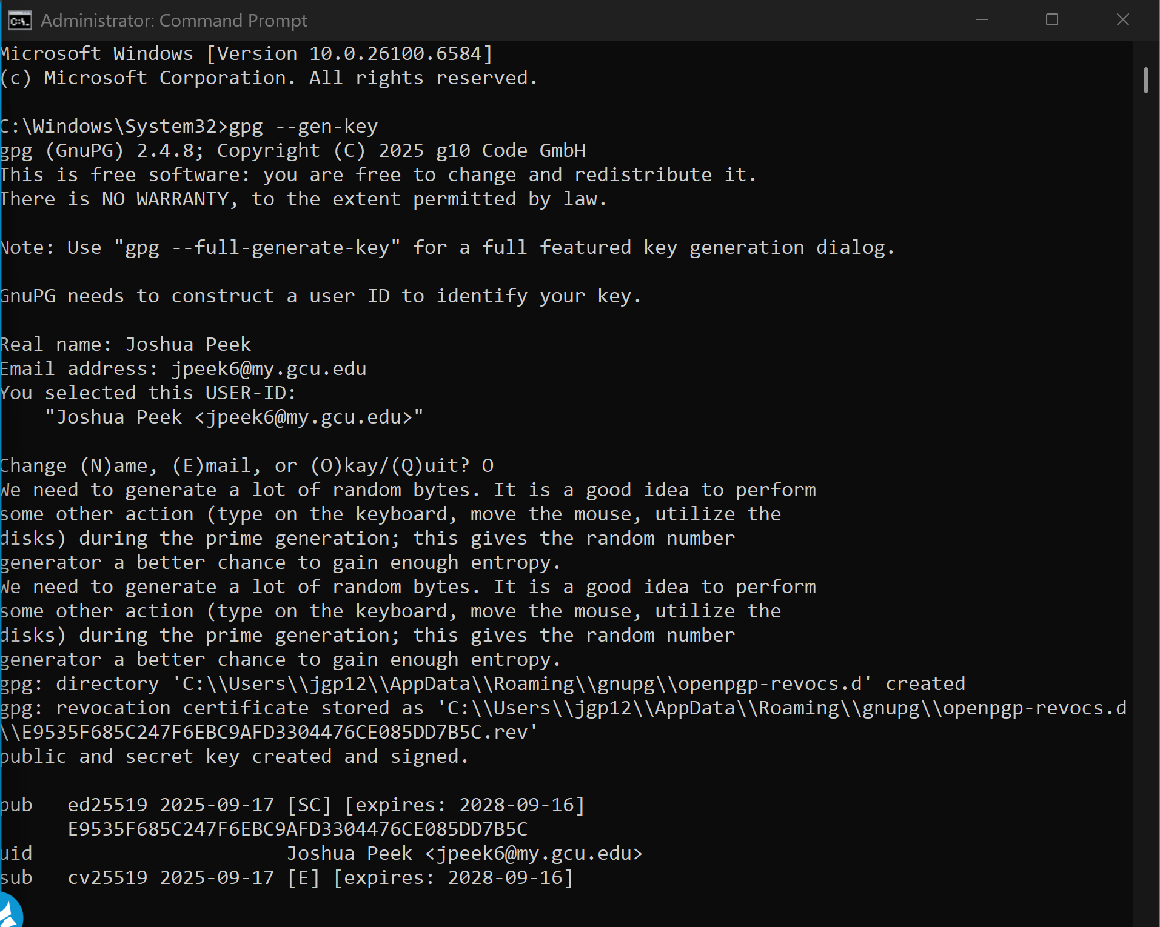

- Take a screenshot of the list of public keys you have at this point.
- Paste the image into a Microsoft Word document.
- Put a caption below the image explaining what is being demonstrated.
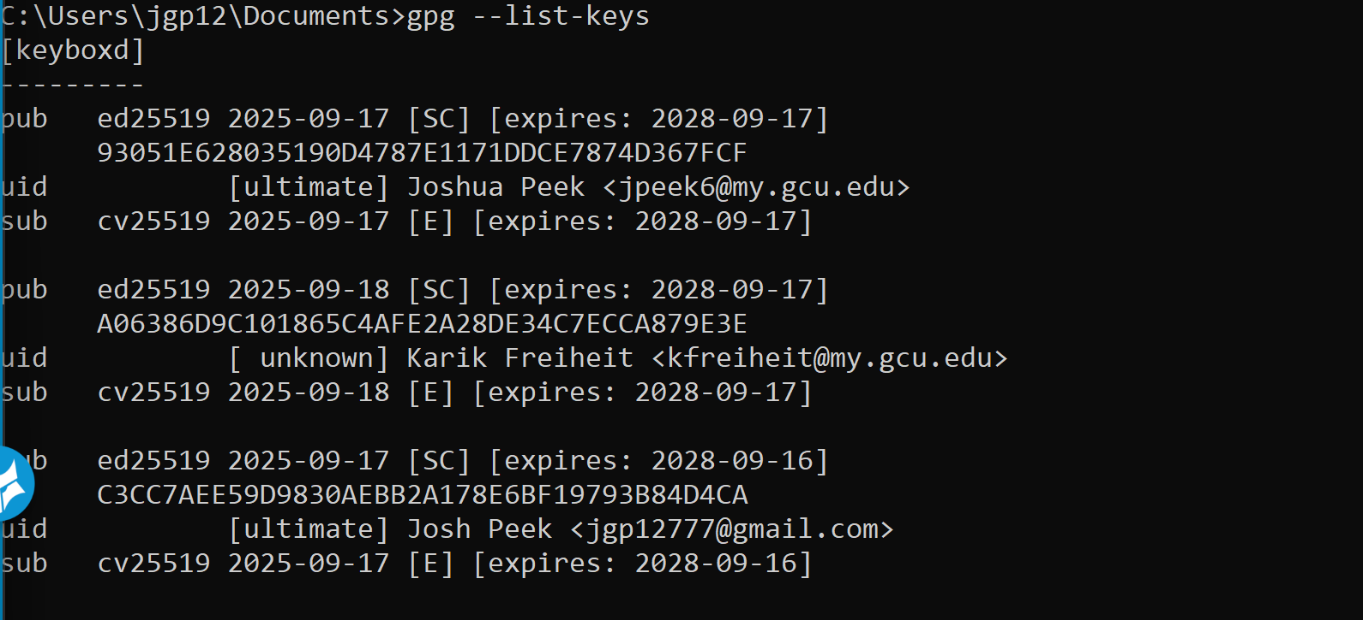
email one account to another
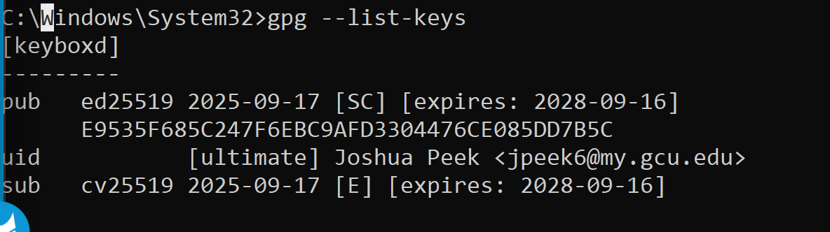
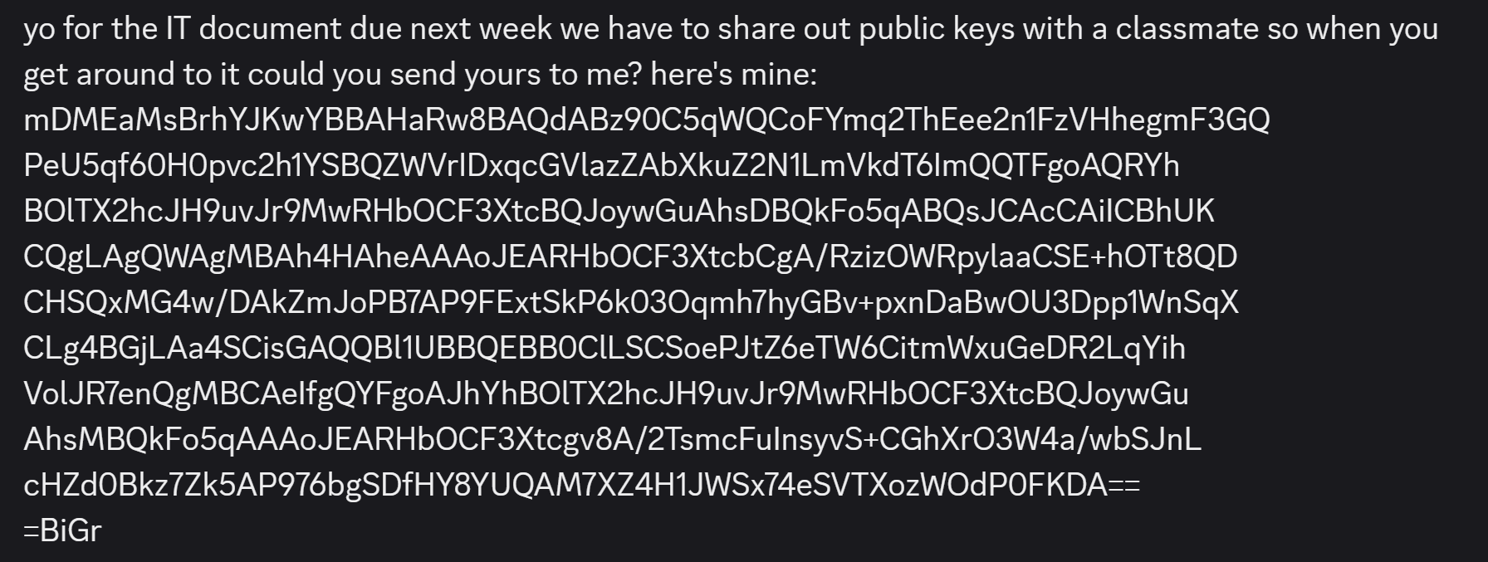
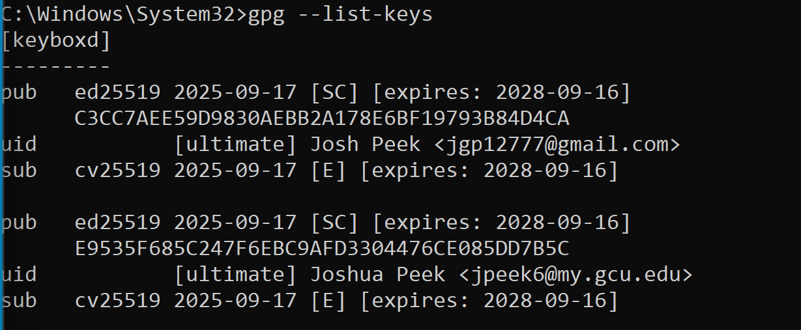
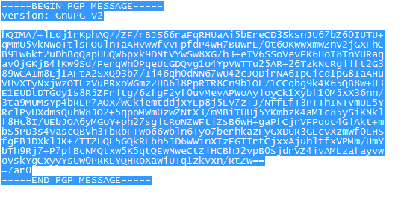
Figure 51 ASCII encoded PGP message sent either as an attached file or as the body of an email.

- Take a screenshot of the encrypted version of your message.
- Paste the image into a Microsoft Word document.
- Put a caption below the image explaining what is being demonstrated.


- Take a screenshot of the unencrypted message from your friend.
- Paste the image into a Microsoft Word document.
- Put a caption below the image explaining what is being demonstrated.

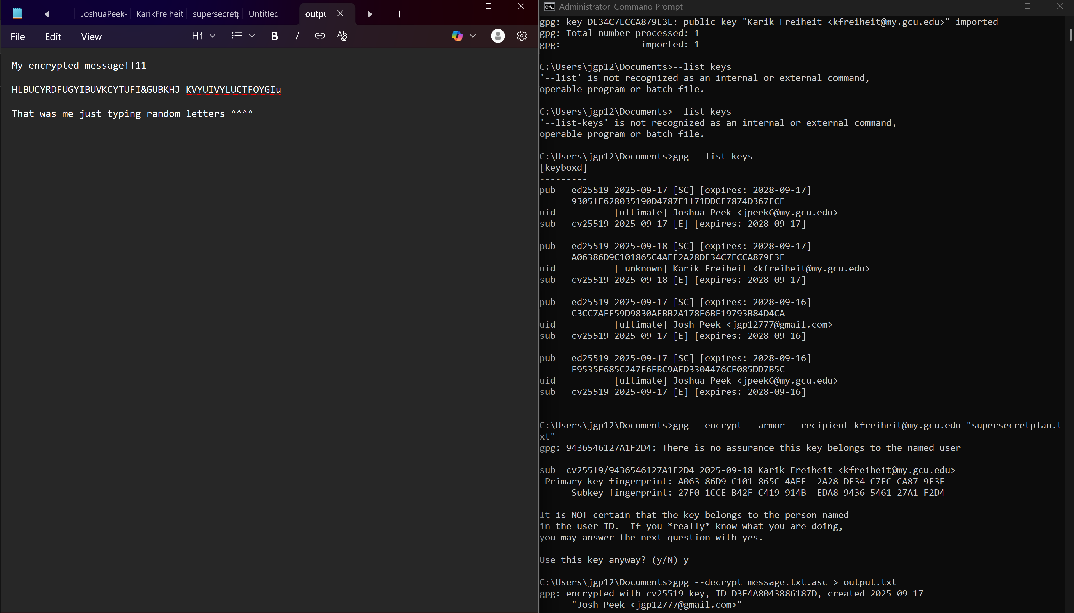

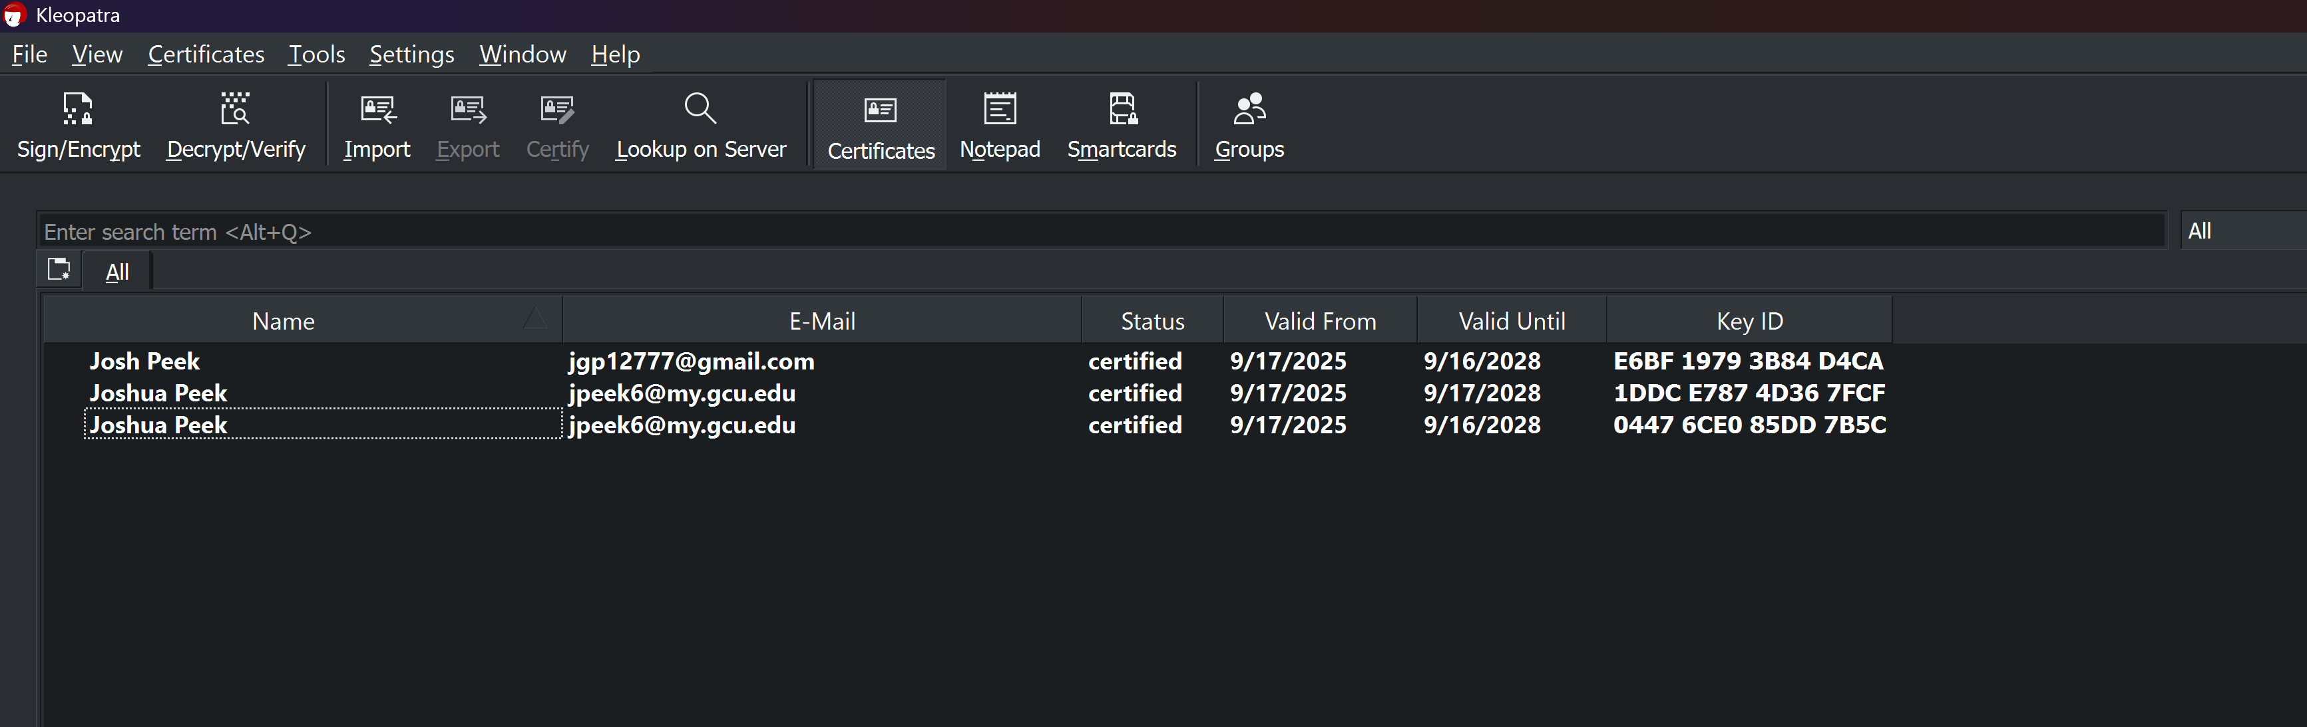

- 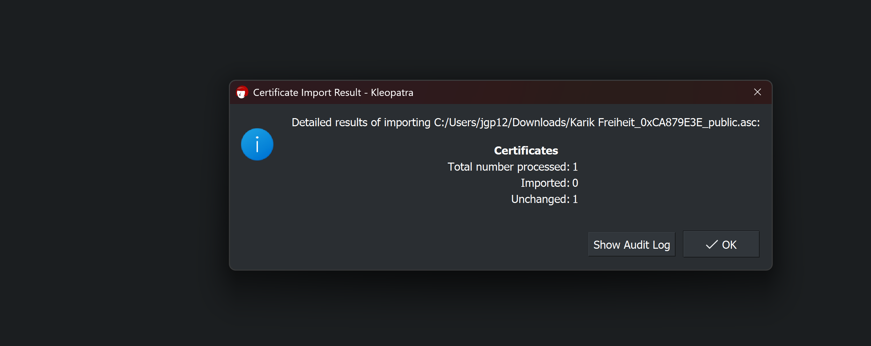

Figure 60 A new key has been imported into the system from professorsluiter@gmail.com.


- Take a screenshot of the application showing a new certificate has been saved..
- Paste the image into a Microsoft Word document.
- Put a caption below the image explaining what is being demonstrated.

- The public key has been imported, as seen in Figure 61.

Figure 61 Assuming I checked the fingerprint and the hash values match, I can trust messages sent from this user.
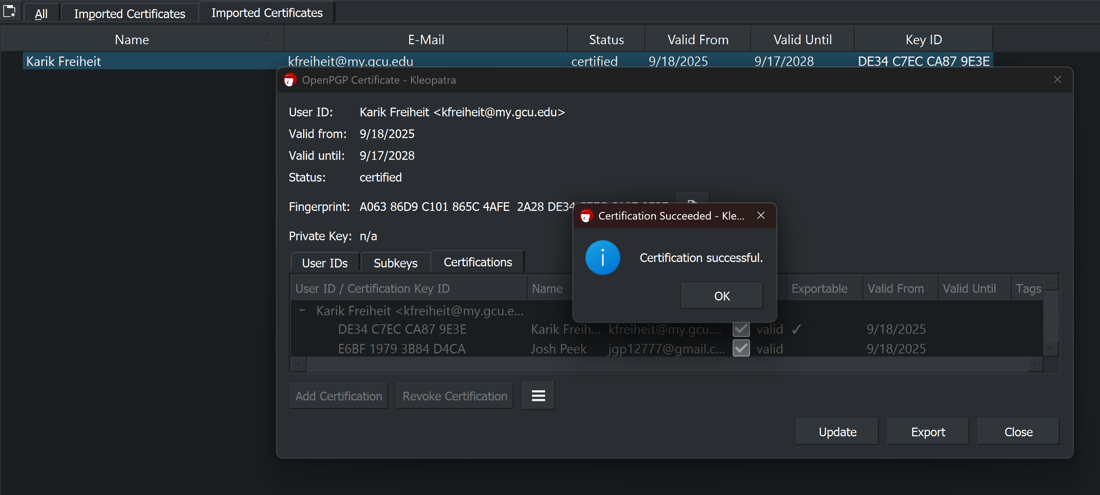

  - Look in the output folder for the decrypted version of the message. You should now be able to see the secret message sent to you by your friend.
  - 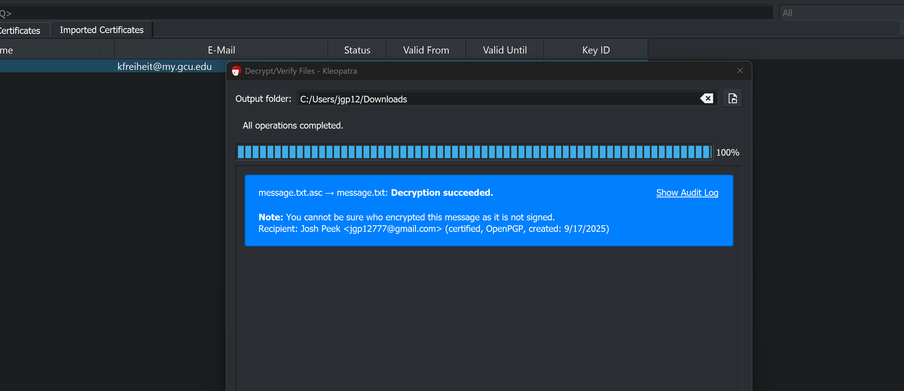

============ End Windows Section =====================

Part 5 – Summarize
Write a comprehensive summary of the key concepts demonstrated in this lesson, ensuring each of the following topics is covered in depth. Provide detailed explanations, examples, and citations from both the lesson material and external research.
- Compare and Contrast Hashing with Encryption:
  - Discuss not only the fundamental differences between hashing and encryption, but also how each is used in modern technology (e.g., data integrity, password protection, etc.).
    - Hashing is irreversible and is usually used for passwords, like when you first enter the password it is stored by the database as hashed and every time you enter it that result is hashed and the result is compared to the hashed first password.
    - Encryption is reversible and usually used for things like messaging and emails, for readable data in transit.
  - Provide examples of real-world scenarios where encryption is necessary, and others where hashing is the best solution.
    - Encryption is good for data that is in transit, such as messages, emails, or pipelines.
    - Hashing is best for storing passwords so that they are not in a recoverable format.
- Compare and Contrast Symmetric and Asymmetric Encryption:
  - Explain the advantages and disadvantages of each in different use cases (e.g., speed vs. security, ease of key distribution, etc.). Symmetric = one shared key (e.g., AES); Asymmetric = keypair (public/private; e.g., RSA/ECC/Kyber).
Symmetric is very fast for bulk data; Asymmetric is slower/heavier (used mainly to set up keys / signatures).
Symmetric is hard at scale (securely sharing the secret is the problem); Asymmetric makes distribution easy (share public key openly), but needs authenticity (PKI, key transparency).
Symmetric gives confidentiality+integrity; Asymmetric adds signatures, non-repudiation, easier rotation & per-recipient encryption.
  - Include a comparison how these two approaches are best applied in the real world. Consider situations where encryption is required but one approach is preferred over the other. For example encryption could be used in all of these situations: tape backups, hard drives, web traffic, chat applications, telephone conversations, USB storage, email.
Tape backups / full-disk / USB storage: Symmetric (AES-XTS/AES-GCM) for performance and offline use.
Hard drives (FDE): Symmetric with hardware assist (AES-XTS); keys unwrapped via asymmetric/smartcard/TPM if needed.
Web traffic (HTTPS/TLS): Asymmetric for auth+key exchange → switch to symmetric for payloads.
Chat apps: Asymmetric identities + ephemeral exchanges; messages encrypted symmetrically per-message/session (Signal-style).
Telephone/VoIP: Signaling uses TLS/DTLS (asymmetric) to agree SRTP keys; media protected symmetrically.
Email: Hybrid—generate a random symmetric key for the message; encrypt that key with recipient’s public key (PGP/S/MIME).
Bulk backups to cloud: Symmetric for data at rest; optionally wrap keys with asymmetric keys of org/HSM.
- Practical Application in Messaging Apps:
  - Based on the comparison of various messaging tools, evaluate your current phone applications in terms of encryption strength and security.
    - E2EE by default, modern “Double Ratchet” with forward secrecy & post-compromise security; excellent. Turn on registration lock PIN, safety number checks, disappearing messages for sensitive chats
    - E2EE by default using the Signal Protocol; good. Lock down cloud backups (prefer encrypted backup), verify security codes, enable 2-step verification
  - Explain whether you would change or configure these apps differently and provide reasons based on what you have learned about encryption.
    - Would I change? Yes, I will use Signal or iMessage (PQ3) for sensitive convos; on WhatsApp/iMessage, ensure encrypted backups; avoid default Telegram for private matters; don’t rely on SMS/RCS for anything sensitive.
  - Support your plan with examples from the apps discussed.
- Research on Quantum Computing and Its Impact on Encryption:
  - Conduct research on the future of encryption in the quantum age. What encryption methods are considered quantum-resistant?
    - NIST finalized FIPS 203 (ML-KEM/Kyber) for key establishment, FIPS 204 (ML-DSA/Dilithium) and FIPS 205 (SLH-DSA/SPHINCS+) for signatures; additional KEM (HQC) selected in 2025 for standardization. Organizations (esp. gov/NSS) are migrating per CNSA 2.0 timelines.
https://www.nist.gov/news-events/news/2024/08/nist-releases-first-3-finalized-post-quantum-encryption-standards
  - Based on current publications, how soon do experts believe quantum computers will become powerful enough to break current encryption standards?
Academic estimates have moved from ~20M noisy qubits (hours) to <1M noisy qubits (≤1 week) under optimistic assumptions, still far beyond 2025 hardware, but a serious planning signal.

https://www.theguardian.com/technology/2025/mar/20/uk-cybersecurity-agency-quantum-hackers
  - Cite at least two reputable sources for your research.

