Activity 2 Guide: Data Encrytion Tools

Windows Instructions
- Install the application with default settings, as shown in Figures 15 and 16.
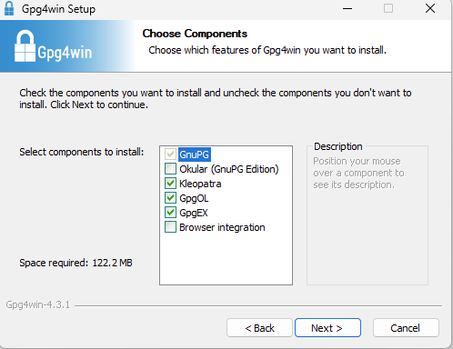
Figure 15 Installation options include the core application, Keopatra (Key manager tool), GpgOL (For Microsoft Outlook email encryption), GpgEX (Shell Extension)

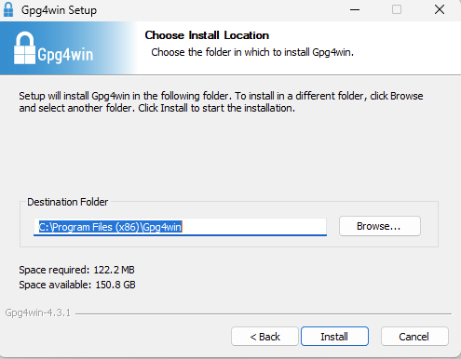
Figure 16 Default install folder selected.

Symmetric Encryption with GPG
- Create a folder to store documents for this assignment, as shown in Figure 17.
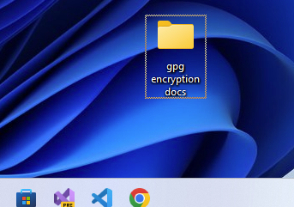
Figure 17 A new folder designated to hold multiple documents that will be created in this lesson.
- For Windows users, turn off the "Hide extensions for known file types" to see .txt extensions on a text file, as shown in Figure 18.
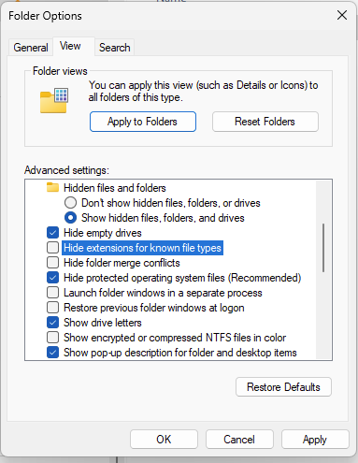
Figure 18 Folder options in File Explorer allow you to show or hide the .txt extension for text files.
- Create a new text document with Notepad or other text editor and add some confidential text, as shown in Figure 19. Visual Studio Code is a good alternative to Notepad.
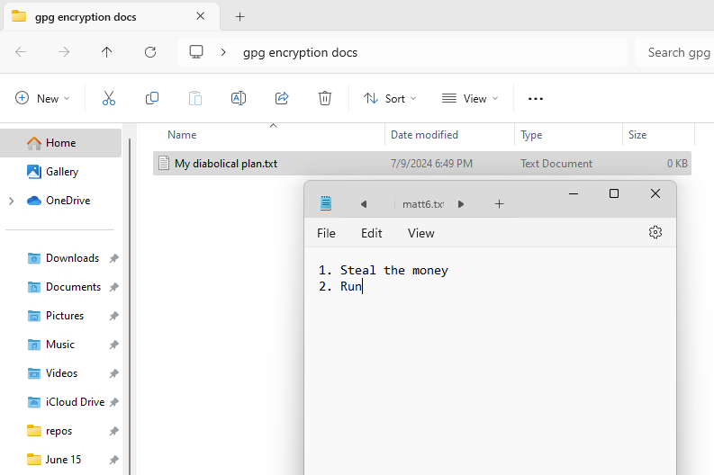
Figure 19 Contents of a text file with sensitive information.

Encrypt with Right-Click
- For Windows, right-click on the text file and choose "Shore More Options," as shown in Figure 20.
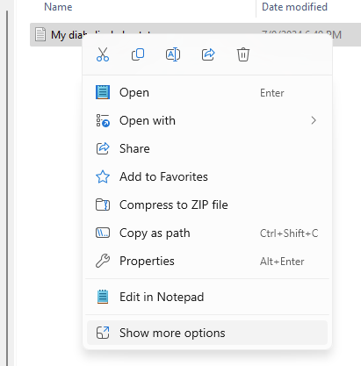
Figure 20 Right-clicking the text file.
- Choose Encrypt under "More GpgEX options," as shown in Figures 21, 22, and 23.
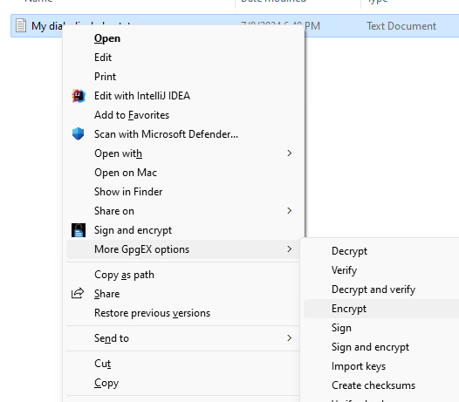
Figure 21 GPG EX has been integrated with the Windows right-click commands to provide Encryption.
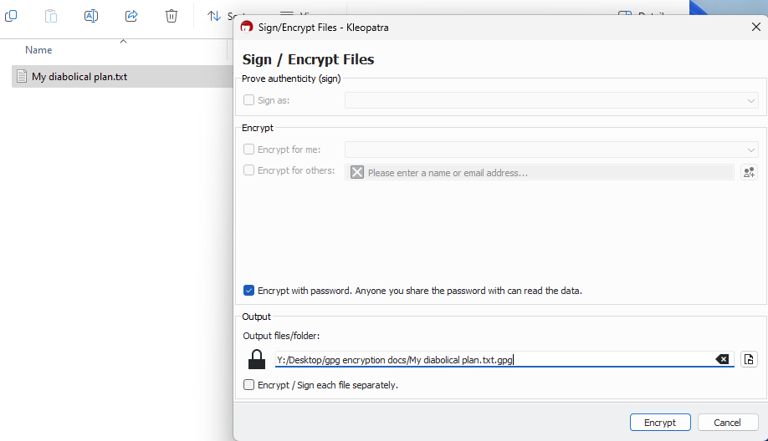
Figure 22 Destination folder is the same as the existing file.
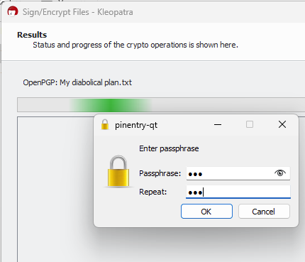
Figure 23 Entering a symmetric password.

The program should generate an encrypted version of the text file with a gpg extension.
- Right-click on the gpg file and open with Notepad to view the encrypted text, as shown in Figures 24 and 25.
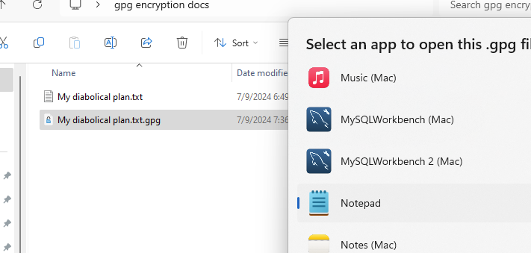
Figure 24 Selecting notepad to view the contents of the encrypted file.

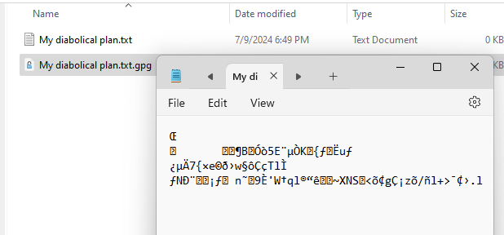
Figure 25 The encrypted file is a binary format. The characters used in the encryption do not display well in Notepad, which is designed to work with the ASCII character set.

- Take a screenshot of the results at this point.
- Paste the image into a Microsoft Word document.
- Put a caption below the image explaining what is being demonstrated.
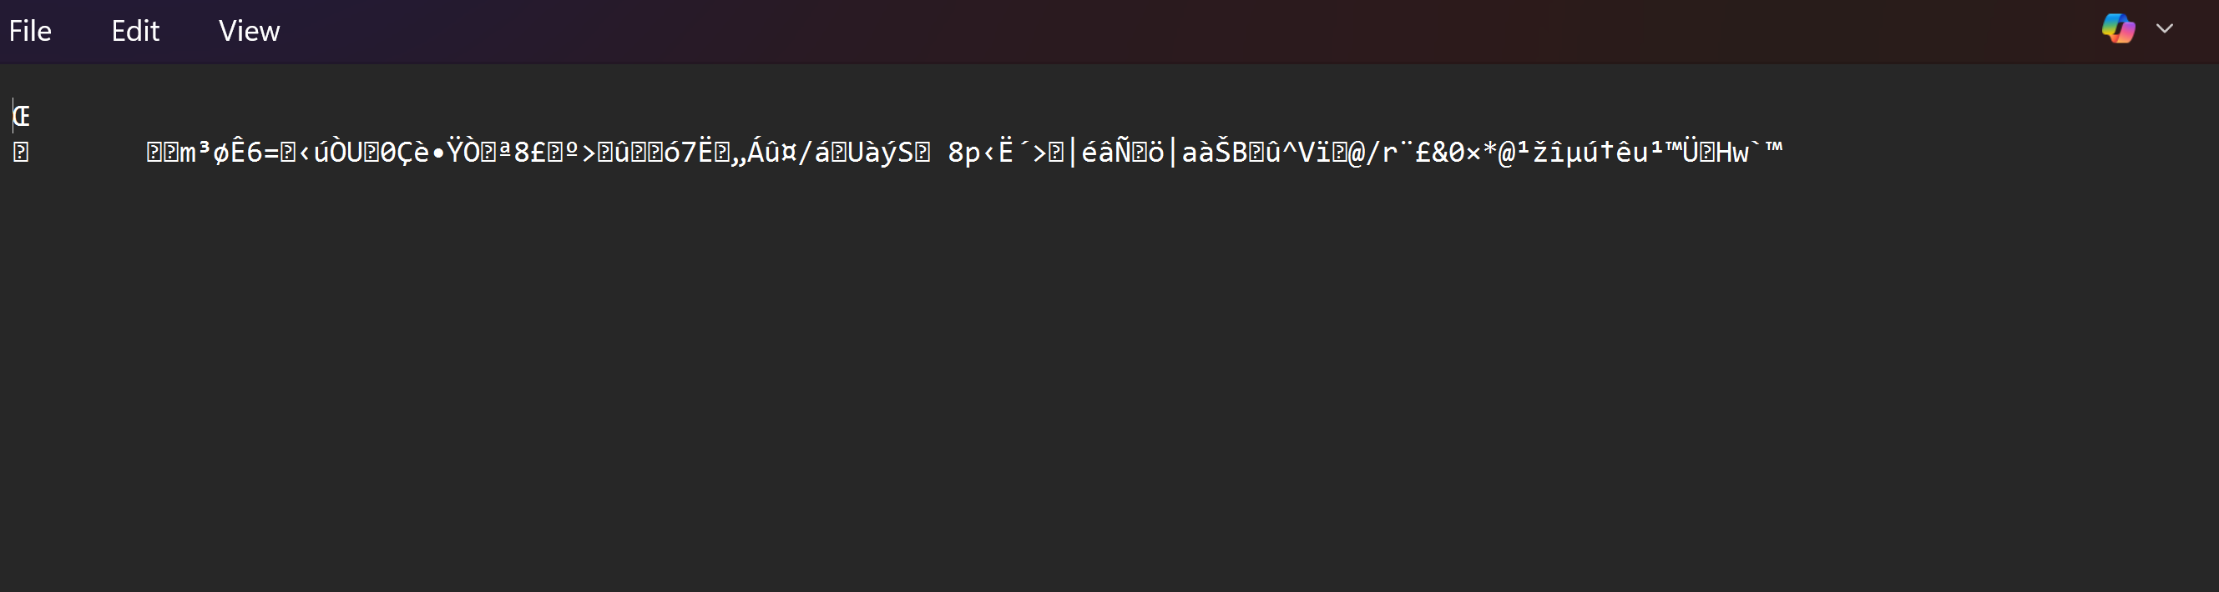


- Take a screenshot of the directory results at this point.
- Paste the image into a Microsoft Word document.
- Put a caption below the image explaining what is being demonstrated.
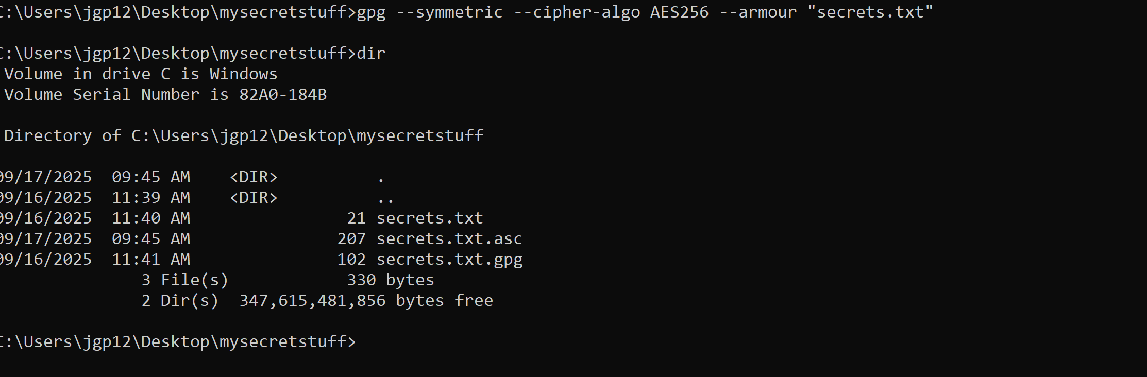
Figure 32 Encrypted message in ASCII characters with TextEdit.

- Take a screenshot of the ascii version of the encrypted document.
- Paste the image into a Microsoft Word document.
- Put a caption below the image explaining what is being demonstrated.
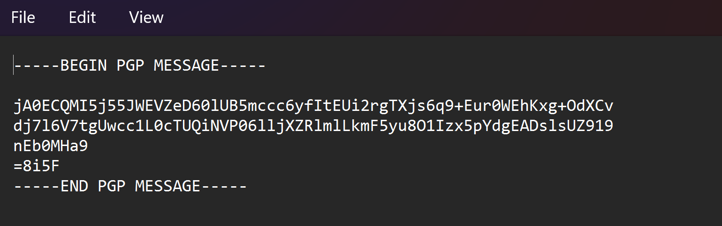
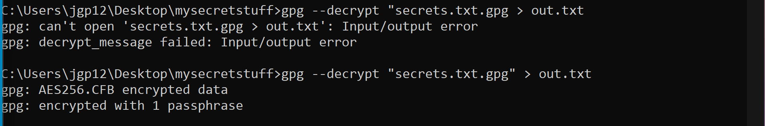

Figure 35 Using the integrated UI commands to decrypt a file.

package com.shadsluiter;

import java.math.BigInteger;
import java.security.SecureRandom;
import java.util.ArrayList;
import java.util.Arrays;
import java.util.Date;
import java.util.List;
import java.util.Scanner;

public class App {
public static void main(String[] args) {
SecureRandom secureRandom = new SecureRandom();

// List of ANSI color codes
List<String> colors = Arrays.asList("\u001B[30m", "\u001B[31m", "\u001B[32m", "\u001B[33m", "\u001B[34m", "\u001B[35m", "\u001B[36m", "\u001B[37m");

// User input
Scanner scanner = new Scanner(System.in);
while(true) {
// black
System.out.println(colors.get(0) + "Welcome to the RSA encryption and decryption program!");
System.out.print("Enter your message: ");
String message = scanner.nextLine();

int bitLength = getBitLength(scanner);

BigInteger exponent = getExponent(scanner);

Date startTime = new Date();
BigInteger e = exponent;

// Generate two 1024-bit prime numbers
BigInteger p = generatePrime(secureRandom, bitLength);
BigInteger q = generatePrime(secureRandom, bitLength);

// Calculate modulus n = p * q
BigInteger n = p.multiply(q);

// Calculate Euler's Totient Function φ(n) = (p - 1) * (q - 1)
BigInteger phi = calculatePhi(p, q);

// Ensure that e is coprime with φ(n)
if (!isCoprime(e, phi)) {
System.out.println("The public exponent e is not coprime with φ(n). Please choose a different value for e.");
continue;
}

// Calculate the private exponent d = e^(-1) mod φ(n)
BigInteger d = e.modInverse(phi);

// Print values with colors
printColored("p: " + p, colors.get(0));
printColored("q: " + q, colors.get(1));
printColored("n: " + n, colors.get(2));
printColored("φ(n) = (p - 1) * (q - 1) = " + phi, colors.get(3));
printColored("e: is the public exponent = " + e, colors.get(4));
printColored("d: is the private key = " + d, colors.get(5));

// Encrypt the message
printColored("Message: " + message, colors.get(0));
BigInteger encryptedMessage = encryptMessage(message, e, n);
printColored("Encrypted message as integer: " + encryptedMessage, colors.get(6));

// Decrypt the message
BigInteger decryptedMessage = encryptedMessage.modPow(d, n);
printDecryptedMessage(decryptedMessage, colors);

Date endTime = new Date();
long timeElapsed = endTime.getTime() - startTime.getTime();
printColored("Time elapsed: " + timeElapsed + " milliseconds", colors.get(7));

// Ask the user if they want to continue
System.out.print("Do you want to encrypt another message? (yes/no): ");
String continueChoice = scanner.nextLine();
if (!continueChoice.equalsIgnoreCase("yes")) {
break;
}
}
}

private static boolean isCoprime(BigInteger e, BigInteger phi) {
return e.gcd(phi).equals(BigInteger.ONE);
}

private static BigInteger getExponent(Scanner scanner) {
// Provide user with multiple choices for the value of e
List<BigInteger> eChoices = new ArrayList<>();

for (int i = 2; i < 9; i += 2) {
// 2 ^ 2 ^ i + 1 =
BigInteger e = new BigInteger("2").pow(2).pow(i).add(BigInteger.ONE);
eChoices.add(e);
}

System.out.println("Choose a value for the public exponent e:");
for (int i = 0; i < eChoices.size(); i++) {
System.out.println((i + 1) + ": " + eChoices.get(i));
}

System.out.print("Enter the number corresponding to your choice: ");
int eChoiceIndex = scanner.nextInt() - 1;
scanner.nextLine(); // Consume the newline character left by nextInt()

return eChoices.get(eChoiceIndex);
}

private static int getBitLength(Scanner scanner) {
int bitLength = 1024;
System.out.println("What bit length would you like to use for the prime numbers? Longer is more secure (40 - 4096)");
while (true) {
System.out.print("Enter a number: ");
bitLength = scanner.nextInt();
scanner.nextLine(); // Consume the newline character left by nextInt()

if (bitLength >= 40 && bitLength <= 4096) {
break;
} else {
System.out.println("Please enter a number between 10 and 4096.");
}
}
return bitLength;
}

private static BigInteger generatePrime(SecureRandom secureRandom, int bitLength) {
return new BigInteger(bitLength, 100, secureRandom);
}

private static BigInteger calculatePhi(BigInteger p, BigInteger q) {
return p.subtract(BigInteger.ONE).multiply(q.subtract(BigInteger.ONE));
}

private static void printColored(String message, String color) {
System.out.print(color);
System.out.println(message);
}

private static BigInteger encryptMessage(String message, BigInteger e, BigInteger n) {
BigInteger messageInt = new BigInteger(message.getBytes());
return messageInt.modPow(e, n);
}

private static void printDecryptedMessage(BigInteger decryptedMessage, List<String> colors) {
printColored("Decrypted integer value: " + decryptedMessage, colors.get(0));
printColored("Decrypted message in byte array: " + Arrays.toString(decryptedMessage.toByteArray()), colors.get(1));
printColored("Decrypted message as an ASCII string: " + new String(decryptedMessage.toByteArray()), colors.get(2));
}
}

- Run the application.
- Encrypt a phrase using a small prime number value, as shown in Figure 49.
- Repeat the encryption using a larger key value, as shown in Figure 50. You should see that the amount of time to encrypt/decrypt grows exponentially with the length of the values of p and q.

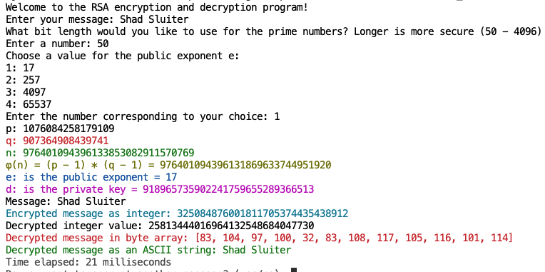
Figure 49 Encrypting a string with a small value for p and q (50 bits).
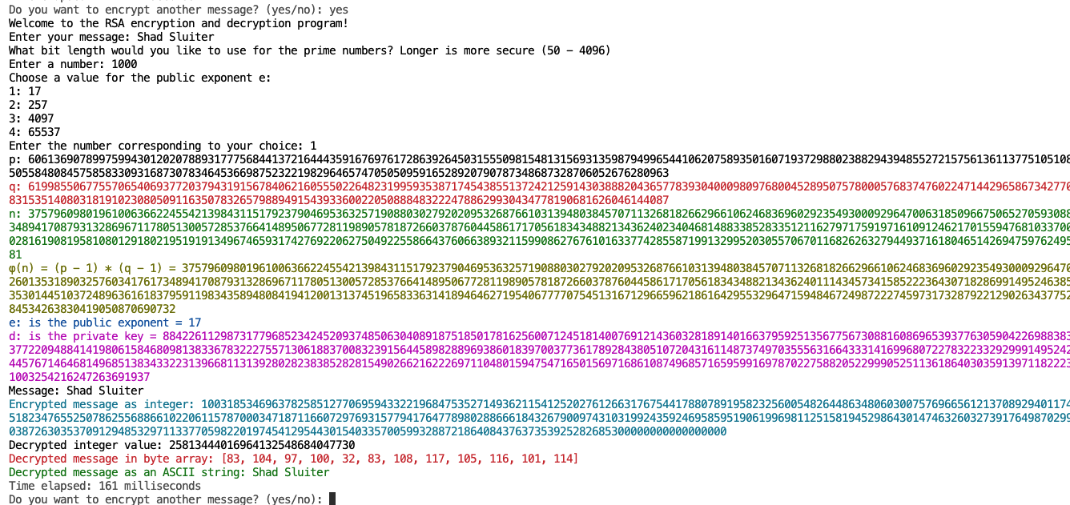

Figure 50 Encrypting a string with a medium-length value for p and q (1000 bits).


- Take a screenshot of the application running one of the encryption operations at this point.
- Paste the image into a Microsoft Word document.
- Put a caption below the image explaining what is being demonstrated.
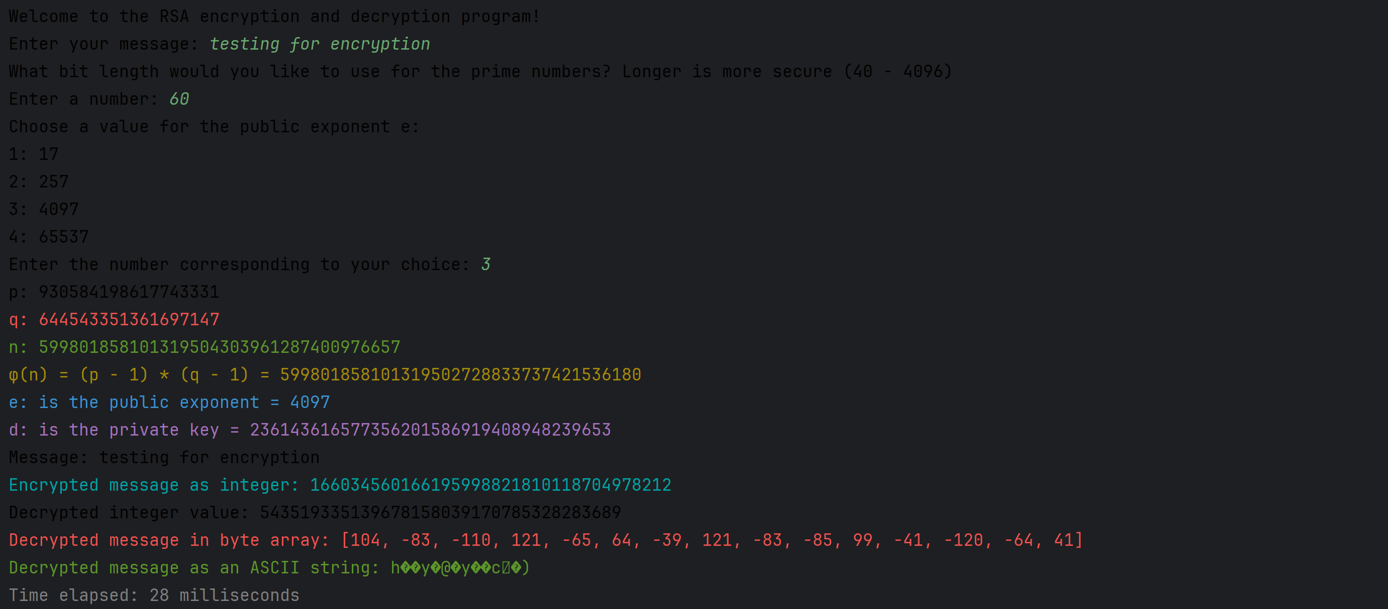
Running the application, small numbers
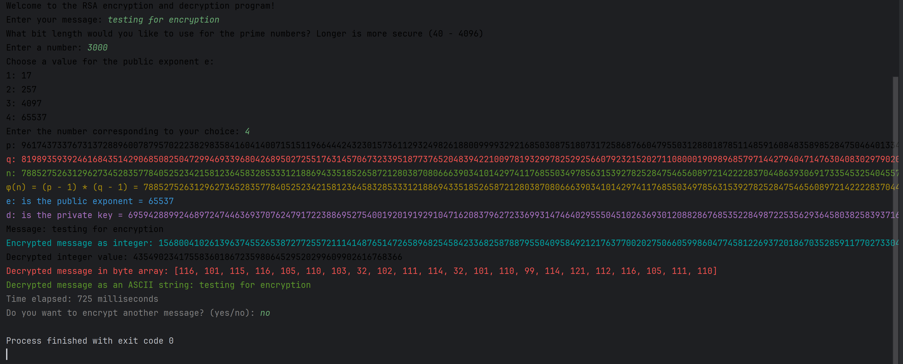Running the application with large numbers

Asymmetric Encryption with GPG
This exercise is best done using a partner or at least two separate email accounts. You will create public/private keys, exchange public keys, encrypt, and share a message and decrypt the message using your private key. We will show the process first using the command line interface and then using the Windows Explorer integration.

Method 1 – Command Line Interface

- Create your own private and public key files.
gpg --gen-key
- Follow the steps through the process:


- Take a screenshot of the information about your key.
- Paste the image into a Microsoft Word document.
- Put a caption below the image explaining what is being demonstrated.
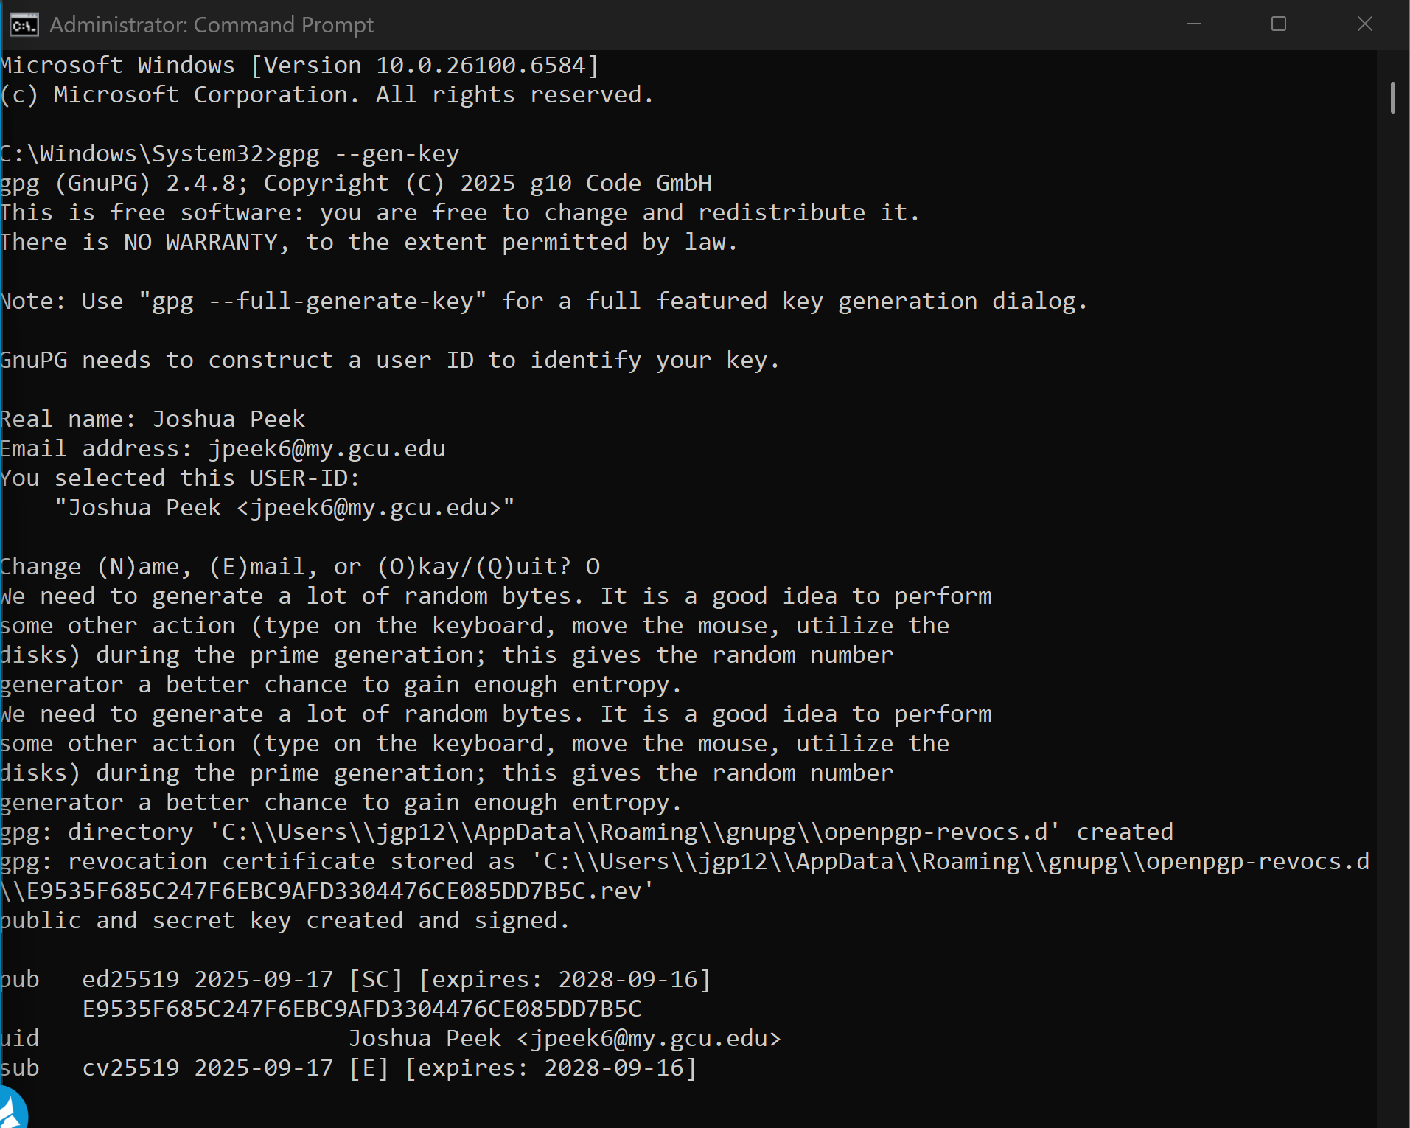
Share your Key with Another User
- Use the --armor option to make it an ASCII file. Dump it to a file. Copy and paste from this line may result in errors due to text encoding differences.
gpg --export --armor youremail@email.com > yourname-public-key.asc.
(use two hyphens for the export and armor options)
- For additional information on how to use GPG, use the following command:
gpg –help
- Share your public key via email. Copy the contents of the public-key.asc file into an email or attach the public-key.asci file. Send it to your friend. You could also share your public key using social media or publish it on a website.
- Your partner also needs to create a public key and share it with you.
- Import the public key made by your partner.
gpg --import yourfriend-pub-key.asc
(two hyphens for import option)
- View the public keys you have imported into your computer.
gpg --list-keys
- Your list of public keys will grow as you work with more individuals and share public keys.

- Take a screenshot of the list of public keys you have at this point.
- Paste the image into a Microsoft Word document.
- Put a caption below the image explaining what is being demonstrated.
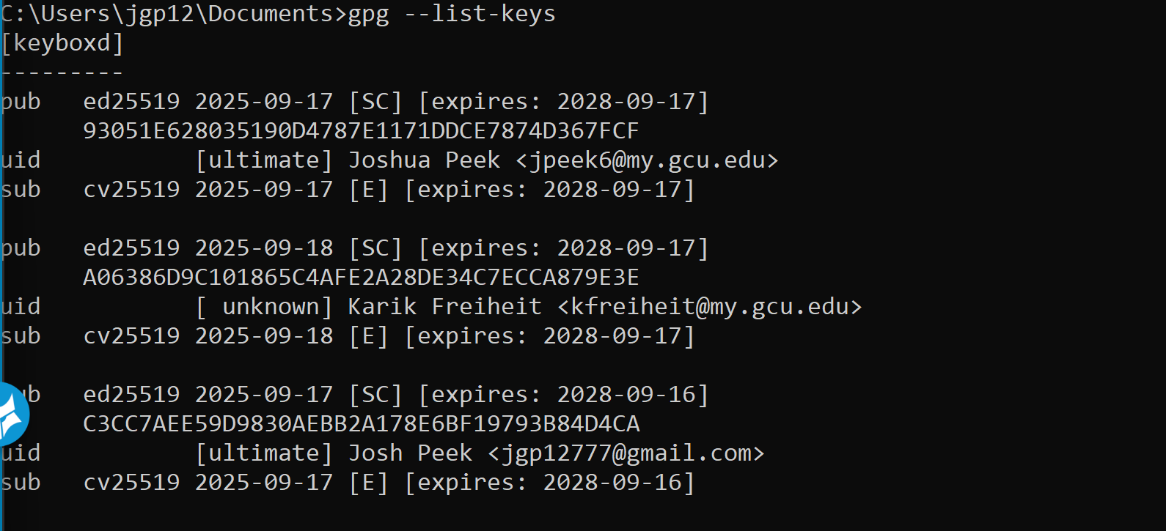
email one account to another
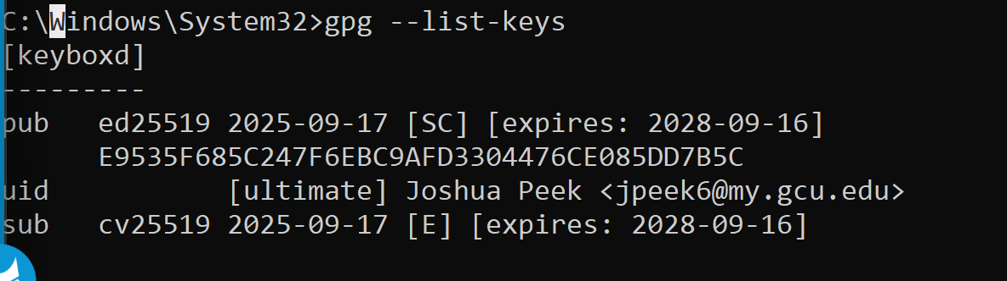
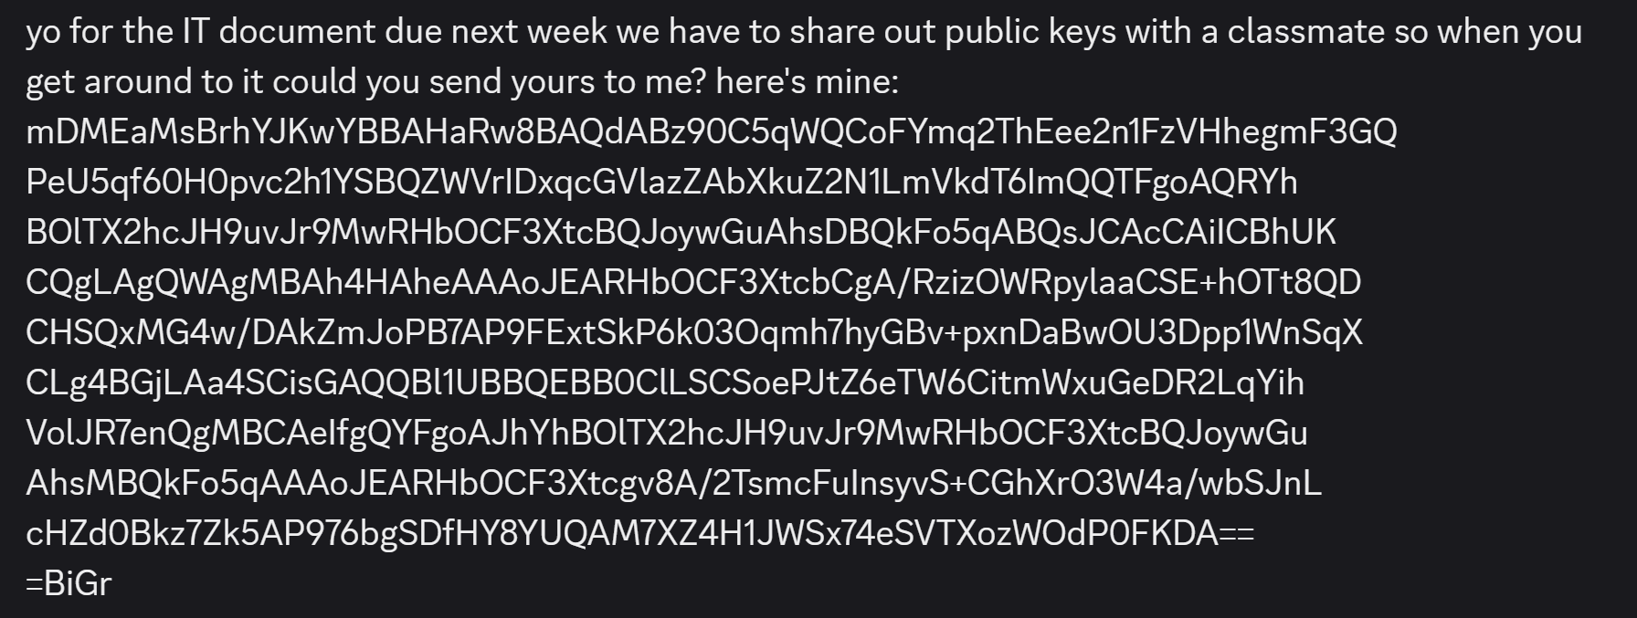
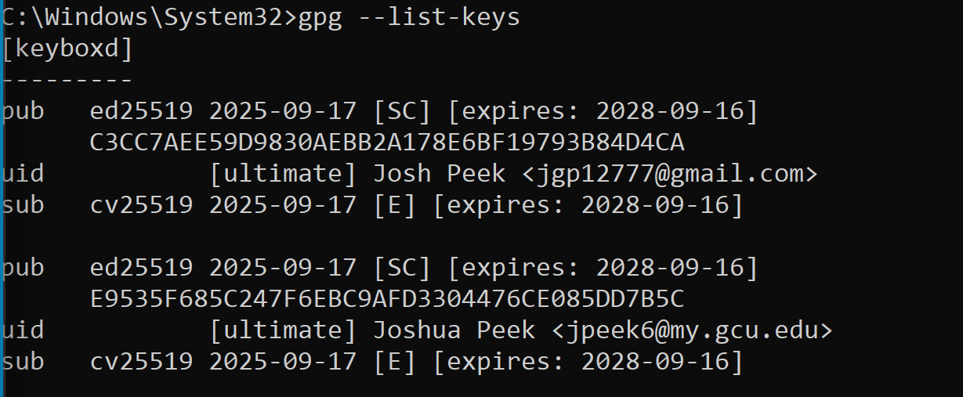
List of keys
Encrypt a Message
With asymmetric encryption, you need to perform the encryption process once per friend. You cannot encrypt a document for a general audience.

- Encrypt a message in preparation for sharing it with another user. In this example, I am going to share a file (filename.txt) with my friend Shad Sluiter, who has shared his public key with me. Once again, copy and paste may not work with command line commands.
gpg –-encrypt --armor –-recipient shad.sluiter@gcu.edu "My diabolical plan.txt"

- This will use the public key (sent from shad.sluiter and imported) to encrypt the text file. The armor option encodes the message in ASCII format.
- Type dir to confirm the encrypted file is there. There should be a new, encrypted file in the same directory as "My diaboloical plan.txt"
- Open the encrypted message. You should see a similar format as shown in Figure 51.
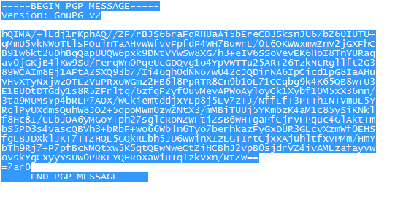
Figure 51 ASCII encoded PGP message sent either as an attached file or as the body of an email.

- Take a screenshot of the encrypted version of your message.
- Paste the image into a Microsoft Word document.
- Put a caption below the image explaining what is being demonstrated.
- Send the encoded message either as an attachment or copy it into the body of the text.
- Send it to your friend who will then download it and decrypt it. Even though email itself may be sent as an unencrypted message, the body of the message is in a secure format.

Decryption
Let's assume you have shared your public key with a friend. Your friend imported the public key into GPG. He/she used your public key to encrypt a message that is intended for you. He/she sent you an email with the ascii version of the encrypted file.
- Open your friend's email.
- Save the encrypted message to a file.
- Run the decrypt command in the command terminal to create an unencrypted text file.
gpg –-decrypt message-from-friend.txt.asc > output.txt
- You must provide your private key to decrypt the message.
- Open the output file with Notepad. You should be able to see the private message.


- Take a screenshot of the unencrypted message from your friend.
- Paste the image into a Microsoft Word document.
- Put a caption below the image explaining what is being demonstrated.

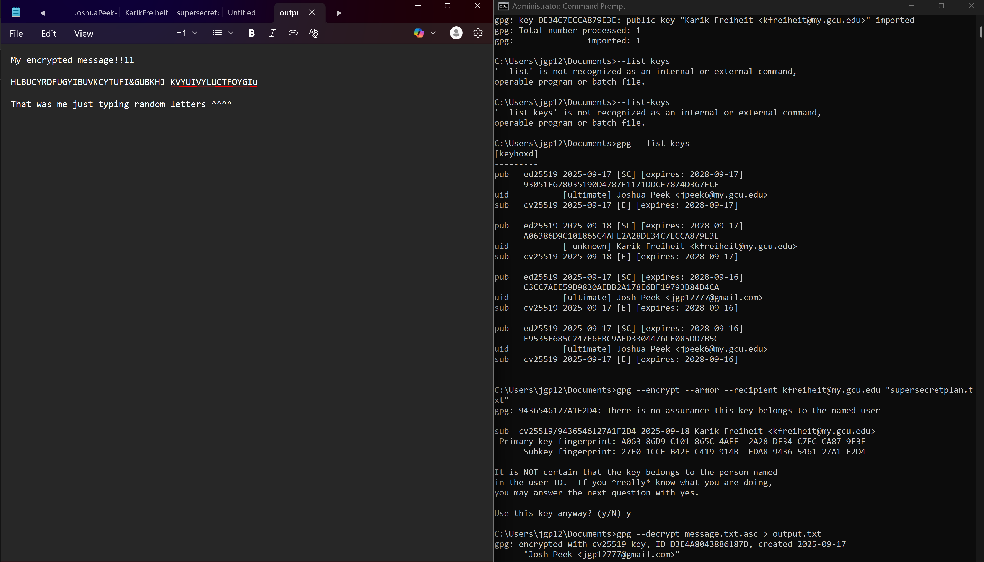

Method 2 – Encryption and Decryption Using File Explorer GUI (Windows)

GPG works equally well with the GUI tools as it does with the command line. We will repeat the process using the GUI application, first in Windows and then instructions will be shown for Macintosh.

Exchange Public Keys with a Partner
- Run the Kleopatra program which was installed as part of the GPG application, as seen in Figure 52.
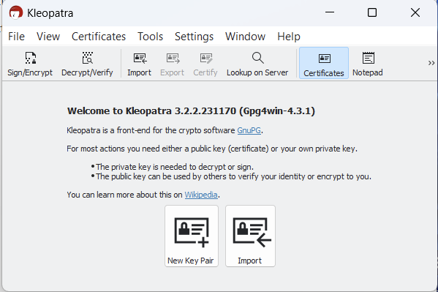
Figure 52 Starting screen for Kleopatra.
- Click New Key Pair.
- Enter your name and email, as shown in Figures 53 and 54.

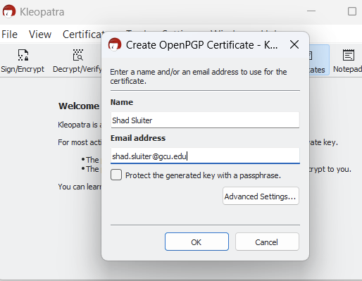
Figure 53 Creating a new public key using the Kleopatra program.

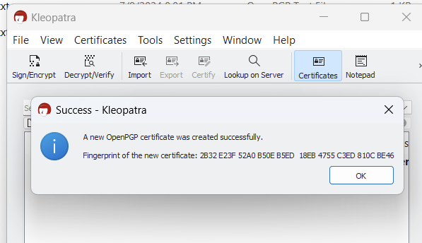
Figure 54 Successfully created a public key. The "fingerprint" is a hash value of the public key. You can share this fingerprint with the public as well. It is used to verify that your public key has not been tampered with.
- Export the Key to a file, as shown in Figure 55. Then select the certificate with your name and choose Export, as shown in Figure 56.

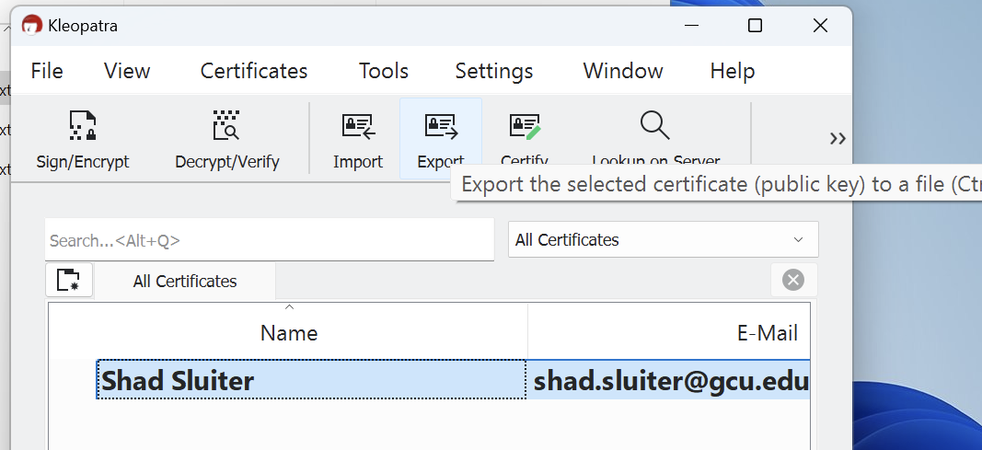
Figure 55 Exporting the public key to a text file.

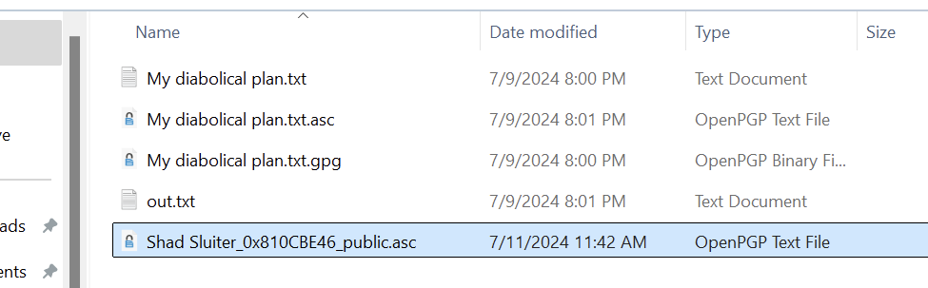
Figure 56 The public key for Shad Sluiter is saved in the project folder.


- Take a screenshot of the Kleopatra list of keys.
- Paste the image into a Microsoft Word document.
- Put a caption below the image explaining what is being demonstrated.
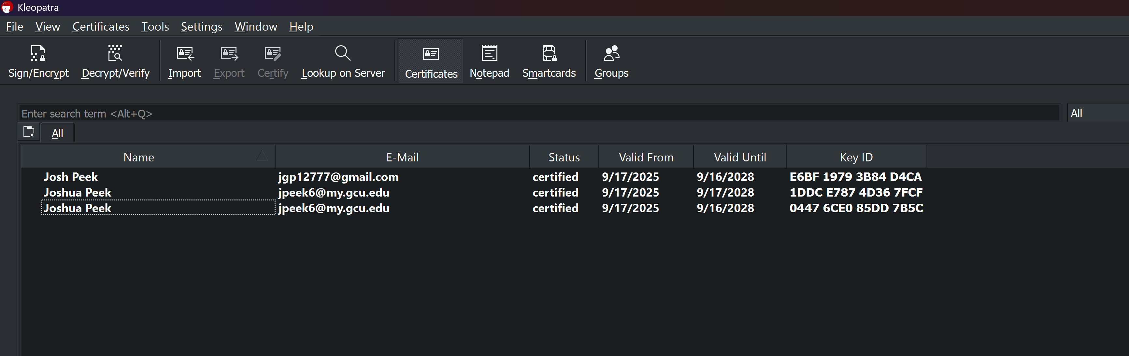

Encrypt the Message
- Right-click on the unencrypted file and choose Sign and Encrypt, as seen in Figure 57.

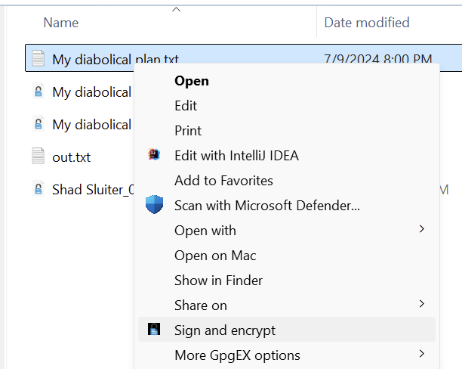
Figure 57 "Sign and encrypt" the file "My diabolical plan.txt"
- Save the file to the project folder.
- Send the public key file to your friend as an email attachment. Your partner needs to share his/her public key file with you.

Import a Key
- After receiving the public key file from your friend, import the file. Click the import button, as shown in Figure 58.

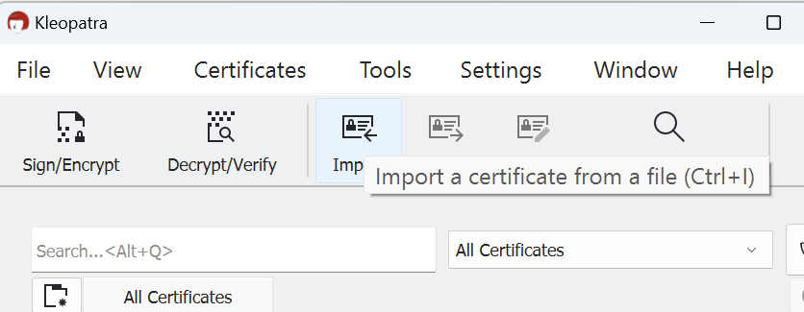
Figure 58 Import a public key from a file sent to you by your partner.

- Select the file received from your friend, as shown in Figure 59.
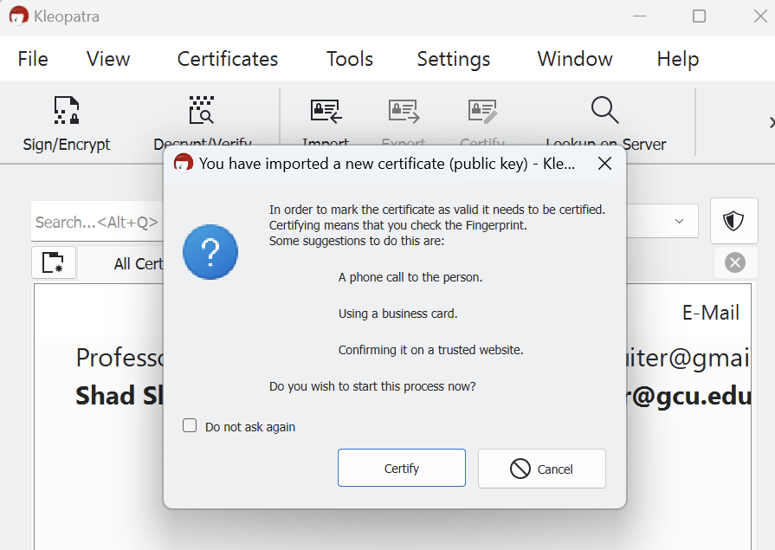
Figure 59 The import message recommends that you verify the "fingerprint" value of your partner's public key.

- You can verify the validity of the certificate using the fingerprint, as seen in Figure 60, or you can implicitly trust your friend.
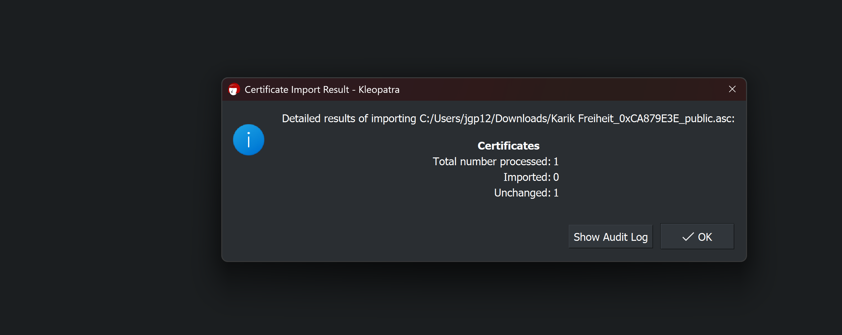
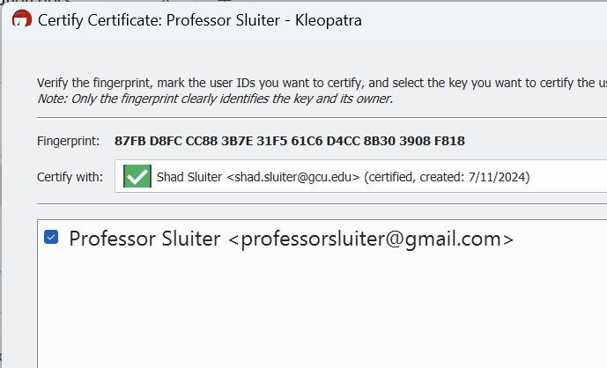
Figure 60 A new key has been imported into the system from professorsluiter@gmail.com.


- Take a screenshot of the application showing a new certificate has been saved..
- Paste the image into a Microsoft Word document.
- Put a caption below the image explaining what is being demonstrated.

- The public key has been imported, as seen in Figure 61.
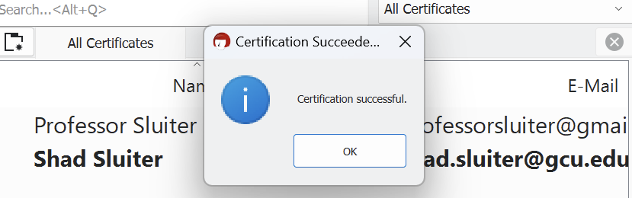
Figure 61 Assuming I checked the fingerprint and the hash values match, I can trust messages sent from this user.
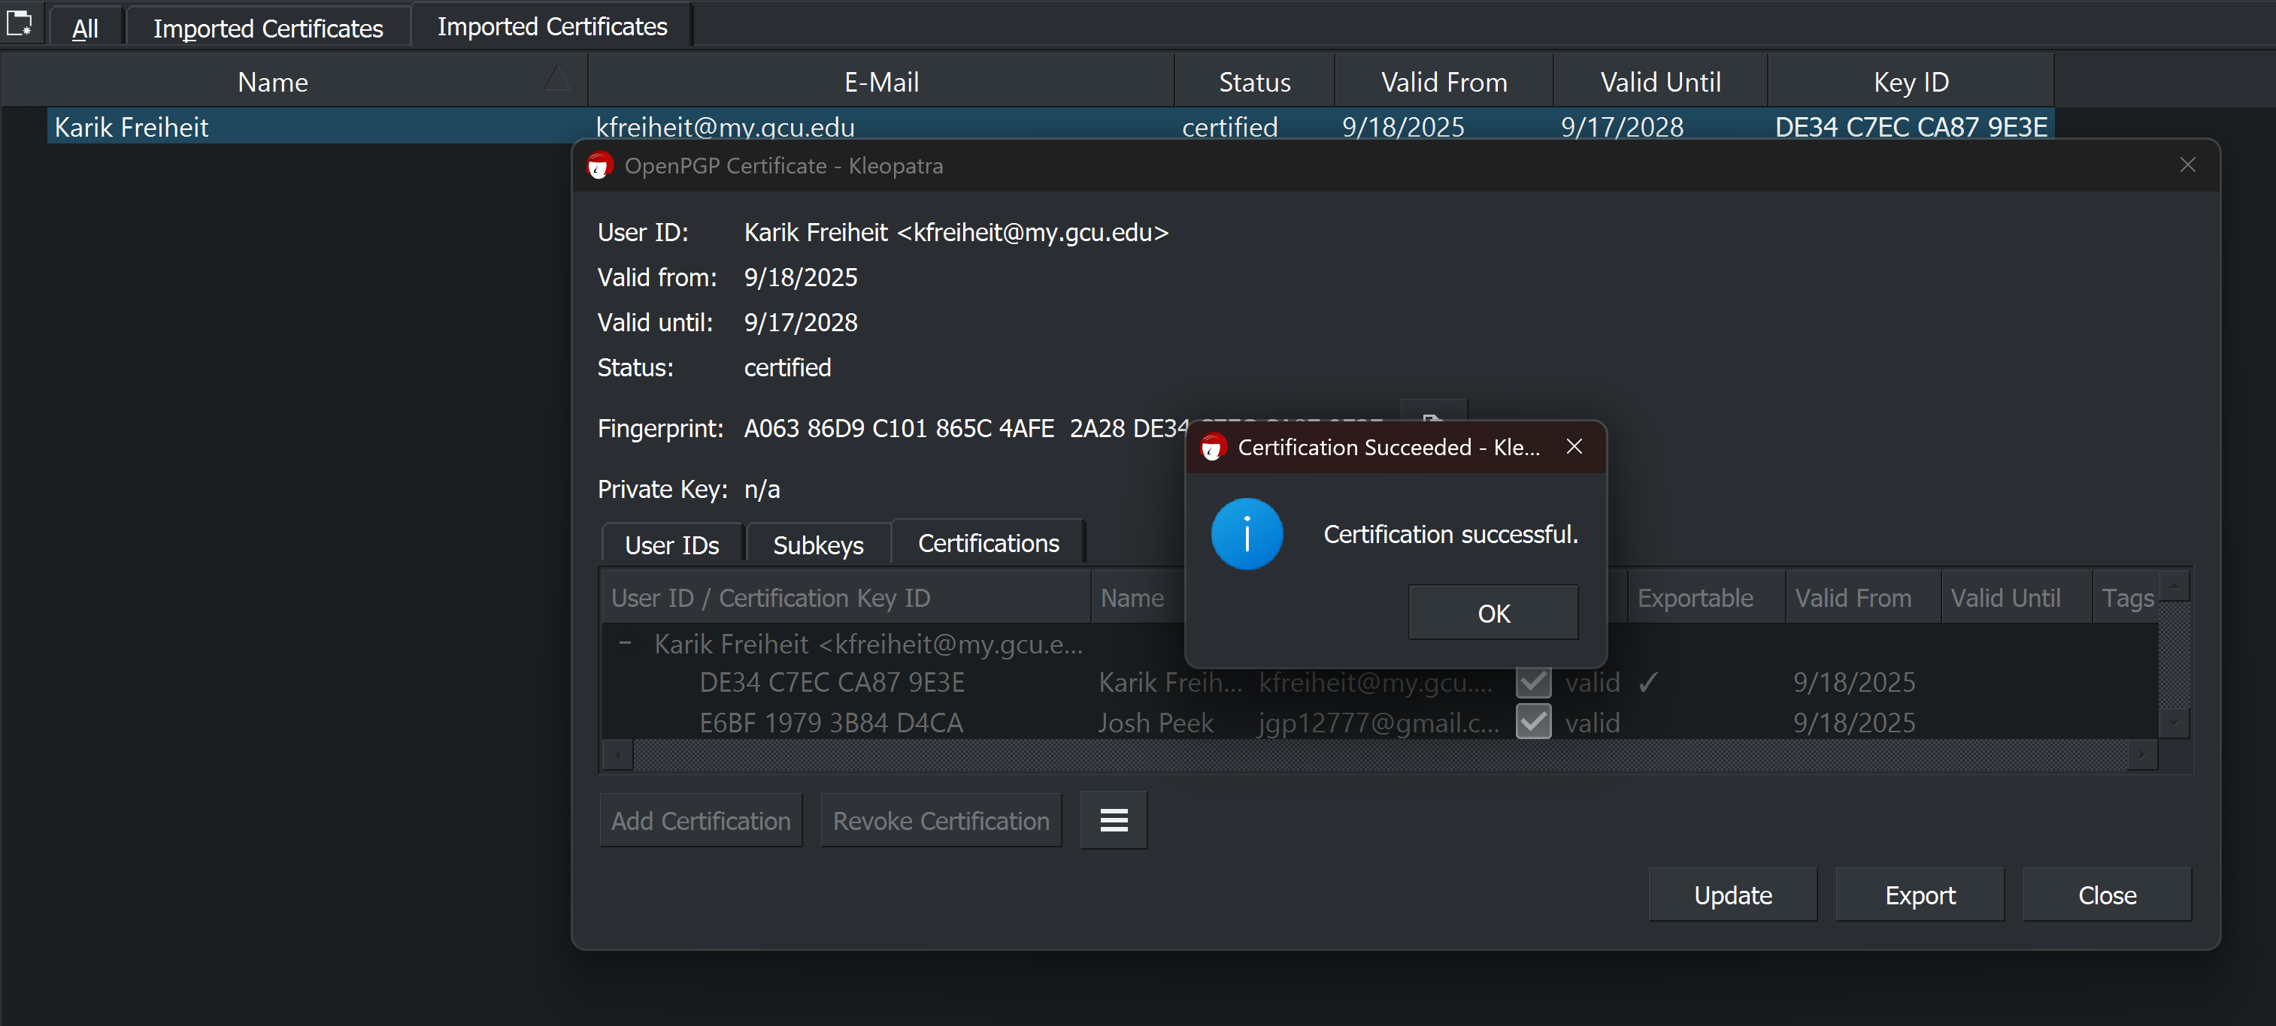

Encrypt a Message

  - Right-click on a text file you wish to encrypt and choose Sign and Encrypt, as shown in Figures 62 and 63.
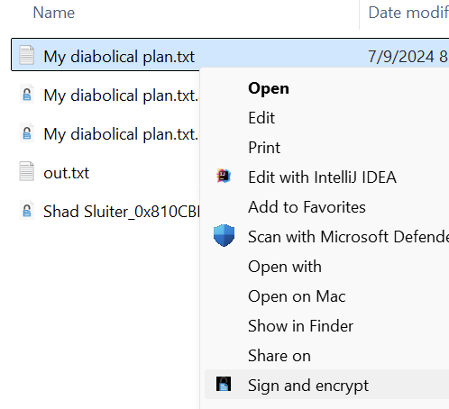
Figure 62 Encrypting a message using a public/private key.

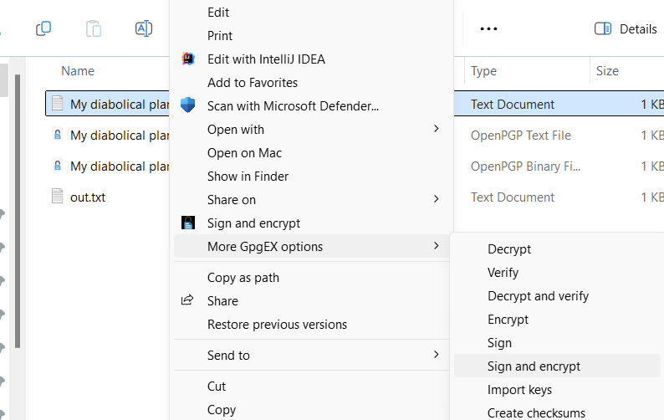
Figure 63 Sign and Encrypt is found in two places in the UI integration.

  - Select the source (your name) and the destination (your partner's name), as shown in Figure 64.
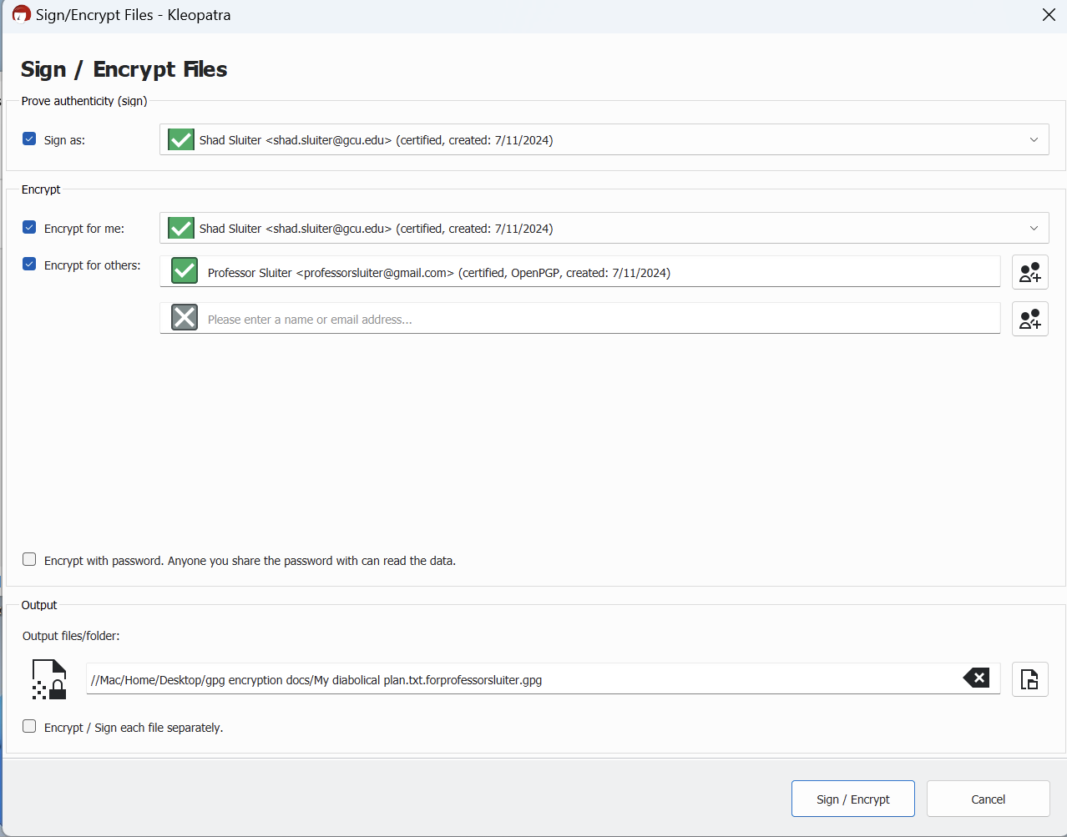
Figure 64 This message is being encrypted by shad.sluiter@gcu.edu specifically for professorsluiter@gmail.com. Include yourself if you want to also be able to decrypt the message.

The resulting encrypted message can only be opened by the person who you designate, as shown in Figure 65. His/her private key is required to decrypt the message.

  - Click Sign/Encrypt.
  - Send the resulting encrypted file to your friend.
  - Your friend should be able to decrypt the file using the Kleopatra GUI application.

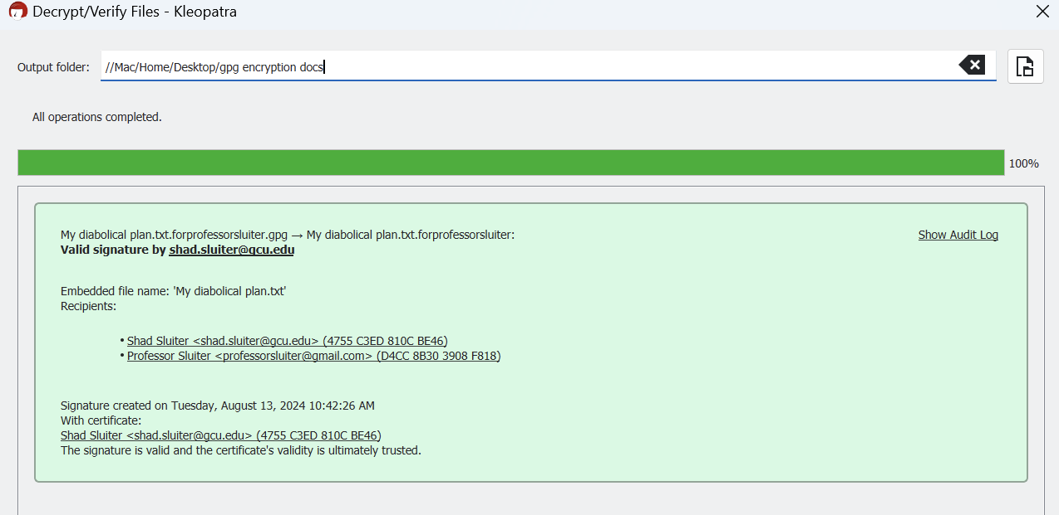
Figure 65 Decrypt is complete for two intended recipients, the sender included himself as a recipient.

- Take a screenshot of the successful decryption at this point.
- Paste the image into a Microsoft Word document.
- Put a caption below the image explaining what is being demonstrated.

  - Look in the output folder for the decrypted version of the message. You should now be able to see the secret message sent to you by your friend.
  - 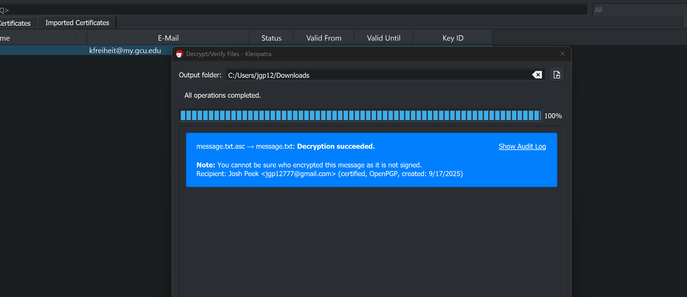

============ End Windows Section =====================

Part 5 – Summarize
Write a comprehensive summary of the key concepts demonstrated in this lesson, ensuring each of the following topics is covered in depth. Provide detailed explanations, examples, and citations from both the lesson material and external research.
- Compare and Contrast Hashing with Encryption:
  - Discuss not only the fundamental differences between hashing and encryption, but also how each is used in modern technology (e.g., data integrity, password protection, etc.).
    - Hashing is irreversible and is usually used for passwords, like when you first enter the password it is stored by the database as hashed and every time you enter it that result is hashed and the result is compared to the hashed first password.
    - Encryption is reversible and usually used for things like messaging and emails, for readable data in transit.
  - Provide examples of real-world scenarios where encryption is necessary, and others where hashing is the best solution.
    - Encryption is good for data that is in transit, such as messages, emails, or pipelines.
    - Hashing is best for storing passwords so that they are not in a recoverable format.
- Compare and Contrast Symmetric and Asymmetric Encryption:
  - Explain the advantages and disadvantages of each in different use cases (e.g., speed vs. security, ease of key distribution, etc.). Symmetric = one shared key (e.g., AES); Asymmetric = keypair (public/private; e.g., RSA/ECC/Kyber).
Symmetric is very fast for bulk data; Asymmetric is slower/heavier (used mainly to set up keys / signatures).
Symmetric is hard at scale (securely sharing the secret is the problem); Asymmetric makes distribution easy (share public key openly), but needs authenticity (PKI, key transparency).
Symmetric gives confidentiality+integrity; Asymmetric adds signatures, non-repudiation, easier rotation & per-recipient encryption.
  - Include a comparison how these two approaches are best applied in the real world. Consider situations where encryption is required but one approach is preferred over the other. For example encryption could be used in all of these situations: tape backups, hard drives, web traffic, chat applications, telephone conversations, USB storage, email.
Tape backups / full-disk / USB storage: Symmetric (AES-XTS/AES-GCM) for performance and offline use.
Hard drives (FDE): Symmetric with hardware assist (AES-XTS); keys unwrapped via asymmetric/smartcard/TPM if needed.
Web traffic (HTTPS/TLS): Asymmetric for auth+key exchange → switch to symmetric for payloads.
Chat apps: Asymmetric identities + ephemeral exchanges; messages encrypted symmetrically per-message/session (Signal-style).
Telephone/VoIP: Signaling uses TLS/DTLS (asymmetric) to agree SRTP keys; media protected symmetrically.
Email: Hybrid—generate a random symmetric key for the message; encrypt that key with recipient’s public key (PGP/S/MIME).
Bulk backups to cloud: Symmetric for data at rest; optionally wrap keys with asymmetric keys of org/HSM.
- Practical Application in Messaging Apps:
  - Based on the comparison of various messaging tools, evaluate your current phone applications in terms of encryption strength and security.
    - E2EE by default, modern “Double Ratchet” with forward secrecy & post-compromise security; excellent. Turn on registration lock PIN, safety number checks, disappearing messages for sensitive chats
    - E2EE by default using the Signal Protocol; good. Lock down cloud backups (prefer encrypted backup), verify security codes, enable 2-step verification
  - Explain whether you would change or configure these apps differently and provide reasons based on what you have learned about encryption.
    - Would I change? Yes, I will use Signal or iMessage (PQ3) for sensitive convos; on WhatsApp/iMessage, ensure encrypted backups; avoid default Telegram for private matters; don’t rely on SMS/RCS for anything sensitive.
  - Support your plan with examples from the apps discussed.
- Research on Quantum Computing and Its Impact on Encryption:
  - Conduct research on the future of encryption in the quantum age. What encryption methods are considered quantum-resistant?
    - NIST finalized FIPS 203 (ML-KEM/Kyber) for key establishment, FIPS 204 (ML-DSA/Dilithium) and FIPS 205 (SLH-DSA/SPHINCS+) for signatures; additional KEM (HQC) selected in 2025 for standardization. Organizations (esp. gov/NSS) are migrating per CNSA 2.0 timelines.
https://www.nist.gov/news-events/news/2024/08/nist-releases-first-3-finalized-post-quantum-encryption-standards
  - Based on current publications, how soon do experts believe quantum computers will become powerful enough to break current encryption standards?
Academic estimates have moved from ~20M noisy qubits (hours) to <1M noisy qubits (≤1 week) under optimistic assumptions, still far beyond 2025 hardware, but a serious planning signal.

https://www.theguardian.com/technology/2025/mar/20/uk-cybersecurity-agency-quantum-hackers
  - Cite at least two reputable sources for your research.

