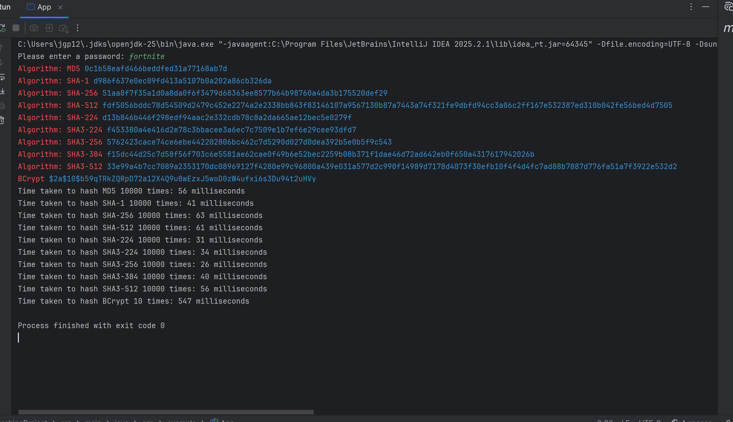

- Take a screen shot of the application running at this point.
- Paste the image into a Word document.
- Put a caption below the image explaining what is being demonstrated.

Password Length | Speed of App (adjust for your CPU) | Alphabet Length | Number of total combinations in pw string | Time to calculate all possible password combinations
5 | 5,000,000 guess / sec | 26 | 26 * 26 * 26 * 26 * 26  = 26 ^ 5
6 | 5,000,000 guess / sec | 26 | 11,881,376 | 2 sec
7 | 5,000,000 guess / sec | 26 | 308,915,776 | 1.03 minutes
8 | 5,000,000 guess / sec | 26 | 8,031,810,176 | 26.77 minutes
9 | 5,000,000 guess / sec | 26 | 208,827,064,576 | 11.60 hours
10 | 4000000 | 26 | 141,167,095,653,376 | 326.78 days (~0.90 years)
11 |  | 26 | 3,670,344,486,987,776 | 23.28 years
12 |  | 26 | 95,428,956,661,682,176 | 605.21 years
Use the bottom half of the chart to calculate some larger alphabets.
8 |  | 52 | 53,459,728,531,456 | 123.75 days
 |  | 72 | 722,204,136,308,736 | 4.58 years

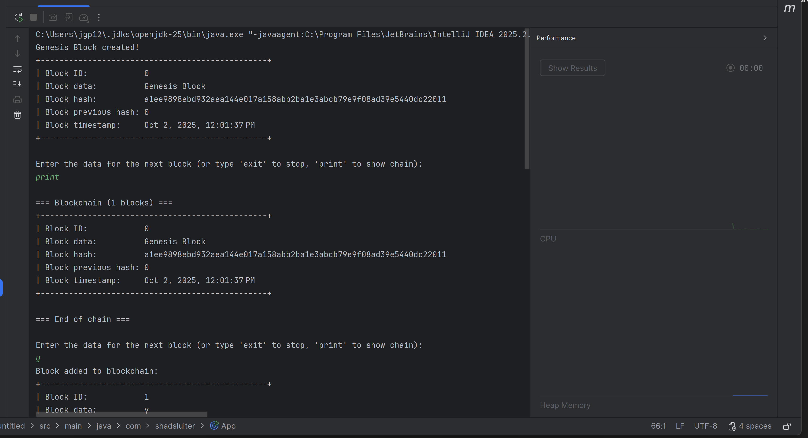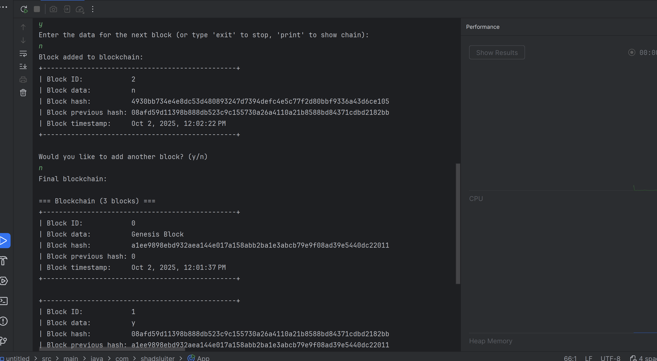

- Take a screen shot of the application running at this point.
- Paste the image into a Word document.
- Put a caption below the image explaining what is being demonstrated.

Summary of Key Concepts
a) Why is hashing better for password security than encryption?
Hashing is a one-way process. After a password has been transformed into a hash, it cannot be reverted to its original form—at least, theoretically. Encryption, on the other hand, assumes that with the correct key, a legitimate user can decrypt the data at any time. If an attacker gains control of the key, they could potentially reveal all the encrypted passwords. By using hashing, particularly when combined with a salt and algorithms like BCrypt or Argon2, the process becomes far more secure. Even if attackers steal the password hashes, the added complexity makes it incredibly difficult for them to reverse-engineer the original passwords. This is why hashing is the preferred method for storing and checking user credentials.
b) If not for passwords, in what other ways does hashing serve to dry up irregularity in the data?
Hashing plays an essential role in maintaining data integrity in various contexts, including:
- File download: Comparing the hash of a file allows users to confirm that the file hasn't been tampered with during download.
- Data transmission: A message can include a hash as a checksum, ensuring that data corruption is detected during transmission.
- Backups and storage: Hashing enables verification that data between two copies remains unaltered.
- Version control (e.g., Git): Each commit is assigned a hash, ensuring that even the smallest change is tracked.
- Digital signatures and certificates: When combined with cryptography, hashes help to authenticate the integrity of messages or documents.
- Blockchain: Each block in the blockchain references the hash of the previous one, ensuring the integrity and immutability of the entire chain.
c) Insights learned about password strength
The lesson highlights that both password length and complexity significantly impact security. For instance, a short, all-lowercase password can be cracked in seconds, while a 12-character password containing a mix of symbols, numbers, and uppercase letters could take millions of years to brute force at typical guessing speeds. The most crucial takeaway is that while incorporating a variety of character types (uppercase, numbers, symbols) boosts security, the length of the password is the most influential factor. Best practices suggest using long, unique passphrases to resist dictionary attacks and brute-force attempts.

Check for Understanding
Although these questions are not graded, they will help you prepare for upcoming assessments.
- What is the primary purpose of hashing?
- A) To encrypt data for secure transmission
- B) To create a unique fingerprint for data to ensure integrity
- C) To compress data for faster processing
- D) To reverse data for future access Answer: B
- How does a hashing function handle inputs of different lengths?
- A) It produces a variable-length output
- B) It produces a fixed-length output regardless of input size
- C) It increases the output size based on input size
- D) It truncates the input to fit a fixed length Answer: B
- What is a hash collision?
- A) When two different inputs produce the same hash value
- B) When a hash function produces an error
- C) When two hash outputs have identical values
- D) When two inputs are reversed into each other Answer: A
- Why is the Birthday Problem analogy useful in explaining hashing?
- A) It shows the probability of multiple people sharing the same name
- B) It illustrates how likely it is for two different inputs to produce the same hash
- C) It explains the probability of cracking a hash
- D) It demonstrates why hashing is faster than encryption Answer: B
- Why is MD5 no longer considered secure for hashing?
- A) It is too slow for modern systems
- B) It produces short hash values that are easy to crack
- C) It is vulnerable to collision attacks
- D) It can be easily reversed Answer: C
- What is a rainbow table?
- A) A tool used to encrypt data
- B) A precomputed list of hash values used to quickly crack passwords
- C) A database of all possible hash values
- D) A tool for reversing a hash value Answer: B
- What is the role of salting in password hashing?
- A) To speed up the hashing process
- B) To add security by ensuring identical passwords produce different hashes
- C) To ensure that hash values can be reversed
- D) To compress the data into a smaller output Answer: B
- Which hashing algorithm is considered highly secure and resistant to brute-force attacks?
- A) MD5
- B) SHA-1
- C) BCrypt
- D) MD4 Answer: C
- Why is it important to use secure hashing algorithms for password storage?
- A) To allow easy decryption when needed
- B) To prevent unauthorized access by making it difficult to reverse-engineer the password
- C) To store the passwords in a smaller format
- D) To allow users to recover passwords if forgotten Answer: B
- How is hashing used in version control systems like Git?
- A) To store file content in an encrypted format
- B) To create a unique identifier for each commit, ensuring changes cannot be modified without detection
- C) To ensure that passwords stored in repositories are secure
- D) To verify that all files in a repository have the same name Answer: B
- What is the purpose of hashing in blockchain technology?
- A) To encrypt the data in each block
- B) To create a secure link between blocks by storing the hash of the previous block
- C) To ensure that all blocks contain the same amount of data
- D) To make the blockchain easier to search Answer: B
- Which of the following demonstrates a use case for hashing in network transmissions?
- A) Encrypting the message to protect against eavesdropping
- B) Creating a value to verify that the data received is the same as the data sent
- C) Compressing the message for faster transmission
- D) Storing a backup copy of the message Answer: B

Rubric

Criteria | % Value | 1: Unsatisfactory | 2: Less Than Satisfactory | 3: Satisfactory | 4: Good | 5: Excellent
Understanding & Demonstration of Hashing Concepts | 30% | Does not explain or demonstrate hashing; major misconceptions or missing screenshots. | Some concepts explained, but lacks clarity or has significant errors; screenshots missing or unclear. | Adequately explains hashing concepts with most major ideas (one-way, fixed output, salting); screenshots mostly present and labeled. | Clear and correct demonstration of all major concepts (hashing, salting, password storage, collisions, cracking basics); screenshots complete and explained. | All major and minor concepts clearly demonstrated, with professional, well-captioned screenshots; answers extend to advanced topics (collisions, rainbow tables, real-world application, blockchain links).
Java Programming: Hashing, Cracking, and Blockchain | 25% | Code missing or does not run; no demonstration of hashing, password cracking, or blockchain demo. | Some code present, but errors prevent execution; only minimal functionality shown; screenshots unclear. | Code runs; basic hashing and password cracking shown; blockchain demo mostly complete; most screenshots included. | Full functionality for password hashing, cracking (dictionary, brute force), and blockchain demo; screenshots for each step, labeled and described. | Complete, correct programs for all parts; thorough, well-explained screenshots and results; discusses variations in algorithms, speed, and practical limitations or improvements.
Analysis & Password Security Table | 25% | No table, calculations, or discussion of password security/cracking time. | Table incomplete, inaccurate, or missing calculations/analysis; security summary missing or unclear. | Table is complete with basic calculations (length, combinations, time); discusses password strength and best practices. | Table complete and accurate, with clear explanation of results; thoughtful analysis of password complexity, real-world implications, and practical advice. | Table fully accurate, clear, and professionally presented; analysis offers deep insight (e.g., length vs. complexity, human behavior, recommendations); supports with charts or visuals.
Documentation, Summary, and Reflection | 20% | Lacks screenshots, captions, summary, or fails to follow instructions; document incomplete. | Most screenshots or summary missing or unclear; captions lack detail; document lacks organization. | Screenshots, captions, and summary included for most required parts; covers key findings and insights. | Well-organized document with all screenshots, clear captions, and a summary that covers all instructions (hashing vs. encryption, data integrity, password strength). | Exceptionally well-organized, clear, and thorough documentation; all screenshots, captions, and summary are professional, insightful, and reflective; goes beyond requirements.

