Activity 4 Guide: Wireshark Network Packet Capture Demonstration


- Take a screenshot of the running application at this point.
- Paste the image into a Microsoft Word document.
- Put a caption below the image explaining what is being demonstrated.
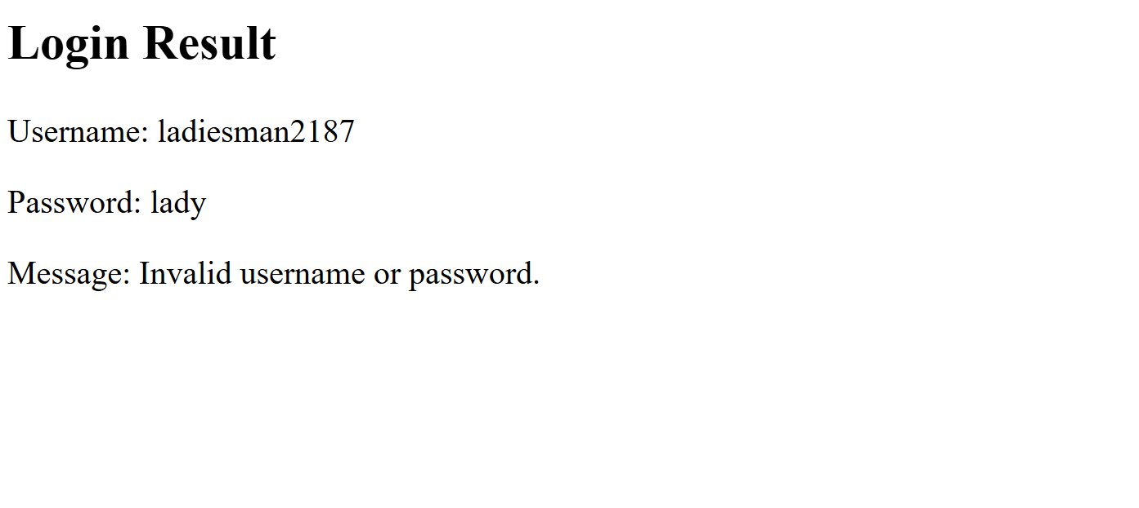
Figure 36 Applying the http filter results in hiding many of the captured packets.


- Take a screenshot of the running application at this point.
- Paste the image into a Microsoft Word document.
- Put a caption below the image explaining what is being demonstrated.
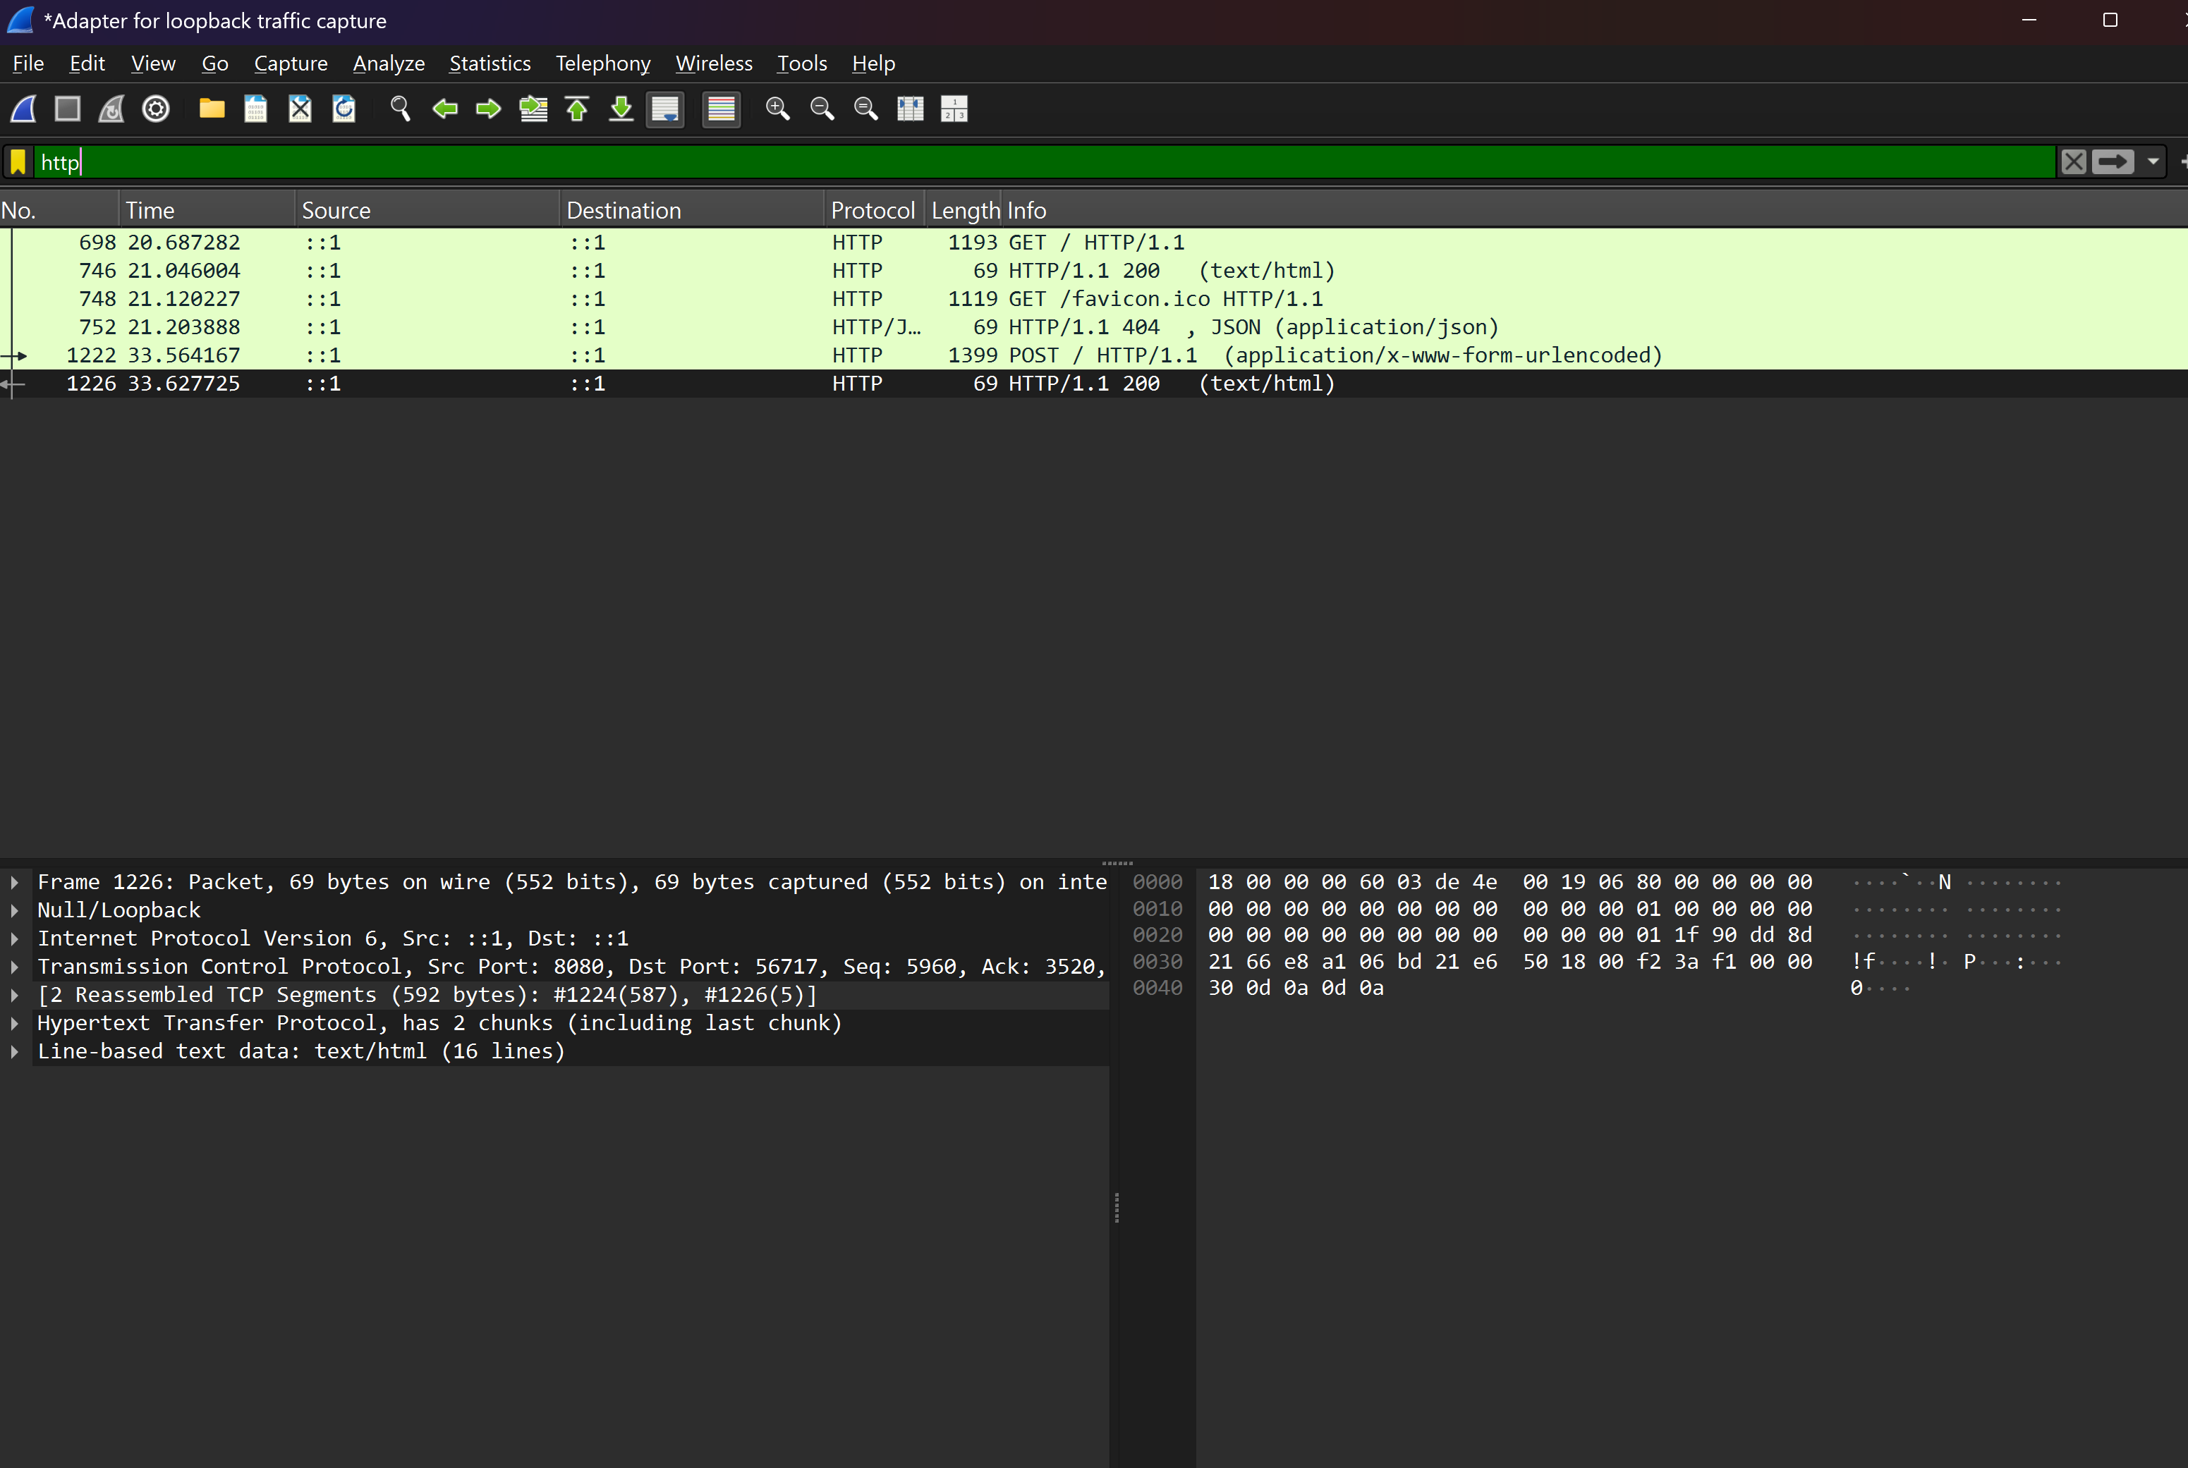

Figure 39 Following the GET request displays the contents of the web page, cookie information and other details about the request.


- Take a screenshot of the running application at this point.
- Paste the image into a Microsoft Word document.
- Put a caption below the image explaining what is being demonstrated.

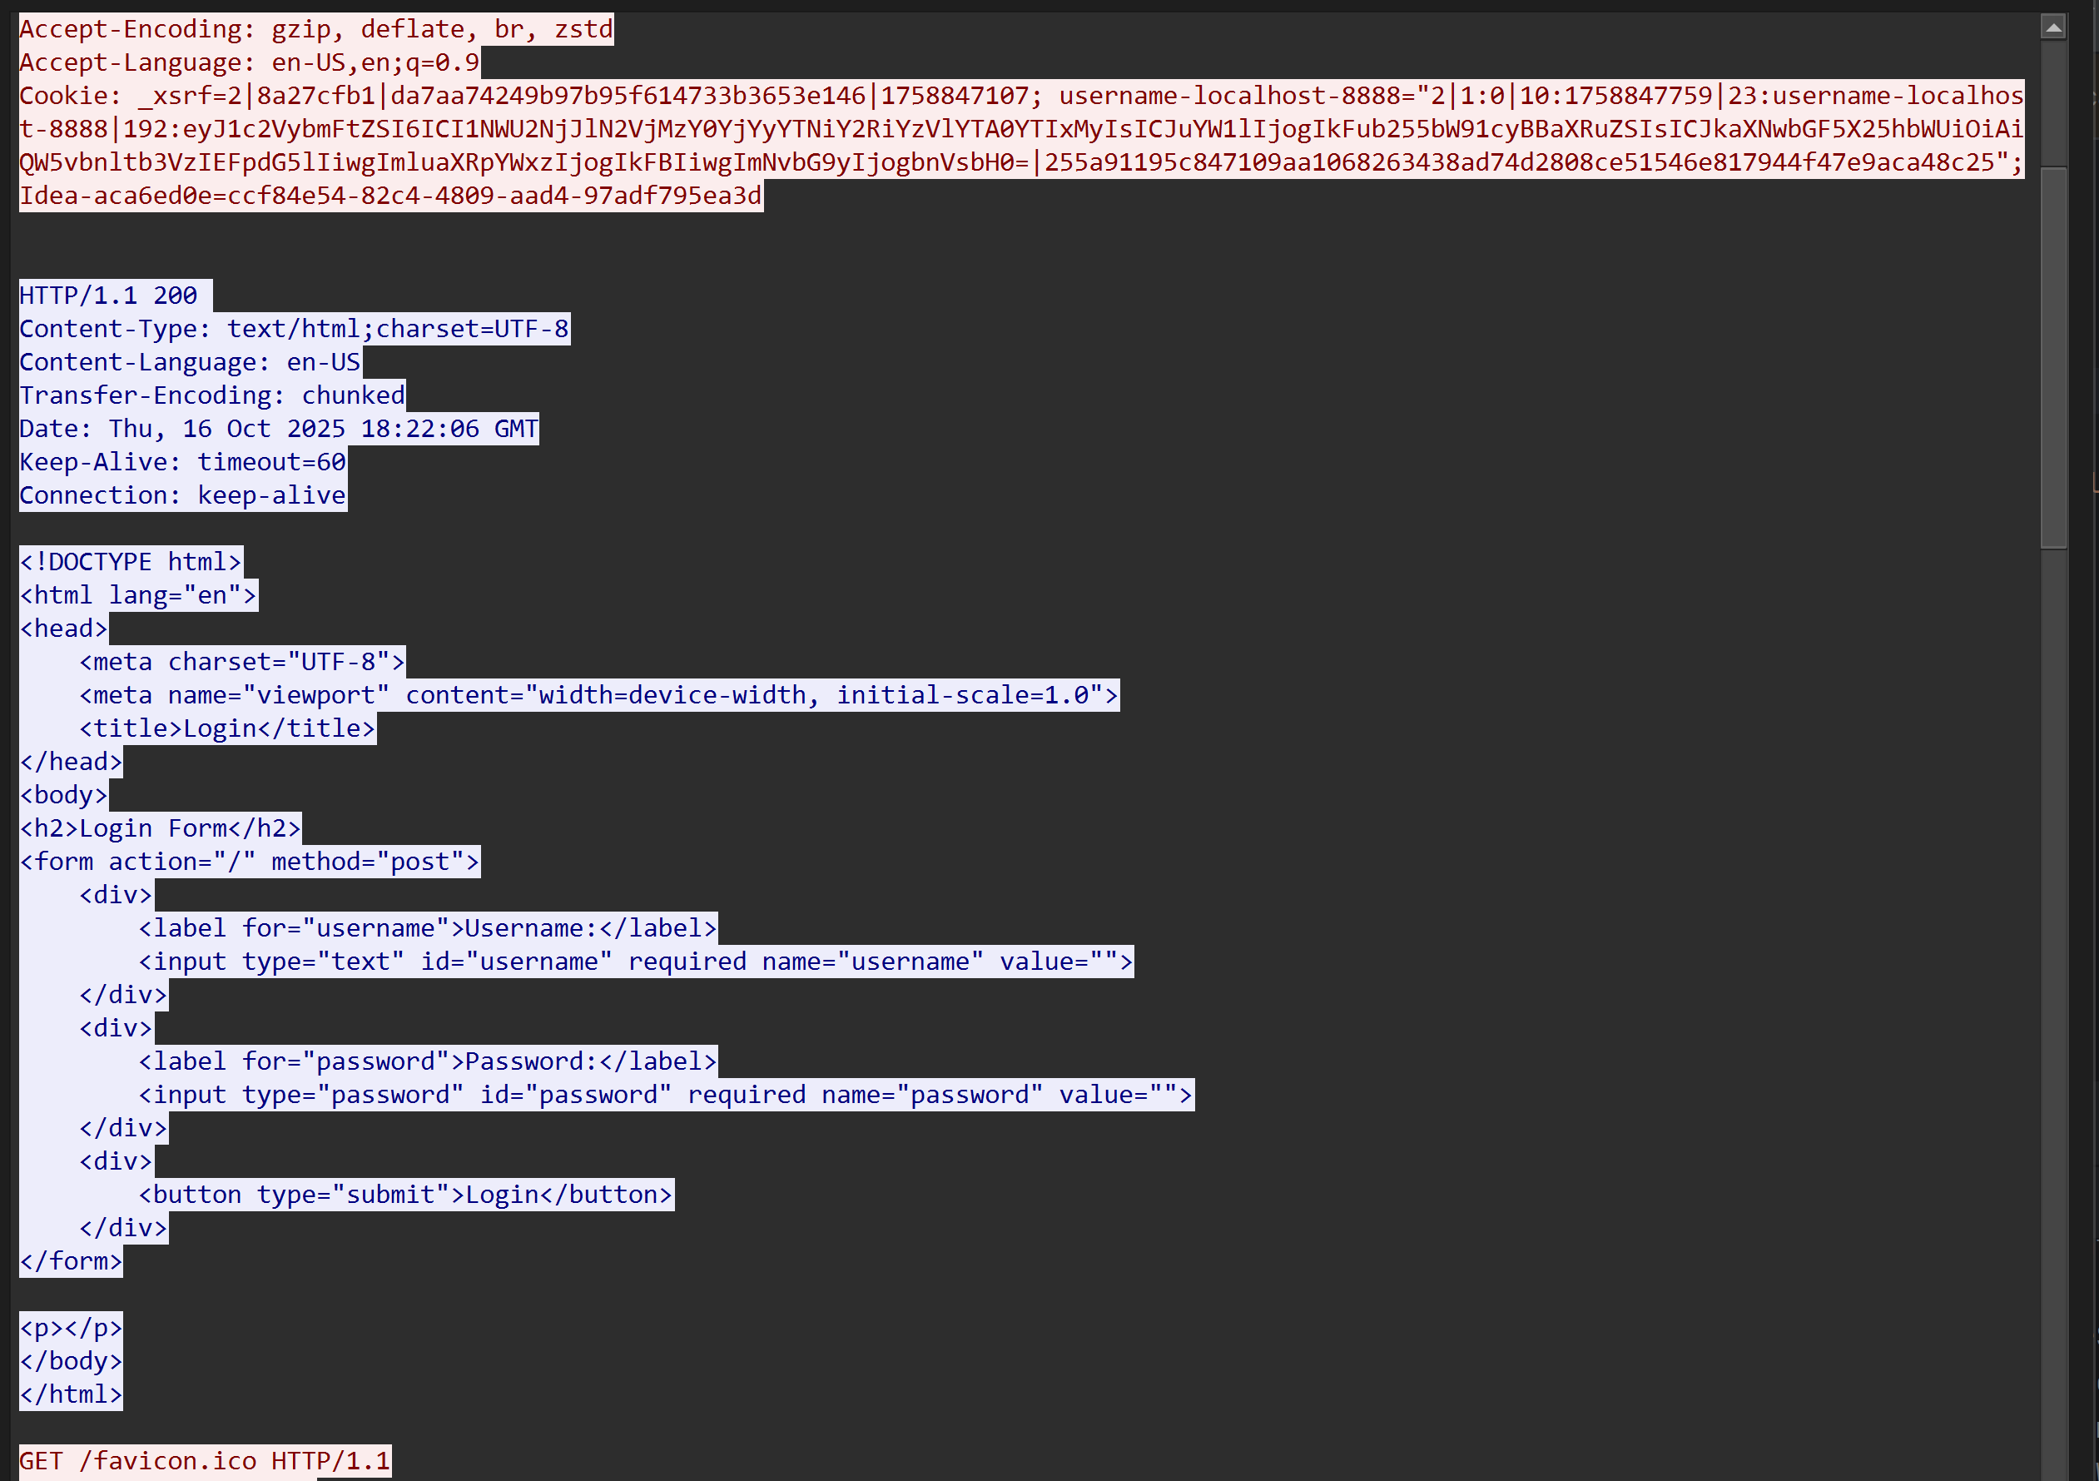


- Take a screenshot of the running application at this point.
- Paste the image into a Microsoft Word document.
- Put a caption below the image explaining what is being demonstrated.
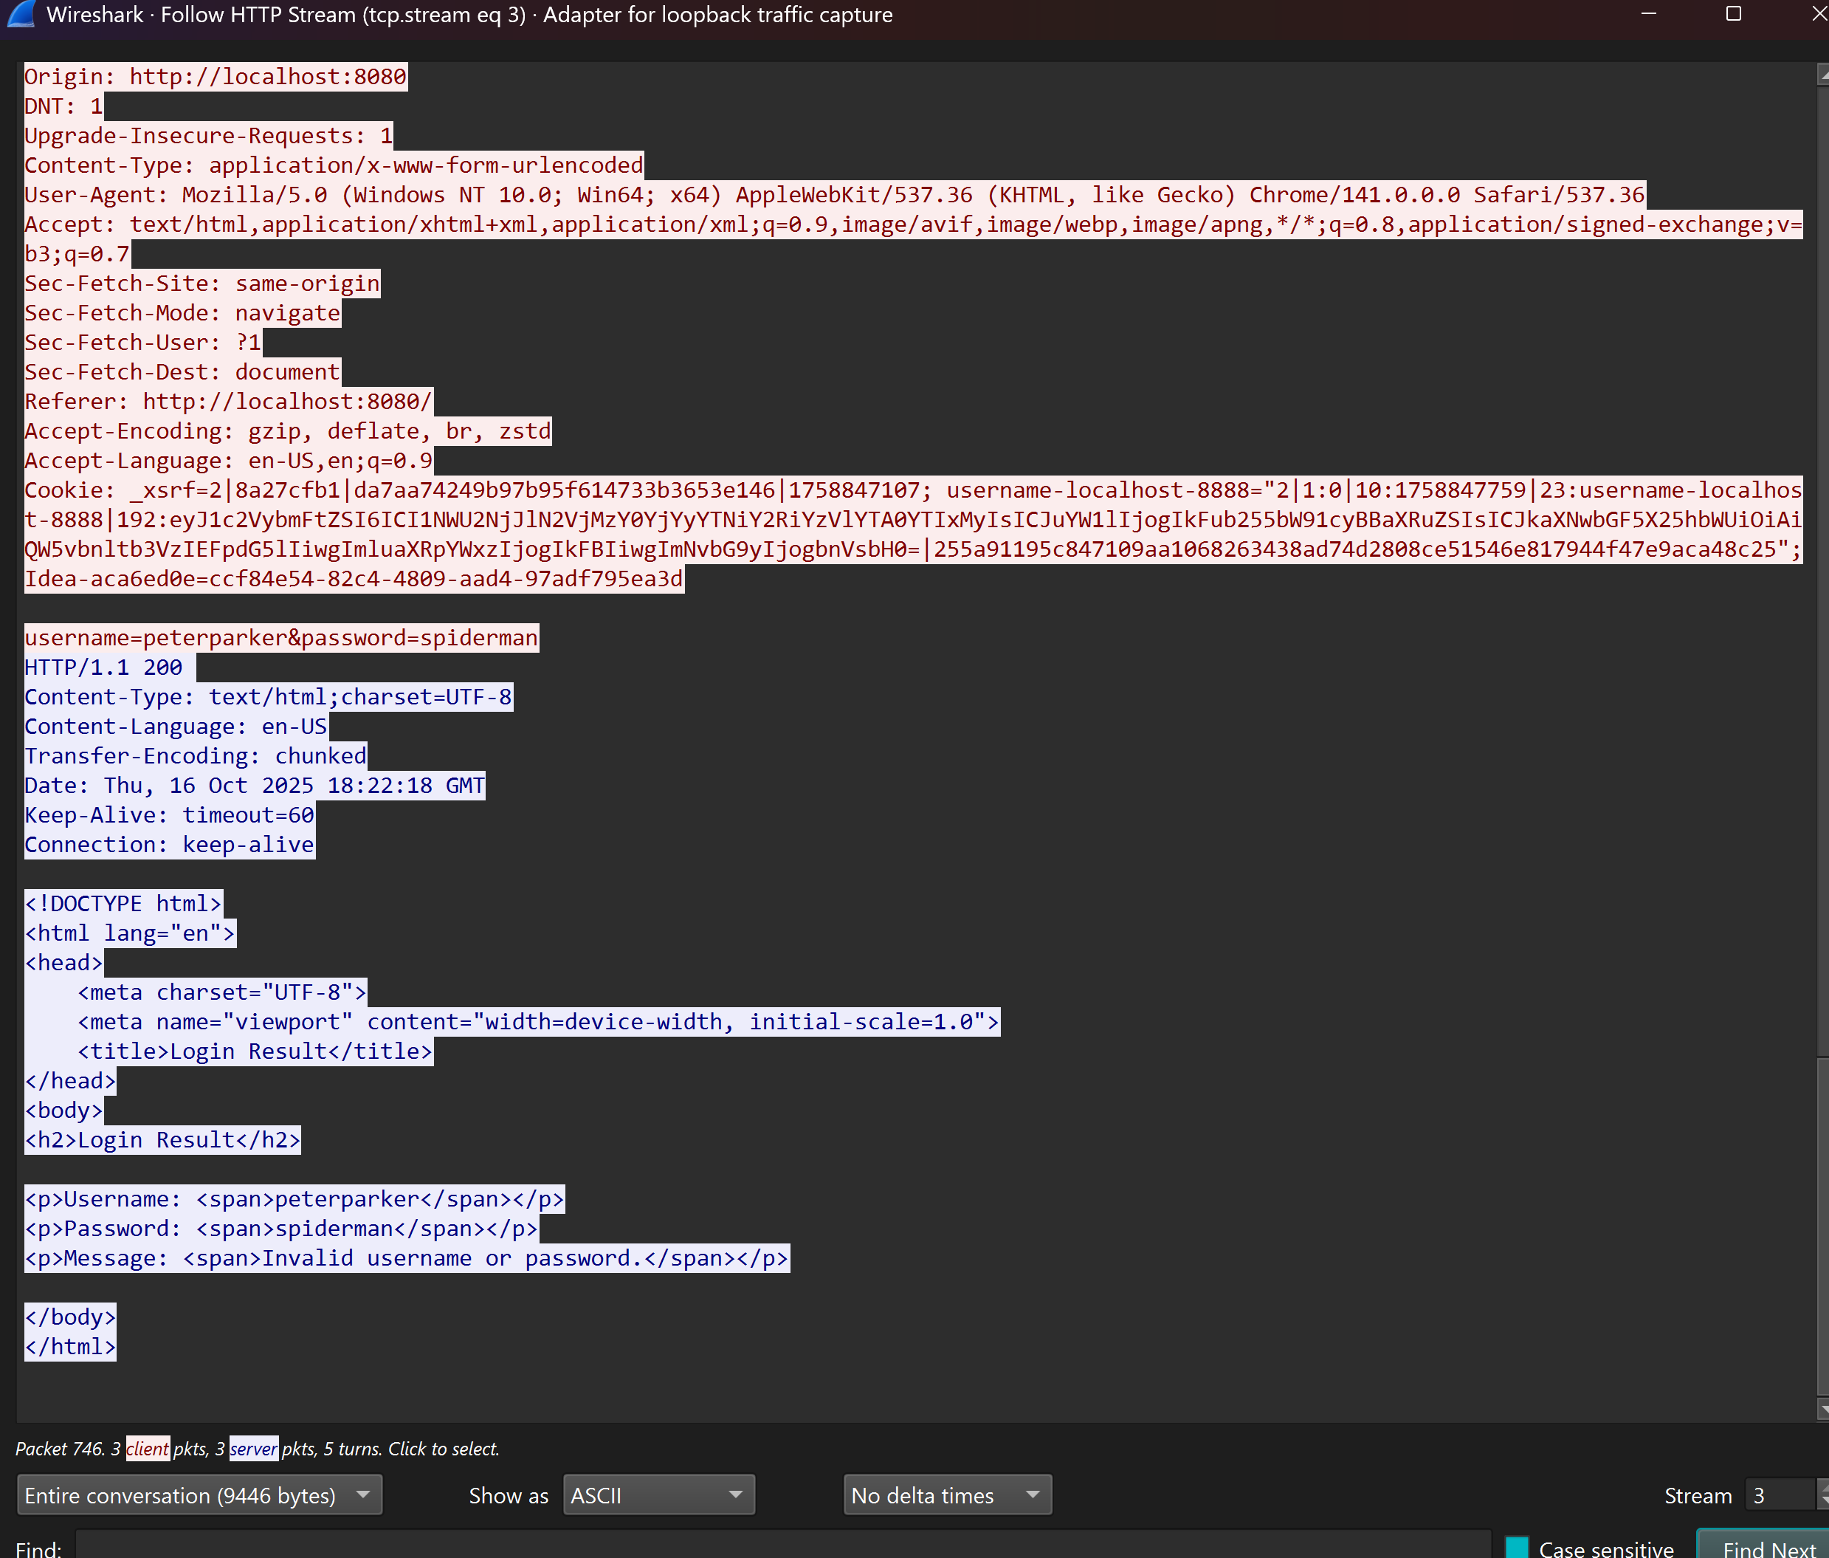

HTTP | Hypertext Transfer Protocol | Sends hypertext pages for World Wide Web applications.
TCP | Transmission Control Protocol | Ensures reliable, ordered delivery of data between computers over a network.
SNMP | Simple Network Management Protocol | Used to monitor and manage network devices such as routers, switches, and servers.
FTP | File Transfer Protocol | Transfers files between a client and a server on a network.
SMTP | Simple Mail Transfer Protocol | Sends outgoing email messages from a client to a mail server or between mail servers.
IMAP | Internet Message Access Protocol | Retrieves and manages emails from a mail server while keeping them stored on the server.
POP3 | Post Office Protocol version 3 | Downloads emails from a mail server to a local device and usually deletes them from the server.
DNS | Domain Name System | Translates domain names (like google.com) into IP addresses that computers can understand.
SSH | Secure Shell | Provides secure remote access and command execution over a network.
UDP | User Datagram Protocol | Sends data quickly without ensuring delivery, used in real-time applications like streaming and gaming.
RDP | Remote Desktop Protocol | Allows users to remotely connect and control another computer’s desktop interface.
VoIP | Voice over Internet Protocol | Enables voice communication and multimedia sessions over the internet.
DHCP | Dynamic Host Configuration Protocol | Automatically assigns IP addresses and network settings to devices on a network.
LDAP | Lightweight Directory Access Protocol | Accesses and manages directory information, like user accounts, in an organized database.
TLS | Transport Layer Security | Provides encryption and secure communication over networks, especially for websites and emails.


- Take a screenshot of the running application at this point.
- Paste the image into a Microsoft Word document.
- Put a caption below the image explaining what is being demonstrated.
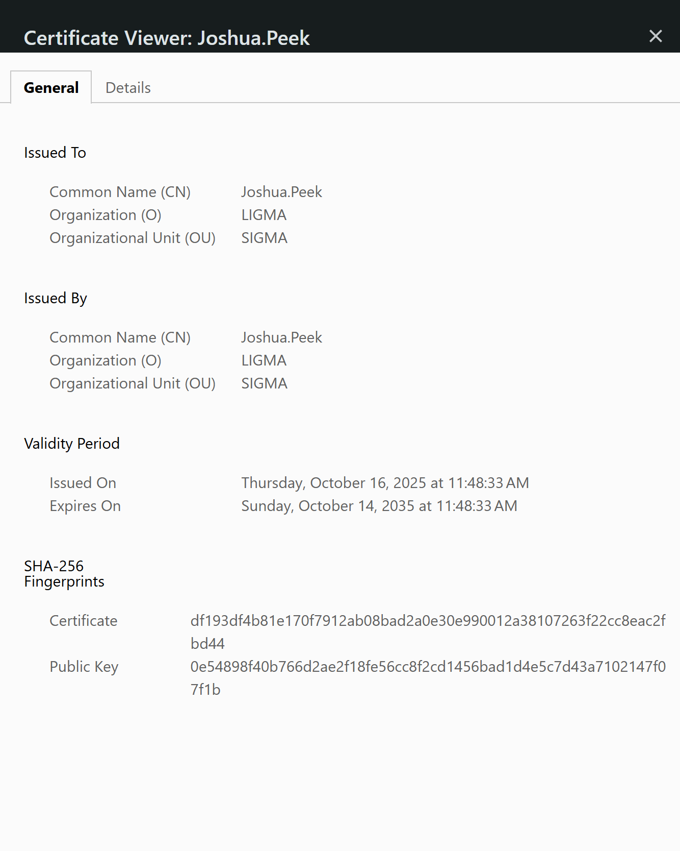

Repeat the Wireshark Process with the SSL-Enabled Application


- Take a screenshot of the running application at this point.
- Paste the image into a Microsoft Word document.
- Put a caption below the image explaining what is being demonstrated.
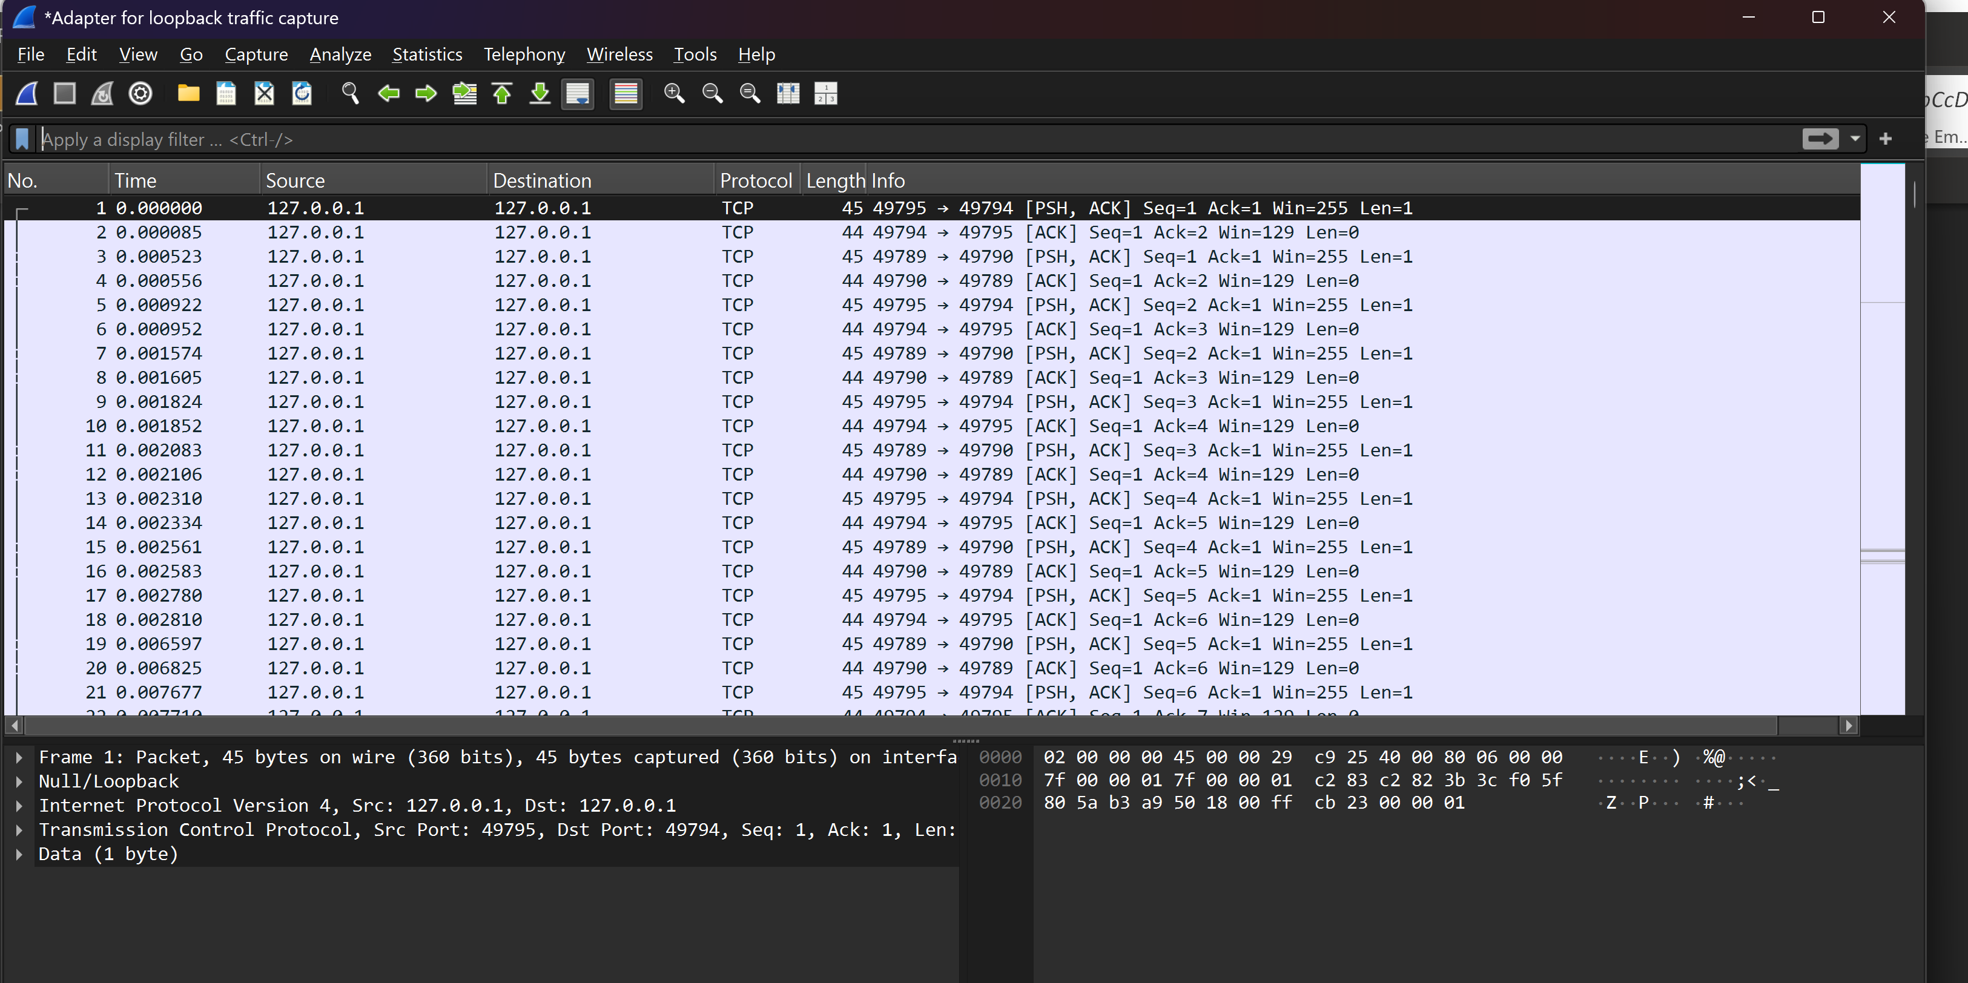
No http captured


- Take a screenshot of the running application at this point.
- Paste the image into a Microsoft Word document.
- Put a caption below the image explaining what is being demonstrated.
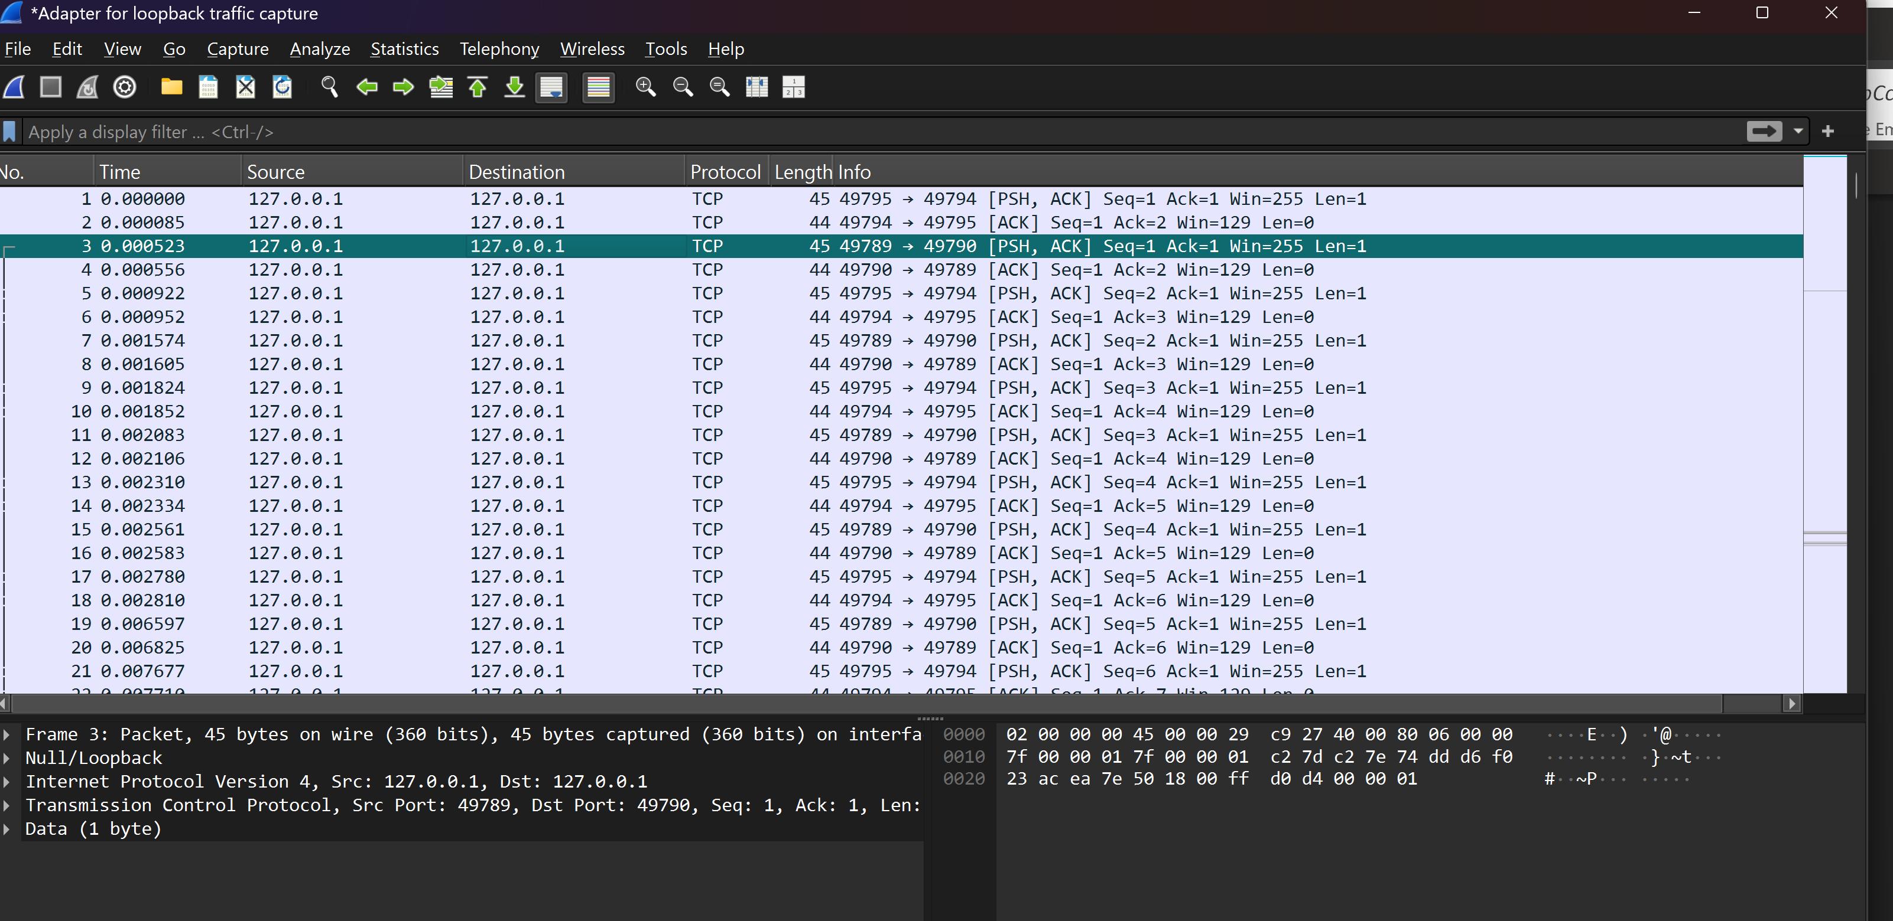TCP shown

Criteria | % Value | 1: Unsatisfactory | 2: Less Than Satisfactory | 3: Satisfactory | 4: Good | 5: Excellent
Network Security Concepts & Wireshark Demonstration | 30% | Demonstrates little or no understanding; screenshots missing or irrelevant. | Some concepts or steps missing; screenshots incomplete or unclear; major errors in explanation. | Demonstrates basic understanding of Wireshark, HTTP, HTTPS, and SSL/TLS with appropriate screenshots. | Demonstrates clear understanding of all steps and concepts; screenshots are relevant and well-labeled. | Demonstrates deep understanding with detailed, annotated screenshots and insightful explanations (e.g., on security risks, encryption, packet contents, protocol transitions).
Spring Boot Login App Development & Testing | 25% | Code not present, not running, or screenshots missing; no functional demonstration. | Partial code or runs with errors; major steps missing; unclear or missing screenshots. | App is functional; login demonstrated; shows HTTP and HTTPS modes; screenshots present. | App fully functional, clearly demonstrates login, HTTP vs HTTPS, and integrates SSL/TLS; all required screenshots and explanations. | App is professional, well-documented; all states and transitions shown (login, error, secure mode); screenshots annotated and steps are easy to follow.
Protocols Table & Security Analysis | 25% | Protocols table not submitted or mostly blank; analysis missing or incorrect. | Table is incomplete or contains significant errors; summary missing or unclear. | Protocols table is mostly complete and accurate; summary paragraph covers key points of lesson. | Table is fully complete and accurate; summary paragraph is clear and insightful about network security. | Table is thorough, accurate, and includes extra detail (e.g., real-world examples); analysis is comprehensive, reflective, and highlights best practices.
Documentation, Screenshots, and Submission Quality | 20% | Screenshots missing, not captioned, or irrelevant; document disorganized or incomplete. | Most screenshots or captions missing; document is difficult to follow; deliverables incomplete. | Most screenshots present and captioned; document follows assignment instructions and is organized. | All screenshots, captions, and deliverables present and well-organized; document is easy to follow and professional in appearance. | Documentation is exceptionally clear and well-organized, with all deliverables, captions, and annotations; formatting and presentation are outstanding.

