18.5 – Azure Mini Project: HDInsight

# Exercise 1: Create a Spark Cluster on HDInsight

Figure - Basics Configuration

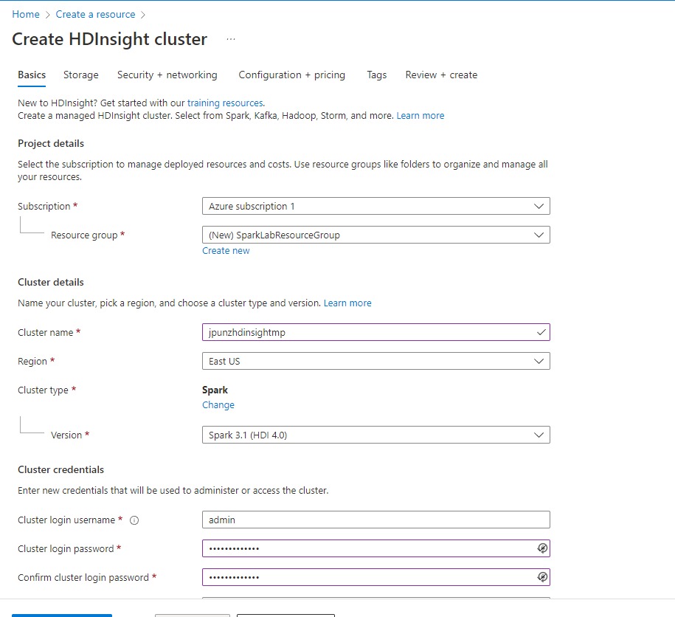

Figure - Storage Configuration

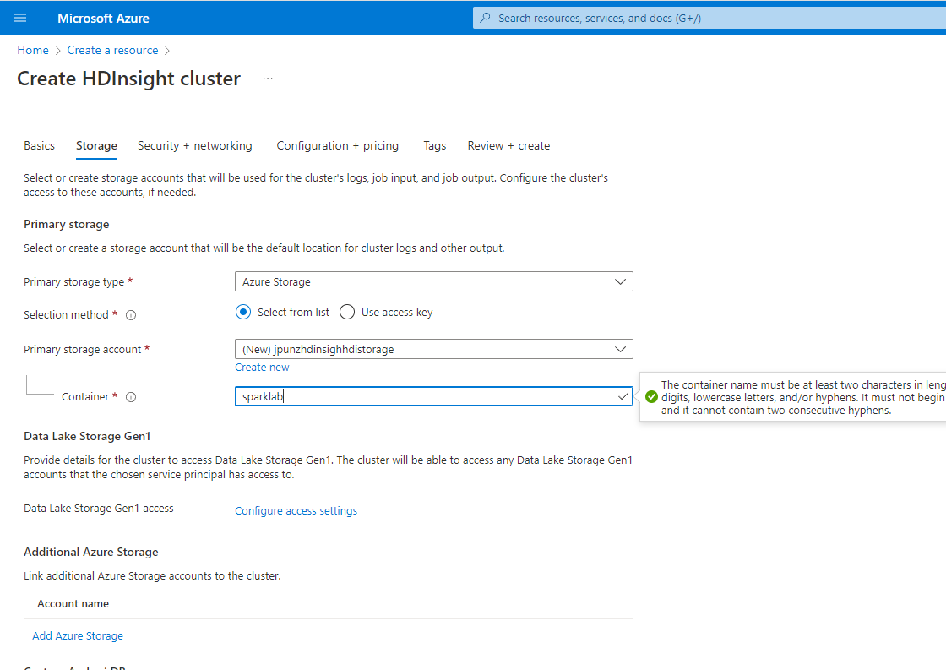

Figure - Node Configuration

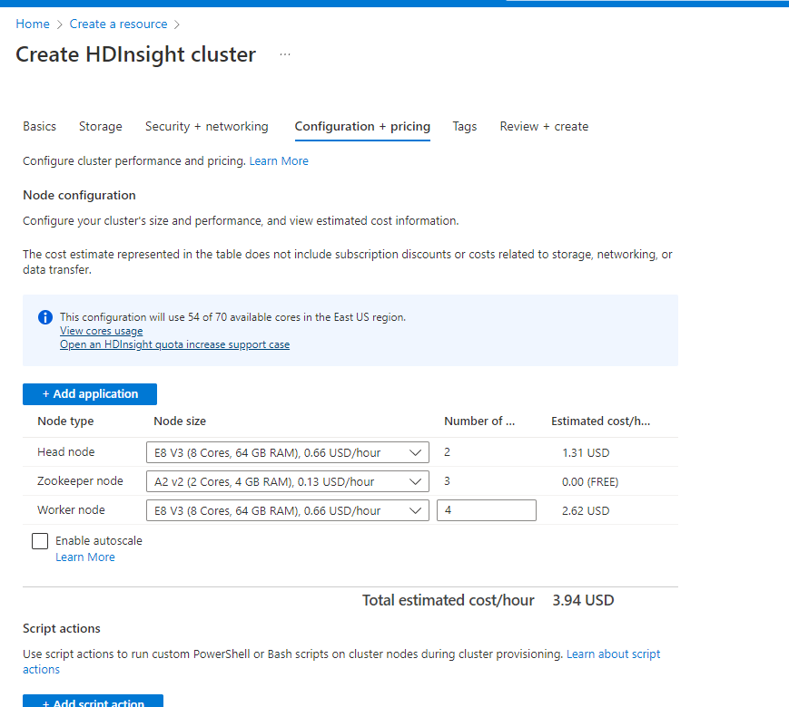

Figure - Configuration Review

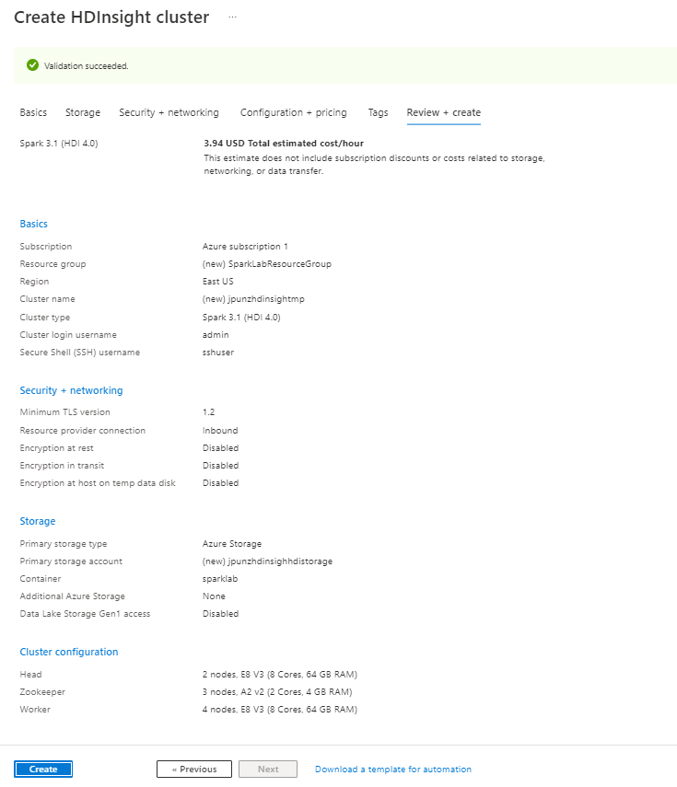

Figure - Resources Created

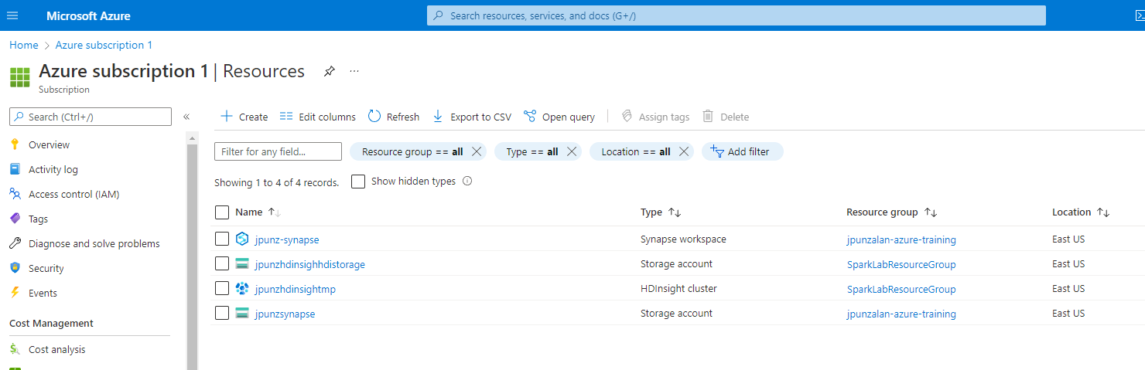

Figure - Upload Files to Blob Container

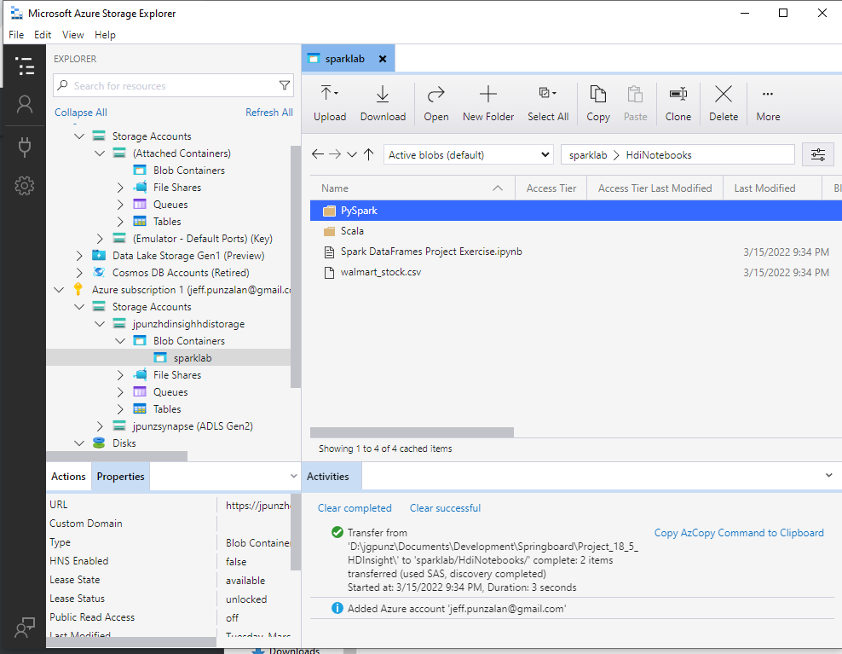

Figure - Check Cluster Dashboard

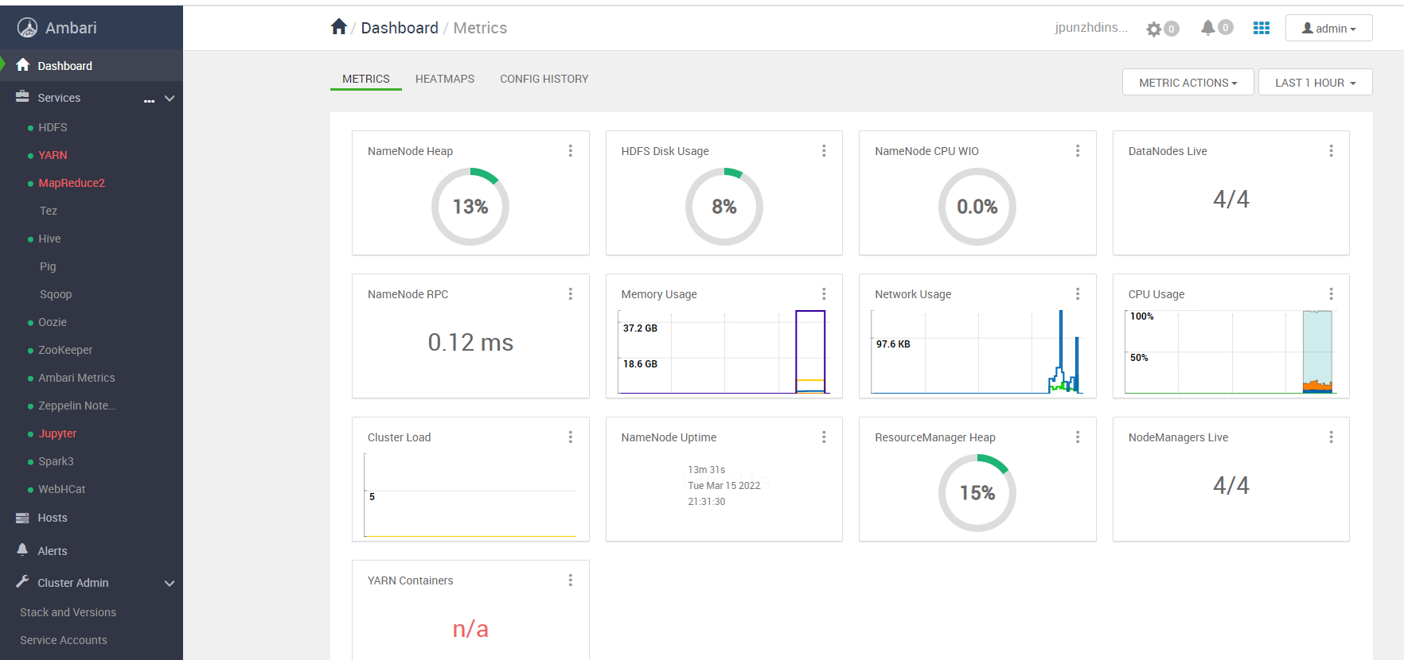

Figure - Run Jupyter Notebook

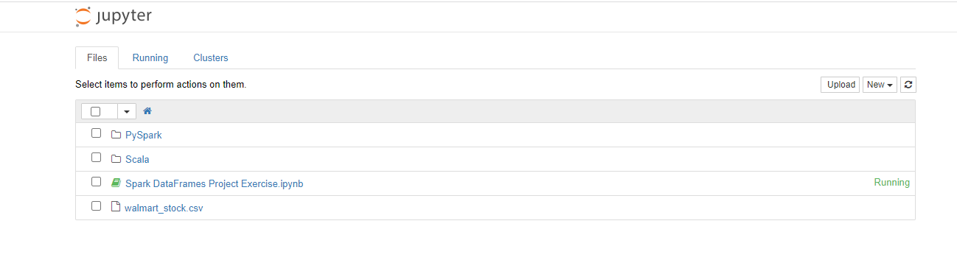

Figure - Delete HD Insight Cluster

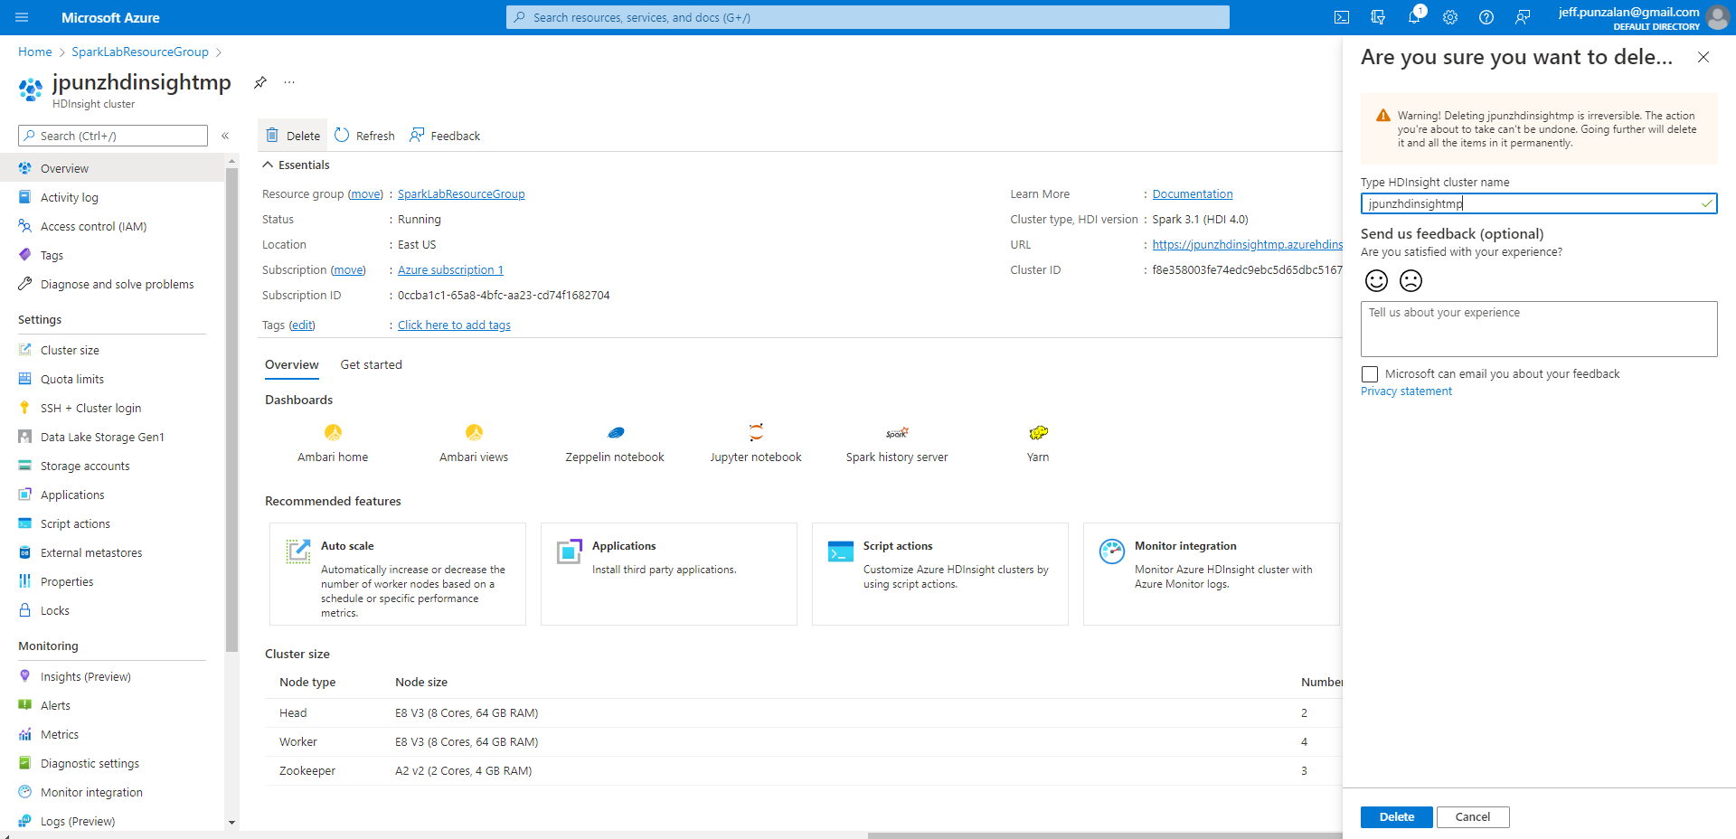

Figure - Delete Project Resource Group

