ReadMe.txt.

**Overall Description**

I created this site dedicated for my love of Coffee.

I wanted to create a slick, calming and simple layout.

I tried to achieve this my basing my colour scheme off of a simple picture I found, see below.



I then created a colour scheme/wheel with this. See below:

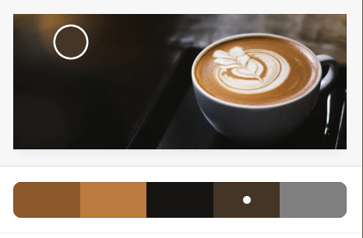

The purpose of the site is to give coffee lovers a place to research the deeper details about coffee.

**Technical Description**

1. Visual
   1. Images

Images were chosen for this website that fit into the colour scheme of the overall site. The main header picture was spread across the top of each page. This was done using CSS:

grid-column-start: 1; -🡪 starts in the left column

grid-column-end: span 3; -🡪 ends in the right column

width: 100%;

display: block;

height: 40vh;

margin-left: auto;

margin-right: auto;

background: url(Coffee-banner.png); 🡪 chooses the picture

background-repeat: no-repeat; 🡪 ensures it doesn’t repeat multiple times in the space

background-size: cover;

* 1. Headings

Unless otherwise stated I used the following colours on the headings and used them to give context to the page – using decreasingly stark colours signifies less significance of headings and allows the user to be drawn to the more significant headings on the pages.

h1 {

color: #9F6834

}

h2 {

color: #9F6834

}

h3 {

color: #7C7A84

}

h4 {

color: gray;

}

* 1. Videos

Inserted multiple YouTube videos into the site. Tried to remove as much of the YouTube branding as I could, but this has mostly been disabled since 2018. I chose videos that were concise but still stayed true to the overall feel of the page. I also chose where to starts the videos so that when the user started them it would be relevant.

Using “?start=119", and standardised the look of the videos using:

iframe {

display: block;

width : 500px ;

height : 250px;

margin: 0 auto;

}

1. Templates / .ejs
   1. 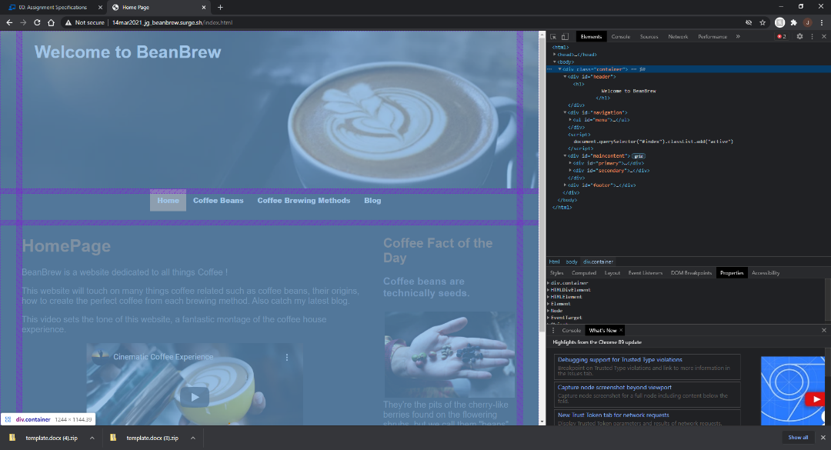Grid

This website was broken up into 3 columns, and 4 rows.

.container {

display: grid;

grid-template-columns: 3% 92% 3%;

grid-gap: 1%;

font-size: 20px;

}

This allows the text not to get to close to the edge, and breaks up the sections on the page for the user, and keeps the sections from running into each other.

The main content is then further broken out into 2 columns, this allows the website to maximise the amount of content in the main section.

* 1. _Layout

<html>

<head>

<link rel="stylesheet" href="css/home.css">

<title>Home Page</title>

</head>

<body>

<div class="container">

<div id="header">

<h1>

Welcome to BeanBrew

</h1>

</div>

<%- yield %>

<%- include('./partials/_footer.ejs'); %>

</div>

</body>

</html>

The _layout.ejs file contains the header and declares where the rest of the content will fill into using “<%- yield %>”. The “<%- include('./partials/_footer.ejs'); %>” then lets the footer to be written on every page after the main content.

* 1. Partials - _Footer / _Secondary

The _Footer, as seen in section ‘b’ above, is placed in every page. placing this into the layout .ejs makes the code more efficient.

The _Secondary.ejs is shared between Home page and blog page.

1. Navigation
   1. Tabs

_navigation.ejs This file is a template for the navigation bar. Naming the <li> of each tab <li id=”name”>, and the subsequently

<script>

document.querySelector("#<%= id %>").classList.add("active")

</script>

Allows the active tab to be shown without re-writing code.

* 1. Flexbox

#navigation {

display: flex;

justify-content: center;

}

#navigation > div {

width: 100px;

margin: 10px;

text-align: center;

}

This sets the navigation to the centre of the page dynamically.

1. Deployed

Using Surge and Harp I deployed the site to:

* http://14mar2021_jg_beanbrew.surge.sh/index.html

**Sources**

**Flex box** -<https://www.w3schools.com/css/css3_flexbox_items.asp>

Dropdown Navig -https://www.w3schools.com/howto/tryit.asp?filename=tryhow_css_dropdown_navbar.

The majority of the content has been derived from other similar coffee websites.