Student Name : 12430732

Url : 14Mar2021_JG_BeanBrew.surge.sh

OK to include in demo video : Yes

|  |  |  |  |  |  |
| --- | --- | --- | --- | --- | --- |
| Grade Band | *Content* | *Structure* | *CSS Rules* | *Project Structure* | Design |
| Baseline | 8 pages in total | Well-formed and structured | Concise | Complete | All fonts, heading and paragraph styles are kept uniform and consistent. |
| Good | Includes Images of multiple styles. | Use of Class/ID/DIV | 4 SS used and called in ‘home.css’ | Complete | Each page has a theme and the navigation gives it a intuitive flow.  >Home  >Coffee Beans  - Different types detail  >Coffee brew methods  - Different types detail  > Blog |
| Excellent | 8 pages in total.  Incl. 4 YT videos. | Navigation bar tells user where they are in the page. With active tabs. | Used grid to split up page into 3 columns.  Then again 2 columns within the main content | Was able to use _layout.ejs to reduce and streamline the amount of code having to be re-written.  I.e. staying away from ‘WET’. | Concise and legible design.  If I had any criticism, it may be too ‘wordy’ or have too much text in some areas. |
| Outstanding | Deployed:  14Mar2021_JG_BeanBrew.surge.sh | No use of Semantic | Flex box used for the navigation bar. | Used following. ejs partials for all:   * _footer.ejs * _navigation.ejs   Used this for Index and Blog page:   * _secondary.ejs | Stayed consistent with the colours. Used the header picture to create the ‘mood’ and the colour wheel. Then used these colours throughout the website.  I even tried to choose images and videos that would keep the same feel.  Starting videos at specific points to make them relevant.  It tries to give a feel of sophistication and elegance. |

Additional Notes:

Techniques you have employed in the project that you have acquired independently. Short notes in each technique/technology:

1. Drop down menu in the navigation bar. Used the below links to help me integrate this into my project. In act I used this website many times to quickly test individual parts of the HTML and CSS separately.
   1. https://www.w3schools.com/howto/tryit.asp?filename=tryhow_css_dropdown_navbar_clic
   2. https://www.w3schools.com/howto/tryit.asp?filename=tryhow_css_subnav
2. Flexbox for navigation. Used this to allow my navigation section to always be in the centre of the screen.
   1. https://www.w3schools.com/css/css3_flexbox_items.asp

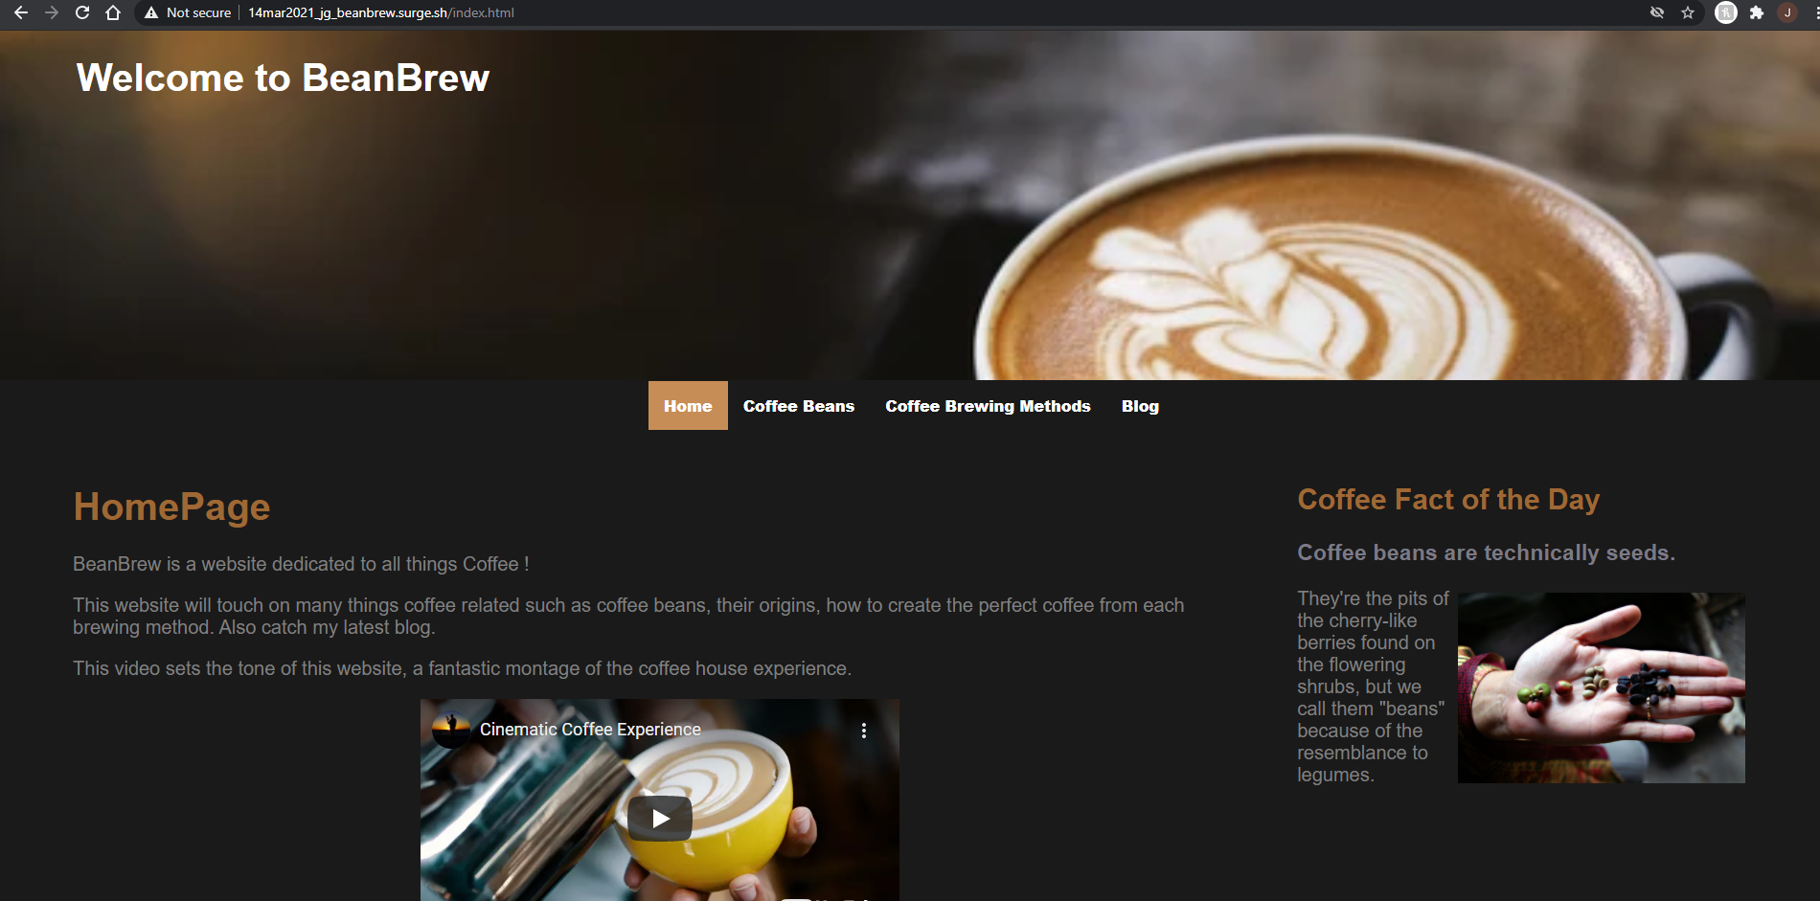

__________________________________________________________________________________________________________

Grading Spectrum

