**Analysis Workflow – ChocAn Database**

**Group 10 – Charles Miller, Joshua Green**

**Texas A&M University – Corpus Christi**

**Scenarios**

**Manager – Prints Weekly Services**

1. Manager logs in
2. Manager selects Print Services
3. Software Prints report
4. No data to print, software displays error

**Manager – Prints Claims**

1. Manager logs in
2. Selects claims to print
3. Selects Print
4. Software prints the selected claims
5. If no claims selected when print selected display error

**Member – Enroll**

1. User logs on as Anonymous
2. User selects Enroll
3. System presents data forms and instructions
4. User fills out data forms
5. User selects submit
6. Error message presented if the user selects submit with null data fields, or invalid information.

**Member – Request Services**

1. Member logs in
2. Member selects request services
3. Member selects desired services
4. Member selects submit
5. If no desired services are selected when submit is selected, print error message

**Member – Pay Fee**

1. Member logs in
2. Member selects Payment Options
3. System present payment options forms and fields
4. Member fills out payment info fields
5. Member selects pay
6. System alters Member’s balance.
7. System displays receipt.
8. Error message is presented if payment info fields are null or invalid.
9. If the fee goes unpaid, System prints error message

**Member – Unenroll**

1. Member logs in
2. Member selects Request Unenroll
3. System requests confirmation from member.
4. Member confirms
5. System forwards request to Operator

**Scheduler – Run Accounting Procedure**

1. Runs procedure on Fridays at designated time.

**Provider – Provide services**

1. Provider logs in
2. Provider opens messages
3. Provider selects service requests
4. System gives Provider the requesting member’s info.

**Provider – File claim**

1. Provider logs in
2. Provider selects File Claim
3. Provider fills out claim form and fields.
4. Provider selects Send
5. Claim form or field(s) are null or invalid, print error message.

**Provider – Member Verification**

1. Provider logs in
2. Provider selects Verify Member
3. Provider fills in Member’s Identifying Information
4. Provider selects Verify Membership
5. System verifies member, prints Verified if yes, Unverified if no.
6. Print error message if information is null or invalid.

**Operator – Member Verify**

1. Operator logs in
2. Operator selects Verify Member
3. Operator fills in Member’s identifying information
4. Operator selects Verify Membership
5. System verifies member, prints Verified if yes, Unverified if no.
6. Print error message if information is null or invalid.

**Operator – Add Actor**

1. Operator logs in
2. Operator selects Add Actor
3. System presents Actor information form and fields
4. Operator fills out Actor information
5. Operator confirms information and selects Add Actor
6. System adds Actor to database
7. Prints error message if null information
8. Print error message if there is an existing Actor with same information

**Operator – Modify Actor**

1. Operator logs in
2. Operator selects Modify Actor
3. System provides Operator Database access
4. Operator searches for Member or Provider to alter.
5. Operator alters desired information
6. Operator selects confirm
7. System updates information
8. Prints error message if information is null or invalid
9. Prints error message if information is duplicated.

**Diagrams**

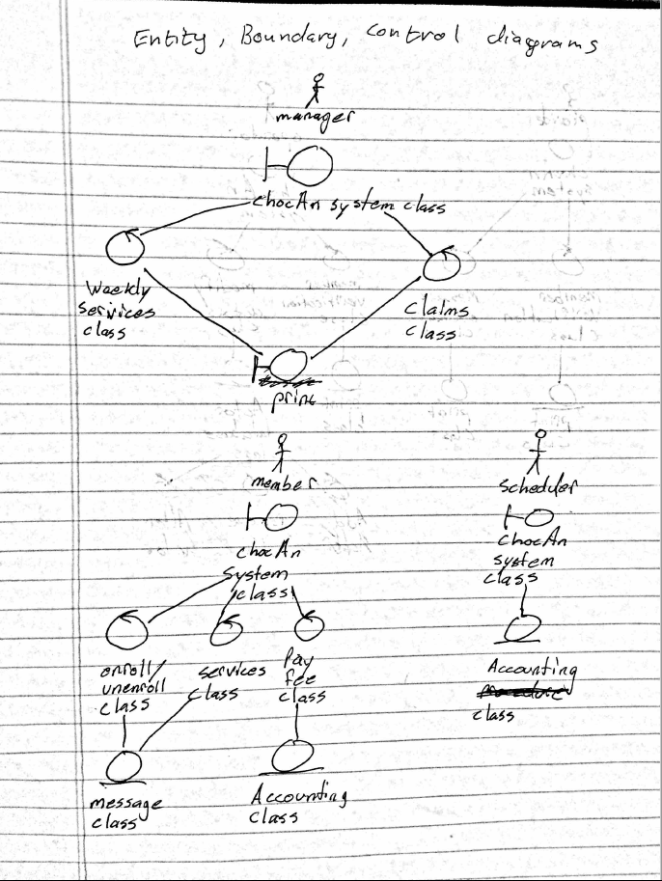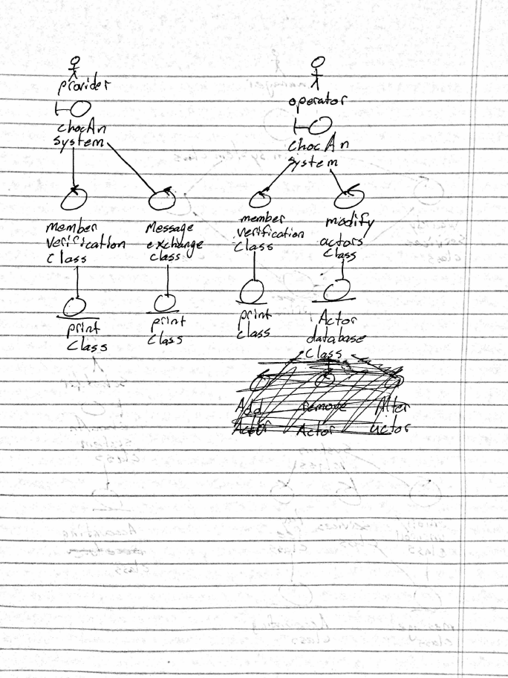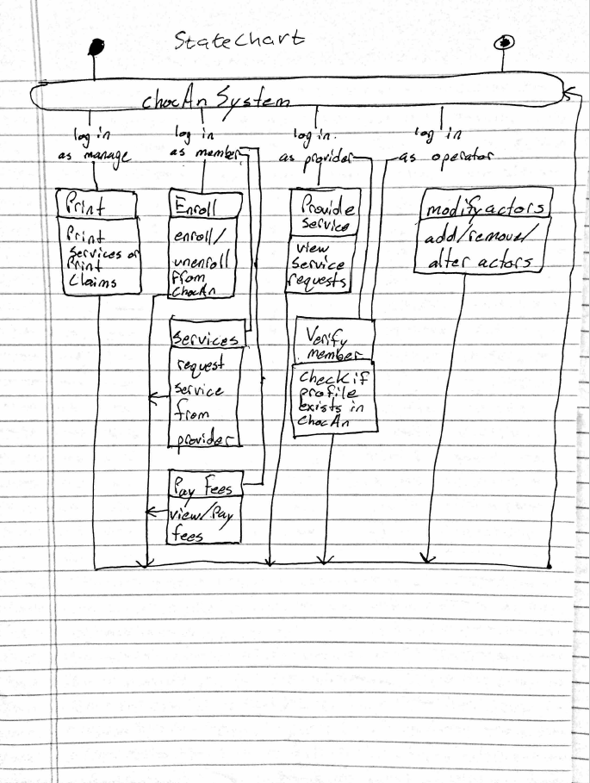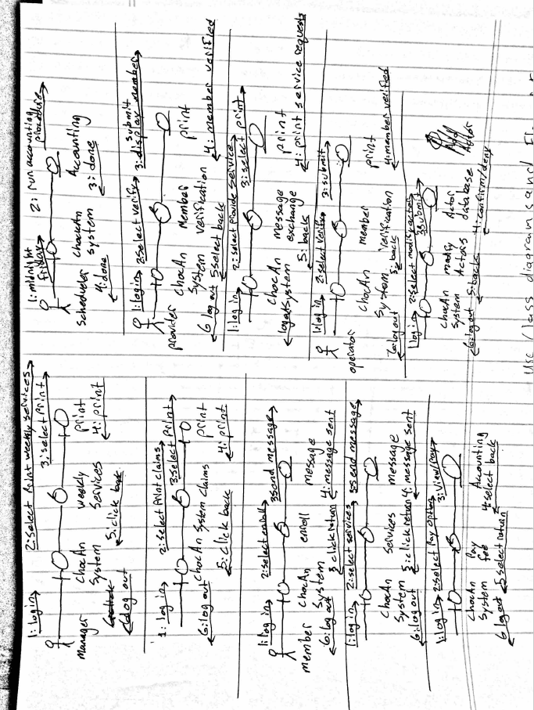

**Contributions**

**Note:** All elements were completed jointly, with one person taking lead, while other was a consultant/correctness checker. Similar to paired programming.

Charles – Spearheaded the design work, took the lead on the Flow of events diagram, the Entity, Controller, and Boundary class diagram, and the statechart.

Joshua – Took lead on the Class diagram, and the Integrated Class diagram. Created and formatted final document.

Scenarios were made jointly. Joint decision was made to overlook certain diagrams as they appeared superfluous to the design work that was already done.