VPAssignment 1
Chapter 1: (5 points per question, 10 points per problem)
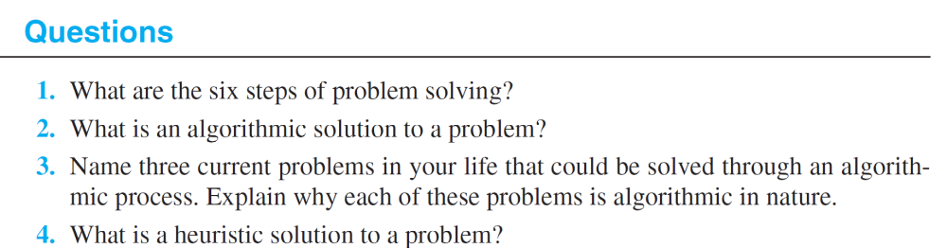

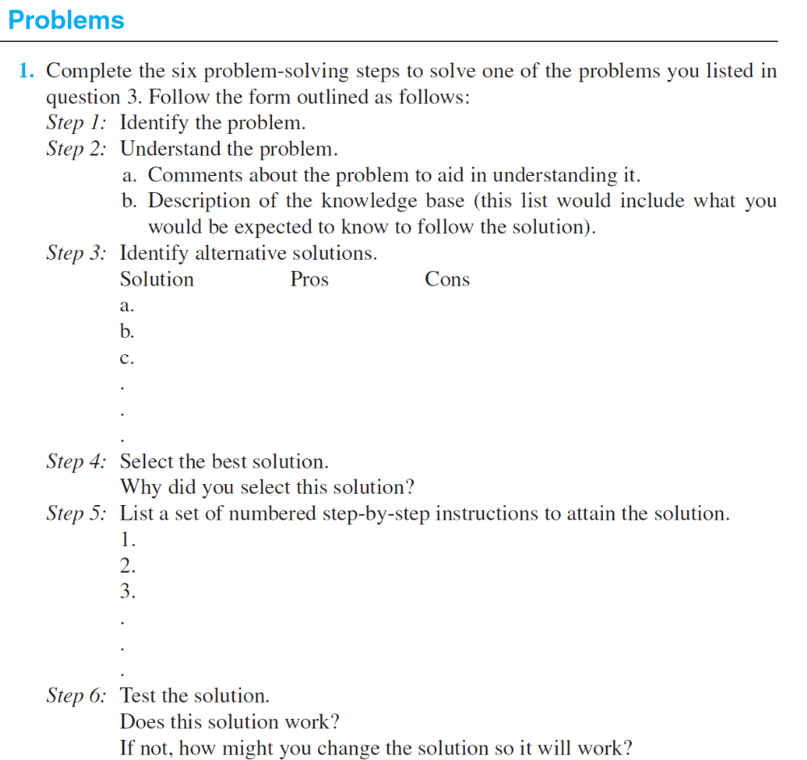
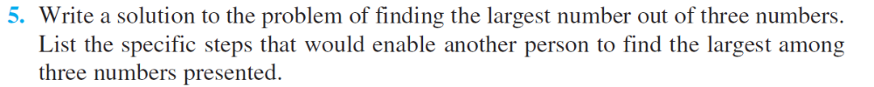

Chapter 2 (10 points per question, and per problem)
