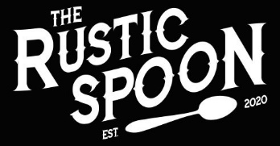

LOCAL SIMPLE HONEST

HOME ABOUT US MENU CONTACT PHOTOS Reservations

**ABOUT**

**US**

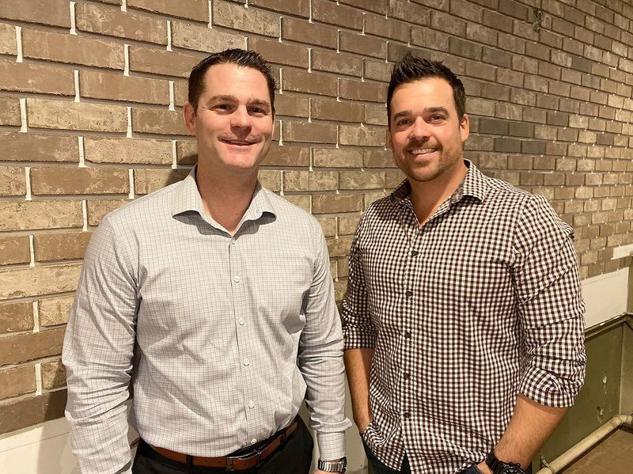

*“The Rustic Spoon, …. rooted in comfort food recipes with a modern Virginia Beach twist.”*

*-Lee Belote, The Virginia Pilot*

*Insert “About Us” Info Here*



©2020 Rustic Spoon 1658 Pleasure House Road Virginia Beach, VA 23455 757-555-5555