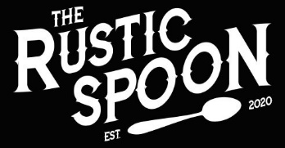

LOCAL SIMPLE HONEST

HOME ABOUT US MENU CONTACT PHOTOS Reservations

*“DEDICATION TO EXECUTION”*

*- RYAN HINES, CO-OWNER*

**Contact**

**us**

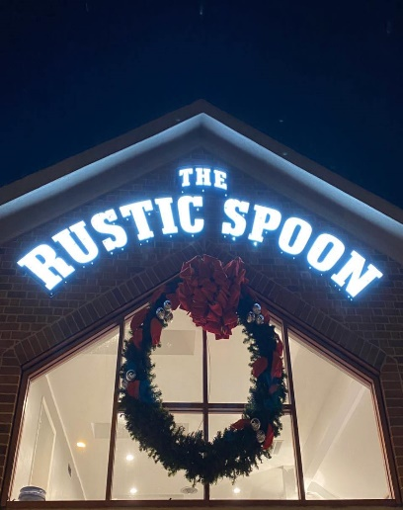

Visit us:

1658 Pleasure House Rd Suite 101

Virginia Beach, VA 23455

call us:

(757)937-8930

fax us:

(757)937-9067



©2020 Rustic Spoon 1658 Pleasure House Road Virginia Beach, VA 23455 757-937-8930

This is the “Contact” page. This page will tell visitors how to call, email, or travel to The Rustic Spoon.

Hopefully, I can layer the Rustic Spoon img in a transparent format