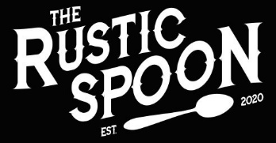

**Carousel 3 signature dish images**

**1-Lunch dish**

**1-brunch dish**

**1-breakfast dish**

Elevated comfort food

HOME ABOUT US MENU CONTACT PHOTOS Reservations

*“DEDICATION TO EXECUTION”*

*- RYAN HINES, CO-OWNER*

**Menu**

(PDF IMAGE SHOWING DISH NAMES AND PRICES)

BRUNCH

FOOD $

LUNCH

FOOD $

BREAKFAST

FOOD $



©2020 Rustic Spoon 1658 Pleasure House Road Virginia Beach, VA 23455 757-555-5555