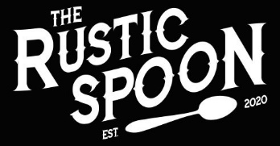

LOCAL SIMPLE HONEST

HOME ABOUT US MENU CONTACT PHOTOS

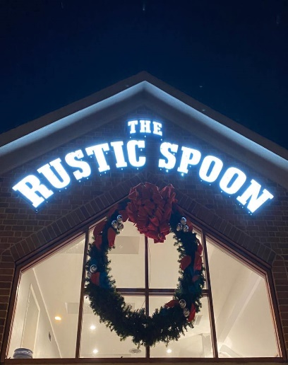**photos**

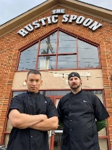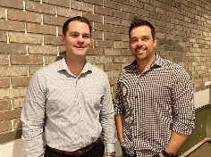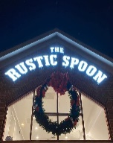

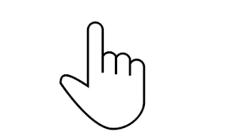



©2020 Rustic Spoon 1658 Pleasure House Road Virginia Beach, VA 23455 757-555-5555

This is the “Photo’s page”. Pictures will be presented as a slide show that must be manually changed to another image by clicking/selecting the image.