Assignment 1
MAP524A
Friday, February 27, 2015
Justin Grice
029929122
John Selmy

Summary
The purpose of this app is to allow users to view both real-time and historical Canadian-Foreign exchange rates. It will allow users to view the data in multiple formats, including graphs for easy comparison, and allows for users to dynamically make changes to these formats for the best viewing experience. It will be based around the Foreign Exchange Rate data set (http://open.canada.ca/data/en/dataset/c81647b8-1f6c-4fb3-8f61-45746211ef27) for historical data and will use the Fixer.io JSON API for real-time exchange rates. Fixer.io was chosen to supplement the Canada Open Data set due to the limitation of the set only providing monthly historical data while Fixer.io provides daily sets for comparison.

Explanation
A mobile app is a good choice for this project because it provides an easy option for users to access the exchange rate data. The limited screen sizes of mobile platforms requires information to be provided in short, easy to read formats. This is ideal for applications that want to display information in graph formats. It is also useful that mobile applications have a touch interface allowing for easier manipulation of the graph elements without requiring bulky UI elements, further allowing us to leverage screen space.

Basic App Features
The app will contain and implement the following features:
- Allows users to get real-time foreign exchange rates
- Allows users to review historical data of foreign exchange rates
- Allows users to view historical data in an interactive graph format
- Allows users to dynamically adjust time ranges of graph and supports multiple rates on same graph for comparison purposes
- Allows users to save rates they’re interested in reviewing later

Expected Users
Expected users for the app are financial analysts that would like to review exchange rate data out of the office or while traveling. People planning to travel can use the app to plan when to exchange their currency ahead of time by predicting changes in the data provided.

Mock-ups
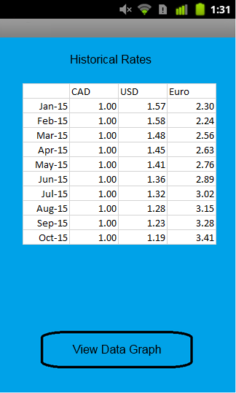
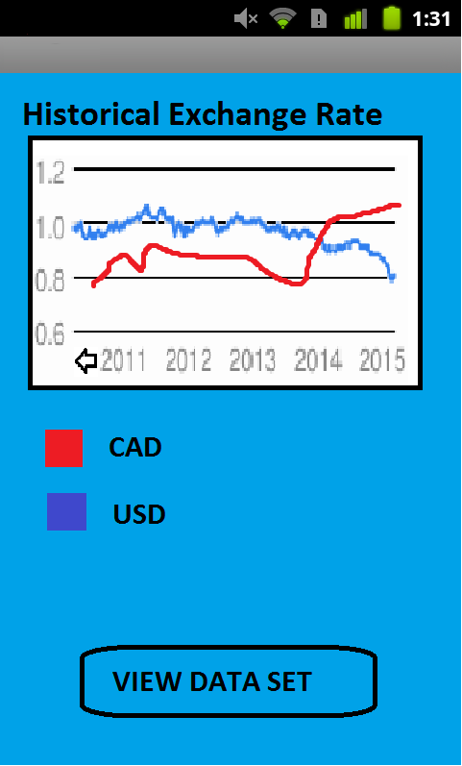
Figure 1 Mock-up of Graph View for Data Figure 2 Mock-up of Tabular Data
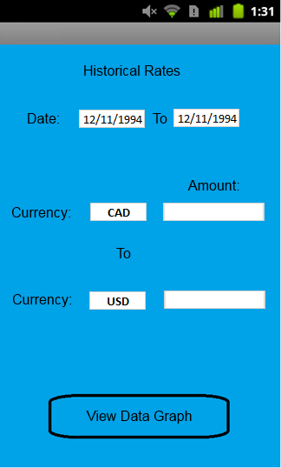
Figure 3 Mock-up of Currency Conversion View

Use-Cases
A common use case for this app is a user wants to find the rate a currency was exchanged at during a certain date range. The app accomplishes this by prompting the user for a date range as well as the 2 currencies being converted, as shown in Figure 1. The user then provides the info and the app automatically updates in real-time to show the average rate over that range.
Another use case is the user wants to find detailed exact exchange rates for currencies over a date range. The app will repeat the steps outlined in the previous use case and then prompt the user to ‘View Data Graph’. When the user selects the option, the app will display Figure 1 with data populated from historical currency data provided by the open data set. The app then prompts the user to ‘View Data Set’ for if the user prefers the detailed data in a table format. When the user selects this option, it displays Figure 2 with the table listing monthly/yearly historical data based on the length of the data range(Large ranges have table data broken down by year with the option to view monthly by default).

Timeline
The following implementation timeline outlines the objectives for the project and estimated completion dates.
Date | Objective
27-Feb-15 | Complete Part 1
06-Mar-15 | Basic Views Completed
13-Mar-15 | Interface to retrieve data from data sets Completed
20-Mar-15 | Integrate data retrieval interface with views
27-Mar-15 | Table and Initial Conversion view Completed fully
03-Apr-15 | Graph view Completed Fully, App Testing Completed
10-Apr-15 | Part 2 Final Report Completed, Project Submitted

Conclusions
The project of implementing an Android application to provide historical foreign exchange rates based on an Open Data set should provide an interactive and simple to use application, while providing accurate, verified data to the end user. The project can be completed in a reasonable timeframe and should be an ideal experience for working with the Android system.

