Language Translation - PoC
Oct 1st 1021
jgrindall

- Demo

  - Please first watch the videos:

http://www.numbersandpictures.com/lang/videos.zip

  - Then open the lesson:

http://www.numbersandpictures.com/lang/vl1154s_glidereflection/vl1154s_glidereflection.html

I have added language translation to the second dropdown only (Definition) so don't look at any other dropdowns. Feel free to experiment and save some new translations into the database.

The videos explain the basic functionality, and more information is below.

- How it works

AS3 Lessons are managed by a file called content_player.

content_player handles loading the lesson, loading any notes, audio, and the slider/pagination.

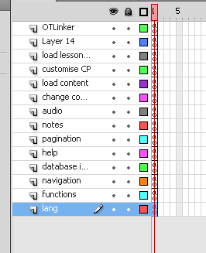

As you can see in the above image, I have just added a few lines of code in a new layer called “lang”, which loads the language manager.

The lesson id is passed into content_player and the language manager loads the translations from a database, as well as displaying the user interface widget.

Each dropdown is pre-processed by a jsfl file, which does the following:

- Inserts a blank frame at the start of the lesson and initiates the manager. The blank frame is needed because the “process me” events (see below) will not reach the Language manager if they are sent immediately.

- Go through the main timeline and convert any StaticText fields that are on the stage into movieclips. It goes through each layer and each keyframe in each layer to find the text fields.

- Go through every library item (in other words, every symbol in the lesson, including new ones that were made in step b!) and find any static textfields. Convert them to movieclips and attach some code that dispatches a “process me” event. This code will run when the textfield appears on the stage. You can see the code snippet in Layer2 below. All it does is dispatch an event.

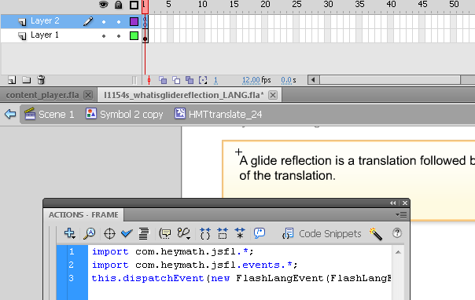

- Update the publish settings of the fla to include the Langauge Manager code (in particular the “process me” event .as file)

- Save and publish. Currently it saves with a new name but it could save with the same name to avoid anyone having to change anything else.

When any “process me” event is dispatched it bubbles all the way up to content_player, which passes it to the Language Manager.

When the textfield disappears from the stage the Language manager removes it from the list of textfields it is managing. If it re-appears (for example scrubbing the slider) then it gets added again.

The GUI widget does the following:

- Allows you to select a language

- Allows you to turn on/off rollovers and clicks

- If turned on then when you rollover a textfield you see the translation in the widget.

- Translations are done by search and replace. In other words if you have a sentence “This is a square” and its translation “C'est un carré” then when you add that to the database it will replace “This is a square” everywhere in that lesson. It will not do anything to “That is a square” for example, translations must match exactly.

- If you click on a textfield and if your userid is registered for editing translations then you can use the edit and click buttons to add a new translation. They are done in reverse order, meaning that the most recent translation of a particular sentence is used if there is more than one in the database.

- Your edits are cached locally until you click on Save

- If you click the “display” button then you can toggle whether the original text or the translated text is shown. You can't do any editing in the “display” mode, you have to turn it off and click on the actual original text fields.

I am envisaging the process being as follows:

- Flash designer makes the lesson, in its original language (can be any, doesn't have to be english)

- .fla is uploaded to cms. The server runs the jsfl file and spits out the new fla, and publishes it to swf. No human should ever open the converted fla, it will be full of many (possibly hundreds) of extra movieclips and attached code, and messing with them is not a good idea. In my opinion it means no editing at all of the converted files.

- When a user opens the file the content_player loads the relevant data from the database. The new swf loads and each of its textfields has the relevant code attached.

It seemed a lot simpler to me to make each lesson in one language and have all available languages listed in the GUI rather than having a subset of languages for each locale.

- Next steps

AS2 - This will not work for AS2. I think if I re-write the whole code it could work, but I have not tried yet.

Handling depths - some textfields are simply hidden underneath something else. We can do these “by hand” by adding into the database the translation. They will appear if the “display” button is selected but it is impossible to have any rollover or click events on them.

Test a lot more AS3 lessons - need to check different languages

Text direction - should be simple to change textfields so that they can go right to left for certain languages.

Need to decide a way to determine which lessons have what languages “available” to them. At the moment I have added es and fr to the database, so they appear in the widget. You can't currently add any Hebrew because there is no button - we need to figure out what buttons appear.

Dirty reads/writes - ideally only one person at a time should edit the translations for a lesson otherwise you will be viewing translations that someone else has already changed - not sure how to enforce that!

The old code in content_player looks a mess to me, needs tidying up a lot!

