Ordinal Numbers | 

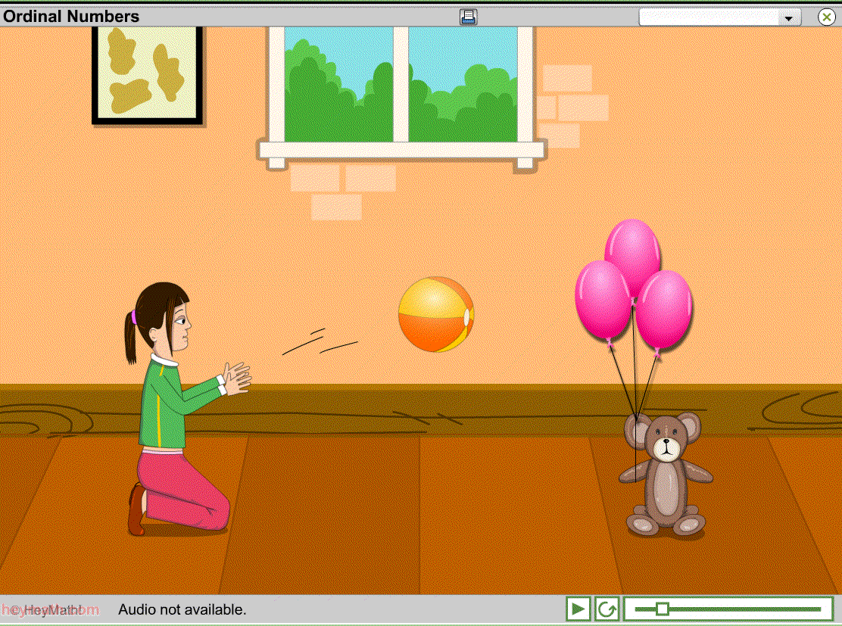  Lesson Contents  - Animation – 1 minute  - Activity – 5 minutes  Learning Objectives  - To apply the concept of ordinal numbers to a temporal setting.  - Practice using ordinal numbers.  Prerequisites  - Some familiarity of ordinal number-words and numerals.  Maths Vocabulary  - First  - Second  - Third  - Fourth  - Fifth  - Sixth  - Seventh  - Eighth  - Ninth  - Tenth | Guide to the Unit  This fun but challenging unit enables students to practice using ordinal numbers in a temporal rather than spatial context.  Animation  Watch this animation carefully. A girl throws a ball into a teddy bear. This causes a chain of events culminating in a toy astronaut flying through the air into the girl’s hands. There are ten toys involved in all, the students may want to view the animation two or more times so that together they can remember the chain of events.  Activity  In the activity students have to order the toys as to their involvement in the chain of events. Initially they must match ordinal numerals with the randomly arranged set of pictures. The students can go back to the animation at any point to revisit what happened. After successfully completing this task the students are then asked to “Select the picture that comes (e.g.) fourth.” This tests their ability to understand ordinal number-words. Once the entire activity is complete lots of balloons are released!  Teacher Information  Name of the School :  Name of the teacher :  Date used :  Signature:  Comments (continue on reverse):

