Repeated Addition on the Number Line | 

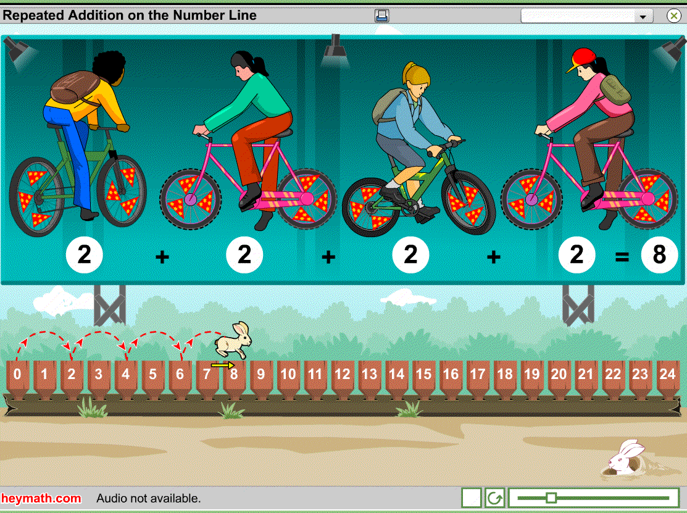  Lesson Contents  - Introduction – 5 minutes  - Activity – unlimited  Learning Objectives  - Understand what repeated addition is.  - Understand the actions required to perform repeated addition on number line.  - Become familiar with representing repeated addition as 2 numbers - the number of jumps and length of each jump.  - Gain a foundation for study of multiplication.  Prerequisites  - Comfort in counting 24 items.  - Familiarity with adding more than two numbers together.  - Familiarity with the number line.  Maths Vocabulary  - Repeated addition | Guide to the Unit  This unit considers repeated addition on the number line in order that students become familiar with representing repeated addition as 2 numbers – the number of jumps and the length of each jump – the same 2 numbers that we use to rephrase repeated addition as multiplication.  Introduction  The bicycle gang is shown on a huge billboard. Each member of the gang puts flags on their bicycle’s wheels. The students consider the number of wheels that 4 bicycles have, the number of flags on the 8 wheels and the number of stars on 3 flags.  Each problem is considered as repeated addition. The students can count to work out the answer, before watching Hopper perform the repeated addition on the number line. How many jumps did Hopper make? How long was each jump? Each question is answered with a visual portrayal of what each jump represents.  Activity  The activity allows students to practice rephrasing repeated addition as the number of jumps Hopper must make, and the length of each jump. Doing this, they will gain a strong foundation for understanding multiplication and also become familiar with the numbers in the multiplication tables.  A scroll bar allows students to check that Hopper has jumped correctly.  In the classroom, students could take it in turns, count together, or have volunteers inputting the answers. The random and unlimited nature of the activity means students can play it many times without repeating the same questions; the students are motivated to do this so that they can collect many smiley rabbit faces.  Teacher Information  Name of the School :  Name of the teacher :  Date used :  Signature:  Comments (continue on reverse):

