Addition on the Number Line – up to 10 | 

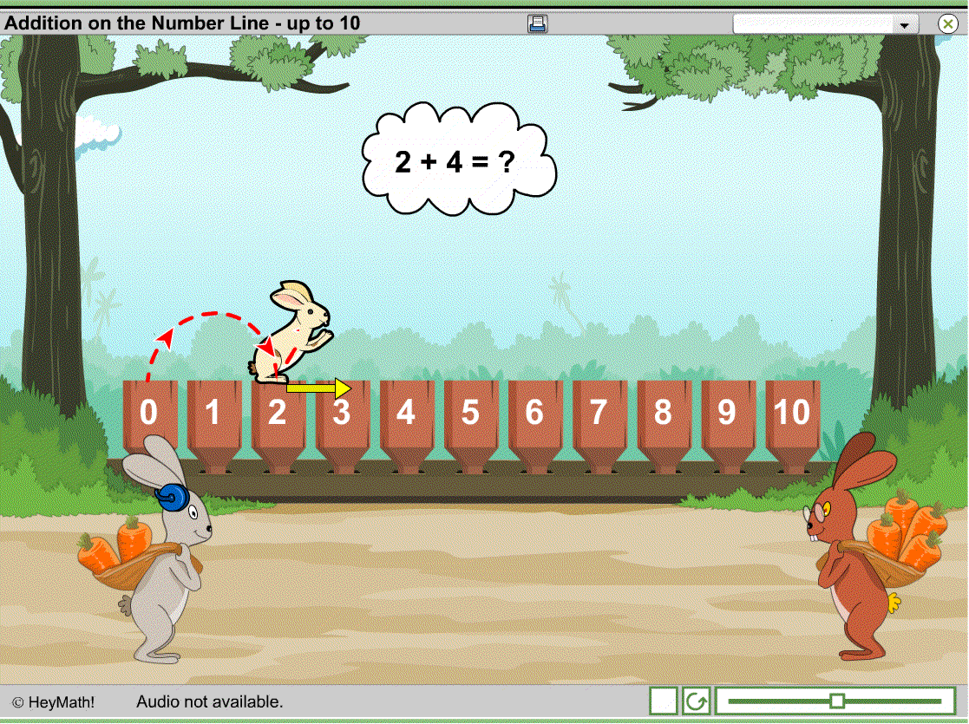  Lesson Contents  - Introduction – 5 minutes  - Activity – unlimited  Learning Objectives  - Understand how addition can be represented using a number line.  - Be able to add 2 numbers using the number line.  Prerequisites  - Familiarity with the number line.  - Be able to count to 10.  - Familiarity with the concept of addition.  - Understand the meaning of the operation ‘+’.  Maths Vocabulary  - Number line  - How many are there altogether? | Guide to the Unit  This unit considers addition as an action on the number line.  Introduction  Hopper the rabbit guides the children through 3 addition problems which are visualised on the number line. The students are gently led though the setting up and solving of these problems. Questions are asked throughout to engage the students and check their understanding.  Activity  The activity allows students to practice considering addition as an action on the number line. They are given an addition problem and are asked to tell Hopper how to jump in order to solve the problem.  In the classroom, students could take it in turns, work together, or volunteer to input the answers. The random and unlimited nature of the activity means students can play it many times without repeating the same questions; the students are motivated to do this so that they can collect many rabbit faces.  Teacher Information  Name of the School :  Name of the teacher :  Date used :  Signature:  Comments (continue on reverse):

