RoboLogo user manual

- Introduction and intended audience

RoboLogo is a Logo programming environment which draws Logo on screen and has the option of running the Logo on a Lego Mindstorms NXT robot too.

The intended audience of this document is a teacher who wishes their pupils to use the product.

- Accessing the application

Please ensure that you have Java installed on your school's computers.
(http://www.java.com/en/download/manual.jsp)

- Navigate your browser to www.johngrindall.com/robologo.  - Click the "Start" button | 
- Click 'open' and wait for the application to download

- If you are asked to confirm the security certificate, click 'accept'.

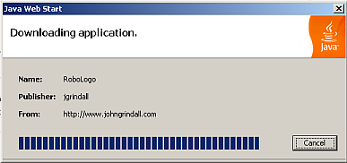

- When the application has loaded users can enter their username and password. In version 1 of robologo the registered usernames and passwords are of the form {userXXX, userXXX}, where XXX can be any characters.

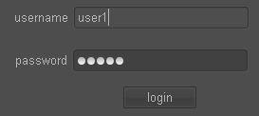

- Creating and testing Logo on-screen

Enter Logo in the panel on the left. Use the draw/stop buttons to test your Logo on screen.



- Running the robot server

The zipped folder robologo.zip contains a folder called robotserver. Double click on the robologo.bat file (Windows) or the robologo.sh file (Linux/Mac).

- Running the software on the NXT

use nxj/nxc

- Executing Logo on the robot

When you log in make sure you ask your teacher for the correct 'host' to enter. If the robot is connected to your own computer enter "localhost"

Enter some Logo and click on the "run on robot" button to send it to the NXT robot.



- Logo syntax

The following table gives examples of the Logo keywords and commands understood by robot logo.

fd 100 | Move forward 100
rt 90 | Turn right 90°
rpt 6 [fd 100] | Repeat 6 times: 'fd 100'
make :a 6 | Set variable :a equal to 6  Variable names must consist of letters only, (no numbers)  and must begin with a colon (:)
proc drawTri()  rpt 3[fd 100 rt 120]  end  drawTri() | A procedure called drawTri, with no input, is defined and then called.  Procedure names must consist of letters only.
proc drawTri(:sideLength)  rpt 3[fd :sideLength rt 120]  end  drawTri(50) | A procedure called drawTri, with one input (:sideLength)  is defined and then called. A triangle of side length 50 is drawn.
proc drawPoly(:s,:n)  rpt :n[fd :s rt (360/:n)]  end  drawPoly(75,5) | a procedure called drawPoly, with two inputs, :s and :n.  A pentagon of side length 75 is drawn.

