GRAVE DETAIL
Cleaning & Preservation LLC

SERVICE MENU, BUNDLES & CARE PACKAGES

You always know who’s at your loved one’s grave — because it’s always Joshua.

gravedetail.com | Cape Girardeau, Missouri | 5-State Regional Service

Monument Type Reference

At booking, customers are asked to identify their monument type from the image below. This ensures accurate pricing before any work is scheduled.

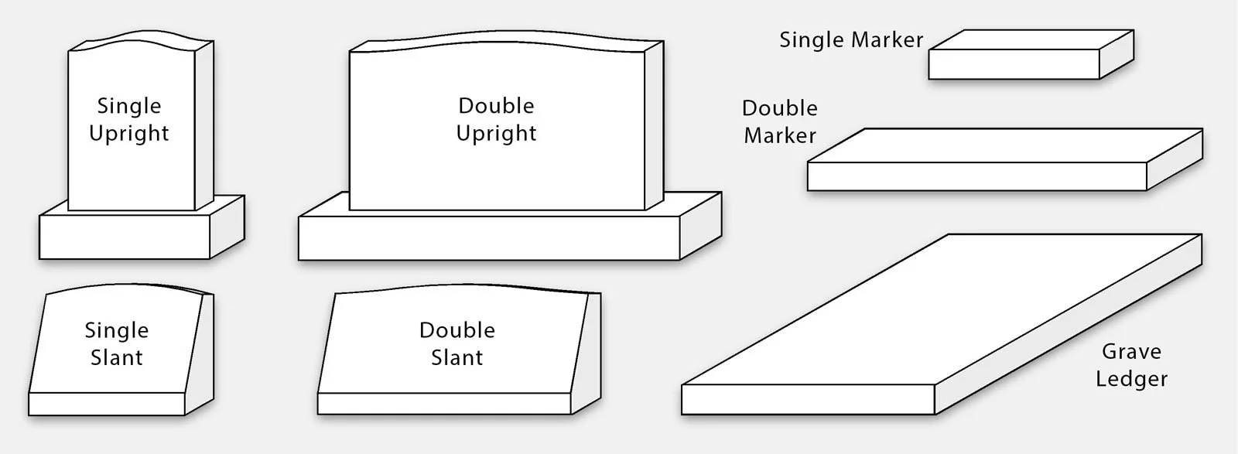

Intake question: "What type of monument most resembles the one we will be cleaning?"

One-Time Cleaning Services
Two tiers. Both done right. Priced by monument type.

OFFER A — Essential Clean
WHAT’S INCLUDED
✓ Full monument cleaning with Orvus WA Paste
✓ 4 GPS-timestamped photos texted/emailed same day
✓ Scheduled within 1 week of booking

OFFER B — Full Service Clean
EVERYTHING IN OFFER A, PLUS:
✓ D/2 Biological Solution growth inhibitor applied
✓ Detailed condition report
✓ Weeding and edging around monument
✓ Groundskeeping damage notation — lawnmower, weed whacker, and mechanical damage documented as a specific line item
Offer B adds $50 to the Offer A base price for your monument type.

Pricing by Monument Type

Monument Type | Offer A | Offer B
Single Marker | $175 | $225
Double Marker | $200 | $250
Single Slant | $210 | $260
Single Upright | $225 | $275
Double Slant | $260 | $310
Double Upright | $300 | $350
Grave Ledger | $325 | $375

Note: Heavily neglected monuments may require a condition-based quote. Joshua will advise before any work begins.

Damage Documentation Report

Lawnmower strikes, weed whacker abrasions, chipped bases, and scratched inscriptions from cemetery groundskeeping are among the most common — and most overlooked — forms of monument damage. Most families never know it happened.

The Damage Documentation Report is a formal, shareable document families can present to cemetery management, an insurance claim, or legal counsel.

DAMAGE DOCUMENTATION REPORT — Add-On: $65
✓ GPS-timestamped photos of each damage point
✓ Written description of impact location, type, and severity
✓ Formatted as a shareable document suitable for official use
✓ Appropriate for cemetery management complaints or insurance claims
✓ Available as a standalone add-on to any one-time service
On all recurring plans (Keeper, Sentinel, Legacy): if damage is found on any visit — cleaning or flower placement — the Damage Documentation Report is automatically produced at no additional charge.

Line 1: Care Packages
Set-it-and-forget-it memorial care — for families near and far

The Guardian | $275
For families who want professional care — just once, done right.
WHAT’S INCLUDED
✓ Full Offer B service on your monument type
✓ D/2 biological growth inhibitor applied
✓ Detailed condition report with groundskeeping damage notation
✓ Weeding and edging around monument
✓ 4 GPS-timestamped photos texted/emailed same day
✓ Direct communication with Joshua before and after
✓ Scheduled within days of booking
The Guardian is built on the full Offer B service tier. Price reflects Single Upright base. Other monument types priced accordingly.

The Keeper | $475 / year
For out-of-town families who want year-round peace of mind.
WHAT’S INCLUDED
✓ 2 full Offer B cleaning visits (spring + fall)
✓ Weeding and edging on each visit
✓ Full condition report after each visit — including groundskeeping damage
✓ Damage Documentation Report auto-generated if damage found — no extra charge
✓ D/2 biological growth inhibitor applied every visit
✓ 4 photos per visit sent same day
✓ Priority scheduling around your chosen dates
✓ Direct cell access to Joshua — always
Tending’s entry plan: $384/yr — 1 visit — unknown contractor — 4–6 week wait. The Keeper: 2 full-service visits, automatic damage documentation, same-week scheduling — for $91 more.

The Sentinel | $575 / year
Three visits. Full coverage. Zero guesswork.
WHAT’S INCLUDED
✓ 3 seasonal Offer B cleaning visits (spring, summer, fall)
✓ Weeding and edging on every visit
✓ D/2 biological growth inhibitor applied every visit
✓ Inscription assessment — repainting quoted separately if needed
✓ Full condition report after each visit — including groundskeeping damage
✓ Damage Documentation Report auto-generated if damage found — no extra charge
✓ 4 photos per visit sent same day
✓ Priority scheduling — your dates locked in first
✓ Direct cell access to Joshua
Tending’s mid-tier: $540/yr — 1 visit — 3–4 week wait. The Sentinel: 3 full-service visits, automatic damage documentation, same-week scheduling — for $35 more.

The Legacy | $1,200 / year
Everything handled. Every visit. Every meaningful date. Nothing left to chance.
WHAT’S INCLUDED
✓ 3 seasonal Offer B cleaning visits (spring, summer, fall)
✓ Weeding and edging every cleaning visit
✓ D/2 biological growth inhibitor applied every cleaning visit
✓ Full condition report every cleaning visit
✓ 5 flower placements on dates you choose — birthdays, holidays, anniversaries
✓ Eyes on the stone every flower visit — damage noted and documented every trip
✓ Damage Documentation Report auto-generated on any visit if damage is found
✓ 8 total documented touchpoints per year — the most comprehensive stone record available
✓ 4 photos every visit sent same day
✓ Full calendar locked in at sign-up with priority scheduling
✓ Direct cell access to Joshua — every call answered by the person doing the work
Tending’s top tier: $708/yr — 1 visit — no flowers — no damage documentation — no personal contact. The Legacy: 8 documented touchpoints for $1,200. There is no comparison.

Family Plot Discounts

All Care Packages apply per-stone discounts for family plots automatically.

Stone | Discount | Example (Keeper)
1st Stone (primary) | Full price | $475
2nd Stone | 20% off | $380
3rd Stone + | 30% off | $332.50

Line 2: Seasonal & Holiday Bundles
Date-driven. Emotion-led. For the moments that matter most.

Seasonal and holiday bundles are standalone purchases — no annual commitment required. Perfect for first-time customers. Many start here.

The Memorial Day Bundle | $325
Honor their service. We’ll make sure the grave is ready.
WHAT’S INCLUDED
✓ Full Offer B monument cleaning
✓ American flag placement
✓ Seasonal flower arrangement ($75 arrangement included)
✓ Scheduled the week of Memorial Day
✓ 4 photos sent same day
✓ Condition report with groundskeeping damage notation
Tending does not offer flag placement or flower placement at any price. This bundle exists only at Grave Detail.

The Remembrance Trio | $450
Three meaningful dates. Three flower placements. One price.
WHAT’S INCLUDED
✓ 3 flower placements on 3 customer-chosen dates
✓ Examples: Mother’s Day, a birthday, Christmas
✓ Seasonal arrangement appropriate to the occasion ($75 arrangement per visit)
✓ 4 photos sent same day as each visit
✓ Eyes on the stone every visit — damage noted every trip
✓ Dates locked in at time of purchase, priority scheduling guaranteed
À la carte rate for 3 placements: $525–$600. The Trio saves you $75–$150 and guarantees your dates before the holiday rush.

The Memorial Year Bundle | $650 / year
Five dates. Five visits. A full year of remembrance — handled.
WHAT’S INCLUDED
✓ 5 flower placements on 5 customer-chosen dates
✓ Any combination: holidays, birthdays, anniversaries, milestones
✓ Seasonal arrangements ($75 per visit included)
✓ 4 GPS-timestamped photos sent same day — every visit
✓ Eyes on the stone every visit — damage noted every trip
✓ Dates collected at intake and locked into your schedule
✓ Priority holiday scheduling — your dates reserved first
✓ Direct cell access to Joshua for any changes
À la carte rate for 5 placements: $875–$1,000. The Memorial Year Bundle saves you $225–$350. Tending offers zero flower placement. Exclusive to Grave Detail.

Available Add-Ons (Any Service)

Service | Price
Damage Documentation Report (formal shareable document) | $65
Inscription repainting (per inscription) | $75 – $150
Weeding & plot edging (standalone) | $75+
Flag placement (standalone add-on) | $35
Bronze marker specialized cleaning | Quoted on-site
Stone crack / chip repair | Condition-based quote
Video documentation (per visit) | Quoted on request
Veteran discount | Applied at checkout

Travel Fees

Travel fees are calculated using Google Maps from Cape Girardeau, Missouri. Distance is one-way. Flat-rate per zone — no surprises at checkout.

Zone | One-Way Distance | Travel Fee
Zone 1 | 0 – 25 miles | Included
Zone 2 | 26 – 50 miles | $35
Zone 3 | 51 – 75 miles | $70
Zone 4 | 76 – 100 miles | $105
Zone 5 | 101 – 125 miles | $140
Zone 6 | 126 – 150 miles | $210

Zone 6 reflects full round-trip cost at $0.70/mile for 300-mile round trips. Multi-job batching in the same area may qualify for a travel fee split — contact Joshua directly.

Why Grave Detail Wins

Tending’s entry plan: $384/yr — 1 visit — unknown contractor — 4 to 6 week wait.
Grave Detail’s Keeper: $475/yr — 2 full-service visits — automatic damage documentation — Joshua, personally, within days.

Tending’s premium plan: $708/yr — 1 visit — no flowers — no damage reporting — no direct contact.
Grave Detail’s Legacy: $1,200/yr — 8 documented touchpoints — 5 flower placements — automatic damage reports — direct cell to the owner.

Tending’s flower placement: Not offered. At any price. Ever.
Grave Detail’s Memorial Year Bundle: $650/yr — 5 placements — eyes on the stone every trip — your dates guaranteed.

Time takes a toll. We take it back.

Grave Detail Cleaning & Preservation LLC
gravedetail.com | Cape Girardeau, Missouri | $2M Liability Coverage | CCUS Methodology

