LIQUIDITY WATCH
Cross-Asset Liquidity, Leverage & Positioning Monitor
[Joshua G. Smith] | September 6, 2026, | For internal / informational use only — not investment advice
Current Backdrop
The big picture remains strong flows into equities with average options and positive gamma, creating an environment of “sogginess.” The problem is leverage: speculative activity will not allow the market to remain at these levels for much longer.

Leverage Watch
Leverage has been an important support for the current bull market, but growth is beginning to slow. OFR equity fund borrowings remain elevated (Figure 1), FINRA margin debt is growing faster than the S&P 500 (Figure 2), and large banks continue to expand lending to asset managers and collateralized financing clients (Figure 3). Historically, similar periods have coincided with strong market performance rather than immediate weakness.
The concern is not the absolute level of leverage but the change in direction. Margin debt growth has largely stalled over the last two months, and preliminary August data suggest only limited additional expansion. If equity returns soften through September and October, leverage growth will contract month-over-month or quarter-over-quarter. While current conditions remain supportive, markets appear increasingly dependent on continued credit expansion — underscored by the fact that the Nasdaq has not made a new all-time high in three months and has been flat for four.

Retail Brokerage Metrics
Retail is no longer becoming more aggressive. YTD DARTs and DATS from brokerage reports show: January–March: gradual decline; April–June: strong reacceleration; July–August: another pullback.
Retail participation remains elevated, while brokers’ willingness to extend credit remains supportive. However, both indicators are showing signs of deceleration (Figure 4). This does not signal an immediate reversal in risk appetite, but one of the key engines is becoming less powerful. If retail demand and leverage expansion continue to moderate, the burden of sustaining higher equity prices will increasingly fall on institutional and foreign capital flows.

Major Capital Flows
Foreign Flows
Foreign flows continue to exhibit a strong preference for U.S. equities despite elevated Treasury yields and expectations that trade uncertainty would result in a rotation toward fixed income (Figure 5). Since mid-2024, foreign bond purchases have stalled and subsequently weakened, while equity inflows have accelerated to new cycle highs. The divergence suggests investors remain focused on the earnings and growth opportunities associated with the AI investment cycle.
However, outside a small group of beneficiaries — including Nvidia, AMD, and Broadcom — free cash flow generation across the broader theme remains limited. Moreover, companies are increasingly using SPVs to obtain cash; however, these credit lines are slowing (Figure 6) and CDS yields are rising.
ETF & Mutual Fund Flows
Mutual funds continue to allocate heavily toward fixed income products, providing an offset to weaker international demand. Combined ETF and mutual fund bond allocations remain substantial, suggesting that fixed income is still attracting capital. Meanwhile, ETF equity issuance remains exceptionally strong, with cumulative equity flows reaching approximately $1 trillion and continuing to support market liquidity (Figure 7).
Households and Bank AUM
Balances are growing faster than the underlying market. This suggests continued inflows into risk assets and an ongoing willingness among investors to maintain elevated equity exposure (Figure 8).
Two problems stand out: flows relative to asset size are tiny compared to other periods (Figure 9), and growth rates should be higher given recent market gains and optimism.

Market Internals & Positioning
While index levels remain near highs, underlying participation has deteriorated. Share volume across U.S. equities has reached –1.5 standard deviations on a lookback since 2025 (Figure 10), indicating reduced conviction among long-term buyers.
The volatility backdrop remains unusually supportive for risk assets. The VIX continues to trade at subdued levels despite elevated valuations and geopolitical uncertainty.
Option volumes: a surge in volumes from April to June resulted in positive dealer gamma, stabilizing markets by depressing volatility (markets finding no clear direction). This has encouraged volatility-selling strategies and systematic positioning.
As September OPEX approaches and dealer exposure resets, this stabilizing influence could weaken.

Path Forward
Catalysts: Another week of energy gains, a potentially hot CPI release, and September OPEX could allow the bear narrative to re-emerge as weaker incremental buying emerges. Rising consumer credit growth alongside continued bank and Fed Treasury holdings activity (Figure 11) points to inflationary pressure that is likely to stay elevated rather than fade.
Infrastructure problems: Semiconductor supply chains remain vulnerable. Taiwan’s advanced chip industry relies on imported natural gas and industrial inputs such as helium, and ongoing disruption in the Middle East has increased risks to energy and shipping routes. Any deterioration in supply-chain stability could amplify existing concentration risks surrounding the AI theme.
Tactical view: These catalysts could provide a reality check to traders, creating a dynamic of slowing leverage growth, fading retail momentum, and reduced gamma support — leaving the market vulnerable to higher volatility.
Probability-weighted view: I assign roughly an 85% probability that the catalysts outlined above materialize. If the market cannot sustain a pullback of more than 5% from current levels, this is likely to trigger systemic selling, pushing the VIX toward the 17–18 range. We expect this drawdown to occur ahead of September OPEX. A confirmed break of that level would open the door to a second leg lower of a similar magnitude (~5% further), which we view as the higher-risk catalyst for a disorderly, flash-crash-style decline rather than an orderly correction

Appendix — Exhibits
Figure 1 — OFR equity fund borrowings YoY vs. S&P 500
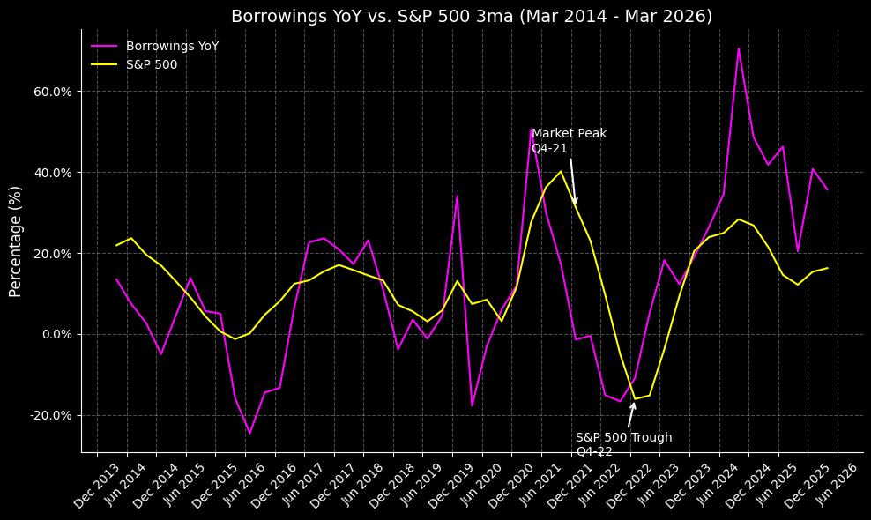
Figure 2 — FINRA margin debt YoY vs. S&P 500
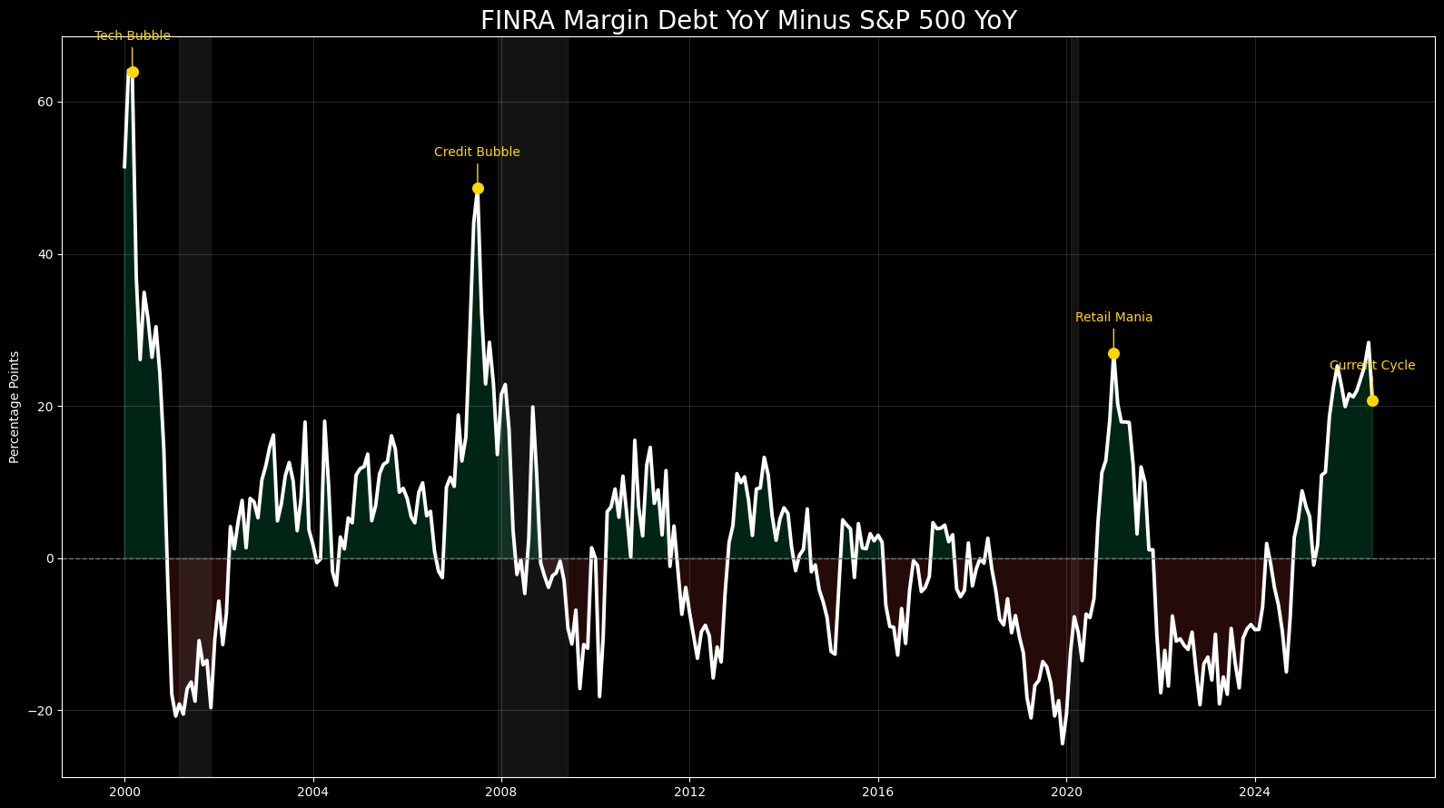
Figure 3 — JPM credit lines / bank lending to asset managers
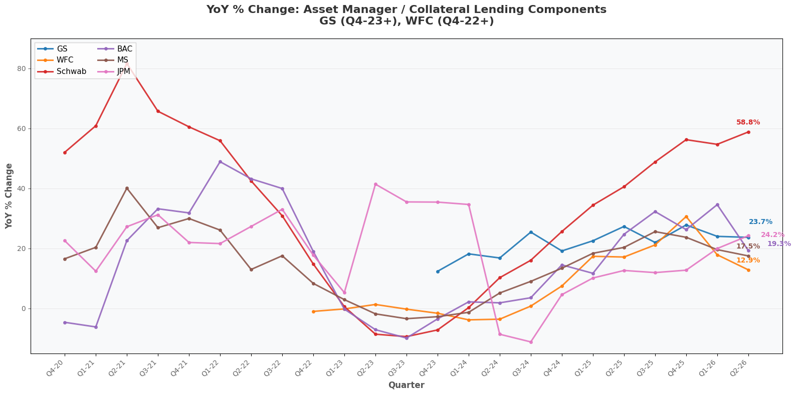
Figure 4 — Retail trading activity growth — DARTs vs. DATS
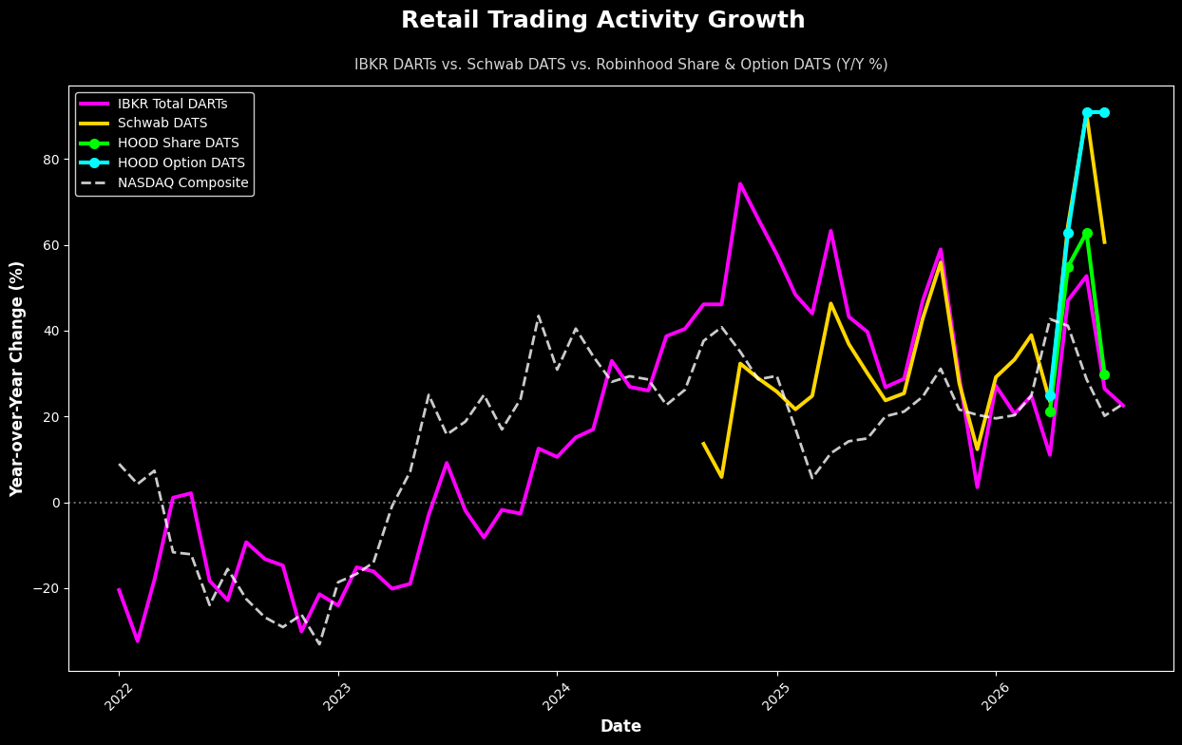
Figure 5 — Foreign investor preference — U.S. equity vs. bond flows
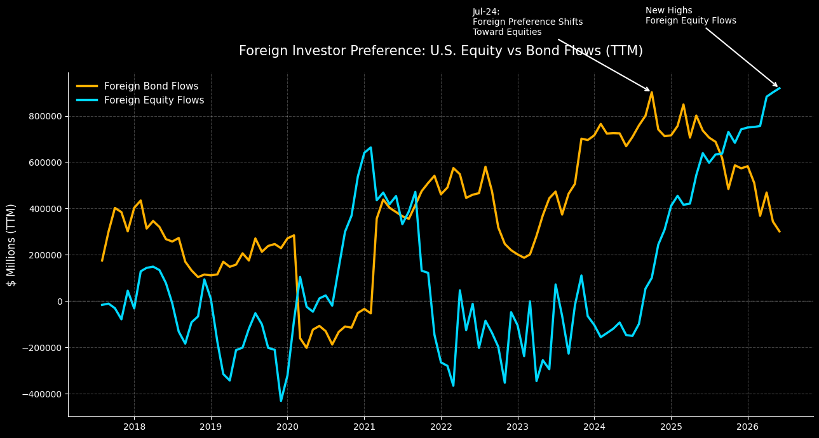
Figure 6 — JPM credit lines, other loans (predominantly SPV loans)
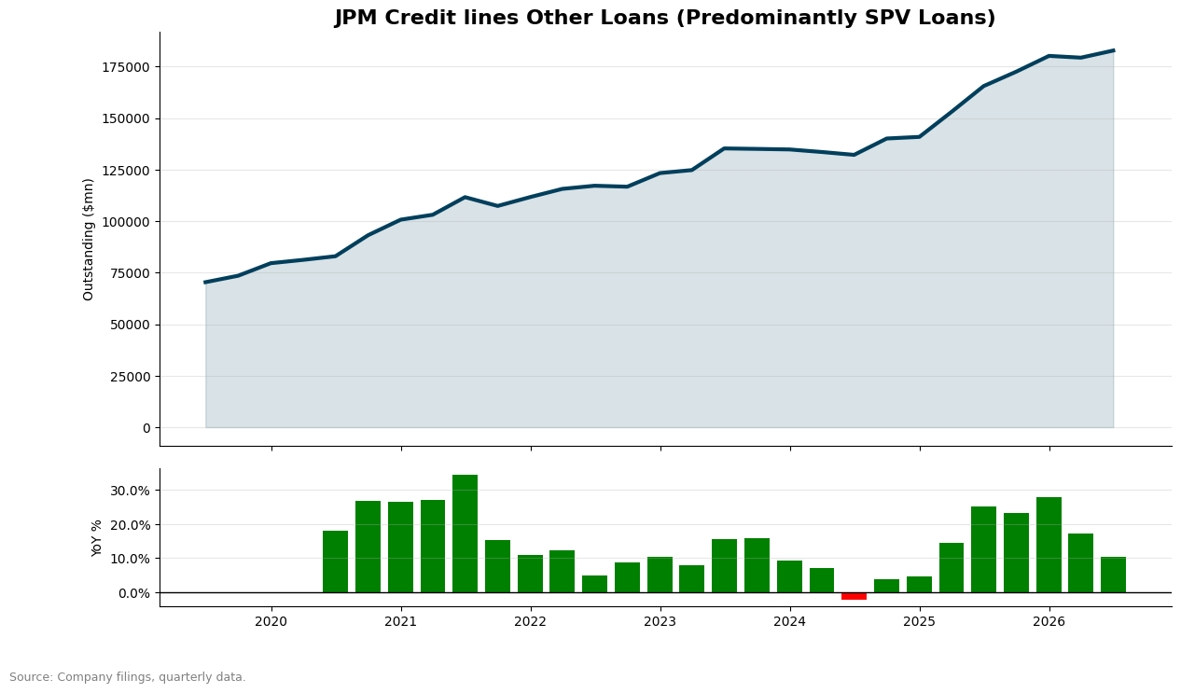
Figure 7 — ICI TTM net flows — bonds vs. domestic equity ETFs
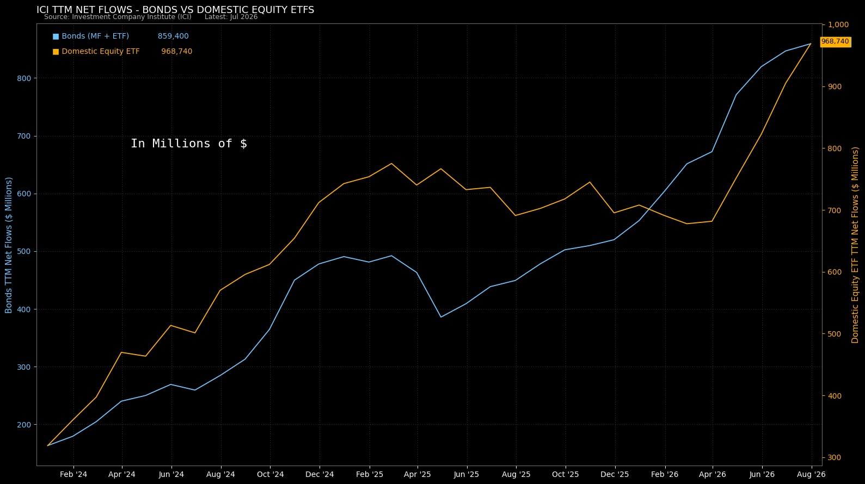
Figure 8 — TTM household equity change vs. AAII bullish sentiment vs. SPX spread
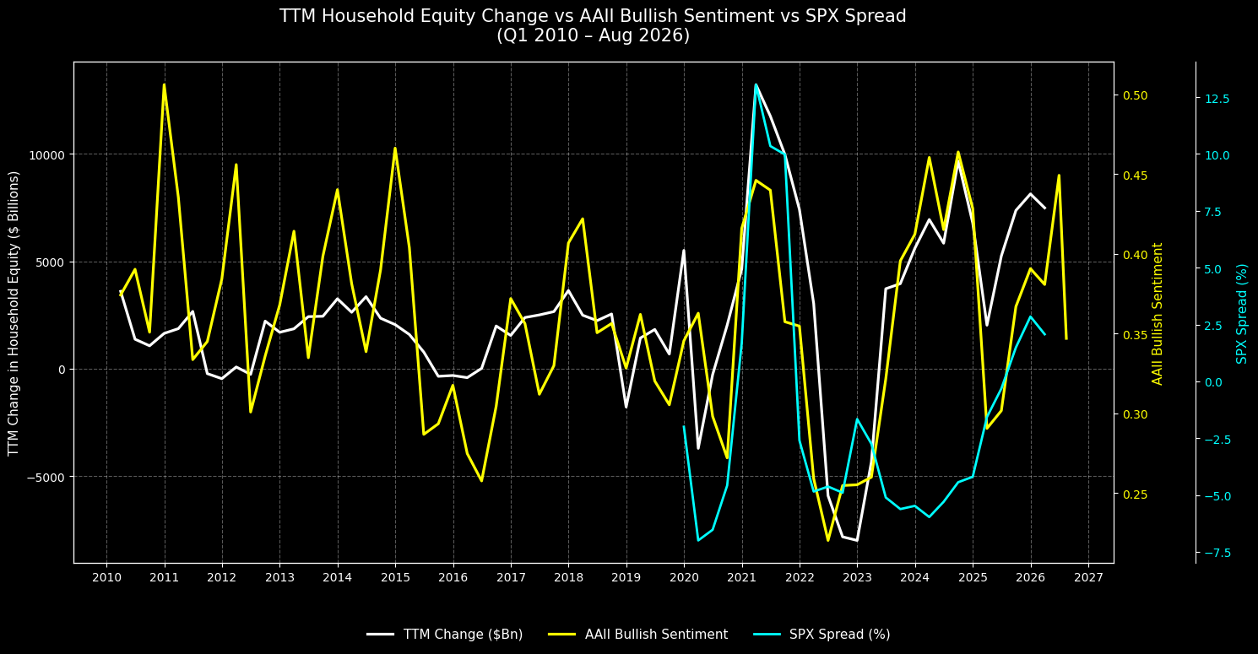
Figure 9 — BlackRock flows — 4-quarter annual rate & % of AUM
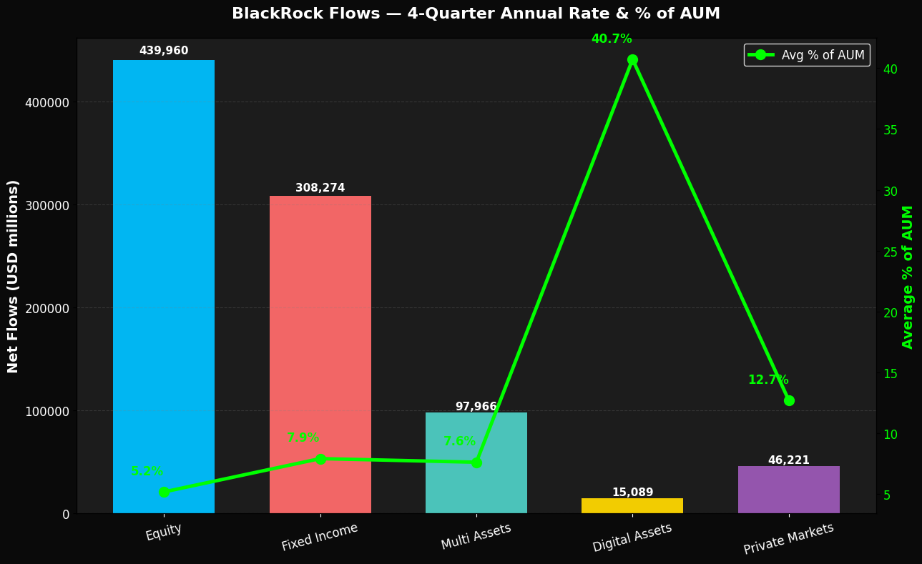
Figure 10 — Options & futures vs. shares, 2-week MA (Z-score)
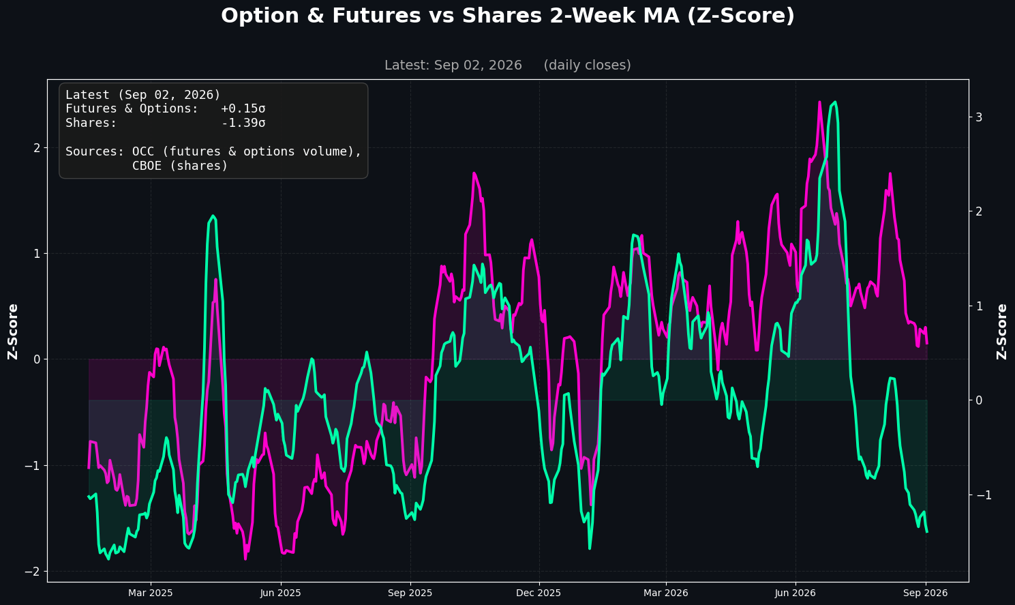
Figure 11 — Inflation to remain sticky — CPI vs. bank & Fed Treasury holdings, alongside consumer credit growth
