Team Exercise #1 - Supply-Demand Analysis in Competitive Markets, Price Controls, Gross Domestic Product, Inflation, Unemployment.

Directions: Answer all questions. Be sure your answers are complete and you explain your reasoning carefully. Some questions may require additional research. You are permitted to use your text, WSJ articles, government websites and any other reference materials you choose. Generative AI tools (e.g., Chat GPT) may be used as long as you reference any text or graphs produced with AI. Team leaders should help divide up the workload among teammates, review/edit the final work product, and list only participating students. Set tight enough deadlines to insure you team completes the exercise on time. If a student "drops the ball" teammates need to pick it up and complete the team exercise. Then submit one copy of the completed exercise using the assignment link on Canvas.

- Leader/Facilitator (list participating team members)

3.
4,

Read the WSJ articles below and answer the following questions:

QUESTIONS:
- (5 pt.) Explain why the market for WTI crude oil can be viewed as a “perfectly competitive market.” How is the price of crude oil determined? Are there a large number of buyers and sellers? Do individual firms buying or selling crude oil have the power to set price? Is this a standardized Is this product? Is there “free entry or exit” in this market? Are there any 1000-pound gorillas in this market that have the ability influence the price of crude oil?
- (2,5 pt.) Has there been an increase or decrease in demand? Remember that some of the factors that could shift the demand curve include changes in preferences, income, the price of substitutes or complements, or a change in the number of consumers in the market. Explain your reasoning carefully.
- (2.5 pt.) Has there been an increase or decrease in supply? Remember that some of the factors that could shift the supply curve include changes in the costs of materials, wages, or other inputs, changes in technology or the number of firms in the market. Explain your reasoning carefully.
- (10 pt.) Draw a supply and demand graph to illustrate the changes described above. Be sure to label your graph and clearly indicate which curve(s) shifts and what happens in your diagram to the equilibrium price and quantity. What is the current price of crude oil? Explain the main factors contributing to the recent increase in oil prices. Then forecast the price of crude oil at the end of this year. To do this you need to explain which of the demand and supply shifters are likely to change over the next few months. Show your forecast in your supply-demand graph of the WTI oil market. What types of financial investment could you make to profit from your economic analysis?
- (20 pt.) In the context of your S-D crude oil model analyze (explain in words) the impact of the following changes in economic conditions (ceteribus paribus) on the equilibrium price and quantity of oil. Show your result in a supply-demand graph (separate graph for each change) of the U. S. oil market.
- economic growth continues which increases household disposable income.
- the price of natural gas (methane) and electricity decrease.
- non-OPEC oil production increases due to improved drilling technology.
- tariffs on steel increase the costs of drilling and producing crude oil.
- Saudi Arabia and Russia agree to reduced oil production.
- (10 pt.) Draw a hypothetical supply-demand graph for the apartment rental market in San Francisco. In your graph what is the equilibrium price and quantity of apartments? Show the impact of a binding price ceiling that San Francisco puts on rental properties. At the price ceiling what is the quantity demanded? What is the quantity supplied? Explain why rent controls typically result in economic inefficiency?
(15 pt.) Pace of Inflation Held Steady in December; Consumer Prices Up 2.7% on Year
7. What is meant by the term inflation? How is inflation measured in the U. S. economy? What is the Federal Reserve Bank’s (FED) target for inflation? What was the percentage increase in the consumer price index (CPI) over the past year? Identify three categories of goods that had price increases faster than the overall rate of inflation and three categories that had increases slower than overall inflation. How much did CPI increase in the month of Dec. 2025? Why did inflation increase in Dec. ? List at least four reasons why prices keep going up. Explain your reasoning. What do you expect the inflation rate to be at the end of 2026? Explain your reasoning. How does this compare to the Federal Reserve Bank (FED) forecast for the rate of inflation at the end of 2026?
8. (15 pt.) A Friday Economic Panic Attack. Are a bad jobs report and rising oil prices signals of trouble ahead…
How many jobs were lost in the U.S. economy in Feb. 2026? How does this compare to the jobs added in the previous month? Explain why job creation has slowed dramatically over the past year. How many job openings are there for each unemployed worker? How fast were nominal wages increasing in Dec. 2025? After adjusting for inflation calculate the change in real wages over the past year. What is the BLS formula for calculating the unemployment rate? What is the unemployment rate in Feb. 2026? Do you expect the unemployment rate to increase or decrease in 2026? Explain your reasoning.

9. (15 pt.) U.S. GDP Grew 2.5% in 2024, but Slowed Slightly in Final Quarter

U.S. GDP Grew 2.5% in 2024, but Slowed Slightly in Final Quarter…
Define what is meant by the terms Real GDP and Nominal (current dollar) GDP? What was the rate of growth in real GDP in the 4th quarter of 2025? What was the rate of growth in prior quarters in 2025? Explain why GDP growth has slowed? What components of GDP contributed the most to 4th quarter GDP? What components contributed the least to 4th quarter GDP? Why is nominal GDP increasing much faster than real GDP? Is the US economy currently in a recession? Will the U.S. economy enter a recession in 2026? Explain your reasoning.

10. (15 pt.) Do Tariffs Raise Prices….

What is a tariff? Explain how 25 percent tariffs on Mexico and Canada. And 20 percent tariffs on China will impact prices for U.S. consumers? What types of products will see the largest pass through of higher prices to consumers? Explain your reasoning. How much will these tariffs impact the U.S. CPI in 2026? Explain. How much will these tariffs impact GDP growth in 2026? Explain. Are you in favor of or against these tariffs? Explain your reasoning.

This weekend WSJ article…
America Braces for Oil Shock as Iran War Throttles Supply
U.S. oil prices this week skyrocketed at their fastest pace on record
By
David Uberti
Follow
March 6, 2026 7:00 pm ET
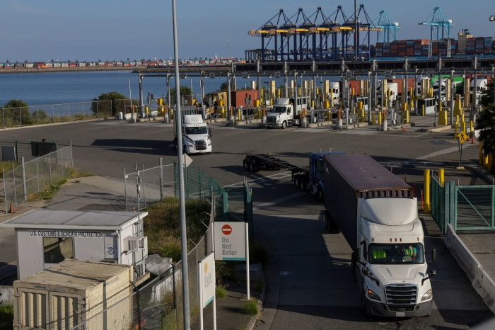Conflict in the Middle East has disrupted shipping around the world. Chris Torres/EPA/Shutterstock
About 8,000 miles from the Middle East, where U.S. forces massed over the past month to prepare for war, Heather Griffith has been jotting a string of rising numbers into a notebook.
The trucker catalogs diesel prices each time she fuels up for the roughly 500-mile round trip she makes six nights a week hauling modular dorm rooms from outside Los Angeles to California Polytechnic State University. A more than $1-a-gallon run-up since January shaves about 5% off her earnings for most journeys.
“Now, we’re going to eat a lot of it,” Griffith said. She would have asked for better rates had she known about the impending geopolitical turmoil.
Griffith is one endpoint of a chain reaction across oil drillers, refiners, tanker operators and financial markets set off in recent weeks by the prospect of war with Iran. If trading since missiles and drones started flying is any indication, millions of Americans like Griffith may soon see higher prices spread beyond the pump and into airfares, factories, construction sites, and even products and produce transported nationwide.
The conflict with Iran throttled one of the key shipping routes for global energy and brought the world to the brink of a shock. Costs of diesel, gasoline and jet fuel have surged at paces that echo 2022, when Russia’s invasion of Ukraine sparked some of the wildest commodity trading on record.
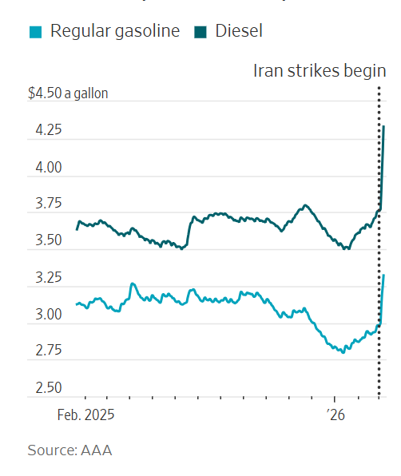
Benchmark U.S. crude futures this week skyrocketed at their fastest rate in records stretching back to 1983, surging 36% to $90.90 a barrel. Many analysts believe $100 oil is fast approaching. Run-ups beyond that could raise the risk of a recession.
Average U.S. diesel prices jumped 51 cents a gallon over the past week, according to GasBuddy, while gasoline costs climbed 32 cents. GasBuddy analyst Patrick De Haan Friday estimated Americans are collectively spending $122 million more on gas every day than they did a week ago.
Energy Secretary Chris Wright said in an interview Friday that “Americans never like high prices.” But he discounted the likelihood of a long-term disruption.
The conflict began “with U.S. oil production at all-time highs, a world well-supplied in oil, new increases in production coming out of Venezuela,” he said. “If this is brief in duration, it’s a small dislocation. It’s a small amount of short-term pain for enormous long-term gain for peace and stability and investment in the Middle East.”
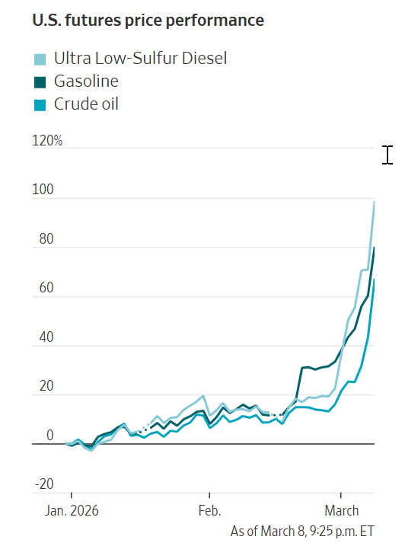
In 2022, Biden administration officials spent months scrambling to contain the chaos the Ukraine war unleashed across commodity markets and supply chains.
“You see why the [1970s] oil shocks were so hard to control,” said Alex Jacquez, a Biden-era official who is now chief of policy and advocacy at Groundwork Collaborative, a progressive think tank. “There’s all these ripple effects that stemmed from this disruption in Eastern Europe that were unforeseen and we were reacting to in real-time.”
Crude prices are far below their 2022 peaks and within historical norms. Energy-rich America is insulated from fallout in ways that Asia and Europe aren’t. But continuing threats to tankers in the Strait of Hormuz, coupled with shut-ins at nearby oil fields, natural-gas terminals and more, slowed exports through the roughly 20-mile-wide shipping lane to a trickle.
Companies and investors were monitoring the military buildup as the U.S. and Israel prepared to strike. But the speed and severity of Iran’s counterattacks across energy powerhouses lining the Persian Gulf caught many off guard.
“That’s where the surprise was,” said Paul Baris, a principal at supply-chain consulting firm Efficio.
Benchmark U.S. crude futures have risen 58% this year. Contracts for diesel and gasoline deliveries next month catapulted even higher.
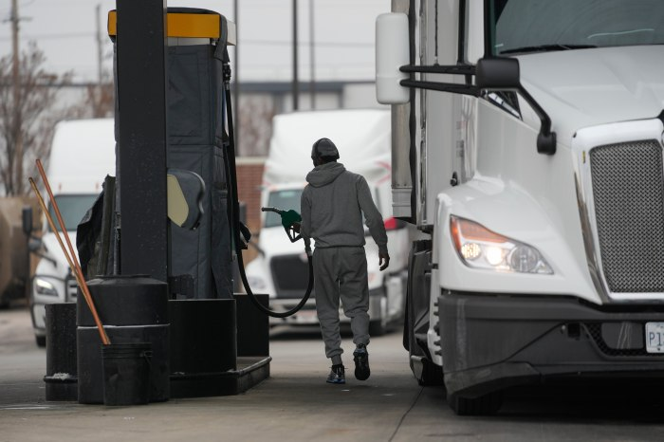Costs of diesel, gasoline and jet fuel have surged. Erin Hooley/Associated Press
On Wall Street, deadly blows across the Middle East have shaken markets. After oil producers began snapping up options to lock in future price levels early this week, some airlines jumped in to shield themselves from risk as the price of jet fuel surged.
“When it’s one headline after another, and you can’t get a rhythm going in the market and have a lot of conviction in your position, it is the time you form an ulcer,” said Rebecca Babin, a senior energy trader for CIBC Private Wealth.
Babin has at times shrunk positions and tightened her risk threshold in response to volatility, racing to understand fast-changing freight costs and insurance premiums.
“Like everybody else, I’m watching if ships are going to move through the strait,” Babin said. “Words are not going to be enough to calm the market at this point—we will need to see action soon to inject some confidence in the veins of traders.”
On Friday, the U.S. International Development Finance Corp. said it would create a $20 billion reinsurance facility to help cover potential losses. But shipowners question how quickly the small agency can spin up insurance products for a war zone.
Some analysts have speculated the Treasury Department could jump into futures markets to help arrest price increases. “We don’t have any plans to be in the crude-trading business,” the Energy Department’s Wright said Friday. He said other measures are on the table.
Wright also pointed to global reserves on hand, casting the recent price run-up as a market overreaction.
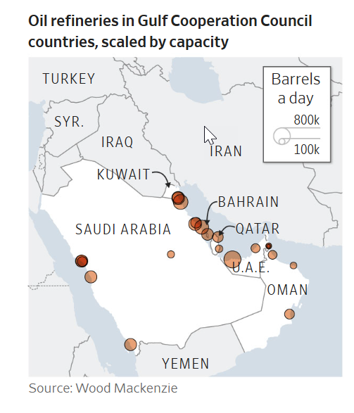
“Uncertainty leads people to emotional reactions,” he said. “But rationality wins out in the end in the market.”
Treasury this week allowed India to temporarily buy Russian oil at sea and eased sanctions to allow transactions with the German branch of Russia’s Rosneft oil company. President Trump also suggested potential Navy escorts of commercial ships through the strait, a tactic employed to stymie attacks on tankers during the Iran-Iraq war in the 1980s.
Some investors and shipping representatives warn that even tankers with federally backed insurance policies would avoid the voyage until fighting dies down or the U.S. military has enough assets in the region to deter strikes.
With skyscraper-size vessels funneling through a six-mile-wide strip of water within the strait at its narrowest point, “there’s less reaction time,” said retired U.S. Navy Capt. Jim McTigue, who commanded a frigate that shepherded tankers in the ‘80s.
“There’s more ability [for Iran] to bring weapons to bear,” he said. “It makes for a very tight environment.”
Should stoppages continue, analysts warn American drillers in the Permian Basin have little interest or wherewithal to immediately pump more crude.
The economics of oil production are often linked to companies’ ability to sell natural gas created as a byproduct. But gas pipelines in the region are nearly maxed out. At the same time, U.S. gas exports are largely spoken for with long-term contracts.
“If you can’t get gas out, you can’t get crude out,” said Rob Wilson, chief operating officer at East Daley Analytics.
Even as America produces more oil than any country ever, some regions of the country still rely on imports. An extended shut-off of jet fuel and diesel from the Middle East into the global market could pit the fuel-poor U.S. coasts against Europe and Asia for supplies.
After a cold winter in the Northeast, “nobody came into this carrying extra inventory,” said Mark Romaine, chief operating officer at Global Partners, which runs fuel terminals across the region. Near-term contracts remain costlier than future supplies, discouraging companies from stockpiling.
The longer the war lasts, the riskier it will become to continue operating hand to mouth.
“The biggest wild card here is duration,” Romaine said. “How long does this go on?”

WSJ oil market articles prior to Iran attack…
- Energy & Oil

Oil Outlook Clouded by OPEC+ Output, Trade Tariff Risks

An unwinding of output cuts will exert downward pressure on oil prices, says ANZ Research
By
Giulia Petroni
Follow
March 4, 2025 12:20 pm ET
[p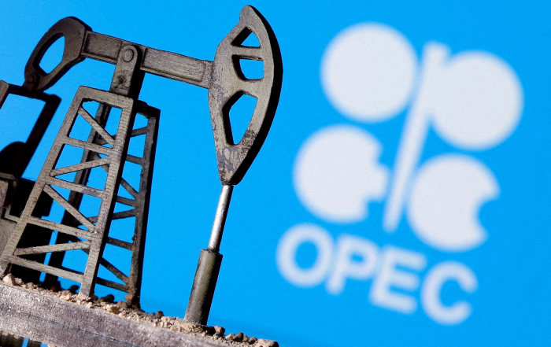OPEC+’s decision to lift output levels, coupled with U.S. tariffs, raise price and demand issues. Photo: dado ruvic/Reuters
OPEC+’s plan to start raising output next month and the latest round of U.S. tariffs on trade partners are weighing on the oil market’s outlook, raising concerns about a supply surplus and demand growth this year.
Brent crude is trading near a five-month low, down nearly 15% from a high of $82 a barrel in January. Mid-afternoon in Europe, it fell 2% to $70.19 a barrel, with the U.S. benchmark, West Texas Intermediate, down 1.6% to $67.27 a barrel.
Prices tumbled after the Organization of the Petroleum Exporting Countries and its allies on Monday agreed to start unwinding some of their voluntary output cuts starting from April, a surprise move that means more crude will hit the market.
The group had delayed plans to unwind its long-standing production cuts several times, and was expected to do so again. “Given the market was largely expecting another delay, oil prices are likely to remain under downward pressure,” analysts at ANZ Research said.
The group of oil producers, which is led by Saudi Arabia and Russia, is set to add around 138,000 barrels a day next month–the first of several monthly hikes that will bring back around 2.2 million barrels a day by 2026. Still, some analysts say OPEC+’s effective production increase could be lower as some members are due to implement cuts to production to compensate for past overproduction.
“Nevertheless, we continue to see scope for OPEC+ to manage the pace of this month to month, as the producer group noted this could be a gradual and flexible return,” analysts at Citi Research said. The U.S. bank expects Brent to fall to a range of $60-$65 a barrel in the next six-to-twelve months, with OPEC+’s additional supply providing more room for potential supply losses caused by U.S. sanctions on Iran and Venezuela.
According to Goldman Sachs, OPEC+’s decision to start raising output in April reflects lower global inventories and a shift in strategy to limit non-OPEC+ oil production growth. The bank warns that higher-than-expected supply and a potential demand hit due to softer U.S. activity and escalating tariffs pose downside risks to its oil price forecast.
Goldman projects Brent crude to average $78 and $73 a barrel in 2025 and 2026, respectively, and WTI at an average of around $74 and $68 a barrel in the same years.
The reason behind OPEC+’s move remains unclear, but the gradual output increase can be paused or reversed based on market conditions. Some analysts suggest the group is aiming to regain market share, while others say U.S. sanctions on Venezuela and Iran might have played a significant role, as they are expected to lower global output.
Meanwhile, concerns over the impact of multiple trade wars on the global economy and crude demand are also weighing on prices after Trump imposed tariffs on Canada, Mexico and China.
The largest potential disruption to oil markets come from tariffs on Canada, as U.S. refiners in the Midwest are heavily dependent on Canadian oil. “The bulk of oil that is at risk from his sanctions and tariffs are medium and heavy grade crudes,” analysts at BMI said. “Pressures are already apparent in the market for this type of oil and further distortions could spillover into the wider crude complex.”
Write to Giulia Petroni at giulia.petroni@wsj.com
Copyright ©2025 Dow Jones & Company, Inc. All Rights Reserved. 87990cbe856818d5eddac44c7b1cdeb8

Follow

OPEC Sticks to Oil-Demand View, Flags U.S. Trade Policy Risks

New U.S. trade policy has the potential to create supply-demand imbalances that are not reflective of market fundamentals, it said
By Giulia Petroni
Feb. 12, 2025 8:26 am ET
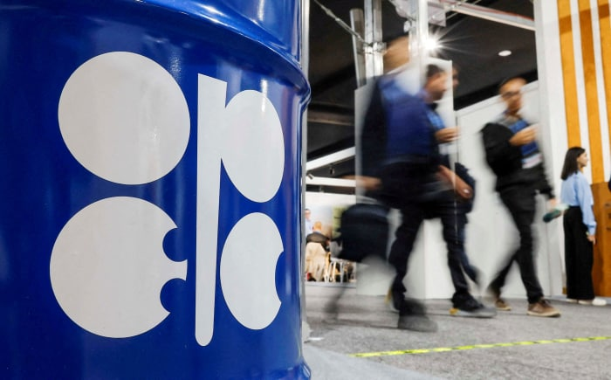Photo: maxim shemetov/Reuters
The Organization of the Petroleum Exporting Countries stuck to its oil-demand forecast after reaffirming plans to gradually hike output from April, but said U.S. President Trump’s trade policy is injecting a dose of uncertainty into markets.
“The new U.S. Administration’s trade policy has added more uncertainty into markets, which has the potential to create supply-demand imbalances that are not reflective of market fundamentals, and therefore generate more volatility,” the Vienna-based cartel said.
OPEC still expects demand to grow by 1.45 million barrels a day this year and 1.43 million barrels a day the next, with strong air travel and road mobility boosting transportation fuel consumption. The group’s overall forecast remains significantly more optimistic than others in the industry, with the International Energy Agency estimating this year’s growth at 1.05 million barrels a day.
Brent crude, the international oil benchmark, traded around $76 a barrel, while the U.S. oil gauge West Texas Intermediate was around $72 a barrel in midday trade on Wednesday. Both benchmarks slid on reports of a large build in U.S. crude stockpiles after rising in the previous session on signs of tighter Russian supplies and drone attacks against energy infrastructure in Russia and Ukraine.
Future price direction remains uncertain, as traders keep their focus on U.S. President Trump’s tariff announcements amid growing concerns that escalating trade tensions could hurt global economic growth and damp oil demand.
OPEC lowered its forecast for supply growth from countries not participating in the Declaration of Cooperation–or DoC–to 1 million barrels a day in both 2025 and 2026 from 1.1 million barrels a day previously. The DoC, the cartel’s formal name for OPEC+, was formed in 2016 and comprises the 12 OPEC members and 10 non-members, of which Russia is the largest producer.
In January, overall OPEC crude-oil production fell by 121,000 barrels a day to 26.68 million barrels a day. UAE production fell by 37,000 barrels a day to 2.9 million barrels a day, while Nigerian output decreased by 29,000 barrels a day to 1.495 million barrels a day. Libya’s production instead rose by 17,000 barrels a day to around 1.28 million barrels a day.
Earlier this month, top ministers of the OPEC+ alliance–which pumps more than half of the world’s crude oil–made no recommendations to change the current oil output policy despite Trump’s calls to bring down the price of oil. The group has been withholding barrels for more than two years and is set to gradually raise output from April after having pushed back its plans multiple times in a bid to shore up prices.
Some market watchers say Trump’s trade turmoil could push OPEC+ to extend existing production cuts once again. However, the group could also decide to start raising output to offset any potential losses resulting from U.S. sanctions against Russia and Iran.
OPEC kept its estimates for global economic growth at 3.1% for this year and 3.2% for the next. Eurozone growth was further trimmed to 0.9% in 2025 and kept at 1.1% in 2026, while U.S. economic growth is still seen at 2.4% and 2.3% for the periods.
“In both developed economies and emerging markets, trade uncertainties have increased inflation expectations above major central banks’ targets and made it more challenging to cut interest rates in 2025,” the cartel said. “The impact of U.S. trade policy on global macroeconomic growth remains to be seen.”
Write to Giulia Petroni at giulia.petroni@wsj.com
Copyright ©2025 Dow Jones & Company, Inc. All Rights Reserved. 87990cbe856818d5eddac44c7b1cdeb8
Why the Oil Shock Probably Won’t Derail the Economy. And One Way It Might.
The U.S. is a net petroleum exporter and productivity is improving, but the bigger risk is stubborn inflation
By
Greg Ip
March 8, 2026 5:30 am ET
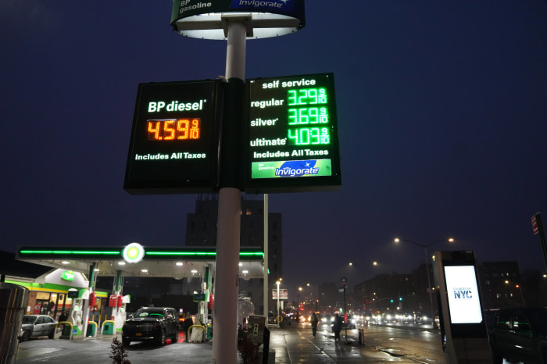Oil prices jumped in the wake of U.S. and Israeli strikes on Iran. Zhang Fengguo/Xinhua/ZUMA Press
It was an ugly week for the economy.
Oil prices surged 39%, all but guaranteeing inflation is about to lurch higher. And it came amid emerging signs of jobs weakness, as payrolls fell and unemployment rose in February.
Those with long memories smell stagflation—a troubling mix of stagnant growth and stubborn inflation—or worse, recession. Higher oil prices helped sink the economy in 1973, 1980, 1990 and 2008.
Odds are neither stagflation nor recession will happen. The economy has grown more resilient to oil shocks, and a productivity renaissance is under way, helped by artificial intelligence. Both should help sustain growth and cushion cost pressures.
Oil loses its bite
Higher oil prices are like a tax, cutting into household consumption while boosting inflation and interest rates.
But that effect has shrunk as the U.S. became less energy dependent. The U.S. consumed 4% less gasoline in 2025 than in 2007, while producing 42% more goods and services (as measured by gross domestic product, adjusted for inflation). The share of households’ consumption of energy, including electricity, natural gas and gasoline, fell from 5.7% in 2007 to 3.7% last year.
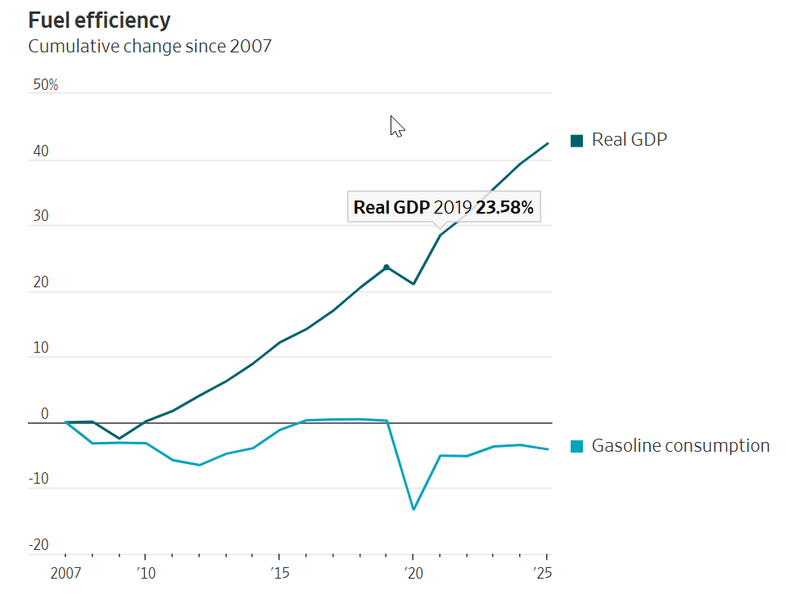
Meanwhile, the shale revolution has turned the U.S. into a net exporter of petroleum and major exporter of liquefied natural gas. That means the hit to consumers is offset by a boost to producers.
Russia’s invasion of Ukraine in 2022, which at one point pushed up oil by $45 a barrel, only trimmed U.S. growth by 0.13 percentage point that year, while raising inflation half a point, a Federal Reserve report found.
Oil closed Friday at $90.90 a barrel, up $24 from a week earlier. JPMorgan estimates that level, if it persists, would trim economic growth by 0.6 percentage point. But neither the bank nor markets expect it to persist. Oil for delivery in September traded at $73 Friday.
Don’t worry about jobs (yet)
Oil alone has never caused a recession; it usually requires some other vulnerability. The 2022 spike didn’t hurt, in part, because the U.S. was adding over 300,000 jobs a month. The labor market looks fragile now, with payrolls surprisingly dropping 92,000 in February from January, and unemployment ticking up to 4.4%.
This, though, doesn’t look like a prelude to a recession. Employment growth has been sluggish for a year, due less to weaker demand for workers than a shrunken supply as immigration dries up.
In spite of that, the economy grew a respectable 2.2% last year. The reason: output per hour worked, i.e. productivity, rose 2.8%. That’s roughly double its prepandemic pace, and a sign the economy is becoming much more efficient.
AI probably played only a minor role. But as its deployment spreads, it could sustain productivity and thus growth above 2%, even with little or no job growth this year.
That would help contain inflation as firms could raise wages without raising prices much. Hourly compensation rose 4.1% last year, yet adjusted for productivity, business labor costs were up just 1.3%.
What could go wrong?
Prolonged closure of the Strait of Hormuz could send oil prices much higher than the market anticipates. Robert McNally, a former energy adviser to President George W. Bush, estimates it will take four weeks for oil flows to fully resume. He considers that an optimistic scenario with no successful Iranian strikes on shipping, yet he still sees that pushing oil well over $100 a barrel. The energy minister of Qatar said it could reach $150.
SHARE YOUR THOUGHTS
How concerned are you about the prospect of stagflation? Join the conversation below.
Outright shortages would hit importers like Europe hardest, but the U.S. wouldn’t be spared; it imports some refined products, such as gasoline, and it pays prices set in global markets.
A financial crackup is another risk. The AI boom, credited for driving growth last year and likely this year, is closely intertwined with bubbly stock valuations. Energy turmoil could unnerve investors already worried about how much tech companies are spending on data centers.
Inflation, stubborn for longer
Oil has often been a culprit in past recessions by prompting the Federal Reserve to raise interest rates (or refrain from cutting them) to get inflation down again.
Until this past week, inflation seemed to be declining gently toward the Fed’s 2% target. Now, inflation-linked financial derivatives imply inflation—2.4% in January—will be 2.9% in the coming 12 months, according to Barclays.
The derivatives also imply inflation will fall briskly thereafter, to 2.44% in the following 12 months. “The market thinks that any inflation impulse will be pretty quickly felt, and not lead to a sustained resurgence in inflation,” said Jonathan Hill of Barclays.
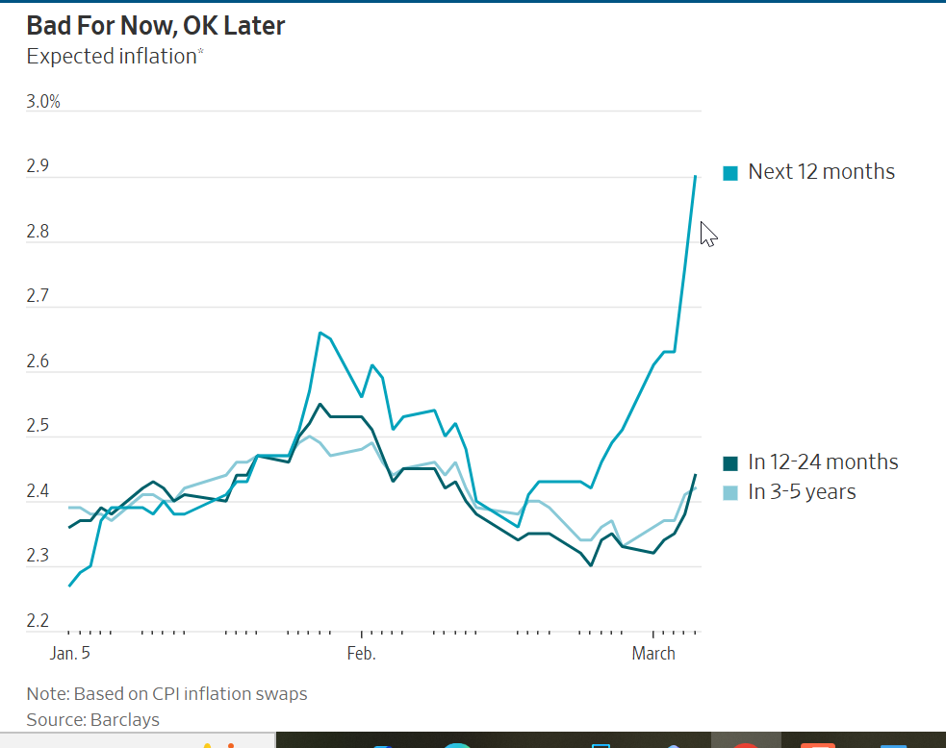This should make the Fed comfortable not raising rates and, if necessary, cutting, should a genuine recession threat loom.
That said, for inflation not to persist assumes the public expects it to come down again, and that isn’t a sure thing. A new paper by Stefan Nagel of the University of Chicago and Ulrike Malmendier of the University of California, Berkeley argues expectations depend heavily on an individual’s lifetime experience. Inflation has now run above 2% for five years, which could weaken younger individuals’ confidence it will come down.
This puts a premium on the Fed making sure it does. Stagflation happened in the 1970s not just because of high oil prices and lower productivity, but because the Fed systematically raised rates too little or cut too much, partly because of political pressure.
President Trump, eager to run the economy hot ahead of the midterm elections, has put intense pressure on the Fed to slash rates. If it succumbs, a temporary oil-induced inflation blip could become something much longer lasting.
Copyright ©2026 Dow Jones & Company, Inc. All Rights Reserved. 87990cbe856818d5eddac44c7b1cdeb8
Appeared in the March 9, 2026, print edition as 'Stagflation, Recession? Probably Not'.
Economic Growth Slowed in Fourth Quarter, Hurt by Government Shutdown
U.S. GDP grew at 1.4% annual rate in 2025’s final quarter
By
Harriet Torry
Updated Feb. 20, 2026 12:38 pm ET
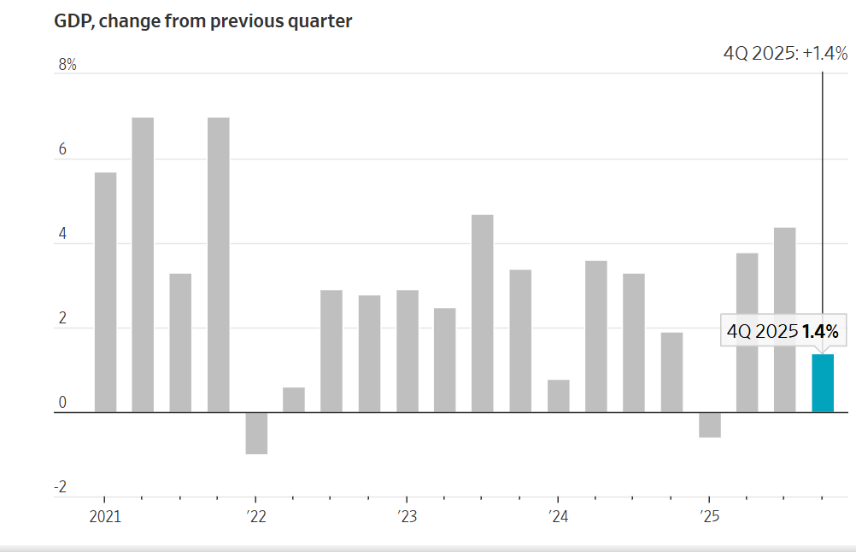
U.S. economic growth slowed sharply at the end of last year, weighed down by a record-long government shutdown and cooler consumer spending.
U.S. gross domestic product—the value of all goods and services produced across the economy—rose at a 1.4% seasonally and inflation adjusted annual rate in the final quarter of last year, the Commerce Department said Friday.
That was much weaker than the 2.5% reading economists surveyed by The Wall Street Journal expected, and marked a sharp slowdown from the third-quarter’s blistering 4.4% rate.
The latest reading capped a year of slightly slower growth overall: In 2025, the economy expanded 2.2%, measured from the fourth quarter of the prior year, down from 2.4% in 2024 and the weakest pace since 2022.
Economists also measure the year in another way—comparing the nation’s total output for 2025 with the prior year—to get a look at broader trends. According to that measure, the economy grew 2.2% last year, down from 2.8% in 2024 and the slowest pace since the economy last contracted in 2020.
Even so, this growth remains the envy of many developed nations. It also followed some big swings throughout the year. The U.S. economy contracted in the first quarter, grew quickly in the next two, then cooled at the end of the year, largely due to the government shutdown that stretched from Oct. 1 through Nov. 12.
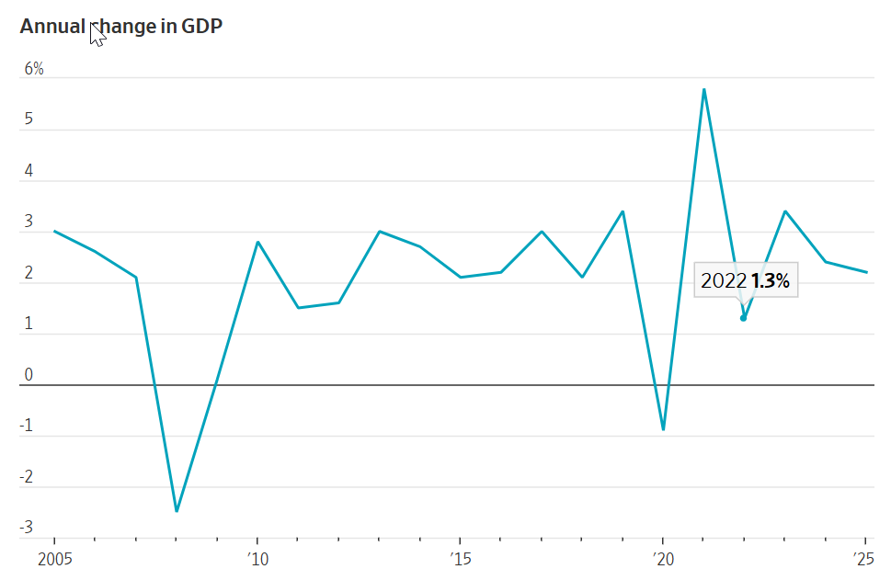Federal government spending in the recent quarter declined at a 16.6% rate, shaving nearly 1.2 percentage points off headline GDP.
Shutdowns can squeeze the economy in many ways, from missed paychecks for hundreds of thousands of federal employees to government contractors losing out on business. Still, economists say the economy generally makes up for growth lost to shutdowns once the government reopens, though possibly in a later quarter.
“If you look at underlying GDP growth, it’s fine,” said Yale Budget Lab Executive Director Martha Gimbel, a former senior adviser at President Biden’s White House Council of Economic Advisers. “I think people need to really remember that there are a lot of wild swings happening in the economy right now.”
Also Friday, the Supreme Court ruled President Trump’s global tariffs are illegal, adding fresh uncertainty to the economic outlook for 2026.
“In some ways, we’re just back in April” of last year, said Gimbel. “We don’t know where this is going to end up—all of the policy uncertainty that we were dealing with last year for the economy—now it’s just back.”
Before Friday’s GDP report was released, Trump took to social media and blamed Democrats for the shutdown and for hurting GDP. He also lashed out again at Federal Reserve Chair Jerome Powell for not lowering interest rates more.
Many consumers, anxious about jobs and income, are delaying purchases. Lucía Vázquez for WSJ
Even excluding the effect of the federal shutdown, growth still slowed in the fourth quarter. A measure of consumer and business spending that strips out the volatile categories of trade, inventories and government spending—known as final sales to private domestic purchasers—rose at an annual rate of 2.4%, solid but also the slowest pace since the first quarter of 2025.
And for the year, this measure rose 2.5%, down from 2.9% in 2024.
In the fourth quarter, business investment remained a bright spot, particularly in artificial intelligence, with spending on intellectual property like software picking up to a 7.4% pace of growth. The housing market continued to weigh on growth, however, as home builders and home buyers struggle with high borrowing costs.
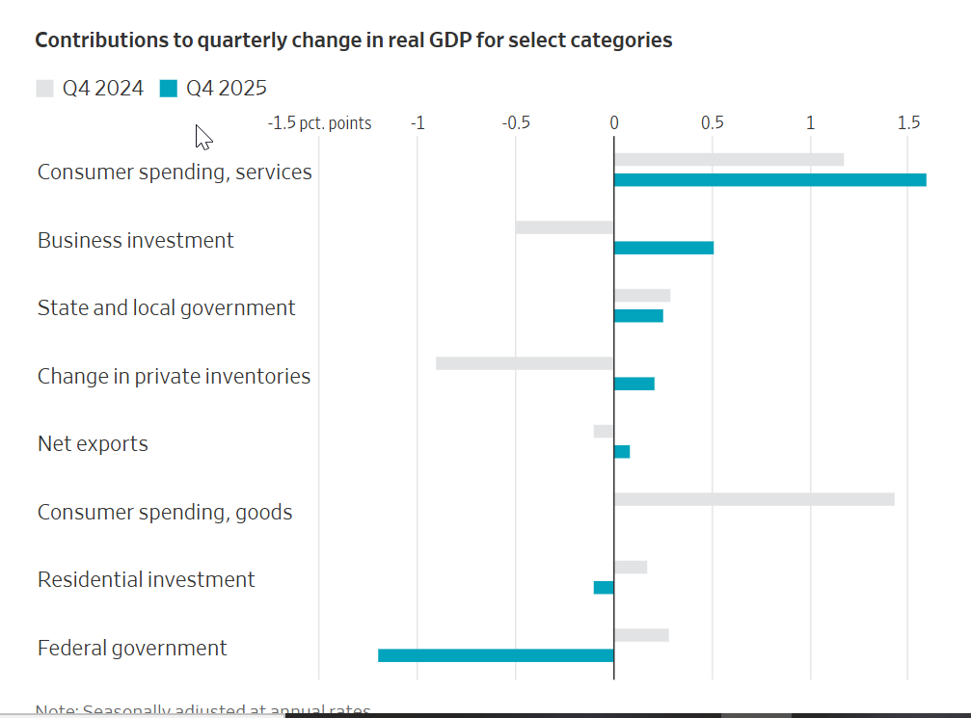Consumer spending, which accounts for more than two-thirds of the economy, rose at a 2.4% rate in the fourth quarter, pulling back from the third quarter. While Americans reined in spending on big-ticket items like cars, likely reflecting the impact of tariffs and expiring tax credits for electric vehicles, their spending on services largely held up.
Households dipped into their savings to fund their spending; the personal-saving rate, the portion of after-tax income that consumers don’t spend, declined to 3.6% in the fourth quarter from 4.2% in the third.
One potentially worrisome trend was a pickup in a key measure of inflation late last year. A separate Commerce Department report out Friday said the personal-consumption expenditures price index, excluding food and energy costs, rose 3% in December from a year earlier, an acceleration from 2.8% in November. Fed policymakers watch this metric closely as they consider the path of interest rates.
“One cannot ignore the rising core inflation that’s spreading out across the economy, which explains the discontent we have across the American public and policy at this current time,” said Joseph Brusuelas, chief economist at RSM.
A separate headline number for inflation rose 2.4% in January from a year earlier, cooler than the 2.7% in December.
Minutes from the Fed’s January policy gathering suggested officials are becoming increasingly concerned about inflation. Most officials cautioned that progress bringing inflation down “might be slower and more uneven than generally expected.” And the risk that inflation might run persistently above the Fed’s 2% goal “was meaningful,” they said.
The Fed held its benchmark short-term rate steady at its last meeting in late January, pausing after a string of cuts in prior meetings.
SHARE YOUR THOUGHTS
What is your biggest takeaway from the GDP report? Join the conversation below.
The U.S. economy is expected to grow 2.2% in 2026, according to the most recent Wall Street Journal survey of economists, thanks to continued investments in AI as well as tax cuts and incentives from last summer’s tax-and-spending megabill.
The labor market remains a concern, even though the unemployment rate remains low. Job creation stalled in 2025, as businesses juggled uncertainty around tariff and immigration policies and rebalanced their workforces following a postpandemic hiring spree. The potential impact of productivity-enhancing AI on the need for workers also left many employers reluctant to hire.
January showed green shoots of improved job creation, though most of last month’s hiring was concentrated in just one sector: healthcare. On Thursday, Walmart said consumers continue to spend cautiously, especially low-income shoppers. The spending gap between high-income and low-income households is widening slightly, Walmart Chief Financial Officer John David Rainey said.
Copyright ©2026 Dow Jones & Company, Inc. All Rights Reserved. 87990cbe856818d5eddac44c7b1cdeb8
Appeared in the February 21, 2026, print edition as 'Economic Growth Slowed, Ending 2025 on Weak Note'.

A Friday Economic Panic Attack
Are a bad jobs report and rising oil prices signals of trouble ahead?

By
The Editorial Board
Follow
March 6, 2026 5:59 pm ET
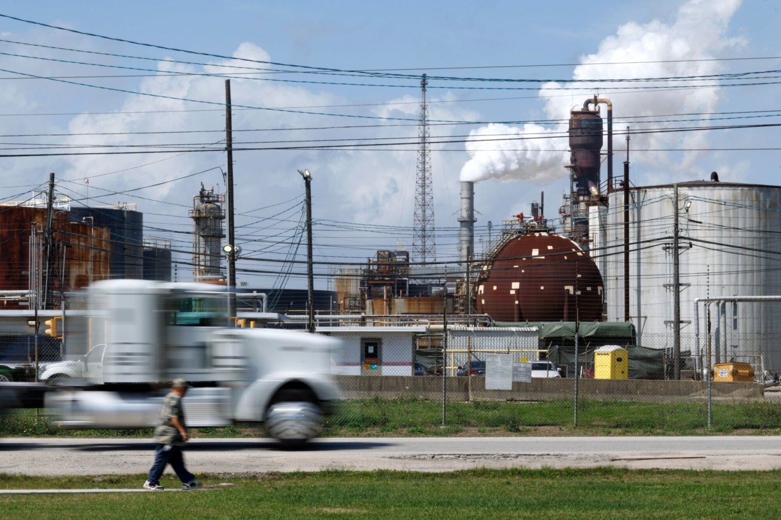The Exxon oil refinery in Baytown, Texas, March 5. Mark Felix/Bloomberg News
Washington’s pessimist caucus is always on duty and the members had a good Friday, as oil prices climbed and the Labor Department said the economy lost jobs in February. Equities fell again on the bad news, but none of this is a cause for a panic attack.
There’s no denying the February report was lousy. The U.S. shed 92,000 jobs and revised down gains for January and December by a combined 69,000. The question is what to make of the declines.
The first point to understand is that the jobs report is unrelated to the Iran war, though Democrats want to link the two. The Labor household and employer surveys took place mid-month before the bombing began.
Some 28,000 of the job losses came in healthcare, but that owes largely to union labor actions. Other industries that shed jobs include leisure and hospitality (27,000), manufacturing (12,000), construction (11,000) and motion picture production (9,500). The monthly job data has been noisy lately, and the household survey was less gloomy.
That survey showed the number of workers employed part-time for economic reasons declined by some one million over the past two months, and the unemployment rate has remained more or less steady at 4.4%—around what it was in 2017. The ADP payroll report and the Institute for Supply Management’s services report this week both showed job growth last month, so go figure.
The labor market has been cooling, with healthcare and social assistance driving most gains. The causes are diffuse. Job growth notably stalled after President Trump began his tariff barrage last April, which created economic uncertainty and raised business costs. His immigration raids have reduced the supply of workers, especially in construction.
Many employers say that an aging population and skills gaps make it hard to find workers in the trades. Rising productivity—2.8% in the last year—may also mean employers need fewer workers and could explain why wage growth has remained strong despite a slowdown in hiring. Average hourly wages rose 0.4% last month and are up 3.8% in the past year.
As for the other cause of Friday’s anxiety, crude oil prices took a big jump to above $93 a barrel. The cause is shipping disruptions through the Strait of Hormuz from the fighting in the Persian Gulf region. Kuwait said that it may have to throttle production as its oil storage facilities fill up, and other producers may also do so temporarily. Qatar, which wants the war to end fast, fed the angst by saying prices could go to $150 a barrel.
Prices will rise further the longer the conflict continues, and Americans will see higher gasoline prices at the pump for a while. But to put current prices in non-panicky perspective, Brent crude traded above $90 a barrel for most of 2022 after Russia’s Ukraine invasion and exceeded $100 a barrel from 2011 to 2014. Neither price surge led to a recession.
Prices will come down assuming shipping bottlenecks ease. The threat level in the Persian Gulf has already declined somewhat with fewer Iranian missile and drone attacks, and Mr. Trump has said the U.S. Navy will escort oil tankers if necessary.
Stopping the flow of oil is part of the Iran regime’s war strategy to cause enough political pain in the Gulf and the U.S. that Mr. Trump and Israel stop the bombing. But that is all the more reason not to panic at a temporary price surge and press ahead to remove Iran’s missile and drone stockpiles and assembly lines and the regime’s brutal enforcers.
Oh, and if Mr. Trump wants a tax-cut boost for the economy while the war continues, he could call off his new 15% universal tariff. Consider it our contribution to easing everyone’s economic anxiety.

Pace of Inflation Held Steady in December; Consumer Prices Up 2.7% on Year
Groceries and restaurant meals had large price increases over the month, while gasoline costs and used-car prices declined
By
Harriet Torry
Follow
Updated Jan. 13, 2026 2:25 pm ET
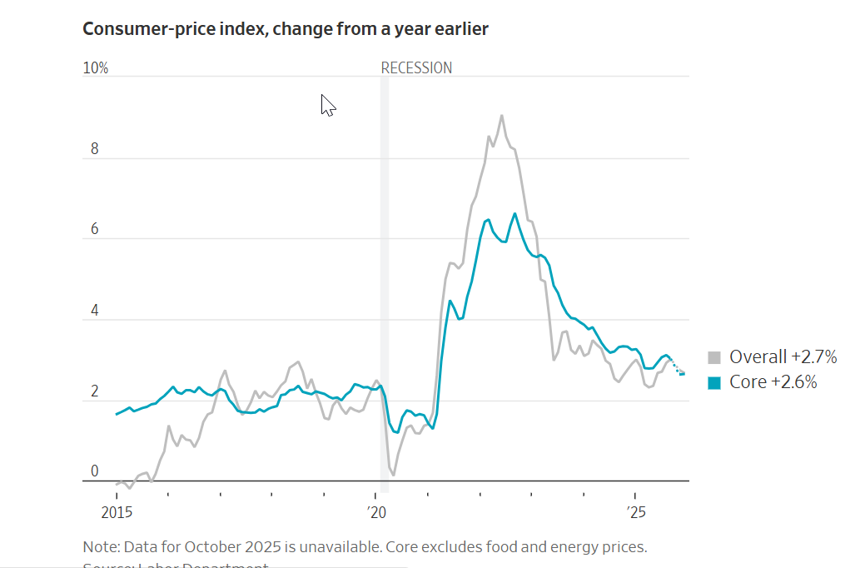
Inflation remained relatively contained at the close of 2025 despite turbulence from tariffs, giving the Federal Reserve some breathing room as it weighs the threat of price pressures against a cooling labor market.
Consumer prices rose 2.7% in December from a year earlier, the Labor Department said Tuesday. That was unchanged from November’s pace and in line with the expectations of economists surveyed by The Wall Street Journal.
The consumer-price index report showed the impact of tariffs is still relatively muted. Last spring, a big fear was that Trump’s new tariffs would fuel massive price increases, but some companies have been eating the cost or raising prices only slowly. Tuesday’s report also offers a measure of relief to Fed officials who lowered rates last month and have signaled they plan to hold them steady for now.
“In a year where there was an incredible amount of angst related to tariffs and the potential for upward pressure on that, we’re finishing the year in a more benign stance than where we started,” said Tom Porcelli, chief economist at Wells Fargo.
Though inflation readings bounced around last year and remain stuck above the 2% rate that policymakers prefer, year-over-year CPI inflation cooled over the course of 2025, to 2.7% in December from 3% in January.
The December report “allows the Fed to start the process of shifting its focus more toward the labor part of the mandate, which is in need of some help right now,” Porcelli added.
High prices remain a top concern for Americans, many of whom thought life would be more affordable by now but instead have had to stomach five years of persistent inflation. Prices for groceries, insurance and housing are much higher than they were just a few years ago, forcing President Trump to pivot from scoffing at complaints about affordability to pitching ideas about how to lower everyday costs.
People paid more for rent, airline fares and visits to the doctor’s office in December compared with the prior month, according to the Labor Department. On the flip side, gasoline costs and used car and truck prices declined.
What’s more, a slowing labor market has left workers anxious. Outside of the two most recent recessions, 2025 saw the lowest pace of average monthly job growth since 2003.
Underscoring the pressure many households are under as demand for workers cools, average weekly earnings of U.S. workers declined 0.3% on the month in December after adjusting for inflation, the Labor Department said in a separate release Tuesday.
The president took a victory lap after the inflation numbers were released. “Great (LOW!) Inflation numbers for the USA,” he wrote on Truth Social. “Thank you MISTER TARIFF!” he added.
Trump also hit out at Fed Chair Jerome Powell, accusing him of being too slow to lower interest rates. Trump and Powell have been locked in an extraordinary public feud since Sunday night, when Powell accused the Trump administration of using the threat of criminal prosecution to pressure the Fed into lowering rates.
Tuesday’s CPI report showed prices rose a seasonally adjusted 0.3% on the month in December. Food overall went up by 0.7% on the month, the largest month-over-month increase since October 2022.
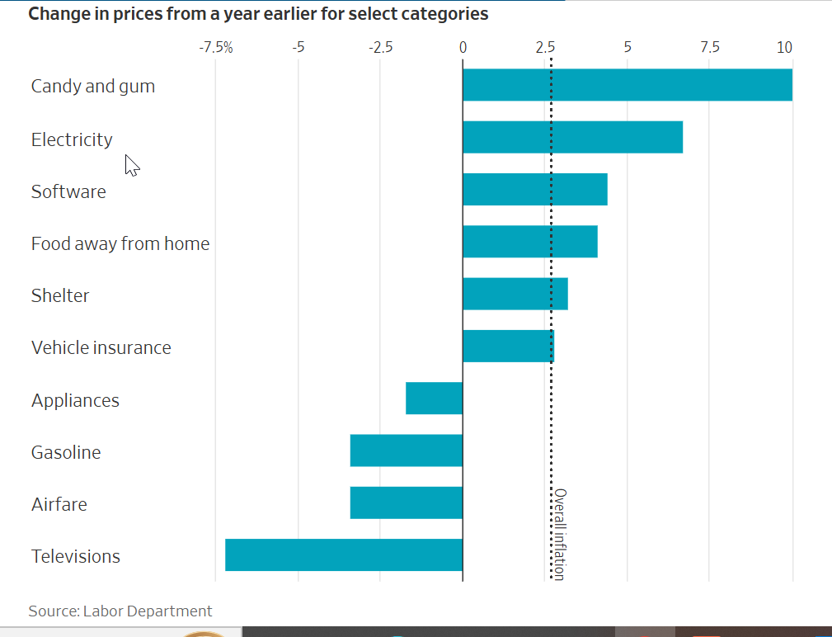Stripping out volatile food and energy costs, the core measure of prices increased 2.6% over the year, the same pace as the prior month and cooler than the 2.8% analysts predicted.
Tuesday’s report marks the first complete look at inflation trends in months. The Bureau of Labor Statistics, which is the stats arm of the Labor Department, wasn’t able to collect prices in the field during the government shutdown in the fall, and the agency had to use technical workarounds to deal with the missing data in the previous inflation report. Many economists believe that, as a result, the month-ago inflation numbers may have been artificially low. (The BLS has said it handled gaps in the price data as best as it could.)
“Distortions caused by the government shutdown have made the inflation data harder to interpret, but the recent run of figures suggests inflation has peaked,” Michael Pearce, chief U.S. economist at Oxford Economics, said in a note to clients after the CPI report’s release, since “tariff-driven price rises have mostly been passed through.”
The impact of tariffs, though milder than many economists predicted, has still affected American consumers. An index measuring goods prices excluding food, energy, and used cars and trucks was up 1.4% on the year in December. While that was lower than the overall rate of inflation, it was the highest reading for that category since October
Trump has shattered the norms around the central bank’s independence. The Wall Street Journal’s Nick Timiraos explains what it means for global finance. Photo Illustration: Jason Boone
U.S. stock indexes were down.
The current U.S. economy represents something of a split screen, with a cooling labor market but still-solid economic growth. Small-business confidence in the U.S. rose in December from the previous month, driven by a jump in those expecting better business conditions going forward, according to the small-business optimism index from the National Federation of Independent Business out Tuesday.
“The U.S. economy has remained resilient. While labor markets have softened, conditions do not appear to be worsening,” JPMorgan Chase Chief Executive Jamie Dimon said Tuesday as the bank issued its fourth-quarter earnings results.
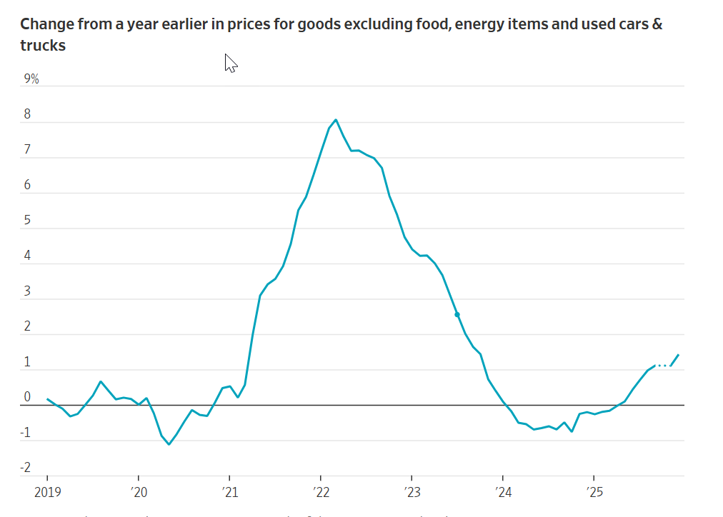The December consumer-price index isn’t likely to change the Fed’s wait-and-see posture at its next policy meeting at the end of this month because officials are likely to want to see more evidence that inflation is leveling off before cutting rates.
The Fed cut its benchmark interest rate at its last three meetings, most recently in December. Officials lowered rates because they were more concerned about risks of a sharper-than-anticipated slowdown in the labor market.
To resume rate cuts, Fed officials are likely to need to see either new evidence that job-market conditions are weakening or that price pressures are fading. It could take at least a couple more months of inflation reports for the latter to materialize.
Economists are interested to see how inflation will fare for January and February, since many businesses adjust their prices at the start of the year.
Copyright ©2026 Dow Jones & Company, Inc. All Rights Reserved. 87990cbe856818d5eddac44c7b1cdeb8
Appeared in the January 14, 2026, print edition as 'Inflation Holds Steady, Giving Fed Breathing Room'.
Harriet Torry is The Wall Street Journal’s economics correspondent for the Western U.S. Previously she covered the U.S. economy and Federal Reserve from the Journal's Washington, D.C., bureau. Harriet joined the Journal in Frankfurt in 2010 as a financial reporter, before moving to Berlin to cover the German government and economy during the eurozone sovereign debt crisis.

U.S. Loses 92,000 Jobs in Widespread and Unexpected Downturn
Healthcare strike weighed on jobs count; crucial moment on interest rates for the Fed
By
Justin Lahart
Follow
Updated March 6, 2026 4:34 pm ET
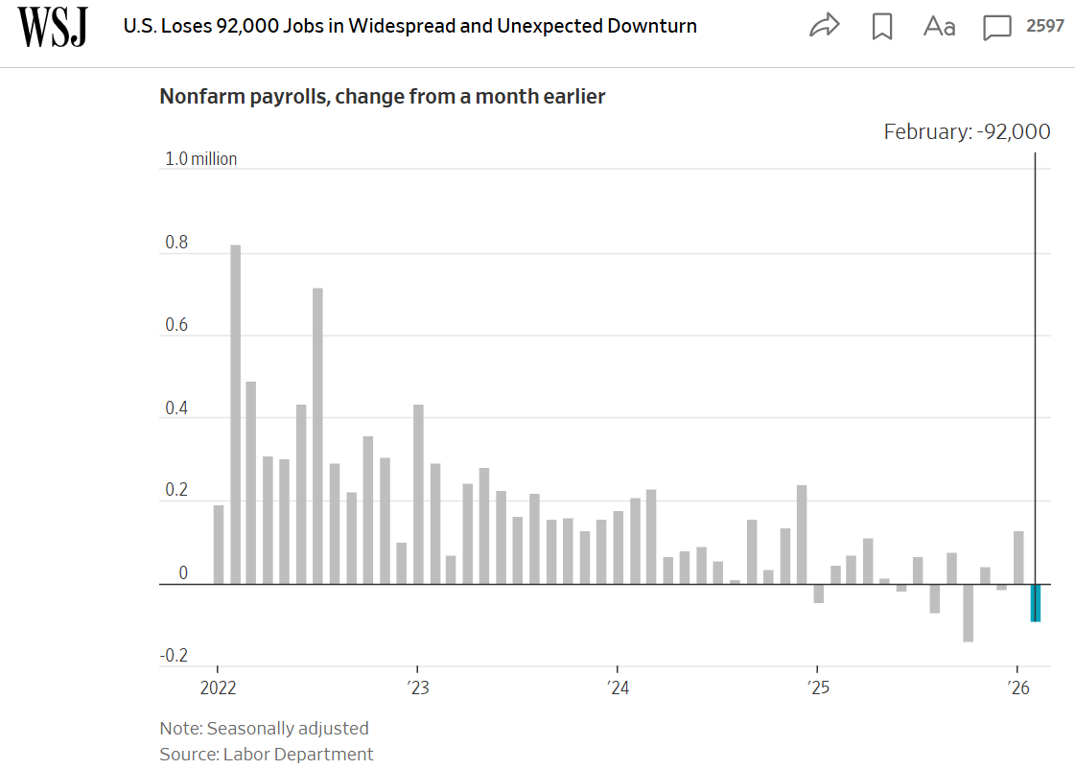
The U.S. lost 92,000 jobs in February, a widespread and unexpected downturn for a job market that continues to struggle across a broad range of sectors.
The employment numbers, reported Friday by the Labor Department, fell far short of January’s gain of 126,000 jobs. They were also much worse than the gain of 50,000 jobs that economists polled by The Wall Street Journal had expected to see.
The unemployment rate ticked slightly higher to 4.4%. While that is still low, the Friday report exposes troubling weaknesses in a labor market that has shown very little employment growth in recent months.
What the Dismal February Jobs Report Means for the Economy and the Fed
The U.S. economy lost 92,000 jobs in an unexpected downturn. WSJ’s Ashby Jones breaks down the latest jobs report.
Healthcare jobs, which have propped up the labor market for months, collapsed. A strike in California was partly to blame, but it also highlighted problems in the rest of the market. Private-sector jobs fell by 86,000.
Employment growth slowed markedly last year, and the U.S. has now lost jobs in three of the past six months. Many employers have been unnerved by back-and-forth tariff policies. Expectations that artificial intelligence could reduce staffing needs have cut into hiring plans. What’s more, the Trump administration has also slashed the federal workforce.
“This is about a labor market that is so soft that it cannot withstand a strike” of 31,000 healthcare workers, wrote inflation Insights economist Omair Sharif in a note to clients. “Because no one else is hiring.”
Kevin Hassett, director of the White House’s National Economic Council, said the economy remained strong. He attributed the February downturn to one-offs, including a change in how the Labor Department’s Bureau of Labor Statistics accounts for businesses opening and closing.
“We had a surprisingly positive one last month and a surprisingly negative one this one. But on average, it’s about what we expect to be seeing,” Hassett said in a CNBC interview.
The numbers raise expectations that the Federal Reserve will have to cut rates.
For the Fed, a labor market stumble comes at an uncomfortable moment because policymakers are already contending with new potential disruptions to energy and commodity prices following the U.S.-Israel military campaign in Iran that has closed key global shipping lanes. Those disruptions raise the prospect of another bout of price increases in an economy where inflation has been above the Fed’s 2% goal for five years.
A central bank that simultaneously watches the job market weaken and inflation risks re-emerge has few good options.
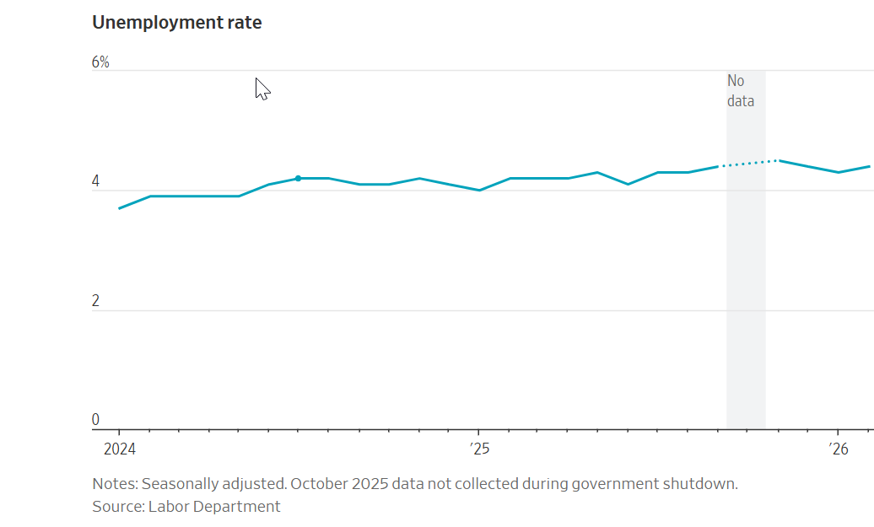
While the Fed is expected to hold rates steady at its meeting later this month, the February employment report will revive questions about whether last year’s three rate cuts were sufficient to protect the labor market. If the unemployment rate continues to rise in the coming months, that could suggest the labor market is weaker than expected and put pressure on Fed officials to resume rate reductions around midyear.
U.S. stocks were in the red. The Dow Jones Industrial Average, the S&P 500 and the Nasdaq composite all fell about 1% or more.
“It’s not pretty,” said Gregory Daco, chief economist at EY-Parthenon.
Daco had expected a weaker report than most economists, forecasting a loss of 15,000 jobs as payback for a strong January report. But not only was the February job decline steeper than he had expected, there were downward revisions to December and January that lowered the U.S. job count by an additional 69,000.
He worries that a lackluster labor market threatens consumer spending, which is the main driver of the entire economy.
“Especially after adjusting for inflation, income growth is under pressure, and therefore people’s ability to spend is constrained,” he said.
Healthcare and social assistance shed 18,600 jobs in February, after adding 116,400 positions in January. The strike that weighed on results included 31,000 workers at Kaiser Permanente.
While white-collar jobs have been under pressure, Friday’s report showed a more marked deterioration in blue-collar work.
Construction lost 11,000 jobs. The sector had been bolstering employment in recent months, driven by the growing demand for new data centers. Leisure and hospitality, which employs roughly one in 10 American workers, lost 27,000 jobs. Manufacturing lost 12,000 jobs.
The unemployment rate for workers age 25 and up with only a high-school education rose to 4.8% in February from 4.6% in January. The unemployment rate for workers with a bachelor’s degree or higher stayed steady at 3%.
Friday’s report also incorporated an annual update to population figures underlying the unemployment rate and other measures. These showed the population was lower in December than previously reported, reflecting the sharp drop in the flow of immigrants into the U.S. since President Trump returned to office.
These revisions don’t have any bearing on the Labor Department’s main jobs count, which is based on a survey of employers.
SHARE YOUR THOUGHTS
What does the jobs report say to you about where the economy is headed? Join the conversation below.
These now show that there were 1.4 million fewer people employed as of December than previously reported. These new estimates are reflected in the Labor Department’s January and February data, but prior data don’t get revised.
That downward revision to employment doesn’t necessarily reflect a deterioration in the labor market. Rather, it is a reflection of changes in immigration that weren’t anticipated when earlier population estimates were drawn up. President Joe Biden tightened immigration in mid 2024, and restrictions have become far more severe under Trump. Each year, the Labor Department updates its population figures based on Census Bureau figures.
Copyright ©2026 Dow Jones & Company, Inc. All Rights Reserved. 87990cbe856818d5eddac44c7b1cdeb8
Appeared in the March 7, 2026, print edition as 'U.S. Jobs Suffer Broad, Surprise Drop-Off'.
Justin Lahart is an economics reporter based in New York. Previously, Justin was a Heard on the Street columnist and wrote the Ahead of the Tape column.

Do Tariffs Raise Prices?

We break down how much of a tariff is ‘passed through’ to customers
By
Jason Douglas
Follow
,
Anthony DeBarros
Follow
and
Danny Dougherty
Follow
March 2, 2025 9:00 pm ET
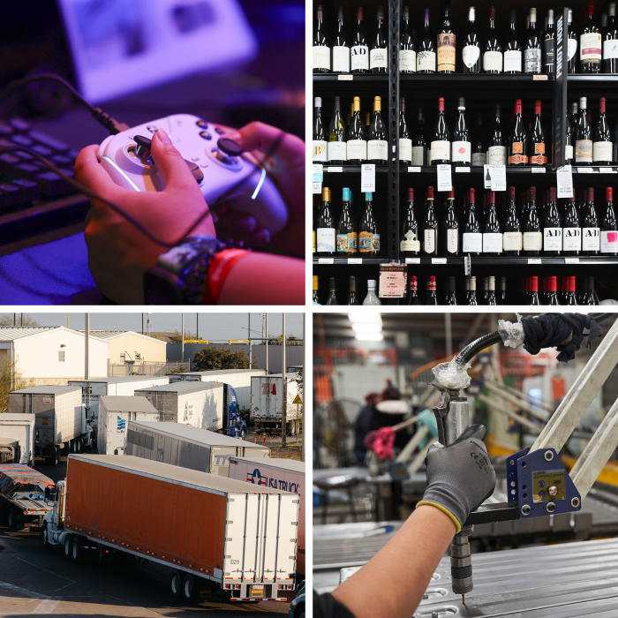Photo: Bloomberg (2), AFP/Getty Images, Christopher Lee for WSJ
President Trump has imposed or threatened tariffs on a range of products and countries. How much more will consumers pay? The question is surprisingly hard to answer.
For example, a 10% tariff on shoes from China would raise their sticker price 4% or so, but on wine or olive oil from Italy, almost 10%.
Why the difference? Tariffs aren’t the only factor at work. Currency changes, the availability of alternatives, and the pricing strategies of producers and importers all play a part. All of this affects “pass-through”—how much of a tariff reaches the consumer.
The Wall Street Journal asked Moody’s, an economic-research firm, to model how various tariffs would affect prices of a range of household goods from different countries. The Journal then applied those effects to typical prices found online.
The results offer an illustration—not a prediction—of how tariffs could ripple through to everyday prices.
For this analysis, Moody’s has applied tariffs of 25% on imports from Mexico and Canada, in line with Trump’s announcement, and 10% on all others. Trump has already implemented an additional 10% tariff on China, and announced another additional 10% levy.
“There are so many different ways that tariffs flow through into prices and the economy,” said Mark Zandi, Moody’s chief economist. “The knock-on effects are sometimes not intuitive.”

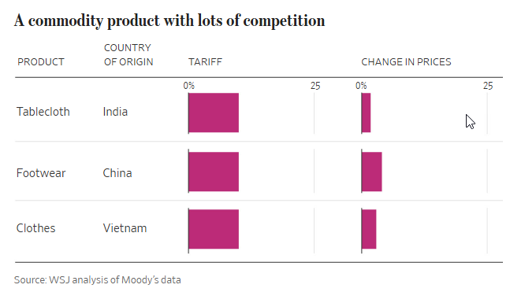
Moody’s analysis suggests a 10% tariff on a tablecloth from India would only raise the final price 2%, from $25.99 to $26.51. Tariff pass-through on tablecloths from India is limited because a lot of countries produce tablecloths and compete fiercely for American consumer dollars.
That range of alternatives is why the effect is even smaller when extended to household linen prices in general, at 0.8%. Consumers aren’t that fussy about where they come from or who makes them. The prices in stores for such commoditylike consumer goods aren’t prone to big swings from tariffs alone. The same would probably be true of clothes, spare parts and accessories for cars, and some common cosmetics.

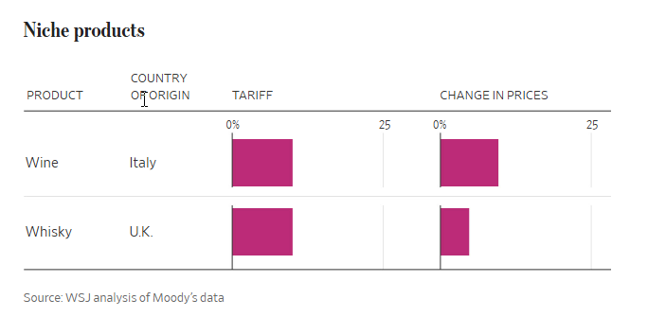
Higher prices on Italian wine don’t drive down consumption much; someone who loves a particular Chianti is reluctant to switch. Sellers are more likely to pass through the full 10% tariff, then, betting they won’t lose many customers as a result. A 10% tariff on a $21.99 bottle from Italy would boost its price almost the full 10%, to $24.08. But Italian wine is a niche product, accounting for a small share of total U.S. wine consumption, so the total impact on the price of all wine is a relatively small 0.3%.
That said, this example illustrates how tariffs on one product can raise prices throughout that group. A Californian winemaker would probably nudge up her price as well, earning fatter profits. As long as her new, higher price is lower than the tariffed alternative, she might pick up some market share.
The wine wholesaler also plays a role. Faced with a higher import bill for Italian wine thanks to new tariffs, the wholesaler might decide to raise prices for alternative wines in his warehouse to compensate for lost profit on the Italian bottles. Of course, he might decide to do the opposite and swallow the lost profit on the tariff, hoping to grab market share from competitors who instead pass on the price increase to consumers.
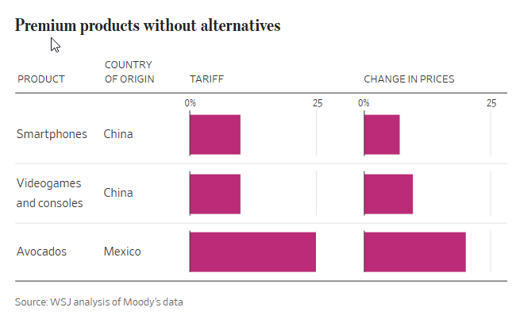
Tariffs are most keenly felt when imported or domestic alternatives are unavailable, or the affected product commands a significant premium. Even if tariffs raise the price of the latest iPhone, Apple fans would probably still buy it.
Videogame consoles and their software fall into a similar category. Videogaming is dominated by a handful of players, mainly Nintendo, Sony and Microsoft. Many of the physical game consoles are made in China, and gamers won’t just swap in another machine to keep playing. That gives producers and importers real power to jack up prices for consumers to offset the pain of tariffs. The Moody’s analysis suggests that nearly all of a 10% additional tariff on game consoles imported from China would be passed through to consumers, raising the price of a $500 machine to $548.
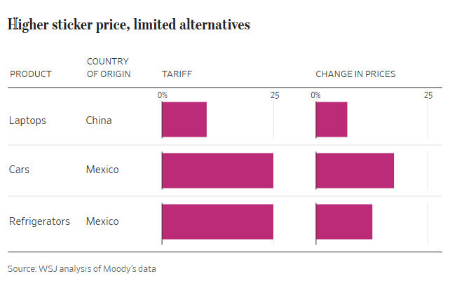
Mexico is the top foreign supplier of passenger cars and sport-utility vehicles into the U.S., accounting for 23% of imports in 2024. Tariffs on Mexican-made cars would likely mean not just higher prices for vehicles shipped across the border, but on all cars as other manufacturers and dealers see a chance to eke out more profit while gaining market share.
This same dynamic is likely to be felt across many products, such as home appliances. Washing machines were hit with tariffs in 2018, which researchers found led to an increase in the price not just of washing machines but dryers also. The two are typically bought together, and retailers saw an opportunity to earn more.
The study also found that prices of domestically made, not just imported, washers rose, as manufacturers raised prices owing to higher labor costs and tariffs on imported parts, and to match price hikes on imported machines. Meanwhile, U.S. manufacturers expect tariffs on intermediate components, such as steel and aluminum, to also feed through to final prices. Those effects aren’t included in the Moody’s analysis here. But they are real.
Write to Jason Douglas at jason.douglas@wsj.com, Anthony DeBarros at anthony.debarros@wsj.com and Danny Dougherty at danny.dougherty@wsj.com

