RabbitMQ Server SetUp and working Sample

1. Download the RabbitMQ for Windows.( <https://www.rabbitmq.com/>)
2. Follow the setup guide from the Website.
3. Setup the path in the environment variable. (till sbin)
4. Open Command Prompt and type “**rabbitmq-server**”

<https://www.compose.com/articles/configuring-rabbitmq-exchanges-queues-and-bindings-part-2/>

How to Enable Management Console ?

1. Open Command prompt
2. Type the below command

“**rabbitmq-plugins enable rabbitmq_management**”

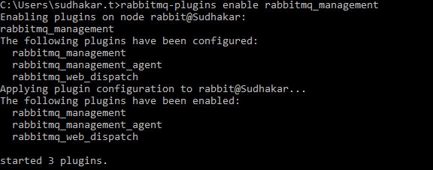

1. Once the plugs ins installed you can go to the browser and enter (<http://localhost:15672/>)

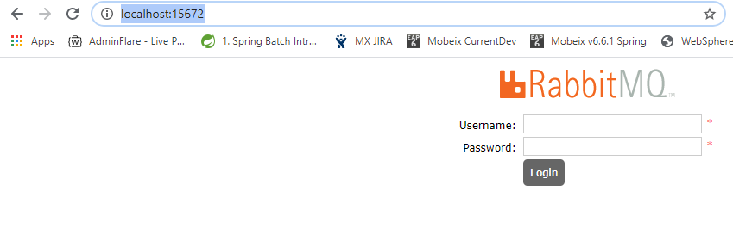

How to Create New User:

1. Login to Admin Console

