

Mobile Programming

GreenyDroid

Mr. Noel Anonas

MI141

Heramia, Johanna Marisse C.  
Tadeo, Jose Lorenzo G.

Table of Contents

**GREENYDROID**

**(Game)**

**Theme:** *Health* / Educational / Game

*GreenyDroid* is a game application that allows the user to know more about every version of android and know more about health tips depending on the version of android. It has different levels from easiest (first version) to hardest (latest version). Every version, there is different *character* that they will be using in mini games. In order to go to the next level, the user needs to do the challenges correctly but if the user cannot do the challenges, they will repeat the challenge from the beginning of their current level. Challenges are composed of questions and mini games (atleast 5 mini games) that should be answered and played by the user.

The target audience are people from 7 years old and above for they will be able to understand the game easily, but 7 years old and below may use it for their entertainment.

The main objectives of this project is to be able to know more about the details of every version of android, to be able to give information that can help the user to live in simple healthy life style and to give user the entertainment.

The features that are included:

* Characters and name of the characters in every level
* Stories in every level
* Mini games
* Questions from the story with choices
* Gives right answers
* Health tips that are connected on the characters
* Changing interface in every level

Features that are NOT included:

* User can’t create their own character
* User can’t change the name of the character
* Health tips are just simple and not numerous

Review of Related Literature

Case Study

GreenyDroid

Game Mechanics

Before the game will start, an instruction will be given to be able to know the objective of the challenge on each level. Read the stories carefully and quickly because stories have time limit. After the story, certain question will be asked and questions should be answered quickly to do the challenge. When the questions are answered correctly, there will be a mini game. Everything must be completed to be able to go to the next level.

Game Instruction

In mini games, to be able to move the character, touch the screen where you want to move the character.

Technical Requirements:

The technologies or software that were used to develop these applications are Android Studio for coding, PowerPoint 2016 for creating background and Photoshop for creating an image.

SCREENSHOTS:



Hi, I am Greeny

***Greenydroid***

***LET’S START***



First Page:

First Page

User should click the “LET’S START” button to start the game.



Hi, my name is Greenydroid. What’s your name?

Insert Name

User should enter his/her name­ and click the screen to go to the next screen.



Hello, nice to meet you [name]. I like you [name]. I hope you like me, too.

I want to tell something about myself and you have to listen very carefully.

Begin

User will see a story that is related to the first version of android.

When the user clicks the “begin” button, the game will start.



I was born on September 23, 2008. I am so small, my eyesight is still developing but I love green vegetable like spinach, asparagus and cucumbers

For the fruits, I love green pears, green bananas, Watermelon, and tomato green. I think that could help.

Next

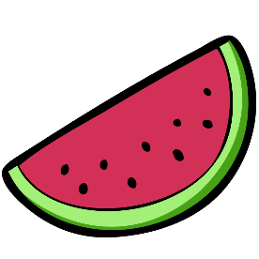

Yummy! I really love color green because it makes me feel relax and happy! Green also stands for growth, freshness and prosperity. I want to grow bigger and better so that I can be the best that I can be.

Next

Please help me, [name]!



Hi, [name]! I know I told you a lot about myself and I hope that you still remember those things. I’m going to ask some questions and you have to answer it. In every correct answer, we will earn points. Yehey! Go, [name]!

Begin

Questions



10

Next

What is my name?

1. Greenyproid
2. Greenydrois
3. Greenydroid
4. Greenydroyd



1. spinach, beans and cucumbers
2. beans, cucumbers and peppers
3. spinach, asparagus and cucumbers

10

Next

1. spinach, cucumbers and lettuce

What are my favorite vegetables?



When is my birthday?

1. September 23, 2007
2. September 22, 2008
3. September 23, 2008
4. September 23, 2009

10

MINI GAME



Congratulations for succeeding the questions and mini game!

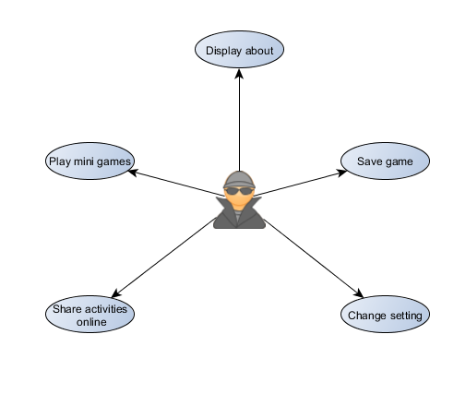USE CASE DIAGRAM

CONTEXT FLOW DIAGRAM

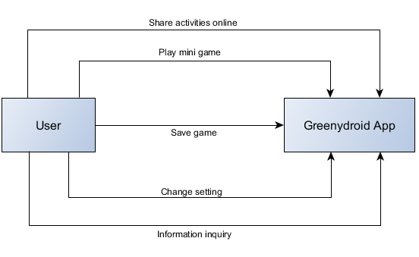

SYSTEM FLOW

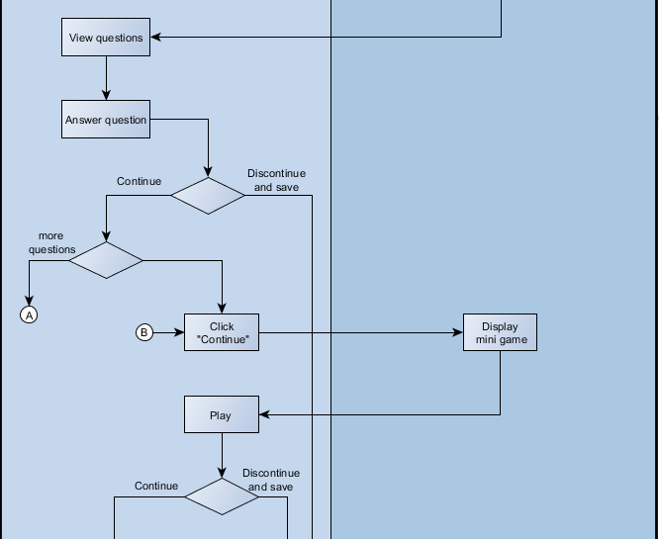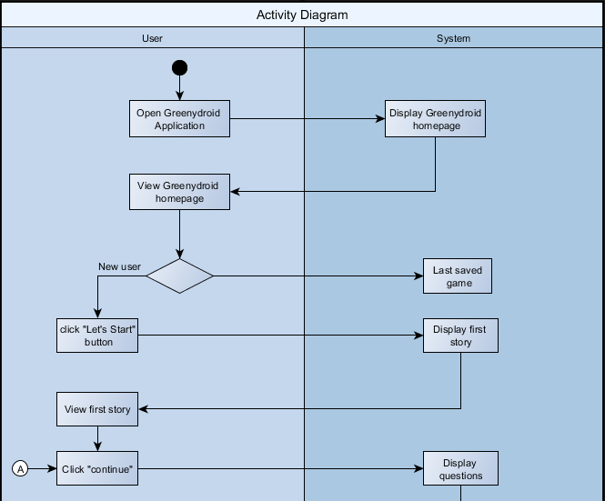

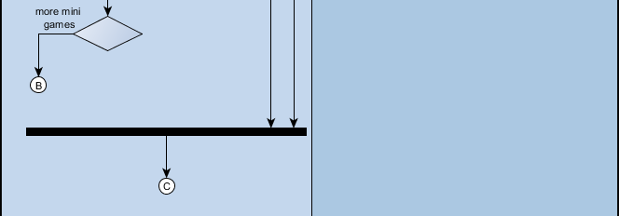

**Story line**

**Android 1.0**

Hi, my name is Greenydroid. What’s your name? [insert name] Hello, nice to meet you [name]. I like you [name]. I hope you like me, too. I want to tell something about myself and you have to listen very carefully. I was born on September 23, 2008. I am so small, my eyesight is still developing but I love green vegetable like spinach, asparagus and cucumbers. For the fruits, I love green pears, green bananas, Watermelon, and tomato green. I think that could help. Yummy! I really love color green because it makes me feel relax and happy! Green also stands for growth, freshness and prosperity. I want to grow bigger and better so that I can be the best that I can be. Please help me, [name]! 🡪 Continue

Hi, [name]! I know I told you a lot about myself and I hope that you still remember those things. I’m going to ask some questions and you have to answer it. In every correct answer, we will earn points. Yehey! Go, [name]!

When is my birthday?

1. September 23, 2007
2. September 22, 2008
3. September 23, 2008
4. September 23, 2009

What are my favorite vegetable?

1. spinach, cucumbers and lettuce
2. spinach, beans and cucumbers
3. beans, cucumbers and peppers
4. spinach, asparagus and cucumbers

What are my favorite fruits?

1. green bananas, watermelon, and spinach
2. green pears, green bananas, Watermelon, and tomato
3. Tomato green, green pears, green bananas, and watermelon
4. green pears, green bananas, Watermelon and cucumbers

What is my name?

1. Greenyproid
2. Greenydrois
3. Greenydroid
4. Greenydroyd

What does color green stands for me?

1. Prosperity, freshness and growth
2. Freshness, growth and happiness
3. Growth, prosperity and coolness
4. Happiness, growth and freshness

What does color green make me feel?

1. Relax and happy
2. Happy and calm
3. Calm and lovable
4. Comfortable and Excited

**Android 1.5 Cupcake**

Hello, [name]! I just want to thank you for making me better. I feel bigger now ☺ Since February 9, 2009, I started to feel a bit different. I have now better communication skills and better design. See? I can now give more information when someone ask me for a place. And also, my mama gave me a cupcake and it was so yummy! I really like it! It’s my favorite food now. It is so sweet, like you [name]. ☺

When I did start to feel a bit different?

1. February 9, 2008
2. February 8, 2009
3. February 9, 2007
4. February 9, 2010

What is my favorite food now?

1. Cake
2. Cupcake
3. Chocolate
4. Cheese

Who gave me my favorite food?

1. Dada
2. Sister
3. Mama
4. Auntie

What are my improvements?

1. Better communication skills and better design
2. Better design and better height
3. Better information and better image
4. Better forever

**Android 1.6 Donut**

Hello again, [name]! Did you miss me? Awww, I miss you too, [name]. Well I just want to tell you what has been up to me. I’m sure you are excited! Because I’m so excited to tell you something. Did you know that my voice and my writing are improving? Yes! And also I can speak now other languages, too! My eyes are getting better. It has faster reflexes than before. I need to be more technical from the next chapter of my life, but don’t worry I’ll guide you and teach you what you can’t understand. You’re my best friend. What friends are for, right?

Lesson Learned

Having a subject like Mobile Programing requires time to learn and willingness to learn for us to be able to pass. Analyzation, memorization, and time management is one of the most important thing that every individual should learn and should have. From the start, it was not easy, but as the time goes by, you will “ENJOY”. You will enjoy learning xml codes and java codes, and even if creating image is not part of this subject, but we do not have choice but to use Photoshop (like no basic knowledge TT_TT) to build characters, images and backgrounds that are needed in our application.