

Mobile Programming

GreenyDroid

MI141

Heramia, Johanna Marisse C.  
Tadeo, Jose Lorenzo G.

Professor: Mr. Noel Anonas

Table of Contents

Description …………………………………………………………………3

Target Audience……………………………………………………..…….3

Project Objective…………………………………………………………..3

Scope and Limitation……………………………………….....................3

Review of Related Literature……………………………………………..4

Story Board

Case Study Background

Problem and Solution

Game Mechanics………………………………………………………….6

Game Instruction………………………………………………………….6

Game Map / Level

Scoring

Cut Scene

Technologies used…………………………………………..

Screenshots…………………………………………………….

Use Case Diagram……………………………………………….

Activity Diagram………………………………………………….

Java Code Snippets…………………………………………………

Graphics Assets and Art Work Example………………………………

Glossary of Terms

Lessons Learned……………………………………………………

Resume of each member………………………………………………..

**GREENYDROID**

**Theme:** *Health* / Educational / Game

*GreenyDroid* is a game application that allows the user to know more about every version of android and simple health tips depending on the version of android. GreenyDroid has different levels from easiest level (first version) to hardest level (latest version). Every version, there is different *character* that they will be using in mini games

In order to go to the next level, the user needs to do the challenges correctly, but if the user cannot do the challenges, they will repeat the challenge from the beginning of their current level. Challenges are composed of questions (multiple choice) and mini games (at least five mini games) that should be answered and played by the user.

The target audience are people from seven years old and above for they will be able to understand the game easily. Seven years old and below may use it for their entertainment.

The main objective of this project is to be able to know more about the simple details of every version of android, to be able to give information for the user to be more knowledgeable in certain food and to give user the entertainment.

The features that are included:

* Different feature of character in every level
* Story in every level
* Questions from the story with choices
* Mini games
* Health tips / information that are connected on the characters or level
* Changing background in every level

Features that are NOT included:

* User can’t create their own character
* User can’t change the name of the character
* Health tips are just simple and not numerous

Review of Related Literature

Category Quiz (Trivia)

Category Quiz is a quiz where the questions must be answered by category such as sports, entertainment, food, geography, music, news etc. If all questions in a category are answered correctly, user will get and extra points, but if question is answered incorrectly, the category gets locked. If the question timer is used (can be enabled/disabled using the game options) the user has 30 seconds to answer the question. Like on our project, it also has question and answer portion that needs to be answered correctly in every level of the game but the user cannot disable nor enable the timer of the game.

Nutrition Tips

This application, like on our application, gives useful nutrition tips and nutritional health facts that can help to and improve a person’s health.

Pou

Pou is pet that you can take care of, like user should give food, give shower, give good outfit, and give some fun. It has mini games that user should play to earn money to buy items and to earn level to unlock items.

Case Study

GreenyDroid

Game Mechanics

Before the game will start, an instruction will be given to be able to know the objective of the challenge on each level. Stories will be given and user should read it and understand it carefully and quickly because stories have time limit. After the story, certain question will be asked and questions should be answered quickly to do the challenge. When the questions are answered correctly, there will be a mini game that should be done perfectly. Everything must be completed to be able to go to the next level.

Game Instruction

In mini games, to be able to move the character, touch the screen where you want to move the character and the character will move. In question and answer, click the corresponding button for the correct answer. If the answer is incorrect, new question will be asked.

Game Map / Level

Technical Requirements:

The technologies or software that were used to develop these applications are: (1) Android Studio. Android Studio provides the fastest tools for building apps on every type of Android device. We use Android Studio for code editing, debugging, performance tooling, a flexible build system, and an instant build/deploy system. (2) Also, we use Photoshop for creating an images and backgrounds.



Hi, I am Greeny

***Greenydroid***

***LET’S START***



First Page:

First Page

User should click the “LET’S START” button to start the game.



Hi, my name is Greenydroid. What’s your name?

Insert Name

User should enter his/her name­ and click the screen to go to the next screen.



Hello, nice to meet you [name]. I like you [name]. I hope you like me, too.

I want to tell something about myself and you have to listen very carefully.

Begin

User will see a story that is related to the first version of android.

When the user clicks the “begin” button, the game will start.



I was born on September 23, 2008. I am so small, my eyesight is still developing but I love green vegetable like spinach, asparagus and cucumbers

For the fruits, I love green pears, green bananas, Watermelon, and tomato green. I think that could help.

Next



Yummy! I really love color green because it makes me feel relax and happy! Green also stands for growth, freshness and prosperity. I want to grow bigger and better so that I can be the best that I can be.

Next

Please help me, [name]!



Hi, [name]! I know I told you a lot about myself and I hope that you still remember those things. I’m going to ask some questions and you have to answer it. In every correct answer, we will earn points. Yehey! Go, [name]!

Begin

Questions



10

Next

What is my name?

1. Greenyproid
2. Greenydrois
3. GreenyDroid
4. Greenydroyd

This is the question that the user should be answer quickly because it has time limit.



1. spinach, beans and cucumbers
2. beans, cucumbers and peppers
3. spinach, asparagus and cucumbers

10

Next

1. spinach, cucumbers and lettuce

What are my favorite vegetables?



When is my birthday?

1. September 23, 2007
2. September 22, 2008
3. September 23, 2008
4. September 23, 2009

10

MINI GAME



Congratulations for succeeding the questions and mini game!

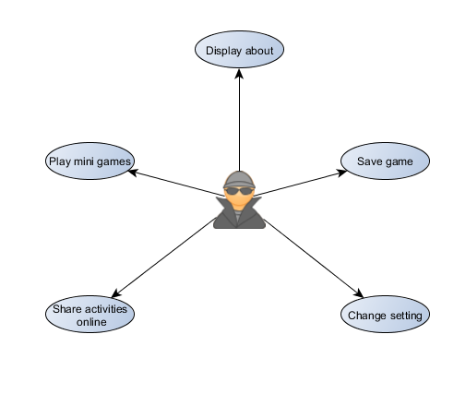USE CASE DIAGRAM

CONTEXT FLOW DIAGRAM

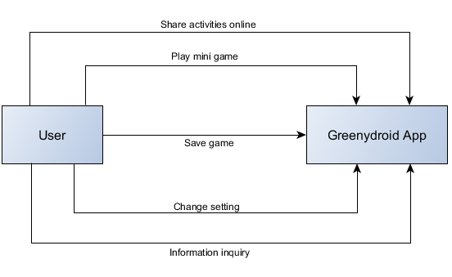

SYSTEM FLOW

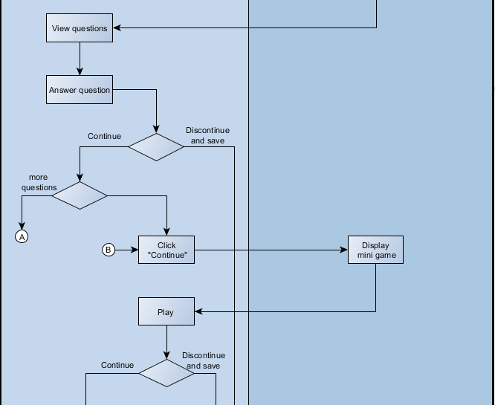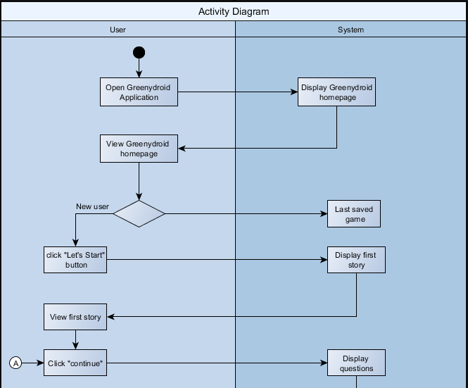

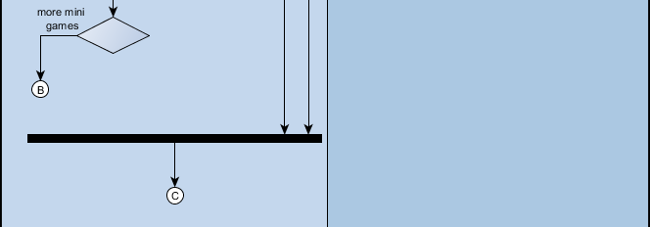

JAVA CODES SNIPPET

1. When button is clicked, new activity will appear.

private void settingButton() {  
 Button setting = (Button) findViewById(R.id.btnSetting);  
 setting.setOnClickListener(new View.OnClickListener() {  
 public void onClick(View v) {  
 Intent i = new Intent(MainActivity.this, SettingActivity.class);  
 startActivity(i);  
 finish();  
 }  
 });  
}

1. When user wants to go back (Back button)

public void backButton() {  
 Button back = (Button) findViewById(R.id.btnBack);  
 back.setOnClickListener(new View.OnClickListener() {  
 public void onClick(View v) {  
 bgdCheck = 1;  
 Intent i = new Intent(SettingActivity.this, MainActivity.class);  
 startActivity(i);  
 finish();  
 SharedPreferences sp = getSharedPreferences("GreenyDroid.txt", MODE_PRIVATE);  
 SharedPreferences.Editor spsave = sp.edit();  
 spsave.commit();  
 }  
 });  
}

1. Turning on and off of music background.

public static int bgdCheck = 0;  
static CheckBox music;  
  
@Override  
protected void onCreate(@Nullable Bundle savedInstanceState) {  
 super.onCreate(savedInstanceState);  
 setContentView(R.layout.activity_setting);  
 backButton();  
  
 music = (CheckBox) findViewById(R.id.checkBox);  
 if (MainActivity.bgdMusic.isPlaying()) {  
 SettingActivity.music.setChecked(true);  
 } else {  
 SettingActivity.music.setChecked(false);  
 }  
  
 music.setOnCheckedChangeListener(new CompoundButton.OnCheckedChangeListener() {  
 public void onCheckedChanged(CompoundButton buttonView, boolean isChecked) {  
 if (isChecked) {  
 SharedPreferences.Editor editor = getSharedPreferences("GreenyDroid.txt", MODE_PRIVATE).edit();  
 editor.putBoolean("Resume", true);  
 editor.commit();  
 music.setChecked(true);  
 MainActivity.bgdMusic.start();  
 } else {  
 SharedPreferences.Editor editor = getSharedPreferences("GreenyDroid.txt", MODE_PRIVATE).edit();  
 editor.putBoolean("Pause", false);  
 editor.commit();  
 music.setChecked(false);  
 MainActivity.bgdMusic.pause();  
 }  
 }  
 });

1. Getting the name of the user.

super.onCreate(savedInstanceState);  
setContentView(R.layout.activity_start);  
  
editName = (EditText) findViewById(R.id.editName);  
name = editName.getText().toString();  
  
Toast.makeText(StartActivity.this, "WARNING! without name, score will not be displayed.", Toast.LENGTH_LONG).show();  
  
final Button cntinue = (Button)findViewById(R.id.btnContinue);  
cntinue.setOnClickListener(new View.OnClickListener() {  
 public void onClick(View v){  
 Intent i = new Intent(StartActivity.this, IntroductionActivity.class);  
 startActivity(i);  
 finish();  
 }  
});

1. Getting answer from the user using the radio button.

static RadioButton A, B, C, D;  
  
protected void onCreate(Bundle savedInstanceState) {  
 super.onCreate(savedInstanceState);  
 setContentView(R.layout.activity_acupcakequestion);  
  
 A = (RadioButton)findViewById(R.id.radioButtonA);  
 A.setOnCheckedChangeListener(new CompoundButton.OnCheckedChangeListener() {  
 @Override  
 public void onCheckedChanged(CompoundButton buttonView, boolean isChecked) {  
 if(isChecked){  
 nextButton();  
 }else{  
 nextButton();  
 }  
 }  
 });  
 B = (RadioButton)findViewById(R.id.radioButtonB);  
 B.setOnCheckedChangeListener(new CompoundButton.OnCheckedChangeListener() {  
 @Override  
 public void onCheckedChanged(CompoundButton buttonView, boolean isChecked) {  
 if(isChecked){  
 nextButton();  
 }else{  
 nextButton();  
 }  
 }  
 });  
 C = (RadioButton)findViewById(R.id.radioButtonC);  
 C.setOnCheckedChangeListener(new CompoundButton.OnCheckedChangeListener() {  
 @Override  
 public void onCheckedChanged(CompoundButton buttonView, boolean isChecked) {  
 if(isChecked){  
 SharedPreferences sp = getSharedPreferences("QuestionCupcake",MODE_PRIVATE);  
 SharedPreferences.Editor spsave = sp.edit();  
 spsave.commit();  
 nextButton();  
 }else{  
 nextButton();  
 }  
 }  
 });  
}

1. Counting score when the answer is correct.

int c = 0;  
String name = StartActivity.name;  
Toast.makeText(CupcakeResultActivity.this, "Score must be 3 to proceed.", Toast.LENGTH_LONG).show();  
  
if(CCupcakeQuestionActivity.D.isChecked()){  
 c+=1;  
}  
if(BCupCakeQuestionActivity.C.isChecked()){  
 c+=1;  
}  
if(ACupcakeQuestionActivity.C.isChecked()){  
 c+=1;  
}

1. If the user’s score is equals to three, he/she may proceed to the next activity, else if less than three, user should try again.

if(c == 3){  
 nextButton();  
}else if(c < 3){  
 retryButton();  
}

private void retryButton(){  
 Button retry = (Button)findViewById(R.id.btnRetry);  
 retry.setVisibility(View.VISIBLE);  
 retry.setOnClickListener(new View.OnClickListener(){  
 public void onClick(View v){  
 Intent i = new Intent(CupcakeResultActivity.this, ACupcakeQuestionActivity.class);  
 startActivity(i);  
 finish();  
 }  
 });  
}

private void nextButton(){  
 Button next = (Button)findViewById(R.id.btnNext);  
 next.setVisibility(View.VISIBLE);  
 next.setOnClickListener(new View.OnClickListener(){  
 public void onClick (View v){  
 Intent i = new Intent(CupcakeResultActivity.this, CupcakeMiniGame.class);  
 startActivity(i);  
 finish();  
 }  
 });  
}

1. J

**Story line**

**Android 1.0**

Hi, my name is Greenydroid. What’s your name? [insert name] Hello, nice to meet you [name]. I like you [name]. I hope you like me, too. I want to tell something about myself and you have to listen very carefully. I was born on September 23, 2008. I am so small, my eyesight is still developing but I love green vegetable like spinach, asparagus and cucumbers. For the fruits, I love green pears, green bananas, Watermelon, and tomato green. I think that could help. Yummy! I really love color green because it makes me feel relax and happy! Green also stands for growth, freshness and prosperity. I want to grow bigger and better so that I can be the best that I can be. Please help me, [name]! 🡪 Continue

Hi, [name]! I know I told you a lot about myself and I hope that you still remember those things. I’m going to ask some questions and you have to answer it. In every correct answer, we will earn points. Yehey! Go, [name]!

When is my birthday?

1. September 23, 2007
2. September 22, 2008
3. September 23, 2008
4. September 23, 2009

What are my favorite vegetable?

1. spinach, cucumbers and lettuce
2. spinach, beans and cucumbers
3. beans, cucumbers and peppers
4. spinach, asparagus and cucumbers

What are my favorite fruits?

1. green bananas, watermelon, and spinach
2. green pears, green bananas, Watermelon, and tomato
3. Tomato green, green pears, green bananas, and watermelon
4. green pears, green bananas, Watermelon and cucumbers

What is my name?

1. Greenyproid
2. Greenydrois
3. Greenydroid
4. Greenydroyd

What does color green stands for me?

1. Prosperity, freshness and growth
2. Freshness, growth and happiness
3. Growth, prosperity and coolness
4. Happiness, growth and freshness

What does color green make me feel?

1. Relax and happy
2. Happy and calm
3. Calm and lovable
4. Comfortable and Excited

**Android 1.5 Cupcake**

Hello, [name]! I just want to thank you for making me better. I feel bigger now ☺ Since February 9, 2009, I started to feel a bit different. I have now better communication skills and better design. See? I can now give more information when someone ask me for a place. And also, my mama gave me a cupcake and it was so yummy! I really like it! It’s my favorite food now. It is so sweet, like you [name].

When I did start to feel a bit different?

1. February 9, 2008
2. February 8, 2009
3. February 9, 2007
4. February 9, 2010

What is my favorite food now?

1. Cake
2. Cupcake
3. Chocolate
4. Cheese

Who gave me my favorite food?

1. Dada
2. Sister
3. Mama
4. Auntie

What are my improvements?

1. Better communication skills and better design
2. Better design and better height
3. Better information and better image
4. Better forever

**Android 1.6 Donut**

Hello again, [name]! Did you miss me? Awww, I miss you too, [name]. Well I just want to tell you what has been up to me. I’m sure you are excited! Because I’m so excited to tell you something. Did you know that my voice and my writing are improving? Yes! And also I can speak now other languages, too! My eyes are getting better. It has faster reflexes than before. I need to be more technical from the next chapter of my life, but don’t worry I’ll guide you and teach you what you can’t understand. You’re my best friend. What friends are for, right?

Graphics Asset and Artwork Sample

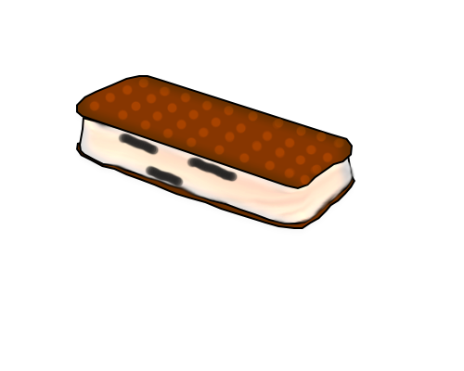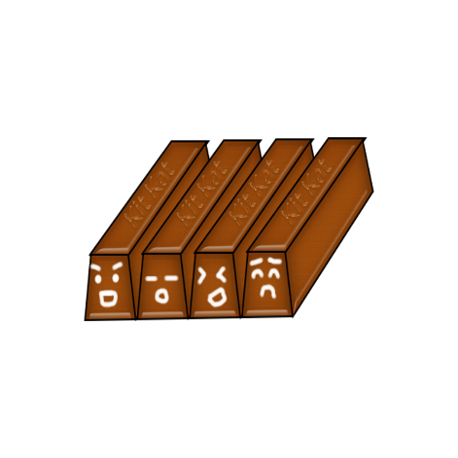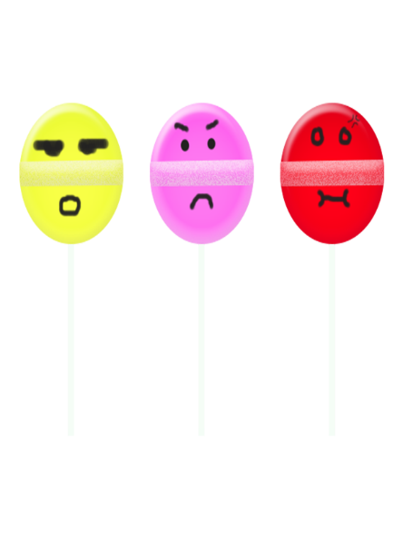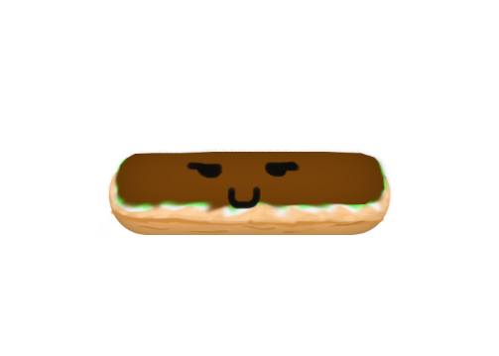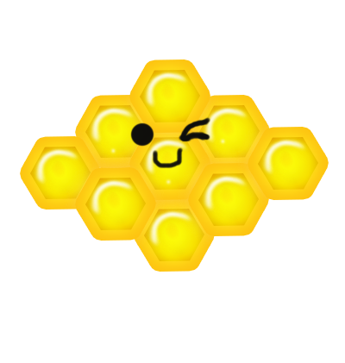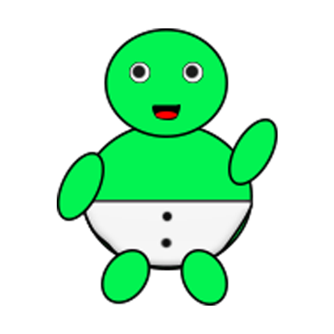

Lesson Learned

Having a subject like Mobile Programing requires time to learn and willingness to learn for us to be able to pass. Analyzation, memorization, and time management is one of the most important thing that every individual should learn and should have. From the start, it was not easy, but as the time goes by, you will “ENJOY”. You will enjoy learning xml codes and java codes, and even if creating image is not part of this subject, but we do not have choice but to use Photoshop (like no basic knowledge TT_TT) to build characters, images and backgrounds that are needed in our application.

**JOHANNA MARISSE CREDITO HERAMIA**

P 53 – 20 12th 15th St., Villamor Air Base, Pasay City

jcheramia@student.apc.edu.ph

+63926 152 3128

**EDUCATION**

June 2014 – Present Asia Pacific College

#3 Humabon Place, Magallanes, Makati City

Bachelor of Science in Information Technology

Major in Mobile and Internet Technology

June 2010 – March 2014 Pasay City South High School

Piccio Garden, Villamor Air Base Pasay City

June 2004 – March 2010 Villamor Air Base Elementary School

Piccio Garden, Villamor Air Base Pasay City

**ORGANIZATIONS**

2015-2016 Junior Philippine Computer Society

Member

2016 – Present Junior Informations System Security Association

Documentations Head

**RESEARCH PROJECT**

THE NEGATIVE EFFECTS OF COURSES CHOSEN BY PARENTS TO THE ACADEMIC PERFORMANCE OF STUDENTS IN ASIA PACIFIC COLLEGE, ACADEMIC YEAR 2015-2016

BALCENA, D.P., GARDON, J.G., HERAMIA, J.C.

**PERSONAL DATA**

December 2, 1997

Pasay City

Tagalog

Single

**JOSE LORENZO GONZALES TADEO**

8291 B. Dapitan St. Guadalupe Nuevo, Makati City

jgtadeo@student.apc.edu.ph

09354811320

**EDUCATION**

June 2014 – Present Asia Pacific College

#3 Humabon Place, Magallanes, Makati City

Bachelor of Science in Information Technology

Major in Mobile and Internet Technology

June 2010 – March 2014 Guadalupe Catholic School

1923 Orense St, Guadalupe Nuevo, Makati City

June 2006 – March 2010 Guadalupe Catholic School

1923 Orense St, Guadalupe Nuevo, Makati City

June 2004 – March 2006 Paco Catholic School

1521 Paz St, Paco, Manila

**ORGANIZATIONS**

2014 – 2015 Junior Philippine Computer Society

Member

2016 – Present Microsoft Community

Assistant Documentations Head

**RESEARCH PROJECT**

THE BENEFITS OF PHYSICAL EDUCATION TO FRESHMEN

STUDENTS WITH HEALTH PROBLEMS IN ASIA PACIFIC COLLEGE, ACADEMIC YEAR 2015 – 2016

TADEO, J, G., SAMSON, J, O., VICTORINO, M, I.

**PERSONAL DATA**

March 26, 1998

Makati City

Tagalog

Single