

**HI! Thank you for making me feel**







SCORE:





YOU FINISH THE FIRST STAGE!



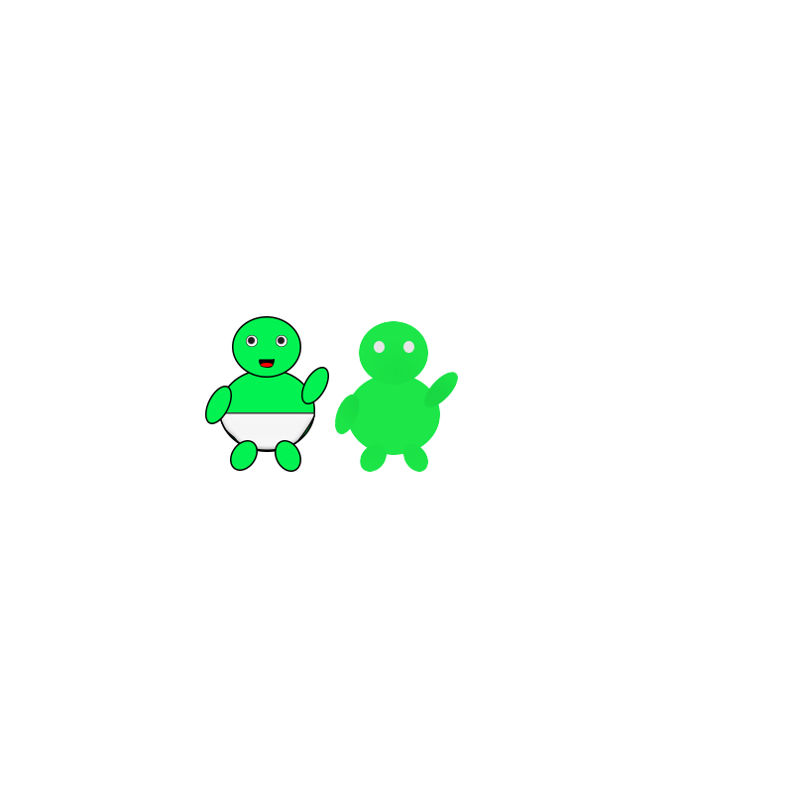

Tap *LEFT* to move LEFT

Tap *RIGHT* to move RIGHT

**Instruction:**

On the next level, you have to catch my favorite food and reach 500 points, otherwise, you can’t continue to the next level. ☹







to feel a bit different. I have now better communication skills and better design.

I feel bigger now ☺ Since February 9, 2009, I started





See? I can now give more information when someone ask me for a place. And also, my mama gave me a cupcake and it was so yummy! I really like it! It’s my favorite food now.





So are you ready to answer the questions?

**IT IS SO SWEET LIKE YOU**



Who gave me my favorite food? ☺





SCORE:





**Instruction:**

On this mini game, ☺ you have to tap my favorite food, otherwise, the game is over ☹





Do you want to continue?

YOU MADE IT!!!

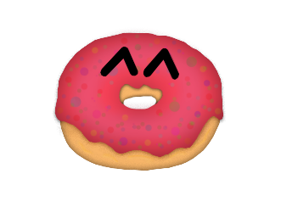



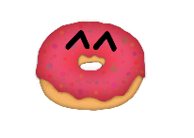

I KNEW YOU CAN DO IT!

Do you wish to continue?

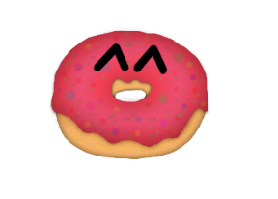



HELLO AGAIN!!! Did you miss me? Awww! I miss you, too! ☺ Well, I just want to tell you, what has been up to me. I know you’re excited! ☺ Let’s start!

