Introduction to Android Studio — Layout Editor Assignment
Justin Guida

Layout Editor — activity_main.xml
The layout contains three objects: a Button (buttonSayHello, text “Say Hello”), a Plain Text / EditText (nameText), and a TextView (textGreeting) with no text.
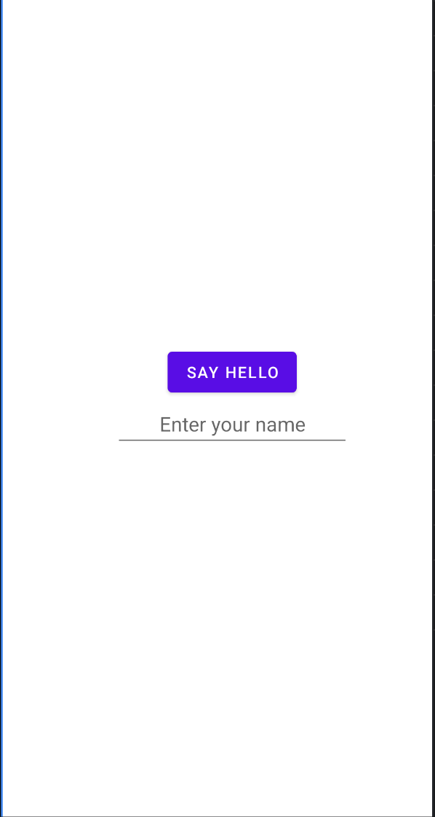

Component Tree
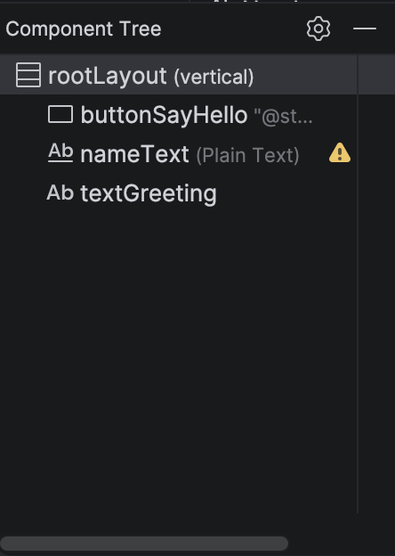

Discussion of Challenges
My initial experience with Android Studio was a mix of curiosity and frustration, which I think is normal when learning a brand new tool. Setting the project up was straightforward once I remembered to choose the No Activity option so that I could select Java as the language, but the first-time build did take several minutes while the environment downloaded and configured its dependencies. Watching the Build tab at the bottom of the screen helped me confirm it was actually working and not frozen.
The biggest challenge I ran into was getting the button centered in the middle of the screen. At first nothing I did seemed to move it. I eventually learned that centering is not done on the button itself — you have to select the root LinearLayout in the Component Tree and change its gravity value. Once I unchecked bottom and set gravity to center (or checked center_horizontal and center_vertical together), all three elements finally moved to the middle. Understanding the difference between gravity (which positions the children inside a container) and layout_gravity (which positions an element inside its parent) was the key insight that made this click.
My second challenge was that the button stretched across the entire width of the screen instead of only being as wide as its text. I fixed this by changing the button’s layout_width from match_parent to wrap_content, which tells the button to only take up as much space as its “Say Hello” label needs. Along the way I also accidentally created a duplicate ID by naming two views rootLayout, and I had to rename the Plain Text field back to nameText to clear the error, since two views cannot share the same ID.
Overall, once I understood that I had to select the correct element in the Component Tree before editing its attributes, the Layout Editor started to make a lot more sense. My main remaining question is when it is better to build a layout visually with the editor versus editing the XML directly, and how the different layout containers (LinearLayout, ConstraintLayout, etc.) compare for positioning elements. I feel much more prepared to access and use Android Studio for the later work in this course.

(Discussion word count: ~366 words.)

