Release 1.4.6

Welcome!
Thank you for downloading ERP BI Solutions for Postbooks and xTuple! ERP BI Solutions provides a data warehousing and business intelligence solution for Postbooks and xTuple using the Pentaho technology stack. The goals of ERP BI Solutions are to:
- Serve as a template for ERP business intelligence solutions, especially solutions implemented with open source technology;
- Provide examples and guides on data warehousing implementation best practices.
- Provide a best set of key performance indicators for measuring ERP performance.
The layers for the solution are shown in the following figure.
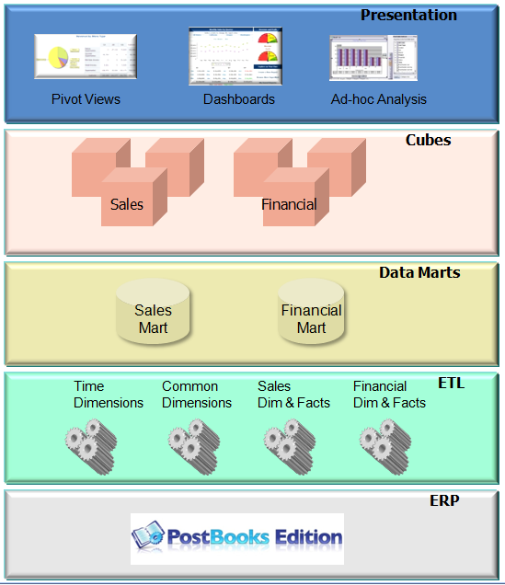

Overview & Pre-requisites
The erpbi-pentaho-postbooks bundle contains the PostBooks business intelligence solution and pre-installed Pentaho community edition components. If you are upgrading from a previous release, see the upgrade considerations in Appendix A.
If you are just getting started it is best to:
- Follow the Quick Start and try the dashboards with the embedded data mart.
- Follow Load Data Mart From Demo Database to try the ETL processes and load the data mart.
- Follow Load Data Mart From Your Database to use the ETL processes to load the data mart with your data.
Before you start, make sure you have Java JDK 1.6 or higher installed. To check your version, enter:
java –version
from the command prompt.
The environment variable JAVA_HOME must be set to the path for the JDK. To check the variable on Windows enter:
set JAVA_HOME
from the command prompt. On Linux and Mac enter:
echo $JAVA_HOME
If you would like to install in your existing community edition or enterprise edition Pentaho, or if you need any help, please use the forums at:
http://sourceforge.net/projects/erpbi/forums
or send an e-mail to jgunderson@erpbisolutions.com

Quick Start
The erpbi-pentaho-postbooks bundle has an embedded data mart with data from the PostBooks demo database. So you can quickly try the Web-based dashboard and pivot tables. The embedded data mart uses the H2 Database as in the following diagram:
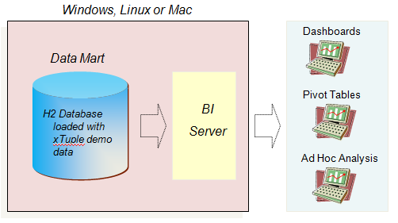
Start by unzipping erpbi-pentaho-postbook.zip. Throughout the instructions the home directory will be referred to as [erpbi home]. On Linux and Mac you will need to set Tomcat scripts as executable. For example:

sudo chmod –R 755 [erpbi home]/biserver-ce/tomcat/*

Start BI Server using start-pentaho.bat on Windows:

[erpbi home]/biserver-ce/start-pentaho.bat

Or by using start-pentaho.sh on Linux:

cd [erpbi home]/biserver-ce
sh start-pentaho.sh

Connect to the server using the following link:
http://localhost:8080/pentaho/content/pentaho-cdf/RenderXCDF?solution=erpbi-reports&path=&action=erpbiHome.xcdf&template=mantle&yearPeriod=2009%2c%2012
You can now try the dashboards by following the instructions in Test Dashboards and Reports

Load Data Mart from Demo Database

You can now try the ETL processes and load the data mart with data from the PostBooks demo database. The erpbi-pentaho-postbook bundle is configured to load the embedded data mart with data from a PostBooks database on the same machine.

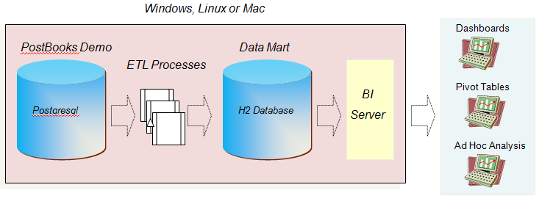
The ETL processes are configured to extract data from a PostBooks database on the same machine with a database name of demomfg using user admin with password admin. If your demo database is in a different location or you want to use a different user/password then see the instructions Setting ETL Properties.
To load the data mart, start Data Integration on Windows using:

[erpbi home]/data-integration/spoon.bat

On Linux start Data Integration using:

cd [erpbi home]/data-integration
sh spoon.sh

On Mac, start Data Integration by navigating to the folder [erpbi home]/data-integration and double clicking on the “Data Integration 32-bit” or “Data Integration 64-bit” icon

Then open the job:

[erpbi home]\ETL\JOBS\Load.kjb
and run.

Load Data Mart from Your Database
When loading the data mart from your PostBooks or xTuple database it is best to define the data mart as a Postgresql database. Postgresql performs better than the embedded H2 Database for large volumes of data. The datamart database should be on the same machine as the BI Server. But your Postbooks/xTuple database may be an another server.
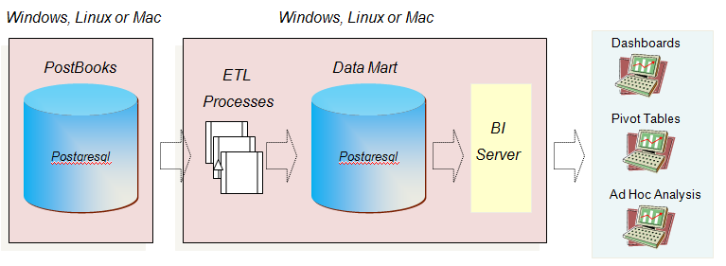
The Postgresql loader is used to load fact tables as this provides the best performance. However the loader does not allow passwords to be supplied. So when you run the ETL processes, the Data Integration console may prompt for a password. To avoid this, you must configure Postgresql to trust the connection. To set up trusted authentication, change the pg_hba.conf file (on Linux: [postgresql home]/main/pg_hba.conf, on Windows: [postgresql home]/data/pg_hba.conf).
Typically, the best solution is to trust local connections. You can do this by changing the ‘md5’ method to ‘trust’ in the local connections:
# IPv4 local connections:
host all all 127.0.0.1/32 trust
# IPv6 local connections:
#host all all ::1/128 trust

Setting up BI Server
The Business Intelligence Server is configured to connect to the embedded H2 data mart. To change the connection settings you must update the JNDI definition in pentaho.xml at:
[erpbi home]\biserver-ce\tomcat\conf\Catalina\localhost
The default connection is shown below:
<Resource name="jdbc/erpi" auth="Container" type="javax.sql.DataSource"
factory="org.apache.commons.dbcp.BasicDataSourceFactory" maxActive="20"
maxIdle="5" maxWait="10000" username="admin" password="admin"
driverClassName="org.h2.Driver"
url="jdbc:h2:../../../h2database/demo"/>

The following attributes must be updated:
Attribute | Description
username | Database user name
password | Database user password
driverClassName | JDBC driver class name. For example: org.postgresql.Driver
url | Connection URL. For example jdbc:postgresql://localhost:5432/demomfg

Setting up ETL and Data Integration
The ETL properties are set in the kettle.properties file. All properties begin with “erpi”. To view and edit the properties start Data Integration using spoon.bat or spoon.sh and select “Edit > Edit kettle.properties file”.

The following are example settings for loading a Postgresql data mart defined in the same database as the Postbooks database on Windows:

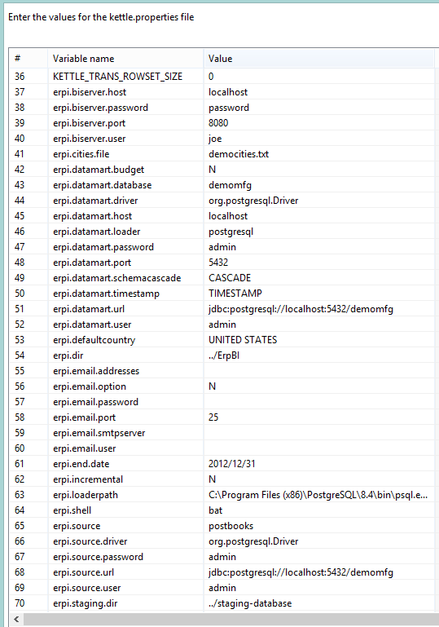

Setting Connection to Your PostBooks Database
The connection to your PostBooks database is defined in the following properties:
Property | Default Value | Description
erpi.source | postbooks | Type of source ERP.
erpi.source.driver | org.postgresql.Driver | Postgresql JDBC driver class
erpi.source.url | jdbc:postgresql://localhost:5432/demo | Connection URL
erpi.source.user | admin | User name
erpi.source.password | admin | User password

Setting Connection to Your Data Mart Database
The data mart database is defined in the following properties:
Property | Default Value | Description
erpi.datamart.driver | org.h2.Driver | JDBC driver class.
erpi.datamart.url | jdbc:h2:../h2database/demo | Connection URL.
erpi.datamart.user | admin | User name
erpi.datamart.password | admin | User password
erpi.datamart.database | demo | Database name
erpi.datamart.port | 5432 | Database port number
erpi.datamart.host | localhost | Database server host name
erpi.datamart.schemascascade |  | Specifies whether database supports cascade schema drops. For Postgresql specifiy CASCADE. For H2 or MySQL do not specify a value.
erpi.datamart.timestamp | TIMESTAMP | Data type for timestamps. For Postgresql and H2 specify TIMESTAMP. For MySQL specify DATETIME.
erpi.datamart.loader | jdbc | Type of loader to use for loading fact tables. For Postgresql specify postgresql. For other databases specify jdbc.
erpi.loaderpath | C:\Program Files\xTuple\postgresql\bin\psql.exe | Path to database loader utility. For example on Windows: C:\Program Files\xTuple\postgresql\bin\psql.exe or on Linux: /usr/lib/postgresql/8.4/bin/psql
erpi.datamart.budget | N | If no budget facts are loaded into the datamart, raise error. Set to “N” if you do not define budgets.

Setting Connection to Your BI Server
The ETL procedures will connect to your business intelligence server to refresh in-memory OLAP data after updating your data mart database.
Property | Default Value | Description
erpi.biserver.host | localhost | BI server host name
erpi.biserver.port | 8080 | BI server port number
erpi.biserver.user | joe | User name
erpi.biserver.password | password | User password

Staging Database
The staging database is a set of comma separated value files produced by the extract in the ETL processes. You can define the path the staging database and you can indicate if the data mart database should be loaded directly from the staging database without extracting data from your PostBooks Database.
Property | Default Value | Description
erpi.staging.dir | ../staging-database | Path to staging database
erpi.staging.direct | N | Directly load from staging with no extract?

Setting the Start and End Dates
The range used to generate dates for the date dimensions is defined in the properties:
Property | Default Value | Description
erpi.start.date | 2002/01/01 | Start date for date dimensions
erpi.end.date | 2012/12/31 | End date for date dimensions.

Be sure that you have periods defined in your PostBooks Fiscal Calendar for this date range.
The start date is also used in the initial data load. Only documents and document line items with a creation date greater than the start date are extracted and loaded.

Geographic Dimension Data
Billing, shipping and delivery data for cities is shown using the openstreetmap from the OpenGeo map server (http://maps.opengeo.org/geowebcache/demo). In the initial load, a geographic dimension table is loaded with the latitude and longitude of cities. By default, only the US states used in the demo database are loaded. You can specify the file used to load city data. The following files are supplied:
- democities.txt – cities used in PostBooks demo database.
- uscities.txt – USA cities.
- worldcities.txt – World cities.
Addresses in ERP documents may not always include a country. To match address with the geographic dimension you can specify a default country for addresses where no country is specified.
Property | Default Value | Description
erpi.cities.path | ../ErpBI/ETL/GE/data/democities.txt | Path to file of city coordinate data.
erpi.defaultcountry | UNITED STATES | Default country name when not specified.

Type of Data Mart Load
To specify whether this is an initial load or an incremental load of update use the following property. Fr mor information see the section on Loading the Data Mart.
Property | Default Value | Description
erpi.incremental | N | Is this an incremental load?

E-Mail Properties for ETL Logs
You can specify one or more e-mail addresses to receive a copy of ETL log files.
Property | Default Value | Description
erpi.email.option | N | Should logs be e-mailed to addresses?
erpi.email.addresses |  | List of e-mail addresses separated by a space
erpi.email.smtpserver |  | SMTP server address.
erpi.email.user |  | SMTP server user id.
erpi.email.password |  | SMTP server user password
erpi.email.port | 25 | SMTP server port. The default for SMTP servers is 25.

The e-mail configuration assumes that authentication is required and secure authentication is not required. If you need to change these settings you can edit the email step in the jobs initial.kjb and incremental.kjb found in:
[erpbi home]\ErpBI\ETL\JOBS

Loading the Data Mart

Initial Data Load
If the kettle property erpi.incremental is set to “N”, the ETL procedures will drop and define the data mart schema and perform an initial load. Only documents and document line items with a creation date greater than the start date defined in FiscalDates.txt are extracted and loaded.

To run the initial load, start Data Integration using spoon.bat or spoon.sh and run job:

[erpbi home]\ETL\JOBS\Load.kjb

Incremental Data Load
If the kettle property erpi.incremental is set to “Y”, the ETL procedures perform an incremental update of the data mart. Only documents and document line items with a creation date or updated date greater than the last extract date are extracted and loaded. Every time the ETL procedures are run, extract dates are save in the DATE_DATE_EXTRACT table.

All dimension data is extracted but only updated if the dimension changes.

To run the incremental data load, start Data Integration using spoon.bat or spoon.sh and run job:

[erpbi home]\ETL\JOBS\Load.kjb.

To run the incremental data load from the command line or from a script you can use the kitchen program ( http://wiki.pentaho.com/display/EAI/Kitchen+User+Documentation ) . For example:
kitchen.bat /file:"c:\ErpBI\ETL\JOBS\Load.kjb" /level:Basic
You can also schedule the program to run using Windows and Linux scheduling facilities. See

http://wiki.pentaho.com/display/EAI/Kitchen+User+Documentation

Test Dashboards & Reports
Start BI Server using start-pentaho.bat or start-pentaho.sh. Connect to the server using the following link:

http://localhost:8080/pentaho/content/pentaho-cdf/RenderXCDF?solution=erpbi-reports&path=&action=erpbiHome.xcdf&template=mantle&yearPeriod=2009%2c%2012

Note that this assumes you are using the server on localhost. Also, when the solution is first started it needs a valid year and period or there will be errors in queries. The above link sets the year and period to 2009, 12. (in URL parameters, %2c is used for commas and %20 is used for spaces).

You should then receive the BI Server logon page. Logon to user admin, password “Car54WhereRU”.

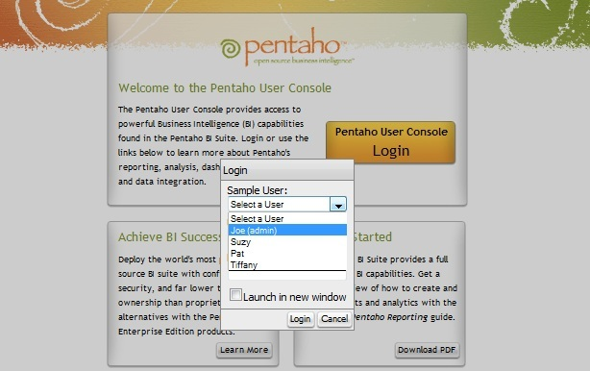

You should next see the ERP Business Intelligence home page:
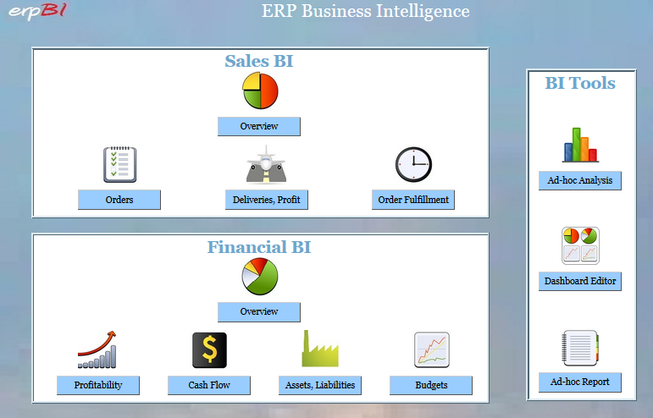
Selecting Sales Overview will show a summary of the three sales subject areas:
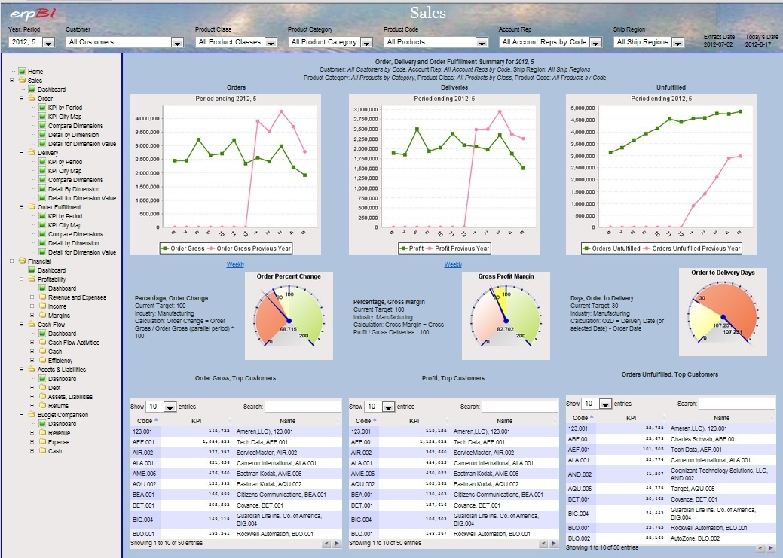
Note that all dashboards contain an explorer frame to navigate to other dashboards. Dashboards also have drop down lists to change the dimension members and measures used in queries. When you select dimension members or measure members from lists, the choice is used on all other dashboards and reports. It is also persisted by user ID.
Also note that many of the dashboards use hyperlinks in charts and lists to link to detailed pivot tables. For example, in the following dashboard you can select a customer name in the top lists to see detail on the customer orders.
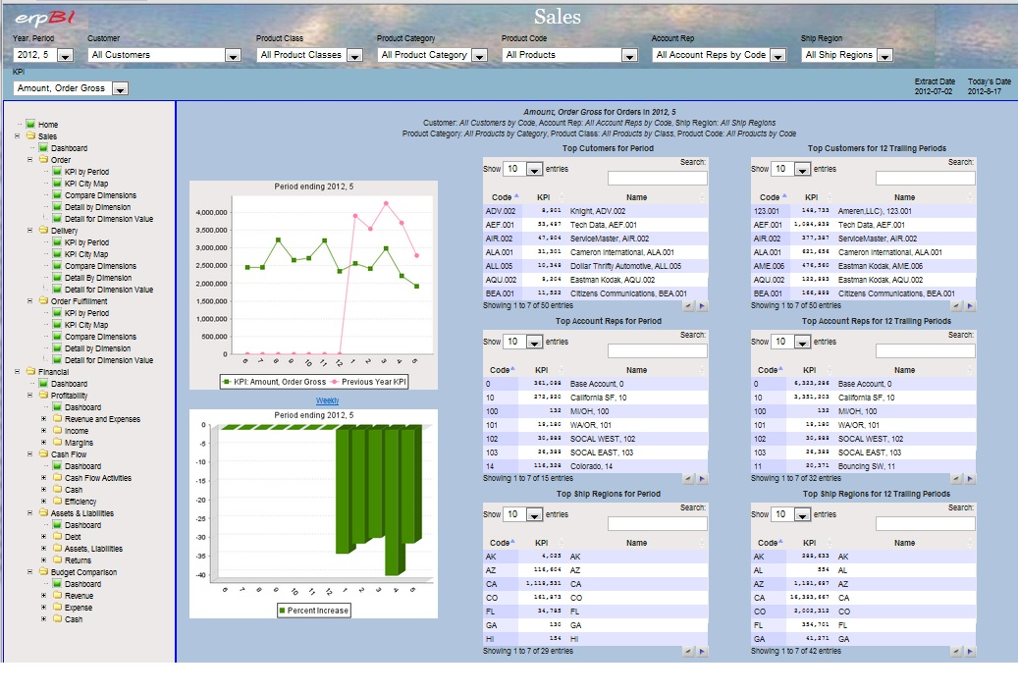

For geographic dashboards the map image is retrieved from OpenGeo.org. You will need to be connected to the Internet to use the geographic dashboards.
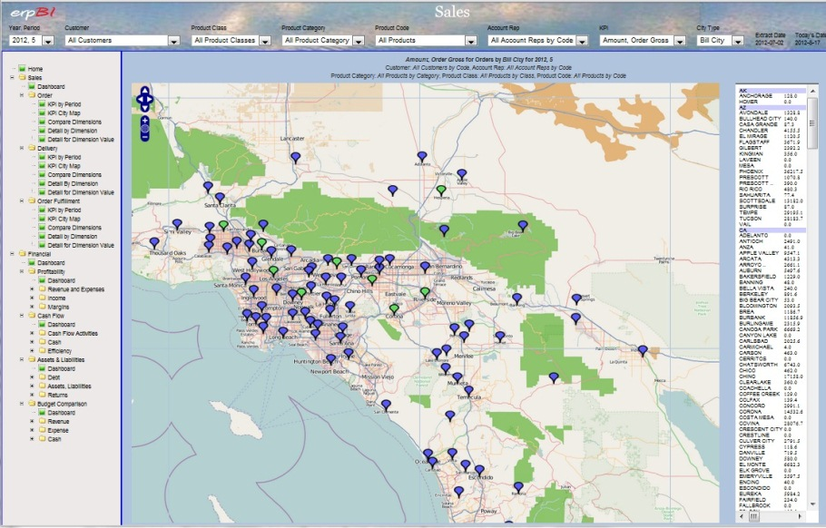
Also, note that pivot tables allow you to drill down into dimension hierarchies.
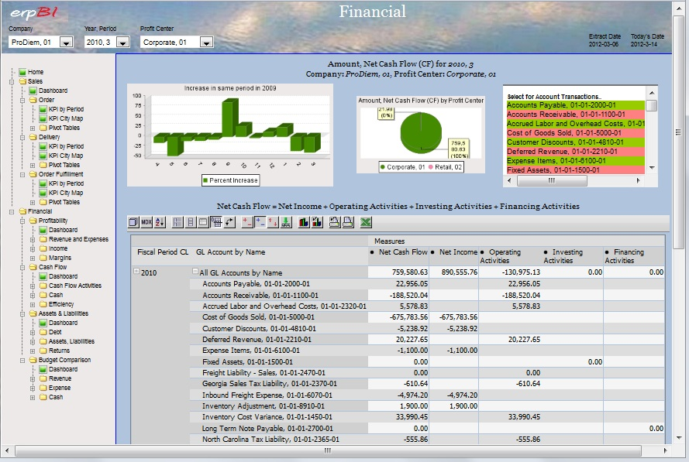
All dashboards can be accessed by using the URL. Also, you can set the initial values of dimension members and measure members used in queries using URL parameters.
You can also explore analytic cubes by selecting “Ad-hoc Analysis” from the home page. Select a cube from the cube list:
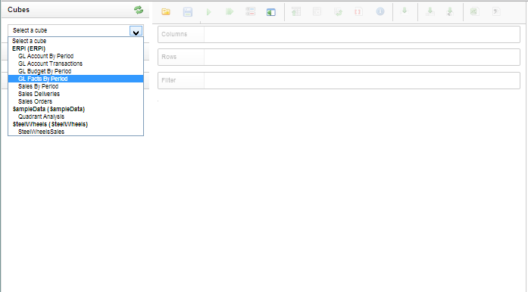
Then drag and drop measures and dimensions to rows and columns.
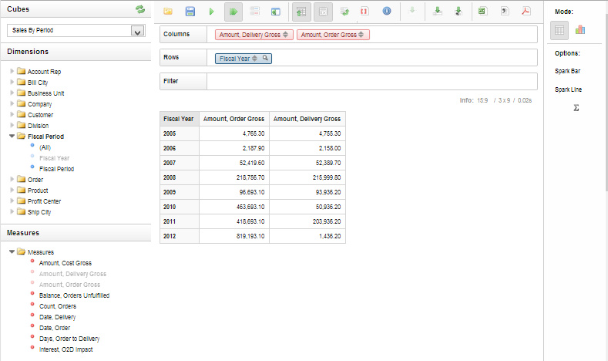
You can also select charts from the options on the right.

Appendix A: Upgrading to a New Release
If you are upgrading, please see the Release Notes document on changes. When upgrading to a new release there are several considerations:
* Are you using the pre-configured Pentaho bundle or your own Pentaho installation?
* Have you changed ETL processes or dashboards/reports?
* Can you run the initial data load again?
If you are using the pre-configured Pentaho bundle and you have not changed ETL processes or dashboards and you can run the initial data load again, then the best approach is to download the new release, make the modifications per documentation and run the initial data load again. Here's a summary:
1. Download ErpBI-Postbooks-Pentaho.zip and extract.
2. Define your database connections to BI Server. - jdbc.properties and context.xml.
3. On Linux and Mac set Tomcat scripts as executable: sudo chmod 755 –R tomcat/*
4. Set your extract date range in FiscalDates.txt.
5. Use your version of cities.txt (if you have a different set of city geographic data).
6. Start Spoon and edit kettle.properties and make any changes for your configuration. Also, note the documentation for any new properties.
7. Run SOInitial and you are set to go!
If you would like to install in your existing community edition or enterprise edition Pentaho, or if you need any help, please use the forums at:
http://sourceforge.net/projects/erpbi/forums
or send an e-mail to jgunderson@erpbisolutions.com
If you have changed ETL procedures you will need to merge your changes with the new versions in [erpbi home]\ErpBI\ETL.
If you do not want to run the initial data load again you must determine if there have been significant data mart schema changes since your last installation.

