|  |
| --- |
| jg studio |
| Zombie TakeOver |
| **[Assignment #1 – Unity Game** |
| Version #02  All work Copyright © 2016 by JG Studio.  All rights reserved. |
| **Jason Gunter** |
|  |



|  |
| --- |
| October 1st, 2016 |

**Table of Contents**

[Your Table of Contents should go here. Make sure that your document’s sections are hyperlinked to their corresponding pages.]

**Version History**

<https://github.com/jgunter7/COMP305_ZombieTakeOver_As1>

1. **Game Overview**

*Zombie takeover is a simple scrolling game, where the player must control an infected ship. The player can infect other ships, by sinking them to gain points. The air force can drop items into the game, such as bombs on buoys and supplies on buoys. The gas tank supplies will allow the zombie ship to continue to wreak havoc on the ocean. Hitting other ships gains points, but also decreases the condition of the ship. Hitting bombs drastically decreases the condition of the ship. If the ship is destroyed, they lose the game after spending all of their lives.*

1. **Game Play Mechanics**

*The player will use the mouse to move their ship horizontally across the screen. They must dodge bombs dropped by the air force to try to stop your ship from destroying and more boats. Destroy other boats and collect fuel tanks to take your zombie ship as far as possible.*

1. **Camera**

*The camera for this game uses an orthographic projection. It is a “birds-eye-view”.*

1. **Controls**

*The user can use the mouse to move the boat left and right along the screen.*

1. **Interface Sketch**

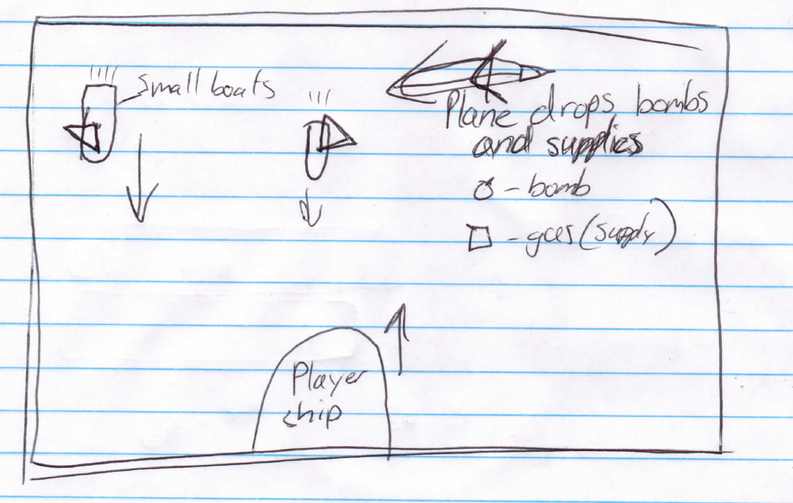

1. **Menu and Screen Descriptions**

*(Include additional screen shots and accompanying descriptions for any menus and additional screen)*

1. **Game World**

*(Describe Your Game Environment)*

1. **Levels**

*(Describe each of your game levels)*

1. **Game Progression**

*Dskjfhsdkjfdsfdsf*

1. **Characters**

*(Describe your game avatar if applicable)*

1. **Enemies**

*The enemies are the planes, which carry the cure. After two planes drop a liquid cure on the player ship, the zombies are cured of their disease.*

1. **Items**

*The player can collect gas tanks that will allow the player to continue through the game.*

1. **Vehicles**

*The player can crush or destroy other* ***boats*** *for bonus points, they do however slightly affect the boats overall condition (health).*

1. **Script**
2. **Scoring**

*The player gains points by the distance they have travelled in the game, which can be increased if they pick up more gas. They can also gain points by infecting/destroying other ships, by hitting them.*

1. **Sound Index**

*(Include an index of all your sound clips)*

1. **Story Index**

*(Outline your game story here)*

1. **Art / Multimedia Index**

*(Include an index of all your graphic and video assets here)*

1. **Design Notes**

*(Include additional design notes here)*

1. **Future Features**

*(Include any future features that are planned to be implemented)*