|  |
| --- |
| Gunter Inc |
| Apple Defender |
| **External Game Documentation** |
| Version #1  All work Copyright © 2015 by Gunter Inc.  All rights reserved. |
| **Jason Gunter** |
|  |

|  |
| --- |
| August 5th, 2015 |

**Table of Contents**

Contents

1. Version History 3

2. Live Site 4

3. Game Overview 5

4. Controls 5

5. Interface Sketch 5

6. Screen Descriptions 6

7. Game World 8

8. Levels 8

9. Characters / Vehicles 8

10. Enemies 8

11. Weapons 8

12. Scoring 8

13. Cheats 9

14. Sound Index 9

15. Art / Multimedia Index 9

# Version History

<https://github.com/jgunter7/COMP397-AppleDefender/>

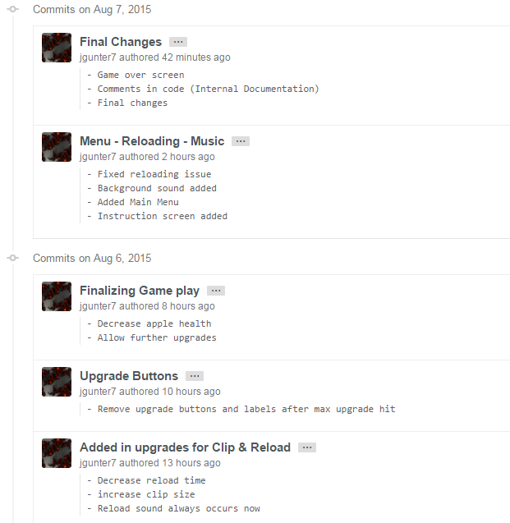

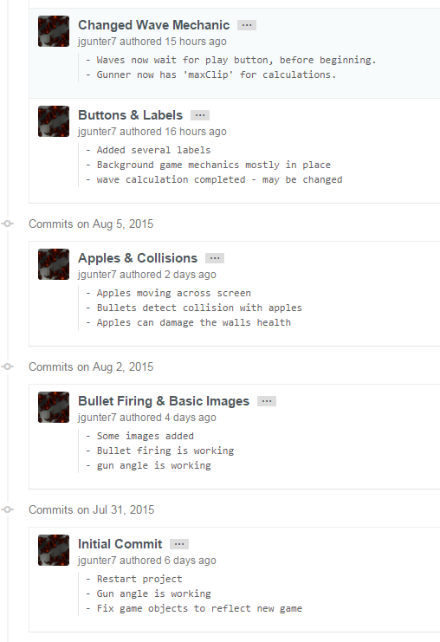

# Live Site

<https://jgunter7.github.io>

# Game Overview

The game allows a player to control a gun / turret which has the ability to fire bullets. The gun starts off with long reloading times and small clip sizes, but can be further upgraded to create an apple destroying nightmare. The player accumulates cash and score, cash can be spent on upgrades to the gun or to the wall the player is trying to protect. The objective of the game is to protect your wall from the onslaught of apples. Once an apple gets close enough to the wall, it will stop and begin to decrease the walls health. If the walls health is depleted, the game is over.

# Controls

The entire game is controlled by the user’s mouse. To initiate the game or read the instructions, the user simply clicks on the corresponding buttons. To play the game, the user uses the mouse to aim at target apples. The gun will shoot a bullet in the direction that the mouse is clicked.

# Interface Sketch

Main Game Screen:

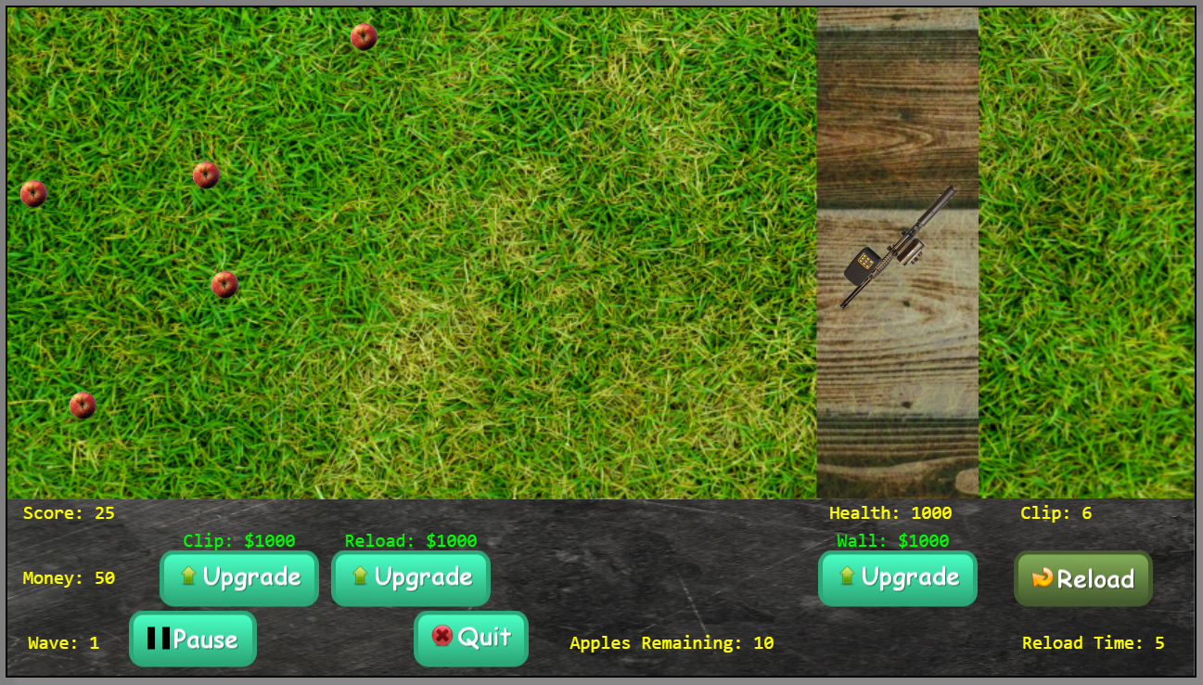

* Gun and wall
* Score, money and wave number
* Clip & reload upgrades and their respective costs
* Pause, play, and quit buttons
* Apples remaining label
* Wall upgrade button and cost label
* Clip (remaining), reload button, and current reload timeout

# Screen Descriptions

Main Menu

* Start and instruction buttons along with game background

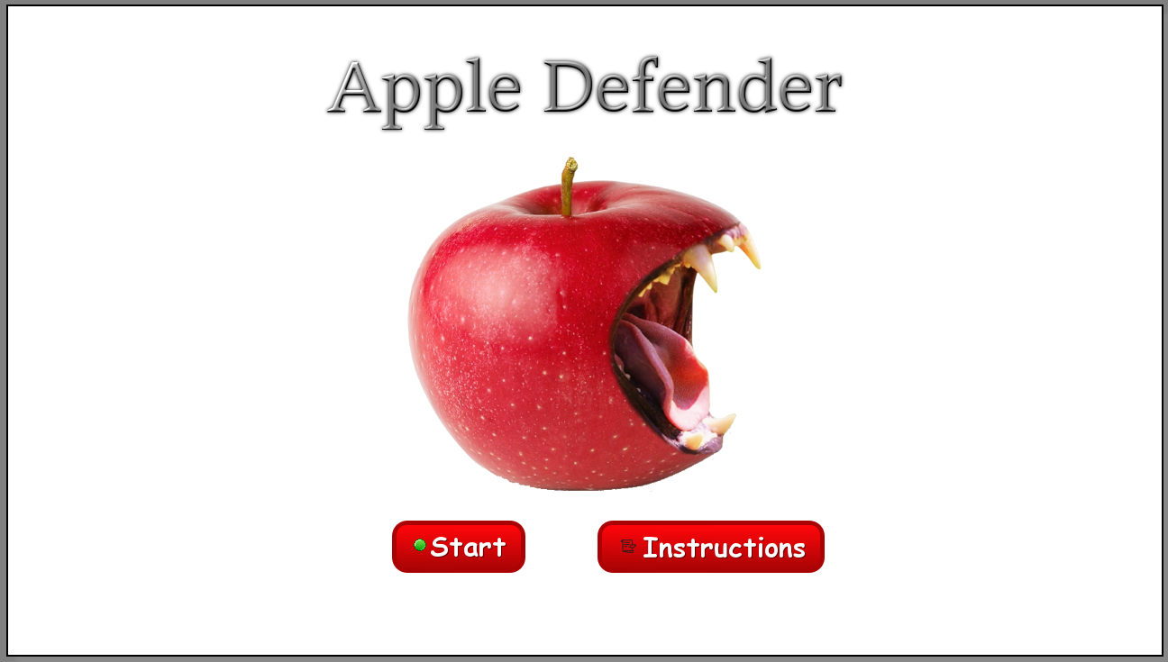

Instructions

* Simple instructions and quit button

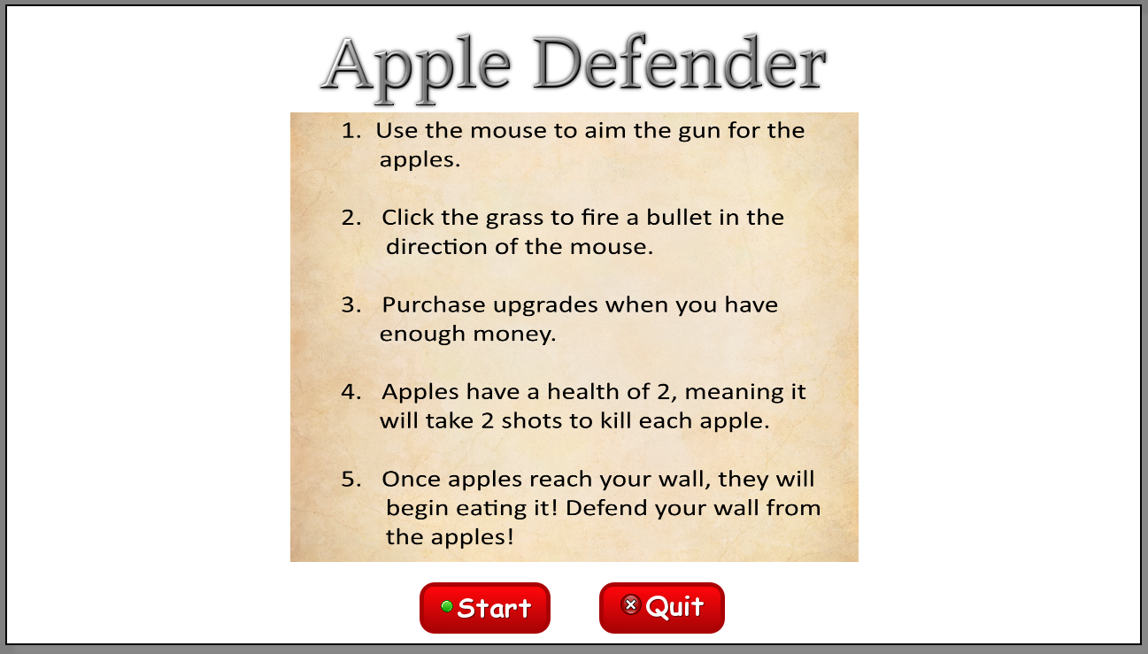

Game Screen

* Shows current score, cash, wave, reload time, bullets left in clip, upgrade costs, and apples remaining for the current wave.



Game Over

* Shows final score, quit and start buttons

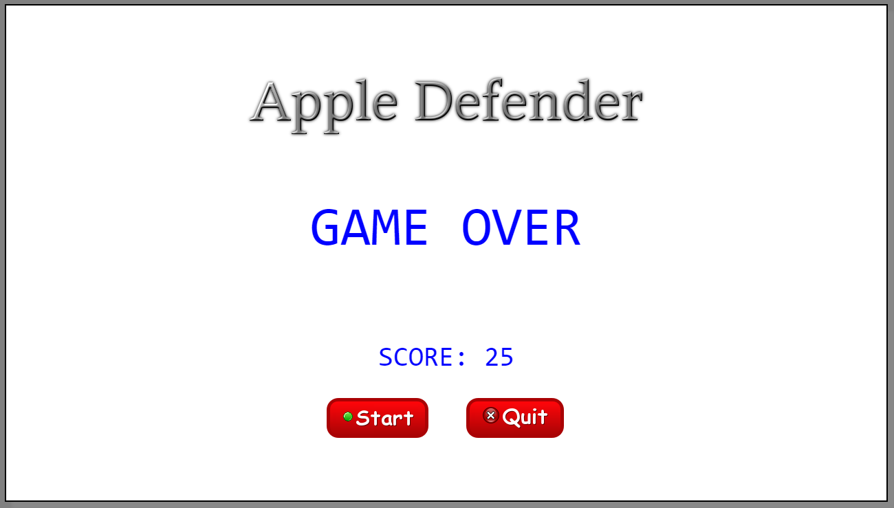

# Game World

The game environment is a 2-D canvas. The player controls a gun / turret which sits upon their wall. The wall is defending a city, or something important. The bottom panel is for displaying game variables and upgrading the user’s items (gun and wall). The apples spawn very far left on the canvas, this makes it appear like waves of apples.

# Levels

The game does not include any levels, the game simply runs on sending more waves of apples. Each wave grows in size, speed, and strength. The position of each apple is random, as is the speed. Both of these calculations are based on what wave the player is currently playing. There is no final wave, and the player is to see how far they can make it before they can no longer sustain their wall health.

# Characters / Vehicles

The only ‘character’ in the game is the gun object, which is controlled by the player’s mouse. The direction / rotation of the gun is calculated based on the angle between the guns position and the mouse position. As the player moves the mouse, they can see the gun changing to match the new direction that the bullet will need to travel. The gun has a fire sound and a reload sound.

# Enemies

The enemies in the game are the apples. The apples travel from left to right. They spawn well before the left side of the stage, creating a ‘wave’ effect. The enemies start off with 2 health, and die when colliding with bullets. They make a noise when they are hit, and they make a different sound when they are killed. If an enemy makes it to the wall, it stops moving and begins to decrease the walls health by attacking it.

# Weapons

The only weapon in the game is the player controlled gun. The gun is rotated based on the mouse position as mentioned before and fires bullet in the direction of the mouse. The gun can only fire bullets if the clip has bullets left, once all bullets have been depleted, the player must wait for the reload timeout. They player can upgrade the guns clip size and reload timeout to make the gun much more useful and destructive.

# Scoring

Each time the player purchases an upgrade, the score is increased. Also, each time an apple is destroyed, the score is increased. The wall health currently does not affect the final score.

# Cheats

The game contains one cheat. If the user fires at the right wall 5 times in a row, they unlock the automatic gun, which shoots for the user, instead of the user having to click a button. Other cheats include code that can be typed into the console tab of the JavaScript debugger in the browser. Some examples of these codes could be:

* Money = 15000; // get $15,000.
* Wall.health = 1500; // set wall health to 1500.
* Play.wave = 44; // set wave to 44. (will take effect next wave unless done in between waves)

# Sound Index

* Bass_loop.wav
* Die.wav
* Reload.mp3
* Shot.wav
* Uh.wav
* Wall_fall.mp3

# Art / Multimedia Index

* Atlas.png 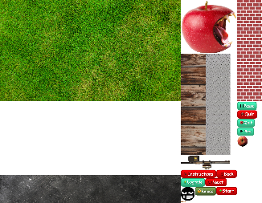
* Logo.png 
* Bgin.png 