|  |
| --- |
| Gunter Inc |
| Side Scroller |
| **External Game Documentation** |
| Version #1  All work Copyright © 2015 by Gunter Inc.  All rights reserved. |
| **Jason Gunter** |
|  |

|  |
| --- |
| July 10th 2015 |

**Table of Contents**

Contents

1. Version History 3

2. Live Site 3

3. Game Overview 4

4. Controls 4

5. Interface Sketch 4

6. Screen Descriptions 5

7. Characters / Vehicles 7

8. Enemies 7

9. Items 7

10. Scoring 7

11. Sound Index 7

12. Art / Multimedia Index 7

# Version History

<https://github.com/jgunter7/COMP397-SideScroller>

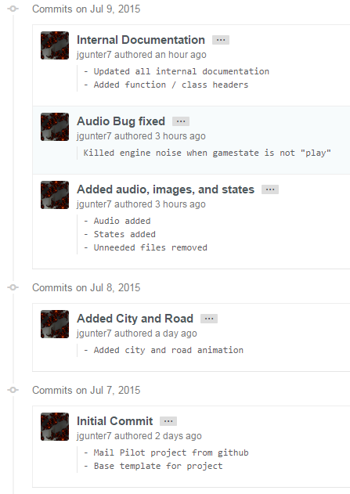

# Live Site

<https://jgunter7.github.io>

# Game Overview

The game allows a user to control a truck with their mouse. The objective is to avoid the sports cars which are traffic on the road, and collect the bags of cash. Each bag of cash increases the user’s score, while each car crash depletes how many lives the player has left. The game includes a main menu, instruction screen, the game play screen, and a game over screen.

# Controls

The entire game is controlled by the user’s mouse. To initiate the game or read the instructions, the user simply clicks on the corresponding buttons. To play the game, the user uses the mouse to guide their truck through the traffic and cash bags.

# Interface Sketch

Main Game Screen:

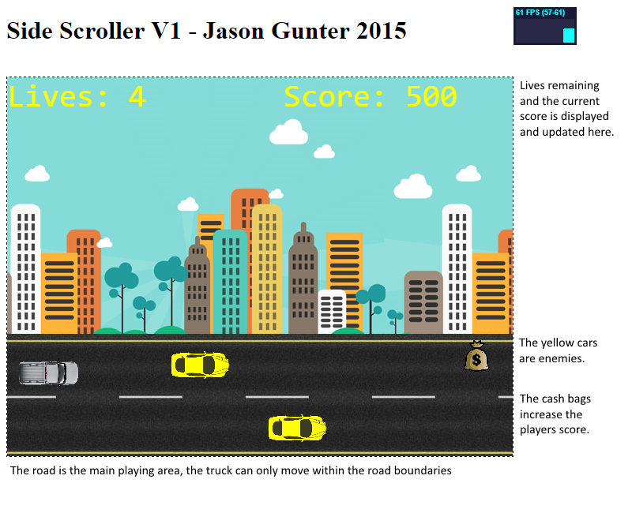

# Screen Descriptions

Main Menu

* Start and instruction buttons along with game background

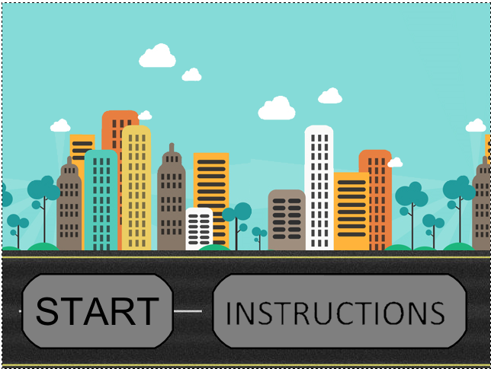

Instructions

* Simple instructions and back button

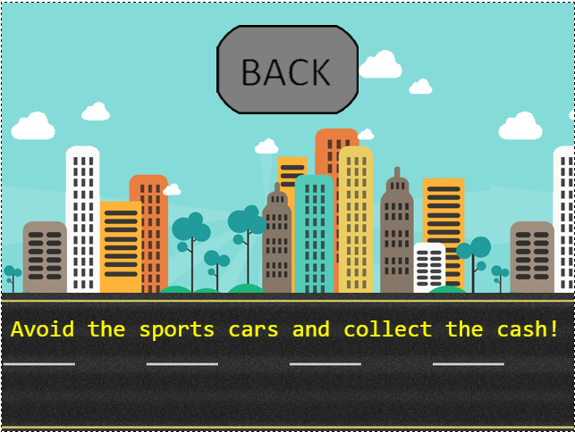

Game Screen

* Shows current lives and score

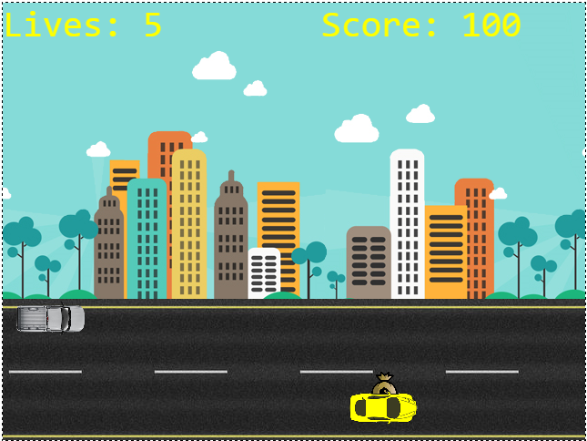

Game Over

* Shows final score, quit and start buttons

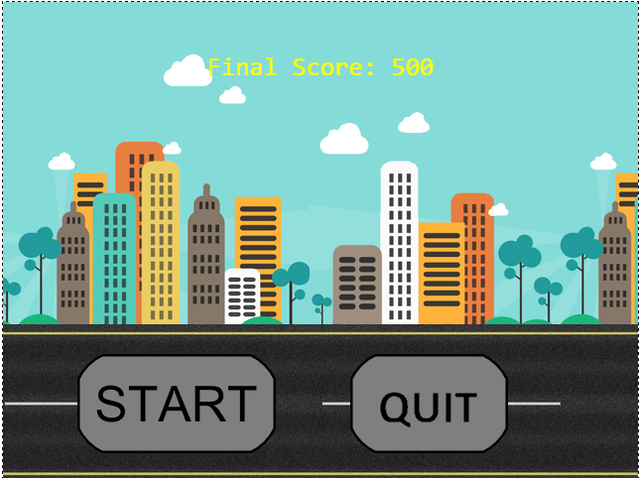

# Characters / Vehicles

The characters avatar is a silver truck which is saved as a sprite. It does not provide any animation and it simply follows the y coordinate of the user’s mouse. The y coordinate is limited to the height of the road image. The collision detection uses rectangles instead of the distance formula because it made the detections must easier and the formula is less processor intensive.

# Enemies

The enemies in the game are the yellow sports cars. They travel the same direction as the user, but much slower, requiring the user to pass them to avoid collision. They make a crash noise on collision and decrease the lives the player has left.

# Items

There is also an item in the game, which is the money bag or “coin”. The money bag is randomly generated, and is placed on the road. Enemies can run over the money bags. When the player’s vehicle collides with a money bag, it is picked up and removed from the road. The player’s score is increased every time they pick up a money bag.

# Scoring

Each time a cash bag is picked up, the users score increases by 100 points. There is no way to lose points, as the player can only lose lives. Once all lives are lost, the player’s final score is displayed on the game over screen. The games objective is to score the highest score before all of your lives run out.

# Sound Index

* Car.wav
* Ching.wav
* Crash.wav

# Art / Multimedia Index

* Atlas.png 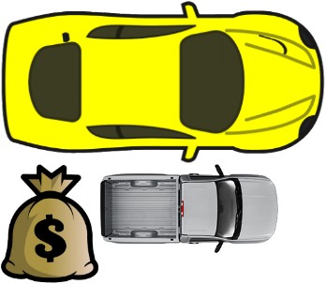
* Back.png 
* City.png 
* Instru.png 
* Quit.png 
* Road.png 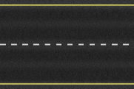
* Start.png 