|  |
| --- |
| Gunter Inc |
| Super7Slots |
| **External Game Documentation** |
| Version #1  All work Copyright © 2015 by Gunter Inc.  All rights reserved. |
| **Jason Gunter** |
|  |

|  |
| --- |
| June 19th 2015 |

**Table of Contents**

Contents

Version History 3

Live Site 3

1. Game Overview 4

2. Game Play Mechanics 4

3. Controls 4

4. Interface Sketch 4

5. Menu and Screen Descriptions 5

6. Scoring 6

7. Bonuses 6

8. Sound Index 6

9. Art / Multimedia Index 6

# Version History

<https://github.com/jgunter7/COMP397-SlotMachine>

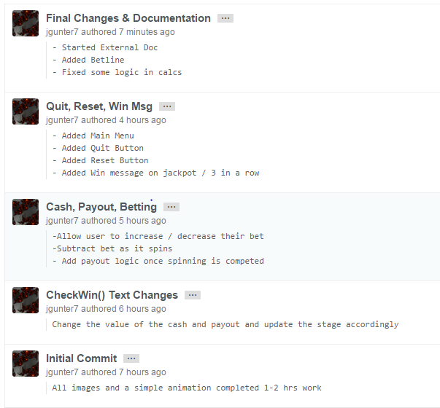

# Live Site

<https://jgunter7.github.io>

# Game Overview

The user is initially presented with a main menu, which then displays the slot machine once the start button is pressed. The user then has options to quit, reset, spin, and alter their bet. The user can bet between $5 - $25, and the spin shows a very simple animation. If the user wins, they are presented with an alert, letting them know how much money the won.

# Game Play Mechanics

Risk & Reward:

* Player must make a bet between $5 - $25, which they have a high risk of losing
* Player must hope for 3 matching items in order to win the payout or jackpot

# Controls

The slot machine is controlled by the user’s mouse. The user can navigate the buttons on the screens to play the game and navigate through the menu and the in-game options.

# Interface Sketch

Main Menu

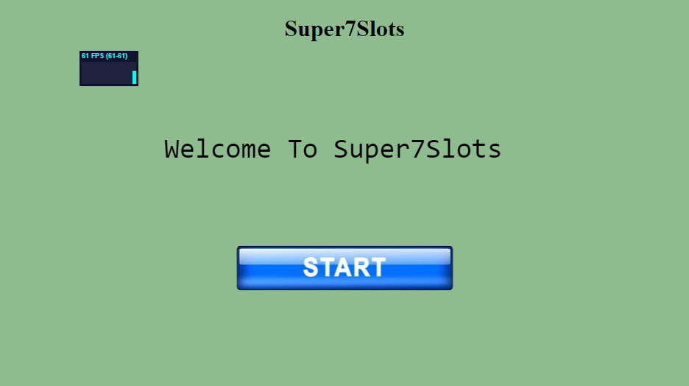

# Menu and Screen Descriptions



Main Menu

* A simple title and a start button

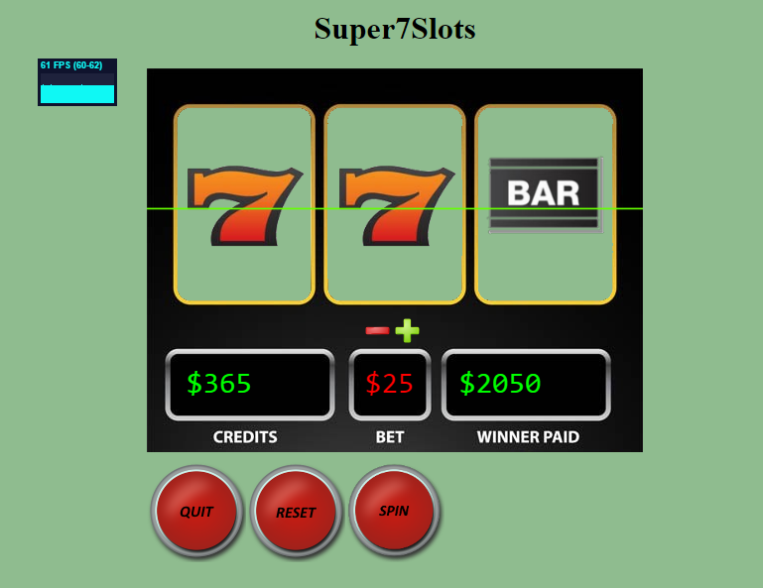

Game Screen

* Quit, Reset, Spin buttons
* Bet buttons, Plus (+$5) and Minus(-$5)

# Scoring

Cash is awarded when the randomly generated slots match all 3 slots as the same image. The payout for this occurrence is 25% of the current ‘Jackpot’. In addition to this, a full ‘Jackpot’ payout is awarded for a match of three 7’s. A very simple slot machine, with very simple game winning condition code.

The cash and the current bet are displayed on screen, the bet is subtracted immediately, and the payout is awarded after the alert box is closed.

There is also a jackpot / payout maximum of $10000. The machine will top out at this amount, and the casino will bank any extra funds instead of adding them to the jackpot.

# Bonuses

I completed two of the four bonuses listed in the assignment outline

* Sound clip for each time the spin button is clicked
* A very simple animation effect (does not look like spinning)

# Sound Index

* Slots.wav

# Art / Multimedia Index

* 7s.png
* Bar.png
* Bell.png
* Betline.png C:\Users\Jason\Desktop\GIT\COMP397-SlotMachine\COMP397-SlotMachine\SlotMachineAs2\img\betline.png
* Cherrys.png
* Lemon.png
* Minus.pngC:\Users\Jason\Desktop\GIT\COMP397-SlotMachine\COMP397-SlotMachine\SlotMachineAs2\img\minus.png
* Orange.png
* Plum.png
* Plus.pngC:\Users\Jason\Desktop\GIT\COMP397-SlotMachine\COMP397-SlotMachine\SlotMachineAs2\img\plus.png
* Quit.png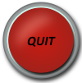
* Reset.png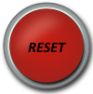
* Slots.png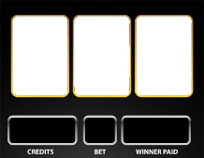
* Spin.png
* Start.png