|  |
| --- |
| Gunter Inc |
| Out of the Woods |
| **External Game Documentation** |
| Version #1  All work Copyright © 2015 by Gunter Inc.  All rights reserved. |
| **Jason Gunter** |
|  |

|  |
| --- |
| May 29th 2015 |

**Table of Contents**

[Your Table of Contents should go here. Make sure that your document’s sections are hyperlinked to their corresponding pages.]

**Version History**

[This is where you keep track of the detailed changes made to your document throughout the course of development.]

1. **Game Overview**

The goal of OOTW is to get to the one path of victory where the users character is safe.

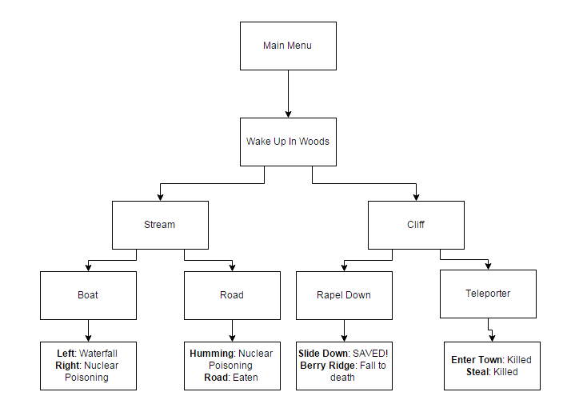

1. **Game Play Mechanics**

Role-Playing:

* Player must act as the character in the game
* Player is provided a storyline and choose different options to change the outcome of the story and attempt to figure out what has happened to them

Risk & Reward:

* Player must make decisions to find the best possible outcome where their character does not die.
* Player does not know the correct path to victory, which means that one wrong choice at the first decision level, could lead them to a certain path of fate, no matter which path they choose after.

1. **Controls**

This game will only make use of the mouse functionality in the ‘impress.js’ framework. All other buttons have been disabled to avoid improper game flow.

1. **Interface Sketch**

Main Menu:

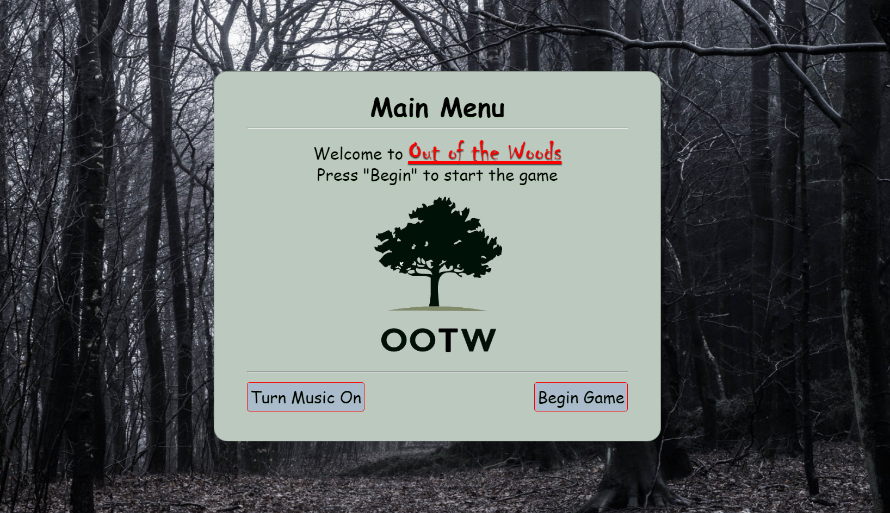

1. **Menu and Screen Descriptions**

First Decision Node:

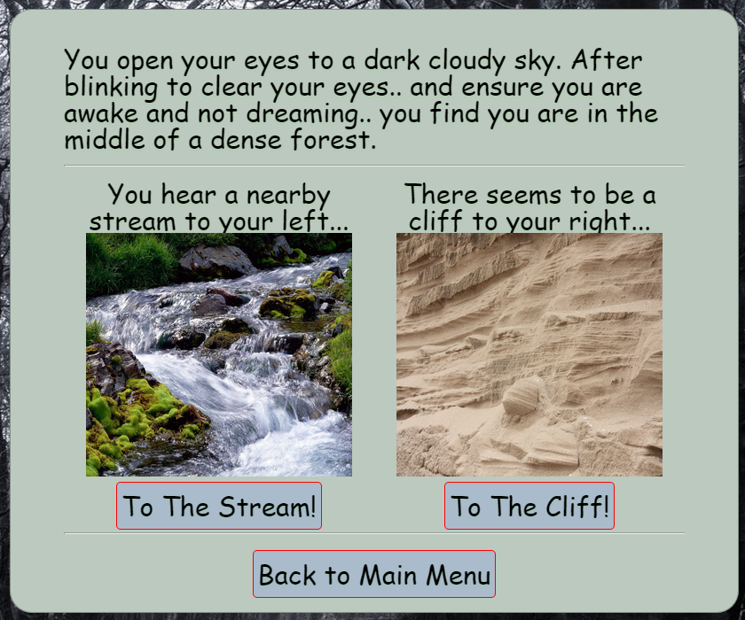

Second Decision Nodes:

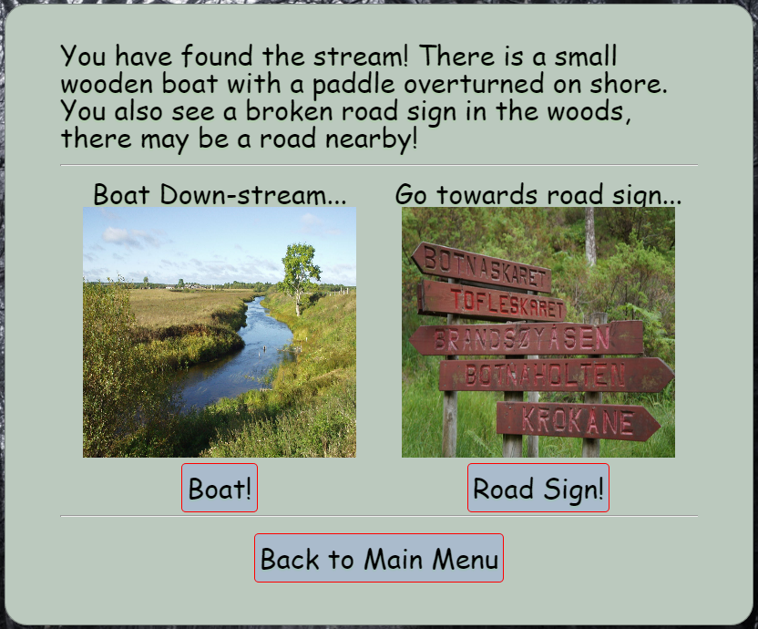

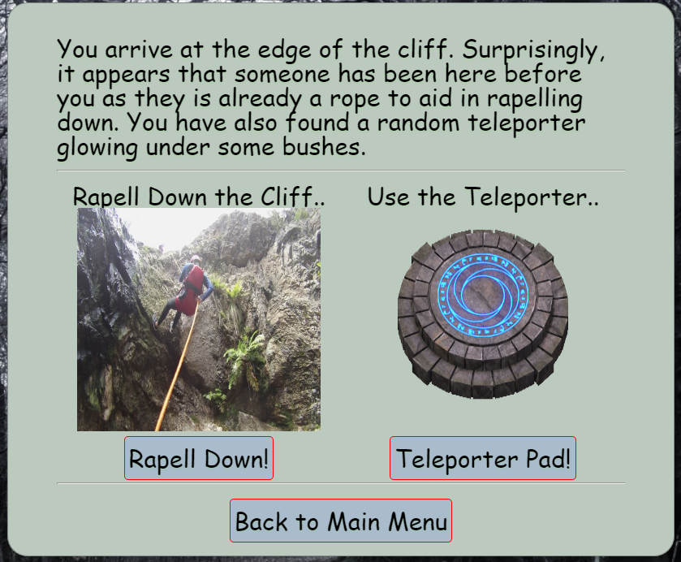

Third Decision Nodes:

Outcome Nodes:

1. **Game Progression**

The game progresses based on what path the user chooses to take. The game is user directed, and won’t do anything until the user makes a decision.

1. **Bonuses**

* Disabled some functionality of the impress.js framework to ensure proper game flow
  + Key presses such as space, arrow keys, and other functional keys in the code
* “One month later” Overlay design at end of game

1. **Sound Index**

Bgm.mp3

1. **Story Index**
2. Wake up in woods
   1. Go to stream
      1. Get in boat
         1. Left path
         2. Right path
      2. Road Sign
         1. Humming noise
         2. Go to road
   2. Go to cliff
      1. Rappel down cliff
         1. Slide down cliff
         2. Cross ridge
      2. Teleporter
         1. Enter town
         2. Steal food
3. **Art / Multimedia Index**
4. Cliff.jpg
5. Cliff_start.jpg
6. Enter_town.jpg
7. Fcliff.jpg
8. Main_back.jpg
9. Mid_woods.jpg
10. Military.jpg
11. Ml.png
12. Nuke.jpg
13. Rcliff.jpg
14. River.jpeg
15. River_fork.jpeg
16. Road.jpg
17. Sheriff.jpg
18. Sign.jpg
19. Stream.jpg
20. Teleporter.gif
21. Town_edge.jpg
22. **Design Notes**

Each decision node consist of a block of text to provide the storyline, 2 images with choices and buttons, a back button if available, and a quit to menu button. Final outcomes consist of an image, a block of text to end the story, and a quit to menu button.

1. **Future Features**

For future development to make the game more interesting, I would add in items that would be required for the user to win. For example, the user must pick up radiation cream, then travel backwards to the cliff to survive the fall down the cliff into an irradiated swamp, the cream would keep the character alive long enough for the military base to save him.