Network Basics
- What is internet and Internet?
Internet: a worldwide set of networks that interoperate using TCP/IP protocols.
internet: a set of computer networks that are connected to each other.
- Does WWW equal to Internet? NO!
WWW: An information sharing model on top of the Internet.
Internet: A networking infrastructure and the related communication standards.
- How do machines communicate with one another on the Internet?
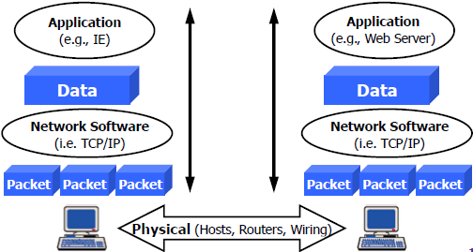
- What are the major components of Internet?
■ Internet applications
■ Telnet, Email, Web browser etc.
■ Internet protocols
■ TCP/IP, FTP, SMTP,HTTP etc.
■ Internet addresses
■ IPv4, IPv6, Domain Name System （DNS）
■ Physical infrastructure
■ hosts, routers, wiring
- What is protocol? Typical protocols of network layer, transport layer and application layer
Protocol = A set of rules for communicating
Network layer
■ Internet Protocol (IP)
■ Basic data transport, Unreliable delivery
■ Versions: IPv4 with 32 bit/4 Byte address, IPv6 with 128 bit/16 Byte address
Transport layer
■ Transmission Control Protocol (TCP)
■ Reliable data transmission, Connection-oriented
■ User Datagram Protocol (UDP)
■ Unreliable data transmission, Connectionless-oriented
Application protocols
■ File Transfer Protocol (FTP) - file exchange applications
■ Simple Mail Transfer Protocol (SMTP) - email applications
■ HyperText Transfer Protocol (HTTP) -WWW applications
- What are the two important design concepts of Internet?
- Layered networking model - ISO’s 7 layers model
Application, Presentation, Session, Transport, Network, Data link, Physical
- Client-server paradigm
Client/server/protocol – defines the interaction between them

- Terms for network devices and examples: node, host node, link, network component

Node - a device that is connected as part of a network with a network address
■ E.g. Computer, PDA, Cell Phone, router, switch, bridge etc.
Host Node - the computer attached directly to the Internet - end point of a network
E.g. ISPs and NSPs
Link - the inter-connection between network devices
Network Component - the equipment that is part of the network infrastructure
■ E.g. Gateway, router, bridge/switch, hub/repeater

- Terms for network performance parameters: bandwidth (bps, Bps), throughput, delay (latency), jitter, error rate (PLR, BER, FER, PER), PLR

Bandwidth - Indicates how much stuff you can send through a connection
bps (bit per second), Bps (Byte per second)
Delay (Latency) - is an expression of how much time it takes for a packet of data to get from one designated point to another
Contributors: Transmission, Processing, Storage, Propagation
Jitter - The variation in delay
Error Rate - The probability of the data units which are transmitted in error (lost/ retransmitted)
BER (Bit Error Rate), FER (Frame Error Rate), PER (Packet Error Rate)
Throughput – the average rate of successful message delivery over a communication channel

- Network types according to the switching function in the network
■ Circuit switching network
■ Message switching network
■ Packet switching network
■ Hybrid switching network

- Different channel access technologies: multi-access and point-to-point

■ Multi-access means shared medium
■ Many end-systems share the same physical communication resources (wire, frequency)
■ Arbitration mechanism
■ Complex channel access control, efficient resource usage
■ Point-to-point
■ Between two points in the network, there must exists a physical channel
■ No contention or collision
■ Simple access control, bandwidth waste

- Network types according to the range of the network: LAN, MAN, WAN, PAN. range, channel access technology, examples of them
Network Types | Range | Channel Access Technology | Example
WAN  (Wide Area Network)  network that spans a large geographic area | < 100 km | PSTN  Satellite  Cellular mobile  Point-point | Backbone
MAN  (Metropolitan Area Network) network that spans a medium area | < 10 km | Microwave  Coaxial cable  Multi-access | City network
LAN  (Local Area Network)  network that spans a limited area | < 1 km | Ethernet  Wireless IEEE  Multi-access  high speed | a lab  a building
PAN  (Personal Area Network) network that spans a small space | Within meters |  | A room  Bluetooth

- Network types according to the user of the network:
Public network
■ The large scale network built by the telecommunication companies
■ All the users can use the network as long as they pay the money
Private network
■ The network built by a certain agency for its special requirements
■ Only providing services to the user inside this agency
■ E.g. the military network, the railway network

- Layered architecture: ISO/OSI 7 layer model, TCP/IP model, Revisory Model, relationship between them, devices at different layers
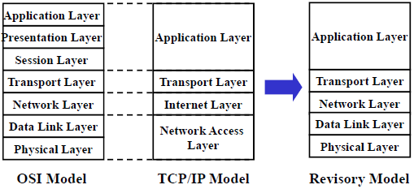
Network Layer: Router
Data Link Layer: Bridge/Switch
Physical Layer: Hub, repeater, optical fiber, twisted-pair
Network Programming Basics
- Basic concepts
- Process: what is a process? Is process equals to program? PID, PPID, special processes, fork(), exec()
A process is an instance of a program that is being executed by the operating system.
Process is the basic unit for resource allocation in operating system.
process ≠ program
■ Program：a file containing instructions to be executed, static
■ Process: an instance of a program in execution, live entity
■ One program can have multiple processes
■ One process can invoke multiple programs

PID (Process ID): Every process has a unique PID.
PPID (Parent PID): Every process has a parent process ID.
Special process
■ PID = 1: init process
■ PID = 0: special kernel process (e.g., idle/swapper process)
■ PID = 2: special kernel process (e.g., page daemon process)

exec(): often used after fork() to load another process
fork(): to create a child process (详见程序图24)
Return 0 in child process. Return PID of child process in parent process.
In fact, when fork() is called, it instantiated an identical process as the original process where it is called. In the parent process, the fork() returns the PID of its new child process, whereas in the child process, fork() returns 0.

- File descriptor: what is a file descriptor? Special file descriptors, Related system calls and their functions: open(), read(), write(), lseek()

A file descriptor is a small integer used to identify a file that has been opened for I/O operation.
It is returned when a file is opened or created, and is used as an argument when later the file is read or written.

(详见程序图30)
open - Be used to open or create a file
■ int open (char *pathname, int oflag, int mode);
close - Be used to close a file
■ int close (int filedes);
read - Be used to reading the data from an opened file
■ int read (int filedes, char *buff, unsigned int nbytes);
write - Be used to writing data into an opened file
■ int write (int filedes, char *buff, unsigned int nbytes);
lseek - Be used to locate in a file
■ long lseek (int filedes, long offset, int whence);
- Signal: what is a signal? Which conditions will generate signals? What can a process do with a signal? Signal() system call and its functions

A signal is a notification to a process that an event has occurred.

5 conditions that generate signal
Kill system call
• Allows a process to send a signal to another process or to itself
Kill command
• Used to send a signal
• Used to terminate a background process out of control
Certain terminal characters
• e.g. the interrupt character (typically control-C or Delete) terminates a process that is running - it generates a SIGINT signal
Certain hardware conditions
• Detects these conditions and then notifies the kernel.
e.g. invalid storage access - SIGEGV
Certain software conditions
• The kernel notices these conditions and generates the signal.
e.g. SIGALRM

Do with signal
Catch the signal
• Provide a function (handler) that is called whenever a specific type of signal occurs.
Ignore the signal
• Choose to ignore a signal
• Two signals that cannot be ignored: SIGKILL, SIGSTOP
Execute the default action
• Allow the default to happen
• default actions of most signals are to terminate the process
(详见程序图40)
Signal() system call – what the program should do when certain signal is received
#include <signal.h>
void (*signal( int sig, void (*handler)(int))) (int) ;

- IP Addresses
- The IP address definition in Linux system
IP address is represented by 32 bit integer that stored in an IP Address structure.
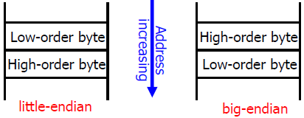
- Big-endian and little-endian byte order, host byte order and network byte order, byte order conversion functions

Host byte order is machine-dependent
■ A program used to output the host byte order
■ Network byte order is machine-independent (big-endian)

■ Byte order conversion functions
■ htonl: convert long int from host to network byte order.
■ htons: convert short int from host to network byte order.
■ ntohl: convert long int from network to host byte order.
ntohs: convert short int from network to host byte order

- DNS
- Function of DNS
Mapping between IP addresses and domain names.

- Host entry structure defined in Linux system
Host entry structure
<netdb.h>
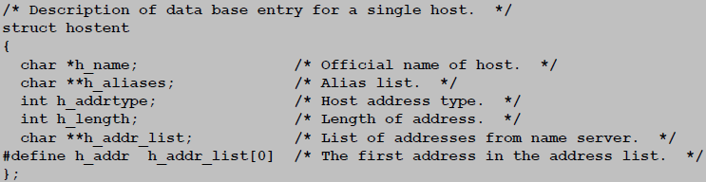

- System calls for retrieving host entries from DNS: (#include <netdb.h>)
■ gethostbyname: query key is a DNS domain name
struct hostent * gethostbyname (const char *hostname);
■ gethostbyaddr: query key is an IP address
struct hostent * gethostbyaddr (const char *addr, int len, int family);

- Connection
- What is a connection? How to identify an endpoint of a connection? How to identify a connection?
Clients and servers communicate by sending streams of bytes over connections.
end-to-end, full-duplex (2- way communication), and reliable.

The IP address in the server socket address identifies the host.
The (well-known) port in the server socket address identifies the service, and thus implicitly identifies the server process that performs that service.

- Well-known port numbers used for some typical applications (DHCP, DNS, TELNET, TFTP, FTP, SMTP, POP, HTTP, SNMP)
 | Server Port No. | Client
DHCP | 67 | 68
DNS | 53 | KERNEL
TELNET | 23 | KERNEL
TFTP
FTP | 21-command, 20-data | KERNEL
SMTP | 25 | KERNEL
POP | 110 | KERNEL
HTTP | 80 | KERNEL
SNMP | 161-get/set, 162-trap | KERNEL

- Functions of netstat, ifconfig and ping
netstat - prints information about the Linux networking subsystem, Display a list of open sockets
e.g., network connections, routing tables, interface statistics etc.
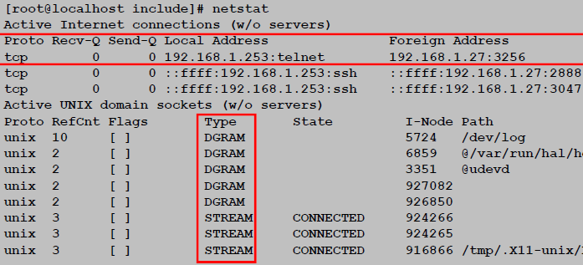

ifconfig - configure the network interfaces, and usually be used to print the configuration of the network interfaces
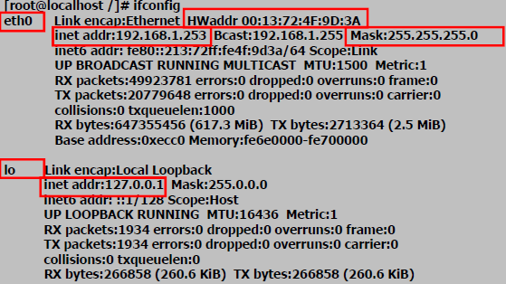

ping - Sends a packet to the host specified by destination and prints out the roundtrip time
(Uses ICMP messages)
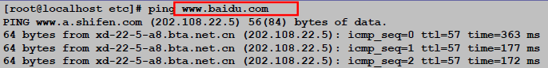
- Sockets interface
- What is a socket? What is the sockets descriptor?
To the kernel, a socket is an endpoint of communication.
To an application, a socket is a file descriptor that lets the application read/write from/to the network.
Remember: All Unix I/O devices, including networks, are modeled as files.

Clients and servers communicate with each other by reading from and writing to socket descriptors.
The main distinction between regular file I/O and socket I/O is how the application “opens” the socket descriptors.

- Internet-specific socket address and Generic socket address, how do we use them in the system calls such as connect(), bind(), and accept()?
Internet-specific socket address
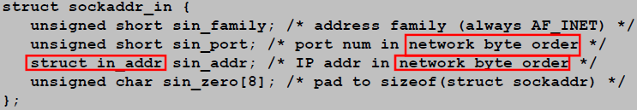
Generic socket address
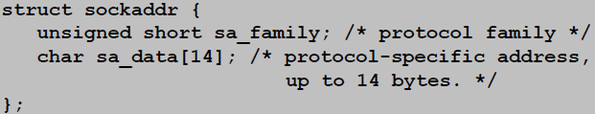
Pointer to generic socket address is used for address arguments to connect, bind, and accept.
Must cast Internet-specific socket address (sockaddr_in *) to generic socket address (sockaddr *) for connect, bind, and accept.

- Different sockets interface types: SOCK_STREAM, SOCK_DGAM, SOCK_RAW.
Stream Socket
Service: reliable
(i.e. sequenced, non-duplicated, non-corrupted) bidirectional delivery of byte-stream data
Metaphor: a phone call
■ int s = socket (PF_INET, SOCK_STREAM, 0);
■ Datagram Socket
■ Service: unreliable, unsequenced datagram
■ Metaphor: sending a letter
■ int s = socket (PF_INET, SOCK_DGRAM, 0);
■ Raw Sockets Service
■ Allows user-defined protocols that interface with IP, Requires `root` access
■ Metaphor: playing with an erector set
■ int s = socket (PF_INET, SOCK_RAW, protocol);

SOCK_STREAM and SOCK_DGRAM are the most common types of sockets used within UNIX
- System calls used in sockets programming (详见程序图28)
- Socket operation (#include <sys/socket.h>)
■ socket() - Returns a socket descriptor
int socket (int family, int type, int protocol);

■ bind() - What address I am on / what port to attach to
int bind (int sockfd, const struct sockaddr *myaddr, socklen_t addrlen);

■ connect() - Connect to a remote host
int connect (int sockfd, const struct sockaddr *servaddr, socklen_t addrlen);

■ listen() - Waiting for someone to connect to my port
■ accept() - Get a file descriptor for a incoming connection

■ send() and recv() – TCP Send and receive data over a connection
ssize_t send (int sockfd, const void *buff, size_t nbytes, int flags);
ssize_t recv (int sockfd, void *buff, size_t nbytes, int flags);

■ sendto() and recvfrom() – UDP Send and receive data without connection
ssize_t sendto (int sockfd, const void *buff, size_t nbytes, int flags, const struct sockaddr *to, socklen_t addrlen);
ssize_t recvfrom (int sockfd, void *buff, size_t nbytes, int flags, struct sockaddr *from, socklen_t *addrlen );

■ close() and shutdown() - Close a connection Two way / One way
■ readn(), writen(), readline() - Read / Write a particular number of bytes

- Byte order operation
htonl() - Convert long int from host byte order to network byte order
■ htons() - Convert short int from host byte order to network byte order
■ ntohl() - Convert long int from network byte order to host byte order
■ ntohs() - Convert short int from network byte order to host byte order

- Address formats conversion
inet_aton() - converts an IP address in numbers-and-dots notation (ASCII string) into unsigned long in network byte order
inet_addr() - converts an IP address in numbers-and-dots notation (ASCII string) into unsigned long in network byte order
inet_ntoa() - mapping a 32-bit integer (an IP address in network byte order) to an ASCII string in dotted decimal format
■ inet_pton() - Similar to inet_aton() but working with IPv4 and IPv6
■ inet_ntop() - Similar to inet_ntoa() but working with IPv4 and IPv6

- Name and address operation
gethostbyname() - retrieving host entries from DN, the query key is a DNS domain name
■ gethostbyaddr() - retrieving host entries from DNS, the query key is an IP address
■ gethostname() - Obtaining the name of a host
■ getservbyname() - Mapping a named service onto a port number
getservbyaddr() - Obtaining an entry from the services database given the port number assigned to it

- Basic flows of TCP/UDP based sockets API (详见程序图46)

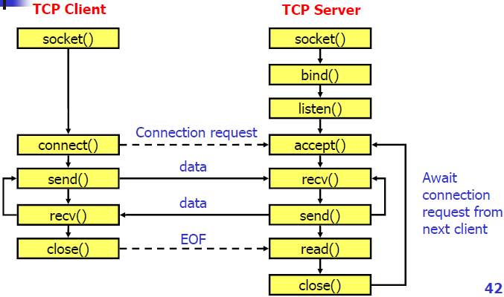
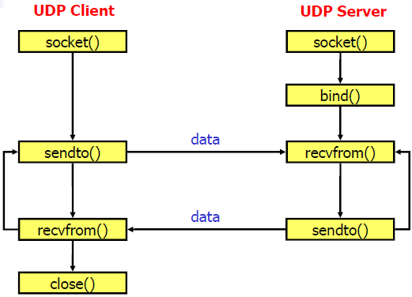
DHCP
- DHCP overview: Basic function, relationship between BOOTP and DHCP, well-known port number, DHCP client, DHCP server, DHCP Relay, DHCP lease, Phases of IP assignment with DHCP
Dynamic Host Configuration Protocol – Transport Protocol
Basic function: Provides automatic configuration of remote hosts. 67-server, 68-client
DHCP is an extension version of BOOTP

DHCP vs. BOOTP – Similarities
The format structure each uses to exchange messages
■ Use of well-known UDP ports for client/server communication
■ IP address distribution as an integral part of configuration service

DHCP vs. BOOTP – Differences
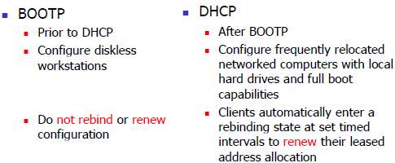

DHCP client - is an Internet host using DHCP to obtain configuration parameters such as a network address
DHCP Relay – used to interconnect hardware and software on different physical network segments called subnets and forward IP packets between each of the subnets.
DHCP server - is an Internet host that returns configuration parameters to DHCP clients
DHCP lease - is the amount of time that the DHCP server grants to the DHCP client permission to use a particular IP address

Phases of IP assignment with DHCP
  - Client makes a request for an IP address
  - DHCP servers offer an IP address
  - Client selects an offer and requests an IP lease
  - Selected DHCP server assigns an IP to the client

- DHCP message format
OP: 1 – request, 2 – reply
HTYPE: Hardware Address Type
■ HLEN: Hardware Address Length
■ HOPS: Client sets to zero, optionally used by relay agents when booting via a relay agent
■ TRANSACTION ID: an integer, Used by the client to match responses with requests
■ SECONDS: seconds elapsed since client began address acquisition or renewal process
FLAGS: Allows control of the request and response. A client uses the leftmost bit to control weather the server sends the response via unicast or broadcast. The remaining bits are reserved for future use
CLIENT IP ADDRESS: Only filled in if client is in BOUND, RENEW or REBIND state
YOUR IP ADDRESS: Client IP address (assigned by server)
SERVER IP ADDRESS: DHCP’s own IP address
ROUTER IP ADDRESS: Router’s own IP address
OPTIONS: TLV encoding style
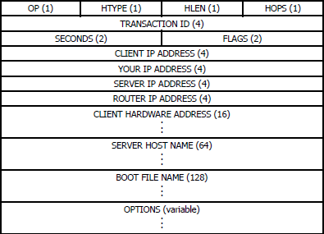

- STD and MSC of DHCP Address acquisition
Address Acquisition:
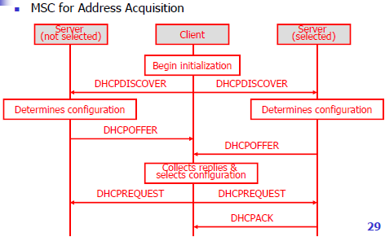
phases: IP lease request, IP lease offer, IP lease selection, IP lease acknowledgment
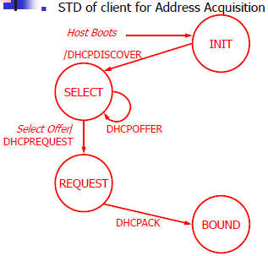

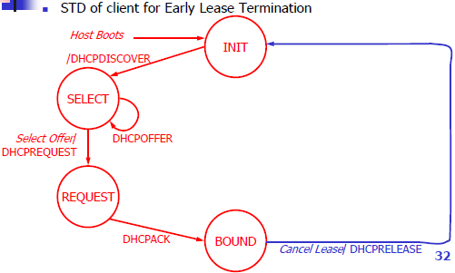
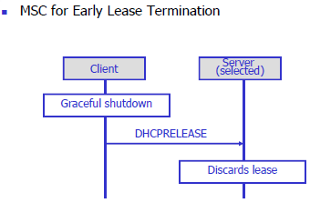
- Procedure of Early lease termination in DHCP

- Procedure of Lease renewal in DHCP
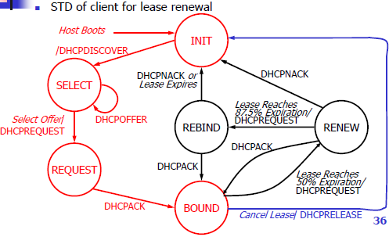
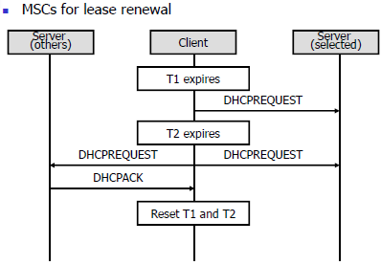

- Basic address acquisition procedure through DHCP relay

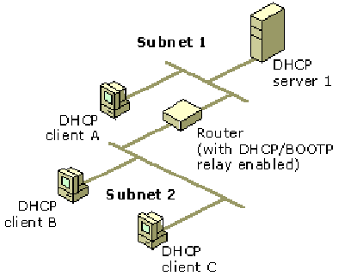
- Router will examine the gateway IP address field in the DHCPDISCOVER
- Broadcast a DHCPDISCOVER on subnet 2, using UDP (67) (i.e. send it to both client B&C)
- If the field has an IP address of 0.0.0.0, agent fills it with the relay agent or router’s IP address, then forward the message to the remote Subnet 1 (i.e. send it to server1)
- DHCP server processes and sends an DHCPOFFER directly to the relay agent identified in the GIADDR field, forward the DHCPOFFER to remote Subnet 1
- A DHCPREQUEST message is relayed from client to server (i.e. send it to both remote Subnet 1&2)
- A DHCPACK message is relayed from server to client
DNS
- Basic functions of DNS, nowadays status of DNS
Basic functions: Translating between IP address and domain name.
Status: Hierarchical structure, Distributed database, Efficient, reliable, general purpose

- Hierarchical structure of domain namespace
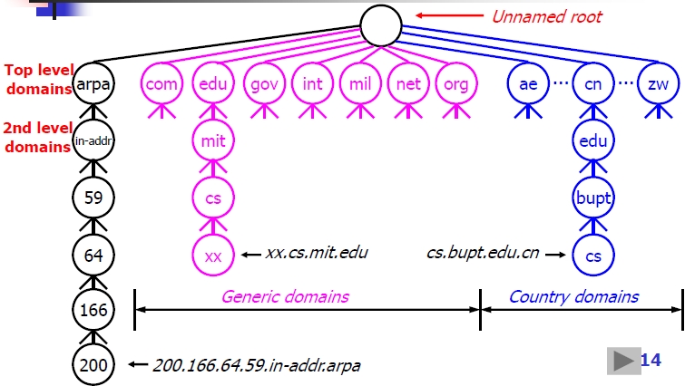

- Important terms
- Domain / domain name / FQDN
Domain:
■ Each element of the hierarchy is referred to as a domain
■ At the top of the hierarchy is the root domain, simply “.”
Domain name:
The domain name of a node is the list of the labels on the path from the node to the root of the tree separated by dots(“.”)
Printed or read left to right, from the most specific (lowest, farthest from the root) to the least specific (highest, closest to the root)
Case insensitive: Components can be up to 63 characters long, the full pathname must not be more than 255 characters
FQDN - The full name of a domain is also called its Fully Qualified Domain Name
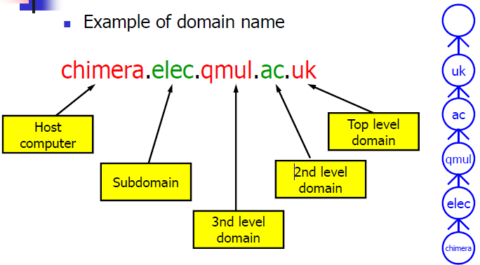
- Domain namespace
Up-ended tree hierarchy of the domain name
- Resource Record
Each domain in the DNS has one or more Resource Records (RRs), which are fields that contain information about that domain:
■ Owner: domain name where the RR is found
■ Type: type of the resource in this RR
■ A – Host Address
■ MX – Mail Exchanger
■ Class: protocol family to use
■ IN – the Internet system
■ TTL: Time To Live (in unit of second) of the cached RRs
■ RDATA: resource data

- Name server / primary server / secondary server / caching server
Name server
repository o information that make up the domain database
Primary server / Authoritative server
holds the name-to-address mappings for the group of hosts it administers
■ knows the official answer
Secondary server
■ maintains a copy of the Primary Server’s database
Caching server
asks DNS queries to other servers but maintains a cache of the responses together with a TTL value
non-authoritative data about other parts of the tree

- Resolver
The client side of DNS
A resolver is the interface between the user program and the domain name servers
A resolver receives a request from a user program, then asks questions to the DNS system on behalf of the application, finally returns the desired information

- Query / response
User sends query to Resolver, then Resolver refers to Cache and sends query to foreign DNS server; DNS server sends response to Resolver, then Resolver returns it to user program.

- Standard query / inverse query / pointer query
Standard query: mapping from domain name to a resource (IP address)
Inverse query: mapping from a resource (IP) to domain name
seldom used because difficult to scan the whole DNS database to find a server
Pointer query: using IN-ADDR.ARPA domain for address to host mapping
The correct DN for machine with an IP address in dotted-decimal format
- Communication model between user program, resolver and name server. How does DNS work together with the user programs (e.g. TELNET, FTP, HTTP)?
User program call system calls such as gethostbyname() or gethostbyaddr which implements the DNS resolver. Resolver will ask for answer on behalf of the user program and return the result to the user program.
- Procedure of the recursive resolution and iterative resolution
Recursive resolution:
If the queried server does not have the information, it must make the appropriate query or queries to get the information
A server fulfills a recursive query either with data in its own memory or by making another recursive query
■ Iterative resolution:
If the queried server does not have the information, it may then respond with the address of another server; the local name server (on behalf of resolver) then queries that server (which might respond with the address of another server, and so on)
Commonly used by name servers on the Internet

- What are the mechanisms in DNS that are possible to improve the querying efficiency?
The query needs be firstly sent to the local DNS server, which can improve the efficiency.
If the local DNS server cannot resolve the query, it must be sent to another root server.

- DNS Message Format
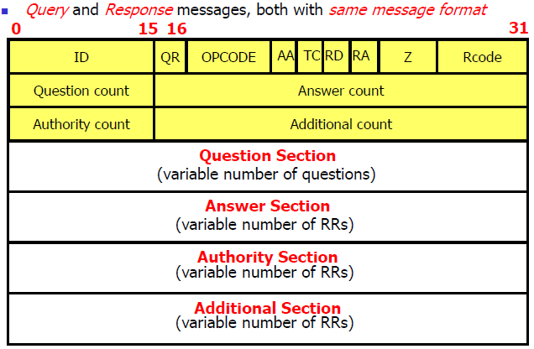
- Types of Resource Record (only the one highlighted using red color in the lecture notes)
NS - Maps a domain name to the name of a computer that is authoritative for the domain
■ A - Maps the name of a system to its address. Separate record for each address.
■ CNAME - Maps an alias name to the true, canonical name
■ MX - Mail Exchanger. Identifies the systems that relay mail into the organization
PTR - Maps an IP address to a system name. Used in address-to-name files.
TELNET
- What is TELNET and telnet?
TELNET is a protocol that provides “a general, bi-directional, eight-bit byte oriented communications facility”
telnet is a program that supports the TELNET protocol over TCP

- What are the advantages of the idea of option negotiation in TELNET?
Enables telnet to evolve to meet new demands without endless new versions of basic protocol

- NVT
- What is NVT? What are its functions?
NVT – Network Virtual Terminal
Solve the problem of lack of a common language between the terminal and the remote host.

- NVT operations
The sending side (User’s keyboard & display) translates native data and control signals into NVT form before sending out, then the receiving side (Server’s system) gets the NVT data and signals and translates into its native form.

- NVT format
NVT uses two sets of characters: data & control
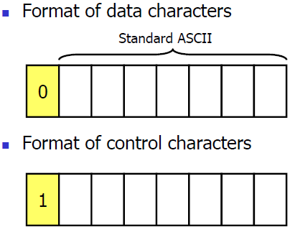

- Data path from the user’s keyboard to the remote system
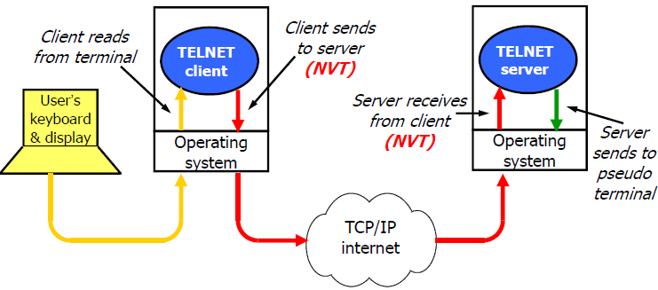

40．TELNET control functions: IAC, DO, DONT, WILL, WONT
IAC | Interpret next octet as command
DON’T | Denial of request to perform specific option
DO | Approval to allow specific option
WONT | Refusal to perform specific option
WILL | Agreement to perform specific option

41．TELNET options example: echo modes, Line mode vs. character mode, character set
echo modes
■ Keyboard input be echoed on the terminal side or not
■ Line mode vs. character mode
■ One line or one character per transmission
■ character set (EBCDIC vs. ASCII)
■ EBCDIC - Extended Binary-Coded Decimal Interchange Code
■ ASCII - American Standard Code for Information Interchange

    - Understand the TELNET session through examples
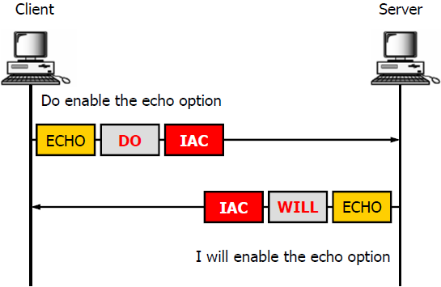
Command sending sequence
Negotiation first, then Login

43．Other Remote Access Technologies
Remote login in text-based system
■ telnet
■ SSH
■ Rlogin
■ Remote desktop in windowing system
■ VNC (Virtual Network Computing)
■ RDP (Remote Desktop Protocol)
TFTP/FTP
- TFTP features, TFTP packet format (you can ignore the errcode definition)
TFTP-Trivial File Transfer Protocol
Features:
Read and write files from / to remote computers
■ Minimal overhead (no security)
■ Designed for UDP
■ Easy to implement
■ Small – possible to include in firmware
■ Often uses to bootstrap workstations and network devices
■ No Access Control / No Directory Retrieval

Packet format
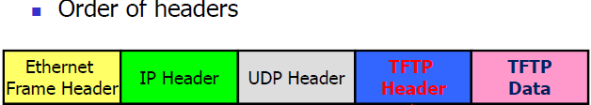
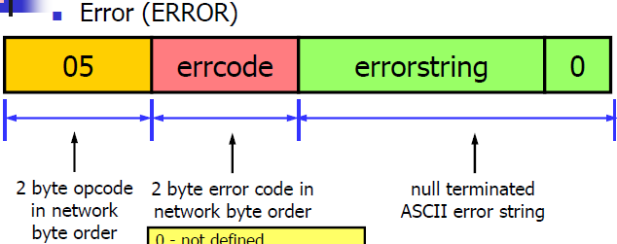
TFTP header consists of a 2 byte opcode
field indicating the packet's type:
1 Read request (RRQ)
2 Write request (WRQ)
3 Data (DATA)
4 Acknowledgment (ACK)
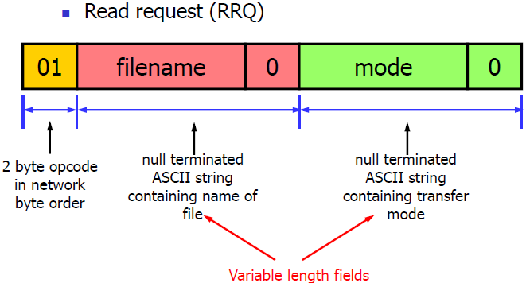
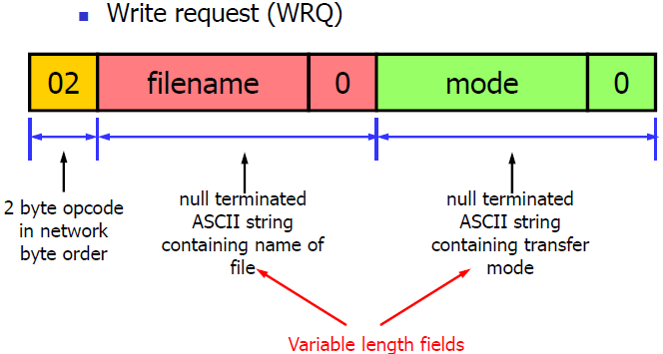
5 Error (ERROR)

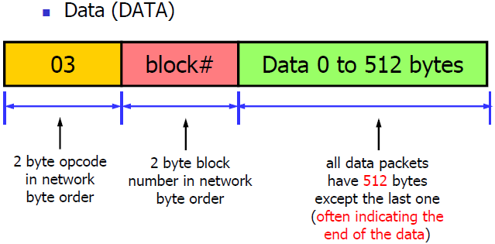
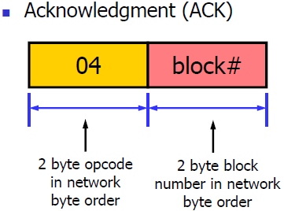

- Transfer mode of TFTP
■ Netascii - for transferring text files
■ all lines end with \r\n
■ provides standard format for transferring text files
■ both ends responsible for converting to/from netascii format
■ Octet - for transferring binary files
■ no translation done

- Typical communication procedure of TFTP
Begin with RRQ/WRQ ——>
Data1 <——
Ack1 ——>
Data2 <——
Ack2 ——>

- Retransmission defined in original TFTP protocol, the sorcerer’s apprentice syndrome problem and how to fix it
■ If a data packet gets lost in the network, the data sender times out and retransmits the last data packet
■ If an ACK is lost, the acknowledgment sender retransmits the last ACK
■ The sender has to keep just one packet on hand for retransmission, since the lock step acknowledgment guarantees that all older packets have been received

SAS - sorcerer’s apprentice syndrome
• Arising when an acknowledgment for a data packet is delayed, but not lost
• Leading to excessive retransmissions
• Once started, the cycle continues indefinitely with each data packet being transmitted exactly twice
Fix it
Principle: break the retransmission loop
■ Sender should not resend a data packet in response to a duplicate ACK
■ If sender receives ACK[n] - don’t send DATA[n+1] if the ACK was a duplicate

- FTP features
Used to transfer files between hosts
■ Used to manipulate files, for example:
■ List directories
■ Delete files
■ Rename files
■ Uses TCP for reliable transfers
■ Official Internet protocol

- FTP model
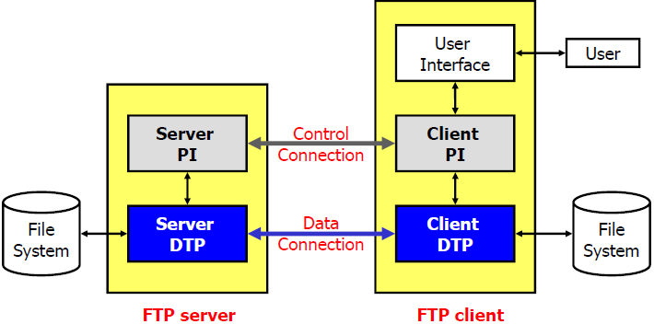
PI (Protocol Interpreter): The user and server sides of the protocol have distinct roles implemented in a user-PI and a server-PI.
DTP (Data Transfer Process): The data transfer process establishes and manages the data connection. The DTP can be passive or active.
Control Connection: The communication path between the client-PI and server-PI for the exchange of commands and replies. Follow Telnet Protocol.
Data Connection: A full duplex connection over which data is transferred, in a specified mode and type. May be a part of / an entire file / a number of files. The path may be between a server-DTP and a client-DTP / between two server-DTPs.

FTP Client
■ Users interact with Client directly
■ Active open of control connection
■ Control connection uses ASCII plain-text
■ Sends commands (over control connection)
■ Receives replies (over control connection)
■ Data connection used to transfer file data
■ FTP Server
■ System process
■ “Listens” for connection on well-known port 21
■ Receives commands
Sends replies

- FTP basic control commands and replies, User’s commands
Usage
■ Usually 4 characters (such as RETR), Arguments separated by spaces
■ Terminated by CR/LF sequence, Sent from client-PI to server-PI
■ The client program translates your requests into the necessary commands and responses
■ 3 command groups
■ Access control
■ USER, PASS, ACCT, CWD, CDUP, REIN, QUIT
Transfer parameter
PORT, PASV, TYPE, STRU, MODE
■ Service
RETR, STOR, APPE, DELE, MKD, RMD, RNFR, RNTO, LIST, NLST
User’s commands
CD mystuff —— CWD mystuff
GET mystuff.doc —— RETR mystuff.doc
PUT timecard.doc —— STOR mystuff.doc
DIR —— NLST

- FTP Control Connection & Data Connection
■ Control connection
■ Remain alive as long as the user keeps the FTP session active
■ Passing commands and replies
■ Used to coordinate the ports used for data connection and establish data connection
■ follows the Telnet protocol in that it uses the NVT ASCII character set
■ Data connection
■ Be created dynamically when needed
■ One data connection persists for one file transfer
■ Used for data transmission

- FTP Active and Passive Mode
Active mode
■ Client sets up to “listen” on a unique port
■ Client uses local socket information to send PORT command to server
■ Server responds with “200” reply to acknowledge the port number
■ Client sends RETR, STOR, or other transfer command
■ Server sends preliminary reply
■ Server does active open (“connect”)
■ File data sent over connection
■ Server sends “226” or other reply
■ Server/client closes data connection
Passive mode
■ Client sends command PASV
■ server listens to a specific port and client should access that port

- Anonymous FTP
Traditional FTP
■ Must log in; Can transfer to and from directories accessible to that account
Anonymous FTP
■ “anonymous” as the account name with e-mail address as password; Access to public directories for downloading only; Not truly anonymous: IP address is known
EMAIL
- Email
- Components of email system
UA (User Agent)
■ end-user mail program
■ Interface between the end users and the email servers
■ E.g., outlook, foxmail, …
■ Mail Server
Responsible for transmitting/receiving emails and reporting status information about mail transferring to the mail sender
■ Both a client and a server
Email protocols
■ SMTP: used for sending an email
■ POP3/IMAP: used for receiving an email

- Basic functions of email system
Composition - creating messages and answers.
■ Transfer - moving messages from the originator to the recipient.
■ Reporting - informing the originator what happened to the message.
■ Displaying - means of showing the messages.
■ Disposition - what happened to the message after it has been read by the receiver.

- Terms: UA, Mail Server, MTA
MTA (Mail Transfer Agent) – SMTP servers and clients provide a mail transport service

- Email address
mailboxname@domain. (See RFC 2822 ) - unique

- Message Format - Header, blank line, body
Headers: from, to, subject, date, postmarks
■ Blank line
■ Body: actual message, may have many parts

In normal usage, the User Agent builds a message and passes it to MTA
The MTA then uses some of the header fields to construct the actual envelope
User provides body & key headers, while mail system provides the rest
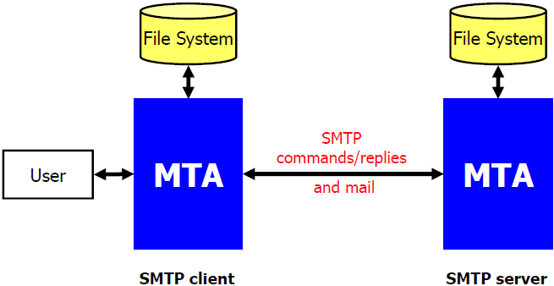
- SMTP
- Basic model
SMTP is a simple ASCII protocol
After establishing the TCP connection to port 25, the sending machine, operating as a client, waits for the receiving machine operating as the server to talk first

- Basic commands and replies
Commands:
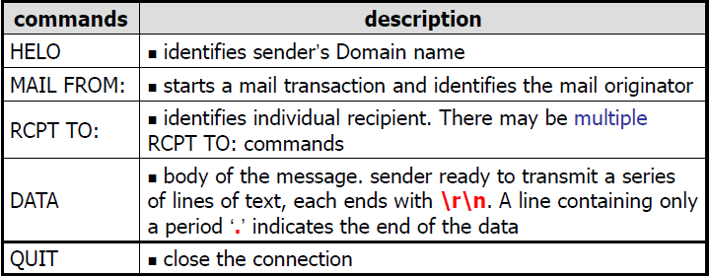
The Server responds with a 3 digit code:
■ 2## -- Success
■ 3## -- Command can be accepted with more information
■ 4## -- Command was rejected, but error condition is temporary
5## -- Command rejected, Bad User!

- POP
- Basic model
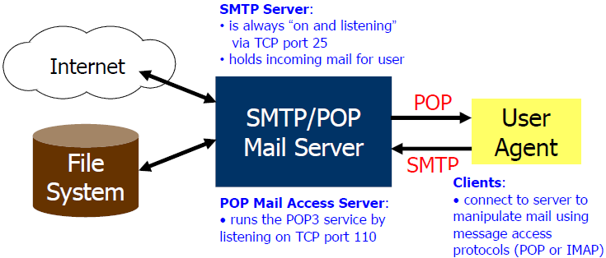
- Basic commands and replies
Commands and replies are ASCII lines
■ Replies start with “+OK” or “-ERR”, may contain multiple lines

USER - specify username
■ PASS - specify password
■ STAT - get mailbox status number of messages in the mailbox.
■ LIST - get a list of messages and sizes.
■ RETR - retrieve a message
■ DELE - mark a message for deletion from the mailbox
■ NOOP - send back positive reply
■ RSET - reset. All deletion marks are unmarked
■ QUIT - remove marked messages and close the (TCP) connection

- IMAP – Internet Message Access Protocol
- Features of IMAP
Features:
■ Folders and messages can be stored on server /local computer
Possible to access your same mail store even using a dumb terminal character based client like Pine.
■ Much better for mobile users than POP (since mail remains on the server)
■ Can selectively copy messages from the server to the local client
■ Gmail supports IMAP

- Comparison of POP and IMAP
POP: mail downloaded and removed from the server, stored in local machine.
IMAP: mail can be stored on server / local machine, better for mobile user.

- Message formats
- RFC 2822: main headers
Consists of completely text in English and expressed in ASCII
Need improvement dut to different language which may not use English alphabet at all, and Video/Audio transmission in mails is required now

- MIME: New headers and main content types
MIME – Multipurpose Internet Mail Extension
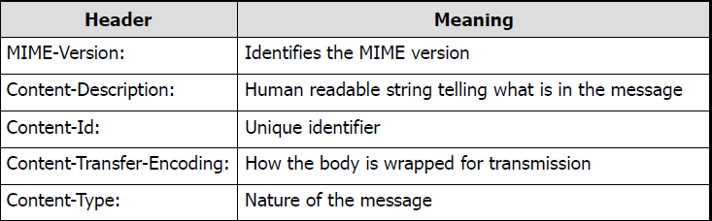

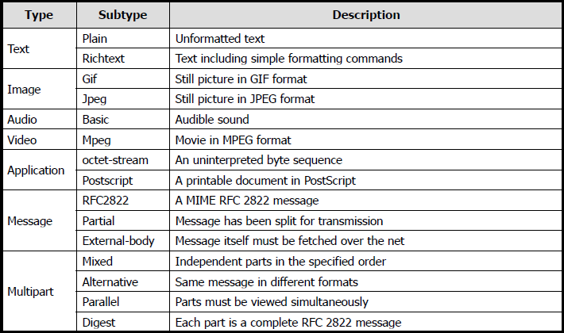

- What are the limitations of SMTP? How POP, IMAP and MIME used to offset the limitations of SMTP?
Only uses NVT 7 bit ASCII format - How to represent other data types?
No authentication mechanisms
Messages are sent un-encrypted
Susceptible to misuse (Spamming, faking sender address)

POP: help receive message from MTA and send it to UA
IMAP: better for mobile user
MIME: help send multipart and multimedia message.
WWW
- Terminologies: WWW, the Web, W3, URL, HTML, HTTP
World Wide Web: WWW, the Web, W3
Is a true information superhighway
■ URL (Uniform Resource Locator)
■ Designates a specific webpage on a specific webserver
■ HTTP (HyperText Transfer Protocol)
■ An application-level transfer protocol standard
■ HTML (HyperText Markup Language)
■ A document format standard

- WWW components
- Client/browser
The Web client is called a “browser”
■ The server is where the data is stored and it is software that runs on well known port (80)
■ The browser and server talk using a protocol – HTTP
(Netscape, Internet Explorer, Maxthon, Mozilla, Firefox, Lynx)

- Web server
The server is software that is running on a remote location. Make “pages” available to the client. Listen at TCP port 80, receives request and respond to client.
After transmisstion of data, connection is terminated. The process is stateless.
(On Unix - Apache, On Windows NT - IIS (Internet Information Server), Both Netscape’s Web Server)

- The web access model
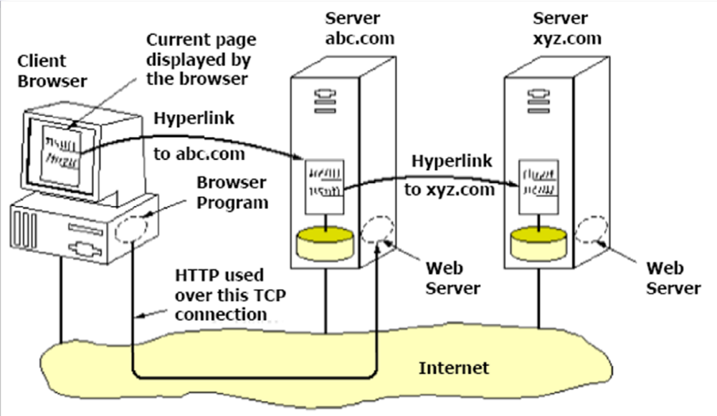

- URL - Uniform Resource Locators
- Structure
protocol://hostname [:port]/directory/item-you-want
A URL consists of 3 parts:
■ The protocol – http by default
■ The DNS name of the host (Port: 80 by default)
■ The directory and file name - Index.html, index.htm, default.htm, default.asp by default

- Used for different services
Protocol can be http, ftp, file, news, gopher, mailto, telnet

- HTML
- Basic web page structure
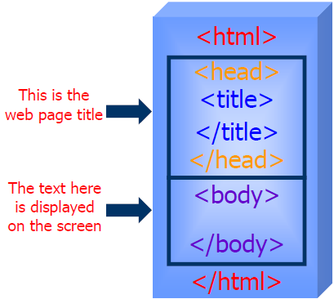

- Basic tags
<P> - paragraph
■ <B> - bold
■ <I> - italics
■ <H1>, <H2>,…<H6> - headers
■ <A> - anchor, to create a link to another place
■ <IMG> - image

- Static vs. dynamic
Static documents
■ Each URL corresponded to a single file stored on some hard disk
■ Edit in HTML format (.html, .htm)
Dynamic documents - are built at request time
■ The URL doesn’t correspond to a single file
■ e.g. website access counter, WWW based date-time server, BBS
■ by ASP, JSP, VB Script, PHP, CGI or other programs (.asp, .shtm, .php, .cgi)

■ Why dynamic documents?
■ automation of web site maintenance, customized advertising
■ database access, shopping carts, date and time service
- CGI – Common Gateway Interface
A standard for interfacing external applications with information servers
A CGI program, on the other hand, is executed in realtime, so that it can output dynamic information for the server
The Web server executes a CGI program to transmit information to the database engine, receive the results and display them to the client.

- HTTP
- Features
Application layer protocol for client/server communication
■ Request/response based
■ Stateless
■ Bi-directional transfer
■ Capability negotiation
■ Support for cache
■ Support for intermediaries: HTTP proxy

- Transaction
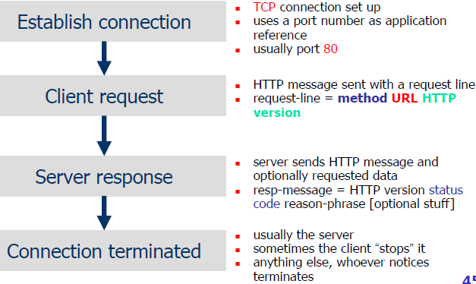
- Main Methods
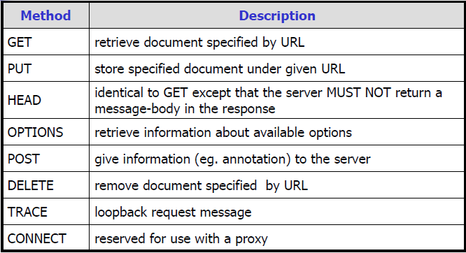
- Performance enhancement of HTTP 1.1
HTTP/1.0 - a “stop and wait” protocol
■ Separate TCP connection for each file
■ Connect setup and tear down is incurred for each file
■ Inefficient use of packets
■ Server must maintain many connections
HTTP/1.1 - specification focus on performance enhancements
■ Persistent connections
Use the same TCP connection for reansfer of multiple files
Reduce packet traffic significantly
■ Pipelining
Multiple HTTP requests can be written out to a socket together without waiting for the corresponding responses
■ Pack several HTTP requests into one TCP/IP packet
■ Enhanced caching options
■ Support for compression

SNMP
- Terminologies: SNMP, MIB, SMI, RMON
SNMP
MIB
SMI
RMON

- Definition, goals and functional areas of network management
Definition
Network management is a service that employs a variety of tools, applications, and devices to assist human network managers in monitoring and maintaining networks
Goals
The overall goal of network management is to help with the complexity of a data network and to ensure that data can go across it with maximum efficiency and transparency to the users
Functional areas
Fault management - locating problems, or faults, on the data network
■ It involves the following steps: Discover/Isolate/Fix the problem
■ Configuration management - Finding and setting up (configuring) network devices to control behavior of the data network
Accounting management - Tracking individual’s utilization and grouping of network resources to ensure that users have sufficient resources & Granting or removing permission for access to the network
■ Performance management - Measuring the performance of the network hardware, software, and media
■ Examples of measured activities are: Overall throughput
■ Percentage utilization
■ Error rates
Response time
Security management - Controlling access to information on the data network
Provides a way to monitor access points and records information on a periodic basis & audit trails and sounds alarms for security breaches

- Different network management architectures and their pros and cons
Centralized Architecture - resides on a single computer system, e.g. IBM NetView
■ All network alerts & events & information, Access all management applications
■ Pros:
■ Easier maintenance & control & to maintain security
■ Cons:
Single system is not redundant or fault tolerant (For full redundancy, the computer system is backed up by another system)
■ More added, difficult or expensive to scale system to handle load
■ Having to query all devices from a single location

Hierarchical Architecture - Uses multiple computer systems
■ One system acting as the central server, Other systems working as clients, Central server requires backups for redundancy
■ Not dependent on a single system, Network management tasks distributed, Network monitoring distributed throughout network, Centralized information storage
■ Pros:
■ Multiple systems to manage the network – more robust and scalable
■ Cons:
■ Information gathering is more difficult and time consuming
■ The list of managed devices managed by each client needs to be predetermined and manually configured – more administration

Distributed Architecture - Uses multiple peer network management systems
■ Contains advantages from central & hierarchical architectures
■ Selected location(s) for all network information, alerts & events
■ Selected location(s) to access all management applications
■ Not dependent on a single system
■ Distribution of network management tasks
■ Distribution of network monitoring throughout the network

- SNMP history, features – Simple Network Management Protocol
SNMP history
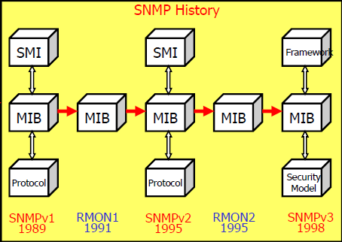
SNMPv1
■ Basic function of read/write MIB
SNMPv2
■ improve performance, security, confidentiality, and manager-to-manager communications
SNMPv3
■ Security enhancement
RMON1
■ Providing monitoring capability at data link layer in OSI model
RMON2
■ Providing monitoring capability above data link layer in OSI model

Features:
■ An application layer protocol that provides a way of monitoring and managing a heterogeneous computer network
■ Is a part of TCP/IP protocol suite
■ Based on client/server model & UDP
■ UDP Port 161: SNMP Get/Set Messages
■ UDP Port 162: SNMP Trap Messages

- SNMP model and components
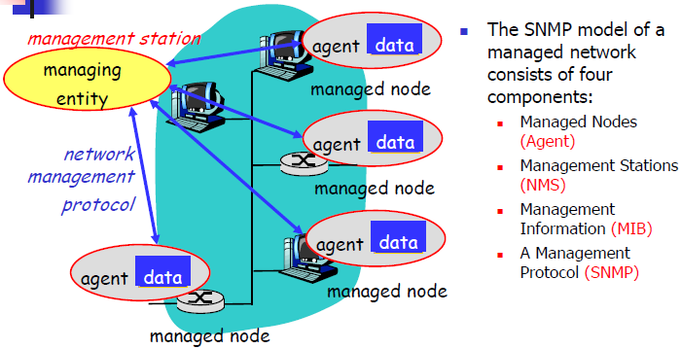

- SNMP framework
- SMI and ASN.1
SMI – Structure of Management Information defines the rules for describing management information, only a subset of ASN.1
Using ASN.1 for an unambiguous description without inconsistencies
ASN.1 (Abstract Syntax Notation One)
An international standard defining the data structure used and how these are transferred between systems (BER, Basic Encoding Rules)

- MIB hierarchy naming
MIB – Management Information Base is a collection of information that is organized hierarchichally
MIB hierarchy naming
Each object has a unique OID (object identifiers) consisting of numbers separated by decimal points, and a more readable name.
When an SNMP manager wants to know the value of an object, it will assemble a GET packet that includes the OID for that object.
The agent receives the request and looks up the OID in its MIB. If the OID is found, a response packet is assembled and sent with the current value of the object. If the OID is not found, a special error response is sent

- SNMP protocol: traps/polling, SNMP commands, SNMP message format
SNMP protocol: traps/polling
■ Traps
■ When abnormal event occurs, an agent sends a trap message to nominated NMS(s)
■ Hence keeps the message short and simple
■ Polling
■ The NMS periodically queries the network devices for information
■ Advantage is NMS is in control and knows the “big picture”
■ Disadvantage is the amount of delay from when an event occurs to when it’s noticed

SNMP commands
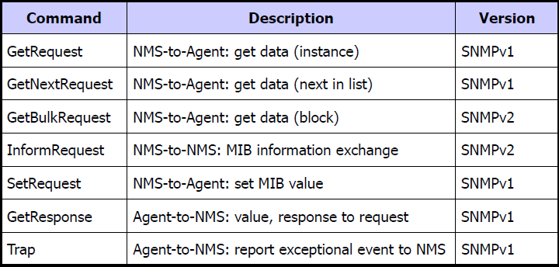

SNMP message format
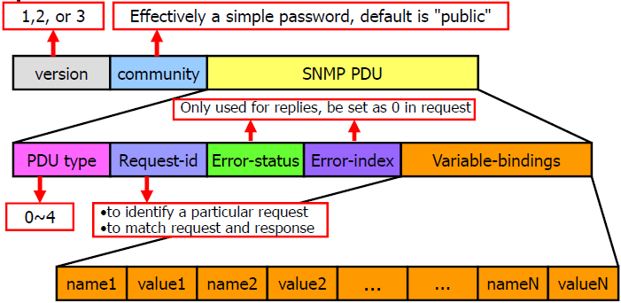

- RMON: Purpose
RMON – Remote Monitoring
Extensions to SNMP provide comprehensive network monitoring capabilities
Real-time Services
- Real-time services
- Isochronous services and QoS requirements
Isochronous pertains to processes that require timing coordination to be successful, such as voice and digital video transmission.
Internet is not isochronous (connectionless, best effort, adaptive routing)

QoS requirements
Sensitive to delay (both end-to-end delay and jitter), but can tolerate packet loss
e.g. delay < 150 ms, jitter < 10 ms

- Jitter compensation via playback buffer
The received data is initially put into a buffer labeled k, which is measured in time units of data to be played.
Incurs playback delay: increasing – large k / compensation effect weakened – small k

- RTP/RTCP
- Functions of RTP/RTCP, relationship between RTP and RTCP
Functions:
RTP - Real-time Transport Protocol
■ Provides end-to-end transmission for real-time applications
■ Does not define any QoS mechanism for real-time delivery
RTCP - RTP Control Protocol
■ RTP’s companion control protocol
Provides feedback on the quality of the data distribution
■ Provides flow control and congestion control for RTP

- Definitions: end system, translator, mixer
End system: An application that generates the content to be sent in RTP packets and/or consumes the content of received RTP packets.
Mixer: An intermediate system that receives RTP packets from one or more sources, possibly changes the data format, combines the packets in some manner and then forwards a new RTP packet.
Translator: An intermediate system that forwards RTP packets with their synchronization source identifier(SSRC) unchanged. E.g., devices that convert encoding without mixing

- RTP features, SSRC vs. CSRC
Features:
The basic sequence information that allows detection of lost, duplicate or reordered packets
Each packet must carry a separate timestamp that tells the receiver the exact time at which the data in the packet should be played
■ RTP is used to transmit digitized audio or video signals over an Internet
RTP is suitable for applications transmitting real-time data, such as audio or video, over multicast or unicast network services
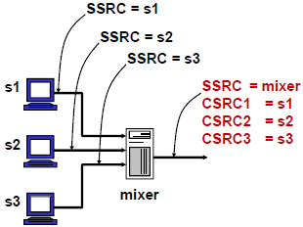
SSRC: 32 bits - The SSRC field identifies the synchronization source (the source of a RTP packet stream). i.e. mixer.
■ CSRC list: 0 to 15 items, 32 bits each - The CSRC list identifies the contributing sources (sources before mixing) for the payload contained in this packet. The number of identifiers is given by the CC field.

- RTCP features, packet types, relationship of RTCP port number with RTP port number
Features
RTCP is a companion protocol and integral part of RTP. It provides control functionality
Primary function
■ Provide feedback on the quality of the data distribution exchanged between sources and destinations of multimedia information
Usage of the feedback report
■ Be directly useful for control of adaptive encodings
■ Allows receivers /monitors to diagnose faults in the distribution
■ RTCP messages are encapsulated in UDP for transmission
Relationship: RTCP-port = RTP-port+1

Packet types
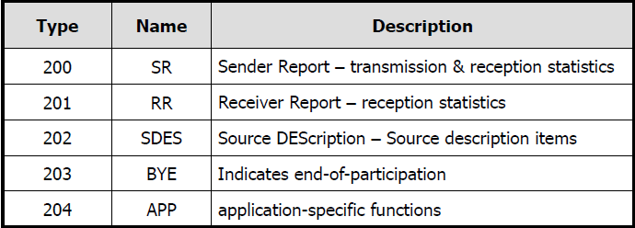

- Multimedia signaling protocols
- H.323
Function
Describes terminals and other entities that provide multimedia communications services over Packet Based Networks (PBN) which may not provide a guaranteed Quality of Service. H.323 entities may provide real-time audio, video and/or data communications

H.323 protocol stack
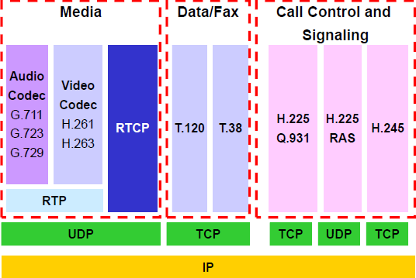

Components
H.323 Terminals: client endpoints that must support:
■ H.225 call control signaling & H.245 channel control signaling
■ RTP/RTCP protocols for media packets
■ Audio codecs, Video codecs support is optional
■ H.323 Gateway: provides translation
■ Provide translation between entities in a packet switched network
H.323 Gatekeepers: Provide following functions
■ Address translation, Admission control, Bandwidth control, Zone management
■ H.323 MCU (Multipoint Control Unit): Providing support for conferences of three or more endpoints.
■ Multipoint Controller (MC) – provides control functions.
■ Multipoint Processor (MP) – receives and processes audio, video and/or data streams

- SIP - Session Initiation Protocol
Function
An application layer signaling protocol that defines initiation, modification and termination of interactive, multimedia communication sessions between users
Based on TCP or UDP

Architecture and components
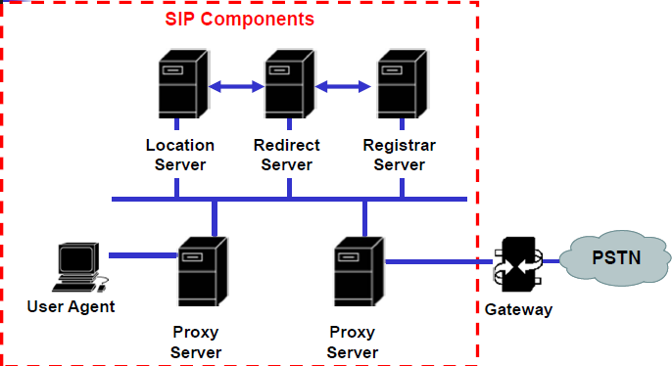
■
UA (User Agent): An application that initiates, receives and terminates calls
■ Both UAC and UAS can terminate a call
■ Proxy Server: An intermediary program that acts as both a server and a client to make requests on behalf of other clients.
Redirect Server: A server that accepts a SIP request, maps the address into zero or more new addresses and returns these addresses to the client.
■ Registrar Server: A server that accepts REGISTER requests.
■ The register server may support authentication.
Location Server: A location server is used by a SIP redirect or proxy server to obtain information about a called party’s possible location(s).

SIP messages – Methods & Responses
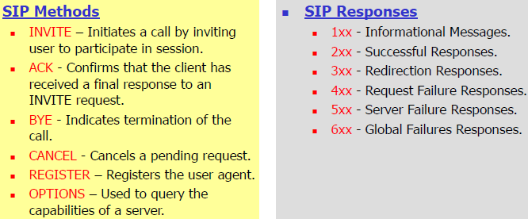

SIP header
Syntax and semantics looks like an HTTP message- message formatting, header and MIME support.
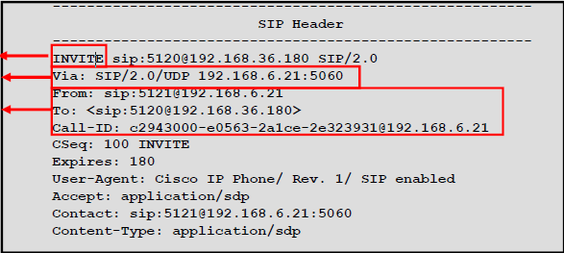

SIP URL
user@host
■ Examples:
■ sip:hostname@vovida.org
■ sip:hostname@192.168.10.1
■ sip:14083831088@vovida.org
int main(){

char hostname[100];
struct hostent *hp;
char **p;
struct in_addr in;
struct in_addr addr;
char **q;

printf("Enter the DNS name or ip address:\n");
scanf("%s",hostname);

if(inet_aton(hostname,&addr)==0)
hp=gethostbyname(hostname);
else{
hp=gethostbyaddr(&addr, 4, AF_INET);
}
if (hp == NULL) {
printf("Host information is not found\n");
exit (0);
}

printf("The host has been found!\n");
//return the official name
printf("The official name of the host is %s\n", hp->h_name);
//return the ip address
printf("The ip address are:\n");
for (p = hp->h_addr_list; *p!=0;p++){
//copy the contents from p to in.saddr
memcpy(&in.s_addr, *p, sizeof(in.s_addr));
printf("%s.\n ",inet_ntoa(in));

}

printf("The aliases of the IP are:\n");
for (q=hp->h_aliases; *q!= 0; q++)
printf("%s\n", *q);

return 0;
}
CLIENT
#define ECHOMAX 255
int main(int argc, char *argv[])
{
int sock;
struct sockaddr_in echoServAddr;
struct sockaddr_in fromAddr;
unsigned short echoServPort;
unsigned int fromSize;
char *servIP;
char *echoString;
int echoStringLen;
int respStringLen;
int i = 2, j = 0;

if (argc < 3)
{
printf("Usage: %s <Server IP> <Echo Word>\n", argv[0]);
exit(1);
}

servIP = argv[1];
echoServPort = 1500;

if ((sock = socket(PF_INET, SOCK_DGRAM, IPPROTO_UDP)) < 0)
printf("socket() failed.\n");
/* Construct the server address structure */
memset(&echoServAddr, 0, sizeof(echoServAddr));
echoServAddr.sin_family = AF_INET;
echoServAddr.sin_addr.s_addr = inet_addr(servIP);
echoServAddr.sin_port = htons(echoServPort);

for(i;i < argc;i++){
echoString = argv[i];
if ((echoStringLen = strlen(echoString)) > ECHOMAX)
printf("Echo word too long.\n");
/* Send the string to the server */
if ((sendto(sock, echoString, echoStringLen, 0, (struct sockaddr *) &echoServAddr, sizeof(echoServAddr))) != echoStringLen)
printf("sendto() sent a different number of bytes than expected.\n");
}
printf("%s: sending data to '%s' (IP: %s)\n", argv[0], argv[1], servIP);

close(sock);
exit(0);
}
SERVER
int main(int argc, char *argv[])
{
int sock;
struct sockaddr_in echoServAddr;
struct sockaddr_in echoClntAddr;
unsigned int cliAddrLen;
char echoBuffer[ECHOMAX];
unsigned short echoServPort;
int recvMsgSize;
int i = 0;

echoServPort = 1500;
printf("%s waiting for data on port UDP %d\n", argv[0], echoServPort);

if ((sock = socket(PF_INET, SOCK_DGRAM, 0)) < 0)
printf("socket() failed.\n");

/* Construct the local address structure */
memset(&echoServAddr, 0, sizeof(echoServAddr));
echoServAddr.sin_family = AF_INET;
echoServAddr.sin_addr.s_addr = htonl(INADDR_ANY);
echoServAddr.sin_port = htons(echoServPort);

/* bind to the local address */
if ((bind(sock, (struct sockaddr *)&echoServAddr, sizeof(echoServAddr))) < 0)
printf("bind() failed.\n");

for (; ; )
{
cliAddrLen = sizeof(echoClntAddr);
if ((recvMsgSize = recvfrom(sock, echoBuffer, ECHOMAX, 0, (struct sockaddr *)&echoClntAddr, &cliAddrLen)) < 0)
printf("recvfrom() failed.\n");

echoBuffer[recvMsgSize] = '\0';
printf("%s: from %s : %s\n", argv[0], inet_ntoa(echoClntAddr.sin_addr), echoBuffer);

if ((sendto(sock, echoBuffer, recvMsgSize, 0, (struct sockaddr *)&echoClntAddr, sizeof(echoClntAddr))) != recvMsgSize)
printf("sendto() sent a different number of bytes than expected.\n");
}

}

