ELEC5660 Proj2 phase2 Name: GUO Jixin ID: 20256203
- Figures plotted by rqt_plot:

/ekf/ekf_odom/pose/pose/position
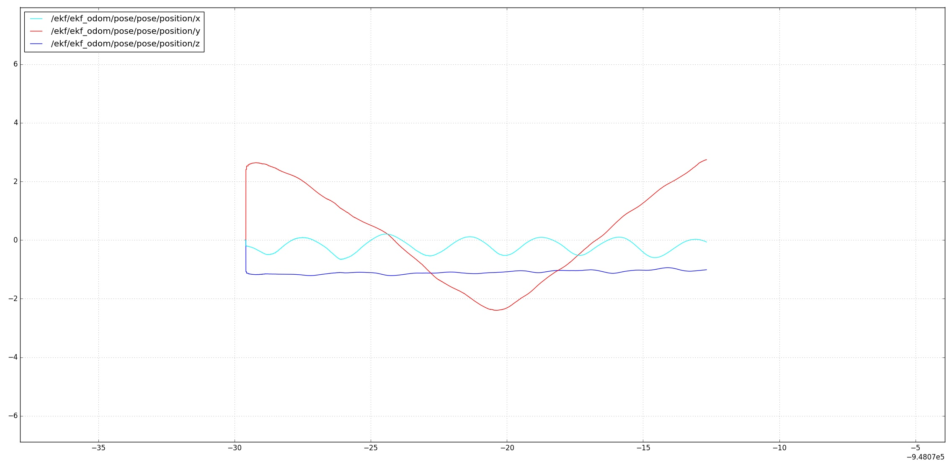
/ekf/ekf_odom/pose/pose/orientation
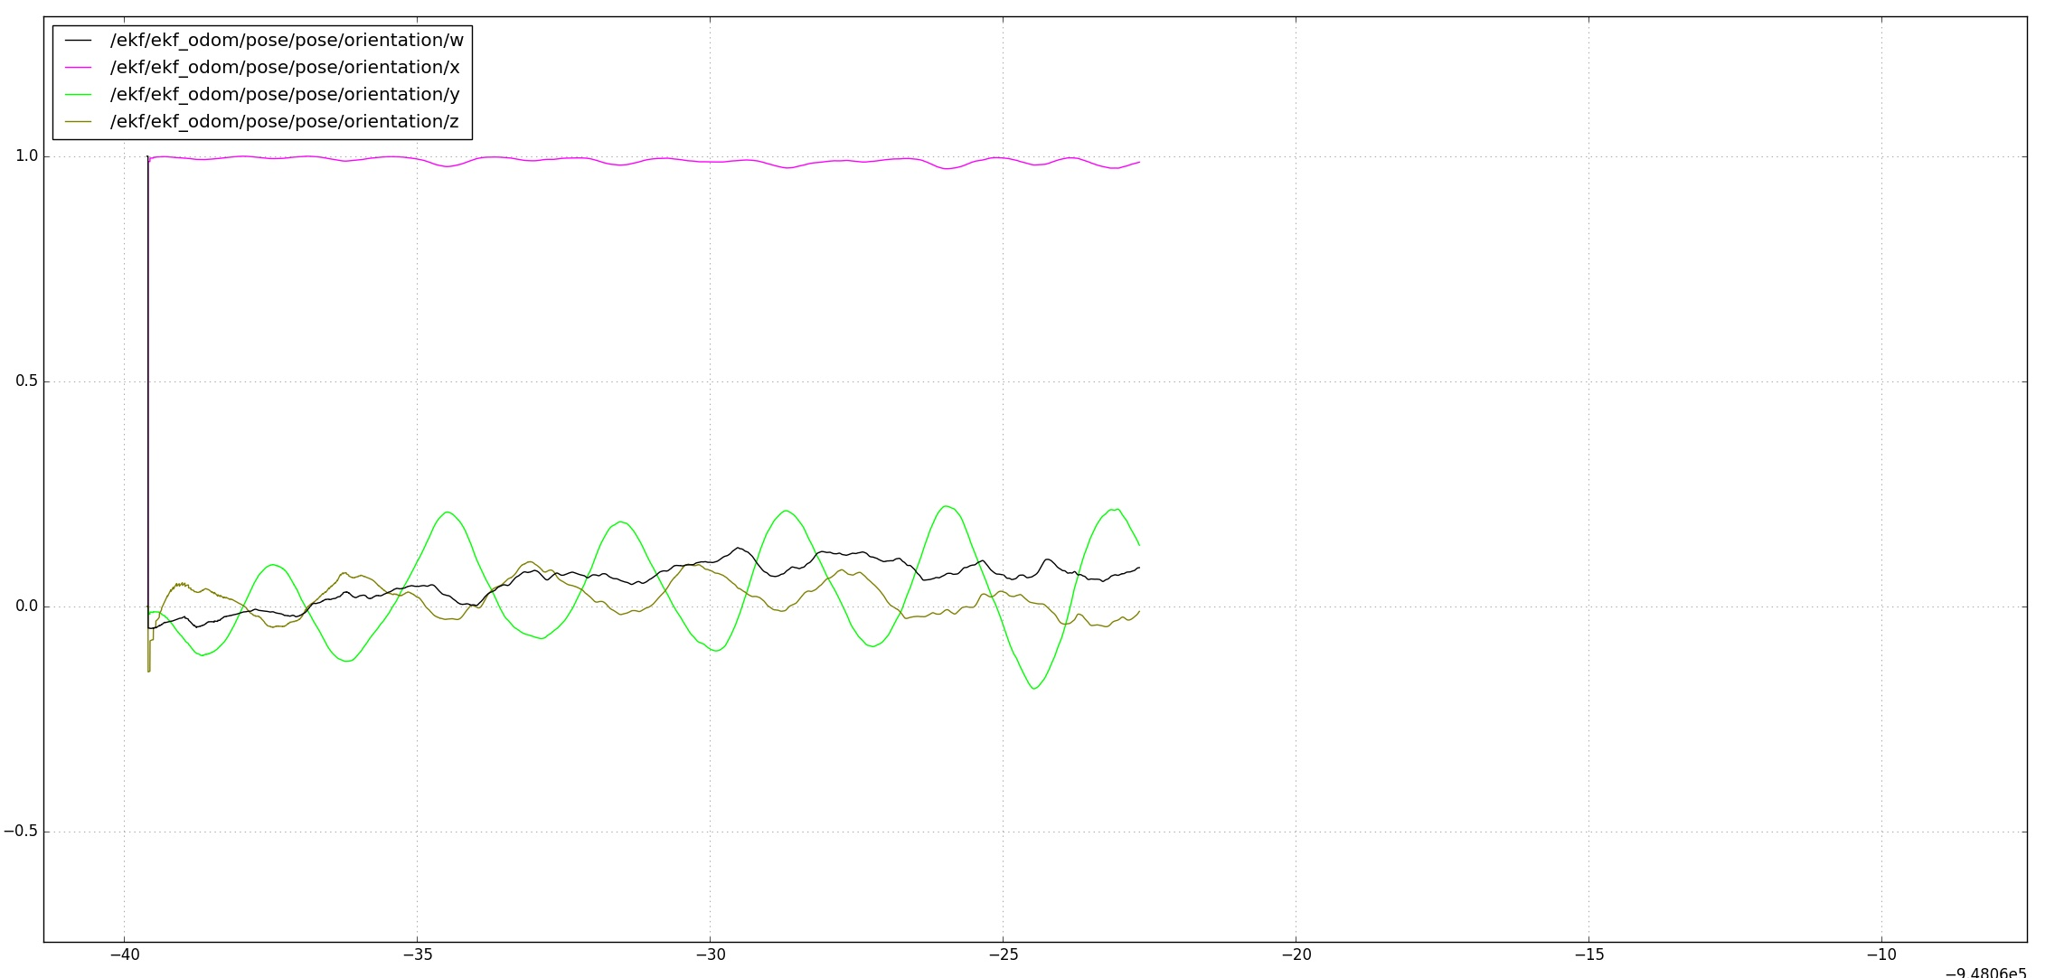
/ekf/ekf_odom/twist/twist/linear
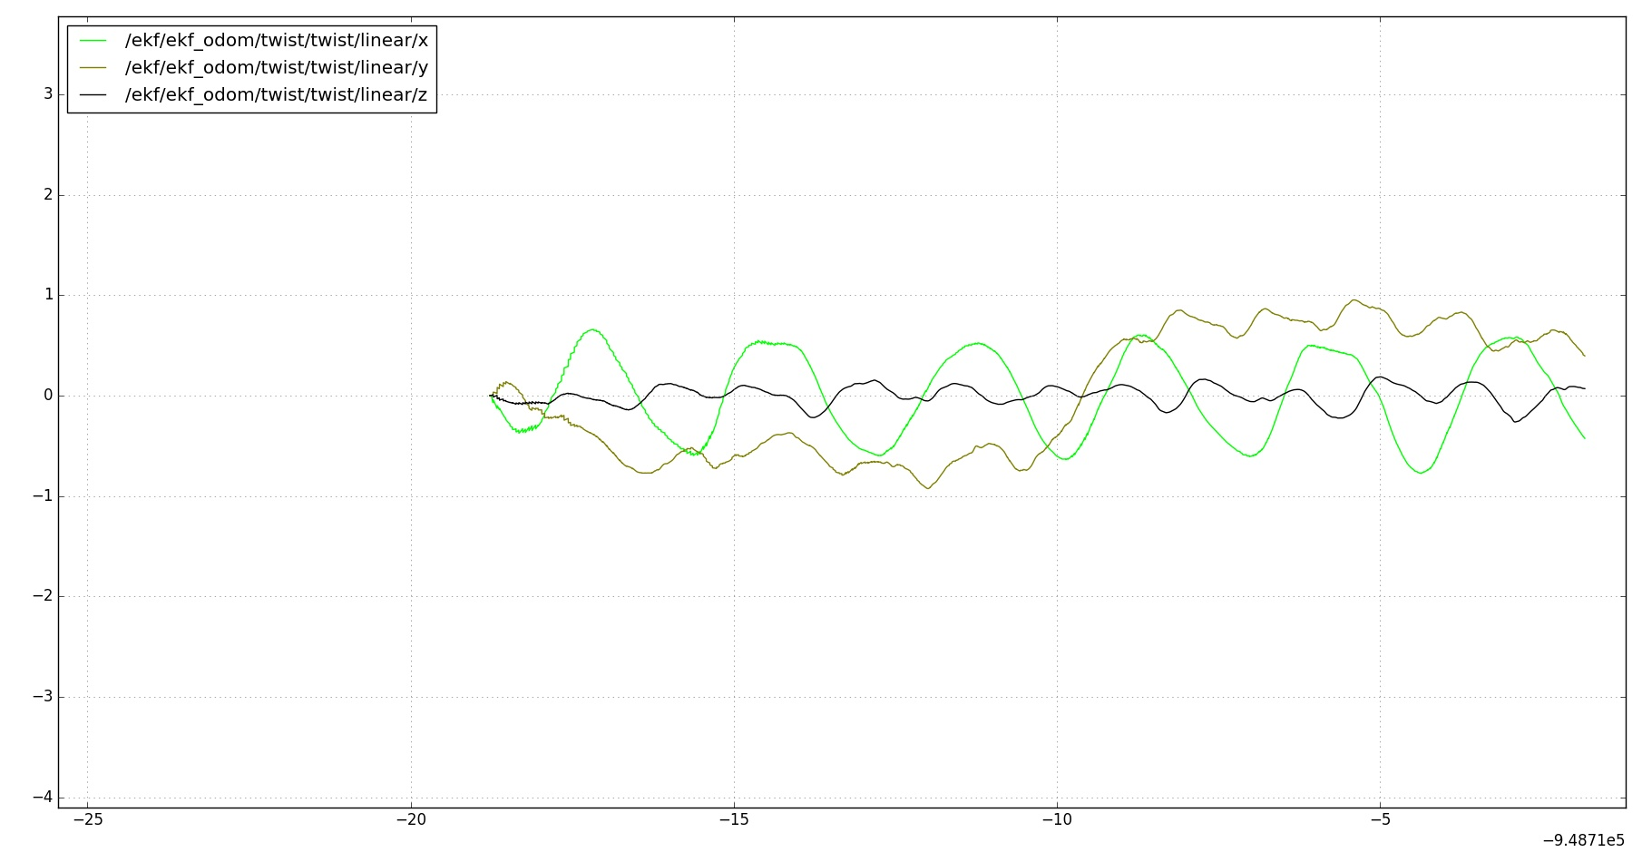

Comparison to: /tag_detector/odom_yourwork/ pose/pose/position
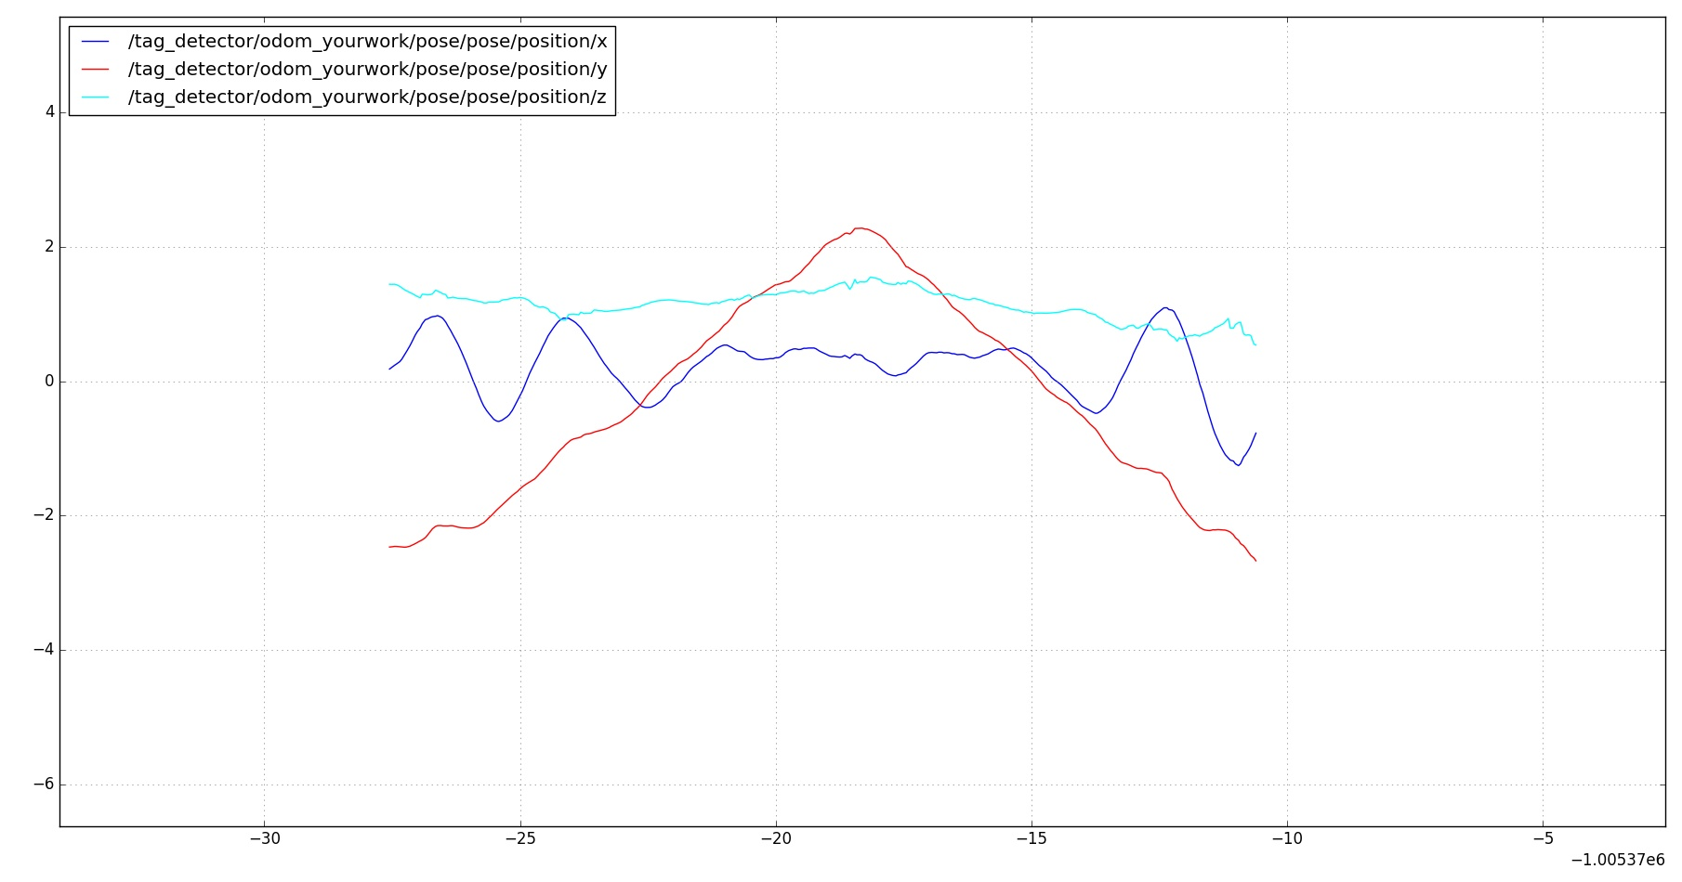

(b) Description about my implementation
1. In camera odom callback, I transform the coordinate from [ world in camera ] to [ imu in world ] and do the ekf update step
2. In imu odom callback, I use the timestamp, angular velocity and linear acceleration and do the ekf prediction step
3. I get the close-form solution for G_inv_dot and R_dot using Matlab symbolic derivative, the script is in the symbolic_derivative.m matlab file
4. I have additional pose.h head file containing R_to_rpy() and rpy_to_R() functions
5. Other implementation details could be found in the ekf.node.cpp, many comments done

(c) Any other things we should be aware of.
1. use camera odom update before imu prediction step, because camera odom acts as initial odom value
2. Be careful about the discontinuous nature in Euler angles when we obtain the Roll, Pitch and Yaw angles from rotation matrix. I check in the camera odom callback. Check the angles.
3. the /ekf/ekf_odom/pose/pose/orientation is flipped from the ref given by TA, I have consulted with the TA. It’s because the camera odom has two possible choices, scene from above and from the ground. So the odom may be flipped.
4. Compared to the odometry from tag detector directly, we could see that after ekf filtering, the odometry we get is smoother.

