ELEC5660 Proj1 phase4 Name: GUO Jixin ID: 20256203
(a) Figures plotted by rviz:
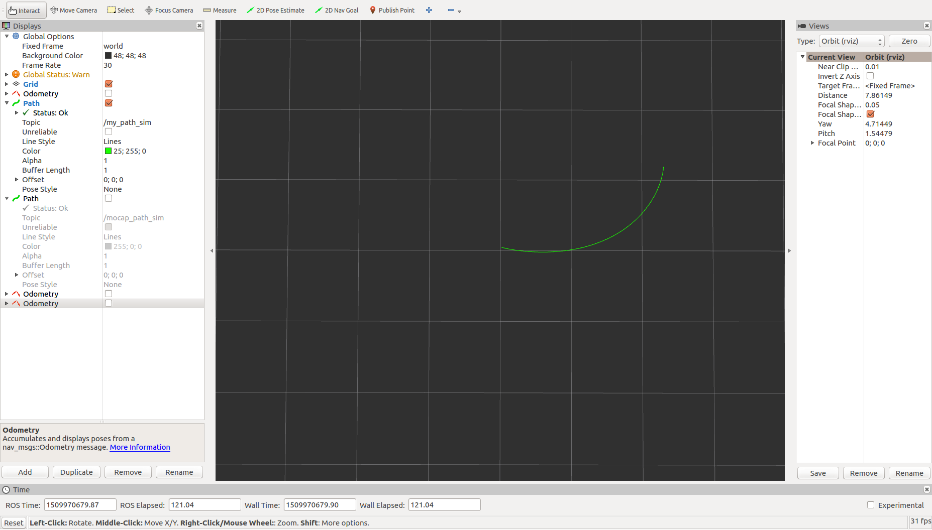
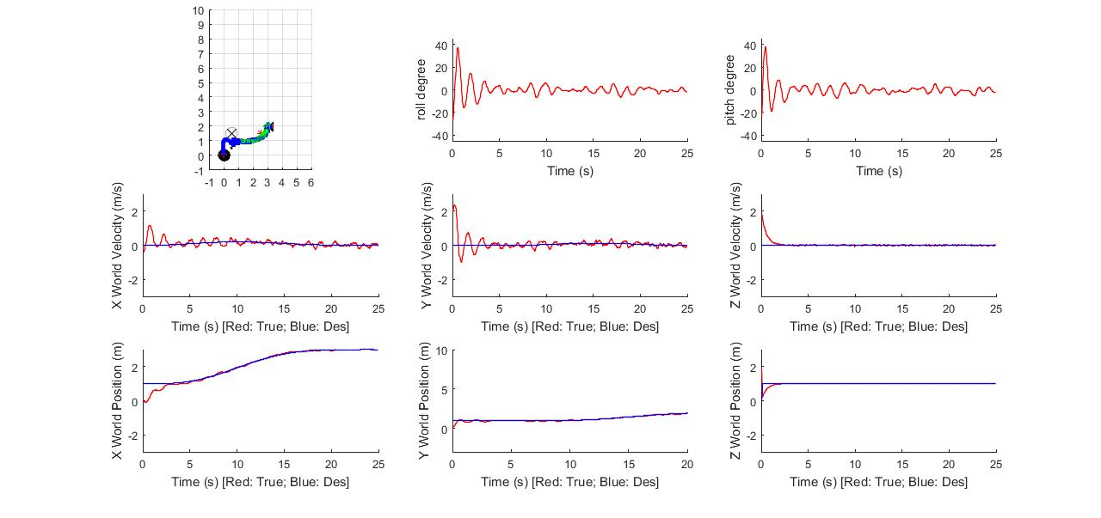
b)plot by matlab
obstacle: (0, 1) start: (0, 0) des: (2, 1)
(b) Analysis of my result and discussion

I choose one obstacle simple implementation. I implement my codes all in pos_vel_mocap ros packages. I also wrote the fake node publishing the odometry information in my local computer to test the result. We could see the plot by matlab and the rviz are quite similar. Also the trajectory in the video shows quite stable control and good following of the minimum snap trajectory.

(c) Any other things we should be aware of.

1. The bug I have met is that at default the matlab only gives the double number up to the fifth digit. So the accuracy of the polynomial coefficients is far from enough. After printing out the result, I find that the trajectory does not meet the continuity constraint. After changing the coefficients to scientific notation, bug fixed.
2. Another takeaway from this project is that I have learned how to use nav_msgs/Path and rviz to test and visualize my implementation, that’s really useful.

