ELEC5660 Proj1 phase1 Name: GUO Jixin ID: 20256203
(a) Figures plotted by simulator:
Hover:
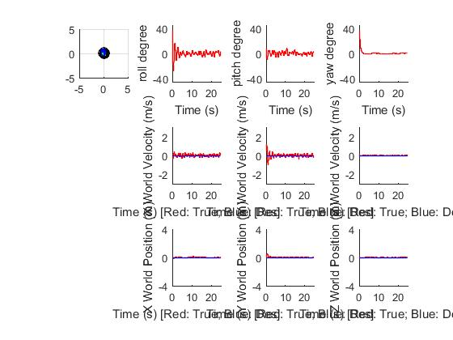
Circle:
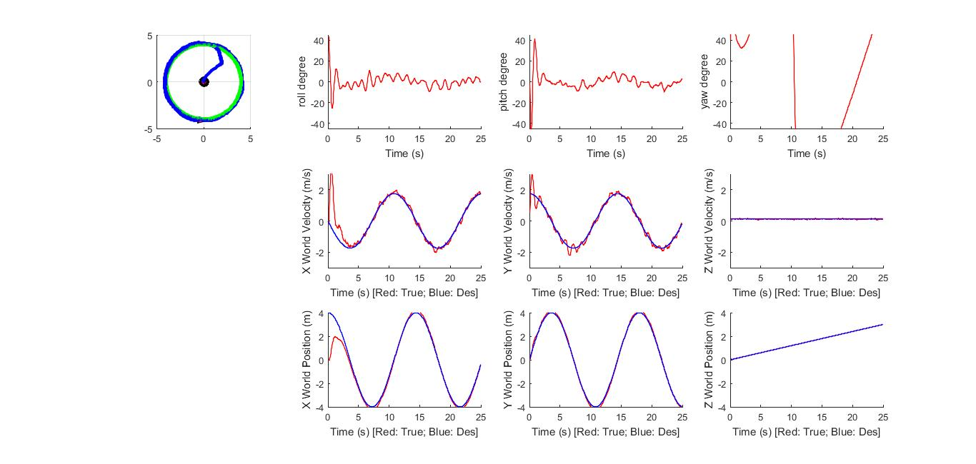
Diamond:
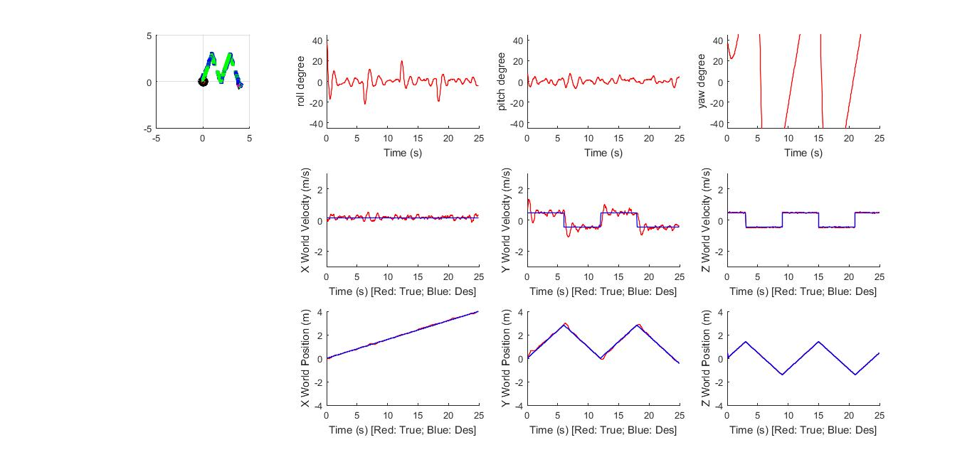
(b) Statistics about your controller. (For example, RMS error between current state and desired state for position, velocity).

For hover trajectory: [rms_pos1, rms_vel1] = [0.0874, 0.2391]
For circle trajectory: [rms_pos2, rms_vel2]= [0.7245, 0.6078]
For diamond trajectory: [rms_pos3, rms_vel3] = [0.1049, 0.3127]

(c) Analysis of your result. (For example, parameter studies).

There are 12 hyper parameters in position and attitude control, including the Kp and Kd for x, y, z and row, pitch, yaw since PD controller has been used. My choice of parameters are of the following. At first, my settling time is quite long. After tuning Kp larger enough, I got satisfactory settling time. Also, after changing Kd larger according to the change of Kp, the overshoot decreases. The procedure of mine is increase Kp first and then increase Kd accordingly, like the concept of Ziegler-Nichols method.

k_p_yaw = 15; k_d_yaw = 10; k_p_p1 = 4; k_d_p1 = 6;
k_p_pitch = 100; k_d_pitch = 30; k_p_p2 = 4; k_d_p2 = 6;
k_p_row = 100; k_d_row = 30; k_p_p3 = 200; k_d_p3 = 100;

(d) Any other things we should be aware of.

I chose the non-linearized version for desired acceleration, which has better performance over the linearized one according to the criterion of RMS of positon and velocity between derised and true states. Comparison is at below.

Non-linearized version:
For hover trajectory: [rms_pos1, rms_vel1] = [0.0874, 0.2391] (better in both !)
For circle trajectory: [rms_pos2, rms_vel2]= [0.7245, 0.6078] (better in both !)
For diamond trajectory: [rms_pos3, rms_vel3] = [0.1049, 0.3127] (better in both !)

Linearized version:
For hover trajectory: [rms_pos1, rms_vel1] = [0.0905, 0.2483]
For circle trajectory: [rms_pos2, rms_vel2]= [0.7336, 0.6083]
For diamond trajectory: [rms_pos3, rms_vel3] = [0.1164, 0.3223]

Furthermore, from the plots at the beginning, we could find out that we achieved pretty good control at position, but only ok control for velocity and roll, pitch, yaw. It suggests that quadrotor may have vibration at the during trajectories. Also, we should notice that we don’t have control over the yaw angle, which means the quadrotor may rotate freely in the x-y plane.

