ELEC5660 Proj1 phase2 Name: GUO Jixin ID: 20256203
[ Minimum Snap Trajectory implementation ]
(a) Figures plotted by simulator:
Path1 Control up to acceleration (continuity constraint):
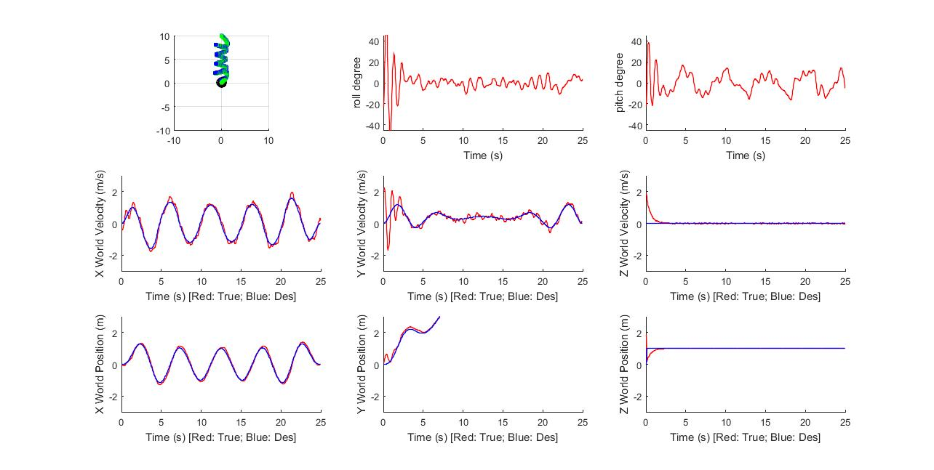
Path1 Control up to jerk (continuity constraint):
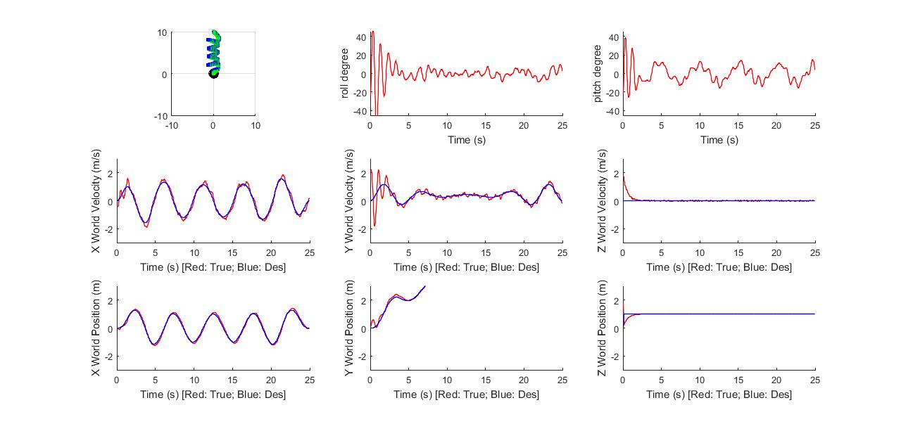
Path2 Control up to jerk (continuity constraint):
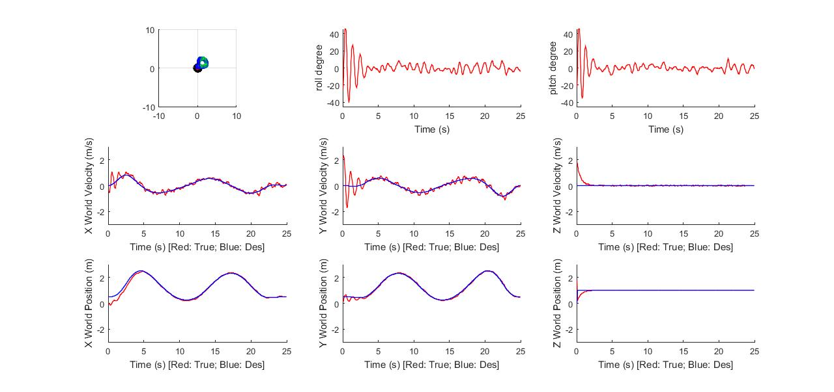
Path3 Control up to jerk (continuity constraint):
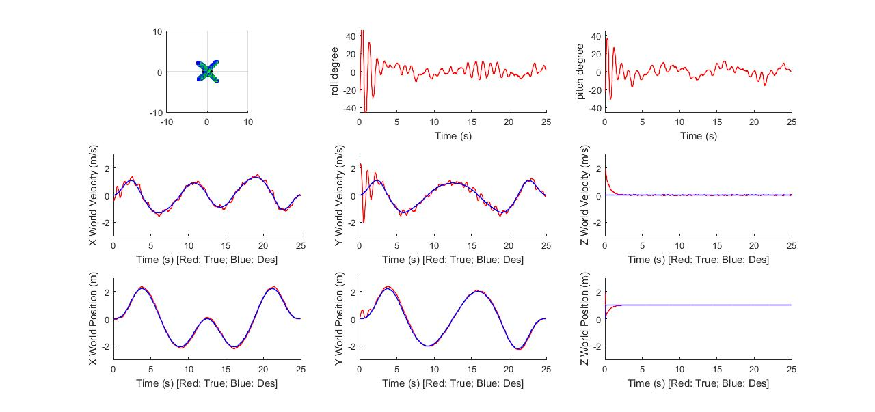
Path4 Control up to jerk (continuity constraint):
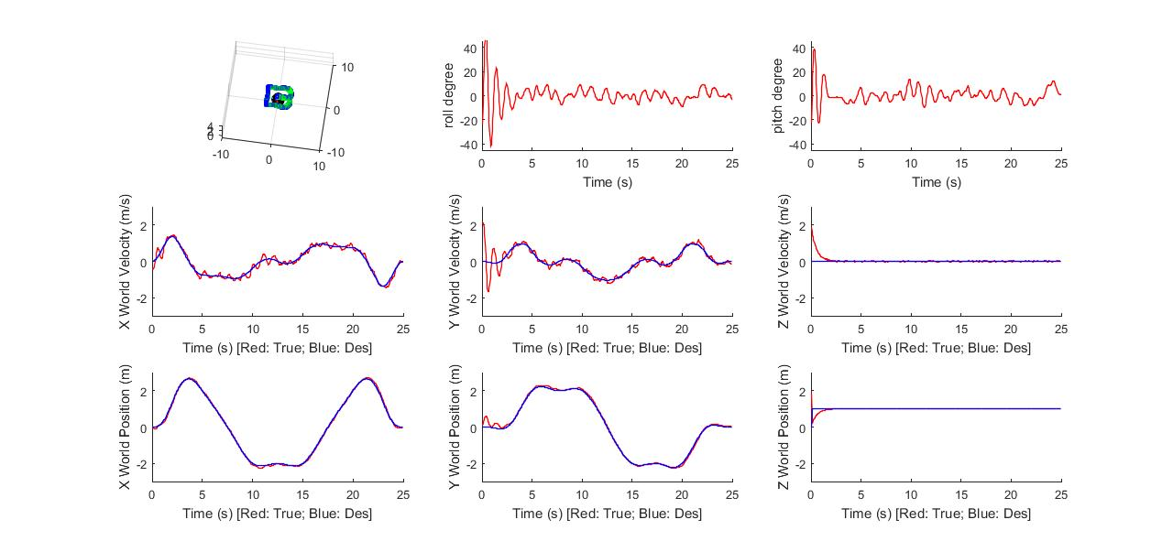

(b) Statistics about your controller. (For example, RMS error between current state and desired state for position, velocity).

Following means which degree of continuity control I am using.
For path1 (acceleration control): [rms_pos1, rms_vel1] = [0.1776 0.4631]
For path1 (jerk control): [rms_pos1, rms_vel1] = [0.1711 0.4639]

For path2 (acceleration control): [rms_pos2, rms_vel2] = [0.1839 0.3894]
For path2 (jerk control): [rms_pos2, rms_vel2] = [0.1928 0.4274]

For path3 (acceleration control): [rms_pos3, rms_vel3] = [0.1765 0.4290]
For path3 (jerk control): [rms_pos3, rms_vel3] = [0.1792 0.4629]

For path4 (acceleration control): [rms_pos4, rms_vel4] = [0.1567 0.4494]
For path4 (jerk control): [rms_pos4, rms_vel4] = [0.1552 0.4008]

(c) Analysis of your result. (For example, parameter studies).
At first, x and y position control have some deviation from desired state, after changing Kd of x, y position both from 6 to 10, we obtain better control.
At first, I see that the quadrotor shows obvious vibration at z-position(high overshoot and high settling time) even though z is kept constant along the trajectory and Kd for z-position is set relatively high, 100-200. Larger kd above 200 would result in unstable condition. After comment out “path = [0 0 0; path]”, I achieve better performance as above.

(d) Any other things we should be aware of.

I chose minimum snap trajectory implementation, although the theory stating that we should enforce continuity constraint up to the jerk to realize minimum snap control, but the above plots and RMS analysis shows no big difference if I just enforce continuity constraint up to the acceleration. And acceleration control almost shows better RMS in position control. Both are ok ??

