ELEC5660 Proj1 phase3 Name: GUO Jixin ID: 20256203

[ 2D A* implementation with h(n) = Euclidean distance]

(a) Figures plotted by simulator:
Map1:
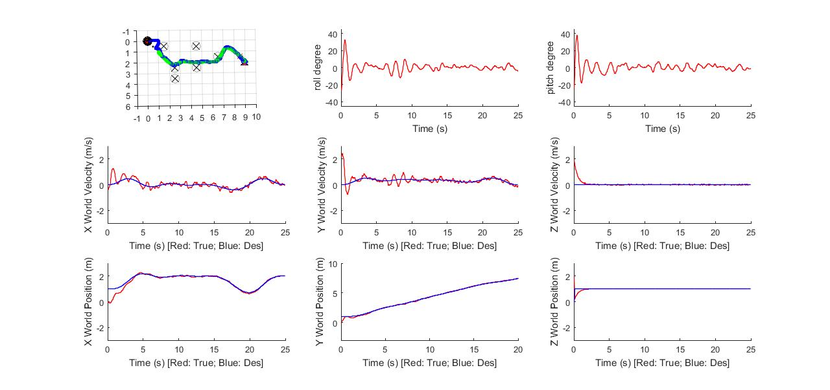
Map2:
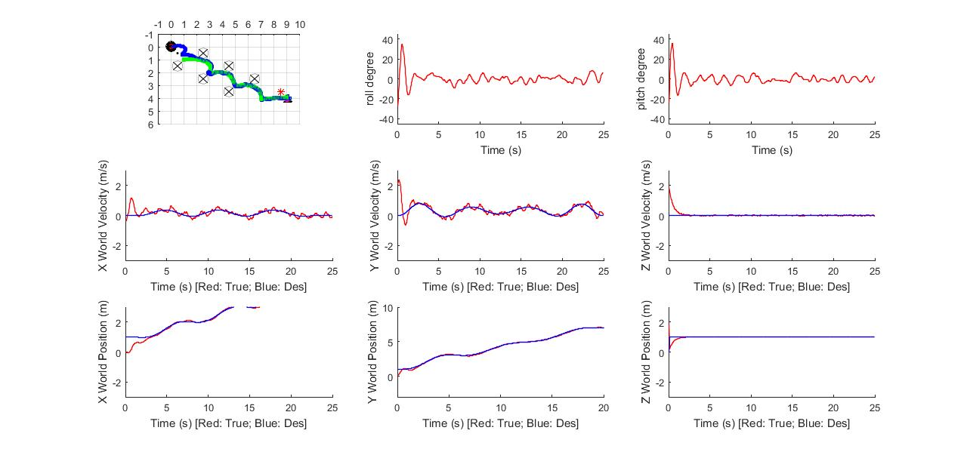
Map3:
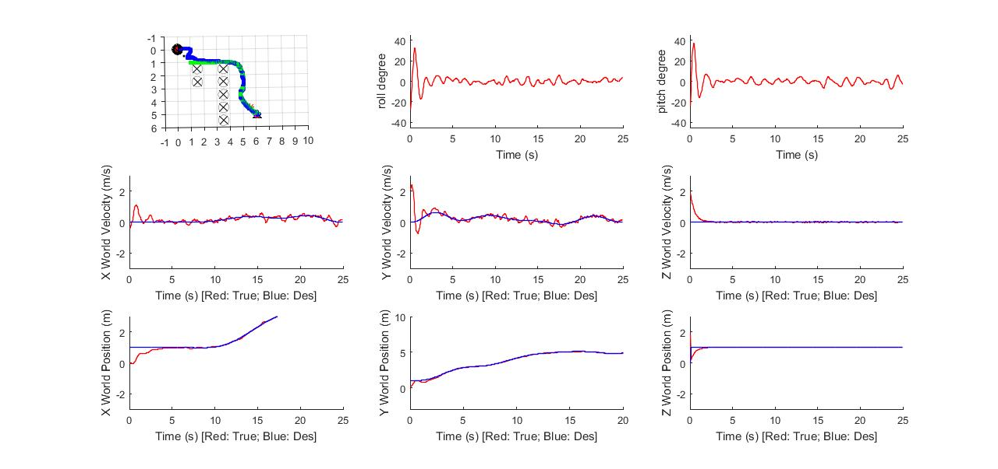
(b) Analysis of your result. (For example, parameter studies).

Path1 for map1 = [1 ,1; 2 2; 2 3; 2 4; 2 5; 2 6; 1 7; 1 8; 2 9]
- Connectivity:
I choose 8-connectivity implementation, which means each time my node would explore 8 different neighbor cells nearby so that my quadrotor would go diagonally.
- Choice of h(n):
Since my quadrotor could go diagonally, Euclidean distance makes sense in this simple case. Taking my previous A* experience, a weighted sum of Euclidean distance and Manhattan distance would result in less nodes expanded for single target case.
- Output Path:
Also, I maintained 2D matrix of ParentX and ParentY indicating the parents for cells explored for outputting the path.
- Optimality:
Also, my search is a graph search, which means I will not expand nodes that are previously expanded. But the optimality of graph search requires more strict condition, which is consistency instead of admissibility. But obviously a weighted sum of Euclidean distance and Manhattan distance is obtained from relaxing the condition, which is consistent. Therefore, my A* algorithm outputs an optimal solution path.

(c) Any other things we should be aware of.

From the plots we obtained above, we could see that our quadrotor has chance of colliding, not sure of the shape of obstacles. So, in general scenarios, these 1*1m grids implementation may be too rough to meet the requirement for obstacles avoidance. Also, for finer grids, we could add more waypoints to decrease the extreme trajectory and to avoid the obstacles completely.

