ELEC5660 Proj1 phase2 Name: GUO Jixin ID: 20256203
[ Minimum Snap Trajectory implementation ]
(a) Figures plotted by rviz:
Different views of a single run
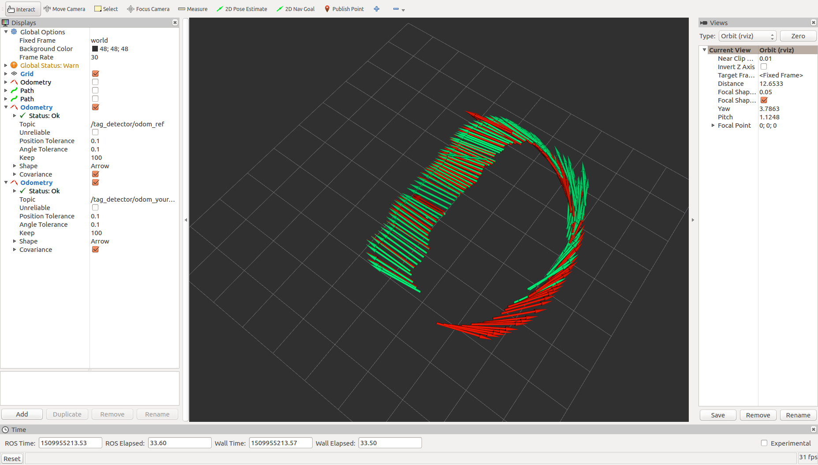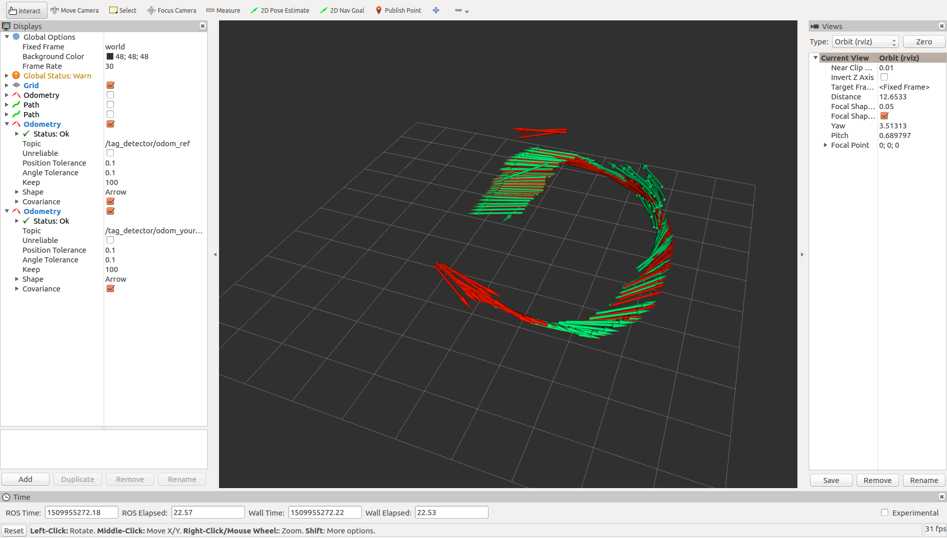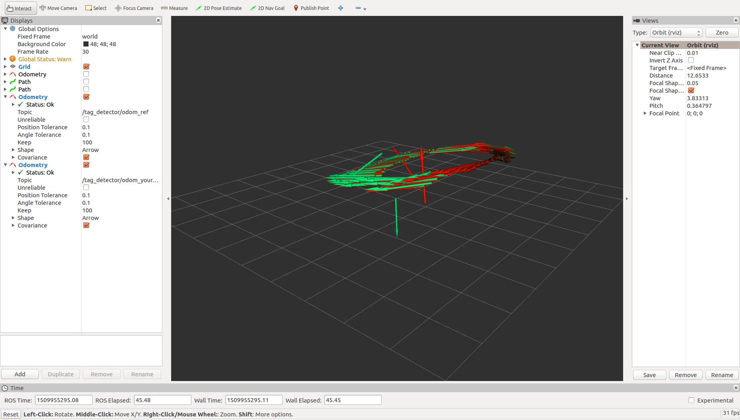

(b) Statistics about your result. (For example, RMS error between current state and desired state for position, velocity).

After using a recurrent formula for computing the RMS between the reference translation vector t and my implementation T. At the end, I get the RMS for x_error, y_error and z_error:
0.232831 0.193553 0.585309
I have tried the theoretical number of points 4. But I ended up with getting the RMS for x_error, y_error and z_error:
4.81913 2.41455 6.87917

(c) Description about my implementation
1. I undistort the points using cv::undistortPoints, one pitfull here is that aftering undistorting, the camera matrix K will be identity.
2. I use all the data points pts_3.size() instead of only 4 points
3. I use SVD to solve Ax = 0
4. reverse the H matrix if needed when the translation vector for z is negative, the reason for this is because we might get the same projection from above the ground and below the ground
5. finally I use a recurrent formula for calculating the RMS error between the reference translation vector t and my implementation T.

(d) Any other things we should be aware of.

1. After the cv::undistortPoints, the camera matrix K would become identity matrix, so do not use the original value for K
2. use all the data points to achieve better performance
3. make good use of RMS and rviz to validate my implementation

