“Rugby Ready” Site Plan

Daniel Viviers

WDD 130

Overview

Purpose

Rugby Ready is an informational website created to teach students the basics of rugby and inspire them to join our college intramural team this spring. The site clearly explains the rules, positions, scoring system, and key strategies of the game using simple language, visuals, and short videos. It also includes my team information, practice schedules, and a sign-up form for interested players. What makes Rugby Ready unique is its blend of education and community—it’s not just about learning the sport, but about building excitement and encouraging new players to experience rugby together.

Audience
For students at BYUI who would like to learn about rugby and hopefully inspire people to learn more. It will also be for recruiting people to my team.

Branding

Website Logo



Style Guide

Color Palette
Primary | Secondary | Accent 1 | Accent 2
#F9F9F1 | #0D4157 | #08C3C5 | #CC4716
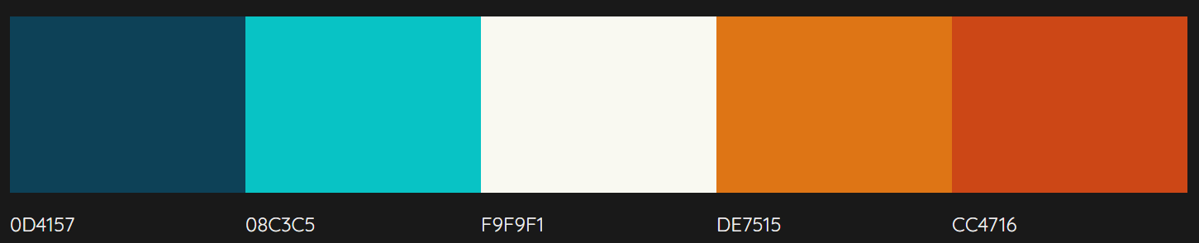

Typography

Heading Font: "Eagle Lake", serif;

Paragraph Font:

"Electrolize", sans-serif;

Navigation
Home Page2 Page3

Content

[put all content for the pages here, including written text and images]


Rugby is a fast-paced, full-energy sport that brings people together with its mix of power, strategy, and pure excitement. It’s a game where anyone can find a place—whether you’re quick on your feet, strong in the tackle, or smart with the ball. Every match is an adventure: you run, pass, kick, and work as a tight unit to outsmart the opposition and score epic tries. The best part? Rugby builds real friendships, confidence, and toughness on and off the field. If you’re looking for a sport that challenges you, pushes you, and fills you with adrenaline every time you play—rugby is calling your name. Come learn, play, and be part of something unforgettable!

https://youtu.be/8ojinRZ7YVA

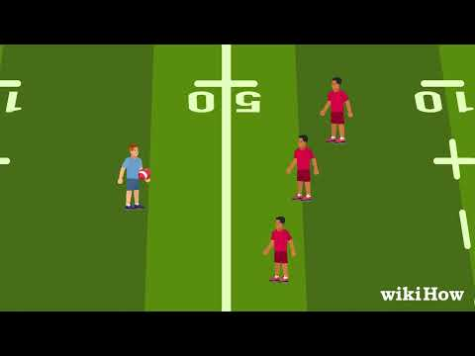



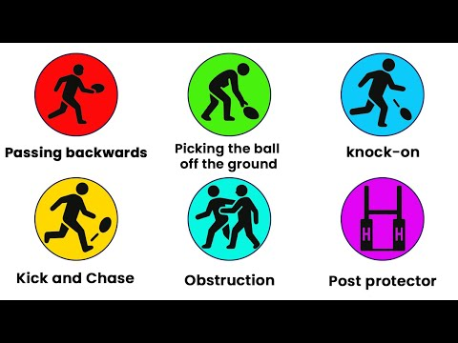


Wireframes

Home

