Joseph Guzman
12/22/2019
Leviathan00
This is the login info for this lab:
ssh server: leviathan.labs.overthewire.org
port: 2223
username: leviathan0
password: leviathan0

Once you login you’ll notice a directory named .backup. Within this directory there is only one file. It is named bookmarks.html. See figure 1 to view the directory structure.
The bookmarks.html file contains about 904 links. I searched for “password” in this file and saw one link that literally contains the password. An easy start for this set of challenges.
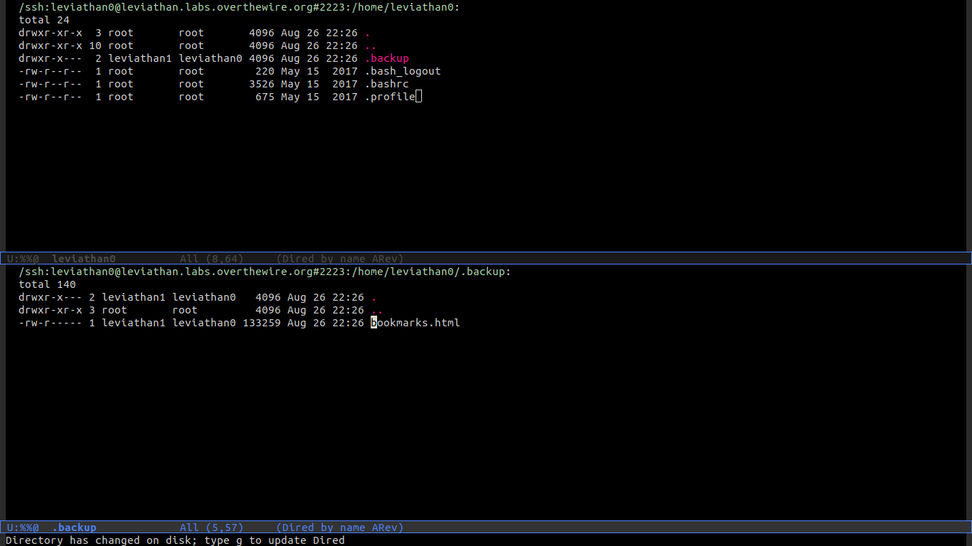
Figure 1: Directory Structure
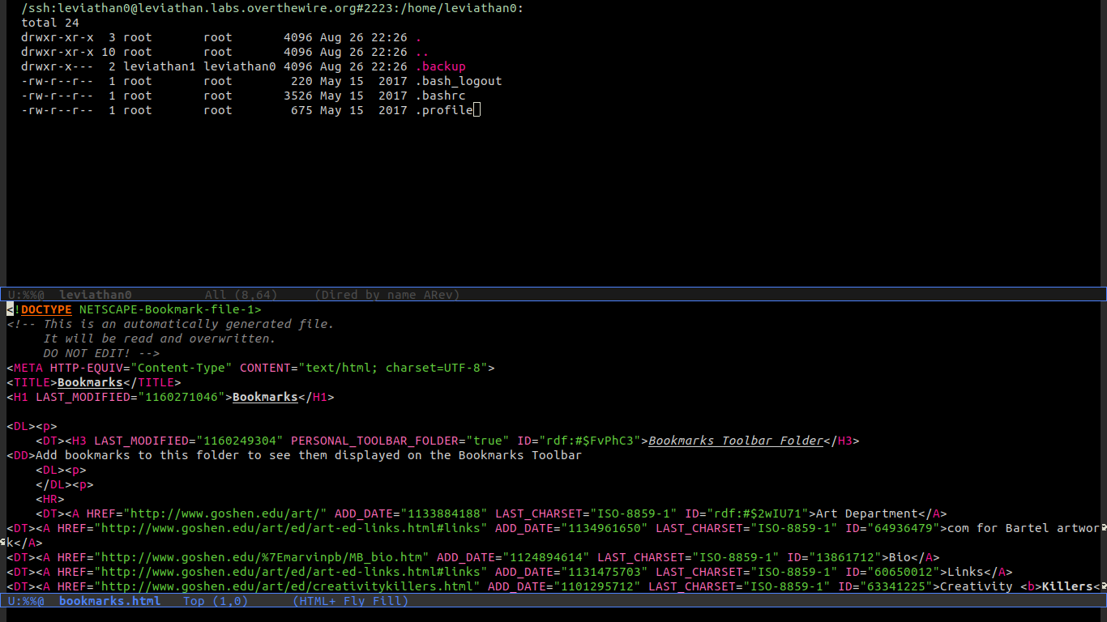
Figure 2: View of HTML code
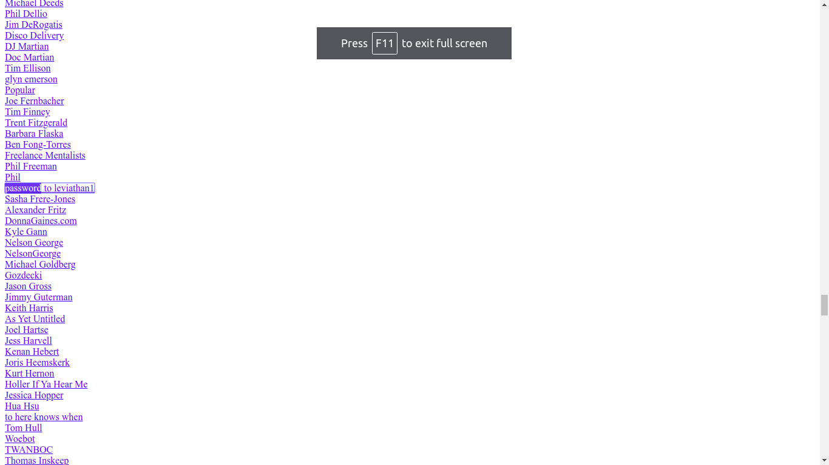
Figure 3: Graphical view of HTML
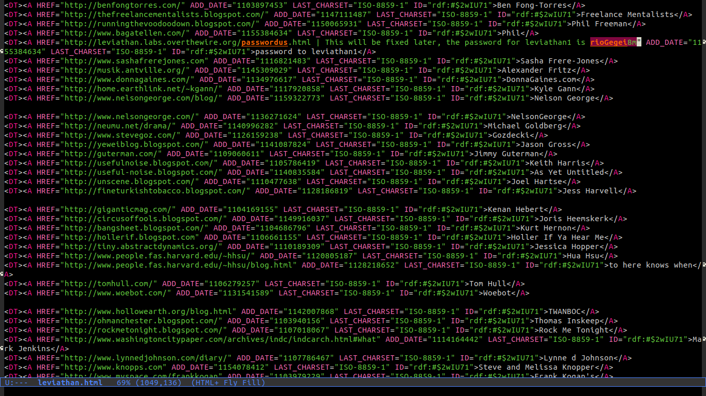
Figure 4: Highlighted password
This is the login info for the next lab:
ssh server: leviathan.labs.overthewire.org
port: 2223
username: leviathan1
password: rioGegei8m

