Joseph Guzman
1/3/2020
Leviathan02
This is the login info for this lab:
ssh server: leviathan.labs.overthewire.org
port: 2223
username: leviathan2
password: ougahZi8Ta

In this lab you are again only given an executable. The executable in this case is called printfile. It appears to just be a clone of the cat command. It will print to stdout whatever file you provide as a command-line argument. After running it a couple times I noticed that it only printed the first file you provide as a command-line argument to stdout.
I was able to convert this ELF 32-bit executable into both a readable assembly file and a decompiled C source code file via the retdec decompiler. With the decompiled version I could clearly see that the /bin/cat binary was being executed with the first command-line argument. See below for a screenshot of this code. You can see the full file in “printfile.c”.
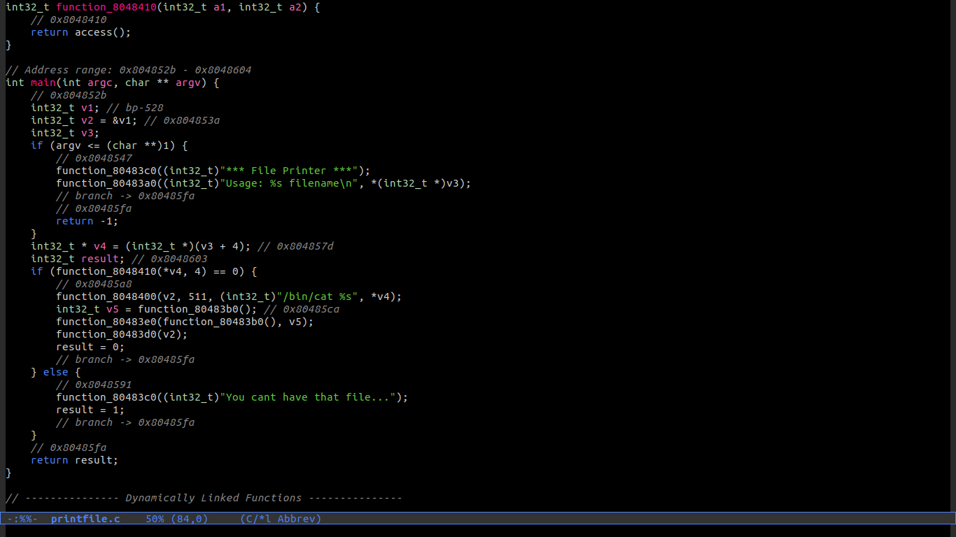
Figure 1: Screenshot of decompiled executable
My first thought was to pass as a command-line argument: "; /bin/cat /etc/leviathan_pass/leviathan3". Which I thought may be executed with two commands. There were two problems. One is that the system call which executes the command likely is not capable of running multiple commands. Second is that the executable checks if the user running the program has access to the file. In the if statement of the above screenshot you can see the check if (function_8048410(*v4, 4) == 0) {. I have a screenshot of the definition of that function. It is just a system call to the access function. If you look at the documentation of access() linked here: http://man7.org/linux/man-pages/man2/access.2.html. You’ll see that the purpose of this function call is to check if the user running this program permission to access the file.
I was stumped at this point so I looked over the writeup provided at: https://jhalon.github.io/over-the-wire-leviathan/. He explains it more briefly what he did is create a symbolic link to a file and use exploit a small problem in the executable. The executable checks if the real user (leviathan2) has permission to a file with access() but then uses /bin/cat to print a file as the effective user (leviathan3). Spaces are allowed in the access() call but spaces will separate arguments for /bin/cat %s.
So we need to provide a command-line argument that meets the following conditions:
- leviathan2 has permission to read it, to pass the access() check
- leviathan3 has permission to read it via /bin/cat %s, can be multiple space-separated files
- Contains the password for leviathan3 so we can make it to the next lab
The solution to the 3rd problem is covered by creating a symbolic link. The solution to the 1st and 2nd problems are to create 2 files one in this case called “pass file.txt” which leviathan2 creates and has the right to read. Then a file called pass which is symbolically linked to “/etc/leviathan_pass/leviathan3”. The argument we provide to the executable is ”pass file.txt”. The executable will check if leviathan2 has access to the file pass file.txt which it does. Then the executable will execute /bin/cat pass file.txt which will cause it to interpret pass and file.txt as two separate arguments. pass is the symbolically linked file so we get the next password.
leviathan2@leviathan:/tmp/my_tmp$ ln -s /etc/leviathan_pass/leviathan3 pass
leviathan2@leviathan:/tmp/my_tmp$ ls -la
total 228
drwxr-sr-x 2 leviathan2 root 4096 Jan 4 02:55 .
drwxrws-wt 3578 root root 225280 Jan 4 02:55 ..
lrwxrwxrwx 1 leviathan2 root 30 Jan 4 02:55 pass -> /etc/leviathan_pass/leviathan3
leviathan2@leviathan:/tmp/my_tmp$ touch "pass file.txt"
leviathan2@leviathan:/tmp/my_tmp$ ~/printfile "pass file.txt"
Ahdiemoo1j
/bin/cat: file.txt: No such file or directory
leviathan2@leviathan:/tmp/my_tmp$

This is the login info for the next lab:
ssh server: leviathan.labs.overthewire.org
port: 2223
username: leviathan3
password: Ahdiemoo1j

