**PetClinic Release Pipeline - AutoTestDemo:**

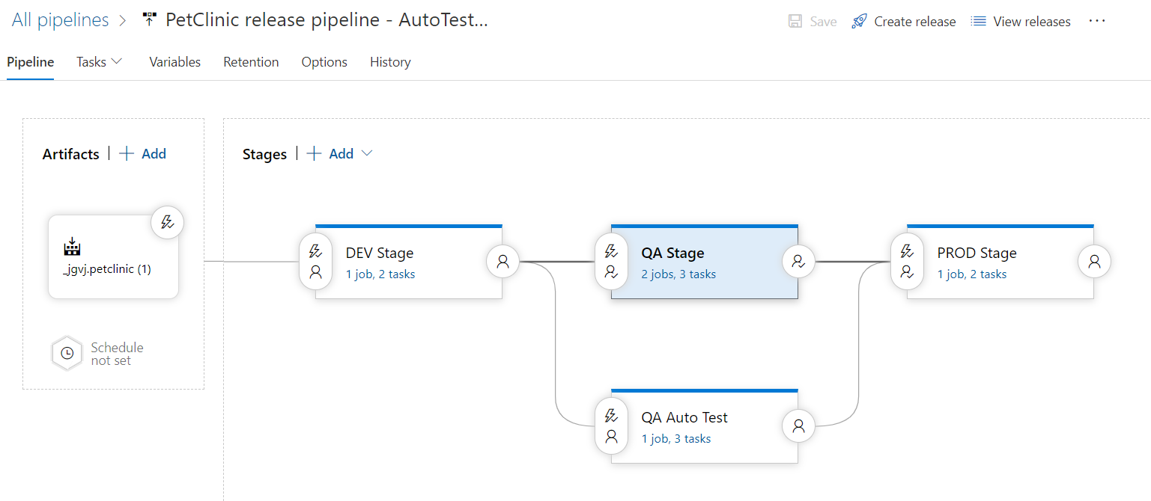

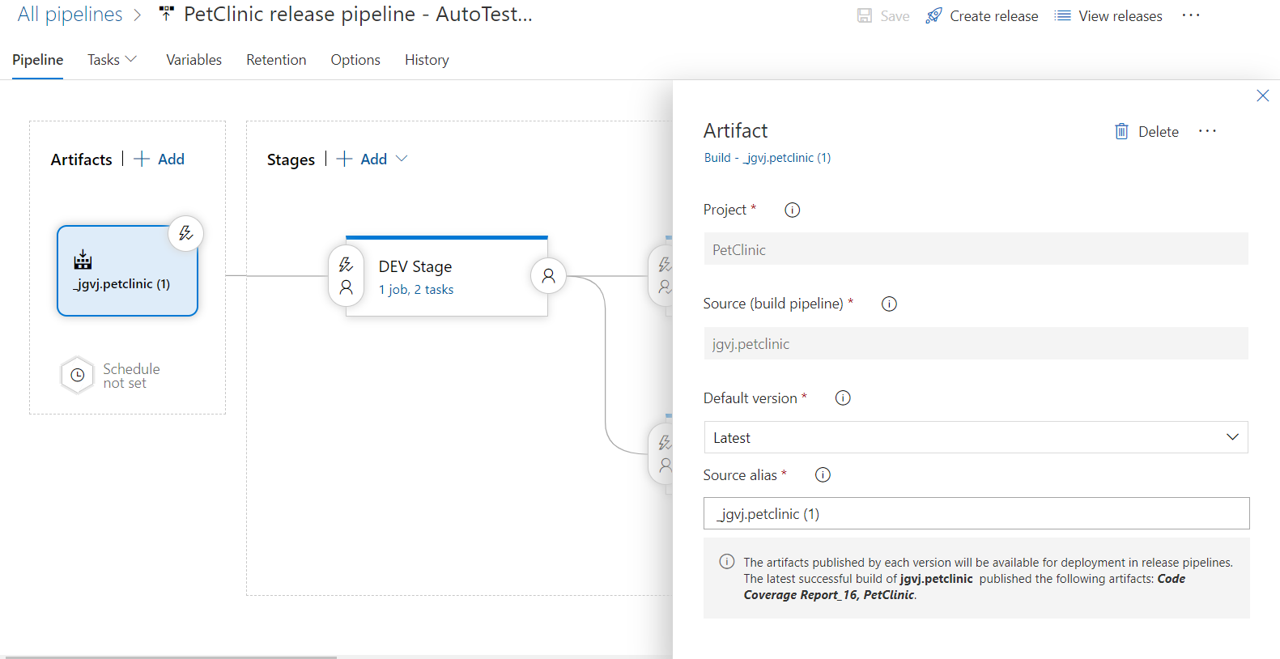

**DEV Stage:**

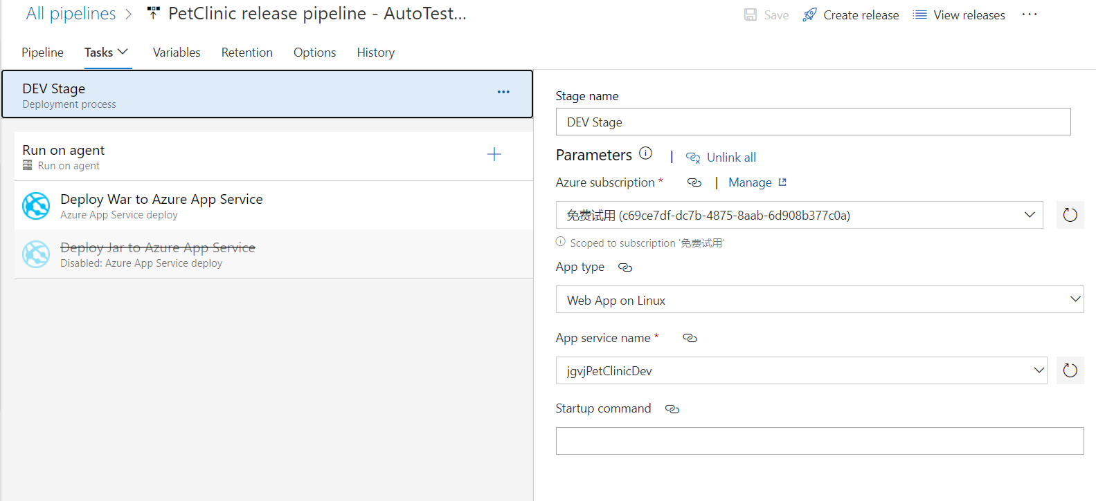

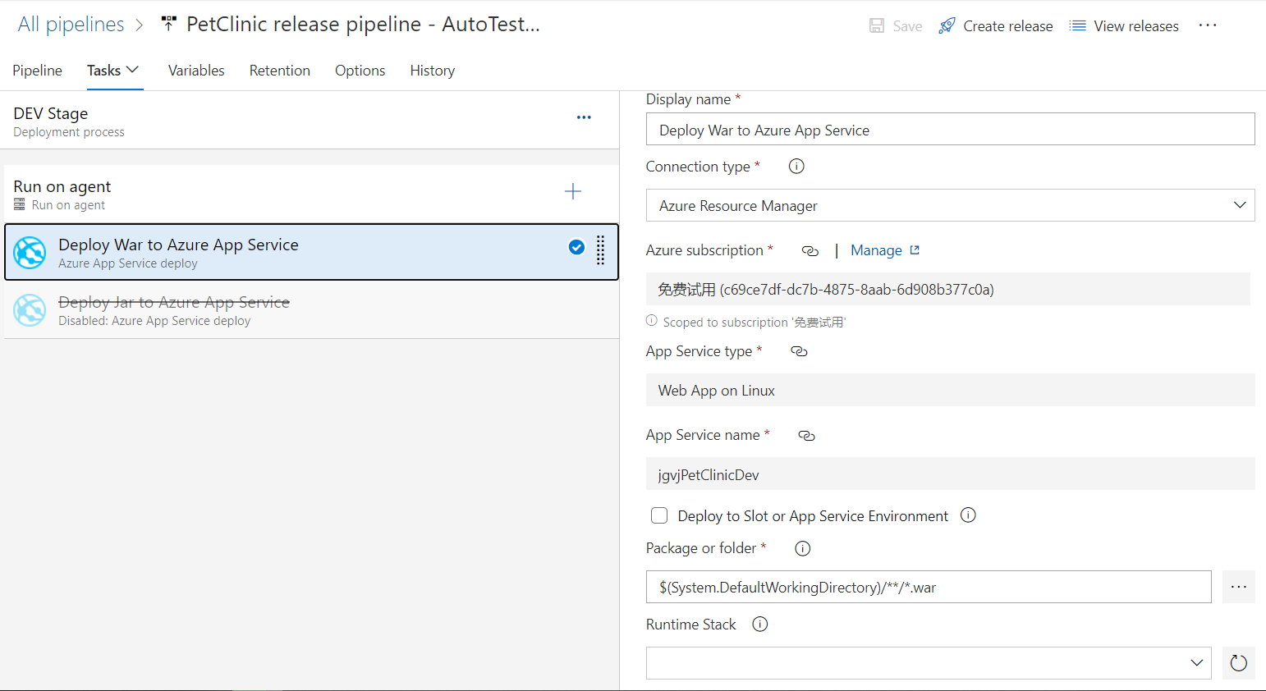

#Your build pipeline references an undefined variable named ‘Parameters.ConnectedServiceName’. Create or edit the build pipeline for this YAML file, define the variable on the Variables tab. See https://go.microsoft.com/fwlink/?linkid=865972

#Your build pipeline references an undefined variable named ‘Parameters.WebAppKind’. Create or edit the build pipeline for this YAML file, define the variable on the Variables tab. See https://go.microsoft.com/fwlink/?linkid=865972

#Your build pipeline references an undefined variable named ‘Parameters.WebAppName’. Create or edit the build pipeline for this YAML file, define the variable on the Variables tab. See https://go.microsoft.com/fwlink/?linkid=865972

#Your build pipeline references an undefined variable named ‘Parameters.StartupCommand’. Create or edit the build pipeline for this YAML file, define the variable on the Variables tab. See https://go.microsoft.com/fwlink/?linkid=865972

steps:

- task: AzureRmWebAppDeployment@4

displayName: 'Deploy War to Azure App Service'

inputs:

azureSubscription: '$(Parameters.ConnectedServiceName)'

appType: '$(Parameters.WebAppKind)'

WebAppName: '$(Parameters.WebAppName)'

packageForLinux: '$(System.DefaultWorkingDirectory)/**/*.war'

StartupCommand: '$(Parameters.StartupCommand)'

**QA Stage:**

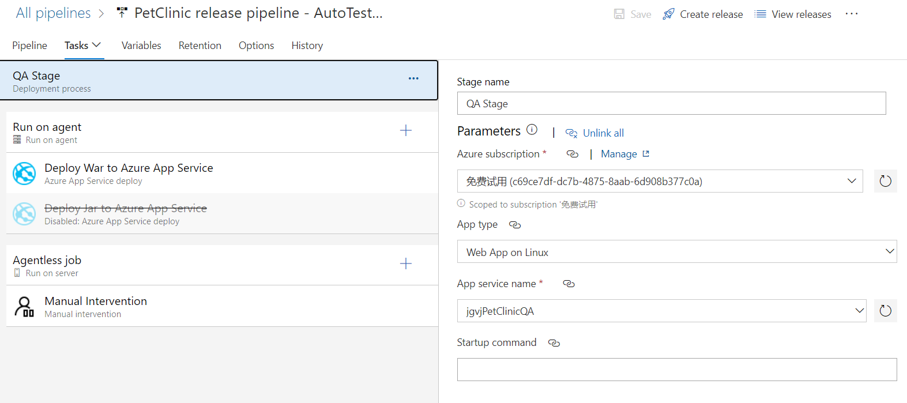

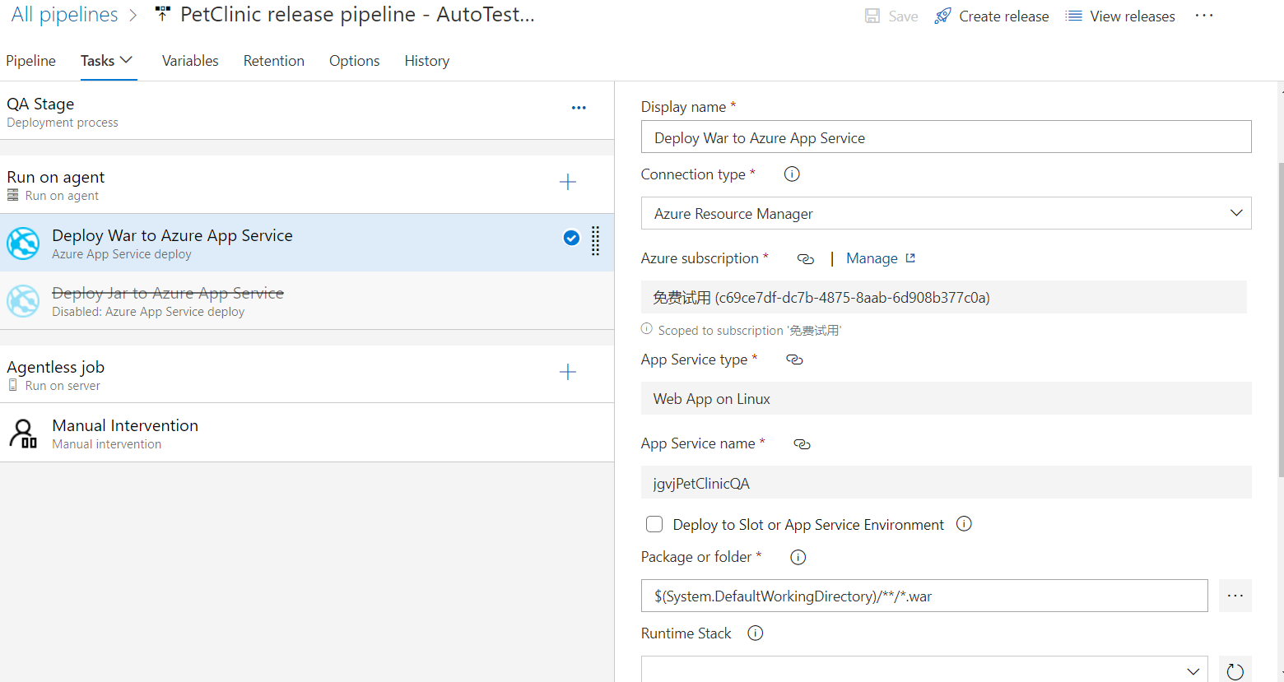

#Your build pipeline references an undefined variable named ‘Parameters.ConnectedServiceName’. Create or edit the build pipeline for this YAML file, define the variable on the Variables tab. See https://go.microsoft.com/fwlink/?linkid=865972

#Your build pipeline references an undefined variable named ‘Parameters.WebAppKind’. Create or edit the build pipeline for this YAML file, define the variable on the Variables tab. See https://go.microsoft.com/fwlink/?linkid=865972

#Your build pipeline references an undefined variable named ‘Parameters.WebAppName’. Create or edit the build pipeline for this YAML file, define the variable on the Variables tab. See https://go.microsoft.com/fwlink/?linkid=865972

#Your build pipeline references an undefined variable named ‘Parameters.StartupCommand’. Create or edit the build pipeline for this YAML file, define the variable on the Variables tab. See https://go.microsoft.com/fwlink/?linkid=865972

steps:

- task: AzureRmWebAppDeployment@4

displayName: 'Deploy War to Azure App Service'

inputs:

azureSubscription: '$(Parameters.ConnectedServiceName)'

appType: '$(Parameters.WebAppKind)'

WebAppName: '$(Parameters.WebAppName)'

packageForLinux: '$(System.DefaultWorkingDirectory)/**/*.war'

StartupCommand: '$(Parameters.StartupCommand)'

**QA Auto Test:**

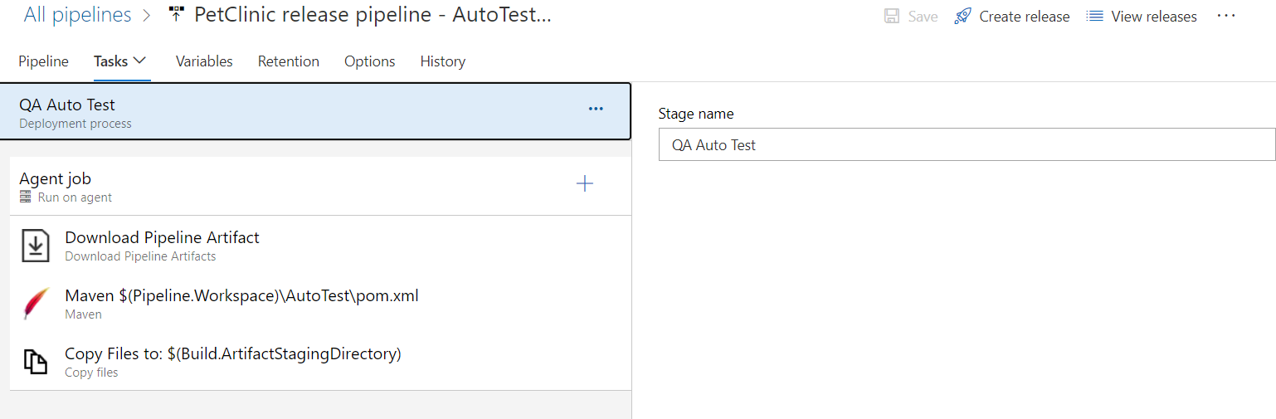

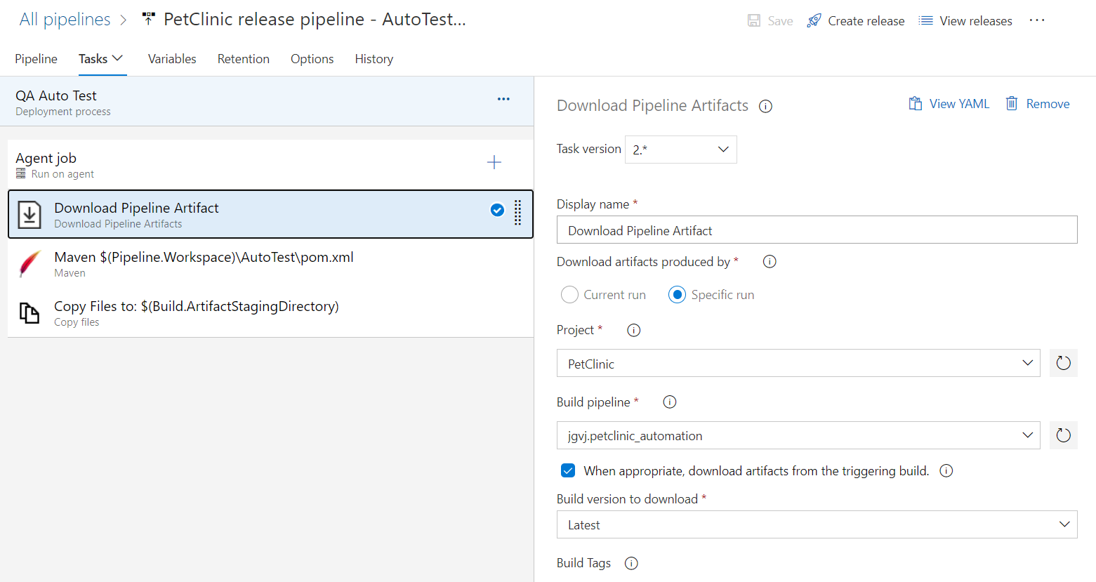

steps:

- task: DownloadPipelineArtifact@2

displayName: 'Download Pipeline Artifact'

inputs:

buildType: specific

project: '31869e95-a00e-4794-9339-9b56d80967c9'

definition: 3

specificBuildWithTriggering: true

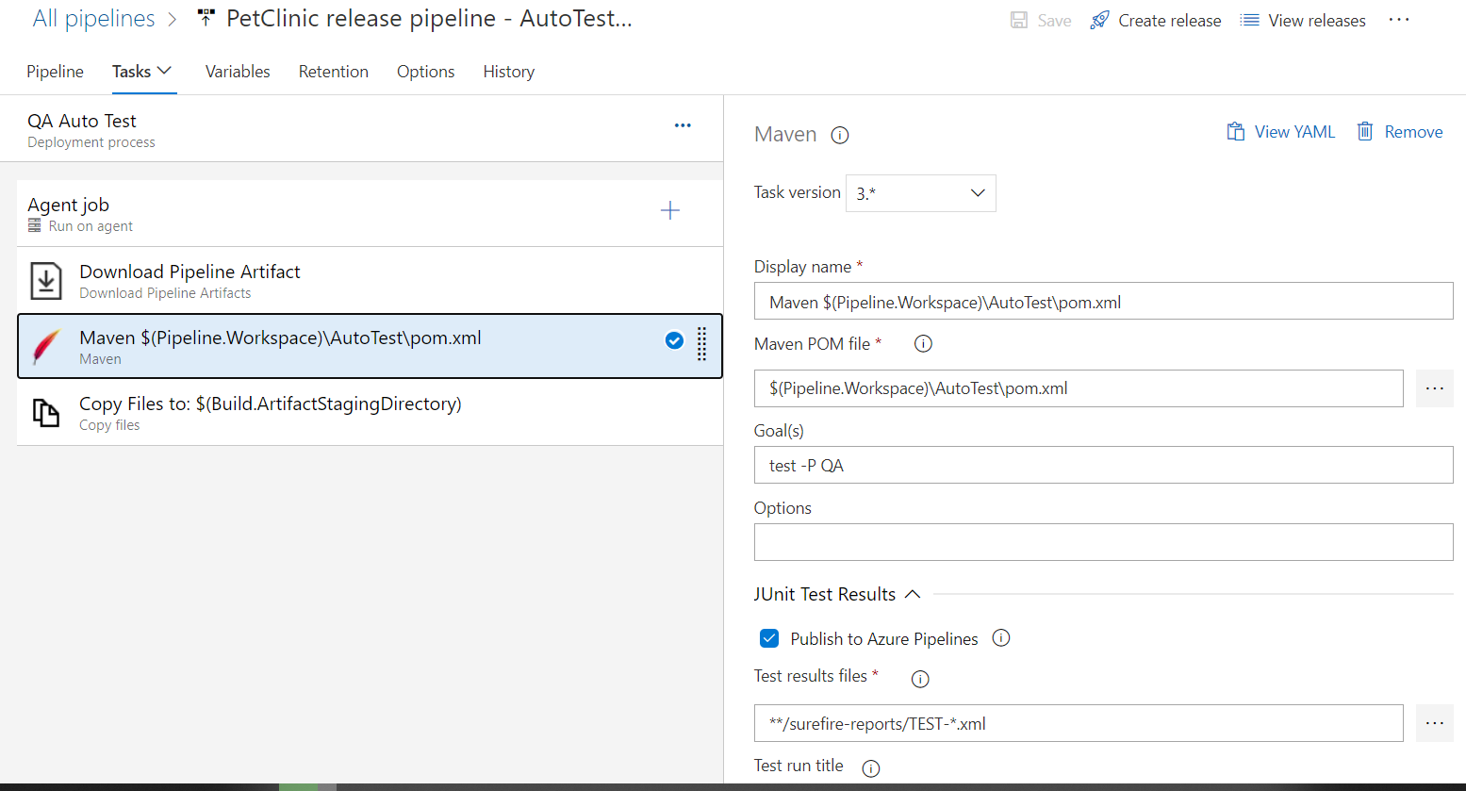

#Your build pipeline references an undefined variable named ‘Pipeline.Workspace’. Create or edit the build pipeline for this YAML file, define the variable on the Variables tab. See https://go.microsoft.com/fwlink/?linkid=865972

steps:

- task: Maven@3

displayName: 'Maven $(Pipeline.Workspace)\AutoTest\pom.xml'

inputs:

mavenPomFile: '$(Pipeline.Workspace)\AutoTest\pom.xml'

goals: 'test -P QA'

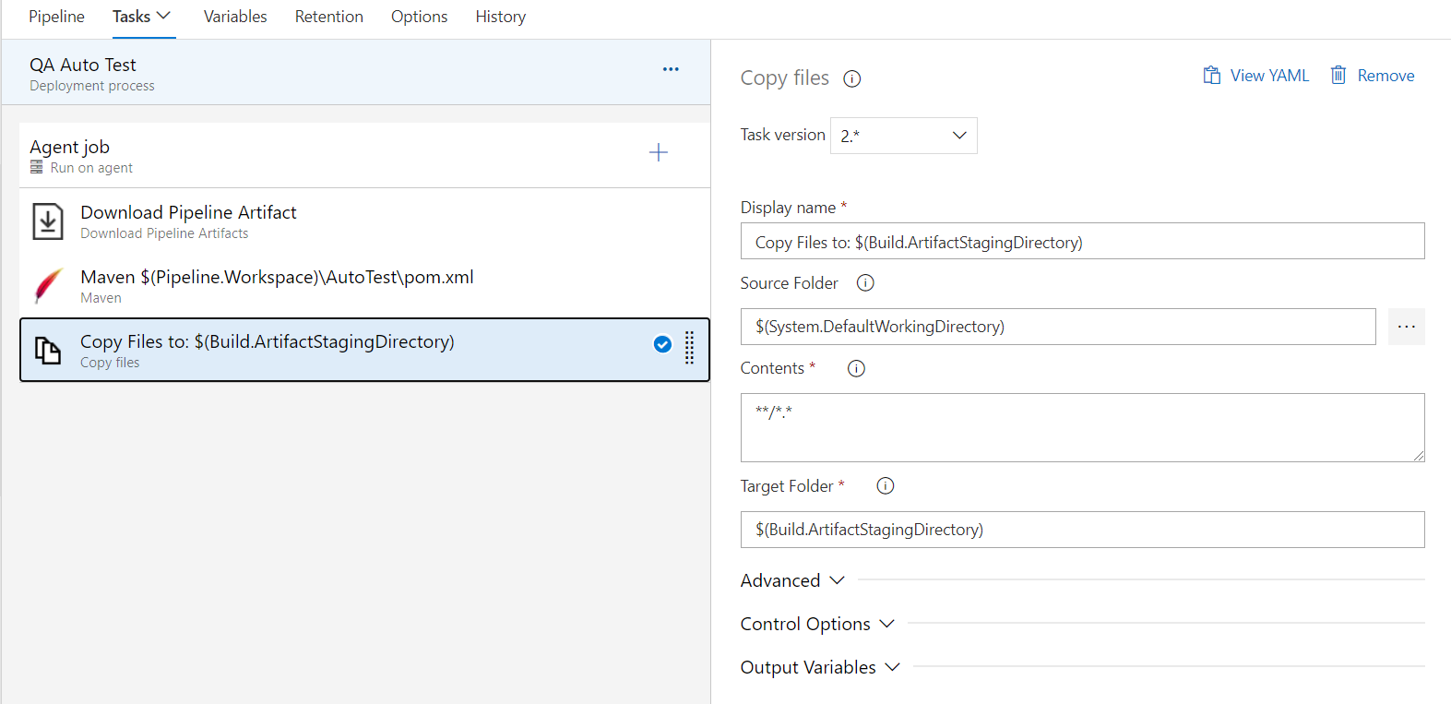

steps:

- task: CopyFiles@2

displayName: 'Copy Files to: $(Build.ArtifactStagingDirectory)'

inputs:

SourceFolder: '$(System.DefaultWorkingDirectory)'

Contents: '**/*.*'

TargetFolder: '$(Build.ArtifactStagingDirectory)'

**PROD Stage:**

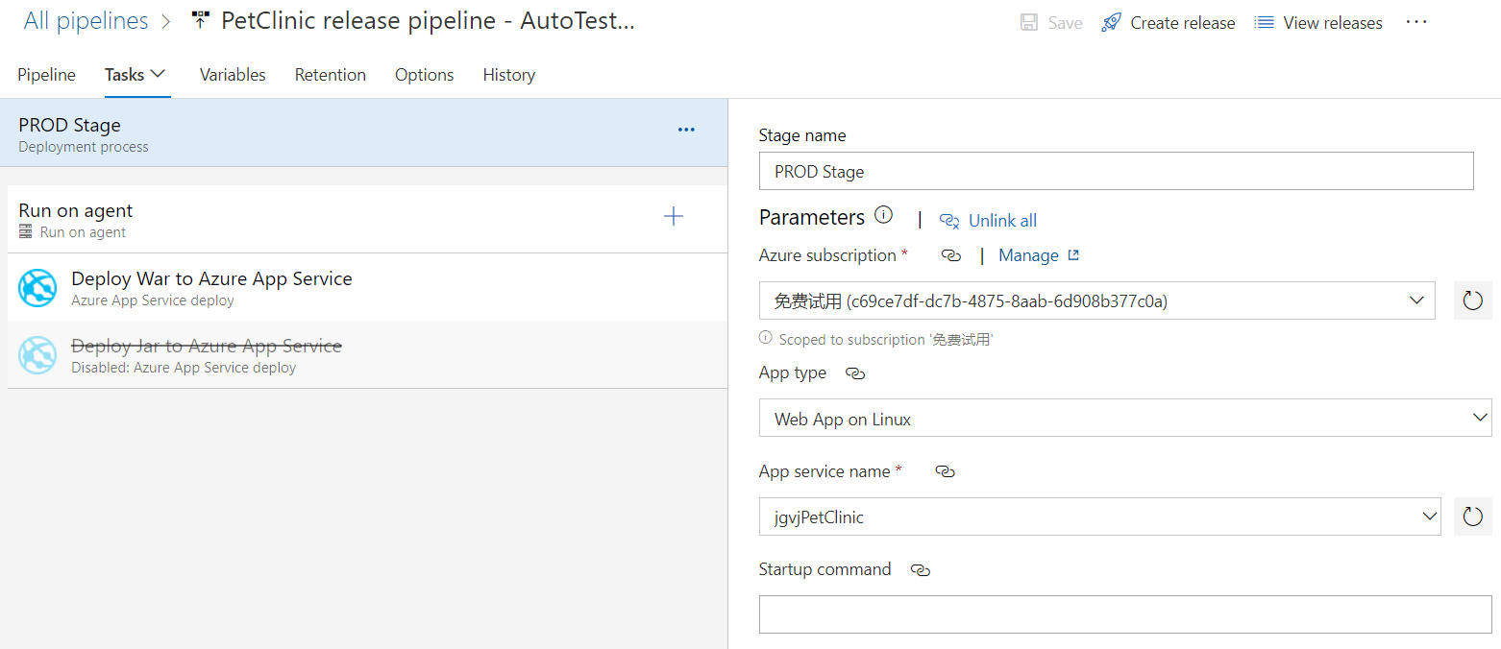

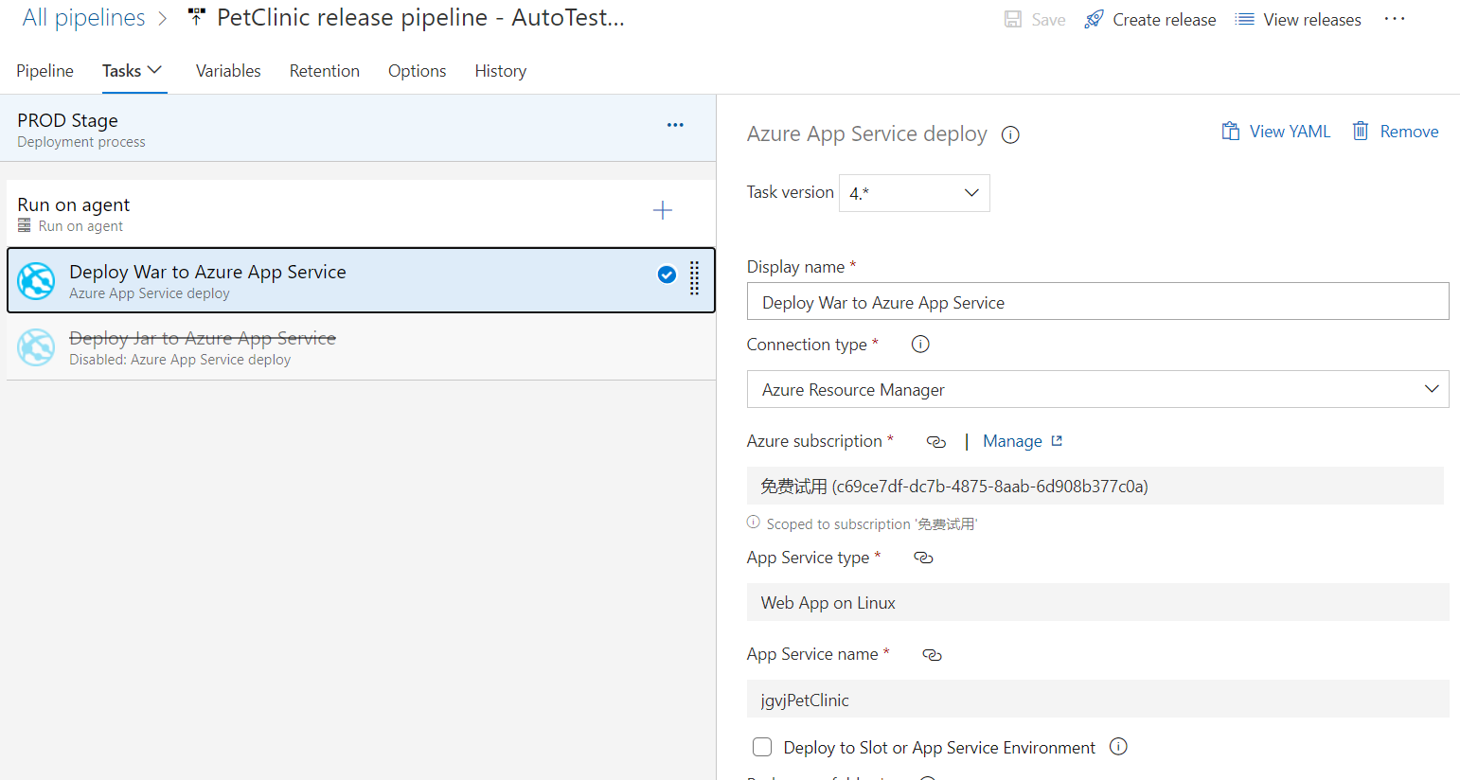

#Your build pipeline references an undefined variable named ‘Parameters.ConnectedServiceName’. Create or edit the build pipeline for this YAML file, define the variable on the Variables tab. See https://go.microsoft.com/fwlink/?linkid=865972

#Your build pipeline references an undefined variable named ‘Parameters.WebAppKind’. Create or edit the build pipeline for this YAML file, define the variable on the Variables tab. See https://go.microsoft.com/fwlink/?linkid=865972

#Your build pipeline references an undefined variable named ‘Parameters.WebAppName’. Create or edit the build pipeline for this YAML file, define the variable on the Variables tab. See https://go.microsoft.com/fwlink/?linkid=865972

#Your build pipeline references an undefined variable named ‘Parameters.StartupCommand’. Create or edit the build pipeline for this YAML file, define the variable on the Variables tab. See https://go.microsoft.com/fwlink/?linkid=865972

steps:

- task: AzureRmWebAppDeployment@4

displayName: 'Deploy War to Azure App Service'

inputs:

azureSubscription: '$(Parameters.ConnectedServiceName)'

appType: '$(Parameters.WebAppKind)'

WebAppName: '$(Parameters.WebAppName)'

packageForLinux: '$(System.DefaultWorkingDirectory)/**/*.war'

StartupCommand: '$(Parameters.StartupCommand)'