MALAWI UNIVERSITY OF BUSINESS AND APPLIED SCIENCES

SCHOOL OF SCIENCE AND TECHNOLOGY
DEPARTMENT OF COMPUTER SCIENCE INFORMATION SYSTEMS

MODULE:
CIS-DSA-221

GROUP MEMBERS:
JOYFUL GWETSE BIT/24/SS/013
THUMBIKO MKANDAWIRE BIT/24/SS/029
CRAIG LISUWALI BIT/24/SS/019

PROGRAMME:
BACHELOR IN INFORMATION TECHNOLOGY

TO:
DR. A. TAYLOR

SUBMISSION DATE: 12 NOVEMBER 2026

- A WEIGHTED GRAPH OF A ROAD NETWORK IN MALAWI

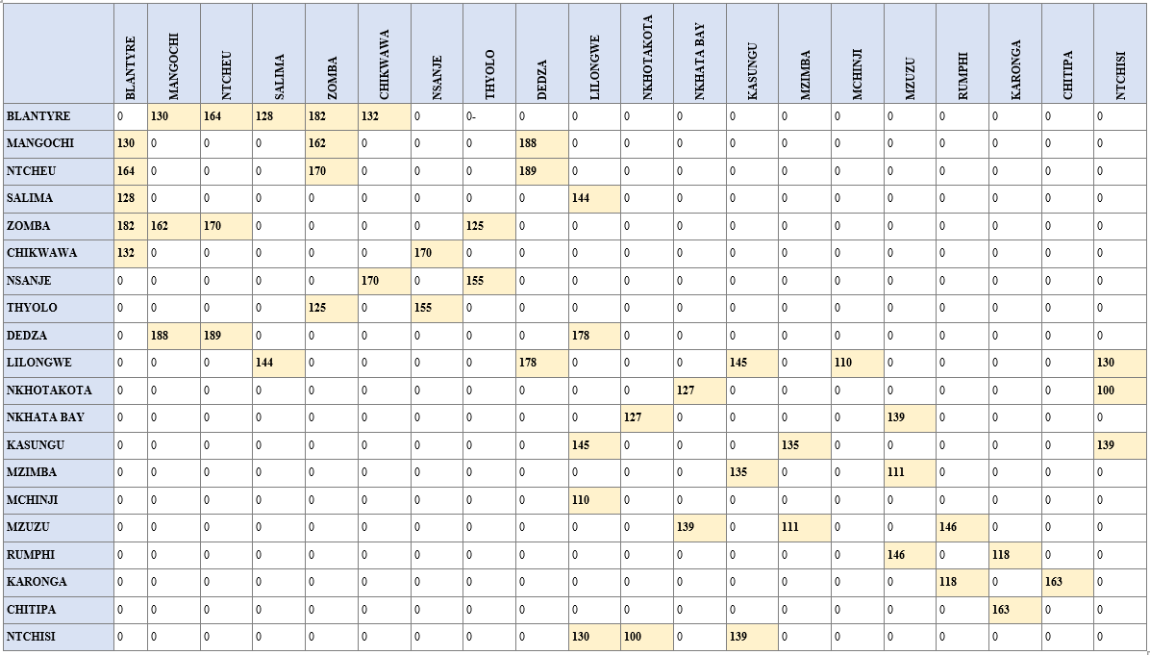
Above is a graph of a road network scenario in Malawi represented in a Matrix format. The graph has nodes which are places in Malawi, and nodes are connected by edges which are roads. Nodes that are directly connected to another node have weights and nodes that have no direct connection to another node have a cell with a 0.

- A DRAWN WEIGHTED GRAPH OF A ROAD NETWORK IN MALAWI

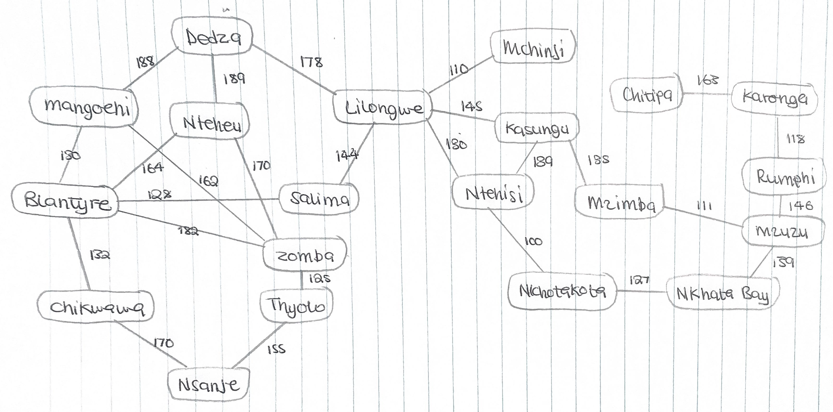
This graph represents a scenario of Malawi’s road network. Each node is a major town or district, and each edge is a road connecting two of them. Each edge has a weight showing the estimate road distance in kilometres.
The graph is undirected, because roads can be travelled in both directions. It has 20 nodes and 26 edges, and it is connected, so you can travel from any town to any other.
Lilongwe and Blantyre are the busiest hubs, each with 5 connections. Zomba has 4. Mchinji and Chitipa each have one connection, so they sit at the ends of the network. The graph contains cycles, such as Lilongwe–Kasungu–Ntchisi, which give alternative routes between towns. The northern towns (Mzuzu, Rumphi, Karonga, Chitipa) link to the rest of the network through Mzimba and Nkhata Bay.

- DIJKSTRA WORK ON THE GRAPH

Dijkstra's Algorithm | Path Reconstruction
function Dijkstra(Graph, source):  for each vertex v in Graph:  dist[v] = INFINITY  prev[v] = -1  dist[source] = 0  PQ = min-priority queue  PQ.insert(source, 0)  while PQ is not empty:  u = PQ.extract_min()  for each neighbor v of u:  alt = dist[u] + weight(u, v)  if alt < dist[v]:  dist[v] = alt  prev[v] = u  PQ.insert_or_decrease(v, alt)  return dist, prev | function ReconstructPath(prev, target):  path = empty list  while target is not UNDEFINED:  path.push_front(target)  target = prev[target]  return path

Shortest distance (km) from Chitipa (source node) to every other node:
NODE | SHORTEST DISTANCE | PREVIOUS NODE
Chitipa | 0 | —
Karonga | 163 | Chitipa
Rumphi | 281 | Karonga
Mzuzu | 427 | Rumphi
Nkhatabay | 566 | Mzuzu
Mzimba | 538 | Mzuzu
Kasungu | 673 | Mzimba
Nkhotakota | 693 | Nkhatabay
Ntchisi | 793 | Nkhotakota
Lilongwe | 818 | Kasungu
Mchinji | 928 | Lilongwe
Salima | 962 | Lilongwe
Dedza | 996 | Lilongwe
Ntcheu | 1185 | Dedza
Mangochi | 1184 | Dedza
Blantyre | 1090 | Salima
Chikwawa | 1222 | Blantyre
Thyolo | 139 | Zomba
Zomba | 1272 | Blantyre
Nsanje | 1392 | Chikwawa

- IMPLEMENTING THE ALGORITHM USING C++
The program implements Dijkstra's Shortest Path Algorithm in C++ to determine the shortest route between selected districts in Malawi. It represents the road network using an adjacency matrix, where each district is treated as a node and the distances between connected districts are stored as edge weights. The algorithm uses a priority queue to efficiently calculate the minimum distance from a chosen starting point to all other locations and keeps track of the optimal path using a predecessor array. After the user enters a starting point and destination, the program displays the shortest route, the distance of each segment along the path, and the total distance travelled. It also validates user input and handles cases where no route exists between the selected locations.

- TESTING THE ALGORITHM
The Dijkstra implementation was tested using a valid route, a query where the source and destination are the same, and an invalid location. For each test, the input, expected output, actual output and result are recorded below. Error handling and a dry run of the algorithm follow.

TESTS
Test 1: Valid Route
Input: Starting Point: Blantyre; Destination: Mzuzu.
Expected Output: A shortest route should be found, and the total distance should be displayed.
Actual Output:
BLANTYRE → SALIMA → LILONGWE → KASUNGU → MZIMBA → MZUZU
Total weight: 663
Result: Pass
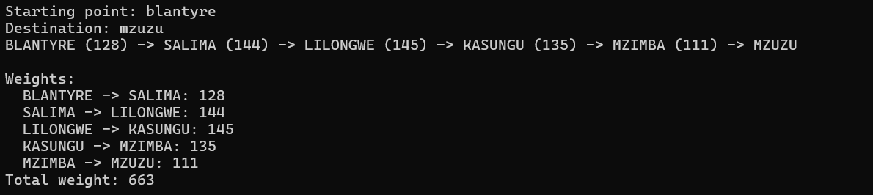
Test 2: Same Source and Destination
Input: Starting Point: Lilongwe; Destination: Lilongwe.
Expected Output: The distance should be 0, and the route should contain only Lilongwe.
Actual Output:
LILONGWE
Total weight: 0
Result: Pass
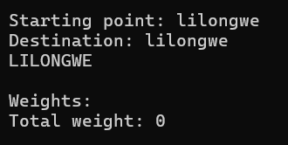
Test 3: Invalid Location
Input: Starting Point: London; Destination: Mzuzu.
Expected Output: An error message requesting a valid location.
Actual Output:
"LONDON" is not in the data. Try again.
Result: Pass
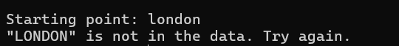
Error Handling
The program responds to invalid input as follows:
Error | System Response
Invalid town name | Displays an error message and asks for another input
Empty input | Prompts the user again
No route available | Displays "No route found"
Dry Run of Dijkstra's Algorithm

Source Node: Chitipa
At each step, the unvisited node with the smallest distance is selected, marked as visited, and its neighbours are updated if a shorter distance is found.
Step | Current Node | Distance | Updated Node | New Distance | Visited Set
1 | Chitipa | 0 | Karonga | 163 | Chitipa
2 | Karonga | 163 | Rumphi | 281 | Chitipa, Karonga
3 | Rumphi | 281 | Mzuzu | 427 | Chitipa, Karonga, Rumphi
4 | Mzuzu | 427 | Mzimba | 538 | Chitipa, Karonga, Rumphi, Mzuzu
5 | Mzimba | 538 | Kasungu | 673 | Chitipa, Karonga, Rumphi, Mzuzu, Mzimba
6 | Kasungu | 673 | Lilongwe | 818 | Chitipa, Karonga, Rumphi, Mzuzu, Mzimba, Kasungu
Shortest Path Obtained: CHITIPA → KARONGA → RUMPHI → MZUZU → MZIMBA → KASUNGU → LILONGWE
Total Distance: 818 km

Conclusion
The program returned the correct shortest routes in all tests. It returned a distance of 0 when the source and destination were the same, and it handled an invalid location without crashing. The dry run follows Dijkstra's procedure: the closest unvisited node is finalised at each step, and the final path and distance of 818 km agree with the program's approach.

- MINIMUM SPANNING TREE IN THE GRAPH
Yes, the Malawi road network graph has a Minimum Spanning Tree (MST). The MST represents the most cost-effective way to connect all towns in Malawi while using the minimum total road distance. Since the edge weights represent distances between towns, the MST can be used to estimate the lowest possible cost of constructing or maintaining a road network while still ensuring that every town remains connected.
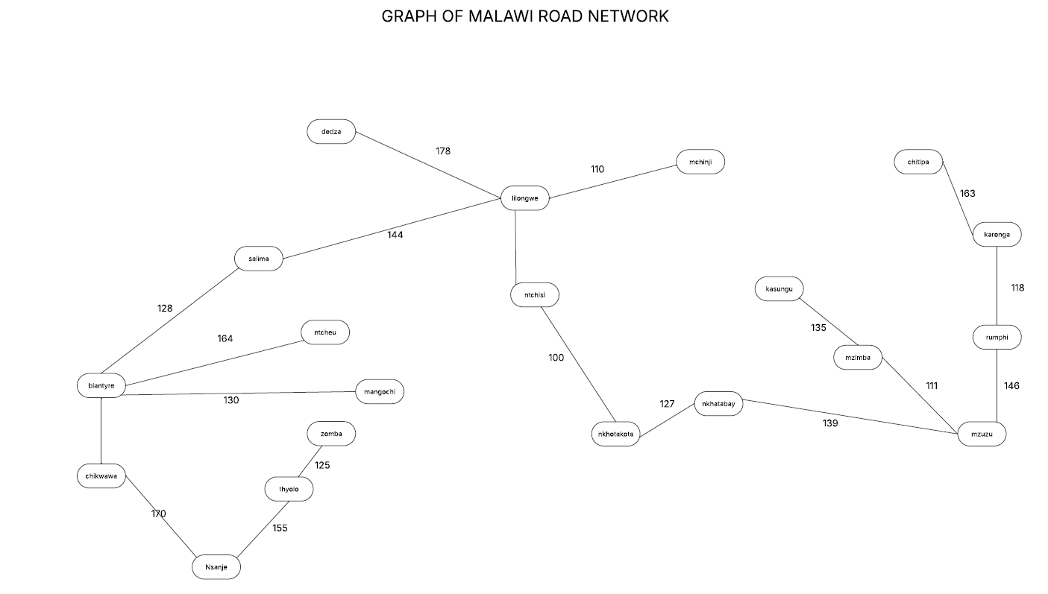

Real-World Scenario
Construction:
When planning road construction, the government aims to connect every town at the lowest possible cost. Constructing all 26 roads would be unnecessary because some roads provide alternative connections that are already available through other routes. An MST removes these redundant roads and retains only the essential connections needed to keep the entire network connected.
Maintenance:
If road infrastructure already exists and maintenance funds are limited, the MST helps identify the roads that are most important to maintain. Keeping these roads in good condition ensures that all towns remain connected, while less critical roads can be given lower priority.

Real-World Use Cases
1. Minimum Construction and Maintenance Cost
The MST connects all towns using the least total distance, reducing the cost of road construction and maintenance. If costs are proportional to distance, the MST provides the lowest overall expenditure.
2. Guaranteed Connectivity
Despite using fewer roads, every town remains connected to the network. It is still possible to travel between any two towns, either directly or through other connected towns.
3. No Redundancy
The MST contains no cycles, meaning there are no unnecessary duplicate routes. This helps distinguish essential roads from optional alternative connections.
Therefore, the MST represents the cheapest set of roads required to keep the entire Malawi road network connected without sacrificing accessibility between towns.

- ALGORITHM FOR FINDING MINIMUM SPANNING TREE
Kruskal's Algorithm would be used to find the Minimum Spanning Tree (MST) of the Malawi road network. It is an optimization algorithm that constructs the MST by selecting roads in increasing order of weight while ensuring that no cycles are formed. The process continues until all towns are connected with the minimum possible total distance.

Steps Followed by Kruskal's Algorithm
- List all edges in the graph.
- Sort the edges from the smallest weight to the largest weight.
- Select the edge with the smallest weight.
- Check whether adding the edge creates a cycle.
- If it does not create a cycle, include it in the MST.
- If it creates a cycle, discard it.
- Repeat the process until the MST contains V − 1 edges.

Why Kruskal's Algorithm is Suitable
- The Malawi road network is relatively sparse, meaning it has fewer edges compared to the maximum possible number of connections.
- It is simple to understand and implement.
- It selects the lowest-distance roads first, helping to minimize the total cost of the network.
- It prevents cycles, ensuring that only essential roads are included in the MST.

This makes Kruskal's Algorithm suitable for the Malawi road network, which contains 20 vertices and 26 edges, as it efficiently identifies the minimum set of roads needed to connect all towns while minimizing the total distance.

Time Complexity: O(E log E)
Where:
- E represents the number of edges.
- log E represents the sorting operation.

